**Asylu**nvi **Pr**ies**cedures**

Report on Policies and Practices in IGC Participating States 2012



intergovernmental consultations on migration, asylum and refugees

Inte governmental Consul lotions  
on migration, asylum and refugees

igc

**Asylum Procedures**

Report on Policies and Practices in IGC Participating States

December 2012

The IGC is an informal, non-decision making forum for inter-governmental information exchange and policy debate on issues of relevance to the management of international migratory flows. The IGC brings together 17 Participating States, the United Nations High Commissioner for Refugees (UNHCR), the International Organization for Migration (IOM) and the European Commission. The IGC is supported by a small Secretariat located in Geneva, Switzerland.

The Participating States are Australia, Belgium, Canada, Denmark, Finland, France, Germany, Greece, Ireland, the Netherlands, New Zealand, Norway, Spain, Sweden, Switzerland, the United Kingdom and the United States of America.

|  |  |
| --- | --- |
| Publisher: | Inter-governmental Consultations on Migration, Asylum and Refugees (IGC) 37-39 Rue de Vermont  1202 Geneva  Switzerland  E-mail: [info@igc-publications.ch](mailto:info@igc-publications.ch)  Internet: [www.igc-publications.ch](http://www.igc-publications.ch) |

ISBN 978-2-8399-1184-9

© 2012 Secretariat of the Inter-governmental Consultations on Migration, Asylum and Refugees (IGC)

All rights reserved. No part of this publication may be reprinted, reproduced or utilised in any form or by any means, electronic or mechanical, or by any information storage and retrieval system, without written permission from the copyright owners.

Printed in France by GPS PUBLISHING

Preface

Three years ago, the Report on Asylum Procedures, published by the IGC Secretariat, achieved great success among not only IGC Participating States but also a larger audience of other governments, universities, research institutes, non-governmental organisations and law offices. Similar to the so-called “Blue Books” published in the 1990s, the 2009 Report provided comprehensive and comparative descriptions of refugee status determination procedures in the 17 Participating States, with a specific focus on efficiency and integrity of asylum systems.

This updated version of the report reflects changes made to national systems since 2009, and comes at a time when the process of harmonisation at the European level is continuing apace and IGC States experience constraints brought on by the economic crisis and new inflows of asylum-seekers. Thus, particular attention in the standardised country chapters is given to recent measures taken by individual States to ensure greater quality, integrity and efficiency of national procedures.

The information contained in the 2012 report was gathered on the basis of substantial contributions from Participating States. All statistical data was obtained directly from Participating States as part of the regular IGC data collection process. Unless otherwise indicated, statistical information reflects first and repeat applications and is presented up to June 2012. Information on asylum law, procedures and policies is current up to November 2012.

This report would not have been possible without the considerable input of dedicated asylum policy-makers and practitioners in Participating States, the assistance of national contact points, and the support of Geraldine Wong Sak Hoi (language editor) and the entire staff of the IGC Secretariat.

The 2012 Asylum Procedures report was edited by Ward Lutin.

Contents

**Preface iii**

**Glossary vii**

**Introduction 11**

**Country Chapt ers 19**

australia 21

Belgium 57

canada 91

denmark 125

finland 151

france 181

germany 207

greece 235

ireland 251

netherlands 277

new Zealand 305

norway 333

spain 361

sweden 383

switZerland 409

united kingdom 435

united states of america 465

**Annexes 499**

1. Statistical Information on Asylum Applications Made in IGC Participating States 501
2. Basic Instruments of International Refugee Law and Human Rights Law:

Relevant Extracts 529

1. Selected UNHCR Executive Committee Conclusions on International Protection 541

Glossary of Terms Used1

**Adversarial:** Involving opposing parties, contested; as distinguished from an ex parte hearing or proceeding, in which the party seeking relief has given legal notice to the other party, and afforded the latter an opportunity to contest it[1] [2].

**Adjudication:** The act of making a formal decision or judgment on a matter.

**Asylee:** An asylum-seeker who has been granted protection under the Immigration and Nationality Act in the United States.

**Asylum:** The grant, by a State, of protection on its territory to persons from another State who are fleeing persecution or serious danger. Asylum encompasses a variety of elements, including *non-refoulement*, permission to remain on the territory of the asylum country, and humane standards of treatment.

**Asylum-seeker (also refugee claimant or applicant):** A person who seeks safety from persecution or serious harm in a country other than his or her own and awaits a decision on the application for refugee status under relevant international and national instruments. Not every asylum-seeker will ultimately be recognised as a refugee, but every refugee is initially an asylum-seeker.

**Carrier sanctions:** Sanctions, usually in the form of fines, imposed on carriers (owners of the conveyance) who bring into the territory of a State persons who lack valid entry documents.

**Cessation clauses:** Legal provisions that set out the conditions in which refugee status comes to an end because it is no longer needed or justified. Cessation clauses are found in Article 1C of the 1951 Convention relating to the Status of Refugees.

**Complementary protection:** Formal permission given by a country under its national law or practice, to reside in the country, extended to persons who are in need of international protection even though they do not qualify for refugee status under the 1951 Convention relating to the Status of Refugees. See *Subsidiary protection.*

**Convention refugee:** A person recognised as a refugee by States under the criteria set out in Article 1A of the 1951 Convention relating to the Status of Refugees, and entitled to the enjoyment of a variety of rights under that Convention. See *Refugee.*

**Country of first asylum:** The first country in which an asylum-seeker has been granted an effective hearing of his or her application for asylum.

**Country of origin information (COI):** Information on conditions in countries of origin, gathered specifically for use in procedures that assess claims of individuals for refugee status or other forms of international protection. COI usually helps to answer questions regarding the political, social, cultural, economic and human rights situation as well as the humanitarian situation in countries of origin[3].

***De novo:*** Beginning anew. An appellate court may undertake a review *de novo*.

***De jure:*** Existing by right or as a matter of law; descriptive of a condition in which there has been total compliance with all the requirements of the law[4].

**Detention:** Restriction on freedom of movement, usually through confinement, of a person by government authorities.

**Diplomatic asylum:** Refers broadly to asylum granted by a State outside its territory, particularly at its diplomatic missions[5].

**Exclusion clause:** Legal provisions that deny the benefits of international protection to persons who would otherwise satisfy the criteria for refugee status. In the 1951 Convention relating to the Status of Refugees, the exclusion clauses are found in Articles 1D, 1E and 1F. See *Removal.*

**Expulsion:** An act by an authority of the State with the intention and with the effect of securing the removal of a person or persons (usually non-nationals or stateless persons) against their will from the territory of that State.

***Ex officio:*** Refers to powers that, while not expressly conferred upon an official, are necessarily implied in the office.

**Family reunification:** Process whereby family members separated through forced or voluntary migration regroup in a country other than the one of their origin.

**Freedom of movement:** A human right laid down in Article 13 (1) of the Universal Declaration of Human Rights, which includes, *inter alia,* the element of “... freedom of movement and residence within the borders of each State.”

**Group-based protection:** Approaches whereby the protection and assistance needs of refugees are addressed without previously determining their status on an individual basis.

**Inclusion clause:** Clause in the 1951 Convention relating to the Status of Refugees (Article 1A (2)) that defines the criteria that a person must satisfy in order to be recognised as a refugee.

**Inquisitorial:** Involving an inquiry or inquest, or the investigation of certain facts and the active involvement of the decision-maker or adjudicator in the proceedings[6].

**Integration:** Generally, the process by which migrants become accepted into society, both as individuals and groups. Integration implies consideration of the rights and obligations of migrants and host societies, of access to different kinds of services and the labour market, and of identification and respect for a core set of values that bind migrants and host communities in a common purpose.

**Interception:** Any measure applied by a State outside its national territory to prevent, interrupt, or stop the movement of persons without required documentation from crossing borders by land, air or sea, and making their way to the country of prospective destination.

**International protection:** Legal protection, on the basis of international law, aimed at protecting the fundamental rights of a specific category of persons outside their countries of origin, who lack the protection of their own countries.

**Judicial Review:** A court's review of a lower court's or an administrative body's factual or legal findings.

**Mandate refugee:** A person who meets the criteria of the UNHCR Statute and qualifies for the protection of the UNHCR, regardless of whether or not he or she is in a country that is a party to the 1951 Convention relating to the Status of Refugees or the 1967 Protocol relating to the Status of Refugees, and whether or not he or she has been recognised by the host country as a refugee under either of these instruments.

***Non-refoulement:*** A core principle laid down in the 1951 Convention relating to the Status of Refugees according to which “no contracting State shall expel or return a refugee in any manner whatsoever to the frontiers of territories where his or her life or freedom would be threatened on account of his or her race, religion, and nationality, membership of a particular social group or political opinion” (Article 33(1) of the 1951 Convention). The principle of *non-refoulement* is a part of customary international law and is therefore binding on all States, whether or not they are parties to the 1951 Convention.

**Permanent residence:** The right, granted by the authorities of a host country to a non-national, to live and work in the territory on a permanent (unlimited or indefinite) basis.

***Prima facie refugee:*** A person recognised as a refugee, by a State or UNHCR, on the basis of objective criteria related to the circumstances in the country of origin, which justify a presumption that the person meets the criteria of the applicable refugee definition.

**Protection Visa (PV):** Permit granted in Australia to asylum-seekers who have been recognised as Convention refugees.

**Quota Refugee:** A refugee, as identified by the UNHCR, who is accepted by a State as part of a yearly Resettlement Programme[7]. See also *Resettlement*.

**Readmission agreement:** Agreement that addresses procedures, on a reciprocal basis, for one State to return non-nationals in an irregular situation to their home State or a State through which they have transited.

**Reception centre:** A location with facilities for receiving, processing and attending to the immediate needs of refugees or asylum-seekers as they arrive in a country of asylum.

**Refugee:** A person who meets the eligibility criteria under the applicable refugee definition, as provided for in Article 1A (2) of the 1951 Convention relating to the Status of Refugees. See also *Convention refugee*.

**Regularisation:** Any process or programme by which the authorities of a country allow non-nationals in an irregular or undocumented situation to stay lawfully in the country.

**Removal:** The act of a State in the exercise of its sovereignty in removing a non-national from its territory to his or her country of origin or a third country after refusal of admission or termination of permission to remain. See also *expulsion*.

**Resettlement:** The transfer of refugees from the country in which they have sought refuge to another State that has agreed to admit them. The refugees (often referred to as resettled or quota or mandate refugees) will usually be granted asylum or some other form of long-term rights.

**Return:** The act of a person returning to his or her country or place of origin or habitual residence. See also *Voluntary return*.

**Revocation:** Rescinding, withdrawing or cancelling of permission or status granted.

**Safe country of origin:** The country of a person's nationality or habitual residence where effective protection can be sought and secured. A safe country of origin does not generally produce refugees.

**Safe third country:** A country in which an asylum-seeker could have had access to an effective asylum regime, and in which he or she has been physically present prior to arriving in the country in which he or she is applying for asylum.

**Stateless person:** A person who is not considered a national by any State under the operation of its law (Article 1 of the 1954 UN Convention Relation to the Status of Stateless Persons).

**Subsidiary protection:** A form of complementary protection granted by EU Member States when “serious harm” is established in accordance with Article 15 of Council Directive 2004/83/EC. See also *Complementary protection.*

**Suspensive effect:** The right to remain in a country pending the outcome of a legal proceeding.

**Temporary protection:** Generally speaking, an arrangement developed by States to offer protection of a temporary nature to persons arriving from situations of conflict or generalised violence, often without prior individual status determination, or individually to persons who cannot return because of a generalised risk to the population in the country of origin.

**Territorial asylum:** Usually, asylum granted within the territorial limits of the State offering asylum[8].

**Unaccompanied minor:** A person below the legal age of majority who is not accompanied by a parent, guardian, or other adult who by law or custom is responsible for the minor.

**Unauthorised entry:** Act of crossing the borders of a State without complying with the necessary requirements for legal entry of that State.

**Visa:** An endorsement by a consular officer in a passport or a certificate of identity that indicates that the officer, at the time of issuance, believes the holder to fall within a category of non-nationals who can be admitted under the State's laws.

**Voluntary return:** The assisted or independent return to the country of origin based on the refugee's free and informed decision. See also *Return*.

Introduction

Introduction

More than three years have passed since the last Report on Asylum Procedures in IGC Participating States - known by many as the “Blue Book” - was published. Although large parts of the 2009 Blue Book remain accurate, asylum systems continuously evolve, and important sections of the country chapters needed to be rewritten. Asylum flows into Participating States have shifted, some States have undergone a complete overhaul of their asylum procedures, and many have introduced changes aimed at better managing the quality, integrity and efficiency of their national procedures and practices, and at tackling abuses.

Data Trends

The 2012 Blue Book provides statistical information on asylum applications and asylum decisions for each individual Participating State, and contains a separate annexe with comparative data charts and tables.

Below are some highlights on the main trends in asylum applications since 1983 and the main nationalities who applied for asylum in 2009, 2010 and 2011.[9]

Figure 1: Evolution of Asylum Applications in IGC Participating States, 1983-20111

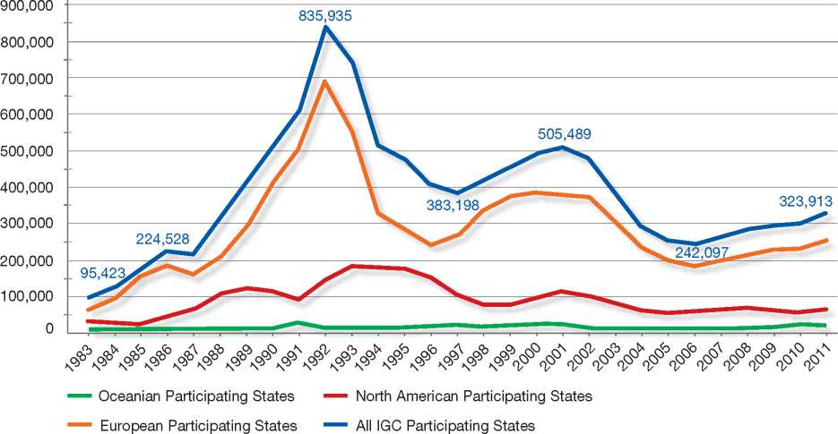

The early peaks in 1992 and 2001 were distinctly marked by the two crises in the Balkans. In 2006, numbers troughed for all IGC Participating States. Thereafter, asylum applications have continuously increased. The main contributors to the trend are European Participating States as the line graph shows. Numbers for France, Germany and Sweden have constantly increased since the last edition of the Blue Book in 2009. With regard to North America, numbers are continuously increasing for the United States while they peaked for Canada in 2008 and dropped thereafter. The combined line graph Oceania for Australia and New Zealand is determined by the near record numbers for Australia since 2010. Actually, the total for 2010 (12,606) only missed the all-time record for 2000 (12,608) only by two applications.

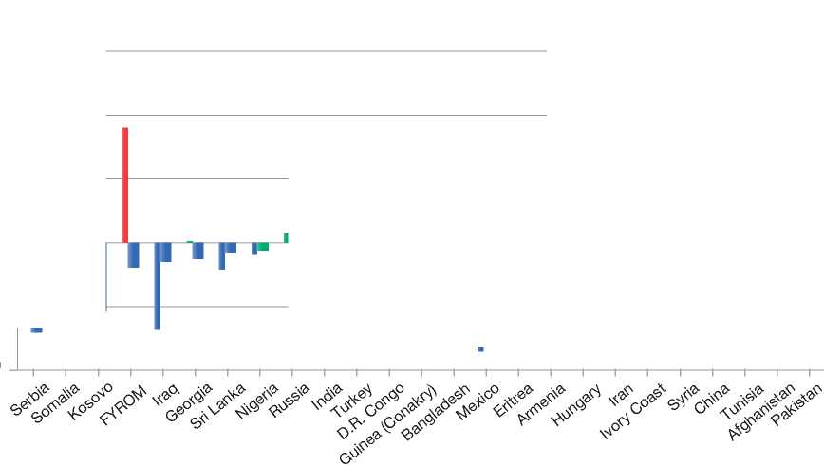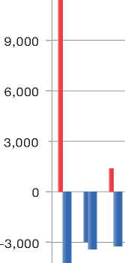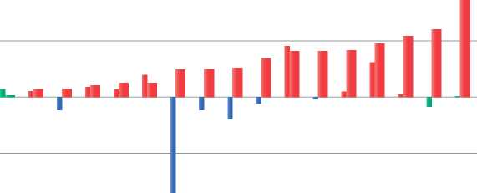

Figure 2: Top Countries of Origin for Asylum Applications in All IGC Participating States , 2011

Numerical Change and Evolution in 2010 compared to 2009, and 2011 compared to 2010

Evolution: (< -5 % | ± 5 % | > 5 %

12,000

-6,000

**Numerical Change:**

**Evo**lution 2010 compared to 2009

**Evo**lution 2011 compared to 2010

In 2009, France, Canada, the United Kingdom and Germany were the top receiving countries in the IGC. From 2010 to 2012, France, Germany, the United States and Sweden were the top receiving countries.

The graph above shows a double comparison for the top 25 countries of origin in 2011. The left bar illustrates the numerical change for these countries between 2009 and 2010 and the right bar the numerical change between 2010 and 2011.

One of the most striking observations is the continuous decline in applications received from Somalia and Iraq. Both countries of origin still remain in the top 10 countries but are no longer part of the top three countries, and in 2012, even fell out of the top five.

The Western Balkan countries have shown a similar trend after the liberalisation of visa requirements for Serbia, the Former Yugoslav Republic of Macedonia (FYROM) and Albania. During the cold months of the years 2010, 2011 and 2012, thousands of asylum applications were received by IGC Participating States. This led to changes in processing asylum cases in Sweden, Germany and Belgium, which reacted by prioritising and accelerating refugee status determination.

The strong fluctuation for Mexico stems from an important shift in the flow between Canada and the United States. In 2009, Canada received 7,500 applications but in the following years, numbers dropped sharply, to reach 650 applications in 2011. On the contrary, the United States saw numbers rise from 1,500 in 2009 to almost 5,000 in 2011.

Among the increases, the most important evolution concerned Afghanistan, which has been the top country of origin of origin since 2009. There have been numerous shifts in the movements between Participating States over the last three years, with numbers slightly decreasing in 2010 but picking up significantly again in 2011. Many Afghans, including large numbers of unaccompanied minors, continue to come to mainly European Participating States but also Australia. Applications from Pakistan were also on the increase in 2011 after rather stable numbers in 2009 and 2010. Hence, Pakistan is back among the top countries of origin.

Due to the conflict, Syria has rapidly become a top country of origin and became the second most important country of origin for the IGC in 2012. Syria is expected to become the top country of origin in 2013. Several Participating States, including Sweden, project for next year a very significant increase over the already high numbers received in 2012. Figures will continue to rise as the situation in Syria deteriorates and reception capacities in neighbouring countries get saturated.

Other countries that were affected by the Arab Spring also showed an increasing trend. Applications from Tunisia rose slightly in 2010 and became the third most important increase in 2011. Algeria also showed a steady but minor increase during the period 2009-2011. The main receiving country for Algeria is France while Tunisians predominantly applied for asylum in Switzerland, which experienced a significant increase to just over 2,500 applications in 2011. This accounted for the overall increase in applications.

Other important countries of origin with significant increases in 2010 and 2011 include Iran and China. Numbers for Iran steadily increased since 2009 in Australia, Germany and the United Kingdom, while China increased in Canada, France and particularly the United States.

The increases in applications for Hungary and Ivory Coast were limited to individual IGC Participating States. Hungarians almost exclusively applied for asylum in Canada and Ivorians mainly in France, Spain and the United States.

Single Procedure, Single Status

One of the main trends identified in the 2009 Report, which was an update of the 1997 Report and thus covered a period of 12 years, was the introduction in most Participating States of a single procedure for granting Geneva Convention status and complementary (or subsidiary) protection. This evolution has now been completed, with the introduction of a single procedure in Australia and New Zealand, and the imminent adoption of a new Immigration, Residence and Protection Bill in Ireland.

There is also an evolution towards a single status, although many Participating States still choose to make a clear distinction between Geneva Convention status and complementary or subsidiary protection status. Australia, Norway and Spain recently introduced a single status, with equal conditions and benefits granted to both types of protected persons.

Large-Scale Reforms of Asylum Systems

Some national asylum systems have undergone a complete overhaul in recent years or are currently in the process of doing so. Australia recently re-introduced the use of regional processing centres on Pacific islands, a controversial measure taken on the basis of a report of an Expert Panel on Asylum-Seekers. In Canada, a series of legislative initiatives have been made to restore a system that was considered “broken”, thereby redrawing the institutions involved in the asylum procedure, shortening processing times, designating (safe) countries of origin, combating human smuggling and promoting return. In Greece, provisional procedures are in place as a new asylum system, which will include new institutions dealing with refugee status determination (RSD) and reception, is under construction. The Netherlands remodelled its RSD and reception processes, which now include a rest and preparation phase before actual processing takes place. Switzerland is also in the process of re-thinking its asylum system.

A Focus on Quality

Participating States are increasingly recognising the need to monitor, maintain and improve the quality of refugee status determination processes. Several States have quality-assurance systems in place that go beyond the regular supervision of caseworkers and draft decisions. Some, such as Ireland, have separate quality units or quality managers. A widely recognised best practice has long been the UK Quality Initiatives, in which the UNHCR was heavily involved. In the past few years, the UNHCR has promoted and further developed quality-management expertise from the Quality Initiatives in the context of two subsequent European projects: Asylum Quality Assurance and Evaluation Mechanism (ASQAEM) and Further Developing Quality (FDQ), which involved both Central and Southern European Member States, as well as more experienced States such as Germany. The UNHCR is also involved in New Zealand's quality assurance system. The United Kingdom continues its quality-related work under the name “Quality Integration”.

Asylum administrations use training as a key catalyst in the development of high-quality asylum systems. Several Participating States have established new training programmes for caseworkers. In Europe, the combined e-learning and face-to-face modules of the European Asylum Curriculum (EAC) are widely considered a best practice, and most European Member States use these modules as a basis for national training on asylum-related topics. The United States developed a combined initial training programme for staff working in different divisions, which is complemented by ongoing weekly training sessions.

Several States have revamped their information provision to asylum-seekers. For example, Belgium, Denmark and Norway use audiovisual tools. Other States, such as Ireland, the Netherlands and the United States, facilitate access to information for asylum-seekers by offering special customer service.

There is growing attention being paid to the vulnerability of certain asylum-seekers, and to the negative impact this vulnerability may have on their access to protection. This is clearly the case for unaccompanied minors and victims of human trafficking, but also for asylum-seekers whose claims are based on gender issues, sexual orientation or gender identity. Participating States such as Australia, Canada, Germany, Spain and Switzerland have developed specific guidance. Spain and the United States have highlighted the development of specific training programmes to raise awareness on these issues. Some countries, such as Belgium, Sweden and Switzerland, aim to provide tailor-made information on procedures and rights to women and/or LGBTI[10] persons.

In order to balance efficiency and integrity measures, additional quality safeguards are being incorporated into accelerated or streamlined procedures. This may be done by providing free legal counsel early in the procedure or by engaging the UNHCR or non-governmental organisations (NGOs) in the RSD process. A new practice that should be highlighted is the Dutch “rest and preparation period” for asylum-seekers that precedes the RSD process. Switzerland is also considering the introduction of a similar preparation period.

Integrity

Maintaining or - if needed - restoring the integrity of the national asylum system is a major preoccupation in many Participating States. Asylum procedures continue to be perceived as important entry channels for irregular migration, raising potential security concerns. In response to irregular boat arrivals, both Canada and Australia have introduced far-reaching anti-smuggling strategies. In Australia, this strategy encompasses - in addition to off-shore processing - the “no advantage” concept, which further removes incentives for asylum-seekers to pay smugglers and venture on dangerous boat journeys.

As identification of asylum-seekers often proves to be problematic - not only in the context of RSD procedures, but also in the context of return - some Participating States, such as Sweden, have taken steps to discourage the common practice of hiding or destroying identity documents, by linking the existence of identity documents to financial allowances and/or access to the labour market. Norway established a National Identity and Documentation Centre to improve the identification of asylum-seekers, and some States have specialised units within their asylum administrations handling document verification. With regard to fingerprinting, a new deep-scanning method is being used by Sweden and France, which should overcome the effects of damaged fingertips.

In order to tackle high numbers of unfounded repeat applications, often made with the aim to avoid removal proceedings, some Participating States have raised the threshold for repeat applications (e.g. the introduction of a one-year ban in Canada and fees for making a second application in Switzerland), or taken measures to make re-applications less attractive (e.g. limited reception benefits in Belgium).

In addition, safe country concepts have been introduced in Canada and Belgium, where lists of (designated/ safe) countries of origin allow the asylum authorities to channel certain caseloads with low recognition rates into an accelerated procedure, thus reducing the pull factor of the asylum system. Switzerland recently introduced the safe third country principle.

Improving the Efficiency of Asylum Procedures

Management principles have clearly found their way into the asylum field. Many asylum administrations are under pressure to increase their performance in order to cope with increasing inflows, large backlogs, reception challenges, and cuts in staff numbers and budgets.

Over the last few years, several Participating States (*inter alia* Sweden, Denmark and Norway) adopted “lean” management principles, initially developed by private companies, to streamline their asylum procedures and reduce processing times. New processing targets and performance measurement strategies have also been introduced in Canada. In order to speed up processing, the general asylum caseload is often channelled into different processing tracks, thus allowing for a prioritised or accelerated processing of specific caseloads in parallel with the normal procedure. By implementing its new eight-day procedure, the Netherlands has now reversed the logic: the accelerated procedure has become the norm, and only cases that cannot be decided within eight days are transferred to an extended procedure. As mentioned before, this eight-day procedure is preceded by a rest and preparation period of at least six days.

Better cooperation between services or departments responsible for different asylum-related tasks is instrumental to increasing efficiency, as progress in one part of the chain is only useful if the other parts follow. This form of chain management within the asylum system can be facilitated by concentrating different services in the same location (e.g. the Police and the Immigration Service in Denmark share the same building, next to the main reception centre), and by digitising the asylum file and allowing all relevant actors access to this information (e.g. Finland and Norway).

Finally, several Participating States have undertaken special measures in recent years to reduce the number of pending cases. Backlog management measures are highlighted in the Canadian, French, Greek and Spanish chapters.

Return

As part of integrity measures, Participating States try to improve the level of implementation of final negative decisions. In order to boost return, return information is provided earlier in the process. Some Participating States, such as Belgium, have developed alternatives to pre-removal detention for families with children. New voluntary return programs have been set up in Canada and Finland. Sweden and the United Kingdom specified that rejected asylum-seekers may continue to receive reception benefits as long as they cooperate on return proceedings.

External Dimension

External dimension is not a key focus of this report. Still, there are some developments that are worth mentioning.

Diplomatic protection is no longer an option in Participating States. Provisions allowing for making an asylum claim in diplomatic missions have been abolished in Spain and Switzerland.

Resettlement is on the rise. New resettlement programmes have been set up in Belgium and Spain and both Australia and Canada have recently increased their quotas for resettlement. With the adoption on 29 March 2012 of a EU joint resettlement programme, European countries will receive more support from the EU to take up refugees already determined by UNHCR to be in genuine need of international protection.

Finally, some Participating States are trying to intensify cooperation with third countries and promote protection-in-the-region programmes. As mentioned before, Australia established processing centres on Nauru and Manus Island and cooperates with countries in the region to fight human smuggling. Denmark mentioned in its country report the continuation of its Regions of Origin project.

EU Harmonisation

At the EU level, the period 2009-2012 has been crucial for harmonising asylum procedures in Member States. Legislative work to establish a Common European Asylum System is due to be finalised in 2012. Whereas a first set of legal instruments created minimum standards that still left room for different interpretations at the national level, the aim of the second generation of legal instruments is to raise the standards and fill gaps. At this writing, negotiations on this second-generation package were in their final phase.

In addition to new or revised legislation, the jurisprudence of the European Court of Justice (ECJ) and the European Court of Human Rights (ECHR) has an important harmonising effect on Member States' practices. A case that was particularly important was that of *Elgafaji* (ECJ case C-465/07), which shed light on the threshold for individualised threat in situations of generalised violence (Art. 15c of the Qualification Directive).

A key development in the European asylum field was the establishment of the European Asylum Support Office (EASO) in 2011. This new European agency, which is located in Malta, aims to foster practical cooperation in the field of asylum. An important tool managed by EASO and mentioned by many European Member States in this report is the European Asylum Curriculum (EAC). EAC comprises online training modules and face-to-face sessions. So far, thirteen modules have been developed. Other EASO-related activities mentioned in the country chapters relate to country of origin information (COI). Some Participating States have been closely involved in setting up EASO's COI function, with a task force and working parties established to elaborate methodologies for reports and meetings, and to make a Common COI Portal operational.

Country Chapters

1.

2.

3.

4.

5.

6.

7.

8.

9.

10.

11.

12.

Australia

51

|  |  |
| --- | --- |
| BackGRound: MajoR asyluM tRends and developMents | 23 |
| national leGal FRaMewoRk | 25 |
| institutional FRaMewoRk | 27 |
| pRe-entRy MeasuRes | 28 |
| asyluM pRoceduRes | 29 |
| decision-MakinG and statuses | 39 |
| eFFiciency and inteGRity MeasuRes | 42 |
| assistance and Reception BeneFits FoR asyluM-seekeRs | 43 |
| status and peRMits GRanted outside the asyluM pRoceduRe | 46 |
| RetuRn | 49 |
| inteGRation | 50 |

annexes

1. Background: Major Asylum Trends and Developments

Asylum Applications

Australia has long afforded protection under its international obligations to those in need. However, reported data has been available only since the early 1990s. Asylum application numbers peaked at 17,000 in 1991 and again in 2000 and 2001, with more than 12,000 each year. Applications fell to around 4,000 per year from 2002 to 2009. In the past three years, however, they have risen sharply again, with 11,491 applications registered in 2010-2011 and 9,846 applications in 2011-2012.

Key Developments

In the 1980s, the Determination of Refugee Status Committee (DORS) had responsibility for examining claims at the first instance and reviewing negative decisions. The DORS Committee consisted of government representatives from the Departments of Immigration, Local Government and Ethnic Affairs (DILGEA)[11], Foreign Affairs, the Prime Minister and Cabinet and the Attorney­General. A representative of the United Nations High Commissioner for Refugees (UNHCR) also attended meetings in an advisory capacity. Where there were clear grounds for humanitarian stay, but where refugee status was not recommended, the Minister for Immigration, Local Government and Ethnic Affairs could approve temporary entry on humanitarian grounds.

Figure 1: Total Asylum Applications by Quarter, January 1992 - June 2012

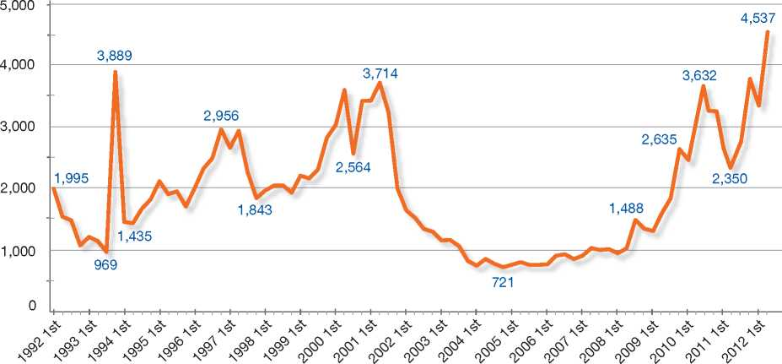

Top Nationalities

In the early 1990s, the majority of asylum-seekers arrived from China and Indonesia. By 2000 and 2001, the top countries of origin were Iraq and Afghanistan. In 2010-2011, the top five countries of origin for non-irregular maritime arrivals (IMAs) to Australia were Afghanistan, Iran, China, Stateless persons, and India.

From 1 July 2011 to 30 June 2012, the top nationalities of origin of applicants for asylum among IMAs were Afghanistan, Iran, Iraq, Sri Lanka, Stateless persons and Iraq.

**Figure 2: Asylum Applications Received from Top 5 Countries of Origin in 2009, 2010 and 2011**

2009

Volumes

2010

Volumes

2011

Volumes

5%

19%

5%

11% 9%

Distribution

|  |  |  |
| --- | --- | --- |
| **Country of Origin:** | | |
| Afghanistan China | India | Iran Iraq |
| Pakistan Sri Lanka | Stateless | Zimbabwe |

15% 10%

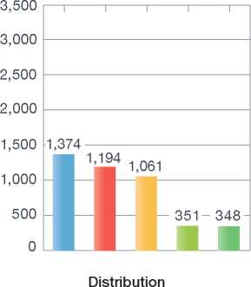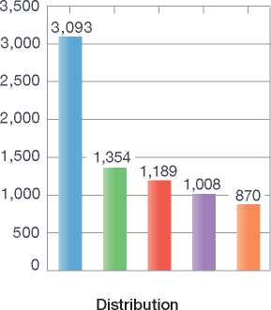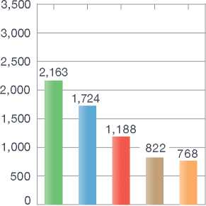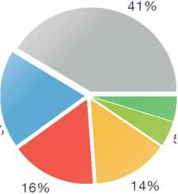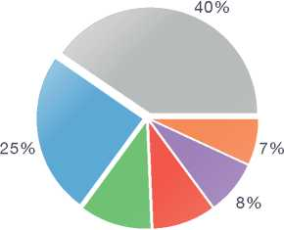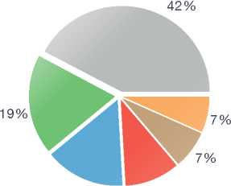

In 1990, a two-stage refugee determination process was introduced comprising:

* A primary stage where determinations were made by a DILGEA officer, and
* A review stage where unsuccessful applicants could seek review of their decision by the Refugee Status Review Committee (RSRC).

For the first time, a non-government representative was involved in the decision-making process - a nominee of the Refugee Council of Australia was represented on the RSRC - in addition to government members from DILGEA, the Department of Foreign Affairs and Trade, and the Attorney-General. Successful onshore refugee applicants were granted a four-year Temporary Entry Permit rather than permanent residence.

In 1993, the Refugee Review Tribunal (RRT) replaced the RSRC. In contrast to the RSRC, the RRT has a statutory basis, makes binding decisions and is independent.

A year later, as part of major reforms to the Migration Act 1958 (the Migration Act) and visa arrangements, a new permanent Protection Visa (PV) was introduced that incorporated refugee status determination as part of the visa eligibility criteria.

In September 2001, legislation was passed such that unlawful non-citizens who first entered Australia at an excised offshore place (certain islands to the north of Australia) were barred from making a visa application. Such persons could be taken to a declared country (for example Nauru) for refugee processing (this was commonly called the “Pacific Solution”).

Further territories became excised offshore places in 2005[12].

Also in 2001, there was the codification of key elements of the refugee definition, such as “persecution”, “particular social group”, “non­political crime” and “particularly serious crime”.

From 12 December 2005, there has been a legislative requirement for the Department of Immigration and Citizenship (DIAC) and the RRT to process PV applications within a 90-day timeframe.

The change in government on 24 November 2007 led to reforms in Australia's asylum policies, including the dismantling of the Pacific Solution. Further details of these reforms are provided below.

The Migration Amendment (Complementary Protection) Act 2011 amended the Migration Act effective 24 March 2012. As a result, claims for protection are considered against the 1951 Convention relating to the Status of Refugees as well as against Australia's *non-refoulement* obligations under other human rights treaties.

In June 2012, the Government established an independent and expert panel to report on the best way for Australia to prevent asylum-seekers from risking their lives on dangerous boat journeys to Australia. On 13 August 2012, the Expert Panel on Asylum-Seekers made 22 recommendations, all of which received the Government's in-principle endorsement. As a result, the Government has increased Australia's Humanitarian Program, committed to greater work with countries of origin, established regional processing arrangements with Nauru and Papua New Guinea, and begun addressing the backlog of family reunion applications under the Special Humanitarian Program[13]. In addition, the Government announced that IMAs who arrive by boat to Australia after 13 August 2012 will have no advantage over those seeking protection through processing arrangements closer to their country of origin.

1. National Legal Framework
   1. Legal Basis for Granting Protection

One of the means by which Australia provides protection to persons who meet the United Nations definition of a refugee, as defined in the 1951 Convention and its 1967 Protocol is through the grant of a Permanent Protection visa (PV). Through this process Australia also meets its *non-refoulement* obligations under other international human rights instruments (such as the Convention against Torture and Other Cruel, Inhuman or Degrading Treatment or Punishment, and the International Covenant on Civil and Political Rights), along with its obligations under the 1951 Convention. The grant of a PV is governed by the Migration Act and the Migration Regulations 1994 (the Migration Regulations).

* 1. Recent/Pending Reforms

Irregular Maritime Arrivals

*The report of the Expert Panel on Asylum­Seekers: August 2012*

On 28 June 2012, the Prime Minister and the Minister for Immigration and Citizenship announced that the Australian Government had invited an Expert Panel to provide a report on the best way to prevent asylum-seekers from risking their lives on dangerous boat journeys to Australia. On 13 August 2012, the Panel delivered its report to the Prime Minister and Minister, making 22 recommendations. A key principle of the report is the “no advantage” principle, which aims to undermine the people-smuggling business model by demonstrating that regular and safe resettlement options to countries such as Australia exist, and that taking a dangerous boat journey to Australia provides no advantage.

The Panel proposed an integrated approach based on incentives to access regular processes and asylum pathways - including an increased Humanitarian Program and greater work with countries of origin - and disincentives to use irregular and dangerous maritime options. The Government has given its in-principle agreement to all of the Panel's recommendations. To date, the Government has:

• Increased Australia's Humanitarian Program to 20,000 places for 2012-13, including an immediate increase of 400 resettlement places for refugees residing in Indonesia and continuing the commitment to resettle over four years 4,000 refugees residing in Malaysia

* Committed to increase capacity building and international engagement to enhance the protection of asylum-seekers and refugees in the region. Such initiatives will establish durable solutions to support displaced persons through resettlement, provision of local support services and assisting regional governments to strengthen their capacity to manage migration flows
* Committed to work more actively with traditional and emerging resettlement countries to create more opportunities for resettlement globally
* Committed to the Transfer and Resettlement Arrangement with Malaysia, entered into in July 2011 (see below)
* Established regional processing arrangements with Nauru and Papua New Guinea, where IMAs to Australia after 13 August 2012 will be liable to be transferred for assessment of their asylum claims, and
* Commenced addressing the backlog of family reunion applications in the Humanitarian Program through changes to concessional arrangements in relation to existing applications and by removing the ability for IMAs to propose a family member in the future and providing greater opportunities to utilise the expanded family stream of Australia's Migration Program.

Australian immigration detention facilities, including those on Christmas Island, continue to be used to accommodate IMAs on their arrival in Australia. Following the passage of enabling legislation in August 2012, those IMAs who arrived on or after 13 August 2012 are liable to be taken to a regional processing country such as Nauru or Papua New Guinea for assessment of their protection claims, unless exempted from transfer by the Minister for Immigration and Citizenship. Transfers of IMAs from Australia to Papua New Guinea commenced on 21 November 2012 and to the Republic of Nauru on 20 December 2012. As of 13 November 2012, Australia continues discussions with Nauru and Papua New Guinea to finalise details regarding processing which will take place under the law of Nauru and Papua New Guinea respectively. The International Organization for Migration (IOM) is coordinating assisted voluntary returns from Nauru and Papua New Guinea, including engaging with clients regarding re-integration packages.

*“No advantage” principle*

The Expert Panel recommended that a principle of “no advantage” shape policy-making on asylum issues. As envisaged by the Expert Panel, the principle provides that people who arrive in Australia by boat should not receive an advantage by being afforded a permanent resettlement outcome faster than those who avail themselves of regular processing opportunities closer to their country of origin, particularly throughout the region. The principle has been adapted more broadly to a spectrum of policy and operational responses relating to IMAs to Australia after 13 August 2012, including in relation to:

* Regional processing arrangements in Nauru and Papua New Guinea, such as the timeframes for processing asylum claims and the provision of resettlement outcomes
* Limiting family reunion rights to remove the incentive for people to travel to Australia by boat with the intention of sponsoring family members once they are granted permanency
* Asylum-seekers processed in Australia who will remain on bridging visas until they are granted a protection visa in accordance with the “no advantage” principle
* Removing the right to work for people who are in the Australian community on Bridging Visas - basic accommodation assistance and limited financial support will be provided
* The potential for those in Australia on Bridging Visas to be transferred to a regional processing country at a future date.

**Complementary Protection Legislation: March 2012**

Complementary protection is the term used to describe a category of protection for people who are not refugees, as defined in the 1951 Convention, but who cannot be returned to their home country because there are substantial grounds for believing that, as a necessary and foreseeable consequence of the removal of the person to the receiving country, there is a real risk that they will suffer significant harm, thus engaging Australia's *non-refoulement* obligations under other human rights treaties - the International Covenant on Civil and Political Rights (ICCPR) and its Second Optional Protocol, or the Convention Against Torture and Other Cruel, Inhuman or Degrading Treatment or Punishment (CAT). Significant harm is defined as:

* Arbitrary deprivation of life
* Having the death penalty imposed and carried out
* Being subjected to torture
* Being subjected to cruel, inhuman or degrading treatment or punishment.

The Migration Amendment (Complementary Protection) Act 2011 amended the Migration Act effective 24 March 2012. As a result, applicants granted complementary protection obtain a PV. This is the same visa granted to Convention refugees.

The Transfer and Resettlement Arrangement with Malaysia: July 2011

On 25 July 2011, Australia entered into a Transfer and Resettlement Arrangement with Malaysia under the auspices of the Bali Process Regional Cooperation Framework. Under the Arrangement, refugee status determination for up to 800 persons who had entered Australia at an excised offshore place were to be undertaken in Malaysia by the UNHCR. Australia agreed to resettle over four years 4,000 UNHCR-mandated refugees (1,000 each year) from Malaysia, who could demonstrate they entered Malaysia and were registered with the UNHCR prior to 25 July 2011 and had remained in Malaysia.

Malaysia committed to treat persons transferred from Australia to Malaysia with dignity and respect and in accordance with human rights standards, and to respect the principle of *non­refoulement.* On 31 August 2011, the High Court of Australia found that the declaration of Malaysia as a country where asylum-seekers could be transferred for processing was invalid and that transfers to Malaysia could not take place. In August 2012, the Expert Panel on Asylum-Seekers recommended the Arrangement be built on further, with strengthened safeguards and accountability.

Immigration Detention Reform: 2009-2012

The Migration Amendment (Abolishing Detention Debt) Act 2009 removed the practice of charging people for their time spent in detention. People convicted of people smuggling or illegal foreign fishing are still liable for their costs of detention and removal, as a deterrent and to recognise the seriousness of these offences. The liability for costs associated with the removal or deportation of unlawful non-citizens also remained unchanged.

In November 2011, the Minister for Immigration and Citizenship announced he would use his public­interest powers under the Migration Act to allow asylum-seekers who arrive by boat in Australia to be considered for release into the community on a Bridging Visa E (BVE). Prioritisation for moving people into the community is based on time in detention, mental health and vulnerability issues and treatment requirements, family links within the community or other community support, and broader detention centre management issues. The completion of initial checks, including health, security and identity, occurs prior to consideration for grant of a BVE. IMAs who arrived prior to 13 August 2012 and who have been released on a BVE have been provided with permission to work and access to public health services as well as other support services through existing government programs. IMAs who arrive on or after 13 August 2012, and who are therefore subject to the “no advantage” principle, do not have access to work rights. These clients will, however, have access to publicly funded national health care and other government support.

Future Potential Changes

The Government is sponsoring further changes to the Migration Act to ensure that persons arriving anywhere in Australia by irregular maritime means will be subject to regional processing, unless specifically excluded or exempted - the Migration Amendment (Unauthorised Maritime Arrivals and Other Measures) Bill. This will remove the incentive for IMAs to take the longer journey to the Australian mainland in an attempt to avoid regional processing arrangements.

1. Institutional Framework
   1. Principal Institutions

The Department of Immigration and Citizenship (DIAC) administers Australia's Humanitarian Program, which is made up of an offshore resettlement component and an onshore protection component. DIAC receives Protection visa applications, and DIAC officers, acting as delegates of the Minister for Immigration and Citizenship, decide if the PV applicant engages Australia's protection obligations under the 1951 Convention and complementary protection provisions.

The Refugee Review Tribunal (RRT) reviews decisions by DIAC to refuse to grant, or to cancel a PV.

The Administrative Appeal Tribunal (AAT) reviews decisions by DIAC not to grant a PV, or to cancel a PV, relying on Articles 1F, 32 or 33(2) of the 1951 Convention. The AAT also reviews decisions by DIAC to refuse to grant, or to cancel a visa on character grounds under section 501 of the Migration Act.

The Federal Magistrates Court or the Federal Court hears applications for judicial review of an RRT decision, if there has been an error of law. Applicants may also pursue judicial review to the High Court, either after having exhausted Federal Court avenues or directly to the High Court's original jurisdiction.

* 1. Cooperation between Government Authorities

There is no structural cooperation between DIAC and the RRT, AAT or the courts, as these bodies work independently when reviewing DIAC's PV decisions. Regular meetings are held between the RRT executive and DIAC to discuss and resolve issues of concern and to settle general PV policy and procedure.

The following government agencies are also involved in the PV procedure:

* The Australian Federal Police: The character test includes Australian Federal Police penal checks in relation to criminal conduct within Australia (and sometimes overseas, if the applicant has resided in a country, other than the country of feared persecution, for 12 months or more)
* Australian Security Intelligence Organisation (ASIO): ASIO conducts security checks to ascertain whether an applicant meets security criteria for grant of a Protection visa
* Department of Foreign Affairs and Trade: The Minister for Foreign Affairs determines whether an applicant may be directly or indirectly associated with the proliferation of weapons of mass destruction.

Confidentiality and privacy principles are adhered to when information is exchanged between DIAC and other principal institutions or government agencies.

1. Pre-entry Measures

Australia has a universal visa system that requires all non-citizens to obtain a visa before entering Australia. Under the Migration Act, citizens and non­citizens entering Australia are required to identify themselves to an immigration inspector or some other person authorised by the Department at a port of entry and to provide certain information. This process is designed to regulate the entry of people to Australia and to ensure that those who enter have the authority to do so, that they are who they claim to be, and that they provide other information if required.

Under this process, the clearance authority examines a person's authority to enter Australia and checks that the person is an Australian citizen, a visa holder or a person eligible for a visa in immigration clearance. The person's travel document is also checked.

* 1. Visa Requirements

Australia has a non-discriminatory immigration program and a universal visa system requiring all non-citizens to obtain a visa before entering Australia. DIAC is the competent authority for issuing visas.

* 1. Carrier Sanctions

The Migration Act allows for fines of up to AUD 10,000 for the master, owner, agent, charter and operator or agent of a vessel that carries any person who does not hold a visa to Australia. As a matter of policy, DIAC may issue Infringement Notices for up to AUD 5,000 for the same offence, where organised malpractice is not an issue.

* 1. Interception

In addition to its universal visa requirement, Australia has a number of programs in place to intercept the entry of persons who pose security, criminal or health risks.

Migration Integrity Officers

Migration Integrity Officers (MIOs) are integrity specialists who locate and treat fraud in DIAC visa programs. These officers are embedded in the Overseas Network and work with operations staff to provide a high-level coverage across several visa programs. There are currently 37 MIOs at 23 posts in 22 countries.

Immigration Alert Checking

The Movement Alert List (MAL) is DIAC's principal electronic alert system that consists of a Person Alert List (PAL) and a Document Alert List (DAL).

The purpose of MAL is to alert DIAC's decision­makers to information the Department holds about a person during the processing of visa and citizenship applications, passenger processing at overseas check-in points (such as at airports) and immigration clearance at the Australian border.

As at 31 October 2012, there were approximately 731,000 identities of interest on PAL. Persons may be listed on MAL when they have serious criminal records, where their presence in Australia may constitute a risk to the Australian community, and if they are subject to exclusion periods prescribed by migration legislation. This exclusion can occur for a number of reasons, including health concerns, debts owed to the Commonwealth or other adverse immigration records.

As at 31 October 2012, there were approximately 1.5 million documents of concern on DAL. These include reported lost, stolen or fraudulently alert travel documents.

Details identifying persons of concern are recorded on MAL as a result of the department's liaison with law enforcement agencies and departmental offices in Australia and overseas.

If there is a MAL true match, a decision on entry is taken by DIAC in consultation with any other relevant agency.

Advance Passenger Processing (APP)

Under the Advance Passenger Processing (APP) system, all airlines and cruise ships must provide DIAC with information on all passengers and crew, including transit passengers, travelling to or via Australia. This information is collected at check­in through the APP system and is transmitted to Australia for use by border agencies prior to the arrival of the vessel. The data transmitted to Australia is cross-checked against Australia's immigration databases.

Airline Liaison Officers

Airline Liaison Officers (ALOs) conduct document and identity checks of Australia-bound passengers at key international gateways. They provide advice to airlines and host governments on passenger documentation and identity issues and, by their visible presence, deter the activities of those involved in people smuggling.

The ALO Program is an adaptive programme, res­ponding quickly to emerging issues, as required. At 30 June 2012, the ALO Program had 20 officers placed at 12 overseas airports, with timely ope­rational support from the department's Tactical Support Unit to identify improperly documented passengers attempting travel to Australia.

The ALO Program was involved in 188 interdictions of improperly documented passengers attempting to travel to Australia in 2011-2012.

Immigration Inspectors at Australia's Border

Under the Migration Act, citizens and non-citizens are required to identify themselves to a clearance authority and provide certain information to enter Australia. This process is designed to regulate the entry of people to Australia and to ensure that those who enter have the authority to do so, that they are who they claim to be, and that they provide other information if required.

1. Asylum Procedures
   1. Application Possibilities and Requirements, Procedures and Legal Remedies

PV Application

A PV application may be made by persons in Australia either at the port of entry or at DIAC offices.

PV applications for those who claim to be members of the same family unit may be made in combination. Only spouses and dependants who are in Australia are eligible for a combined application. This reduces the number of individual PV application forms that need to be submitted (and the PV application charge payable4) by a family unit. Family unit members can make claims of their own and may make separate PV applications if they so wish.

Access to Information on PV Procedures

Some information on the PV procedure is available in English on the DIAC website[14].

Staff at DIAC offices can also provide additional information on the PV procedure.

* + 1. Outside the Country

***Applications at Diplomatic Missions***

It is not possible to make an asylum application at an Australian diplomatic mission except for those within the Refugee category of the offshore Humanitarian Program, as described below.

1. The PV application charge is AUD 30 per application for applicants in the community who have the financial means to pay.

***Resettlement/Quota Refugees***

Average Yearly Quota of Refugees

On 23 August 2012, the Government increased Australia's 2012-2013 Humanitarian Program to 20,000 places per annum, comprising 12,000 places for the Refugee category, with the balance of places for the offshore Special Humanitarian Program (SHP) and onshore protection needs.

Selection of Refugees

The priorities in the 2012-2013 Program will be on resettling those groups currently travelling to South-East Asia at a point closer to their home countries; to continue to provide resettlement for refugees in Australia's immediate region; and to work with the UNHCR to identify those in need of resettlement in other parts of the world, such as Africa and the Middle East.

The Government is committed to providing more opportunities for vulnerable and displaced persons to pursue safer resettlement options in Australia as part of an orderly Humanitarian Program. In 2011-2012, there were 6,718 visas granted under the offshore component of the Humanitarian Program (Refugee category and SHP). The majority (40.9 per cent) of visas were granted to refugees in the Asia Pacific region, followed by the Middle East and South-East Asia region (37.1 per cent) and Africa (21.5 per cent).

The top five countries of birth under the offshore component of the 2011-2012 Program were Burma, Iraq, Afghanistan, Bhutan and Ethiopia.

Criteria for Resettlement

The Refugee category provides resettlement in Australia to persons who are subject to persecution in their home country and are currently outside their home country. The majority of applicants who are considered under this category are identified and referred by the UNHCR for resettlement. The Refugee category includes the women at risk program. Each year, 12 per cent of the Refugee category allocation is set aside for women-at-risk and their dependants. Australia has consistently exceeded this allocation for the past few years.

The Special Humanitarian Program provides resettlement for persons who are subject to substantial discrimination amounting to human rights violations in their home country and are living outside their home country. An Australian citizen or permanent resident or community organisation in Australia, who is willing to support the application (a “proposer”), must propose the application and support the person in Australia.

In addition, all applicants are required to meet health and character criteria to be eligible for the grant of a visa.

Procedures

Applications for a visa under the Refugee category may be made at an Australian diplomatic mission.

Refugee and Humanitarian visa applications that are accompanied by a proposal form for the Special Humanitarian Program category may be made at the DIAC office in Sydney or Melbourne[15].

Following an assessment of claims, the application is either refused for not meeting the criteria or forwarded to the relevant overseas post for further consideration, interview and decision.

There is no provision to appeal decisions to refuse resettlement to offshore applications based on the merits of the application. However, a refugee applicant may access judicial review (through the courts) based on the lawfulness of the decision. Refused applicants may also reapply at any time.

* + 1. Inside the Territory

Persons who have entered Australia and are either living in the community or are in immigration detention centres, may apply for protection by completing and lodging the approved application form for a PV.

* + 1. At Ports of Entry (non­offshore entry persons)

If a person, regardless of his or her immigration status, states at a port of entry (a seaport or airport) that he or she has a fear of return to the country of citizenship or usual residence, a full entry interview of the person is conducted by an immigration inspector or an officer authorised by DIAC to ascertain the reasons for the person's arrival in Australia, including the nature of any claims for asylum the person may make. It is not an assessment of the merits of the claim for protection.

After the full entry interview has been conducted, details of the case are provided to a senior DIAC officer representing the Refugee, Humanitarian and International Policy Division. Based on the information given by the person, the assessing officer will decide whether the person at face value may engage Australia's protection obligations. This is a low threshold test. If the assessing officer considers that the person may, at face value, engage Australia's protection obligations, the person will be provided with a publicly funded migration agent (immigration consultant) to assist with the preparation and lodgement of a PV application. Arrangements will then be made for the person to be transferred to the nearest immigration detention facility. The PV application is processed in the normal PV procedure, as described below. Priority is given to finalising detention cases.

If the person does not provide information or make claims that the assessing officer considers at face value may engage Australia's protection obligations, arrangements may be made for the person to be removed. A person, however, can still apply for a PV at any time after the entry interview while he or she remains in immigration detention in Australia, if new information or claims are made, or if the person requests a PV application form.

* + 1. Irregular Maritime Arrivals (offshore entry persons)

IMAs who arrived in Australia as offshore entry persons due to their method and place of arrival are not able to make a valid PV application unless the Minister intervenes to lift the application bar under section 46A of the Migration Act to allow them to do so.

Following the passage of enabling legislation in August 2012, offshore entry persons who arrived on or after 13 August 2012 are liable to be taken to a regional processing country such as Nauru or Papua New Guinea for assessment of their protection claims, unless exempted from transfer by the Minister for Immigration and Citizenship.

***Application and Admissibility***

Asylum-seekers may make a PV application with DIAC either in person or via the postal service. PV applications are processed in DIAC regional offices in Sydney, Melbourne or Perth by trained PV decision-makers.

For a PV application to be valid, a PV applicant must be physically present in Australia, must complete the relevant form (Form 866) and pay the prescribed fee of AUD 30 unless in immigration detention.

Applicants who entered Australia lawfully and are living in the community and whose PV applications are found to be valid may be eligible for a Bridging Visa (BV), which allows them to remain lawfully in Australia for the duration of the asylum procedure. The BV is issued with certain conditions and is valid until the primary PV application is finally determined[16]. A further BV may be granted if a person pursues judicial review or seeks ministerial intervention after a final determination of his or her PV application. This is done on a case-by-case basis.

Invalidity and Appeal

A PV application will be invalid if form 866 is incomplete and omits material information or information allowing a decision-maker to consider the substantive issues raised by the PV application (e.g. the applicant's reasons for claiming protection). However, if the PV applicant later provides the necessary information, the invalid PV application will become a valid PV application.

A PV application will also be invalid if a cheque is dishonoured for the application fee, or if a person who has been refused a PV makes a further (repeat) PV application or, per section 48B of the Migration Act, if a person who has been refused a PV makes a further application [17] .

A PV application is also invalid if a person is affected by any of these provisions:

* Section 46A of the Migration Act provides that a visa application made by an offshore entry person unlawfully in Australia is invalid. The Minister can lift this application bar under section 46A(2) of the Migration Act
* Section 48A of the Migration Act provides that a non-citizen who has made a PV application cannot make a subsequent PV application while they remain within the Migration Zone.

The Minister can lift this bar under section 48B of the Migration Act

* Section 91E of the Migration Act provides that a person covered by the 1989 Comprehensive Plan of Action approved by the International Conference on Indo-Chinese Refugees or who has a prescribed connection with a declared safe third country cannot in certain circumstances make a valid PV application. The Minister can lift this bar under section 91F
* Section 91K of the Migration Act provides that a PV application by a Temporary Safe Haven visa holder (or someone who has held such a visa) will not be a valid application unless the bar has been considered and resolved by reference to exercise of the Minister's public interest power under section 91L
* A PV application made by a person who is a national of two or more countries (dual national), or where the person has a right to re-enter and reside in a country in respect of which there is a ministerial declaration in force and in which the person has at some stage resided for a period of at least seven days, will not be valid unless the application bar in 91P(1) of the Migration Act has been resolved through exercise of the Minister's power under the Migration Act.

A decision that a PV application is invalid is not eligible for appeal before the RRT, but may be subject to judicial review before the Courts. The applicant may commence proceedings in the Court within 28 days of the actual notification of the decision.

Accelerated Procedures

Australia does not have an accelerated procedure in place. However, as a matter of policy, certain categories of applications are given a higher priority. The order of priority is as follows:

* Detention cases
* Sensitivity and priority level of cases involving unaccompanied minors in the community should be considered in each individual case and priority given accordingly
* Torture/trauma cases
* PV applicants in receipt of Asylum-Seeker Assistance (ASA)
* Special needs applicants, such as persons with physical or psychological disabilities, or who are in serious ill health
* Further PV applications made following a decision by the Minister to lift the section 48A bar to make a further PV application
* All new initial PV applications.

Depending on local arrangements, other priorities may be instituted. For example, in the interests of efficient case management, cases with similar claims from a particular country can be aggregated and then specially assigned to a decision-maker; although each case must still be considered on its individual merits.

Normal Procedure for Protection Visas

After a PV application is determined to be valid, a PV decision-maker from DIAC assesses the PV applicant's claims against Refugees Convention criteria, with reference to up-to-date information on conditions in the applicants' home country. The assessment also takes into account Australia's obligations under other human rights treaties to which Australia is a party, namely the International Covenant on Civil and Political Rights (ICCPR) and the Convention against Torture and Other Cruel, Inhuman or Degrading Treatment or Punishment (CAT). All PV applications are assessed on an individual basis. Section 65A of the Migration requires all primary PV decisions by DIAC to be made within three months of application, or a report must be made to Parliament indicating why this timeframe was not met.

Other Requirements

Where a PV applicant is found to be a person to whom Australia has protection obligations, the PV applicant must satisfy the following criteria before a PV is granted:

* Have undergone a health assessment (chest x-ray, HIV test and medical examination)
* Be of good character
* Not be a security risk to Australia
* Be physically present in Australia at the time of the decision.

Interview

Under current DIAC policy, all PV applicants are interviewed prior to a primary decision being made on the application.

DIAC uses sensitive questioning techniques for children and victims of torture/trauma during the interview process.

Review/Appeal of Protection Visa Decisions

Merits Review

If DIAC refuses a protection claim, the PV applicant may appeal the decision at an independent tribunal—the RRT or the AAT, depending on the basis for the initial refusal.

The applicant has 28 days from the date of notification of the decision to refuse a PV (or seven working days for an applicant in immigration detention) to make an appeal with the RRT or AAT.

The RRT undertakes a fresh merits review of DIAC decisions to refuse or cancel a PV. A decision on the review by the RRT must occur within three months of application, or a report must be made to Parliament explaining why this timeframe was not met. If the RRT is unable to make a decision favourable to the applicant on the written evidence available, it must give the applicant the opportunity for a personal hearing. A fee of AUD 1,400 becomes payable if the RRT affirms the original refusal decision.

The AAT reviews DIAC decisions which refuse to grant a PV, or cancel a PV, relying on Articles 1F, 32 or 33(2) of the 1951 Convention. The AAT also reviews DIAC decisions that refuse to grant or cancel a visa on character grounds under section 501 of the Migration Act.

Judicial Review

An asylum-seeker may apply for judicial review of an RRT decision in the Federal Magistrates Court or the Federal Court if there has been an error of law, including consideration of whether the correct procedures were followed in the decision­making process, whether the person was given a fair hearing, whether the decision-maker correctly interpreted and applied the relevant law (including the provisions of the 1951 Convention), and whether the decision-maker was unbiased. Applicants may also pursue judicial review to the High Court, either after having exhausted Federal Court avenues, or directly to the High Court's original jurisdiction.

If a failed PV applicant is subject to removal (i.e. the application has been finally determined by a Tribunal) and has a pending judicial appeal or request for ministerial intervention, then that person will not be removed from Australia until a final determination is made by the court, tribunal or the Minister.

Freedom of Movement during the Procedure

There are no restrictions placed on the freedom of movement of PV applicants who enter Australia lawfully and maintain their lawful status. If a person is complying with immigration processes and is not a risk to the community, then detention cannot be justified. However, undocumented arrivals and persons who have been denied entry will be detained for the management of health, identity, and security risks to the community.

Immigration Detention

The Australian Government considers mandatory immigration detention an essential component of strong border control. A balance is needed between the requirement to protect Australia from people who may pose a risk to its national security and Australia meeting its obligations to those found to be in need of protection.

Detention that is indefinite or otherwise arbitrary is not acceptable and the length and conditions of detention, including the appropriateness of both the accommodation and the services provided, are subject to regular review. Detention in immigration detention centres is only used as a last resort and for the shortest practicable time. While in immigration detention all clients are able to access the services they require to meet their daily needs. This includes health care and access to appropriate recreational activities.

Three groups are subject to mandatory detention:

* All unauthorised arrivals, for management of health, identity and security risks to the community
* Unlawful non-citizens who present unacceptable risks to the community
* Unlawful non-citizens who have repeatedly refused to comply with their visa conditions.

In all cases, DIAC must justify a decision to detain and not presume detention.

Flexible immigration detention options include immigration residential housing, immigration transit accommodation, alternative places of detention and community detention (residence determination).

DIAC currently contracts out the provision of immigration detention services and the provision of health care within them. The guidelines for the provision of immigration detention services and the standard of care provided by the detention service providers have been developed to be consistent with sector standards, with Australia's international human rights obligations and with the Australian Government's Key Immigration Detention Values.

The length and conditions of detention, including the appropriateness of both the accommodation and the services provided, are subject to regular reviews by DIAC senior officers and the Commonwealth Ombudsman, an independent official charged to represent the interests of the public. The reviews consider the lawfulness and appropriateness of the person's detention, their detention arrangements and other matters relevant to their ongoing detention and case resolution.

Scrutiny from a number of external parties helps to ensure that people in immigration detention are treated humanely, decently and fairly. These parties include parliamentary committees, the Minister's Council on Asylum-Seekers and Detention, the Commonwealth Ombudsman, the Australian Human Rights Commission (AHRC), the Detention Health Advisory Group and the UN High Commissioner for Refugees.

DIAC facilitates visits by federal parliamentarians and parliamentary committees who regularly visit immigration detention facilities and report on conditions in these facilities. The Commonwealth Ombudsman has a statutory right to enter immigration detention facilities to investigate complaints and can undertake their own inquiries into aspects of immigration detention. While AHRC has no express rights or powers of entry to immigration detention facilities, DIAC facilitates visits wherever possible.

The Australian Government facilitates access to legal advice and representation for PV applicants in immigration detention as well as those PV applicants not in detention. This includes the assistance of professional interpreter and translation services at all points, if required. The service includes assistance with the preparation, lodgement and presentation of applications for visas through the primary decision and merits review stages. Upon arrival at an immigration detention centre, people are informed, as part of the induction process, of their rights to receive visits from their legal representatives, contact legal assistance by phone and to receive and send material to legal representatives via fax or post.

Offshore entry persons who arrive on or after 13 August 2012, and are subject to be taken to a regional processing country, but whose claims are processed in Australia, will be provided with claims assistance.

Offences committed while in detention, or during escape from detention, may be considered as grounds to refuse to grant, or cancel, a visa under the Migration Amendment (Strengthening the Character Test and Other Provisions) Act 2011.

*Recent Reforms to Detention Policies Affecting Families*

As a signatory to the Convention on the Rights of the Child (CROC), Australia takes its obligations very seriously.

The community detention program (also known as residence determination) was established in June 2005. In October 2010, the existing program was expanded for unaccompanied minors, families and other vulnerable adults. Community detention is a form of immigration detention that enables people in detention to reside and move about freely in the community without needing to be accompanied by an officer under the Migration Act.

Expanding the Australian Government's existing community detention program has enabled significant numbers of unaccompanied minors and vulnerable family groups to be relocated from immigration detention facilities to community­based accommodation. It has also given effect to the Government's policy not to separate children from their families while they are in immigration detention, wherever possible.

DIAC takes a risk-based approach to the management of immigration clients, including ensuring that appropriate identity, health and security risk assessments are undertaken prior to moving clients into the community. Under the Migration Act, before approving any client for community detention, the Minister for Immigration and Citizenship must be satisfied that it is in the public interest to do so.

Placements in community detention are voluntary. Living in community detention requires a certain level of independence and self-sufficiency, which means it is important that clients are fully informed about community detention and agree to being put forward for consideration for the program. All clients are informed of the conditions of their community detention arrangements upon entry into the program. Conditions include a mandatory requirement to report regularly to the Department and/or their service provider, and reside at the address specified by the Minister. Conditions may also include supervision and curfew arrangements. These conditions are managed sensitively by departmental case managers.

Clients in community detention arrangements continue to work with their case managers on the resolution of their status and are encouraged to keep an open mind about the range of possible outcomes, including return.

*Bridging Visa E (BVE) as an Alternative to Detention*

If a person complies with the immigration process and is found not to be a risk to the community, they remain in the community until their immigration status is quickly and effectively resolved. This community status resolution model manages non-vulnerable clients in the community, including unlawful non-citizens and Bridging Visa E holders, who require a level of intervention to facilitate resolution of their case to a substantive immigration outcome. The service is premised on early engagement with the client, implementing a client plan, and cases being managed as quickly as practicable to a substantive immigration outcome. Clients are managed in ways that recognise their individual circumstances.

Recent high numbers of IMAs and the increased demand that this has placed on the immigration detention network have led to the increasing use of alternatives to detention such as community detention and the use of the Bridging Visa E9.

IMAs who arrived in Australia before 13 August 2012 and who satisfy initial health, security and identity checks are considered on a case-by-case basis for the grant of a Bridging Visa while their protection claim is assessed. Those who arrived on or after 13 August 2012 are liable to be taken to a regional processing country, such as Nauru or Papua New Guinea for assessment of their asylum claims, unless exempted by the Minister for Immigration and Citizenship.

IMA clients who are liable for transfer to a regional processing country, but whose transfer cannot be effected in the near future, may be considered for release into the community on a Bridging Visa10.

On 22 November 2012, the Minister for Immigration and Citizenship announced new processing and management arrangements for those people who arrived by boat after 13 August who are not taken to Nauru or Manus Island. People who have their claims processed in Australia and are found to be refugees will remain on Bridging Visa E (BVEs) until they are issued with a protection visa in accord with the “no-advantage” principle.

Work rights will not be provided for IMAs who arrived on or after 13 August 2012 and are released into the community on BVEs. Asylum Seeker Assistance Scheme (ASAS) up to the current capped level of 89 per cent of Centrelink Special Benefit will continue to be available for asylum­seekers until completion of any merits review process. Beyond that point, if the decision is that the BVE holder is not owed protection, any access to the Community Assistance Scheme (CAS) will be settled on a case by case basis where this promotes resolution and there are clear needs.

Reporting

During the PV procedure, PV applicants must report such things as change of address to DIAC. Even though there are mandatory requirements in the Migration Act to inform DIAC of any change of address, non-compliance with this requirement by a PV applicant is dealt with on a case-by-case basis. If a person fails to notify DIAC of address changes, he or she may not receive important information in relation to their PV application. For example, the PV applicant may fail to request a review of the PV decision to the RRT or make an appeal for judicial review within the timeframe stipulated in the Migration Act.

Repeat/Subsequent Applications

Section 48A of the Migration Act provides that a PV applicant whose application for a PV has been refused, whether or not the application has been finally determined, may not make another PV application. However, under section 48B of the Migration Act, the Minister for Immigration and Citizenship has a non-delegable, non-compellable power to lift the restriction on further applications,

and allow a person to make a fresh PV application, if the Minister is satisfied that it is in the public interest to do so.

There is no limit on the number of times that a person can request that the Minister lift the bar to allow a subsequent PV application*.*

Requirements and Procedure for a Repeat Application

When a request is made to the Minister for Immigration and Citizenship to allow a fresh PV application, DIAC officers examine the case against the relevant Ministerial Guidelines. DIAC can initiate a referral to the Minister without a request being made by the applicant, when new information arises that would bring a particular case within criteria specified in Minister's Guidelines.

Where the case is assessed to meet the guidelines for referral to the Minister, the case is forwarded to the Minister in the form of a submission summarising the particulars of the case and the person's immigration history when new information in support of the applicant's claims for protection becomes available, or if there has been a change of circumstances in the applicant's country of nationality, or habitual residence, and the information appears to be credible, is related to Australia's *non-refoulement* obligations, and enhances the applicant's chances of making a successful claim. The information raised must also meet one of the following requirements:

* It was not known to the applicant during the consideration of the previous application
* It was not known to the applicant but is now known to DIAC and is relevant to the claims
* It was available to the applicant, but for plausible and compelling reasons, was not provided earlier.

Where the Minister for Immigration and Citizenship decides to lift the section 48A bar, a fresh PV application may be made. The fresh PV application is considered by a DIAC PV decision­maker in accordance with standard PV application procedures, guidelines and legislation.

Review/Appeal

Decisions of the Minister under section 48B of the Migration Act are non-compellable and non­delegable and are not judicially reviewable. However, an applicant will have access to merits and judicial review if the fresh PV application is refused by DIAC.

1. Safe Country Concepts
2. Safe Country of Origin

Australia does not apply the “safe country of origin” concept within its asylum system.

Asylum Claims Made by a Citizen of an EU Member State

A claim for asylum by an EU Member State citizen is considered individually based on the merits of the claim, having regard to Australia's obligations under the 1951 Convention, complementary protection criteria and the domestic legislative framework.

1. First Country of Asylum

Subject to the applicant meeting all requirements for grant of a Protection visa, asylum-seekers who are found to be owed protection are granted Permanent PVs regardless of their mode of arrival in Australia or whether they have passed through a country where they may have claimed asylum en route to Australia.

1. Safe Third Country

As part of the PV assessment process, decision­makers examine whether effective protection in a safe third country is available to the applicant. Decision-makers consider section 36 (3)-(7) of the Migration Act, which requires them to consider whether the applicant has taken all possible steps to exercise legally enforceable rights to enter and reside, whether temporarily or permanently, in a safe third country[18].

If the applicant has not exercised that right, they are not considered to be a person to whom Australia has protection obligations and the application must be refused on the basis of section 36 (3) of the Act.

When undertaking an assessment of whether an applicant will have effective protection in a safe third country, decision-makers refer to the facts and circumstances of each application. Decision­makers will consider information provided by the applicant, including visa and passport evidence, as well as take into account comprehensive up- to-date country information. If a decision has been made to return a person to a safe third country, the applicant may have that decision reviewed in light of any new information or change in circumstance.

Other “safe third country” provisions are found in subdivisions AI and AK of the Migration Act. These provisions prevent certain non-citizens from making a valid PV application, including those covered by a Comprehensive Plan of Action (Indo-Chinese Refugees), those who are a national of two or more countries, and those who have resided in a specified country for a continuous period of at least seven days. The bar on making a valid application may be lifted if the Minister for Immigration and Citizenship thinks that it is in the public interest to do so.

There is a Safe Third Country Agreement between Australia and China in which China agreed to accept the return of Vietnamese refugees from Australia who had already been resettled in China and to whom China continues to afford protection.

In practice, these provisions have not been used in recent years.

1. Special Procedures
2. Unaccompanied Minors

Guardianship

As a signatory to the Conventions on the Rights of the Child (CRC), the Australian Government takes its obligations towards unaccompanied minors very seriously. Unaccompanied minors (UAMs) are covered by the Immigration Guardianship of Children Act 1946 (IGOC Act). The IGOC Act ensures that minors, who arrive in Australian territory unaccompanied and are seeking to stay, have a legal guardian.

Unaccompanied minors who fall under the IGOC Act are wards of the Minister for Immigration and Citizenship and the Minister becomes their legal guardian. The Minister delegates the function as a guardian of wards to officers of the department and to officers in relevant child welfare authorities in each State and Territory. A guardian is appointed to minors to advocate for the best interests of the minor. Guardianship continues until the ward turns 18 years of age, leaves Australia permanently or becomes an Australian citizen.

Protection Visa Process

UAMs may apply for protection after arriving in Australia. If a UAM is found to be owed protection by Australia and they meet other visa requirements, they are granted permanent PVs, subject to the “no advantage” principle applied to irregular maritime arrivals after 13 August 2012.

Specific procedural safeguards embedded in the PV process for examining the claims of UAMs include the following:

* Decision-makers' questions during the interview are tailored to the child's age, stage of language development, background and level of maturity
* Child-friendly interview procedures are used to allow a child to discuss freely the elements and details of his or her claim
* UAMs are provided with interpreters to ensure clear communication between the child and the decision-maker
* Country of origin information includes a range of information regarding the situation of children in countries of interest
* Applications from UAMs are given processing priority.

Figure 3: Asylum Applications by

Unaccompanied Minors

No data available.

Benefits

UAMs are provided with migration advice and application assistance by a registered migration agent under the IAAAS.

UAMs qualify without delay for income support and assistance, including medical treatment if required, under the ASAS. An Unaccompanied Humanitarian Minors (UHM) settlement program is available to provide care and welfare supervision and settlement services.

1. Stateless Persons

Australia is a party to the Convention relating to the Status of Stateless Persons and the Convention on the Reduction of Statelessness (the Statelessness Conventions). Australia has implemented its obligations under the Statelessness Conventions through a combination of policy, procedural guidance and citizenship legislation.

The Government is strengthening existing practices and the identification and assessment of persons who claim to be stateless. For example, on 1 July 2012, the Department of Immigration and Citizenship implemented guidelines for PV decision makers on assessing claims of statelessness. The guidelines support more robust findings on statelessness as they relate to protection claims.

Australia recognises that there are difficulties in returning claimed stateless persons with no lawful right to remain in Australia unless their country of habitual residence or former nationality is willing to accept them. The Department of Immigration and Citizenship continues to progress case resolution for those who do not engage Australia's protection obligations but who have claimed to be stateless. Where a person who has claimed to be stateless does not engage Australia's protection obligations, the Minister for Immigration and Citizenship may consider intervention based on his non- compellable public interest powers.

In the period 1 July 2009 to 30 June 2012, a total of 710 protection visas were granted to persons reporting to be stateless (19 in 2008-09, 190 in 2009-10, 479 in 2010-11 and 653 in 2011-12).

1. Offshore-Entry Persons

Excision

In September 2001, the Migration Amendment (Excision from Migration Zone) Act 2001 (the excision legislation) amended the Migration Act. The effect of the excision legislation is that non-citizens who have entered Australia at an excised offshore place (as defined in the excision legislation) without a valid visa are barred from making valid visa applications on arrival or during their stay in Australia[19]. Under Section 46A of the Migration Act, the Minister can lift the bar to making a valid visa application if it is believed to be in the public interest. “Lifting the bar” allows a person to make a valid visa application.

As a result of the excision legislation, legislative and policy distinctions have been made between onshore- and offshore-entry persons. The onshore caseload refers to those persons arriving in Australia through regular means as a valid visa holder (chiefly at an airport), and who subsequently apply for protection. “Offshore entry persons” refers to those persons who arrived at an excised offshore place, without a valid visa or immigration clearance, and who apply for protection after entry. Offshore entry persons are commonly referred to as irregular maritime arrivals (IMAs).

The PV process for the onshore caseload is governed by statutory provisions within the Migration Act, which specifies a timeframe for decision-making, review rights through the Refugee Review Tribunal (RRT), and provides for a right of judicial review to remedy any potential legal errors in either the primary or review decision­making process.

The PV process for offshore-entry persons was, until 24 March 2012, governed by a series of non- statutory processes that partially mirrored the statutory provisions of the Migration Act in providing for a primary assessment and merits review process. The non-statutory primary assessment process was originally referred to as Refugee Status Assessment (RSA) from 2008 until 1 March 2011, whereupon it was replaced by the Protection Obligations Determination (POD) process, which applied to the IMA caseload until 24 March 2012. IMAs who arrived from 24 March 2012 or who arrived before that date but were not at the interview stage, have been allowed into the statutory process.

Proposed Changes to Excision Legislation

The Migration Amendment (Unauthorised Maritime Arrivals and Other Measures) Bill 2012 (the Bill) passed the House of Representatives on 27 November 2012. This Bill seeks to implement recommendation 14 of the Expert Panel's Report that the Migration Act be amended so that arrival anywhere in Australia by irregular maritime means provides individuals with the same status.

The Expert Panel's reasoning in making this recommendation was the need to reduce any incentive for people to take even greater risks with their lives by seeking to reach the Australian mainland to avoid being subject to regional processing arrangements. The Report stated that “such attempts would increase the existing dangers inherent in irregular maritime travel”.

Currently, people who arrive at an excised offshore place - such as Christmas Island - can be taken to a designated country for regional processing, while people who arrive at the Australian mainland are not subject to these provisions.

If passed, the Bill will make all individuals who arrive by irregular maritime means liable to regional processing. The Bill does not excise the Australian mainland from the migration zone. A person will be subject to regional processing based on their status as unauthorised maritime arrivals - that is by arriving in Australia in the migration zone by sea without a visa in effect.

Regional Processing

Amendments to the Migration Act to provide for the designation of a country as a regional processing country and to provide a clear legislative authority for the taking of offshore-entry persons to a regional processing country received assent on 17 August 2012. As a result, all persons who enter Australia at an excised offshore place after 13 August 2012 are liable to be transferred to a regional processing country, such as Nauru or Papua New Guinea, as soon as is reasonably practicable for determination of their asylum claims unless exempted by the Minister.

IMAs who are liable for transfer to a regional processing country but who are released into the community on a Bridging Visa may have their claims processed in Australia in accordance with the “no advantage” principle. However, their status as offshore entry persons remains unchanged. These IMAs may be transferred to a regional processing centre at a future date.

Return

Persons who are found not to have engaged Australia's protection obligations process may be returned to a country where they have a right of entry and long-term residence.

For those asylum-seekers who are subject to regional processing arrangements, processes are in place to ensure that transfers to a regional processing country are consistent with Australia's *non-refoulement* obligations, both in relation to the processing country and to countries where they may be subsequently sent. The Memoranda of Understanding with both Nauru and Papua New Guinea explicitly state that asylum-seekers will not be expelled or returned to another country where their life or freedom would be threatened on account of their race, religion, nationality, membership of a particular social group or political opinion; or where there is a real risk that they will be subjected to torture, cruel, inhuman or degrading treatment or punishment, arbitrary deprivation of life or the imposition of the death penalty.

1. Decision-Making and Statuses
   1. Inclusion Criteria
      1. Convention Refugee

Decision-makers assess the merits of a protection claim against the criteria for the grant of a PV as set out in the Migration Act. A PV is granted to persons in Australia who are owed protection under the 1951 Convention, or complementary protection under the complementary protection provisions implemented on 24 March 2012 (see below).

* + 1. Complementary Protection

With the implementation of complementary protection legislation on 24 March 2012, a protection assessment also includes consideration of Australia's *non-refoulement* obligations that arise under human rights conventions to which Australia is a party, including:

* The International Covenant on Civil and Political Rights (ICCPR) and its Second Optional Protocol, and
* The Convention against Torture and Other Cruel, Inhuman or Degrading Treatment or Punishment (CAT).

Previously, these obligations were met through the ministerial intervention process.

* 1. The Decision

Applications for PVs are assessed by decision­makers who are experienced and trained in law, policy and procedures concerning the 1951 Convention and complementary protection obligations. Decision-makers are required under the Migration Act to notify the applicant of the decision to grant or refuse a visa in writing as prescribed by the legislation. In the case of a decision to refuse a visa the applicant is provided with written reasons and the criteria he or she failed to satisfy as well as the reason a particular criterion was not satisfied. The applicant is also informed of his or her review rights and where to apply for review. A notification letter is given by hand to applicants or sent by registered post to their authorised recipient.

* 1. Types of Decisions, Status and Benefits Granted

If a person is found to meet the requirements for Australia's protection obligations, he or she will be granted a permanent PV.

Benefits

PV holders are entitled to the following benefits:

* Permanent residence
* Capacity to sponsor certain family members to Australia[20]
* Right to education
* Right to work and immediate access to social welfare benefits on the same basis as Australian citizens
* Permission to travel and enter Australia
* Travel documents
* Eligibility to apply for Australian citizenship after holding the permanent residence visa for a specified period.

Residence Requirement for Citizenship

Persons who became permanent residents on or after 1 July 2007 may apply for citizenship if they have been lawfully resident in Australia for the four years immediately preceding their citizenship application, and that includes 12 months as a permanent resident.

Persons who became permanent residents before 1 July 2007 and apply for citizenship before 30 June 2010 must have been physically present in Australia as a permanent resident for a total of two years in the five years preceding their application for citizenship, including one year in the two years before applying.

* 1. Exclusion

Australia considers Article 1F of the 1951 Convention and any security-risk cases, when assessing a claim for protection. All claims for protection are screened for exclusion. When protection visa application is refused on the basis that the person meets the exclusion clause under Article 1F, the applicant may have his or her case reviewed by Administrative Appeals Tribunal (AAT), and subsequently by the court.

If the excluded PV applicant has been assessed to be a threat to the Australian community and the national interest, he or she may be detained in accordance with the detention provisions in the Migration Act.

* 1. Cessation

People found to be owed Australia's protection obligations are granted a permanent visa, providing they meet other visa criteria, including required health and security checks. Cessation consideration will generally only arise if visa cancellation or criminal deportation processes have been instigated. This process is instituted by the Department. Cases that invoke Article 1C of the 1951 Convention are assessed on a case-by- case basis.

A person whose status is subject to a cessation decision may have the decision to refuse a PV application or cancel a PV reviewed by the Refugee Review Tribunal (RRT) if he or she is in Australia, and subsequently, to have the RRT's decision reviewed by the court.

* 1. Revocation

Australia does not have a specific provision to revoke a PV. Australia may cancel a PV only in unique and exceptional cases where there are national interests or security concerns that may justify cancellation of a PV. However, the cancellation powers in the Act are used rarely for PV holders. A decision to cancel a visa may be subject to review by the court.

Section 82 of the Migration Act requires that a decision-maker must undertake a detailed assessment of international obligations arising under treaties to which Australia is a party, prior to cancelling or refusing to grant a visa.

* 1. Support and Tools for Decision-Makers

DIAC's Refugee Law and Complementary Protection Guidelines provide advice and assistance to departmental decision-makers on the law relevant to the assessment of whether Australia has protection obligations to persons seeking protection in Australia under the 1951 Convention and complementary protection provisions. The effect of relevant provisions in Australia's domestic law, namely the Migration Act, on the assessment process are also explained. These guidelines provide the basis for training provided to protection decision-makers in the department.

Australian protection decision-makers use the following tools:

* Domestic legislation (the Migration Act and the Migration Regulations)
* Australian case law
* Protection Visa Procedures Advice Manual (PVPAM), which provides guidance on policy and practice and sets out migration law provisions relevant to the determination of PV applications, including key articles of the 1951 Convention and 1967 Protocol, and details of other human rights instruments that decision­makers must consider
* DIAC Refugee Law Guidelines, which are prepared by in-house lawyers to provide legal guidance on assessment of protection obligations under the 1951 Convention
* DIAC Complementary Protection Guidelines, which are prepared by in-house lawyers to provide legal guidance on assessment of protection obligations under the complementary protection provisions of the Migration Act
* UNHCR Handbook on Procedures and Criteria for Determining Refugee Status and UNHCR guidelines on policies and procedures in dealing with unaccompanied children seeking asylum
* DIAC Gender Guidelines, outlining how to assess gender-related claims and deal with clients making such claims in a sensitive manner, giving regard to their personal circumstances
* DIAC's Gender Guidelines have been developed to help officers to effectively and sensitively address and assess the gender dimension of claims of onshore applicants for Protection visas and offshore applicants for Refugee and Humanitarian visas in line with international best practice standards. The guidelines are also intended to assist DIAC decision makers assessing the claims of offshore entry persons undergoing a refugee status assessment.
* Recognising that women may experience particular acts of persecution and discrimination differently from men because of their gender, the guidelines provide advice on how decision makers can best approach claims of gender-related persecution. The guidelines consider gender-related persecution and procedural issues that can influence applicants and their ability to present their claims, the lodgement of applications, interview management and confidentiality.

• DIAC Onshore Protection Interim Procedures Advice instructions, which provide supplemen­tary guidance to decision-makers.

1. Country of Origin Information

The Country Research Section (CRS) at DIAC is responsible for providing country of origin information (COI) to primary decision-makers. All COI is made available and accessible to departmental officers via an electronic database, CISNET. CRS prepares research papers on the general human rights situations in high-priority countries or on complex issues of interest to decision-makers.

CRS also has developed Country Guidance Notes (CGNs) that identify and synthesise COI relevant to assessing specific claims, outline relevant policy issues, and provide guidance to decision­makers to assist in their assessment of particular IMA caseloads. They are publicly available and intended to ensure greater consistency and transparency in decision-making.

COI Research at the Refugee Review Tribunal

On 17 February 2009, it was announced that the Refugee Review Tribunal (RRT) would publish its country of origin research to provide greater transparency in its decision-making. Since then, more than 2,300 research documents from the major countries of reference for RRT reviews have been published, including country of origin information from China, India, Afghanistan, Iran, Iraq, Bangladesh, Indonesia, Lebanon, Sri Lanka, Syria, Zimbabwe, Pakistan and Egypt.

The published research contains a range of open­source material, including general background information, commissioned research and opinions from academics and experts, as well as responses researched in answer to specific questions posed by RRT members in relation to particular reviews. These responses are carefully edited to protect the identity and privacy of individual visa applicants and to maintain the integrity of the review process.

1. Efficiency and Integrity Measures
   1. Technological Tools
      1. Biometric Information

Most PV applicants are required to provide a digital photograph of their face and a scan of their fingerprints in order to have a valid PV application. Children under 5 years are not required to provide personal identifiers, and children between 5-14 years old are only required to provide a digital photograph (with the consent of a parent or guardian).

Facial images and fingerprint scans are converted by the Biometric Acquisition and Matching System (BAMS) into biometric templates and compared against other departmental records. Data is also automatically stored on and checked against the National Automated Fingerprint Identification System (NAFIS), which contains information on a person's dealings with law enforcement agencies. Data may also be checked against the databases of other countries or agencies where permitted.

Two provisions in the Migration Act (sections 46 and 40) allow for the acquisition of fingerprints from non-citizens who apply for a visa, including a PV. The powers are discretionary and the purpose for acquiring fingerprints must be in accordance with section 5A (3) of the Act. Fingerprints may only be collected by way of an identification test conducted by an officer who has been authorised by the Minister for Immigration to do so. Fingerprints cannot be acquired from children under the age of 15 years or from persons who are incapable of understanding the general nature, effect and purposes of a requirement to provide them. Fingerprints can also be acquired from PV applicants by informed consent.

Whether acquired by way of a formal legislative requirement or by informed consent, the applicant must be advised in a language that they are reasonably likely to understand, why and how the fingerprints will be collected, to whom they may be disclosed, as well as their rights under the Privacy Act 1988 and the Freedom of Information Act 1982.

Facial images and fingerprint scans are converted by the Biometric Acquisition and Matching System (BAMS) into biometric templates and compared against other departmental records. Data is also automatically stored on and checked against the National Automated Fingerprint Identification System (NAFIS), which contains information on a person's dealings with law enforcement agencies. Data may also be checked against the databases of other countries or agencies where permitted.

* + 1. DNA Tests

DNA testing may be used as a last resort strategy when claims are doubtful or if credible documentation cannot be provided to substantiate claimed familial relationships. DNA testing is not mandatory and an applicant is under no obligation to agree to a test when testing is suggested.

If the PV applicant decides to undertake DNA testing, DIAC provides information on how to arrange a test that will meet the Department's requirements. Any test obtained outside the departmental requirements may not be accepted.

* + 1. Forensic Testing of

Documents

The Document Examination Team located within the Department has the capacity to provide forensic-document examination services to decision-makers. This service is provided upon request and on a case-by-case basis.

* + 1. Database of Asylum Applications/Applicants

The Integrated Client Service Environment (ICSE) is a departmental system that records the lodgement and consideration of all visa applications. It is a central repository of client information that the decision-maker uses to record all the events that relate to a client in relation to his or her PV application. This tool captures the entire PV process from the receipt of application to the finalisation of the protection claim.

* + 1. Others

In addition to the Movement Alert List (MAL) and Airline Liaison Officers (ALOs), the following tools are at the disposal of decision-makers:

• The Security Referral Service (SRS), which allows for information for PIC 4002[21] referrals to be captured in a structured electronic format

and sent to the Australian Security Intelligence Organisation (ASIO) for assessment

• The Identity Services Repository (ISR), a tool that captures client identity information that will assist decision-makers in assessing and recording the identity of clients at first contact and throughout further contact with the department.

* 1. Length of Procedures

All primary PV decisions by the Department are required to be made within the statutory timeframe of 90 days from the Department's receipt of the completed application. Cases for which these timeframes are not met are subject to periodic reports to Parliament.

* 1. Pending Cases

As at October 2012, there were 3,307 initial PV applications by non-IMAs and 2,286 IMA applications on hand at the primary stage. In 2011-2012, about 65 per cent of the pending initial caseload was processed in under 90 days.

* 1. Information Sharing

An international agreement with Five Country Conference (FCC) countries - the United Kingdom, Canada, New Zealand and the United States - has been signed for the purpose of cross-checking fingerprints. This system of data exchange allows biometric information to be cross-checked between the databases of the Participating States. DIAC also shares information with Australian Federal Police and Department of Foreign Affairs and Trade on cases involving fraudulent documents.

1. Assistance and Reception Benefits for Asylum-Seekers
   1. Procedural Support and Safeguards
      1. Legal Assistance

All PV applicants are able to make their own private arrangements and engage a lawyer or other agent at their own expense or seek legal aid. Legal representatives or other agents may be present during an interview, but they may not initiate any active involvement in the interview. However, at the end of the interview, PV applicants may consult privately with their representative or agent.

* + 1. Migration Agents

PV applicants are encouraged to use registered migration agents to assist them during the PV procedure. The Office of Migration Agents Registration Authority (MARA) or a DIAC office can make a list of Registered Migrant Agents available to them.

* + 1. Immigration Advice and Application Assistance Scheme (IAAAS)

The IAAAS is government-funded and provides migration advice and application assistance free of charge to all PV applicants in detention and to IMA and other vulnerable PV applicants in the community. In addition, there are 23 IAAAS providers around Australia who are Registered Migration Agents or officers with legal aid commissions. These IAAAS providers do not provide legal advice as such and do not work under the free general legal aid scheme funded by the Government.

PV applicants do not need to accept an offer to use IAAAS services, but if they seek immigration assistance from someone who is not an IAAAS provider, they need to fund the assistance themselves. Eligibility for IAAAS-funded assistance ceases when the PV has been granted or refused following appeal. IAAAS is not available to rejected asylum-seekers requesting ministerial intervention or applying for judicial review.

* + 1. Interpreters

DIAC encourages the use of accredited interpreters from the Department's Translating and Interpreting Services during the PV interview process and bears the cost.

* + 1. UNHCR

The UNHCR Regional Office in Canberra has no direct role in the determination of refugee status in Australia but holds a general monitoring function. In accordance with its supervisory role, the UNHCR engages with the Government of Australia on an at least bimonthly basis to discuss issues related to legislation, policy and practices that may arise in the asylum system. The UNHCR's supervisory role with respect to individual protection claims brought to its attention, its official positions, country of origin information, and best practices are generally well-received by government authorities.

PV applicants may approach the UNHCR directly with a request for assistance, and in such instances DIAC will provide the UNHCR with access to information on the individual asylum-seekers. The UNHCR plays a supervisory role in the case of individual protection claims brought to its attention to ensure consistency with the 1951 Convention.

In addition, the Public Information Unit of the UNHCR raises awareness about UNHCR's work and refugee issues amongst parliamentarians, schools, the media and the general public.

* + 1. NGOs

NGOs in Australia provide support and assistance to asylum-seekers and refugees. NGO support includes the following:

* Assist refugees in countries of first asylum when they repatriate to their homelands
* Provide settlement support to refugees
* Advocate on behalf of a particular refugee community
* Community education on refugees
* Seek funding for specific projects to enhance capacity to serve the refugee community
* Provide legal advice and assistance to refugees
* Provide information on advocacy for refugees and humanitarian entrants in Australia
* Provide support services for refugees, asylum­seekers and other vulnerable persons in immigration detention
* Provide tracing and restoration of family links
* Emergency support where the need arises.

The Australian Government consults the Refugee Council of Australia (RCOA) and other NGOs that provide assistance on key issues that have an impact on asylum-seekers. The Minister holds his or her own consultation with NGOs as and when required, while the Department consults with NGOs for their input in major policy changes. The NGOs do not have access to departmental information provided by asylum-seekers.

* 1. Reception Benefits
     1. Accommodation

Australia does not have reception centres to accommodate asylum-seekers. Financial assistance provided under the Asylum-Seeker Assistance Scheme (ASAS) may cover the cost of accommodation.

* + 1. Social Assistance

The Australian Government established ASAS to provide financial assistance to eligible PV applicants during the period in which their applications for protection are processed. ASAS is managed by the Department and is administered through contractual arrangements by the Australian Red Cross Society. Applications and enquiries relating to ASAS are made with the Australian Red Cross Society.

Financial assistance provided under ASAS is 89 per cent of the Special Benefit paid by Centrelink, part of the Department of Human Services, and is paid every two weeks. The maximum financial assistance paid to PV applicants depends on family composition. The financial assistance provided under ASAS is to cover food, accommodation and basic health care. To be eligible for ASAS, asylum­seekers must fulfil the following requirements:

* They must have made a pending valid PV application for more than six months (primary processing time) but assistance may be granted earlier where exemption criteria are met
* They must be in financial hardship
* They must hold a Bridging Visa or other visa
* They must not be eligible for either Commonwealth or overseas income support, and
* They must not be the spouse, de facto or sponsored fiance(e) of a permanent resident.

Asylum-seekers can be exempted from the above eligibility criteria if they fall under one of the following categories:

* UAMs, elderly persons or families with children under 18 years of age
* Persons unable to work as a result of a disability, illness or the effects of torture and/or trauma.
  + 1. Health Care

No person in Australia is refused emergency medical treatment on the basis of their immigration status. Health services are provided to PV applicants by qualified health professionals. To be eligible for Medicare (the Australian Government's health insurance scheme), PV applicants must meet the following criteria:

* They must have an un-finalised application for a permanent visa
* They must hold a valid Bridging Visa with work rights.

Some asylum-seekers without work rights may qualify for Medicare if they are the spouse, child or parent of an Australian citizen or permanent resident. ASAS recipients who do not have access to Medicare may receive assistance with their health-care costs and be referred to counselling services.



Australian Mental Health Criteria

All clients entering immigration detention undergo mental health screening for signs of mental illness and torture and trauma within 72 hours of their arrival. The service provider's mental health staff use the Harvard Trauma Questionnaire to identify potential victims of past torture and trauma. If a person is identified as, or declares to be a survivor of, torture or trauma, he or she is referred for torture and trauma counselling, which is delivered by a specialist. Subsequent mental state examinations are offered to identify any emerging health concerns that may arise during a client's time in immigration detention. These examinations occur after seven days in immigration detention, and then at intervals of six, 12 and 18 months, and then every three months thereafter. Additional assessments will occur when triggered, for example, when concerns are raised about a person's mental health, or in conjunction with significant events, such as the refusal of a visa application.

Torture and trauma counselling is provided by state and territory Forum of Australian Services for Survivors of Torture and Trauma member organisations on the Australian mainland, and the Indian Ocean Territories Health Service on Christmas Island.

The Australian Government has implemented mental health policies that reflect best-practice approaches to identifying existing or emerging mental health issues, providing mental health support to people in immigration detention, and to preventing self-harm in immigration detention. The mental health policies were developed in consultation with the Department's Detention Health Advisory Group, with reference to the Government's National Mental Health Policy and standards recommended by the Royal Australian College of General Practitioners.

Individuals in immigration detention facilities also have on-going access to the on-site Mental Health Team and can be referred for more specialised care if required. On-site mental health services are provided through the Health Services Provider (HSP) and include mental health nurses, psychologists and psychiatrists who are registered with the appropriate professional organisations and institutions.

State governments in Australia have issued advice to hospitals in their states not to seek payment for medical services from asylum-seekers. Asylum­seekers are provided full medical care, which includes pathology, diagnostic, pharmaceutical and other services.

* + 1. Education

Children between the ages of six and 15 are eligible for primary and secondary school education. Those who are living in community residence within the detention facilities are provided with tailored education programs to meet their developmental needs, while those living in the community have access to the public education system.

* + 1. Access to Labour Market

PV applicants who are granted a Bridging Visa with work rights are able to access the labour market while their applications for protection are being considered. Permission to work is generally made available to PV applicants who are lawfully present, respect necessary timeframes, and are actively engaged to resolve their immigration status, as well as those seeking ministerial intervention. Permission to work is attached to most Bridging Visas for cases of financial hardship or upon nomination by an employer. However, work rights are not provided for IMAs who arrived after 13 August 2012 who are granted BVEs and are subject to the “no advantage” principle[22].

* + 1. Family Reunification

On 22 September 2012, the Minister for Immigration and Citizenship announced changes in response to the recommendation of the Expert Panel on Asylum-Seekers to the Special Humanitarian Program (SHP) to remove family reunion concessions for irregular maritime arrivals.

In accordance with the Expert Panel's recommendation, people arriving by boat after 13 August 2012 will be unable to propose family members under the humanitarian program. However, applicants proposed by unaccompanied minor refugees who arrived before 13 August 2012 will still be eligible for SHP visas on the strength of their family relationship alone. People affected by changes to the SHP would be able to sponsor their family through the regular family stream of Australia's Migration Program (which was increased by 4000 places per year) subject to meeting eligibility criteria.

Applicants sponsored by IMAs will be required to meet the same requirements as others applying for migration through the family stream, including the relevant visa application charges.

* + 1. Access to Benefits by Asylum-Seekers Found Not to Be Owed Protection

ASAS payments cease upon grant of PV or 28 days after notification that PV applications have been refused by the Department. However, some asylum-seekers found not to be owed protection who seek appeal at the RRT may be eligible for ASAS if they meet the exemption criteria. ASAS payments cease when the RRT makes a decision on the application.

Applicants who are refused a PV, who reside lawfully in the community, whose cases are finalised and who do not depart from Australia within 28 days of their asylum application being finalised, may continue to have access to the following benefits: emergency health care, and primary and secondary education for children.

The Community Assistance Support (CAS) program provides assistance to lawful non-citizens living in the Australian community who hold bridging visas and meet certain eligibility criteria. CAS administers a range of services which focus on the well-being of people who hold bridging visas and have complex needs. These people must be clients of the Department of Immigration and Citizenship who are working with the department to resolve their immigration status.

CAS provides help to clients by arranging access to health and welfare services, providing financial assistance, and providing additional case management to resolve their immigration status.

1. Status and Stays Granted outside the Asylum Procedure
   1. Humanitarian Grounds

The Minister for Immigration and Citizenship has non-compellable powers to substitute a more favourable decision than that of the RRT or the AAT in relation to character issues, if the Minister considers that it is in the public interest to do so. These public interest powers allow visas to be granted on broader humanitarian grounds where the criteria for the grant of the visa applied for has otherwise not been met, or to give effect to Australia's international obligations under human rights treaties that have not otherwise been considered as part of complementary protection processing.

The Minister's intervention powers are intended for unique and exceptional cases where the Minister considers it is in the public interest for that person to remain in Australia.

The following factors may be relevant, individually or cumulatively, in assessing whether a case involves unique or exceptional circumstances that would result in referral to the Minister for consideration to intervene to grant a visa:

* Particular circumstances or personal characteristics of a visa applicant that provide a sound basis for believing that there is a significant threat to the person's personal security, human rights or human dignity on return to his or her country
* Circumstances in which the application of relevant legislation leads to unfair or unreasonable results in a particular case
* Strong compassionate circumstances such that a failure to recognise them would result in irreparable harm and continuing hardship to an Australian citizen or an Australian family unit (in which one member of the family is an Australian citizen or permanent resident)
* Circumstances where exceptional economic, scientific, cultural or other benefit to Australia would result from the visa applicant being permitted to remain in Australia
* The length of time the person has been present in Australia (including time spent in detention) and his or her level of integration into the Australian community
* Compassionate circumstances regarding the age and/or health and/or psychological state of the person.
  1. Withholding of Removal/ Risk Assessment

The Australian Government may undertake, as a risk management tool, a pre-removal clearance prior to a person being removed from Australia. The pre-removal clearance is an internal assessment that reviews whether or not there are outstanding protection claims that have not already been considered by the Department. It complements the PV process, as well as other processes which can be pursued where protection is refused, including independent merits review, ministerial intervention, and requests to allow further purported protection claims to be considered.

A pre-removal clearance is undertaken where risk factors are identified that may contravene Australia's *non-refoulement* obligations under the 1951 Convention, International Covenant on Civil and Political Rights (ICCPR) and Convention Against Torture (CAT).

Once a pre-removal clearance is issued, it will be valid for a period of twelve months from the date of the clearance, unless there is a change in the person's circumstances or a change in country information. An example of a change in circumstance includes where a person has made a complaint to a UN body such as the UN Human Rights Committee or the UN Committee against Torture. The UN bodies may issue Australia with an Interim Measures Request (IMR) in response to the complaint. An IMR is a request not to remove the person until the UN body can hear and give its views on the person's complaint.

Where an IMR is issued, all removal arrangements for the person are generally suspended while further assessment is undertaken to determine whether or not the request is warranted.

* 1. Obstacles to Return

Bridging Visas and Removal Pending Bridging Visa (RPBV)

Asylum-seekers who are unable to be returned or removed may be granted a Bridging Visa including a Removal Pending Bridging Visa (RPBV) to enable them to be released from immigration detention and remain lawfully in Australia while arrangements for their removal are made. All applicants must meet the relevant character and security requirements before a visa can be granted.

There is no formal application form for the RPBV visa. The visa process may be started by the Minister issuing an invitation or indicating that he or she is inclined to exercise his or her power under section 195A of the Migration Act. The eligibility criteria for RPBV as set out in the Migration Regulations are as follows:

* The person is in immigration detention
* The Minister is satisfied that the person's removal from Australia is not reasonably practicable at that time, for reasons other than the person being party to proceedings in a court or review tribunal related to an issue in connection with visas
* The Minister is satisfied that the person will do everything possible to facilitate their removal from Australia
* Any visa applications made by the person, other than a repeat PV application, must have been finally determined.

RPBV visa holders have access to a range of social support benefits:

* Work rights
* Access to certain social security benefits, such as Special Benefit and Rent Assistance
* Access to Medicare benefits
* Access to early Health Assessment and Intervention services
* Eligibility for Torture and Trauma counselling
* Public education for school-aged minors; access to English as a Second Language service for school-aged children.

The RPBV is granted by the Minister personally and allows the holder to remain in Australia. The RPBV ceases if the holder departs Australia, and does not allow re-entry. The RPBV does not have a cessation date and is reviewed after a period of time as specified by the Minister at the time of grant.

Holders of an RPBV are subject to eight mandatory conditions covering reporting, behaviour and cooperation with removal planning. Should the holder breach any of these conditions, the RPBV can be cancelled by the Department or ceased by the Minister. Additionally, the RPBV can be ceased by the Minister if removal is considered reasonably practicable.

* 1. Community Status Resolution Service (CSRS)

DIAC's national Community Status Resolution Service (CSRS) assists eligible compliance clients in the community to reach a timely, durable immigration outcome (namely grant of a substantive visa or departure from Australia). The assistance provided is based on a number of “status resolution” principles such as early intervention, active engagement the provision of needs-based support, and promotion of client “self-agency”.

The CSRS is specifically targeted at non- vulnerable bridging visa holders who require some level of intervention to resolve their immigration status (note bridging visas may be granted to clients to enable them to remain in the community while they work cooperatively with the department to resolve their immigration status). Examples of target groups include clients on a departure pathway who are resistant or reluctant to depart; clients whose immigration process has become protracted and might be inclined to return to their country of origin with the right support and counselling; and clients whose substantive visa application process has become delayed. Clients who quickly self-resolve are not referred to the service. Similarly, clients with significant vulnerabilities are not referred to the CSRS - instead such clients will be referred to the Case Management service for more intensive support and assistance.

The CSRS provides a central contact point for engaging and communicating viable pathways with clients in accordance with the above­mentioned status resolution principles. The service's Community Status Resolution Officers (CSROs) establish rapport with clients, clearly identify possible client pathways, and undertake an assessment of options to facilitate a timely and durable immigration outcome tailored to the client's specific needs and services. A key aspect of the CSRO role is to liaise with other areas and status resolution program services within DIAC to ensure a joined-up, holistic and well-planned approach to managing client cases. CSROs also use the services of external agencies to deliver needs based community support and returns assistance where appropriate, in order to facilitate timely immigration outcomes.

Effective status resolution, as applied in the CSRS, not only accelerates outcomes but aims to deter further non-compliance. It builds client, community and stakeholder confidence in the status resolution approach, and trust in the department and in the integrity of the migration program.

* 1. Group-Based Protection

Australia does not have procedures in place for granting group-based protection under the current PV framework. Historically, Australia has granted temporary haven to certain prescribed groups. The current Australian migration framework allows the Government to develop regulations as necessary to tailored to the particular circumstances of new groups, if the need arises.

Safe Haven

The Subclass 449 Humanitarian Stay (Temporary) visa provides temporary safe haven in Australia to persons who have been displaced by upheaval in their country and for whom the Australian Government considers the most appropriate assistance to be temporary safe haven. It was used to assist displaced Kosovars in 1999 and East Timorese in particularly vulnerable situations. The visa provides temporary stay on the understanding that holders return to their home country when the Australian Government considers it safe to do so.

Application for this visa is by acceptance of an offer made by a departmental officer who is authorised for this purpose. Such an offer can only be made to a person or caseload specified by the Immigration Minister. The visa is granted by a delegated departmental officer. This visa is administered separately from the PV and is not counted as part of the Humanitarian Program. Past and present holders of Subclass 449 visas may not apply for any other visa, including a PV, unless the Minister allows it.

* 1. Regularisation of Status over Time

Australia does not have procedures in place to regularise the status of a person over time. Under the current migration framework, a non-citizen must have a visa to enter and remain lawfully in Australia. If a person is found to be unlawfully in Australia, they may be removed.

* 1. Regularisation of Status of Stateless Persons

Australia has implemented its obligations under the conventions on statelessness through a combination of policy, procedural guidance and citizenship legislation.

The Government is strengthening existing practices and the identification and assessment of persons who claim to be stateless. For example, on 1 July 2012, the Australian Government Department of Immigration and Citizenship (DIAC) implemented guidelines for Protection visa decision makers on assessing claims of statelessness. The guidelines support more robust findings on statelessness as they relate to protection claims.

Australia recognises that there are difficulties in returning claimed stateless persons who have no lawful right to remain in Australia unless their country of habitual residence or former nationality is willing to accept them. DIAC continues to progress case resolution for those who do not engage Australia's protection obligations but who have claimed to be stateless. Where a person who has claimed to be stateless does not engage Australia's protection obligations, the Minister for Immigration and Citizenship may consider intervention based on his non-compellable public interest powers.

1. Return

Section 198 of the Migration Act provides the legislative basis for the removal of unlawful non­citizens, including rejected asylum-seekers, from Australia in particular circumstances.

That section requires officers of the Department to remove an unlawful non-citizen (that is, a person with no lawful right to remain in Australia) from Australia as soon as is reasonably practicable. The Act does not define a period of time that is considered as soon as reasonably practicable, but officers must ensure that there are no unwarranted delays in progressing and effecting a removal.

Where a person's claims have been fully assessed and the Government has determined that the person is not owed protection, a pre-removal clearance is conducted as a final measure prior to removal, if the person engages particular risk factors. It is designed to identify any changes in the person's circumstances or in the country of return that may give rise to protection or humanitarian issues, and is independent of any other processes initiated by the person. In addition, at any stage a client can submit reasons why they cannot be removed from Australia, which are assessed prior to removal.

* 1. Pre-departure Considerations

The pre-removal clearance is an assessment that makes a final check to confirm that removal of the person will not be inconsistent with Australia's *non-refoulement* obligations. This clearance is in addition to any assessment made in connection with a previous PV application or ministerial intervention request and is designed to identify any changes in the person's circumstances or their country of return that could give rise to a breach of Australia's *non-refoulement* obligations.

* 1. Procedure

The Department of Immigration and Citizenship works collaboratively with service partners to achieve timely and client-focussed solutions. Officers will engage with non-citizens and stakeholders early and effectively to establish and maintain cooperative relationships.

Protection Visa applicants whose refusal decision is affirmed by the Refugee Review Tribunal and who have no other legal reason to stay in Australia are expected to depart. If the person remains in Australia and has no legal right to be allowed a further stay, the Department will seek to enforce removal.

Where possible, officers will give consideration to community-based arrangements (rather than detaining the non-citizen in an immigration detention centre) and work to facilitate the voluntary return and removal of individuals in the first instance. However, should an individual refuse to comply with voluntary arrangements, DIAC will enforce removal.

DIAC also provides an Assisted Voluntary Return program (AVR) for lawful non-citizens who require assistance to leave Australia. The support provided through the AVR program is intended to facilitate return through the provision of immigration information and return counselling; specified financial assistance associated with return; and immediate post-return assistance.

Additionally, for asylum-seekers who are irregular maritime arrivals (IMAs), the department provides individualised reintegration packages to promote voluntary, sustainable return of these persons to their home countries. The department has contracted the International Organization for Migration (IOM) to provide a range of services, including:

* Providing information about the country of return
* Counselling in relation to the benefits of voluntary return
* Providing information regarding services and local support that may be available on return including reception assistance, and
* Assessing and delivering possible reintegration packages.

Reintegration packages will be tailored to individual needs through the non-citizen's engagement with IOM and primarily consist of in-kind assistance (that is, skills training, opportunities for business start-up, job placement support) and a smaller cash component.

* 1. Freedom of Movement/ Detention

There are no restrictions on the freedom of movement of PV applicants who entered Australia lawfully and maintain their lawful status. However, with undocumented arrivals or where entry has been denied and they have requested protection, applicants will be detained to conduct health, character and security checks. If these persons pose no risk to the national interest or the Australian community, they will be allowed to live in the community while their applications for refugee status are being considered, if not subject to regional processing arrangements.

Australian Case Law on the Application of National Security Criteria in the Granting of PVs

*Plaintiff M47 / 2012 v Director-General of Security & others [2012] HCA 46*

The plaintiff commenced proceedings in the original jurisdiction of the High Court challenging the validity of the decision to refuse him a Protection Visa and challenging his continued detention. The plaintiff argued that ASIO had denied him procedural fairness when making a fresh adverse security assessment in 2012, that the requirement that he satisfy public interest criterion 4002 was invalid, and that the Migration Act did not authorise the removal and detention of a person found to be a refugee.

On 5 October 2012, a majority of the High Court of Australia held invalid a regulation, public interest criterion 4002, which prevented the grant of a Protection Visa to a refugee if the Australian Security Intelligence Organisation ("ASIO") had assessed the refugee to be a risk to security. Accordingly, a majority of the Court held that the decision to refuse the plaintiff a Protection Visa on the basis of that regulation had not been made according to law. The court held that matters relating to security are more appropriately determined under the character provisions of section 501 of the Migration Act.

* 1. Readmission Agreements

Australia has a small number of return and readmission agreements in place, but they are confidential.

1. Integration

Persons who are granted a Protection Visa under the offshore Humanitarian Program as a refugee have access to a range of integration programs.

PV holders are eligible for the services provided by Humanitarian Settlement Service (HSS). HSS, which is delivered under contract to DIAC, provides initial, intensive settlement support through a comprehensive orientation program. HSS services are generally provided for approximately six months, but may be extended in particular cases. Services provided under the HSS are as follows:

* On-arrival reception and induction, which includes meeting eligible entrants on arrival and providing them with initial orientation
* Accommodation services, which helps entrants to find appropriate and affordable accommodation
* Information about referrals to other settlement agencies and community programs
* An orientation program.

Complex Case Support (CCS) is available to help newly arrived humanitarian migrants resolve difficult situations and is available for up to five years from arrival. The Settlement Grants Program (SGP) also provides services aimed at improving orientation and participation in Australian society for new arrivals. SGP also puts in place specific programmes targeted at groups such as youth and women, and accommodation services such as information on accessing housing and tenancy rights through its Housing Services project.

Prior to arrival, resettled refugees have access to the Australian Cultural Orientation (AUSCO) Program, which is delivered offshore to refugee and humanitarian entrants over five years of age and aims to enhance their settlement prospects. AUSCO courses are designed to prepare entrants for travel to Australia, create realistic expectations about their life in Australia and provide a practical introduction to Australian life, laws, culture and values. Free English-language tuition is also provided through the Adult Migrant English Program (AMEP) for eligible adult migrants and humanitarian entrants who do not have functional English. AMEP also provides employment counselling and e-learning opportunities.

A citizenship test exists to prove the legislative criteria for citizenship have been satisfied. Those with a permanent physical or mental incapacity may be considered eligible for citizenship without having to sit the citizenship test.

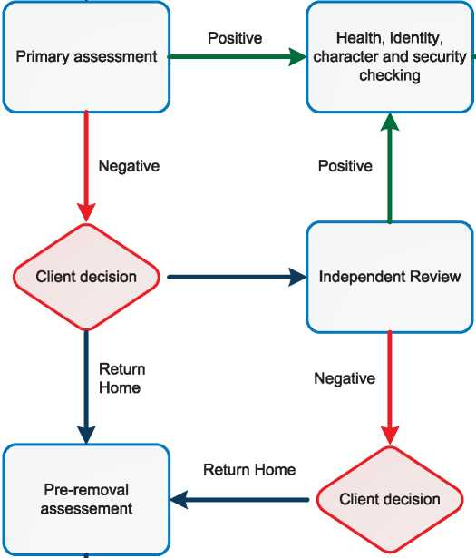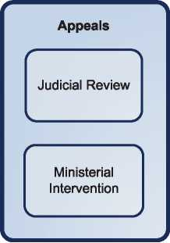

1 f

Positive

►

**/ \**

Referral for

Permanent Visas

**s /**

Obtain Travel Documents

1. Annexes
   1. Flow Chart: Protection Assessment of Irregular Maritime Arrivals

**' '**

Screened In

**< >**

**' '**

IAAAS and lodgement of claims

**\* ?**

**r**

*f '*

Depart Australia

**s /**

* 1. Additional Statistical Information

Figure 4: Asylum Applications from Top 10 Countries of Origin in 2009, 2010, 2011 and first half of 2012

**2009 2010 2011 Jan-Jun 2012**

|  |  |  |  |  |  |  |  |  |
| --- | --- | --- | --- | --- | --- | --- | --- | --- |
| **1** | Afghanistan | 1,374 | Afghanistan | 3,093 | Iran | 2,163 | Afghanistan | 2,126 |
| **2** | China | 1,194 | Iran | 1,354 | Afghanistan | 1,724 | Pakistan | 813 |
| **3** | Sri Lanka | 1,061 | China | 1,189 | China | 1,188 | Iran | 790 |
| **4** | Zimbabwe | 351 | Stateless | 1,008 | Pakistan | 822 | Sri Lanka | 777 |
| **5** | Iran | 348 | Iraq | 870 | India | 768 | China | 567 |
| **6** | Iraq | 322 | Sri Lanka | 783 | Stateless | 517 | India | 465 |
| **7** | Pakistan | 266 | Fiji | 550 | Iraq | 508 | Iraq | 383 |
| **8** | Fiji | 262 | Pakistan | 470 | Egypt | 418 | Stateless | 335 |
| **9** | Malaysia | 231 | India | 411 | Sri Lanka | 371 | Egypt | 166 |
| **10** | India | 213 | Egypt | 328 | Fiji | 277 | Fiji | 142 |

**Figure 5: Decisions Taken at the First Instance in 2009, 2010 and 2011**

|  |  |  |  |  |  |  |  |  |  |
| --- | --- | --- | --- | --- | --- | --- | --- | --- | --- |
|  | **Geneva Convention** | | **Subsidiary/**  **Complementary**  **Protection and Humanitarian Status** | | **Rejections** | | **Withdrawn, Closed, Abandoned Cases** | | **Grand**  **Total** |
| **Number** | **%** | **Number** | **%** | **Number** | **%** | **Number** | **%** |  |
| **2009** | 2,932 | 51% | 0 | 0% | 2,846 | 49% | 0 | 0% | **5,778** |
| **2010** | 3,010 | 35% | 0 | 0% | 5,512 | 65% | 0 | 0% | **8,522** |
| **2011** | 4,835 | 42% | 0 | 0% | 6,783 | 58% | 0 | 0% | **11,618** |

**Figure 6.a: Positive [23] First- and Second-Instance Decisions,Top Countries of Origin in 2009**

**Rate out of Total Decisions [24]**

|  |  |  |  |  |
| --- | --- | --- | --- | --- |
|  | | **Total Positive** | **Total Decisions** | **Rate** |
| **1** | **Afghanistan** | 913 | 916 | 99.7% |
| **2** | **Sri Lanka** | 408 | 510 | 80.0% |
| **3** | **Iraq** | 264 | 281 | 94.0% |
| **4** | **Zimbabwe** | 244 | 324 | 75.3% |
| **5** | **China** | 210 | 1,122 | 18.7% |
| **6** | **Iran** | 204 | 232 | 87.9% |
| **7** | **Pakistan** | 151 | 218 | 69.3% |
| **8** | **Myanmar** | 73 | 94 | 77.7% |
| **9** | **Egypt** | 56 | 116 | 48.3% |
| **10** | **Stateless** | 53 | 57 | 93.0% |

Total Positive Decisions by Status

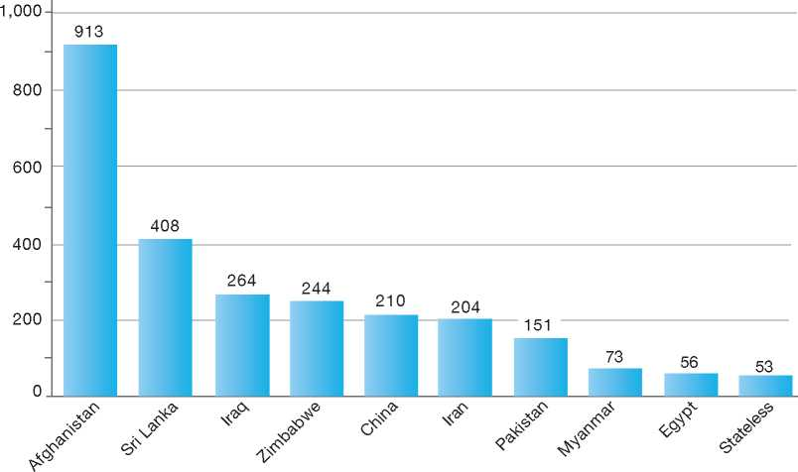

**Total Positive Decisions by Status**

| Geneva Convention Status

**Figure 6.b: Positive [25] First- and Second-Instance Decisions,Top Countries of Origin in 2010**

**Rate out of Total Decisions [26]**

|  |  |  |  |  |
| --- | --- | --- | --- | --- |
|  | | **Total Positive** | **Total Decisions** | **Rate** |
| **1** | **Afghanistan** | 1,025 | 2,047 | 50.1% |
| **2** | **Sri Lanka** | 474 | 787 | 60.2% |
| **3** | **Iraq** | 208 | 416 | 50.0% |
| **4** | **Stateless** | 207 | 512 | 40.4% |
| **5** | **Iran** | 207 | 500 | 41.4% |
| **6** | **China** | 194 | 1,164 | 16.7% |
| **7** | **Zimbabwe** | 174 | 284 | 61.3% |
| **8** | **Pakistan** | 158 | 268 | 59.0% |
| **9** | **Egypt** | 60 | 167 | 35.9% |
| **10** | **Myanmar** | 40 | 61 | 65.6% |

Total Positive Decisions by Status

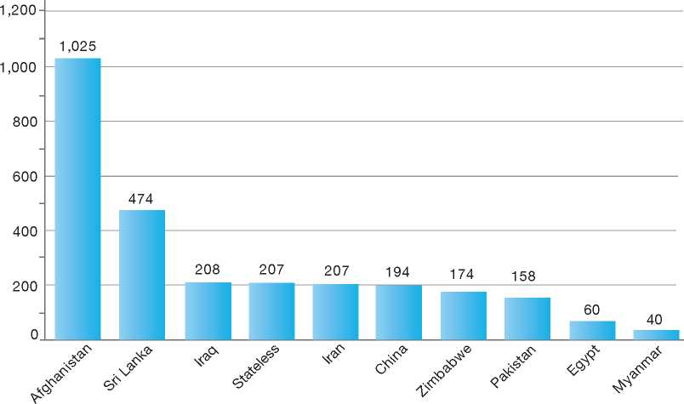

**Total Positive Decisions by Status**

| Geneva Convention Status

**Figure 6.c: Positive [27] First- and Second-Instance Decisions,Top Countries of Origin in 2011**

**Rate out of Total Decisions [28]**

|  |  |  |  |  |
| --- | --- | --- | --- | --- |
|  | | **Total Positive** | **Total Decisions** | **Rate** |
| **1** | **Afghanistan** | 1,213 | 2,121 | 57.2% |
| **2** | **Iran** | 1,185 | 2,108 | 56.2% |
| **3** | **Stateless** | 516 | 858 | 60.1% |
| **4** | **Iraq** | 445 | 701 | 63.5% |
| **5** | **Sri Lanka** | 306 | 572 | 53.5% |
| **6** | **Pakistan** | 296 | 601 | 49.3% |
| **7** | **China** | 130 | 1,061 | 12.3% |
| **8** | **Egypt** | 117 | 414 | 28.3% |
| **9** | **Bangladesh** | 88 | 172 | 51.2% |
| **10** | **Zimbabwe** | 75 | 183 | 41.0% |

Total Positive Decisions by Status

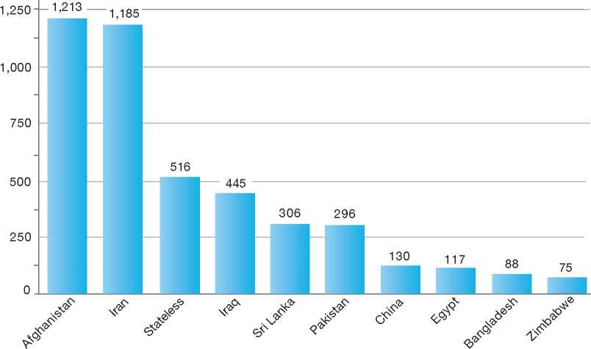

**Total Positive Decisions by Status**

| Geneva Convention Status

1.

2.

3.

4.

5.

6.

7.

8.

9.

10.

11.

12.

Belgium

BackGRound: MajoR asyluM tRends and developMents 59

national leGal FRaMewoRk 61

institutional FRaMewoRk 62

pRe-entRy MeasuRes 63

asyluM pRoceduRes 63

decision-MakinG and statuses 72

eFFiciency and inteGRity MeasuRes 76

assistance and Reception BeneFits FoR asyluM-seekeRs 78

status and peRMits GRanted outside the asyluM pRoceduRe 82

RetuRn 83

inteGRation 84

annexes

86



1. Background: Major Asylum Trends and Developments

Asylum Applications

In the early 1980s, Belgium received fewer than 5,000 applications per year. The numbers started to increase in the mid-1980s, however, reaching a peak of 27,000 in 1993 and another peak of 42,000 in 2000. Annual applications have decreased considerably since the second peak, and in 2006 and 2007, Belgium received around 11,000 applications per year. Since 2009, Belgium witnessed a sharp increase: 17,186 cases (22,000 persons) in 2009, 19,941 cases (26,560 persons) in 2010, and 25,479 cases (31,915 persons) in 2011. In 2012, there seems to be a stabilisation, with numbers comparable to 2011.**[29]**

Important Reforms

Major reforms over the period since the early 1980s included an increase in staff, and the provision of benefits in kind at reception centres rather than general cash benefits.

Until 1 June 2007, the asylum procedure was characterised by a two-phase system, whereby the Immigration Department (ID) was responsible for the admissibility phase and the Office of the Commissioner General for Refugees and Stateless Persons (CGRS) proceeded with the in­depth investigation (eligibility phase). Decisions of inadmissibility made by the ID could be appealed before the CGRS. Decisions of the CGRS regarding eligibility could be appealed before the Permanent Refugee Appeals Commission (administrative court). This asylum system led to lengthy procedures and

Figure 1: Total Asylum Applications by Quarter, January 1992 - June 20121

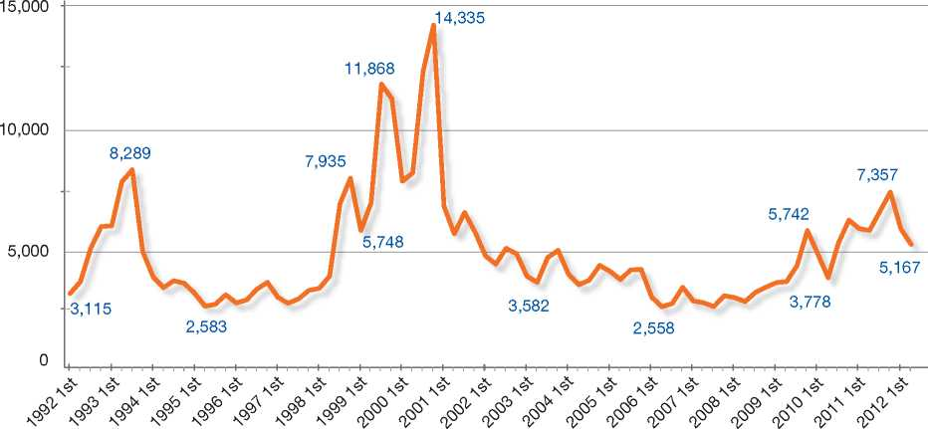

Top Nationalities

In the 1990s, most claims came from Zaire (now the Democratic Republic of Congo), Romania, India and the former Yugoslavia. Since 2000, most claims have come from Russia, the former Yugoslavia, Iraq, Iran and Afghanistan. Top nationalities represented in 2011 were Afghanistan, Guinea, Iraq, Kosovo, Serbia, Democratic Republic of Congo, Pakistan and the Former Yugoslav Republic of Macedonia (FYROM). considerable backlogs within the different asylum instances. As a result, Belgium undertook substantial reform in the period between 2006 and 2007.

The significant legislative reforms adopted in 2006 resulted in the introduction of subsidiary protection and a new single asylum procedure, which came into effect on 1 June 2007. The single procedure considers grounds for both Convention refugee status and subsidiary protection in the examination of asylum claims.

In addition, the legislative reforms resulted in the following institutional changes:

* The Office of the Commissioner General for Refugees and Stateless Persons (CGRS) became the central body responsible for the adjudication of asylum claims
* The Council for Aliens Law Litigation replaced the former Permanent Refugee Appeals Commission as the body responsible for hearing appeals of decisions taken by the CGRS
* The Council of State became a court of cassation where appeals of decisions taken by the Aliens Litigation Council can be heard.**[30]** the EU average for asylum applications. On the one hand, this can be explained by the ongoing poor security situation in countries like Afghanistan, Iraq and Russia (Caucasus). On the other hand, the influx was also linked to the worsening socio­economic situation in the Western Balkans and Armenia. The fact that Belgium already hosts substantial communities of these nationalities/ ethnic minorities is also a factor of importance. The number of subsequent applications remains high (on average around 20 per cent of all applications) and the number of unaccompanied minors tripled

**Figure 2: Asylum Applications received from Top 5 Countries of Origin in 2009, 2010 and 20112**

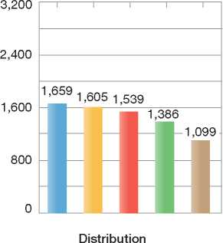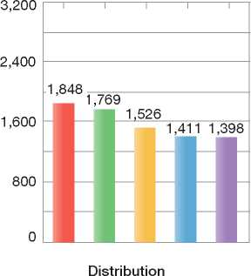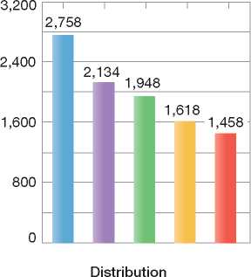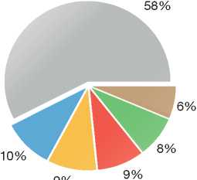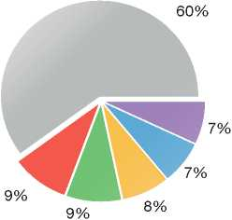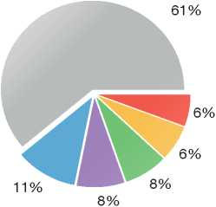

2009

Volumes

2010

Volumes

2011

Volumes

|  |  |  |
| --- | --- | --- |
| **Country of Origin:** | | |
| Afghanistan | Armenia | Guinea (Conakry) Iraq |
| | Kosovo | Russia | Others |

Important Developments

Since 2009, Belgium witnessed a substantial increase in the influx of asylum-seekers and ranks among the top five EU countries for asylum applications. Taking into account the number of inhabitants, Belgium received in 2011 five times in four years' time, from 521 in 2008 to 1,483 in 2011.

The fact that asylum figures reached peak levels year after year led to a crisis of the asylum and reception systems. The length of the asylum procedure increased together with the backlog. The reception system became saturated and alternative reception places had to be created inhotels even as 12,000 asylum-seekers remained without accommodation. The federal Government responded with a variety of measures on the legislative and operational levels to tackle these crises.

On the organisational level, the Government decided to reinforce the capacities of the asylum instances. So between 2009 and 2011, the CGRS recruited nearly 140 extra personnel consisting mainly of protection officers (caseworkers), administrative support and interpreters. Furthermore, in 2011, the reception capacity was increased to around 23,500 places.

In 2012, Belgium changed its resettlement policy from an *ad hoc* approach to a structural approach. Following the adoption of the EU Resettlement Programme, Belgium pledged to resettle 100 persons in 2013. This structural commitment emerged after the implementation of two successful *ad hoc* projects in 2009 (47 Iraqi and Palestinian refugees from Syria and Jordan) and in 2011 (25 Eritrean and Congolese nationals who fled the Libyan conflict).

Country-specific Action Plans

The visa liberalisation of countries in the Western Balkans - Serbia and the Former Yugoslav Republic of Macedonia (FYROM) in 2009 and Bosnia-Herzegovina and Albania in 2010 - caused a sharp increase in the number of asylum-seekers arriving in Belgium. It soon became clear, however, that many of these cases were socio-economically motivated and consequently signified an abuse of the asylum system. To tackle the influx, the Belgian State Secretary for Asylum and Migration conducted several prevention campaigns in the Western Balkans. In parallel, the Government strengthened its return policy (both assisted voluntary return and forced return). Furthermore, the CGRS adopted specific measures to increase efficiency, while simultaneously maintaining a high level of quality decision-making. Cases were handled in a prioritised manner; specific instructions were issued with regard to the examination of claims and the motivation of asylum decisions; the decision-making capacity was increased; and a better coordination was established between the CGRS, the Immigration Department and Fedasil (the Federal Agency for the Reception of Asylum­Seekers) in order to shorten timeframes. These initiatives, in turn, proved capable of significantly decreasing the number of asylum applications from the Western Balkans. A similar country-specific action plan was applied to the Armenian caseload from October 2010 to March 2011.

1. National Legal Framework
   1. Legal Basis for Granting Protection

Refugee status is granted on the basis of the 1951 Convention relating to the Status of Refugees (1951 Convention). The asylum procedure and the competencies of asylum institutions are governed by the Aliens Act of 15 December 1980 (Law regarding the entry, residence, settlement and removal of aliens)[31]. The Aliens Act includes provisions for subsidiary protection (i.e. complementary protection), residence permits granted for medical or health reasons, and humanitarian status.

* 1. Recent/Pending Reforms

Since the last major legislative reforms in 2006­2007, the Aliens Act and Royal Decree have only witnessed minor adaptations, mainly to transpose the EU Directives or to follow the developing jurisprudence. The Reception Act and several other Royal Decrees dealing with asylum issues have some seen some minor changes.

Since 2010 asylum-seekers who have not received a first-instance decision six months after lodging their asylum application are entitled to a work permit. This is a transposition of the EU Reception Directive[32]. A Royal Decree further stipulates the modalities of access to the labour market for asylum-seekers and contains provisions on the material aid asylum­seekers receive in reception centres.

Some new procedural rules were adopted for the Council for Aliens Law Litigation: the harmonisation and equalisation of the period for lodging an appeal, modified *pro bono* rules, and fines for manifestly unfounded appeals. The Royal Decree pertaining to free legal assistance has also changed. In the past an asylum-seeker was automatically considered as not having sufficient means of subsistence. This presumption has become rebuttable.

In order to tackle the asylum and reception crises, the Reception Act stipulates that from 2011 on, asylum-seekers introducing a subsequent asylum application can no longer benefit from material assistance, when the Immigration Department decides not to take the application into consideration because of a lack of new elements.

On 24 November 2011, the Parliament introduced the concept of safe countries of origin into Belgian legislation and on 11 May 2012, the following countries were put on the list: Albania, Bosnia- Herzegovina, Montenegro, the Former Yugoslav Republic of Macedonia (FYROM), Kosovo, Serbia and India.

Further reforms of the Aliens Act are still under consideration, including an enhanced procedure to assess new facts and circumstances of a subsequent application. According to the current procedure, this particular competence lies with the Immigration Department. Yet following the proposal, this competence will move to the CGRS. In addition, another potential reform introduces the concept of “first country of asylum” to avoid so-called secondary movements. An asylum application could then be rejected based on the assumption that the asylum-seeker already enjoys sufficient protection and refugee status in another country.

1. Institutional Framework
   1. Principal Institutions

The institutions involved in the asylum procedure are as follows:

* The Immigration Department (ID), Ministry of Interior, registers all asylum claims submitted inside the territory or at the border, applies the Dublin II Regulation, delivers orders to leave the territory and enforces returns
* The Office of the Commissioner General for Refugees and Stateless Persons (CGRS) is the independent federal administrative body with the competence to grant or refuse claims for refugee status or subsidiary protection
* The Council for Aliens Law Litigation (CALL) hears appeals of decisions taken by the Immigration Department or the CGRS
* The Council of State hears appeals by cassation of decisions of the Council for Aliens Law Litigation.
* Fedasil, the Federal Agency for the Reception of Asylum-Seekers, is responsible for the reception of asylum-seekers and also coordinates voluntary return programmes.
  1. Cooperation between Government Authorities

The CGRS and the Immigration Department work together closely on an organisational level. Since the Department has certain competencies within the asylum procedure (including the Dublin procedure and determining if subsequent applications can be taken into consideration), the two organisations also cooperate on a practical level. However, when it comes to decision­making, no consultation takes place in order to uphold the independence of the CGRS. Both the CGRS and the Immigration Department are financed by the Ministry of the Interior.

The Council for Aliens Law Litigation (CALL) works independently. Due to the independent position of the CALL as an appeal court, there is no structural cooperation with the other asylum agencies.

However, since the setting up of the so-called “Enhancement” or “Business Improvement Project” initiated by the Federal Government in November 2010, more attention has been paid to the asylum process as a chain transcending the three asylum authorities. The project was set up to evaluate productivity and efficiency and to find further opportunities for reducing the processing times of asylum claims while maintaining high quality standards.

The CGRS has no structural cooperation with the Police or the Justice department. When *ad hoc* cooperation and information-sharing do take place between these agencies, the basic principles of confidentiality and privacy are guaranteed. The Immigration Department cooperates with the Police on border management and Justice Department on the issue of unaccompanied minors.

The CGRS and the Immigration Department also cooperate with other government agencies, such as the Federal Agency for the Reception of Asylum-Seekers (Fedasil), the Ministry of Foreign Affairs, the National Register. This, however, is done on a more *ad hoc* basis.

At the international level, the CGRS also cooperates with foreign state authorities. In general, this takes the form of practical cooperation within EU and international fora (EASO, IGC, etc.). Yet, the CGRS is also involved in bilateral capacity-building efforts. As an example, the CGRS is currently assisting in strengthening the asylum authority in Burundi.

1. Pre-entry Measures

To enter Belgium, foreign nationals must have a valid travel document, such as a passport, and in certain cases, a visa issued by Belgium or one of the other States party to the Schengen Agreement.

* 1. Visa Requirements

The Immigration Department of the Ministry of Interior is the competent authority for issuing visas to nationals from a majority of countries that fall outside the Schengen area. A person may appeal a decision not to issue a visa before the Council for Aliens Law Litigation.

* 1. Carrier Sanctions

Carrier sanctions are applicable to airplanes and ships. According to the Aliens Act and the Chicago Convention, administrative fines may be imposed on private or public carriers if it is found that they have transported passengers who are not in possession of valid travel documents. The administrative fine amounts to **€** 3,750 per passenger.

* 1. Interception

Memoranda of Understanding (MOUs) have been concluded between the Government and carriers in an effort to collaborate on the prevention of illegal migration. According to the MOUs, carriers that cooperate with government authorities in combating illegal migration may be subject to reduced carrier sanctions if and when they should become applicable.

Belgium does not carry out pre-departure clearance in countries of origin or transit.

1. Asylum Procedures Children of asylum-seekers may have their asylum claims included with those of their parents. Unaccompanied minors have the legal capacity to apply for asylum themselves, or their guardian can make this application in the name of the unaccompanied minor. Persons over the age of 18 must file their own asylum claims.

Access to Information

Different information brochures on the asylum and reception procedures exist in a number of languages. The brochures may be obtained at reception centres, offices of government agencies involved in the asylum procedure, and through non-governmental organisations (NGOs). Staff are available at closed centres and open reception centres to provide asylum-seekers with additional information on procedures.[33]

Informing Applicants about the Asylum Procedure

With the support of the European Refugee Fund, the CGRS and Fedasil have developed a DVD and accompanying brochure called “Asylum in Belgium”, available in 11 languages. The short DVD provides, clearly and concisely, a chronological overview of the different steps in the asylum procedure and for reception. Furthermore, rights and obligations are explained. Since 2011, the DVD is being shown to all asylum-seekers upon their arrival. A brochure is then distributed to the viewers. The easy visuals of the DVD facilitate understanding among all types of asylum-seekers. At the same time, it also provides applicants with more realistic expectations of the process.

Furthermore, there are information brochures geared specifically at women asylum-seekers, plus leaflets explaining the asylum procedure for claims that are lodged in a closed centre, at a border post or in prison.

Finally, the CGRS developed a comic strip named “Kizito” aimed at minors. It provides an accessible, attractive instrument of learning for unaccompanied minors who make an application for asylum. Most leaflets/brochures and the comic book Kizito are available in electronic version on the CGRS website5.

* 1. Application Possibilities and Requirements, Procedures and Legal Remedies

Foreign nationals seeking asylum may apply for it at airports and seaports. Applications inside the territory must be made at the Immigration Department within eight days after arrival in Belgium. Applications may also be introduced in detention centres, prisons and closed centres.

* + 1. **Outside the Country *Applications at Diplomatic Missions*** Belgium does not have a legal procedure in place for persons to make an asylum claim at diplomatic missions.

Resettlement/Quota Refugees

In the past, Belgium engaged in *ad hoc* resettlement of refugees upon the request of the United Nations High Commissioner for Refugees (UNHCR) and with the approval of the federal cabinet. Applications for resettlement were processed individually. In 1996, for example, the Belgian Government resettled a group of refugees from Zepa and Srebrenica. Furthermore, the two most recent *ad-hoc* experiences involved the resettlement of 47 Iraqis from Syria and Jordan in 2009, and 25 Eritrean and Congolese refugees from the Shousha camp at the Tunisian-Libyan border in July 2011.

Belgium changed its resettlement policy from an *ad hoc* approach to a structural approach in 2012. Following the adoption of the EU Resettlement Programme in March 2012, Belgium made a pledge to resettle 100 refugees in 2013. The refugees will be selected through a mixed selection process: during selection missions and possibly on a dossier basis (for vulnerable cases).

There is no specific legal framework for resettlement in Belgian legislation. Resettled refugees go through the normal asylum procedure after arrival in Belgium, although this is a mere formality. Initial reception is offered by Fedasil, the reception agency. Resettled refugees stay for about six weeks in a reception centre and move afterwards to a municipality. Fedasil staff assist the refugees with mainstream services and with integration into Belgian society (for an estimated period of 12 months).

1. At Ports of Entry

A person who has been refused entry to the Schengen territory at a border post will be notified of a *refoulement* decision. Such a decision may be based on the use of false documents or on not having satisfied entry conditions. According to the Chicago Convention and the Aliens Act, this person may be sent back to the place of departure.

Asylum applications may be made at the border. The Federal Police who receives the asylum application will notify the Border Control Department of the Immigration Department which will proceed with registering the application. If this is the case, return will be suspended, and the case will be examined without triggering a right to enter Belgian territory. Usually, the asylum-seeker will be taken to a closed centre for the duration of the procedure (for up to a maximum of two months). Families with children will be placed in so-called “open housing units”, which are better adapted to their specific needs, but which are in legal terms considered closed centres.

A first interview with an officer of the Immigration Department takes place to obtain all the necessary information for determining which EU Member State is responsible for the asylum application according to the Dublin II Regulation. If Belgium is responsible for examining the claim, a protection officer (caseworker) and interpreter of the CGRS will visit the closed centre or housing unit to interview the asylum-seeker. The asylum-seeker has the right to free legal representation. The procedure in the closed centre or housing unit is similar to the normal procedure described below, although determinations are made within a shorter timeframe.

In case the asylum application results in the granting of international protection, the asylum­seeker is given permission to enter the territory.

1. Inside the Territory

Responsibility for Processing the Claim

The Dublin System

*Application and Procedure*

The Immigration Department determines whether Belgium is responsible for processing an asylum claim under the Dublin II Regulation[34]. If it determines that Belgium is not responsible for processing the claim, the Department issues a refusal along with an order for the person to leave the country. A *laissez-passer* is provided so the person can travel to the country responsible for processing his or her claim.

*Freedom of Movement/Detention*

Persons whose claims are considered to be Dublin cases may be detained for a maximum period of one month while the Immigration Department determines which country is responsible for the claim. In particularly complex cases, detention may be extended for an additional month. Persons may be detained for one of the following reasons:

• They are holders of an expired residence permit or an expired visa for another Dublin country

• They do not have the necessary travel documents and have resided in another Dublin country.

Persons may also be detained for a maximum period of one month after a decision has been made to return the person to the country responsible for the asylum application. Detention is applied to ensure removal from Belgium.

*Conduct of Transfers*

Transfers are carried out either voluntarily or involuntarily. Persons who are in detention may be escorted to the border (or airport), while others may travel voluntarily to the country responsible for their claim, either at their own expense or with transportation expenses covered by the Immigration Department.

*Suspension of Dublin Transfers*

Dublin transfers may be suspended for some time based on a pending procedure at the Council for Aliens Law Litigation, or if a person is unable to travel, for instance for medical reasons.

Asylum Case Law: Dublin Transfers to Greece

In the judgment of 21 January 2011 in the case of *M.S.S. v Belgium and Greece* (Application no. 30696/09), the European Court of Human Rights ruled that the expulsion of an asylum-seeker may result in a breach of the prohibition of torture and inhuman and degrading treatment under Article 3 of the European Convention on Human Rights “where substantial grounds have been shown for believing that the person concerned faces a real risk of being subjected to torture or inhuman or degrading treatment or punishment in the receiving country” and that in such circumstances “Article 3 implies an obligation not to expel the individual to that country”. The Court found that the deficiencies in the asylum procedure and the detention and living conditions in Greece meant that “by transferring the applicant to Greece the Belgian authorities knowingly exposed him to conditions of detention and living conditions that amounted to degrading treatment”. This position has been further backed by a ruling of the Court of Justice of the European Union in January 2012 in the joint cases C-411-10 and C-493/10 *(N.S. andM.E.).* In view of this judgment, transfers to Greece under the Dublin II Regulation have been suspended by the majority of EU Member States.

*Review/Appeal*

Persons may appeal the Immigration Department's decision to transfer them under the Dublin Regulation before the Council for Aliens Law Litigation within 30 days of the decision. This is a non-suspensive judicial review.

Under a special procedure (“urgent necessity”), the lawyer of the asylum-seeker may request a suspension of transfer when removal is imminent and would cause irreparable harm if carried out. The lawyer must show to the Council that an appeal for annulling the Dublin decision would in all likelihood result in a suspension of the removal order for the asylum-seeker. The Council may grant a suspension of transfer if the asylum-seeker can prove that, upon transfer to a Dublin country, he or she would be subject to *refoulement*.

Application and Admissibility

Application

When filing an asylum application with the Immigration Department, asylum-seekers are required to do the following:

* Have their photographs and fingerprints taken
* Undergo a chest x-ray to detect tuberculosis
* Appear at an interview with immigration officials, usually on the same day the asylum claim is filed, and with the assistance of an interpreter, if requested
* Make declarations in order to establish identity, travel route and origin
* Complete a questionnaire in order to establish the reasons for fleeing as well as the possibility to return to the country of origin. This questionnaire gives the CGRS the opportunity to prepare its examination and interview of the asylum-seeker.

The Immigration Department also determines the language in which the asylum procedure will proceed (Dutch or French).

Admissibility

Since the 2007 reform of the asylum procedure, the term “admissible” is no longer in use and has been replaced by “taken into consideration”. Both the Immigration Department (subsequent applications) and the CGRS (applications from EU Member States and safe countries of origin) can decide whether or not to take an application into consideration.

If the Immigration Department finds that, under the Dublin II Regulation, Belgium is responsible for processing an asylum claim, the asylum-seeker's complete file is forwarded to the CGRS.

In case of a subsequent application for asylum, the application will be “taken into consideration” when the Immigration Department determines that the new information provided indicates a well-founded fear of persecution or a real risk of serious harm. The file will then be forwarded to the CGRS. As at the end of 2012, reforms were still pending with regard to a transfer from the Immigration Department to the CGRS of the competence to assess new information in a subsequent application.

Profiling of Asylum-Seekers

After the Immigration Department has forwarded asylum cases to the CGRS and before the cases are assigned to caseworkers, senior protection officers (caseworkers) screen the applications in order to assess the specific profile of the asylum-seeker.

This initial profiling allows cases to be assigned to the appropriate officer, and for all preparation work and Country of Origin Information (COI) research to be conducted efficiently before the interview. It also allows specific needs of applicants (such as disabilities) to be dealt with, and adequate reception to be organised. Electronic data collection assists in this.

The organisation of both casework and COI research is structured geographically. All caseworkers are specialised in examining caseloads from specific geographical regions and COI researchers work in geographical units more or less mirroring the caseworkers' geographical desks. There are also caseworkers specialised in handling specific caseloads, such as unaccompanied minors, gender-specific cases and potential exclusion cases.

Inadmissibility and Appeal

Asylum applications may “not be taken into consideration” by the Immigration Department if the asylum-seeker has previously made an identical application - see the section on Repeat Applications.

Applications[35] made by citizens of an EU Member State or a state that has signed a Treaty of Accession with the EU may “not be taken into consideration” by the CGRS. Applications made by citizens originating from a safe country of origin may “not be taken into consideration” by the CGRS, if the declarations of the asylum­seekers do not clearly indicate a well-founded fear of persecution or a real risk of suffering serious harm8.

In certain cases - such as asylum applications made by persons who are in detention - the law provides that a decision to take an application into consideration has to be made within a 15-day time limit. For applications made by citizens of an EU Member State, the CGRS has to take a decision within a five-working-day time limit. For citizens originating from a safe country of origin, the CGRS has to take a decision within a 15-working-day time limit. Appeals against decisions “not to take into consideration” can be made before the Council for Aliens Law Litigation within 30 days. Such cases are only open for an appeal of annulment and have no suspensive effect.

An appeal in cassation9 against the decision of the Council for Aliens Law Litigation can be made with the Council of State within 30 days of the decision being handed to the applicant. Such an appeal has no suspensive effect.

Freedom of Movement

If asylum-seekers do not possess the necessary documents to enter the territory, they may be detained in a closed centre while awaiting a decision by the Immigration Department. Alternatives for detention have been developed for families with children. These families are placed in “open housing units”, which are better adapted to their specific needs, but which are in legal terms considered closed centres. In cases where the protection of public order or national security is concerned, the detention may in certain cases be extended but it cannot exceed a total of eight months. Detained persons may file an appeal against the decision with the Council Chamber of Correctional Court in the area of stay, and reintroduce the appeal each month of his or her detention. In exceptional cases, the asylum-seeker may be at the Government's disposal.

Accelerated Procedures

For an accelerated or prioritised procedure, the time period can vary:

• Five working days in case the applicant is an EU national

1. See the section on Safe Countries of Origin.
2. Court of last resort.



* 15 working days in case the applicant originates from a safe country of origin
* 15 days in case the applicant is detained at the border or files an application while in prison
* 15 days in case the Minister demands a prioritised assessment (injunction right)
* 15 days in case the applicant is considered a threat to public order or national security
* Two months for specific cases (e.g. subsequent applications).

An accelerated procedure may apply to citizens of EU Member States or of a state that has signed a Treaty of Accession with the EU. However, if the asylum claim of an EU citizen is taken into consideration, the claim will proceed to the normal procedure rather than to an accelerated procedure. Decisions on the taking into consideration of claims by EU nationals are made by the CGRS within five working days. For more information on applications from EU nationals, see Safe Country Concepts.

The CGRS applies an accelerated procedure to citizens from a safe country of origin. As a result, their claims are be treated within 15 working days. Only an appeal for annulment is available to them, and the Council for Aliens Law Litigation will have to render a judgment within two months. For more information, see Safe Country Concepts.

There are also provisions in place to apply an accelerated procedure in cases where the asylum­seeker is being held in a closed centre, is subject to a security measure or is detained in a penitentiary. The CGRS must give priority to the examination of these types of cases and make a decision within 15 days.

In the period between 2010 and 2011, there was a large increase in the number of asylum applications from nationals of Balkan countries. This increase revealed both abuse of the asylum system and active smuggling rings. The Minister made use of his injunction right (Article 52/2 of the Aliens Act) and requested that the CGRS examine applications from those countries within a shorter timeframe, namely 15 days.

Normal Procedure

Application Requirements

Under the normal procedure (and for accelerated procedures), asylum-seekers are required to do the following:

* Make their application within eight days of arrival in Belgium
* Submit all their identity documents and any other documentation that may be relevant to their claim
* Appear at an interview, which provides them with an opportunity to explain the particulars of their claim.

Interviews/Examination of Case

Interviews are conducted by a protection officer (caseworker) of the CGRS from one of the six geographical desks (Africa, The Balkans, Eastern Europe, Middle East/Asia, Democratic Republic of Congo and a Project desk). The protection officer drafts an interview report, the content of which is treated as confidential. The protection officer then examines the individual asylum story against the objective situation in the country of origin and submits a proposal to his or her supervisor for a decision on the case.

Improving the Quality of Asylum Interviews

In order to ensure a better quality of the interviews, the CGRS has adopted a Charter for Asylum Interviews, which contains best practices and a manual for conducting interviews. A copy of this Charter is available to the asylum-seeker in every interview room at the CGRS.

As correct interpretation is key to the quality of the asylum interview, deontological guidelines for translators/interpreters were developed. They describe the duties and rights of translators and interpreters, and give practical information on conduct during the interview.

A supervisor is a senior caseworker who manages a unit of four to eight caseworkers. The supervisor will on the one hand systematically review the quality of every decision of the caseworker. On the other hand, he or she has the duty to coach the caseworkers. Some protection officers are part­time supervisors.

Under the single asylum procedure, the CGRS first examines claims within the framework of the Geneva Convention and then considers grounds for subsidiary protection.

Review/Appeal of Asylum Decisions

Appealing CGRS Decisions

The Council for Aliens Law Litigation (CALL) has full competence to confirm, annul or change a decision taken by the CGRS. It is also possible to appeal the decision to grant subsidiary protection status with a view to obtaining refugee status. Since the CALL has full jurisdiction, the asylum­seeker runs the risk of losing even his or her subsidiary protection status. Full jurisdictional appeals, which have suspensive effect, must be made within 30 days of a CGRS decision. In case the asylum-seeker is detained, appeals must be made within 15 days. The asylum-seeker is eligible to obtain free legal assistance for his or her appeal.

The following categories of asylum-seekers, whose claims have been rejected by the CGRS, can make only an appeal for annulment before the Council for Aliens Law Litigation: (1) citizens of an EU Member State or of a state that has signed a Treaty of Accession with the EU, and (2) citizens originating from states that are considered to be “a safe country of origin”. This appeal has to be made within 30 days of a decision. In such cases, only the legality of the decision made by the CGRS may be examined. In case of annulment of the CGRS decision, the case is sent back and the CGRS has to render a new decision. This appeal has no suspensive effect.

The procedure before the Council for Aliens Law Litigation is a paper process. The appellant and his or her legal representative may make an oral intervention during the hearing. When lodging a full jurisdictional appeal, the applicant is allowed to present new information during the court session based on a number of conditions (e.g. this information could not have been put forward earlier in the procedure). However, new information may not be included in an appeal for annulment.

A court session is normally organised in every appeal case. However, the Council has the possibility to treat an appeal merely on the basis of written documents. Both the applicant and the deciding body nevertheless have the possibility to ask to be heard. The appeal body then is obliged to organise a court session. Both parties - that is, the asylum-seeker and his or her representative, and the CGRS - are present at the hearing. Hearings at the Council for Aliens Law Litigation are open to the public, but a private hearing is possible if requested.

The Council for Aliens Law Litigation may confirm, review or annul the CGRS decision if a full jurisdictional appeal has been lodged. If an appeal for annulment has been lodged, the CALL may either reject the appeal or annul the CGRS decision. If the CALL decides to annul a decision of the CGRS for reasons of substantial irregularities that cannot be repaired by the Council, or because there are essential elements lacking that prevent the Council from reaching a decision without additional research, the case is returned to the CGRS for an examination of the file while taking into account the elements of the judgment in order to obtain a new decision. The CALL does not dispose of a power of investigation of its own. The judgment of the CALL is based solely on the elements submitted by the appellant and the defendant for the purposes of the appeal. In most cases, the CALL must reach a decision within three months. In certain cases, the CALL must reach a decision within two months. This occurs when the Minister uses his or her right of injunction to prioritise cases, or when the application is not taken into consideration because the applicant originates from an EU Member State or a safe country of origin.

The Minister for Immigration and Asylum Policy may appeal a CGRS decision to grant Convention refugee status or subsidiary protection within 30 days of the decision. This appeal is made before the Council for Aliens Law Litigation.

Appealing Decisions of the Council for Aliens Law Litigation

Decisions of the Council for Aliens Law Litigation may be appealed only by cassation before the Council of State. All appeals before the Council of State have no suspensive effect and must be filed within 30 days of the decision of the CALL. All cassation appeals undergo an admissibility procedure. Cases are inadmissible if they are found to be without cause, to be manifestly inadmissible or to be beyond the competence or jurisdiction of the Council of State.

If the Council of State annuls the decision being appealed, the case is returned to the Council for Aliens Law Litigation for a new hearing, and the CALL must observe the judgment that has been rendered.

Freedom of Movement during the Asylum Procedure

Detention

In certain cases specified by the Aliens Act, the Immigration Department may decide to hold an asylum-seeker in a closed centre during the determination procedure at the CGRS or pending return following a negative decision on the asylum claim. Decisions to detain may be appealed before the Council Chamber of the Correctional Court. Appellants have the right to free legal assistance during their appeal.

Examples of cases that may lead to detention include asylum-seekers at the border who do not fulfil the entry conditions, and asylum-seekers on the territory:

* Who had been served a removal order by Ministerial or Royal Edict in the last 10 years
* Who resided in another country or several other countries for three months or longer after leaving the country of origin, and left the last country of residence without fear of persecution as described in the 1951 Convention and without a real risk of serious harm
* Who introduced an asylum application more than eight working days after entering Belgium, without providing a valid reason for this delay
* Who refuse to disclose their identity or nationality or provided false information or documents in this regard
* Who made an application for the sole reason of delaying removal from Belgium.

Asylum-seekers awaiting transfer to another State party to the Dublin II Regulation may also be detained.

Asylum-seekers can be detained in one of the six closed detention centres managed by the Immigration Department. If the asylum procedure has not been concluded after two months, and in cases where refugee status or subsidiary protection has been granted within these two months, the asylum-seeker is released from detention.

Having been condemned by the European Court of Human Rights (ECHR) for having detained a family with four children while awaiting their transfer to Poland under the Dublin II Regulation, Belgium has introduced “housing units” for families as an alternative to detention. Asylum­seeking families who apply at the border will stay in these houses during the course of the asylum procedure and are assisted by a coach. As is the case for persons staying in detention centres, the asylum procedure will be accelerated. Despite their open structure, from a legal point of view, these houses are considered as detention centres.

Reporting

All asylum-seekers must choose a residence in Belgium when submitting their asylum application. The elected domicile is the official address where the asylum-seeker can be contacted by the asylum authorities. In case no domicile has been elected, the address of the Office of the Commissioner General for Refugees and Stateless Persons will be automatically considered as elected domicile. Asylum-seekers who are detained in a detention centre or prison will by default have their elected domicile at those addresses.

Any changes of elected domicile must be reported to the asylum authorities by registered post. A failure to do so may result in not receiving the summons for a hearing or requests for information or the asylum decision, and may eventually result in a negative decision.

Asylum-seekers are assigned a place in a reception centre but have freedom of movement on the whole Belgian territory. The house rules of the reception centre often state that an asylum-seeker cannot be absent for more than three consecutive nights. However, this is not aimed at restraining the freedom of movement but is merely a measure for managing available reception places, so that no reception place is vacant for too long.

In case a family with children is assigned to an open housing unit, they have to sign an acceptance contract which stipulates that if they leave the housing unit definitively without prior authorisation, they may, when apprehended, be subject to detention in a closed centre. This will also be the case when they do not cooperate in the process towards their return.

Repeat/Subsequent Applications

Requirements and Procedure

In the case of a second or subsequent application for asylum, the Immigration Department checks whether the new information that has been provided indicates a well-founded fear of persecution or a real risk of serious harm. If the information is accepted as a new element, the Immigration Department will forward the claim to the CGRS for examination. The procedure before the CGRS is similar to the normal procedure, although the procedure may be accelerated so that a decision may be taken within two months. If the Immigration Department considers that there is no new information, the claim will not be taken into consideration and the asylum-seeker will no longer be able to benefit from material assistance.

The Aliens Act stipulates that new elements or information being presented “have to relate to facts or situations that have occurred after the last phase in which the alien had been able to provide them”. The interpretation of what constitutes new elements is broad, and may include changing conditions in the country of origin or new documentary evidence.

As at the end of 2012, reforms to the Aliens Act intended to deal more efficiently with subsequent applications (20 per cent of all applications) and to shift to the CGRS the competence to take a subsequent application into consideration, were pending.

Detention

The Aliens Act provides for the possibility of detaining asylum-seekers who have submitted a subsequent claim, if the Immigration Department finds that the sole objective of the application is “to delay or thwart the execution of a previous or upcoming decision leading to removal”. In this case the asylum application will be processed in an accelerated way.

Appeal

If the Immigration Department issues a decision not to take the claim into consideration, the asylum­seeker has the right to appeal for annulment within 30 days before the Council for Aliens Law Litigation. This appeal does not have suspensive effect and will be accelerated.

1. Safe Country Concepts
2. Safe Country of Origin

In November 2011 Belgium introduced the possibility to designate safe countries of origin, and the Royal Decree implementing this concept came into force on 1 June 2012. Under this procedure, the Minister for Asylum and the Minister for Foreign Affairs submit, following the advice of the CGRS, a list of safe countries to the Government for consideration. The list must be reviewed at least once a year. There are currently seven countries on this list: Albania, Bosnia-Herzegovina, the Former Yugoslav Republic of Macedonia (FYROM), Kosovo, Serbia, Montenegro and India.

For nationals of these countries claiming asylum, individual treatment of their application is still guaranteed, but it will be subject to an accelerated procedure (15 working days) at the CGRS and will require a higher standard of proof. The CGRS has the possibility to not consider the asylum applications if the declarations of the asylum-seeker do not clearly indicate a well-founded fear of persecution or a real risk of suffering serious harm. Only an appeal for annulment is possible, and the Council for Aliens Law Litigation will have to render a judgment within two months. Since the appeal does not have an automatic suspensive effect, the right to reception will in principle cease within 30 days.

Asylum Claims Made by EU Nationals

Declaration No. 56 relating to the Spanish Protocol, which is contained in the annex to the Treaty of Amsterdam[36], states that, “Belgium declares that, in accordance with its obligations under the 1951 Geneva Convention and the 1967 New York Protocol, it shall [...] carry out an individual examination of any asylum request made by a national of another Member State”.

If a citizen of a Member State or of a state that has signed a Treaty of Accession with the EU, makes an asylum claim, the CGRS has five working days to decide whether to proceed with an examination of the claim, after determining whether there is a well-founded fear of persecution or a serious risk of harm being invoked in the claim.

While the EU national is not entitled to a full jurisdictional appeal, he or she may appeal for the annulment of a decision by the CGRS not to take his or her claim into consideration, within 30 days of that decision, before the Council of Aliens Law Litigation. While this appeal has no suspensive effect, it is possible for the asylum-seeker to make a request for a suspension of removal together with his or her appeal.

1. First Country of Asylum

The concept of “first country of asylum” has not been transposed into the Belgian Aliens Act and can therefore, following jurisprudence from the Council for Aliens Law Litigation in 2010, not be invoked. However, in 2012 reforms to introduce such a concept were pending. Such a concept would allow a more efficient case handling of those asylum-seekers who already received protection in another State.

Following the current legislation, if a person who has been granted international protection in another state enters the asylum procedure in Belgium, his or her fear of persecution or serious harm will not be examined *vis-a-vis* the country in which he or she obtained this protection, but rather in the context of the country or countries of nationality or, in the case of stateless persons, *vis­a-vis* the former place of residence.

1. Safe Third Country

Belgium does not have any safe-third-country policies in place.

1. Special Procedures
2. Unaccompanied Minors

Unaccompanied minors (UMs) may not be detained. Instead, they are initially housed in specific centres (Observation and Orientation Centres, OOC) for the purposes of registration and identification. During his or her stay in the OOC, each unaccompanied minor is assigned a personal coach who will monitor the minor and determine his or her possible needs.

Unaccompanied minors who apply for asylum will be transferred to reception facilities with special areas for UMs. They can also be transferred to more specialised reception centres to allow for better care of their specific needs. At a later stage they may be redirected to individual housing.

Competent Authority

The CGRS prioritises the processing of applications by unaccompanied minors. Each geographical team of the CGRS has caseworkers and supervisors competent in assessing the claims of UMs. These staff members have received specialised training covering, *inter alia,* interview techniques, intercultural communication and specific needs of vulnerable groups. The unaccompanied minor will be interviewed in a hearing room specifically suited to minors. The CGRS has also appointed a coordinator for UMs, who is in close contact with all other services concerned.

Guardianship

The Guardianship Service (GS), created in 2004, is administered by the Ministry of Justice and has the mission to ensure judicial protection of all unaccompanied minors by systematically appointing a guardian. The Guardianship Service is in charge of the general coordination and supervision of the guardians, and also deals with issues such as identification and age assessment. The guardian assists the UM in all legal duties, all residence procedures and any other legal or administrative procedures. Either the UM or the guardian can file the asylum application.

Unaccompanied minor asylum-seekers originating from the EEA (European Economic Area) do not have access to the benefits provided in the

Guardianship Act, as problems can be resolved quite simply and rapidly through direct contact with the national authorities or diplomatic or consular representations of those countries. However, a pilot project exists at the Ministry of Justice for unaccompanied European minors in vulnerable situations, which aims at guaranteeing adequate social counselling and support to the minor, without however including the appointment of a guardian.

| **Figure 3: Asylum Applications by Unaccompanied Minors in 2009, 2010 and 2011** | | | |
| --- | --- | --- | --- |
|  | **2009** | **2010** | **2011** |
| Total Asylum Applications | 17,186 | 19,941 | 25,479 |
| of which Unaccompanied Minors | 935 | 1,081 | 2,039 |
| Percentage | 5% | 5% | 8% |

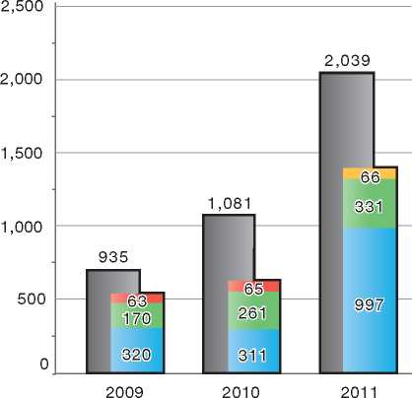

Country of Origin:

| Afghanistan D.R. Congo

Guinea (Conakry) Iraq

Age Determination

The Guardianship Service is responsible for determining whether a person can be considered an unaccompanied minor. The GS will, based on the person's declarations and presented documents, try to get confirmation of the name, nationality and family ties of the person. In case of doubt, age assessment can be done by means of a medical test. The test is organised by and under the control of the GS and can be done at the request of the Immigration Department, the CGRS or the GS. The so-called “triple test” is performed where the person is referred to a forensic odontologist. The age assessment is based on the clinical impression of an experienced dentist, a radiological examination of the dentition and the hand and the wrist of the non-dominant hand, and the medial ends of both collarbones. The average age of the results of these three tests will be approximate and will always indicate a range with a margin of error. In case of doubt the lowest attested age will be taken into consideration.

Asylum Interview

Standardised interview forms and guidelines have been specifically developed for interviewing UMs. Interviews take place in rooms specially adapted for this purpose. During the interview the guardian has to be present, otherwise the interview cannot proceed. A lawyer or other trusted representative can also be present at the interview.

The interview will be adapted to the minor's degree of mental development and maturity. Personal, cultural and family factors will also be taken into account. The caseworker makes efforts to put him or her at ease and to ensure that he or she understands the procedure. Questions tend to be open-ended, and simple sentence structures are used. The interview is usually shorter than other interviews in the normal procedure, and it involves regular breaks. Generally, minors under the age of six are not interviewed unless doing so is considered necessary.

Information

In 2008, a special booklet was introduced to address the information needs of unaccompanied minor asylum-seekers. The booklet, in the form of a comic strip called Kizito, is designed to help minors better understand the different steps in the asylum procedure.

1. Temporary Protection

The Aliens Act integrates the Temporary Protection Directive[37]. The law lays down, among other things, the conditions for persons who have been granted temporary protection to file an application for refugee status. The Act also stipulates that persons granted temporary protection may obtain a one-year residence permit which is automatically renewable, first for a term of six months, then for a second term of one year.

1. Stateless Persons

Belgium has not yet ratified the 1961 UN Convention on the Reduction of Statelessness and there is no specific procedure foreseen in Belgian law concerning the recognition of statelessness.

In practice, persons who want to be recognised as a stateless person will have to start a procedure before the Court of First Instance, as these courts are competent in issues of nationality in general. The Courts will investigate whether the person has a right to a nationality of one of the countries with which he or she has certain ties. The courts take a decision after an advice of the Public Prosecutor's Department.

There is no automatic right to remain once a person has been granted the status of statelessness. The person will need to contact the Immigration Department and introduce an application for a residence permit on humanitarian grounds (according to Article 9 bis of the Aliens Act).

The Belgian authorities are undertaking preparations to establish a specific procedure on statelessness as the current judicial procedure has certain deficiencies. The CGRS, which has the expertise of dealing with asylum cases and has the required knowledge on countries of origin, will become the responsible authority. The CGRS is already responsible for the issuance of certificates to recognised refugees and stateless persons.

1. Decision-Making and Status
   1. Inclusion Criteria

When considering the merits of a claim, a CGRS caseworker must first consider whether the criteria for granting refugee status are met. If this is not the case, the caseworker must then consider whether the applicant meets the criteria for subsidiary protection.

* + 1. Convention Refugee

Convention refugee status is granted to persons who have a well-founded fear of persecution in the meaning of the 1951 Convention and whose claim is found by the CGRS to be credible.

* + 1. Complementary Forms of Protection

Subsidiary protection is provided to persons whose claims are credible and who do not meet the criteria for Convention refugee status but run a real risk of serious harm if returned to their country of origin. “Serious harm” comprises the death penalty or execution, torture or inhuman and degrading treatment or punishment, or a serious threat to life or person as a result of random violence, in the case of an international or national armed conflict.

For medical cases where *refoulement* to the country of origin would be in violation of Article 3 ECHR, as well as for humanitarian cases, a separate procedure is available outside of the asylum procedure.

* 1. The Decision

The CGRS caseworker submits a proposal for a decision on an asylum claim to his or her supervisor, who will then present it to the Commissioner General or one of two deputy commissioners for their approval. Decisions are made in writing and provided to the asylum-seeker (by registered mail or by messenger against receipt), the legal representative and the trusted representative. Negative decisions must be justified with motives provided for the refusal.

* 1. Types of Decisions, Status and Benefits Granted

The CGRS may take the following types of decisions:

* Granting of Convention refugee status
* Granting of subsidiary protection
* Refusal to grant Convention refugee status and refusal to grant subsidiary protection
* Refusal to take into consideration an asylum claim made by a citizen of an EU Member State or of a state that has signed a Treaty of Accession with the EU
* Refusal to take into consideration an asylum claim made by a citizen of a country listed on the safe countries of origin list
* Closure of the asylum application by the CGRS, if the asylum-seeker has voluntarily withdrawn his or her claim, has returned to the country of origin, has had his or her status regularised, has acquired Belgian nationality, or has died before the completion of the procedure.

The CGRS is also the competent authority for excluding persons from protection, for applying cessation clauses and for revoking Convention refugee status or subsidiary protection. These types of decisions are described below.

Benefits

Recognised refugees are entitled to the following benefits:

* Permanent residence
* The right to work and to obtain social security benefits equivalent to those available to Belgian citizens
* A travel document in the form of a “blue passport”
* Family reunification for spouses and minor children (in the case of unaccompanied minors recognised as refugees, the mother and father are eligible for family reunification)
* A proof of refugee status certificate issued by the CGRS
* The possibility of naturalisation, after two years of residence in Belgium.

Beneficiaries of subsidiary protection are entitled to the following:

* A residence permit valid for one year, which can be renewed yearly by the municipality, upon instruction from the Immigration Department
* A permanent residence permit, after five years from the date of the asylum application
* The right to travel abroad. If the person does not have a passport, the Ministry of Foreign Affairs (*FOD Buitenlandse Zaken*) will issue an “alien's passport” when he or she becomes eligible for a permanent residence permit
* Other benefits, such as the right to work and to obtain social assistance, and the possibility for family reunification, are identical to those available to recognised refugees.
  1. Exclusion
     1. Refugee Protection

The CGRS considers Article 1F of the 1951 Convention, as well as any security-risk cases, when examining a claim for asylum. All claims before the CGRS are screened for exclusion. Senior caseworkers who are specially trained on exclusion issues are in charge of processing those cases.

An asylum-seeker who has been excluded may lodge an appeal within 30 days of notification of the CGRS decision. The Council for Aliens Law Litigation has full jurisdiction in such appeals, meaning that it can confirm, change or annul the decision of the CGRS. This appeal has a suspensive effect.

Excluded persons are not entitled to any alternative protection status but they may be protected from *refoulement*. According to its international obligations, as set out in the European Convention on Human Rights and the UN Convention against Torture and Other Cruel, Inhuman or Degrading Treatment or Punishment (CAT), Belgium does not forcibly return excluded persons. Over time, excluded persons may become eligible for a residence permit, for instance through family reunification or on the basis of Article 9.3 of the Aliens Act.

The detention of persons deemed to be security risks is possible on the basis of an evaluation of the risk posed by the person. According to the Aliens Act, the length of detention may not exceed eight months.

* + 1. Subsidiary Protection

Persons may be excluded from subsidiary protection on the basis of criteria set out in the Aliens Act. These criteria are almost identical to those found in Article 1F of the 1951 Convention. The ground of “serious crime”, however, is further elaborated in the Aliens Act as a serious crime that has been committed in Belgium or abroad, either before or after the claim for asylum was made.

The asylum-seeker may lodge an appeal with full legal power with the Council for Aliens Law Litigation within 30 days of notification of the CGRS decision. This appeal has a suspensive effect.

The detention of persons deemed to be security risks is possible on the basis of an evaluation of the risk posed by the person, but may not exceed eight months.

* 1. Cessation

A Convention refugee may cease to benefit from this status if he or she meets one of the criteria set out in Article 1C of the 1951 Convention. The asylum­seeker may lodge an appeal with full jurisdiction with the Council for Aliens Law Litigation within 30 days of notification of the CGRS decision. This appeal has a suspensive effect.

The Commissioner General has the competence to apply cessation clauses at his or her own initiative. The Immigration Department can provide the Commissioner General with information that may lead to cessation of status. In principle, cessation does not have an impact on the person's right to remain in Belgium.

Subsidiary protection ceases to apply if the circumstances that led to the provision of subsidiary protection cease to exist or have evolved in such a way as to render protection unnecessary. To safeguard beneficiaries from a real risk of serious harm, the CGRS examines the changes in country conditions very closely before determining whether these changes are significant and lasting.

Similar to cessation of Convention refugee status, cessation of subsidiary protection status may be initiated by the Commissioner General. During the first five years of residence in the country (period of limited residence), the Minister for Migration or his or her representative (Immigration Department) may make a formal request to the Commissioner General to abrogate the status of subsidiary protection. In this case, the Commissioner General must write a motivated decision within 60 days. Cessation of subsidiary protection status during the period of limited residence (the first five years) may lead to an order to leave the country.

* 1. Revocation

According to the Aliens Act, the CGRS may withdraw Convention refugee status or subsidiary protection from its beneficiary for the following reasons:

* The person made false declarations, failed to disclose information or presented fraudulent documents that had, or could have had, a bearing on the outcome of the asylum claim
* The person's behaviour would indicate that he or she no longer had a well-founded fear of persecution.

The Commissioner General can revoke status at his or her own initiative. The Minister of Migration or his or her representative (Immigration Department) may make a formal request to the Commissioner General to do the following:

* Revoke refugee status or subsidiary protection status in the case of fraud. The Commissioner General must then write a motivated decision within 60 days. Revocation of status may lead to an order to leave the territory. Revocation on the basis of fraud is possible within the first 10 years of residence in the country
* Revoke subsidiary protection status from persons who should have been excluded. The law foresees that the decision of the Commissioner General should be accompanied by an opinion on whether return to the country of origin would be in conformity with Article 3 ECHR. Revocation on this basis is possible within the first five years after the status has been granted. This period is extended to the first ten years in cases where the status has been obtained through fraud or when the behaviour of the applicant indicates that he or she never feared persecution.

The person may lodge an appeal with full jurisdiction with the Council for Aliens Law Litigation.

* 1. Support and Tools for Decision-Makers
     1. Country of Origin Information

Cedoca, the research and documentation centre of the CGRS, is one of the biggest and most specialised COI units in Europe. It is composed of a 41-member team that provides support for the assessment of the asylum applications to caseworkers and to the legal service of the CGRS. A project team and administrative assistants are responsible for developing and maintaining the documentary intranet of the CGRS, called *InSite*.

The 26 Cedoca researchers each specialise in specific geographical areas. They provide information on the countries of origin of asylum­seekers in the form of Subject-Related Briefings (around 250 annually). These reports cover a variety of topics. Every year, they answer about 2,000 requests for information in individual asylum files. Cedoca also organises in-depth training sessions and briefings on a given country, and is involved in the organisation of fact-finding missions. To ensure up-to-date and comprehensive information, Cedoca researchers consult national and international sources and can consequently call upon an extended network of contacts in countries of origin. The researchers take great care to ensure that their research does not put their contacts, the asylum-seekers, or their relatives at risk. Recently the organisation began experimenting with social media such as Facebook, Twitter and YouTube to collect information.

On the international scene, Cedoca is an active player in workshops, projects and presentations. Cedoca is the co-author of the EU Common Guidelines on COI and the EU Common Guidelines on (joint) fact-finding missions. It is also heavily involved in the COI-related activities of the European Asylum Support Office (EASO).

* + 1. Language Analysis

The Language Analysis Desk, located within Cedoca, may be requested to make recordings of asylum-seekers' speech. These are forwarded to language analysts in order to determine the region of origin of the applicant. The conclusions of the language analysts are considered as one of many elements that may factor into the final decision of the CGRS. Mainly due to budgetary constraints, the use of language analysis has declined in recent years and is now rarely used.

* + 1. Psychological Support Unit

The main task of the psychological support unit is to provide advice to protection officers on the mental and psychological capacities of asylum­seekers in cases where this may have an important bearing on the claim. These include situations in which asylum-seekers claim to be experiencing loss of memory, post-traumatic stress disorder or depression. The unit conducts a psychological evaluation of the asylum-seeker and provides a report to the caseworker.

Although the report reflects only on the psychological capacities of the asylum-seeker, it may play an important role in the decision­making process, particularly in cases in which the psychological capacity of the person may form the basis of contradictions that would otherwise undermine the credibility of the claim.

The Unit is also responsible for assessing medico- psychological certificates submitted by asylum­seekers, as some asylum-seekers produce questionable or false medico-psychological certificates.

* + 1. Gender Unit

For the assessment of asylum applications based on gender-related motives, the CGRS has set up a “Gender Unit” composed of a full-time coordinator and eleven reference persons within the caseworkers' geographical sections and the legal section who devote a portion of their time to gender issues. Their main task is to improve and harmonise the assessment of gender-related asylum applications at the CGRS.

Gender-Sensitive Asylum Procedures

Gender-sensitive procedures at the CGRS ensure that all persons with asylum claims related to gender, gender identity and sexual orientation have the chance to put forward all relevant elements of their claim, e.g. by organising individual hearings for each adult applicant, by offering the possibility of being interviewed by a caseworker of the same sex, and by offering day care for children during the interview.

An information brochure, “Women in the Asylum Procedure”, has been provided in nine languages since mid-2011 to all women asylum applicants. The brochure provides information on the application process and on organisations that provide legal, medical and social assistance to migrant women.

All caseworkers receive training on gender issues. Furthermore, a specific training for interpreters was developed in 2012. The Gender Unit developed a handbook with all reference texts, notes, documents and information relevant for processing gender-related asylum applications. It outlines specific tools to handle asylum applications from persons who put forward their sexual orientation in support of their asylum application. The use of keywords in the database allows caseworkers to extract gender-specific statistics.

Belgium also has a special policy on female genital mutilation (FGM). Persons who obtain protection on the basis of FGM receive a yearly permit, which can be renewed only upon presentation of a medical certificate confirming that FGM has not been performed. If the person fails to provide a certificate, the Gender Unit invites the person concerned for an interview and, if necessary, refers the case to the judiciary.

* + 1. UNHCR Handbook

The UNHCR Handbook on Procedures and Criteria for Determining Refugee Status does not hold any legally enforceable provisions for the CGRS and is used as a manual for the application of the 1951 Convention.

* + 1. Training Programmes

The CGRS has established a Knowledge and Learning Centre (KLC) to provide training to personnel. The KLC has its legal basis in a Royal Decree, which stipulates that the personnel of the CGRS should receive continuous training on the application of the Geneva Convention and other national and international standards, interviewing techniques, intercultural communication, and on the specific needs of vulnerable groups.

The KLC thus provides training to newly recruited protection officers (learning trajectory including training and observation during one month), but also organises regular training based on the specific needs and objectives of the organisation and personnel. The competences are evaluated annually through a tool called “development circles”.

Belgium is one of the first countries that has gradually introduced the European Asylum Curriculum (EAC) into its training programme for protection officers. The EAC project set up uniform training modules for the asylum authorities in the European Union as a means to harmonise asylum policies throughout Europe. Within the CGRS, all newly recruited protection officers follow the basic training modules on inclusion, interviewing techniques and evidence assessment. In addition, more experienced protection officers are progressively taking up these and other EAC modules. Belgium has taken a leading role in the development and promotion of EAC training. Within the CGRS several persons participated in the “train-the- trainer” sessions.

1. Efficiency and Integrity Measures
   1. Technological Tools
      1. Fingerprinting

All asylum-seekers are fingerprinted after making a claim for asylum at the Immigration Department. The fingerprints are stored (for 15 years) in the national PRINTRAK system, which also contains data on other categories of aliens. The data of asylum-seekers are sent to EURODAC to check previous applications or irregular entry in other EU Member States.

* + 1. Age Determination

See section 5.3.1 on Unaccompanied Minors.

* + 1. DNA Tests

The Immigration Department may request a DNA test in cases where family members, including children, who were not initially included in an asylum claim, are subsequently added to the claim. While DNA tests are used very rarely in the asylum procedure, they are still considered useful as the results are nearly 100 per cent accurate.

* + 1. Forensic Testing of Documents

The Immigration Department and the CGRS may make a request to the Police to verify identity documents when there are doubts about the documents' authenticity. The documents are sent to the Police Department, which specialises in fraudulent documents. Forensic testing of documents is not systematically undertaken in the asylum procedure, as the majority of asylum-seekers claim to not be in possession of identity documents.

* + 1. Database of Asylum Applications/Applicants

All asylum applicants are registered in a “waiting register”, a subdivision of the national/population register in which all inhabitants of Belgium are registered. The waiting register contains identity information, information on places of residence and information on each stage of the asylum procedure and the decisions taken. The Immigration Department is responsible for the first entry of an application into the register and remains responsible for later changes relating to identity information. The local municipalities can also introduce a number of changes to the register, for example the place of residence, the civil status of the persons and the residence documents delivered to the asylum-seeker.

If a person is granted refugee status or the status of subsidiary protection, the data in the waiting register is transferred to the “foreigner's register”. Access to the waiting register is limited to a certain number of governmental institutions.

* 1. Length of Procedures

Asylum applications must be made within eight working days of the person's arrival in Belgium or before a valid permit to remain in Belgium expires. An asylum-seeker arriving at the border without valid documents to enter the territory must submit his or her application to the border authorities. However, no penalties are imposed on a person who does not meet these requirements and applications made after these deadlines will be processed. The fact that an asylum-seeker has not immediately submitted his or her asylum application might however damage the applicant's general credibility as it is a negative indication of his or her urgent need for protection.

In general, the Aliens Act does not stipulate time limits to the CGRS to render a decision. The CGRS however aims to render this decision within three to six months after the asylum application has been deemed admissible by the Immigration Department. Time limits may be extended for particularly complex files.

For specific cases shorter time limits are in force:

* Five working days in case the applicant is an EU national
* 15 working days in case the applicant originates from a safe country of origin
* 15 days in case the applicant is detained at the border or files an application while in prison
* 15 days in case the Minister demands a prioritised assessment (injunction right)
* 15 days in case the applicant is considered a threat to public order or national security
* Two months for specific cases (e.g. subsequent applications).

The appeal body (Council for Aliens Law Litigation) also has set timeframes:

* Three months for the regular procedure
* Two months for cases marked for prioritised assessment by the CGRS (e.g. safe country of origin)
* Three days/72 hours for the procedure in extreme urgency.

These time limits indicated in the Aliens Act are however not legally enforceable.

* 1. Pending Cases

The significant backlog of cases at the CGRS, caused by a great influx of asylum application in the years 1999 and 2000, was to a large extent eliminated by 2009, mainly as a result of the declining number of new asylum applications and the addition of staff and resources. One method used to prevent the backlog from getting bigger was the Last In First Out (LIFO) measure: new cases were prioritised, while old cases were put on hold. A large number of these old cases that had been pending for many years were subject to regularisation.

The backlog reached its lowest levels at the end of 2007 and 2008, with a caseload of around 5,000 files. Due to a marked increase in asylum applications, especially during the second half of 2010, the backlog at the CGRS once again increased to 10,560 files at the end of 2010. As at 30 September 2012, the backlog amounted to 12,553 files[38]. Taking into consideration that 4,500 files represents a normal caseload, the actual backlog amounts to 8,053 files.

Starting in 2010, Belgium experienced asylum and reception crises. It was thus deemed of utmost importance that the backlog be cleared, not only for asylum-seekers awaiting a decision, but also to eliminate pressure on the reception system. Restoring the procedure's efficiency and credibility was also deemed necessary to prevent further abuse of the asylum system. A variety of measures were taken to limit the influx (e.g. legislative changes) but also to strengthen the capacity of the asylum instances.

Measures to improve efficiency

In the years 2010 and 2011, the CGRS increased its decision­making capacity thanks to the rapid recruitment, training and integration of new staff. In order to increase efficiency the CGRS has also taken several internal measures aimed at clearing its backlog and shortening processing times, without jeopardising the quality of the asylum examination or increasing work pressure on individual protection officers.

Different action plans were developed that outlined a variety of measures to increase efficiency and effectiveness, *inter alia:*

* Special actions targeting the processing of asylum applications and motivation of decisions (e.g. special instructions concerning certain profiles, priority and fast-track processing of certain categories, restriction of the motivation of a decision to the arguments that are strictly necessary)
* The creation of an IT platform
* Extended communication about objectives at organisational and team levels
* Special actions aimed at decreasing the number of unfounded asylum applications (country-specific actions) through a coordinated approach.

An "Enhancement" or “Business Improvement Project” that was carried out between 2011 and 2012 helped to develop and implement further enhancement initiatives.

As at 30 September 2012, the Council for Aliens Law Litigation has accumulated a backlog of 5,258 asylum-related files. In addition the CALL still has a backlog of 1,400 files inherited from the now-defunct Permanent Appeals Commission for Refugees.

The Council of State was able to clear most of its backlog of asylum-related files. In 2007 there were nearly 21,000 pending cases. With the introduction of the Council for Aliens Law Litigation and the admissibility filter for appeals at the Council of State, the number of new files dropped drastically, which helped to eventually clear the unprecedented backlog by 2012.

* 1. Information Sharing

The only information-sharing agreements to which Belgium is party are the Dublin Regulation and the agreements with Denmark, Norway, Iceland and Switzerland that extend the application of the Dublin II Regulation to those states. Specific information on asylum-seekers can be released to other EU Member States, in accordance with Article 21 of the Dublin II Regulation. No information on an asylum-seeker can be released to a third country, unless the asylum-seeker consents to it.

* 1. Single Procedure

Since the introduction of subsidiary protection in October 2006, Belgium has put in place a single asylum procedure. In other words, asylum-seekers need to make only one application for international protection in order to obtain either Convention refugee status or subsidiary protection. The CGRS first determines whether the applicant meets the criteria for refugee status, and if this is not the case, it will determine whether grounds exist for granting subsidiary protection.

1. Assistance and Reception Benefits for Asylum-Seekers
   1. Procedural Support and Safeguards
      1. Legal Assistance

At each stage of the asylum procedure following the taking into consideration of the asylum application by the Immigration Department, asylum-seekers are entitled to legal aid. If an asylum-seeker cannot afford legal aid by himself or herself, the state may provide this free of charge. Requests for such assistance can be made at a legal aid office.

Asylum-seekers appearing before the CGRS may have their legal representatives present during the interview. An asylum-seeker can also personally assign a person with whom he or she has a special bond of trust for assistance during the asylum procedure. A trusted representative has to meet certain conditions: he or she has to reside legally in Belgium, he or she cannot be the subject of an asylum application and he or she may not represent a danger to public order or national security. Neither the legal representative nor the trusted representative may make an intervention during the interview. However, he or she may, at the end of the interview, explain the reasons for which the asylum-seeker might be entitled to refugee status or subsidiary protection.

* + 1. Interpreters

Upon registration of the asylum application, the asylum-seeker is asked to choose the language he or she wishes to use throughout the asylum procedure. During interviews at all the different stages of the asylum procedure, an interpreter is available free of charge.

The CGRS uses independent and impartial interpreters for interpretation to and from Dutch, French or English during asylum interviews. Translators are also available to the CGRS for the translation of documents or declarations submitted by the asylum-seeker. The Interpreters' Service, a special unit within the CGRS, coordinates the work of interpreters and translators.

In the reception centres, asylum-seekers can rely on so-called “community interpreting” and translating services in order to enable them to access different (social) services. Some organisations offer their services free of charge (subsidised by the Government), whereas others charge a fee. These interpreters and translators have signed a code of conduct.

* 1. Reception Benefits

According to the Reception Act, every asylum­seeker has the right to reception conditions that would allow him or her to lead a life of human dignity. Since the 2007 reform of the asylum system, state aid for asylum-seekers has shifted from financial aid to material aid. This material aid comprises accommodation, food, clothing, medical, social and psychological help, access to interpretation services, access to legal representation, access to training, access to a voluntary return programme, and a small daily allowance (pocket money). An asylum-seeker can however also choose not to accept the offered place in a reception centre and to instead stay at a private address. In that case, he or she will not be entitled to material aid (except for medical assistance).

Asylum-seekers and their dependants are entitled to reception benefits for the duration of the procedure, including any appeal procedure that has a suspensive effect. However, in case of the introduction of a subsequent asylum application, the Reception Agency can restrict the right to material aid to medical aid only for those claims that do not contain new elements and as a result are not taken into consideration by the Immigration Department.

The Reception Act also stipulates special reception arrangements for minors and for vulnerable persons. A complaint mechanism and possibilities for appeal with regard to reception benefits are available under the law. Violations of the right to reception benefits can be brought before the labour tribunal.

Persons who apply for asylum at the Immigration Department must register with the communal authorities where they are residing within eight days of submitting their application.

* + 1. Accommodation

Fedasil coordinates and oversees the different types of accommodation to ensure a common level of living conditions. In addition to Fedasil, a number of partner organisations are involved in managing the centres and private accommodation, among them the Red Cross Society, Local Reception Initiatives run by local Public Centres for Social Welfare, and NGO partners Cire and Vluchtelingenwerk Vlaanderen.

On the day that an asylum claim is filed with the Immigration Department, the dispatching service of Fedasil will assign a reception centre to the asylum-seeker. The asylum-seeker is then provided with a brochure outlining his or her rights regarding reception during the asylum procedure. The Reception Act stipulates that asylum-seekers may apply for a transfer to individual (private) accommodation after a four-month stay in a collective reception centre.

The Reception Act envisions that a social worker conduct an individual assessment within a maximum of one month after the start of reception in order to determine if the reception facility is adapted to the specific reception needs of the resident.

Three specialised Observation and Orientation Centres (OOC) are geared specifically at unaccompanied minors, irrespective of their administrative status. In principle the unaccompanied minor will stay here for 15 days (renewable once)[39] during which period registration and identification of the minor will take place and a guardian assigned. After this period the unaccompanied minor asylum-seeker will be transferred to open reception centres, which have specific areas designed for them, or to specialised reception initiatives. Due to the increase in the number of unaccompanied minor asylum-seekers, specifically in 2011 and 2012, additional reception places were created and in May 2012 Belgium counted a total of 1,203 places for unaccompanied minors.

Due to the sharp increase in the number of applications, the reception network became saturated and Fedasil, between October 2009 and April 2012, proved no longer able to provide reception places to all asylum-seekers. As a result, around 12,282 asylum-seekers were not assigned to a reception centre. On the one hand, the Belgian Government tackled this reception crisis via the creation of 9,400 new reception places, in military facilities, Red Cross, federal and other reception centres as well as places in hotels. The number of reception places increased from 15,611 (July 2007) to almost 25,000 (May 2012).

On the other hand, legislative changes to the Reception Act introduced a variety of limitations to the right to reception. As mentioned before, Fedasil may exclude asylum-seekers filing a subsequent application from reception and material aid, unless their asylum claim is taken into consideration by the Immigration Department. (Persons undergoing medical treatment are exempted from these limitations). Also, reception rights will expire three days after a negative decision is issued on appeal, or when the time limit of the order to leave the territory has elapsed. Additionally, in order to free spaces for new arrivals, asylum-seekers were exceptionally offered the possibility to leave a reception facility and apply for financial aid during a few months in 2012. This possibility was only offered to asylum­seekers who had their asylum request pending for more than 6 months, who resided in a reception facility without interruption for at least 6 months and who had found alternative housing (signed a lease).

After the decision by the CGRS not to take into consideration an application (safe country of origin concept) or a negative decision by the Council for Aliens Law Litigation, rejected asylum-seekers (except for residents who belong to certain exempted categories) are transferred to “open return” places. At the end of 2012 there were 300 places available, located in four federal reception centres, where they receive the same material aid as during the procedure, in combination with intensified return assistance (see Section 10.2).

* + 1. Social Assistance

Upon arrival at a reception centre, each asylum­seeker is assigned a social worker who assists each resident individually. The social assistance comprises of, *inter alia*, providing information on access to material aid and its concrete implementation, on daily life in a reception facility, on the activities and training available to the resident, on the stages of the asylum procedure (including the possible judicial appeals and their consequences), as well as on the content and importance of the programmes of voluntary return. The social assistance also includes support in the execution of administrative tasks.

The tasks of the social worker consist, among other things, in helping the resident to overcome and improve the emergency situation in which he or she resides. To this end, the social worker provides information, advice and social guidance, if necessary by referring to external services. The tasks of the social worker also include the assessing the specific needs of the resident and, where necessary, the transfer of a resident to another reception facility.

* + 1. Health Care and

Psychological Counselling

According to the Reception Act, medical services are available to all asylum-seekers whether or not they reside in reception centres. These services are provided by a resident doctor or a consulting general practitioner.

A Royal Decree sets out which medical care is covered. Some treatments that are not covered, but are important in everyday life, can still be reimbursed by Fedasil, such as certain drug prescriptions or eyeglasses for children.

Rejected asylum-seekers may in some cases (e.g. due to a medical problem or pregnancy) also rely on care in the assigned reception centre. Those who are no longer entitled to general medical care (e.g. illegally staying third-country nationals) still have a right to emergency medical assistance if needed.

Asylum-seekers who receive material aid are also entitled to psychological counselling. To this end Fedasil or one of its partners can sign an agreement with specialised agencies and institutions.

* + 1. Education

Schooling for minors between the ages of six and 18 years is mandatory. Special “transition” classes, often close to the reception centre, are organised for children of asylum-seekers. Kindergarten classes are offered to younger children (from 2.5 up to 6 years).

Adults have the possibility of taking a range of classes organised at the reception centres: there are classes, for example, in language, information technology, cooking and sewing. Asylum-seekers may also take classes outside the reception facilities in centres for basic education or adult education. Similar education possibilities are offered to asylum-seekers residing in private accommodation. Reception centres also organise activities such as sports and cultural outings.

* + 1. Access to Labour Market

Since 12 January 2010, asylum-seekers who fulfil certain criteria are allowed to apply for a labour card “C”, which enables them to work in Belgium. They may include asylum-seekers who have not received a first-instance decision within six months of registration of their asylum application. These asylum-seekers can work until a decision is taken by the CGRS, or in the case of an appeal, until a decision has been issued by the Council for Alien Law Litigation.

This labour card “C” allows the asylum-seeker to do any job in salaried employment for any employer, and is valid for 12 months (renewable).

At this time, asylum-seekers are not allowed to do voluntary work. However, they are entitled to perform certain community services (maintenance, cleaning) inside the reception centre for pocket money.

Adult asylum-seekers who have access to the labour market (with a valid labour card “C”) can register as job-seekers at one of four Offices of Employment and are then entitled to a free assistance programme and vocational training.

* + 1. Family Reunification

No possibilities for family reunification exist for asylum-seekers awaiting a final decision on their claim.

* + 1. Access to Integration Programmes

Each reception centre has a budget to organise community activities, with the aim of integrating the centres into the local communities. Activities such as parties, sports and recreation take place inside or outside the centre, and bring together residents of the centre and members of the community. The reception centres also engage in outreach to the community, providing information on migration, asylum, and foreign cultures.

Asylum-seekers in Flanders and Brussels may take part in an integration programme designed for new immigrants (*inburgering*) four months after starting the asylum procedure (see section 11 on Integration).

* + 1. Access to Benefits by Rejected Asylum-Seekers

The following persons have the right to an extension of their reception benefits after receiving a negative decision on their claim:

* Persons who due to medical problems cannot leave the reception facility and who have submitted an application for a residence permit on the grounds of a serious medical condition (under Article 9 ter of the Aliens Act)
* Persons who, for reasons beyond their control, cannot be returned to their country of origin or of habitual residence
* Persons whose parent or guardian has the right to material benefit
* Persons who need to finish their school year (demand for prolongation at the earliest three months before the end of the school year)
* Persons who cannot leave because of a pregnancy (prolongation applies at the earliest from the seventh month of the pregnancy and ends at last two months after birth)
* Persons who have submitted an application for a residence permit on the grounds of parenthood of a Belgian child (under Article 9 bis of the Aliens Act).

In some cases, children of irregular migrants without any means of subsistence and their families have the right to be accommodated in the reception network. In these cases the Centre for Public Welfare will have established that the children are in need because the parents are not complying or are not able to comply with their obligation to support their children, often due to their illegal residence status. In order not to separate the children from their parents, the right to reception is extended to the parents.

1. Status and Permits Granted Outside the Asylum Procedure
   1. Humanitarian Grounds

The CGRS may include in a negative decision a note to the Minister of Migration and Asylum Policy to consider any humanitarian grounds put forth by the asylum-seeker. There is no legislative basis underpinning this practice.

Situations that may warrant such a clause include the following:

* The person's medical condition and age
* Pregnancy or child delivery
* The presence of relatives who are residents of Belgium.

The Minister and the Immigration Department decide whether or not such an advice should be followed. The advice is not binding and its value is limited as the Council for Aliens Law Litigation is not obliged to uphold such a humanitarian clause in its appeal decision.

Receiving a humanitarian clause does not lead to an alternative protection status. It can be a ground for introducing an application for regularisation of stay on humanitarian grounds, if there are no indications of a danger to public order or national security. Decisions on such applications are however taken on a discretionary basis by the Immigration Department, as explained in section 9.5.

* 1. Withholding of Removal/ Risk Assessment

Before a person is removed from Belgium, the Immigration Department will do a risk assessment to determine whether or not removal will violate the *non-refoulement* principle of the 1951 Convention, the provisions contained in Article 3 of the ECHR, or fundamental freedoms.

* 1. Regularisation of Status over Time

The Immigration Department may regularise the status of a rejected asylum-seeker on a case- by-case basis. See section on “Exceptional Circumstances” below.

* 1. Regularisation of Status of Stateless Persons

Belgium has not ratified the 1961 UN Convention on the Reduction of Statelessness and there is no specific procedure concerning the recognition of statelessness foreseen in Belgian law. However, the Belgian authorities are undertaking preparatory works to establish a specific procedure on statelessness.

In practice, persons who want to be recognised as a stateless person will have to start a procedure before the Court of First Instance, as these courts are competent on issues of nationality in general. The Courts will investigate whether the person has a right to a nationality of one of the countries with which he or she has certain ties. The courts take a decision after receiving the advice of the Public Prosecutor's Department.

There is no automatic right to remain once a person has been granted the status of “stateless person”. Since stateless persons do not have a nationality, they cannot easily be removed to another country. The person may introduce an application for a residence permit on humanitarian grounds with the Immigration Department, as he or she cannot return to his or her country of origin as a result of “exceptional circumstances” (Article 9 bis of the Aliens Act).

* 1. Exceptional Circumstances

Certain persons, who are present in Belgium but do not possess a right of residence, can apply for a residence permit on humanitarian grounds on the basis of Article 9 bis of the Aliens Act. It has to be noted that this article in reality does not state that a residence permit can be obtained on humanitarian grounds. In fact, this article allows an exception to the rule that a foreign national must request an authorisation of residence at the diplomatic representation of Belgium abroad. More specifically, the article states that in exceptional circumstances and on the condition that the applicant is in possession of an identity document (there are certain exemptions), a foreign national can apply for an authorisation of residence in Belgium himself or herself. The foreign nationalmust in principle prove that he or she is not able to return to the country in order to introduce a request for authorisation of residence. In practice a double evaluation (admissibility and eligibility) is made: on the one hand an assessment of the circumstances that would justify an application in Belgium, and on the other hand an assessment of the reasons invoked for wishing to stay in Belgium.

An exact definition of the categories of persons who can qualify for a residence permit on the basis of humanitarian grounds has not been laid down in the Aliens Act, which means that in essence decision-making on such applications is in most cases discretionary. Important elements that can be taken into account are a protracted asylum procedure and “pressing humanitarian situations”. The procedure for granting residence permits on these grounds does not have suspensive effect for rejected asylum-seekers who do not have a right of stay in Belgium. The exceptional circumstances are examined on a case-by-case basis.

1. Return
   1. Pre-departure Considerations

When an asylum-seeker is issued a removal order, he or she is asked to leave the country independently, at his or her own initiative. He or she receives an information package outlining the possibilities for voluntary return. The person is expected to voluntarily adhere to that decision and can make use of the voluntary return programme. If he or she fails to leave the territory, he or she may be held in a detention centre or “housing unit” (in case of families with children) in order to enforce the return.

* 1. Procedure

Voluntary Return

Fedasil (Federal Agency for the Reception of Asylum-Seekers) is responsible for organising the voluntary return programme and all parallel measures (information, communication, etc.). In fulfilling this responsibility, Fedasil delegates several tasks to third parties. The voluntary return programme consists of two parts: return and re-integration.

The International Organization for Migration (IOM) is responsible for the practical implementation of this return programme, called REAB (Return and Emigration of Asylum-seekers ex-Belgium). Some of the tasks are then re-delegated by IOM to a network of NGOs, reception centres and local authorities (REAB partners). Through a counselling process, migrants receive from the REAB network information on voluntary return and opportunities to reintegrate into their country of origin. The NGO Caritas has had a structural involvement in implementing the reintegration programme. Like IOM, Caritas delegates post-return support and assistance to local branches in the country of origin.

The REAB programme is intended not only for asylum-seekers who withdrew their application or were rejected, but also for irregular migrants. A person who wants to return will receive

* A flight to the airport nearest to his or her final destination
* A “reinstallation” fee of € 250 per adult and € 125 per minor. This rule does not apply to citizens of countries with a visa-free regime (e.g. Western Balkans, Brazil)
* Reimbursement of travel documents, transport to the airport (limited to € 50 per person).

Additionally, reintegration support can be granted to persons who wish to return voluntarily. Since 2012, this support has however been limited to (rejected) asylum-seekers who do not originate from countries with a visa-free regime (e.g. Western Balkans). With this support, reintegration in the country of origin can be facilitated. The amount of the support can be as high as € 2,200 per person (€ 700 for general reintegration plus € 1,500 for micro-business development or wage subsidy). Vulnerable groups are entitled to additional reintegration support, covering for example medical costs. The reintegration support is provided in the form of in-kind assistance. The amount is not paid to the returning migrant but to a local “reintegration partner”, which in most cases is the local branch of IOM or Caritas, which manages the budget together with the migrant. The reintegration support is partially funded by the European Return Fund.

The modified Reception Act of 19 January 2012 introduces the “return path”. Fedasil formally provides individual counselling on return to the asylum-seeker for the whole duration of the asylum procedure. Towards the end of the asylum procedure, rejected asylum-seekers can be transferred to “open return places” in different reception centres (see above 8.2.1), where they receive intensified return assistance. This return path, which prioritises voluntary return, is jointly managed by Fedasil and the Immigration Department.

Enforced Return

Belgium also has the possibility of enforcing returns and detaining rejected asylum-seekers pending return. The enforced return is executed in collaboration with the Federal Police. The conditions of forced return can vary from situations where the person clearly cooperates towards his or her removal, to a situation where the Federal Police will escort the person in the plane until he or she reaches his or her final destination on a secured flight.

* 1. Freedom of Movement/ Detention

Pending return, rejected asylum-seekers may be detained for a period of two months. Detention may be extended for an additional two months under the following circumstances:

* If the necessary measures to remove the person have been taken within seven working days of the start of detention
* If these measures continue and return remains a possibility within a reasonable period of time.

Following the additional two-month detention period, the Minister is the only authority who may decide to extend the period of detention. Following five months of detention, the person must be released.

If the alien refuses to be removed from the territory, a new two-month period of detention begins.

* 1. Readmission Agreements

EU readmission agreements are a means whereby Member States of the European Union can seek to enforce the return of both nationals of the country concerned and third country nationals, where there is good evidence that they transited or resided in that country. The purpose of the readmission agreement is to set out reciprocal obligations as well as administrative and operational procedures, to facilitate the return and transit of people who no longer have a legal basis to stay in the Member State of the European Union.

In Belgium the Ministry of Interior (Immigration Department) and the Ministry of Foreign Affairs are the competent authorities for negotiating and implementing readmission agreements. Belgium has concluded bilateral readmission agreements, but also has a long tradition in the negotiation and conclusion of readmission agreements within the Benelux (Belgium, Netherlands, Luxembourg) framework.

1. Integration

Due to its federal structure, the main responsibilities for integration policy in Belgium lie with the different (linguistic) Communities and Regions. The federal level retained some competences for a few integration programmes that mainly support the integration policies of the Communities/ Regions. As a consequence, there is no real Belgian model for integration, as different authority levels (Region/Community) can issue different integration policies.

In Flanders the integration policy is laid out in the Civic Integration Decree. The Decree lists the various target groups that are obliged to participate in the civic integration programme (*inburgering*). The civic integration programme is organised by a “welcome office” (eight offices in Flanders and Brussels). The individual in question signs a contract for his or her integration program. This primary civic integration programme consists of a training programme that is underpinned by individual coaching and guidance efforts tailored to the individual needs of the person. The training programme consists of Social Orientation to get acquainted with Flemish and Belgian society, Dutch language lessons and a Career Orientation. After successful completion of the first civic integration programme a certificate is awarded, and the person can move up to the secondary integration programme. During this programme the persons can further shape the choice they made during the primary civic integration, whether it is to enter the labour market or to continue their education.

The integration policy is intended for a range of different target groups. Recognised refugees and persons granted subsidiary protection are part of the obligatory target group. Since 2012, there is no longer an obligation for asylum-seekers to follow the civic integration programme. However, they preserve their right to follow one or more components of the civil integration process, starting four months into the asylum procedure.

The Walloon Region and the French Community have placed the responsibility of integration on the immigrant in the sense that the individuals'

efforts towards social cohesion are voluntary. There are no standard integration programmes available. There are, however, seven regional integration centres which, in cooperation with local organisations, provide services such as job orientation to refugees.

The Brussels-Capital Region has initiatives from both the Flemish Community Council and the French Community Council. The Flemish Community Council implements the Flemish policies on migrants in Brussels. The obligation to participate in the Flemish civic integration programme does not apply to Brussels. The Council also aims to create additional elements to complement elements that the Flemish policies do not cover. Furthermore, the French Community Council develops programs which are executed by the municipalities and the associations that are active in the field of social cohesion.

As stated before, the Federal Government has a number of instruments to support the integration policies of the Regions and Communities.

12 Annexes

12.1 Asylum Procedures Flow Chart

**Immigration Department (ID)/Asylum application**At the border: upon arrival  
On the territory: within 8 working days

**Determination of the state  
responsible**for examining the asylum  
application  
(Dublin II Regulation)

**Examination of multiple asylum  
applications**

x /

73  
<D  
o  
z;

73  
o

w

ra <D ***CL CL m***

o  
c

Decision not to consider the application

**Transfer to the  
Dublin State responsible**

**Examination by Belgium**

Decision to consider the application

**Granting**

of Refugee Status

**Refusal** of refugee status  
**Granting** of subsidiary protection

Refusal of refugee status Refusal of subsidiary protection status

**Decision not to consider**

the asylum application

i (EU nationals/Safe Countries of Origin)

c  
o

o

<D

2 tn Q_ 25

<D

£2

25

7D

O

'n

CD P

-2 =5

CD V)

05

**^Council of Aliens Law Litigation (CALL)'** The CALL can modify, confirm or annul decision taken by the CGRS. The CALL can only annul decisions taken by the ID >

▼

**Full jurisdiction appeal**(within 30 calendar days)  
suspensive effect

z i s

**r Appeal for annulment** (within 30 calendar '

days) (urgent) appeal for suspension/  
appeal for annulment  
non-suspensive effect

**Granting** of

Refugee  
Status

**k.**

( \

**Refusal** of  
refugee status  
**Granting** of  
subsidiary  
protection  
status

X /

**Refusal** of

Refugee  
Status

**Refusal** of

subsidiary protection status k

**STAY**

**Annulment of  
the decision  
taken by ID/  
CGRS** + file  
returned to ID/

CGRS

**<**

**Rejection** of  
the appeal for  
annulment

REFUSAL OF STAY

' i

**^Examination by the Council of State'**

Non-suspensive appeal in cassation

„ (30 Calendar days) y

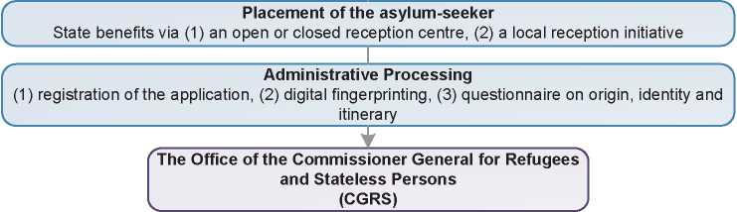

1. Additional Statistical Information

Figure 4: Asylum Applications from Top 10 Countries of Origin in 2009, 2010, 2011 and first half of 2012 [40]

**2009 2010 2011 Jan-Jun 2012**

|  |  |  |  |  |  |  |  |  |
| --- | --- | --- | --- | --- | --- | --- | --- | --- |
| **1** | Afghanistan | 1,659 | Kosovo | 1,848 | Afghanistan | 2,758 | Afghanistan | 1,476 |
| **2** | Russia | 1,605 | Iraq | 1,769 | Guinea (Co.) | 2,134 | Guinea (Co.) | 907 |
| **3** | Kosovo | 1,539 | Russia | 1,526 | Iraq | 1,948 | Russia | 709 |
| **4** | Iraq | 1,386 | Afghanistan | 1,411 | Russia | 1,618 | D.R. Congo | 659 |
| **5** | Armenia | 1,099 | Guinea (Co.) | 1,398 | Kosovo | 1,458 | Kosovo | 517 |
| **6** | Guinea (Co.) | 1,052 | Serbia | 1,233 | Serbia | 1,109 | Iraq | 465 |
| **7** | Iran | 732 | FYROM | 1,082 | D.R. Congo | 1,007 | Pakistan | 452 |
| **8** | D.R. Congo | 670 | Armenia | 986 | Pakistan | 933 | Bangladesh | 361 |
| **9** | Serbia | 514 | D.R. Congo | 786 | FYROM | 819 | Cameroon | 321 |
| **10** | Syria | 347 | Syria | 388 | Albania | 809 | Serbia | 295 |

Figure 5: Decisions Taken at the First Instance in 2009, 2010 and 2011 [41]

|  |  |  |  |  |  |  |  |  |  |
| --- | --- | --- | --- | --- | --- | --- | --- | --- | --- |
|  | **Geneva Convention** | | **Subsidiary/**  **Complementary**  **Protection and Humanitarian Status** | | **Rejections** | | **Withdrawn, Closed, Abandoned Cases** | | **Grand**  **Total** |
| **Number** | **%** | **Number** | **%** | **Number** | **%** | **Number** | **%** | **15,275** |
| **2009** | 2,415 | 16% | 450 | 3% | 12,380 | 81% | 0 | 0% |
| **2010** | 2,680 | 16% | 800 | 5% | 13,135 | 79% | 0 | 0% | **16,615** |
| **2011** | 3,800 | 19% | 1,260 | 6% | 14,935 | 75% | 0 | 0% | **19,995** |

**Figure 6.a: Positive [42] First-Instance Decisions, Top Countries of Origin in 2009 [43]**

**Rate out of Total Decisions 18**

|  |  |  |  |  |
| --- | --- | --- | --- | --- |
|  | | **Total Positive** | **Total Decisions** | **Rate** |
| 1 | Iraq | 605 | 1,180 | 51.3% |
| 2 | Russia | 300 | 2,085 | 14.4% |
| 3 | Afghanistan | 285 | 1,245 | 22.9% |
| 4 | Guinea (Conakry) | 265 | 705 | 37.6% |
| 5 | Rwanda | 140 | 270 | 51.9% |
| 6 | China | 130 | 225 | 57.8% |
| 7 | D.R. Congo | 115 | 740 | 15.5% |
| 8 | Kosovo | 115 | 1,065 | 10.8% |
| 9 | Iran | 95 | 745 | 12.8% |
| 10 | Cameroon | 85 | 370 | 23.0% |

Total Positive Decisions by Status

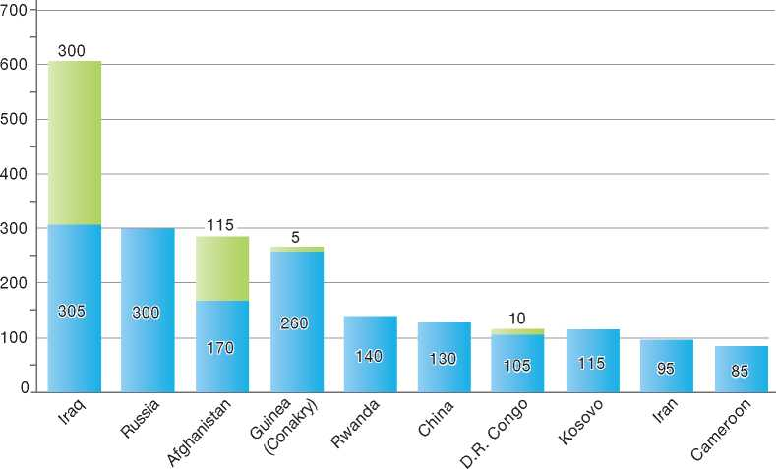

**Total Positive Decisions by Status**

| Geneva Convention Status | | Subsidiary/Complementary Protection and Humanitarian Status

**Figure 6.b: Positive [44] First-Instance Decisions, Top Countries of Origin in 2010 [45]**

**Rate out of Total Decisions 18**

|  |  |  |  |  |
| --- | --- | --- | --- | --- |
|  | | **Total Positive** | **Total Decisions** | **Rate** |
| 1 | Iraq | 725 | 1,185 | 61.2% |
| 2 | Afghanistan | 665 | 1,415 | 47.0% |
| 3 | Guinea (Conakry) | 375 | 1,010 | 37.1% |
| 4 | Russia | 210 | 1,630 | 12.9% |
| 5 | China | 155 | 220 | 70.5% |
| 6 | Kosovo | 140 | 1,820 | 7.7% |
| 7 | Rwanda | 115 | 340 | 33.8% |
| 8 | Serbia | 115 | 955 | 12.0% |
| 9 | Syria | 100 | 280 | 35.7% |
| 10 | D.R. Congo | 90 | 565 | 15.9% |

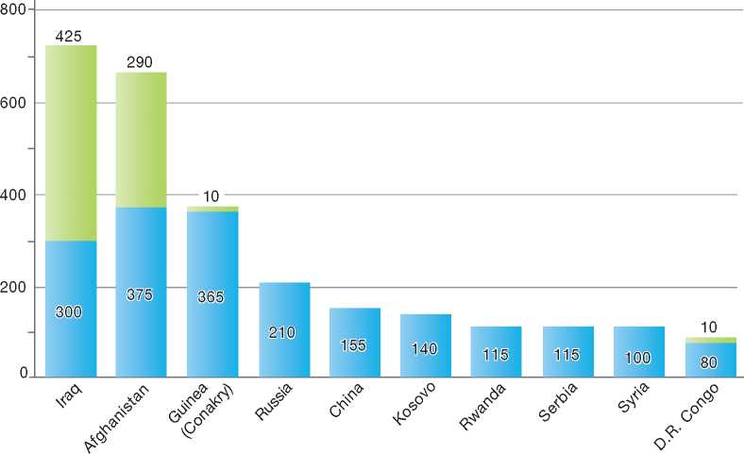Total Positive Decisions by Status

**Total Positive Decisions by Status**

Geneva Convention Status | | Subsidiary/Complementary Protection and Humanitarian Status

**Figure 6.c: Positive [46] First-Instance Decisions, Top Countries of Origin in 2011 [47]**

**Rate out of Total Decisions 18**

|  |  |  |  |  |
| --- | --- | --- | --- | --- |
|  | | **Total Positive** | **Total Decisions** | **Rate** |
| 1 | Iraq | 1,150 | 1,500 | 76.7% |
| 2 | Guinea (Conakry) | 855 | 1,920 | 44.5% |
| 3 | Afghanistan | 820 | 1,530 | 53.6% |
| 4 | Russia | 340 | 2,240 | 15.2% |
| 5 | Kosovo | 240 | 2,760 | 8.7% |
| 6 | China | 190 | 245 | 77.6% |
| 7 | Rwanda | 140 | 440 | 31.8% |
| 8 | Somalia | 130 | 315 | 41.3% |
| 9 | Senegal | 110 | 290 | 37.9% |
| 10 | Serbia | 100 | 1,410 | 7.1% |

Total Positive Decisions by Status

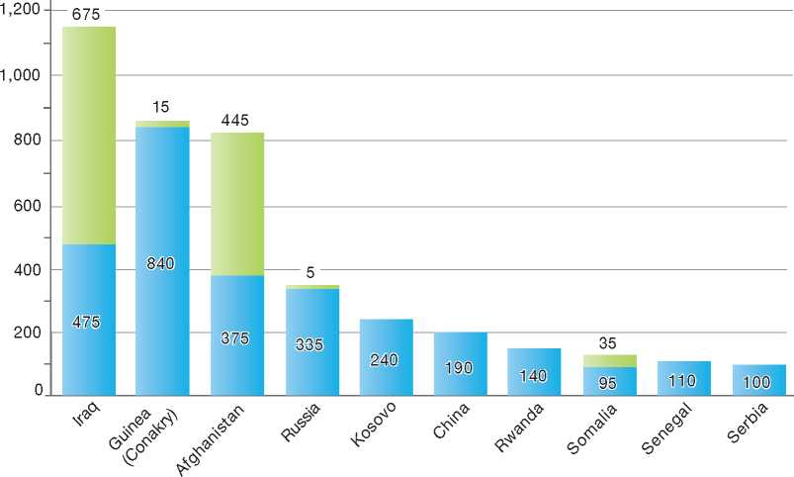

**Total Positive Decisions by Status**

| Geneva Convention Status | | Subsidiary/Complementary Protection and Humanitarian Status

1.

2.

3.

4.

5.

6.

7.

8.

9.

10.

11.

12.

Canada

BackGRound: MajoR asyluM tRends and developMents 93

national leGal FRaMewoRk 96

institutional FRaMewoRk 98

pRe-entRy MeasuRes 99

asyluM pRoceduRes 100

decision-MakinG and statuses 107

eFFiciency and inteGRity MeasuRes 111

assistance and Reception BeneFits FoR asyluM-seekeRs 113

status and peRMits GRanted outside the asyluM pRoceduRe 115

RetuRn 117

inteGRation 118

annexes 119



1. Background: Major Asylum Trends and Developments

Asylum Applications

In the early 1980s, Canada received between 5,000 and 8,000 asylum applications per year. Numbers increased to 35,000 in 1985 and peaked in 1988 with 45,000, but then dropped to 20,000 in 1989. Between 1990 and 2000, the number fluctuated between 37,000 and 21,000. Applications peaked again in 2001, with some 44,000, then decreased until 2005 to some 20,000, but rose to more than 28,000 in 2007 and almost 37,000 in 2008. From January to the end of June 2012, 10,400 claimants were referred. The number of referrals to the Refugee Protection Division (RPD) **in** the calendar year 2011 was 24,981 claimants. These numbers were 22,543 in 2010 and 33,970 in 2009.

in 2010 were Hungary, China, Colombia, Mexico, Sri Lanka, Haiti, Nigeria, Saint Vincent, India and Pakistan. In 2011, the ten top countries were Hungary, China, Colombia, Pakistan, Namibia, Mexico, Nigeria, Saint Vincent, Sri Lanka and India. The top five countries in the first six months of 2012 (Hungary, China, North Korea, Pakistan and Slovak Republic) were the source of 32 per cent of all referrals during the period.

Important Reforms

In the late 1980s, the Canadian refugee status determination system became a quasi-judicial process and remains so today. This change was undertaken, in part, due to a Supreme Court of Canada decision[48] in 1985, which declared the lack of an oral hearing in the refugee status determination process to be in contravention of Canada's Charter of Rights and Freedoms.

Figure 1: Total Asylum Applications by Quarter, January 1992 - June 2012

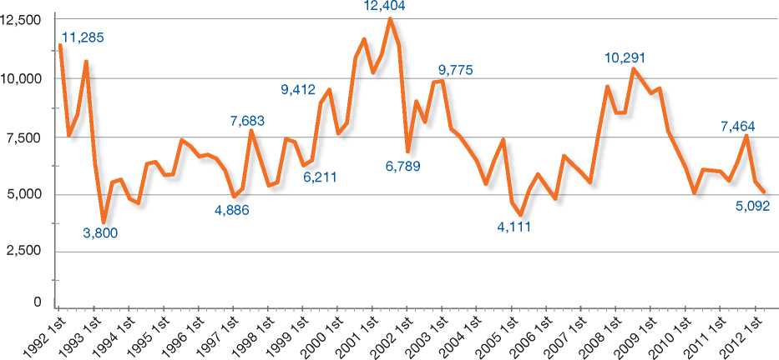

Top Nationalities

In the early 1990s, Sri Lanka, Somalia and Iran were top source countries of asylum claimants. In the late 1990s and until 2001, top source countries included Sri Lanka, China, Pakistan and Hungary. From 2001 to 2007, Pakistan, Colombia and Mexico were the leading countries of origin, although numbers of claimants from Pakistan have decreased significantly in recent years. The top five countries for refugee claimants for 2007 were Mexico, Haiti, Colombia, the United States (mainly U.S.-born children of third-nationality claimants), and China. Top source countries of refugee claims The Immigration and Refugee Board (IRB) was created, and a new refugee status determination system began work in January 1989. The IRB, a quasi-judicial tribunal, was given the responsibility for adjudicating refugee claims. This task was delegated to the Convention Refugee Determination Division (CRDD) at the IRB. The IRB applies the provisions of the Convention relating to the Status of Refugees (1951) and its Protocol Relating to the Status of Refugees (1967), which are reflected in Canadian immigration law. The IRB determination process added the requirement for an oral hearing. The process was then modified by legislation passed in 1992 and 1995, and further modified by the Immigration and Refugee Protection Act (IRPA) in 2002 and the Protecting Canada's Immigration System Act (PCISA) in 2012.

With the proclamation of IRPA in June 2002, the Refugee Protection Division (RPD) replaced the CRDD. The IRB remains an independent and impartial decision-making body with respect to refugee protection claims in Canada. The Act, which remains in effect today, incorporates Canada's obligations under the Convention against Torture and Other Cruel, Inhuman or Degrading Treatment or Punishment (CAT).

IRPA introduced a number of other significant changes to Canada's system of refugee status determination, as follows:

* The expansion of the grounds under which a claimant could be granted Canada's protection, to include consideration of the CAT and Articles 6 and 7 of the International Covenant on Civil and Political Rights (ICCPR)
* Under the former Act, refugee hearings were conducted by a two-member panel. Under IRPA, this was changed to a single member
* IRPA introduced a pre-removal risk assessment (PRRA) that permits refused asylum-seekers and other inadmissible persons to apply for protection before being removed from Canada on the grounds that there is new evidence or evidence that it was not possible or reasonable to provide at the original hearing
* IRPA also modified the provisions governing detention by requiring an earlier detention review. Previous legislation required that a review of the grounds for detention be held every seven days. IRPA modified these provisions to require an initial detention review by the IRB within 48 hours or without delay after 48 hours, at least once during the seven days following, and at least once every 30 days thereafter. IRPA also extended the authority to detain foreign nationals who are already inside Canada if they failed to establish their identity, may pose a danger to the public or are a flight risk.

Along with IRPA, the Canadian Charter of Rights and Freedoms is an important overarching element in Canadian refugee protection. The Supreme Court of Canada ruled in 1985 that the Charter applies to refugee claimants as well as to Canadian nationals, and since that time, there have been a number of important Court decisions affecting both the substance and procedures of law relating to refugee protection.

In November 2001, the Canadian federal government made a commitment that all persons claiming refugee protection would be required to undergo front-end security screening to ensure that persons who could pose a risk to Canada would not be granted protection and could not use the refugee status determination process to gain admittance into Canada.

Finally, in December 2002, Canada and the United States signed the Safe Third Country Agreement (STCA), which came into effect on 29 December 2004.

Recent Developments

In April 2008, Citizenship and Immigration Canada (CIC) published amendments to the Protected Persons Manual (PP1) to include age and gender­sensitive guidelines, which outline the procedures to be followed by officers who conduct eligibility interviews with minors and vulnerable persons. Their purpose is “to support priority processing for refugee protection claims made by vulnerable persons and to ensure special accommodation during the front-end examination process”. They include provisions for officers to consider the particular vulnerability and needs of these persons, and they provide direction on how to identify unaccompanied or separated children and victims of gender-based violence[49].

Bill C-3, An Act to Amend the Immigration and Refugee Protection Act (Security Certificates) received Royal Assent on 14 February 2008. This legislation, introduced as the result of a decision by the Supreme Court of Canada (SCC), changed the provisions governing *ex parte* in camera proceedings that use secret evidence, by introducing an independent agent to represent the interests of the person subject to security certificates during proceedings in which secret information is used. This legislation, prompted by a decision of the SCC, makes the security certificate provisions of IRPA more fully compliant with the Canadian Charter of Rights and Freedoms, and strikes a balance between the right of the individual to know the Government's case against him and the continued maintenance of national security and the safety of Canadians.

The SCC in its ruling found that detention under security certificates does not violate the Charterprovision against cruel and unusual punishment, as IRPA allows for a “robust and meaningful” review of the grounds for detention. Nonetheless, the amendments introduced by Bill C-3 also modified and extended the detention review process. Previous legislation had provided that permanent residents held under a security certificate had to be provided a detention review after 48 hours. Bill C-3 extended to all foreign nationals the right to have a detention review at the IRB within 48 hours and at least once every six months thereafter. Prior to this change, review of the detention of a foreign national held under a security certificate was not required until after the certificate had been reviewed by a Federal Court judge and found reasonable.

Under the Safe Third Country Agreement (STCA) between the United States and Canada, there were four types of exceptions to the STCA: family member; unaccompanied minors; document holder and public interest exception. Previously, under the public interest exception, the STCA did not apply to nationals of countries for which Canada has imposed a temporary suspension of removal (TSR).

On 23 July 2009, paragraph 159.6(c*)* of the Immigration and Refugee Protection Regulations was repealed and the exception to the STCA for TSR countries was removed. Consequently, nationals from countries under a TSR who arrive at a Canada-US land border are ineligible to make a refugee claim in Canada, unless another exception applies. Nationals from these countries already in Canada or arriving at a port of entry that is not a land border with the U.S. will not be affected by this measure and will continue to have access to Canada's asylum system.

This decision follows a review by the Government of Canada of U.S. policies and practices that confirmed the continued designation of the United States as a country with a refugee protection program that meets international standards. In

**Figure 2: Asylum Applications received from Top 5 Countries of Origin in 2009, 2010 and 2011**

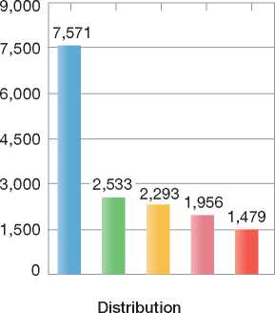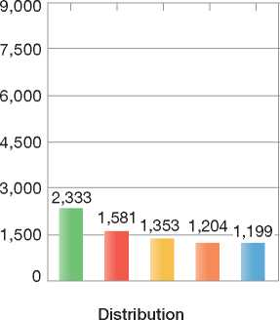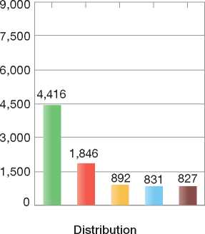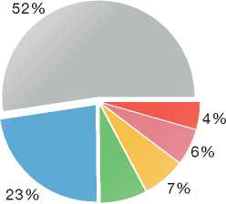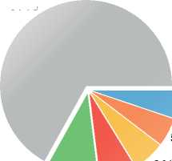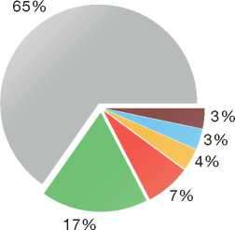

2009

Volumes

2010

Volumes

2011

Volumes

8%

67%

|  |
| --- |
| **Country of Origin:** |
| | China Colombia Czech Rep. Hungary Namibia  Mexico | Pakistan Sri Lanka Others |

addition, the Federal Court of Appeal has upheld the legality of the Safe Third Country Agreement between Canada and the United States, as well as the designation of the United States as a safe third country. The Supreme Court of Canada declined to hear an appeal of that decision.

In October 2011, Canada repealed the Source Country class. The class allowed persons from certain designated countries to apply for resettlement from within their own country. Applicants residing within those countries were also eligible to apply without a referral from the UNHCR or a private sponsor. This provision is known as direct access. With the repeal of the class, direct access for persons residing in designated source countries was removed. All refugees wishing to be resettled now need to be referred by the UNHCR or a private sponsorship organisation.

1. National Legal Framework
   1. Legal Basis for Granting Protection

Refugee Protection

The Immigration and Refugee Protection Act (IRPA) is the primary legal document concerning immigration to Canada and the granting of refugee protection. The 1951 Convention relating to the Status of Refugees, including the definition of a Convention refugee, is incorporated into IRPA.

Complementary Protection

Under IRPA, the definition of torture as found in the Convention against Torture (CAT) has been incorporated into national law. Persons identified as facing a danger of torture, a risk to life or a risk of cruel or unusual treatment or punishment are recognised as “persons in need of protection”. Such persons can apply for permanent residence following a positive IRB decision on their claim and are granted the same rights and status as those found to be Convention refugees.

The case *Suresh v. Canada (Minister of Citizenship and Immigration), [2002]* 1 SCC clarified Canada's obligation under the CAT. The Supreme Court of Canada affirmed that Canada can remove those who pose a risk to Canadian society, even refugees, following an administrative process that balances the seriousness of their conduct against the risk faced upon return. The substantive limit the Court placed upon Government is that removal leading to torture would generally be a breach of fundamental justice.

Under IRPA, persons may obtain permanent residence on the basis of a positive pre-removal risk assessment (PRRA). Those would be at risk if returned to their country of origin are granted protected person status and may obtain permanent residence. A Temporary Resident Permit (TRP) may also be issued under the provisions of the Protected Temporary Resident Class designation to persons who were determined to be refugees outside of Canada and who are in urgent need of protection. These persons may apply for permanent residence from within Canada. Finally, outside of the asylum process, IRPA also provides for the granting of permanent residence on humanitarian and compassionate grounds.

* 1. Recent Reforms

Protecting Canada's Immigration System Act (PCISA)

On 28 June 2012, the Protecting Canada's Immigration System Act (PCISA) received Royal Assent. While most of the provisions of the Bill come into force on 15 December 2012, certain provisions came into effect on 28 June 2012. The legislation introduces changes that build on the reforms to the refugee determination system passed in June 2010 as part of the Balanced Refugee Reform Act (BRRA)*.* The legislation also includes measures to deter human smuggling and provides for the authority to introduce biometric screening for visa applicants. A description of the key measures related to Canada's refugee determination system associated with the legislation follows.

*Processing Times*

Decisions on claims are made by public servants at the Refugee Protection Division (RPD) of the Immigration and Refugee Board of Canada (IRB) as described in the BRRA, but the time lines for conducting hearings are accelerated particularly for those from a Designated Country of Origin (DCO). For instance, upon eligibility, hearings will be held in 30 days for inland claimants from designated countries of origin, 45 days for DCO claimants at ports of entry, and 60 days for claimants from countries not subject to a designation. These timelines are set out in Regulations.

*Designated Country of Origin (DCO) Policy*

Amendments to the DCO policy[50] have been made to provide for more flexibility in designating countries that are not generally refugee-producing for the purposes of expediting the processing of claims made by nationals of those countries. As well, countries will have to be designated as a whole or not at all; for example, there is no authority to designate parts of a country or groups within a country.

Countries can be designated if they meet either quantitative or qualitative criteria, although designation is not automatic. DCO quantitative triggers to designate a country focus on rejection, withdrawal and abandonment rates. Qualitative criteria are also set out that allow for the review of countries for possible designation where there are too few claims to meet the quantitative triggers.

*Composition of the Refugee Protection Division*

On Royal Assent of PCISA, decision-makers at the RPD may have been appointed under the Public Service Employment Act (PSEA). After the coming into force of both the BRRA and the PCISA, all new decision-makers of the RPD will be appointed under the PSEA and new decision-makers will no longer be appointed by the Governor In Council (GIC).

*Refugee Appeal Division*

Under the legislation, the Refugee Appeal Division (RAD) at the IRB was implemented. Appeals are decided by Governor-in-Council appointees at the RAD. The RAD provides most claimants and the Government of Canada with an opportunity to establish that the RPD decision was wrong in fact or law or mixed law and fact. It also allows for the introduction of new evidence by claimants that was not reasonably available at the time of the RPD hearing and, in exceptional cases, allows for an oral hearing.

Timelines for finalisation of decisions at the RAD are set in Regulations. The regulations require that an appeal decision be made in 90 days in cases where no oral hearing is held.

Certain groups of claimants do not have access to the RAD. These include DCO claimants; those determined by the RPD to have a manifestly unfounded claim or a claim with no credible basis; those who were subject to an exception under the Safe Third Country Agreement; those who arrived as part of a designated irregular arrival[51]; and those whose claim was referred to the IRB before the new system came into effect (i.e. those in the backlog). All refused refugee claimants continue to have the option of asking the Federal Court to review a negative decision.

*Post-Claim Recourses*

The BRRA amended access provisions to the pre-removal risk assessment (PRRA) by barring failed refugee claimants from accessing the PRRA process for one year following a final negative refugee determination at the IRB. The bar has been extended to three years for claimants from designated countries of origin. These same bars will also apply to subsequent risk decisions.

As part of the BRRA, there was no access to a pre-removal risk assessment (PRRA) for one year following a final negative decision from the IRB to facilitate timely removals. This change, however, may lead people to other avenues of recourse that remain available. To avoid this situation, limits on other measures that could be used to delay removal have been introduced.

One measure is that following a final negative decision from the IRB, there is no access to humanitarian and compassionate consideration (H&C) for one year. In addition, claimants are no longer able to submit an H&C application while their refugee claim is pending. Claimants have the option of withdrawing their refugee claim in order to apply for H&C, but this has to be done prior to substantive evidence being heard at the hearing before the IRB. To further ensure that delays in removals are minimised, the following measures were also introduced:

* Prevent the RPD and the RAD at the IRB from re-opening previously decided refugee claims and appeals once a final decision has been made at a higher level (e.g. no re-opening of claims by the RPD once the RAD has made a decision)
* Establish the authority to make regulations that would outline the factors that may or must not be considered when a request to defer a removal is received by the Canada Border Services Agency (CBSA), and
* Remove the automatic stay of removal for certain groups of failed refugee claimants upon filing an application for leave for judicial review at the Federal Court. This includes DCO claimants; those determined by the RPD to have a manifestly unfounded claim or a claim with no credible basis; those who were able to make a refugee claim based on an exception to the Safe Third Country Agreement; and those who arrive as part of a designated irregular arrival. This means that these rejected refugee claimants could be removed from Canada pending the Federal Court's review of a negative decision, unless they receive a judicial stay of removal upon application to the Federal Court.

*Assisted Voluntary Return and Reintegration (AVRR) Pilot Program*

This program also helps to remove low-risk rejected refugee claimants more quickly. The AVRR pilot includes claimants from all countries. In addition, the AVRR pilot program would be opened to those in the current system in order to expedite removals and further contribute to overall backlog reduction efforts.

*Serious Criminality*

The measures also further restrict access to the refugee system for those who committed a serious crime. These changes mean that a person who was convicted of a serious crime in or outside Canada is now denied access to the RPD, regardless of the length of their sentence.

*Additional Amendments*

The transfer to the IRB of the PRRA function and outstanding PRRA's is expected to occur two years after the new system comes into force.

A number of measures related to human smuggling have also been introduced. These measures are as follows:

* Establish mandatory detention of irregular arrivals to allow for the determination of identity and illegal activity, with an exemption for minors under the age of 16
* Prevent migrants who are part of a smuggling operation from obtaining permanent resident status for a period of five years. There are travel restrictions and reporting requirements for such persons
* Strengthen the ability to revoke the refugee status of persons who no longer require Canada's protection.

*Resettlement*

With respect to resettlement, changes will be made to the Private Sponsorship of Refugees (PSR) Program in 2013. To manage inventories, CIC has placed a cap on the number of resettlement applications to the PSR program accepted from each Sponsorship Agreement Holder (SAH). CIC will manage the allocation of resettlement application spaces and consult with SAHs through a council composed of government and SAH representatives.

CIC has also proposed regulatory changes to address low approval rates, large application inventories and delays during processing in the PSR Program. The proposed changes will require applicants and their sponsors to submit a complete application for permanent residence and a sponsorship application together to a designated office in Canada. The changes will also limit certain types of sponsors, namely groups of five or more Canadian citizens or permanent residents and community sponsors, to submitting applications for persons recognised by either the United Nations High Commissioner for Refugees (UNHCR) or a foreign state as a refugee.

1. Institutional Framework
   1. Principal Institutions

Citizenship and Immigration Canada (CIC)

The Minister for Citizenship and Immigration Canada (CIC) has overall responsibility for refugee policy and programs, including those related to asylum. CIC also makes specific determinations on which foreign nationals may be referred to the Immigration and Refugee Board (IRB) to apply for refugee protection. Those granted refugee protection may apply for permanent residence status from CIC. Finally, CIC decides on claims for refugee protection made outside of Canada, such as for resettlement purposes.

The Monitoring, Analysis and Country Assessment Division (MACAD) was created in July 2011 within the Refugee Affairs Branch of CIC. MACAD's main business lines are spread across two units and include:

• Monitoring and reporting on asylum trends, refugee claimant behaviours and the overall performance of Canada's refugee protection system

* Preparing assessments and reviews to support a number of policy tools related to asylum and refugee protection, information on the countries of origin of asylum-seekers and countries of mass arrivals, at-risk populations, and displaced populations, and
* Responding to information requests related to Canada's asylum system, including requests for data, analysis, and country of origin profiles.

Immigration and Refugee Board (IRB)

The IRB Research Directorate gathers current, public and reliable information on countries of origin for the purposes of refugee status determination. The research team produces responses to information requests (RIRs) which answer general questions about country conditions. Published RIRs can be viewed on the IRB's internal and external websites. The Research Directorate compiles and publishes National Documentation Packages (NDPs) containing information on each country of origin in the IRB caseload to provide decision-makers, claimants and counsel across the country with a comprehensive overview of country conditions. The NDPs can also be viewed on the IRB's internal and external websites and are available for consultation at IRB regional offices. The Research Directorate also gathers claimant­specific information in response to requests from RPD decision-makers.

The Refugee Protection Division (RPD) of the IRB, an independent, quasi-judicial, and generally non-adversarial tribunal, is responsible for processing inland claims for refugee protection. The RPD considers whether a claimant is either a Convention refugee or a person in need of protection. In considering whether a claimant is a person in need of protection, the RPD assesses whether they face a danger of torture, a risk to life or of cruel and unusual treatment not based on a Convention ground.

The newly established Refugee Appeal Division (RAD) of the IRB is responsible for reviewing first- instance RPD decisions and, in certain cases, evidence that was not before the RPD decision­maker at the time of the RPD decision. The RAD is staffed by decision-makers at the IRB appointed by the Governor in Council. The RAD provides an opportunity for claimants to establish that the RPD decision was wrong in fact or law or mixed law and fact, allow for the claimant to introduce new evidence that was not reasonably available at the time of the RPD decision, or for the Minister to introduce evidence that was not before the RPD decision-maker. In exceptional cases, an oral hearing may be held. After considering the appeal, the RAD will confirm the determination of the RPD, set it aside and substitute a different decision, or in certain circumstances refer the matter back to the RPD for re-determination, giving directions to the RPD that it considers appropriate.

The IRB also gained responsibility for the pre­removal risk assessment (PRRA) function, which will be transferred to the IRB within two years after the provisions establishing the new refugee determination system come into force. CIC will retain the authority to conduct pre-removal risk assessments for people who have been found to be inadmissible for serious criminality, organised crime, war crimes or national security.

The Federal Court of Canada is responsible for the judicial review of negative IRB decisions to assess for errors of law or of fact or to determine if a principle of natural justice has been breached.

Canada Border Services Agency (CBSA)

The Canada Border Services Agency (CBSA) refers refugee claims made at ports of entry to the IRB. In addition, CBSA is responsible for security screening of refugee claimants, detention of foreign nationals in accordance with provisions in IRPA, and the removal of persons who are inadmissible to Canada. CBSA is also responsible for the implementation of the newly established Assisted Voluntary Return and Reintegration (AVRR) pilot program.

* 1. Cooperation between Government Authorities

All three institutions involved in the area of asylum (i.e. IRB, CIC and CBSA) work both individually and in concert with each other. In addition to referring asylum claims to the IRB for adjudication, CIC formulates refugee policy and grants permanent residence to recognised refugees and other protected persons. While the IRB reports to Parliament through the CIC Minister, it retains its independence with respect to the consideration of specific cases. The CBSA is responsible for the return of rejected asylum-seekers and works together with CIC to enforce immigration legislation.

1. Pre-entry Measures

To enter Canada, foreign nationals must be in possession of a valid travel document and a valid visa, if required, and must not otherwise be inadmissible to Canada.

* 1. Visa Requirements

All foreign nationals must apply for a visa before travelling to Canada, unless exempted from that requirement under Canada's Immigration and Refugee Protection Regulations. Exemptions from the visa requirement are based on a traveller's nationality, travel document, a combination of travel document and nationality, and/or purpose of entry to Canada. The competent authority for Canadian visa policy and issuance is CIC.

* 1. Carrier Sanctions

Any carrier transporting people into Canada is obligated under the law to ensure that it does not transport anyone lacking the prescribed documents for legal entrance into the country. If a carrier contravenes this law, inadvertently or otherwise, it is obligated to make arrangements and cover all costs to effect the removal of the person(s) back to the point of embarkation. If a carrier fails to comply with its obligations, it may face fines, seizure of assets, or criminal charges, as warranted.

* 1. Interception

Canadian law prescribes that any carrier seeking to transport people into Canada comply with the Advance Passenger Information (API)/Passenger Name Record (PNR) regime. This information is used to pre-screen a carrier's manifest for any persons inadmissible either because they fail to comply with Canada's immigration regulations or because they pose a security threat.

* 1. CBSA Liaison Officers

Canada has expanded its overseas presence of CBSA personnel through the deployment of Liaison Officers who assist carriers and host government officials in maintaining rigorous screening systems to ensure that carriers comply with Canadian law.

1. Asylum Procedures
   1. Application Possibilities and Requirements, Procedures and Legal Remedies

Claims for asylum can be made at any port of entry (at a border crossing, an airport or a seaport), or inland at a CIC office. In addition, CIC has an administrative process to select refugees overseas for resettlement.

* + 1. Outside the Country

Resettlement/Quota Refugees

CIC is responsible for managing Canada's resettlement program. Both Convention refugees and persons in refugee-like situations, including members of the Humanitarian-Protected Persons Abroad Class (HPC), are eligible for resettlement. Each year, a target is allocated for resettlement through the government-assisted refugees (GAR) privately sponsored refugees (PSR) programs. The PSR program enables organisations and private persons to participate in refugee identification and settlement. Regulations establish the following two classes of persons who are eligible for resettlement:

* Convention Refugees Abroad Class - the United Nations High Commissioner for Refugees (UNHCR), other referral organisations and private sponsorship groups identify Convention refugees outside their country of origin to be resettled in Canada
* Country of Asylum Class - persons outside their country of origin who are not Convention refugees but who are affected by conflict or are victims of serious human rights violations and have been identified for resettlement by a private sponsorship group.

In all cases, processing is completed at Canadian diplomatic missions. A visa officer decides whether the person identified meets eligibility and admissibility requirements for resettlement. Although decisions may be reviewed by the Federal Court of Canada, there is no appeal process on resettlement referral decisions.

Under the Balanced Refugee Reform Act, the number of refugees granted protection through resettlement has increased by 2,500. Between 12,000 and 14,500 refugees will be resettled every year after the initial phase-in period.

* + 1. At Ports of Entry

When foreign nationals seek to enter Canada, they must meet the requirements of the Immigration and Refugee Protection Act. At the port of entry, border services officers (BSO) assess the admissibility of travellers based on the information presented to them by the traveller as well as the information made available to them in the systems to which they have access. If an officer becomes aware that a person is inadmissible, the person could be denied entry to Canada. If the person wishes to make a claim for asylum, an officer will interview the claimant to determine whether the claim is eligible to be referred to the IRB. Specialised refugee processing units have been established at Montreal and Toronto airports and the Fort Erie land border, which are staffed by CBSA officers dedicated to processing asylum claims, thereby decreasing the number of detentions and processing time of applications.

Undocumented asylum-seekers may make claims using the same procedure, without being differentiated from other asylum-seekers, but may be detained for reasons of identity.

Inadmissible Persons

Any person deemed inadmissible may be detained for up to 48 hours on the authority of a CBSA officer, if the officer is not satisfied of the person's identity, or if there are reasonable grounds to believe the inadmissible person is a danger to the public or unlikely to appear for an immigration process. Within the first 48 hours, the CBSA has authority to review the initial decision to detain and may release the person or impose conditions.

Any detention deemed necessary to continue beyond 48 hours will be reviewed within this timeframe by the Immigration Division of the IRB. If it is justifiable to do so, the Immigration Division may extend the detention for seven days, and subsequently up to terms of 30 days upon review if necessary. If the detention is deemed unwarranted, the person will be released and the IRB may impose any conditions it considers necessary.

Once the claim is referred to the RPD, asylum­seekers are provided with a Basis of Claim (BoC) form to complete in order to gather initial information. This form must be submitted directly to the IRB within 15 days following referral of the claim.

Responsibility for Processing the Claim

The Safe Third Country Agreement (STCA)

The Safe Third Country Agreement (STCA) between Canada and the U.S. was signed on 5 December 2002 and came into force on 29 December 2004. The Agreement establishes rules for the sharing of responsibility by the two countries for hearing refugee claims made by persons at ports of entry along the Canada-U.S. land border. The STCA also outlines procedures for processing refugee claims made by persons who, during removal, are in transit by air through Canada or the U.S.

The general principle of the STCA requires that the country in which the refugee claimant arrived first take responsibility for adjudicating a refugee claim, if the claimant does not qualify for an exception under the Agreement.

The STCA is based on the fact that both Canada and the U.S. maintain refugee protection programs that meet international standards and that both have mature legal systems that offer procedural safeguards. The STCA acknowledges the international legal obligations of both governments under the principle of *non-refoulement* outlined in the 1951 Convention and the 1967 Protocol, as well as in the 1984 Convention against Torture[52].

*Application and Procedure*

The STCA applies to asylum-seekers entering Canada from the U.S. at the land border.

There are four categories of exceptions to the application of the STCA, as follows:

* Family member exceptions - persons may be exempted if they have a family member[53] who is a Canadian citizen, a permanent resident, a protected person, a holder of a valid work permit, a holder of a study permit, a recipient of a stay of removal on humanitarian and compassionate grounds, or an asylum-seeker who is appearing before the IRB
* Unaccompanied minors (UAMs) exception - UAMs who are single and have no family member or legal guardian residing in the U.S. or Canada may be eligible to apply for asylum
* Document holder exceptions - persons may apply for asylum if they hold a valid Canadian (non-transit) visa, a work permit, a study permit, or a travel document (for permanent residents) issued by Canada, or if they are not required to have a temporary resident visa to enter Canada but require a U.S.-issued visa to enter the U.S.
* Public interest exceptions - persons may be exempted if they have committed a crime that could subject them to the death penalty in the U.S. or a third country.

The STCA does not apply to Canadian or U.S. citizens or habitual residents of Canada or the U.S. who are stateless.

If the immigration officer examining the asylum claim at the Canada-U.S. land border port of entry determines that the person does not fit any of the above-mentioned exceptions, the person is returned to the U.S. forthwith.

*Freedom of Movement/Detention*

The grounds and procedures for detention of individuals deemed ineligible under the STCA are the same as they are for other inadmissible claimants. However, detention is usually not required since under the Agreement those deemed ineligible do not have recourse to a PRRA and are generally returned to the U.S. the same day.

*Conduct of Transfers*

Transfers of ineligible cases back to the U.S. involve coordination on both sides of the border. The sending party informs the receiving party that a person is en route, and they are provided with an official explanation of the claim and why it was found to be ineligible prior to the release of the person. Escorts are usually not required, and individuals return to the U.S. via their own means. The UNHCR monitors the agreement and has access to various points of entry for first-hand monitoring.

*Suspension of STCA Transfers*

There is no specific mechanism that allows for the suspension of transfer of persons deemed ineligible under the STCA, unless they are reclassified under one of the allowed exceptions outlined above. In a more general sense, either party can suspend the agreement as a whole for a three-month period.

*Review/Appeal*

When a refugee claimant disagrees with a Canadian officer's finding of ineligibility, the formal mechanism to correct errors is to file a request for leave to seek judicial review with the Federal Court of Canada. This mechanism is available for all decisions rendered by the Government of Canada.

*Dispute Resolution Mechanism between Governments*

As mandated under Article 8.2 of the Agreement and articulated in the statement of principles, a dispute resolution mechanism exists for resolving differences between the Canadian and US governments respecting the interpretation and implementation of the terms of the Agreement. This mechanism is not an appeal process for claimants.

* + 1. Inside the Territory

Any person in Canada may make an asylum claim inland at any point, provided it is done prior to the issuance of a removal order. However, even once a removal order is issued, the person may request a PRRA prior to removal. Rejected asylum claimants may request a PRRA prior to removal if it has been more than a year since the last IRB decision. Rejected claimants from designated countries of origin (DCO) may only request a PRRA prior to removal if it has been more than three years since the last IRB decision.

Application and Eligibility

When a person makes the claim at a local CIC office in Canada, the person is interviewed by an immigration officer. During the interview, the asylum-seeker may be assisted by an interpreter. The asylum-seeker is also asked to complete a questionnaire and to have his or her photograph taken. Persons 14 years of age or older are fingerprinted.

If the immigration officer decides that the claim is eligible, the claim is forwarded to the IRB for determination. A person's claim may be found ineligible if he or she:

* Has already been granted asylum in Canada or in another country to which he or she can be returned
* Has previously been refused asylum in Canada or withdrew or abandoned his or her previous claim
* Has previously made a claim that was deemed ineligible for referral to the IRB, or was rejected by the IRB
* Came to Canada from, or through, a designated safe third country where a claim for asylum could have been made, or
* Is inadmissible on grounds of security, violating human or international rights, serious or organised criminality.

If the immigration officer does not make an eligibility determination within three working days, the claim is deemed eligible and automatically sent to the IRB.

The asylum-seeker must then complete a medical examination. The asylum-seeker is also given aremoval order, which is conditional on the result of his or her asylum claim at the IRB. In other words, should the asylum-seeker's refugee claim be refused, the removal order becomes enforceable.

Once the claim is deemed eligible for referral to the IRB, the asylum-seeker is provided with a Basis of Claim (BoC) form to complete in order to gather initial information. For inland claims, the BoC form is submitted to CIC or the CBSA during the eligibility interview, and transmitted to the IRB. The BoC form, including its content, is described in the RPD Rules.

Asylum-seekers may choose to seek a Federal Court judicial review of determinations of eligibility as well as other decisions.

Asylum-Seeker Rights and Obligations

Refugee claimants receive a document of terms and conditions, which outlines their obligations during the refugee status determination process. Failing to abide by these obligations may result in the issuance of a warrant.

The *Singh v. Minister of Employment and Immigration [1985]* 1 S.C.R. 177 Supreme Court of Canada ruling held that refugee status determinations made on the basis of a transcript of an interview were inconsistent with the requirements of fundamental justice. As a result, Canadian legislation was revised so that asylum­seekers were afforded an opportunity to make their case at an oral hearing. All applicants will receive an oral hearing before the IRB.

Normal Procedure

After the BoC form has been submitted to the IRB an initial hearing will be scheduled with a decision­maker at the RPD. Hearing for claimants from non- DCOs will be scheduled within 60 days of referral. Hearings for claimants from DCOs will be heard in shorter timelines.

Refugee claimants are required to provide the IRB with identity and travel documents, including passport, birth certificate, any education certificates, police or medical reports, membership cards for political or other groups, and any documentary evidence on conditions in their country of origin.

Full hearings follow the tribunal process and are non-adversarial. Claimants have the right to be assisted by a legal representative or counsel at their own expense[54]. Hearings are held in private, but the UNHCR can observe. The Minister's representative may participate in the hearing to intervene on behalf of CBSA or CIC. Claims are reviewed by CIC and the CBSA on the Minister's behalf to determine if an intervention is warranted at the IRB based on criminality/security or program integrity/credibility concerns.

Dependants who are included in their parents' or guardians' asylum claim must appear at the hearing, although they may be required to be present only at the start of the hearing to establish identity. The first-level hearing is conducted by civil servant decision-makers, who assess each claim individually on its merits, and the hearing would be scheduled within 60 days for claimants who are not from a designated country of origin.

Review/Appeal of IRB Decisions

A claimant (except those who do not have a right of appeal) whose case is rejected by the RPD has a right to appeal on the merits of their case before the Refugee Appeal Division (RAD) of the IRB. This is the designated institution for all decisions on the appeals process. The RAD is staffed by Governor in Council-appointed decision-makers. Appeals by the claimant or Minister may be based on questions of fact, questions of law or mixed fact and law. Claimants will also have the opportunity to introduce new evidence not previously available at this stage of the process. The Minister will also be able to introduce new evidence. The procedure is paper-based, although oral hearings may take place in exceptional circumstances. If there is no oral hearing, decisions are made within 90 days.

The following rejected claimants, however, do not have access to the RAD:

* Those from DCOs
* Those determined to have a manifestly unfounded claim or a claim with no credible basis
* Those subject to an exception in the Safe Third Country Agreement
* Those who arrived as part of a designated irregular arrival
* Anyone who made a claim under the previous system
* Those wishing to appeal decisions to end a person's protected status.

All failed claimants would still have the option of asking the Federal Court to review negative decisions. The IRB cannot reopen previously decided claims or appeals once a final decision has been made at a higher instance.

Refugee claimants and the Minister of CIC or the Minister of Public Safety may apply to the Federal Court for a judicial review of an IRB decision. This application must be filed within 15 days of the IRB decision for refugee matters*.* First, the refugee claimant or the Minister's representative must obtain the Court's permission, or leave, for a judicial review. The role of the Federal Court is to review IRB decisions for errors of law, or of fact, or if a principle of natural justice was breached. If the judicial review is allowed, the Federal court usually returns the case back to the IRB for a new hearing. New evidence may be presented at the new IRB hearing in accordance with the relevant legislation. All claimants may apply for leave for judicial review.

A request for leave for judicial review has the effect of suspending the person's removal from Canada, with the exception of certain groups of rejected refugee claimants. These include:

* Claimants from DCOs
* Those determined by the RPD to have a manifestly unfounded claim or a claim with no credible basis
* Those who were able to make a refugee claim based on an exception to the Safe Third Country Agreement, and
* Those who arrive as part of a designated irregular arrival.

This means that these persons could be removed from Canada while the Federal Court reviews a negative decision, unless they receive a judicial stay of removal upon application to the Federal Court.

There are possibilities for further appeals before the Federal Court of Appeal and the Supreme Court of Canada. However, the Federal Court must certify a question of general importance on judicial review in order to access these avenues of appeal.

Failed refugee claimants who have a removal order in effect may apply to CIC for a pre-removal risk assessment (PRRA) if it has been one year since the last IRB decision, or three years for claims from DCOs*.*

Freedom of Movement during the Asylum Procedure

Detention

*Procedure*

The CBSA has the legislative authority to arrest and detain foreign nationals, including asylum­seekers believed to be inadmissible to Canada. For all detentions, an officer must have reasonable grounds to believe the person is inadmissible to Canada and is a danger to the public or is unlikely to appear for an immigration proceeding. A person may also be detained if an officer is not satisfied of the identity of the person in the course of any procedure under IRPA.

The CBSA has jurisdiction over the detention for the first 48 hours after an arrest. If a CBSA officer does not release the person during this time, the case is referred to the Immigration Division of the IRB. Once the case is before the IRB, the IRB Member reviews the reasons for detention according to the following schedule: within 48 hours of the arrest or without delay afterwards; once in the following seven days; and once every 30 days for as long as the person remains detained. The IRB has the authority to order continued detention or to release the person with or without conditions.

The Protecting Canada's Immigration System Act (PCISA) provided the authority to mandatorily detain persons who participated in an irregular arrival to allow for the investigation into identity, admissibility and illegal activity. Under this approach, claimants would see a first detention review within 14 days and subsequent reviews after every 180 days. A person would be released earlier if he or she receives a positive decision on their refugee claim by the IRB. The Minister of Public Safety may, under exceptional circumstances, order the release of a detained person when grounds for detention no longer exist. Designated foreign nationals under the age of 16 are excluded from mandatory detention.

*Detention Facilities*

The CBSA operates three immigration holding centres (IHCs) located in Toronto, Ontario; Vancouver, British Columbia; and Laval, Quebec; all of which are for lower-risk detainees. CBSA relies on provincial correctional facilities to detain higher-risk detainees (such as criminals or persons suffering serious medical or psychological problems) and lower-risk detainees in areas not served by a CBSA IHC. A person detained in a provincial facility for immigration reasons is required to follow the rules of the institution.

*Safeguards*

While there is no limit imposed on the length of detention, detention is used only as a last resort. Alternatives to detention, such as release on conditions or financial guarantees, are always considered before detaining someone.

Where safety or security is not an issue, the detention of minors is avoided, regardless of whether a child is unaccompanied or accompanied by a parent or legal guardian and alternatives to detention are considered. For unaccompanied minor asylum-seekers, the preferred option is to release them, with conditions, into the care of child welfare agencies, if those organisations are able to provide an adequate guarantee that the child will report to the immigration authorities as requested. In 2010-2011, the average length of detention of minors was 6.1 days. The responsibility for child protection rests with the provincial youth protection agencies.

Where safety or security is not an issue, detention is avoided or considered a last resort for elderly persons, pregnant women, persons who are ill, persons who are handicapped, and persons with behavioural or mental health problems. For persons falling under these categories, Canada will always consider alternatives to detention.

Persons detained under IRPA have a right to apply for leave to the Federal Court of Canada for judicial review of the decision to detain.

Reporting

RPD Rule 4(3) states that if the claimant's contact information changes, the claimant must without delay, and no later than 10 days before the date fixed for the hearing, provide the changes in writing to the Division and to the Minister.

Should asylum-seekers not report address changes, they may not receive notice to appear for their hearing at the IRB, which may result in non­attendance and abandonment of their claim.

Repeat/Subsequent Applications

An asylum-seeker in Canada may make only one claim for asylum. A re-application for asylum is ineligible for referral to the IRB if an asylum claim by the person had previously been rejected by the IRB, had been deemed ineligible for referral to the IRB, or had been withdrawn or abandoned.

However, IRPA allows rejected asylum-seekers awaiting removal to apply for a PRRA. Rejected asylum-seekers from non-DCO countries are restricted from applying for a PRRA for a period of one year following the last IRB decision. For DCO claims, access to the PRRA will be restricted for three years following the last IRB decision. For most PRRA applicants, a positive determination results in the granting of protected person status.

Under the PCISA, the IRB is not able to re-open previously decided refugee claims and appeals once a final decision has been made at a higher level (e.g. no re-opening of claims by the RPD once the RAD has made a decision).

* 1. Safe Country Concepts
     1. Safe Country of Origin

The Balanced Refugee Reform Act introduced a Designated Country of Origin (DCO) policy. Accordingly, the Minister of CIC may designate countries when certain quantitative triggers relating to acceptance rates and volume of applicants are met. These countries may be those that do not normally produce refugees, have a robust human rights record and offer strong state protection.

Applicants from designated safe countries are still able to make a claim and are entitled to an expedited hearing at the RPD, but would not have access to the RAD at the IRB. DCO claims are heard by public servant decision-makers at the IRB within 30 days for claims made at inland immigration offices, and within 45 days for claims made at ports of entry. Rejected claimants continue to have the option of asking the Federal Court to review a negative decision. However, there is no automatic stay of removal for DCO claimants should they decide to ask the Federal Court to review a negative decision.

DCO Designation Criteria

It is a two-step process for a country to be considered for designation. Designation is not automatic. First, a country must meet one of two quantitative thresholds or limits set out in a ministerial order. The triggers for a review are based on rejection, withdrawal and abandonment rates. A rejection rate (which includes abandoned and withdrawn claims) of 75 per cent or higher would trigger a review. Similarly, an abandonment and withdrawal rate of 60 per cent or higher would trigger a review. For claimants from countries with a low number of claims, a qualitative checklist is applied and includes:

* The existence of an independent judicial system
* Recognition of basic democratic rights and freedoms, including mechanisms for redress if those rights or freedoms are infringed, and
* The existence of civil society organisations.

Once a country is triggered for a review, CIC conducts a review in consultation with other government departments. The Minister of Citizenship, Immigration and Multiculturalism makes the final decision on whether to designate a country.

*Restricted Work Permits*

In addition to accelerated processing, DCO claimants are ineligible to apply for a work permit and associated benefits until their claim is approved by the IRB or their claim has been in the system for more than 180 days and no decision has been made.

* + 1. First Country of Asylum

There is no legal requirement for an asylum­seeker to have applied for asylum in the first or earlier country of asylum. However, failure to do so may have a negative impact on the assessment of the person's subjective fear or credibility. That said, there exist authorities to designate safe third countries in IRPA.

* + 1. Safe Third Country

According to IRPA, a country can be designated a safe third country by considering the following criteria:

* Whether the country is party to the 1951 Convention and the CAT
* The policies and practices of the country with respect to the 1951 Convention and the CAT
* The human rights record of that country, and
* Whether the country is party to an agreement with Canada on sharing responsibility for asylum claims.

To date, the United States is the only country that has been designated a safe third country by Canada[55].

* 1. Special Procedures
     1. Unaccompanied Minor Asylum-Seekers

Eligibility Stage

As may adults, children may make a refugee claim in Canada. Claims for refugee protection may be made inland or at a Canadian port of entry. CBSA and CIC officers assess admissibility and determine whether a claim is eligible to be referred to the Refugee Protection Division (RPD) of the IRB.

Age- and Gender-Sensitive Guidelines

Measures are in place to ensure that the best interests of children are taken into consideration throughout the refugee claims process. For example, on 4 April 2008, amendments to the Protected Persons Manual (PP1) that include age- and gender-sensitive guidelines were published. These outline the procedures to be followed by officers who conduct eligibility interviews with minors and vulnerable persons. The guidelines include instructions for officers to consider the particular vulnerability and needs of children, and provide direction on how to identify unaccompanied or separated children and children at risk.

The guidelines instruct officers that if a child is unaccompanied or separated, or if, during the interview, it becomes apparent that he or she is otherwise at risk, the child is to be referred to the appropriate provincial or territorial child protection agency. Jurisdictional responsibility for child welfare protection matters rests with the provinces and territories, and local child protection agencies determine the level of care and treatment that children who come within their jurisdiction require. This jurisdictional responsibility includes the appointment of a guardian when that is deemed appropriate.

At the IRB

The IRB appoints a designated representative where the person who is the subject of the proceedings is a child under the age of 18 (a minor), or an adult who is unable to appreciate the nature of the proceedings.

The designated representative is responsible for protecting the interests of the minor or the person who is unable to appreciate the nature of the proceedings, as well as explaining the process to them.

In the case of a minor, the designated representative is usually the child's parent, although another family member, a legal guardian, a friend, or a worker from

an agency that provides such services can also act as a designated representative. In the case of a person who is unable to appreciate the nature of the proceedings, the designated representative can also be a family member, a friend or a worker from an agency that provides such services.

Designated representatives must be 18 years of age or older; understand the nature of the proceedings before the IRB; be willing and able to act in the best interests of the minor or the person who is unable to appreciate the nature of the proceedings; and not have interests that conflict with those of the person they represent.

The role of a designated representative for a minor or a person unable to appreciate the nature of the proceedings include:

* Deciding whether to retain counsel and, if counsel is retained, instructing counsel or assisting the represented person in instructing counsel
* Making other decisions regarding their case or assisting them to make those decisions
* Informing them about the various stages and procedures in the processing of their case
* Assisting in gathering evidence to support their case and providing evidence and being a witness at their hearing if necessary
* Protecting their interests and putting forward the best possible case to the Division, and
* Informing and consulting them to the extent possible when making decisions about their case.

A designated representative is not the same as counsel and the Division must designate a representative even when the minor or the person who is unable to appreciate the nature of the proceedings has legal or other counsel.

**Figure 3: Asylum Applications by**

**Unaccompanied Minors**

No data available.

Best Interests of the Child

When determining the procedure to be followed while considering the claim of an unaccompanied minor, the best interests of the child are given primary consideration. This principle is articulated in the IRB Chairperson's Guideline on Child Refugee Claimants: Procedural and Evidentiary Issues[56], and in the Protected Persons Manual.

* + 1. Stateless Persons

Although Canada has not ratified the 1954 Convention relating to the Status of Stateless Persons, it is a signatory to the 1961 Convention on the Reduction of Statelessness. All asylum­seekers, regardless of whether they are stateless, have the same rights, and their cases will be treated individually on their merits.

1. Decision-Making and Status

The IRB considers both Convention refugee and “persons in need of protection” grounds at the time of determination.

* 1. Inclusion Criteria
     1. Convention Refugee

The RPD grants Convention refugee status to persons who have a well-founded fear of persecution in the meaning of Article 1A (2) of the 1951 Convention.

* + 1. Persons in Need of Protection

Section 97 of IRPA affords complementary protection to persons who, if removed, on a balance of probabilities would be personally subject to:

* A danger of torture, believed on substantial grounds
* A risk to their life, or
* A risk of cruel and unusual treatment or punishment.

Such persons are referred to as “persons in need of protection”.

* 1. The Decision

Under IRPA, members of the RPD assess whether claimants are Convention refugees or persons in need of protection. Decisions are made based on the evidence provided and the law, following a full hearing. Decisions and the reasons for the decisions, whether positive or negative, can be given orally at the end of the hearing or provided in writing. Written reasons must be provided in the case of negative decisions and in certain other circumstances, such as when the claimant or the Minister's counsel requests written reasons. If the decision is given orally, a transcript of the reasons

is provided as written reasons.

Claimants with a right of appeal may appeal a negative RPD decision on their claim to the RAD. Appeals by the claimant or Minister may be based on questions of fact, questions of law or mixed law and fact. Claimants and the Minister also have the opportunity to introduce new evidence to the RAD that was not before the RPD, but only if that evidence was not reasonably available at the time of the RPD decision, unless it is in response to evidence presented by the Minister. The Minister is not subject to these same restrictions on new evidence. The procedure is generally paper­based, although oral hearings may take place in exceptional circumstances. Decisions are made within 90 days if no oral hearing is ordered. The RAD may decide to uphold the RPD decision or to overturn it. If the RAD decides to overturn the RPD decision, it may substitute its own decision for that of the RPD or it may, in limited circumstances, refer the case back with directions to the RPD for a new hearing. In substituting its own decision, the RAD may grant protection to Convention refugees and/or persons in need of protection or reject claims for protection.

* 1. Types of Decisions, Status and Benefits Granted

The RPD of the IRB can either grant protection to Convention refugees or persons in need of protection or reject claims for protection.

The IRB Chairperson may order an appeal be decided by a three-member panel. Decisions by a three-member panel of the RAD are binding on RPD panels and single member panels of the RAD. Processes and procedures for the RPD and RAD are further articulated in their respective rules of practice and procedure and other policy instruments such as guidelines and practice notices.

A removal order becomes effective when the RPD issues a negative decision for a claimant who does not have a right of appeal to the RAD or the claimant fails to file an appeal to the RAD within specified timeframes. If the claimant files an appeal to the RAD, the removal order becomes effective 15 days after the RAD notifies the claimant of a negative decision. A failed refugee claimant must leave Canada within 30 days of the removal order becoming effective unless they seek leave for judicial review of the decision from the Federal Court.

“Protected Person” Status and Benefits

Convention refugees and persons in need of protection both obtain the status of “protected persons”. Thus, both groups are protected against *refoulement* and are entitled to the same set of benefits. Protected persons may apply for permanent residence status from CIC following the IRB decision and then for citizenship after three years of residence in Canada.

As permanent residents, protected persons have access to the following benefits:

* Most of the social benefits that Canadian citizens receive, including health care coverage
* The right to live, work and study anywhere in Canada
* Protection under Canadian law and the Canadian Charter of Rights and Freedoms.

Protected persons may include in their application for permanent residence family members who are located in Canada or overseas. If, for any reason, a family member is inadmissible to Canada, the protected person and any admissible family members will not be affected. They will be granted permanent residence, provided they meet all other statutory requirements.

Claimants who are part of a designated irregular arrival are prevented from applying for permanent resident status for a period of five years, should they successfully obtain refugee status. They are also prevented from sponsoring family members for five years.

* 1. Exclusion

The RPD and the RAD of the IRB apply Articles 1F and 1E of the 1951 Convention in the assessment of protection claims. If the RPD believes, before a hearing, that there is a possibility that sections of the exclusion clauses apply to the claim, the RPD must notify the Minister in writing and provide any relevant information. The Minister has the right to intervene in such cases, and may do so either by attending the hearing or by so indicating in writing.

Once a claim has been referred to the RPD, and before a decision has been made, CIC and the CBSA have the authority to review claims to determine if there are reasonable grounds for opposing a refugee claim on the basis of criminality/security or program integrity/credibility concerns, and may attend the hearing and present evidence as to why the claim should not be

accepted on behalf of the Minister of Public Safety or the Minister of CIC. Ministerial interventions in the refugee status determination process aim to ensure that persons who are major criminals or who may compromise national security do not enjoy the benefit of Canada's protection. They also aim to protect the integrity of the refugee status determination system.

* + 1. Refugee Protection

Persons excluded from refugee status (and thus deemed inadmissible[57] [58]) under the IRPA guidelines outlined above have recourse through the PRRA process, provided they file their request within 15 days of the issuance of the inadmissible ruling.

In the event that the individual's circumstances fail to meet the threshold for either a positive PRRA ruling (which may grant the right to apply for permanent residence) or a stay of the removal order, there is still recourse to staying the removal under the principle of *non-refoulement*.

The Supreme Court of Canada ruled as follows in *Suresh*11 that:

*“the Minister's discretion to deport under s. 53 is confined to persons who pose a threat to the security of Canada and have been engaged in violence or activities directed at violence. Expression taking the form of violence or terror, or directed towards violence or terror, is unlikely to find shelter under the Charter. Provided that the Minister exercises his/her discretion in accordance with the Act, the guarantees of free expression and free association are not violated”.*

In other words, Canada can remove those who pose a risk to Canadian society, even refugees, following an administrative process that balances the seriousness of their conduct against the risk faced upon return.

The substantive limit the Court placed upon Government is that removal to torture would generally be a breach of fundamental justice. However, Canada has never invoked this exception to remove anyone when a Canadian tribunal has found a substantial risk of torture.

* + 1. Persons in Need of Protection

Persons excluded from protected person status under the IRPA guidelines outlined above have recourse to appeal through the PRRA process, provided they file their request within 15 days of the issuance of the inadmissibility ruling. Rejected claimants may request a PRRA prior to removal if it has been more than a year since the last IRB decision. Rejected claimants from designated countries of origin (DCO) may only request a PRRA prior to removal if it has been more than three years since the last IRB decision.

* 1. Cessation

The cessation clauses of the 1951 Convention are reflected in section 108 of IRPA and are applied by the IRB. The grounds for cessation include:

* The person has voluntarily re-availed himself or herself of the protection of the country of nationality
* The person has voluntarily reacquired his or her nationality
* The person has acquired a new nationality and enjoys the protection of that new country of nationality
* The person has voluntarily become re­established in the country in respect of which the person claimed refugee protection
* The reasons for which the person sought refugee protection cease to exist.

These clauses may be applied directly by the Refugee Protection Division of the IRB. The Minister may make an application to cease refugee protection, after the person has been granted refugee status. Such applications are made relatively infrequently. However, the PCISA provides for more active cessation measures in the case of claimants who arrive as part of a designated irregular arrival. All claimants who entered Canada as a part of designated irregular arrivals will be prevented from applying for permanent residence for a period of five years, if they receive refugee status, and will be subject to a review of their protection needs within that timeframe to determine if cessation should be pursued.

In addition, the PCISA included changes to the cessation provisions of the IRPA. Under the new system, an application to cease refugee protection will suspend the processing of a permanent resident application. Additionally, cessation

decisions of the RPD of the IRB will not be eligible for appeal to the RAD.

The cessation clauses are used only in exceptional cases. Persons who have been the subject of a cessation of their refugee status may ask the Federal Court for leave for judicial review of the IRB's decision.

* 1. Revocation

IRPA also has provisions that allow for the vacation of refugee status. An application to vacate refugee protection may be brought by the Minister, if the decision was obtained as a result of directly or indirectly misrepresenting or withholding material facts relating to a relevant matter. However, the RPD may reject the application if it is satisfied that other evidence considered at the time of the first determination would have justified conferring refugee protection.

If the Minister's application is allowed, the claim is deemed to be rejected and the decision granting refugee protection is nullified and the claim is deemed rejected.

Under the PCISA, vacation decisions of the RPD of the IRB will not be eligible for appeal to the RAD. A person whose status is vacated may seek leave at the Federal Court for judicial review of the RPD's decision.

* 1. Support and Tools for

Decision-Makers

* + 1. Country of Origin Information

The IRB Research Directorate gathers current, public and reliable information on countries of origin for the purposes of refugee status determination. The research team responds to information request (RIRs) made by RPD decision-makers. Published RIRs can be viewed on the IRB's internal and external websites. The Research Directorate compiles and publishes National Documentation Packages (NDPs) containing information on each country of origin in the IRB caseload to provide decision-makers, claimants and counsel across the country with a comprehensive overview of country conditions. The NDPs can also be viewed on the IRB's internal and external websites and are available for consultation at IRB regional offices. The Research Directorate also gathers claimant­specific information for RPD decision-makers.

The Monitoring, Analysis and Country Assessment Division (MACAD) at CIC is responsible for reporting and analysis of asylum and refugee statistics; developing and implementing frameworks for comprehensive assessments of countries of origin, countries of mass arrivals, and populations at risk; as well as qualitative and quantitative forecasting to support asylum and resettlement policy development. This Division analyses country conditions related to democracy, human rights, at- risk populations, and state protection to support policy decision-making - for example, in relation to designated countries of origin and pre-removal risk assessment. MACAD is also responsible for monitoring, analysing and reporting on the implementation performance of the in-Canada asylum system, as well as its impact on refugee claimant behaviour, in collaboration with key partners, such as CBSA.

* + 1. Chairperson's Guidelines

The Chairperson's Guidelines provide guiding principles for adjudicating and managing cases. They serve primarily as a source of guidance for decision-makers, but also for the personnel supporting adjudicative functions. They may have an adjudicative or an operational content. While they are not mandatory, decision-makers are expected to apply them or provide a reasoned justification for not doing so. Within the IRB, Guidelines have generally been employed to achieve strategic objectives, as opposed to simply managing daily operations. The Immigration and Refugee Protection Act, in section 159(1)(h), provides statutory authority for the Guidelines. For example, guidelines have been issued for vulnerable persons and on women asylum-seekers.

* + 1. Jurisprudential Guides

Jurisprudential Guides are policy instruments that support consistency in adjudicating cases which share essential similarities. A Jurisprudential Guide serves to build a Division's jurisprudence upon well-reasoned decisions.

Drawing on the common law tradition of precedent and the tribunal tradition of policy-making through adjudication, Jurisprudential Guides articulate policy through the application of the law set out in a decision of the Board to the specific facts of another individual case before a decision-maker. This is to be contrasted with Guidelines, which are general statements, not incorporated in any decision of the Board.

The application of a Jurisprudential Guide is not mandatory. However, decision-makers are expected to apply Jurisprudential Guides in cases

**Performance Measurement**

A comprehensive performance measurement strategy for the new refugee system has been completed and will guide the formal three-year evaluation following the implementation of the new system. Performance results will inform policy for possible remedial corrections, guide evidence-based policy development and ensure public accountability. This initiative details quantitative performance measurement of key activities throughout the asylum process in order to support strategic management of a system that is intended, under the new legislation, to be more streamlined and fair.

Unlike jurisprudential guides, decision-makers are not required to explain their decision not to apply a persuasive decision.

with similar facts or provide reasoned justifications for not doing so.

* + 1. Policies

Policies are formal statements that explain the purpose and the mechanics of operational initiatives at the Board. A policy sets out specific responsibilities for action by decision-makers and personnel supporting the adjudicative process. Policies are flexible instruments, and the degree to which they are mandatory varies with the content of the policy. They often contain elements that are mandatory, but may also provide general guidance or define areas in which the exercise of discretion is required.

* + 1. Chairperson's Instructions

Instructions provide formal direction that obliges specific IRB personnel to take or to avoid specific actions. In contrast to Policies, Instructions are limited to a specific and narrow practice area and may also include organisational concerns (e.g. relations between decision-makers and Refugee Protection Officers) that define roles and responsibilities consistent with the principle of adjudicative independence and impartiality.

* + 1. Persuasive Decisions

Persuasive decisions are decisions that have been identified by a division head (the Deputy Chairperson of the Refugee Protection Division or the Immigration Appeal Division, or the Director General of the Immigration Division) as being of persuasive value in developing the jurisprudence of a particular division. These decisions are well written, provide clear, complete and concise reasons with respect to the particular element that is considered to have persuasive value, and consider all of the relevant issues in a case. Accordingly, members are encouraged to rely upon persuasive decisions in the interests of consistency and effective decision-making. This consistency also helps parties and counsel prepare for proceedings before the IRB, and may encourage early resolution without a hearing, where appropriate.

The use of persuasive decisions enables the IRB to move toward a consistent application of the law in a transparent manner. Their designation promotes efficiency in the hearing and reasons- writing process by making use of quality work done by colleagues.

The Chairperson has the authority to have an appeal decided by a three-member panel. The three-member panel would produce a decision that is binding on panels of the RPD and single­member panels of the RAD. In appeals conducted before a panel of three members, IRPA provides for the ability of RAD to accept written submissions from the UNHCR and any other person described in the Rules of the Board.

1. Efficiency and Integrity Measures
   1. Technological Tools
      1. Fingerprinting

All asylum-seekers 14 years of age or older are fingerprinted at the time of application.

* + 1. DNA Tests

DNA testing is not an element of Canada's asylum procedures. Successful claimants (protected persons) may apply for permanent residence. They may include in their application family members, including dependent children, or sponsor family members later, as may any other permanent resident of Canada. If the applicant or sponsor is unable to establish the relationship with a child, and the immigration officer would otherwise refuse the application with respect to the child, the applicants may be offered DNA testing, at their own expense, as a means of preventing refusal of the family member's application for a visa.

**Processing Timelines**

Internal processing procedures have been updated. This involved revising how hearings are scheduled and rescheduled, as well as registry procedures. A Business Process Improvement exercise helped to identify file movement and assist in developing more efficient procedures.

* + 1. Forensic Testing of Documents

Forensic testing may be done at the option of the RPD decision-maker. From time to time, the IRB requests that CIC or the Royal Canadian Mounted Police (RCMP) conduct forensic testing of documents, usually passports. However, for practical considerations, decision-makers are encouraged to reserve such testing for evidence that is crucial to determining the case.

* + 1. Database of Asylum Applications/Applicants

CIC maintains a database of all clients, including refugee claimants. In the case of refugee claimants, all who are 14 years of age or older are fingerprinted. This practice, in use since 1993, enables authorities to identify repeat claimants, and those who have been convicted of criminal offences in Canada.

* + 1. Video Conferencing of Asylum Hearings

As the IRB must deal with cases in a timely manner, and at the Division's discretion, a hearing may be conducted by video conference with the asylum-seeker.

* 1. Length of Procedures

There is no time limit placed on making refugee claims. However, once a claim is made, at a port of entry (POE), a Basis of Claim (BoC) form must be submitted directly to the IRB within 15 days following referral of the claim. For inland claims, the BoC form must be submitted to CIC or the CBSA during the eligibility interview, and transmitted to the IRB.

DCO claims are heard at the IRB within 30 days for claims made at inland immigration offices and within 45 days for claims made at ports of entry. Claimants from non-DCO countries have their claims processed at the RPD within 60 days. The RAD makes decisions on appeals within 90 days in cases where no oral hearing is held.

* 1. Pending Cases

As at 30 September 2012, there were approximately 33,700 pending claims before the Refugee Protection Division (RPD) - a significant decrease from a high of 62,000 claims in October 2009.

Ongoing Backlog-Clearance Efforts

Governor in Council-appointed decision-makers whose mandates extend past the coming into force of the new refugee status determination provisions are authorised under PCISA to continue hearing legacy cases, and therefore they may assist in further reducing the inventory; however, reduction in legacy cases by the IRB after the coming into force of the new system is uncertain at this stage. This will depend mainly on the volume of cases it receives, compared to what it is currently funded to process.

* 1. Information Sharing

Canada exchanges information on refugee claimants with other refugee-receiving countries, on a bilateral basis, in accordance with legal and privacy considerations of both States. The Canada-U.S. Statement of Mutual Understanding on Information Sharing (SMU) allows for the sharing of information on a case-by-case basis. The Asylum Annex to the SMU allows for the systematic or case-by-case sharing of information on asylum-seekers who attempt to access the asylum system in Canada or the U.S.

Until the Asylum Annex is fully and systematically implemented, requests for information are made on a case-by-case basis. Requests from the U.S. are made directly to CIC or CBSA, which in turn request information on individual asylum-seekers from the IRB.

In April 2007, Canada, the United States, the United Kingdom and Australia signed the Hunter Valley Declaration. Under this agreement, CIC and CBSA agreed to work towards the systematic exchange of biometric data with the four cited countries. The High Value Data Sharing Protocol that has subsequently been implemented allows biometric data to be cross-checked between the four above­mentioned countries as well as with New Zealand. This information may be used by the Minister for CIC to intervene in refugee proceedings, or used by IRB decision-makers to assist them in confirming identity and credibility of applicants.

* 1. Single Procedure

Prior to the coming into force of IRPA, refugee status was determined solely on the grounds outlined in the 1951 Convention. Since the coming into force of IRPA in June 2002, protection is allowed on the grounds of the 1951 Convention (section 96 of IRPA) and the Convention against Torture (section 97 of IRPA). Asylum-seekers need to make only one application for protection in order to obtain Convention protection or be determined to be a person in need of protection. The combination of Convention refugee and additional grounds for protection has been referred to as the “consolidated grounds”. Both sets of protection afford the same benefits to those determined to be in need of protection.

Monitoring & Analysis Unit

The Monitoring & Analysis Unit within CIC conducts on-going monitoring to ensure the integrity of the new asylum system is maintained. This is measured through ten “Metrics of Success” and additional indicators. Success is measured against the objectives of refugee reform, which include a more streamlined process with limited system abuse. Findings will be discussed quarterly.

1. Assistance and Reception Benefits for Asylum-Seekers
   1. Procedural Support and Safeguards
      1. Legal Assistance

Refugee claimants appearing before the IRB can represent themselves at a hearing or have the assistance of counsel throughout the process at their own expense. Also, persons such as family members, friends or volunteers who receive no remuneration for doing so may act as counsel to the claimant.

Bill C-35, an Act to Amend the Immigration and Refugee Protection Act, came into force on 30 June 2011, making it an offence for anyone other than an authorised representative to advise or represent a person, for a fee or other consideration, in connection with an application or proceeding under IRPA. A ministerial regulation was also brought into force on the same day, designating the Immigration Consultants of Canada Regulatory Council (ICCRC) as the new regulator of immigration consultants.

This statutory change also enabled the Government to make regulations relating to the disclosure of information concerning the professional or ethical conduct of representatives to their respective governing bodies, and to create an oversight mechanism of the governing body designated by the Minister of Citizenship and Immigration to regulate immigration consultants to ensure that the body is serving the public interest.

Legal aid services are of provincial jurisdiction. As such, refugee claimants may contact the legal aid office in the province where they reside for assistance during the procedure at the IRB and further on at the appeal stage. There are also local community groups that offer counsel and other support services.

* + 1. Interpreters

In accordance with IRB Rule 19(1) of the RPD rules, if a claimant needs an interpreter for the proceedings, the claimant must notify an officer at the time of the referral of the claim to the RPD and specify the language. A claimant may change the language and dialect, or if they had not indicated that an interpreter was needed, they may indicate that they need an interpreter, by notifying the RPD in writing no later than 10 days before the date fixed for the proceeding.

* + 1. UNHCR

In accordance with IRPA, representatives of the UNHCR monitor process relating to refugee protection in Canada, and observe RPD hearings without limitation, consistent with the UNHCR's duty and right to observe and monitor the refugee status determination process. Also as part of its supervisory responsibility, the UNHCR consults with CIC on legislative and procedural developments, and comments on policy and practice when necessary and appropriate. Canada's cooperation with the UNHCR in its supervisory role is consistent with our international obligations under Article 35 of the 1951 Convention.

When Canada and the U.S. signed the Safe Third Country Agreement (STCA), the UNHCR was invited to monitor implementation of the Agreement. The UNHCR accepted this invitation, submitting a written report on the first year's implementation to both Canada and the U.S., and

subsequently undertaking regular visits to monitor access to territory and procedures. The UNHCR's operations in relation to the STCA involve close cooperation with CBSA officials, who provide UNHCR staff with unhindered access to ports of entry and asylum-seekers.

The UNHCR conducts regular monitoring of detention facilities where persons of concern, including refugee claimants, are detained. In addition, the UNHCR maintains the right to make written submissions to a three-member panel appeal hearing at the Refugee Appeal Division (RAD).

* + 1. NGOs

NGOs do not have a formal role in the asylum process. They may, however, provide information and orientation to individual asylum-seekers, on a voluntary basis or according to the level of funding from non-federal sources.

8.2 Reception Benefits

Persons determined to be eligible to make an asylum claim are issued a Refugee Protection Claimant Document, which identifies them as persons in the asylum procedure. Refugee claimants are asked to provide this document in order to be entitled to apply for a variety of services, such as the services detailed below.

1. Accommodation

Low-income accommodation is a provincial responsibility and therefore programs may vary depending on the province in which the claim is made. There is no federal program in place to provide accommodation to asylum-seekers in Canada.

While accommodation under provincial programs is not free of charge, the rental cost is heavily subsidised. As well, asylum-seekers may apply for social assistance, which could indirectly subsidise housing costs, as well as cover other living costs.

1. Social Assistance

Provincial and municipal governments provide social assistance to asylum-seekers to cover basic necessities. Social assistance eligibility and rates vary from province to province.

1. Health Care

The Interim Federal Health Program (IFHP) provides limited, temporary coverage of health­care benefits to protected persons (including resettled refugees), refugee claimants, rejected refugee claimants and other specified groups who are not eligible for provincial or territorial health insurance. The IFHP does not cover services or products that a person may claim under a private insurance plan.

The IFHP offers three main types of coverage:

*Health-care coverage*

Health-care coverage is available to:

* Successful refugee claimants
* Most privately sponsored refugees (PSRs)
* Most individuals who have received a positive decision on a PRRA, and
* Refugee claimants from all countries, until the DCO policy applies to the claimants' country of origin.

Health-care coverage provides coverage that is similar to the coverage Canadians receive through their provincial or territorial health insurance plans. With this coverage, eligible beneficiaries are covered if they need medical services for an illness, symptom, complaint or injury, including hospital services, services of a doctor or registered nurse, laboratory, diagnostic and ambulance services. What has changed is that medications and immunisations are covered only when needed to prevent or treat a disease posing a risk to public health or to treat a condition of public safety concern. This package does not provide coverage for elective surgery, cosmetic surgery, services related to fertility or sterilisation, home care or long-term care.

*Expanded health-care coverage*

Expanded health-care coverage is available to persons who are or were receiving income support through the Resettlement Assistance Program or the equivalent support in Quebec, including:

* Government-assisted refugees, and
* Privately sponsored refugees who receive such income support as part of a blended sponsorship.

Expanded health-care coverage provides coverage that is similar to the coverage Canadians receive through their provincial or territorial health insurance plans while the person continues to receive income support through the Resettlement Assistance Program or the equivalent in Quebec, or (for those

privately sponsored refugees who did receive such income support for a period of time as part of a blended sponsorship) as long as the person is under private sponsorship. With this coverage, eligible beneficiaries are covered if they need medical services for an illness, symptom, complaint or injury, including hospital services, services of a doctor or registered nurse, laboratory, diagnostic and ambulance services. In addition, this package also covers the cost of certain supplemental health-care benefits. Examples include:

* Prescribed medications and other pharmacy products
* Limited dental and vision care
* Prosthetics and devices to assist mobility
* Home care and long-term care
* Psychological counselling provided by a registered clinical psychologist, and
* Post-arrival health assessments.

*Public health or public safety health-care coverage*

Public health or public safety health-care coverage is available to:

* Rejected refugee claimants
* Refugee claimants whose claim is suspended, and
* After the DCO policy takes effect, new refugee claimants from DCOs.

Public health or public safety health-care coverage covers the cost of hospital services, services of a doctor or registered nurse, laboratory and diagnostic services, immunisations and medications provided in Canada, but only to diagnose, prevent or treat a disease posing a risk to public health or to diagnose or treat a condition of public safety concern.

1. Education

School-aged children are eligible to attend school. Once they have been determined eligible to make a refugee claim, and while awaiting the determination of their claims, asylum-seekers may also benefit from provincially-funded language training programs.

1. Access to Labour Market

Non-DCO asylum-seekers may apply for authorisation to work. Work permits are granted for a period of 24 months to claimants who have passed a medical examination. CIC provides open work permits to refugee claimants so that they may support themselves as they await finalisation of their claim. DCO claimants are ineligible to apply for a work permit until their claim is approved by the IRB or if their claim has been in the system for more than 180 days and no decision has been made.

1. Family Reunification

There is no availability of family reunification for asylum-seekers. However, persons who have been determined to be Convention refugees or protected persons may apply for permanent residence. They may also include family members who are located in Canada or overseas in their application for permanent residence. Protected persons who arrived as part of a designated irregular arrival are restricted from sponsoring family members for a period of five years.

1. Access to Benefits by Rejected Asylum-Seekers

Pending removal, rejected asylum-seekers may continue to have access to social assistance provided by provincial governments until the date of departure from Canada. Those with a work permit may also continue to work granted their work permit is still valid, while school-aged children are eligible to receive education. Rejected refugee claimants (those whose claims have been rejected by the IRB, and whose right to judicial review or any appeal of that judicial review has been exhausted) are eligible for public health or public safety health-care coverage from the IFHP until they are removed from Canada.

1. Status and Permits Granted Outside the Asylum Procedure
   1. Humanitarian and Compassionate Grounds

According to section 25 of IRPA, the Minister and his delegates have the authority to grant exemptions from requirements of the Immigration and Refugee Protection Act or to grant permanent resident status to foreign nationals who are otherwise inadmissible, where doing so is justified on humanitarian and compassionate (H&C) grounds.

Any foreign national who is inadmissible or does not meet the requirements of the Act may apply

for H&C consideration. H&C is granted on a discretionary basis, taking into consideration any relevant factors, such as the individual's establishment in Canada, general family ties to Canada, the best interests of any children involved, the hardship of having to apply for permanent residence from abroad, as well as any other issues raised by the applicant. This, however, excludes any grounds that have already been raised within the refugee protection process, such as a risk of persecution, torture or inhumane treatment as well as public policy consideration, which are now dealt with separately. H&C decision-makers no longer consider risks contained in section 96 (Convention refugee) and section 97 (person in need of protection) of IRPA.

An application for permanent residence on H&C grounds does not put into effect a stay of removal; however, most applications for H&C consideration are examined prior to the applicant's removal. Procedurally, it is only possible to submit one H&C application at a time, subject to payment of the required fee. A negative H&C decision cannot be appealed; however, applicants may ask the Federal Court to review the decision.

Rejected asylum-seekers are restricted from accessing H&C consideration for one year following a final negative decision from the IRB. In addition, claimants are no longer able to submit an H&C application while their refugee claim is pending. Claimants can withdraw their refugee claim in order to apply for H&C, but this has to be done prior to substantive evidence being heard before the IRB. Exceptions would be made to consider best interests of children directly affected or where there is risk to life caused by a health or medical condition for which no adequate care is available in the country of origin.

* 1. Pre-Removal Risk

Assessment (PRRA)

Anyone who has been given notice that their removal order is being enforced, including rejected asylum-seekers, may ask for a pre-removal risk assessment (PRRA). This process is currently conducted by CIC, but will be transferred to the IRB within two years of the coming into force of the new legislation. CIC will retain the authority to conduct pre-removal risk assessments for persons who have been found to be inadmissible for reasons of serious criminality, organised crime, war crimes or national security.

This paper-based assessment (without a hearing) is done on the basis of the 1951 Convention and on the basis of danger of torture or risk to life or of cruel and unusual treatment or punishment. An application for PRRA suspends the person's removal. When an application is made, a PRRA officer reviews the documents provided by the applicant and any new evidence that was not presented at the asylum hearing. Only in some cases are applicants asked to appear at an interview with the PRRA officer, generally for reasons of credibility.

Persons who are not eligible for pre-removal risk assessment include:

* Persons who are not eligible for a hearing at the IRB for reasons of having left a safe third country
* A repeat claimant who is being removed from Canada less than six months after he or she previously left the country
* A person who has been granted Convention refugee status by a country to which he or she can return
* Those wishing to apply for PRRA within one year of an IRB decision on a refugee claim, and DCO claimants wishing to apply within three years.

When a claim for PRRA is accepted, the successful applicant may receive the status of “protected person”, which would allow them to receive permanent residence. If the claim is rejected, the removal order again comes into effect. Rejected applicants may apply to the Federal Court for a review of the decision.

In the event that the person's circumstances fail to meet the threshold either for a positive PRRA ruling or for a stay of the removal order, there is still recourse in IRPA to stay the removal under the principle of *non-refoulement*.

The Supreme Court of Canada has ruled that under exceptional circumstances the possibility exists whereby a person if proven to pose an immediate security threat to Canada, could be expelled even where a substantial risk of torture exists. However, Canada has never invoked this exception to remove anyone where a Canadian tribunal has found a substantial risk of torture.

The Minister of CIC may exempt habitual residents of certain countries, or particular groups within those countries, from the one-year bar on access to a PRRA. This is intended to offer a safety net for failed claimants who face renewed risks due to a change in country conditions.

* 1. Obstacles to Return

A Temporary Suspension of Removal (TSR) may be issued if non-protection-related circumstances in a particular case warrant such a halt. Such a suspension may be ordered by the Minister of Public Safety in light of war, civil unrest, natural disaster or other such generalised threats in the country of origin that threaten the lives or security of the entire population. There are currently five such TSRs in place, for Afghanistan, the Democratic Republic of Congo, Haiti, Iraq, and Zimbabwe.

An Administrative Deferral of Removal (ADR) may be issued by the CBSA after consultation with a Migration Integrity Officer and the Department of Foreign Affairs and International Trade, when immediate action is required to temporarily defer removals in situations of humanitarian crisis.

* 1. Temporary Protection

While Canada does not have a temporary protection regime in place, IRPA Regulations provide the Minister of Public Safety with discretion to “impose a stay on removal orders with respect to a country or a place if the circumstances in that country or place pose a generalised risk to the entire civilian population”. This stay of removal is subject to exceptions for serious criminals and security risk cases.

When a suspension of removal order is issued, affected persons are entitled to hold a work or student permit; however, these documents do not confer any status. The majority of those under a temporary suspension of removal in Canada are or have been refugee claimants.

Persons under a temporary suspension of removal may apply for reconsideration, based on humanitarian and compassionate grounds, to remain in Canada permanently.

* 1. Regularisation of Status over Time

A removal may be suspended if a decision is made to lay aside the inadmissibility ruling and grant individual permanent residence status based on either a PRRA ruling or an application for admission on H&C grounds. However, there is no program in Canada currently that results in automatic regularisation over time.

* 1. Regularisation of Status of Stateless Persons

Stateless persons whose application for refugee protection has been rejected have access to consideration on humanitarian and compassionate grounds (H&C) and to a pre-removal risk assessment (PRRA), as do other unsuccessful claimants. All foreign nationals, regardless of whether they are stateless, may also be eligible for a Temporary Resident Permit (TRP), which may eventually lead to permanent residence[59].

A stateless person on whom a removal order is in effect may, under IRPA, be removed by the CBSA to the country from which he or she came; the country in which he or she last permanently resided; or the country in which he or she was born. Provided that sufficient travel documents are procured to facilitate removal, the conditions for suspending a removal order would be the same if the person were a citizen.

In the event that sufficient travel documents cannot be procured, the removal is de facto suspended until either such time as they can be provided or as the person's status is regularised in Canada.

* 1. Temporary Resident Permits (TRP)

Under section 24(1) of IRPA, a CIC or CBSA officer may issue a temporary resident permit (TRP) to an inadmissible foreign national if the officer is of the opinion that it is justified in the circumstances and if there is little or no risk to Canadian society. A TRP, however, can be cancelled at any time and does not stay a removal order. It may also not be requested within one year of an IRB decision on asylum being made.

A TRP may also be issued under the Protected Temporary Resident Class to persons who have been determined to be refugees outside Canada and who are in urgent need of protection.

1. Return

Persons on whom a removal order is in effect are required to leave the country within 30 days of its issuance. The Canada Border Services Agency (CBSA) has responsibility for the implementation of the removal order.

* 1. Pre-departure Considerations

When a person has exhausted the appeals process, he or she is informed of the decision to effect the removal order. Measures may be taken at this time to ensure that the individual complies with the order.

Where required, appropriate travel documents and visa(s) are obtained to facilitate the return journey. Where required, escorts are provided and officials in any country through which the person may be transiting are informed accordingly. Suitable arrangements, including the provision of qualified escorts, are made in the case of minors or medical cases.

* 1. Procedure

Assisted Voluntary Return and Reintegration (AVRR)

An Assisted Voluntary Return and Reintegration pilot program exists to encourage voluntary departure, providing incentives to return. Under this scheme, claimants are provided counselling and education on their rights and obligations, particularly with a view to ensuring the claimant appears for removal. They are also offered a plane ticket back to their country of origin and in-kind funding of up to CAD 2,000 is provided by service providers in the claimant's country of origin in order to facilitate reintegration. This may be through employment or education assistance.

Participation in the AVRR program is subject to conditions, such as not participating in criminal activities, cooperation in obtaining travel documents, and complying with reporting requirements and limits on when the individual may return to Canada. This program is intended to help achieve the aim of more removals effected within one year of a final IRB decision, as well as reducing the cost of enforcement related to removal*.* Persons whose applications have been determined to be manifestly unfounded or fraudulent do not have access to the AVRR program.

* 1. Freedom of Movement/ Detention

The degree of freedom of movement that a person has during the return process varies from case to case. A person assessed as voluntarily complying with the removal order, who does not pose either a flight or safety risk, is not subject to significant movement restrictions or provided with escorts. However, where there are concerns regarding compliance, measures such as detention and the provision of escorts to the final destination may be taken to ensure that the persons is returned.

* 1. Readmission Agreements

Canada has readmission agreements in place with the Czech Republic, Hong Kong, Jamaica, Lebanon, Portugal, Serbia and Slovenia. Conclusion of readmission agreements with Kosovo and Somalia are currently under consideration. As detailed above, Canada has a Safe Third Country Agreement in place with the United States.

1. Integration

Settlement programs and services are administered by CIC and delivered through a network of CIC offices, community organisations, educational institutions and the private sector. CIC remains committed to providing comparable and accountable settlement services across Canada. CIC funds Service Providing Organisations (SPOs) to deliver integration or settlement programs. It should be noted that, under the Canada-Quebec Accord, the Government of Canada transfers funds to the Quebec Government for it to deliver its own settlement program to newcomers.

The same integration services are largely available to protected persons and resettled refugees, although resettled refugees have access to the Resettlement Assistance Program, which includes income support, welcome at point of entry, reception, temporary accommodation and specialised settlement services tailored specifically to their needs. Privately sponsored refugees receive settlement support in the form of housing, shelter and food from their sponsors.



1. Annexes
   1. Asylum Procedure Flow Chart

|  |  |  |  |
| --- | --- | --- | --- |
|  | Sent back for re-determination |  | |
|  |  |  |
|  | **Yes** |  |

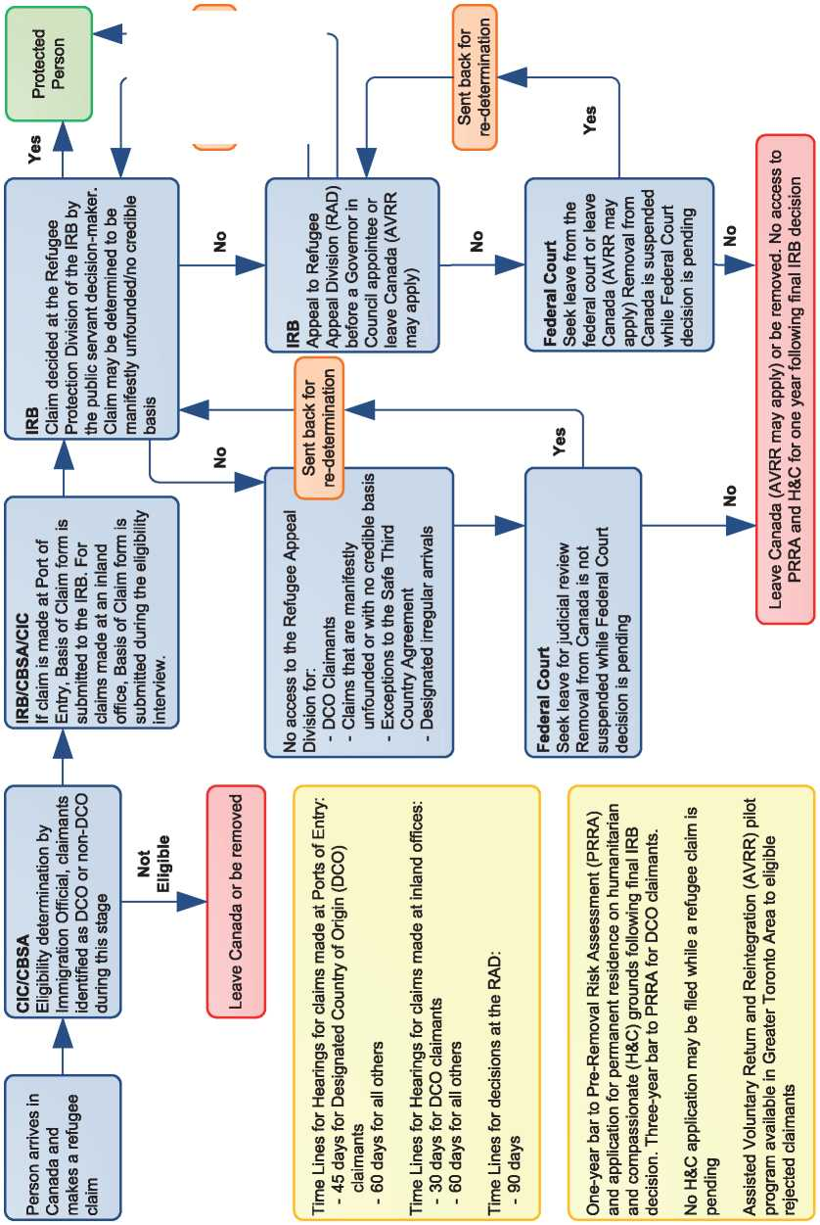

* 1. Additional Statistical Information

Figure 4: Asylum Applications from Top 10 Countries of Origin in 2009, 2010, 2011 and first half of 2012

**2009 2010 2011 Jan-Jun 2012**

|  |  |  |  |  |  |  |  |  |
| --- | --- | --- | --- | --- | --- | --- | --- | --- |
| **1** | Mexico | 7,571 | Hungary | 2,333 | Hungary | 4,416 | Hungary | 1,393 |
| **2** | Hungary | 2,533 | China | 1,581 | China | 1,846 | China | 772 |
| **3** | Colombia | 2,293 | Colombia | 1,353 | Colombia | 892 | India | 397 |
| **4** | Czech Rep. | 1,956 | Sri Lanka | 1,204 | Namibia | 831 | North Korea | 373 |
| **5** | China | 1,479 | Mexico | 1,199 | Pakistan | 827 | Colombia | 362 |
| **6** | Haiti | 1,437 | Haiti | 1,063 | India | 753 | Pakistan | 351 |
| **7** | United States | 1,150 | Nigeria | 856 | Nigeria | 686 | Nigeria | 338 |
| **8** | Sri Lanka | 824 | United States | 770 | Mexico | 656 | Slovakia | 326 |
| **9** | Nigeria | 767 | St. Vincent & G, | 689 | St. Vincent & G, | 654 | Sri Lanka | 248 |
| **10** | St. Vincent & G | 628 | India | 592 | Sri Lanka | 629 | Croatia | 240 |

**Figure 5: Decisions Taken at the First Instance in 2009, 2010 and 2011**

|  |  |  |  |  |  |  |  |  |  |
| --- | --- | --- | --- | --- | --- | --- | --- | --- | --- |
|  | **Geneva Convention** | | **Subsidiary/**  **Complementary**  **Protection and Humanitarian Status** | | **Rejections** | | **Withdrawn, Closed, Abandoned Cases** | | **Grand**  **Total** |
| **Number** | **%** | **Number** | **%** | **Number** | **%** | **Number** | **%** |  |
| **2009** | 11,189 | 42% | 0 | 0% | 9,883 | 37% | 5,761 | 21% | **26,833** |
| **2010** | 12,336 | 38% | 0 | 0% | 13,758 | 42% | 6,539 | 20% | **32,633** |
| **2011** | 12,932 | 38% | 0 | 0% | 16,074 | 47% | 5,223 | 15% | **34,229** |

**Figure 6.a: Positive [60] First- and Second-Instance Decisions,Top Countries of Origin in 2009**

**Rate out of Total Decisions [61]**

|  |  |  |  |  |
| --- | --- | --- | --- | --- |
|  | | **Total Positive** | **Total Decisions** | **Rate** |
| **1** | **Colombia** | 2,441 | 3,104 | 78.6% |
| **2** | **Haiti** | 1,046 | 2,307 | 45.3% |
| **3** | **China** | 991 | 1,534 | 64.6% |
| **4** | **Sri Lanka** | 985 | 1,045 | 94.3% |
| **5** | **Mexico** | 508 | 3,906 | 13.0% |
| **6** | **Nigeria** | 439 | 586 | 74.9% |
| **7** | **Afghanistan** | 282 | 300 | 94.0% |
| **8** | **Pakistan** | 247 | 366 | 67.5% |
| **9** | **Rwanda** | 241 | 272 | 88.6% |
| **10** | **Eritrea** | 235 | 238 | 98.7% |

Total Positive Decisions by Status

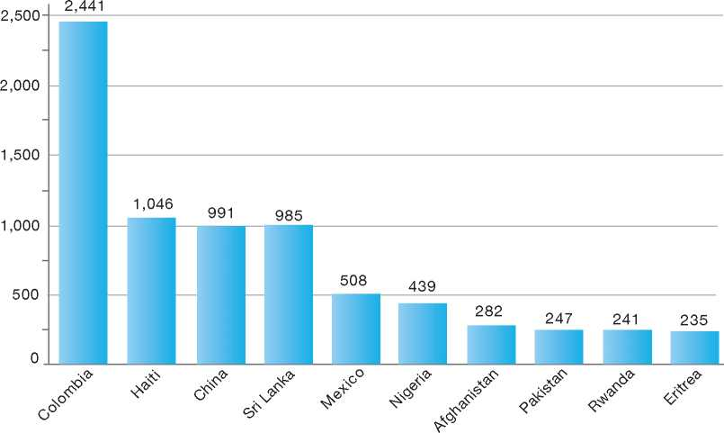

**Total Positive Decisions by Status**

Geneva Convention Status

**Figure 6.b: Positive [62] First- and Second-Instance Decisions,Top Countries of Origin in 2010**

**Rate out of Total Decisions [63]**

|  |  |  |  |  |
| --- | --- | --- | --- | --- |
|  | | **Total Positive** | **Total Decisions** | **Rate** |
| **1** | **Haiti** | 2,505 | 4,304 | 58.2% |
| **2** | **Colombia** | 1,267 | 2,290 | 55.3% |
| **3** | **China** | 884 | 1,468 | 60.2% |
| **4** | **Mexico** | 655 | 4,126 | 15.9% |
| **5** | **Nigeria** | 593 | 847 | 70.0% |
| **6** | **Sri Lanka** | 513 | 651 | 78.8% |
| **7** | **Afghanistan** | 412 | 438 | 94.1% |
| **8** | **Somalia** | 383 | 406 | 94.3% |
| **9** | **Iran** | 271 | 333 | 81.4% |
| **10** | **Pakistan** | 253 | 371 | 68.2% |

Total Positive Decisions by Status

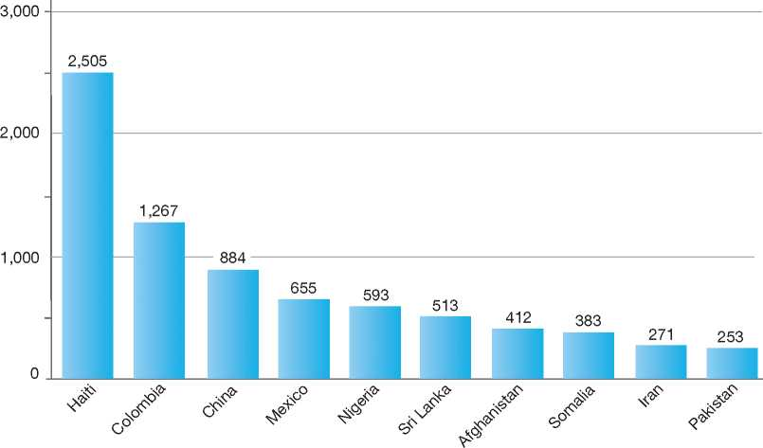

**Total Positive Decisions by Status**

| Geneva Convention Status

**Figure 6.c: Positive [64] First- and Second-Instance Decisions,Top Countries of Origin in 2011**

**Rate out of Total Decisions [65]**

|  |  |  |  |  |
| --- | --- | --- | --- | --- |
|  | | **Total Positive** | **Total Decisions** | **Rate** |
| **1** | **Haiti** | 1,441 | 2,871 | 50.2% |
| **2** | **Mexico** | 1,025 | 5,209 | 19.7% |
| **3** | **China** | 961 | 1,625 | 59.1% |
| **4** | **Nigeria** | 837 | 1,260 | 66.4% |
| **5** | **Somalia** | 647 | 678 | 95.4% |
| **6** | **Colombia** | 633 | 1,590 | 39.8% |
| **7** | **Pakistan** | 429 | 567 | 75.7% |
| **8** | **Afghanistan** | 392 | 443 | 88.5% |
| **9** | **Iran** | 331 | 375 | 88.3% |
| **10** | **St. Vincent & G.** | 287 | 746 | 38.5% |

Total Positive Decisions by Status

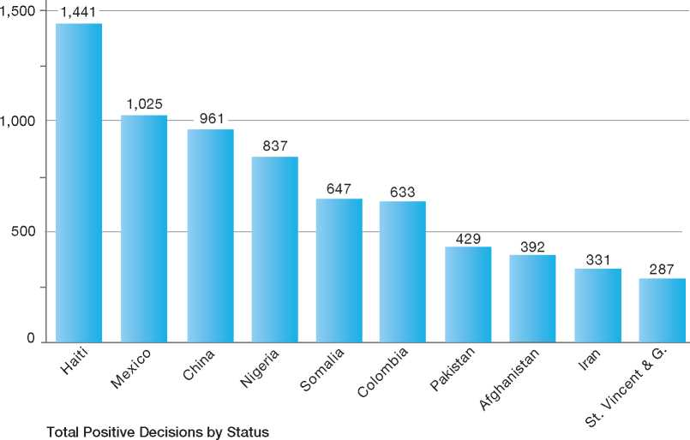

Geneva Convention Status

Denmark

BackGRound: MajoR asyluM tRends and developMents

national leGal FRaMewoRk

institutional FRaMewoRk

pRe-entRy MeasuRes

asyluM pRoceduRes

decision-MakinG and statuses

eFFiciency and inteGRity MeasuRes

assistance and Reception BeneFits FoR asyluM-seekeRs

status and peRMits GRanted outside the asyluM pRoceduRe

RetuRn

inteGRation

annexes

127

129

130

130

130

136

138

139

142

143

144

146

1.

2.

3.

4.

5.

6.

7.

8.

9.

10.

11.

12.



1. Background: Major Asylum Trends and Developments

Asylum Applications

In the early 1980s, Denmark was receiving fewer than 1,000 asylum claims per year. In 1984, however, there was a significant increase when over 4,000 claims were received. The number of annual claims fluctuated between 4,000 and 9,000 between 1985 and 1991. Numbers peaked in 1992 and 1993 at some 14,000 annual claims, then decreased significantly to between 5,000 and 6,000 between 1994 and 1997, and peaked again between 1999 and 2001 at around 12,000 claims, respectively. 12,000 claims, respectively. Since 2002, numbers have decreased significantly and in 2007, some 2,000 claims were received. This was followed by a 27 per cent increase in applications in 2008, a significant 60 per cent increase in applications in 2009, and a 32 per cent increase in 2010. In 2011, numbers dropped by 25 per cent, resulting in a total of 3,806 applications by the end of 2011.**[66]** then, the top countries of origin have not changed significantly, with increasing numbers of claims received from Russia and Iran and fewer claims from Somalia. Since 2009, there has been little change in the top countries of origin of asylum-seekers, the majority of whom come from Afghanistan, Iran, Syria, Serbia and Montenegro. There was a marked increase in numbers of unaccompanied minors arriving from Afghanistan in 2008 (302) and 2009 (386). This number subsequently dropped to 169 unaccompanied minors arriving from Afghanistan by the end of 2011.

Important Reforms

On 17 January 2002, the Government presented its new “Policy for Foreigners” which, among other things, rested on the fundamental consideration that the policy for foreigners must honour Denmark's treaty obligations.

Act No. 365 of 6 June 2002 (Bill No. L 152 of 28 February 2002) includes amendments to the Aliens Act and the Marriage Act that were introduced in

Figure 1: Total Asylum Applications by Quarter, January 1992 - June 20121

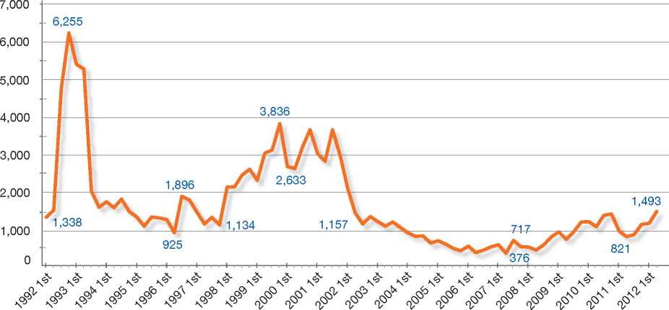

Top Nationalities

From 1992 to 2001, the majority of asylum-seekers arriving in Denmark hailed from Somalia, Iraq, the former Yugoslavia, and Afghanistan. Stateless Palestinians also arrived in large numbers. Since accordance with the Government's new policy for foreigners.

Under the Act, the “de facto refugee” concept was abolished. Residence permits may now be issued only to asylum-seekers who are eligible for protection according to criteria set out in international legal instruments, such as the 1951 Convention relating to the Status of Refugees (1951 Convention), the United Nations (UN) Convention against Torture and Other Cruel,

Inhuman or Degrading Treatment or Punishment (CAT), and the European Convention on Human Rights (ECHR).

The Act also abolished the possibility to apply for asylum in Denmark from a Danish diplomatic mission abroad.

Act No. 60 of 29 January 2003 (Bill No. L 23 of 2 October 2002 regarding the processing of claims made by unaccompanied minors) includes an amendment that puts into law the usual administrative practice of granting residence permits to unaccompanied minor asylum-seekers (UAMs). The amendment also provides that all unaccompanied minors seeking asylum will be appointed a personal representative to safeguard their interests during the procedure as well as an attorney, if the case is being dealt with under the manifestly unfounded procedure. According to the amendment, the Immigration Service must initiate a search for the parents of unaccompanied minors seeking asylum.

Act No. 292 of 30 April 2003 (Bill No. L 157 of 29 January 2003 regarding a reform of the activation and tuition efforts concerning adult asylum-seekers etc. and the system of periodic cash payments to asylum-seekers etc.) includes amendments that state that asylum-seekers must carry out certain tasks at the accommodation centre and take part in relevant activities in order to maintain and strengthen the asylum­seekers' abilities. Furthermore, the amendment introduced various levels of periodic support payments to asylum-seekers depending on which stage of the asylum process the applicant is at, the applicant's family relations, and the applicant's fulfilling of his or her obligations at the accommodation centre.

**Figure 2: Asylum Applications Received from Top 5 Countries of Origin in 2009, 2010 and 2011**

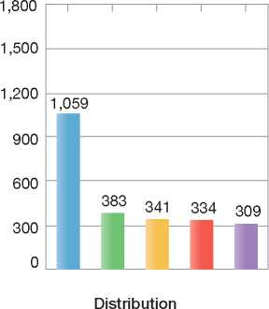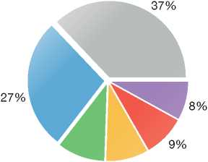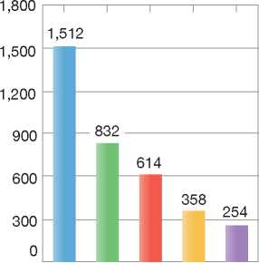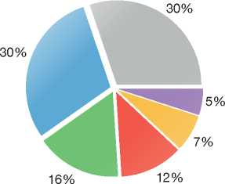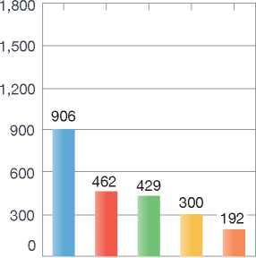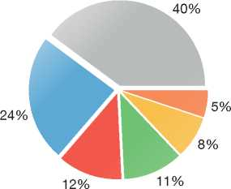

2009

Volumes

10% 9%

2010

Volumes

Distribution

2011

Volumes

Distribution

|  |  |  |
| --- | --- | --- |
| **Country of Origin:** | | |
| Afghanistan Iran | Iraq | Russia |
| Serbia Syria | Others |  |

Act No. 403 of 1 June 2005 (Bill No. L 79 B of 23 February 2005) changes the criteria for the selection of refugees for resettlement (quota refugees), including both refugees under the 1951 Convention and other persons in need of protection. During the selection process, greater emphasis is now placed on the potential of the refugee to integrate into Danish society. Act No. 403 includes a requirement to provide resettled refugees with additional information on settling in Denmark and a pre-departure integration course.

More recently, reforms made to the reception of asylum-seekers have been aimed at preparing rejected asylum-seekers to return to, and reintegrate in, their countries of origin. These changes were a consequence of the evolution of the asylum situation in Denmark, namely the decline in the number of applications received and in the recognition rate.

Act No. 572 of 18 June 2012 changed the number of members of the Refugee Appeals Board. The Board makes the final ruling on applications for asylum rejected by the Immigration Service. As of 1 January 2013, the Refugee Appeals Board will consist of five members instead of the current three. The new members will be appointed by the Danish Ministry of Foreign Affairs and the Danish Refugee Council.

Regions of Origin Initiative

In 2003, the Regions of Origin Initiative was introduced as part of Denmark's international development assistance policy.

The overall objective of this initiative is to help secure access to protection and durable solutions by refugees and internally displaced persons (IDPs) as close to their country of origin as possible. Enhanced protection in the regions of origin is believed to improve protection of, and living conditions for, refugees and IDPs, and thereby also diminish the need for secondary movements.

The Regions of Origin Initiative was developed during the same period that the United Nations High Commissioner for Refugees (UNHCR) elaborated its “Framework for Durable Solutions”. Thus, the initiative incorporates key elements of the UNHCR approach. In addition, it draws on aspects of cooperation within the European Union (EU).

The Regions of Origin Initiative is managed and implemented by the Ministry of Foreign Affairs and includes cooperation on aspects of the programme pertaining to Danish refugee and asylum policies.

At the moment, the Regions of Origin Initiative supports activities in twelve countries: Kenya, Afghanistan, Somalia, Ethiopia, and South Sudan

- which are all priority programme countries for Danish bilateral assistance - as well as Iraq, Jordan, Syria, Cote d'Ivoire, Liberia, Yemen and Guinea.

It is expected that by 2012, more than DKK 2 billion (e 270 million) will have been committed to the Regions of Origin Initiative.

1. National Legal Framework
   1. Legal Basis for Granting Protection

The asylum procedure and the competencies of asylum institutions are governed by the Aliens Act (Consolidation Act 1543 of 21 December 2010). The 1951 Convention has been transposed into Danish law by reference. Relevant provisions of the European Convention on Human Rights (ECHR) have also been transposed into the Aliens Act by reference (Act on the European Convention on Human Rights).

In accordance with the Protocol on the position of Denmark, annexed to the Treaty of the European Union and the Treaty establishing the European Community, Denmark is not bound by the EU asylum acquis. However, Denmark has a parallel agreement enabling Denmark to take part in Council Regulation (EC) No. 343/2003[67] and Council Regulation (EC) No. 2725/2000[68].

* 1. Pending Reforms

The Government Platform of October 2011 states that asylum-seekers and rejected asylum-seekers who are cooperative and who have stayed in Denmark as asylum-seekers for six months will be permitted to work and live outside the asylum centres. The Government appointed a working group to make recommendations on implementing these and other objectives related to the conditions for asylum-seekers. The findings of the working group were published in a report in June 2012 and on 19 September 2012, a political agreement was

reached on new conditions for asylum-seekers. The agreement contains, *inter alia*, the following initiatives:

* Asylum-seekers who are cooperative towards the authorities will, after six months, be permitted to work and to be accommodated outside the asylum centre system
* A special focus on improved conditions for asylum-seeking families with minor children
* An increased focus on return and reintegration of rejected asylum-seekers.

Amendments to the Aliens Law concerning these initiatives are expected to be put forward in early 2013.

1. Institutional Framework
   1. Principal Institutions

The Ministry of Justice is responsible for all matters concerning asylum and humanitarian permits, immigration, family reunification, the EU and citizenship. All integration matters are the responsibility of the Ministry of Employment and the Ministry of Social Affairs and Integration.

The Danish Immigration Service under the Ministry of Justice processes applications for asylum at the first instance.

The Refugee Appeals Board is an independent body responsible for hearing appeals of Immigration Service decisions on asylum cases. It is the final avenue for appeal in asylum cases where the decision of the Immigration Service may be contested. Under the manifestly unfounded procedure, the Danish Refugee Council (a non­governmental organisation) cooperates with the Immigration Service in helping to determine that a case is indeed manifestly unfounded.

The National Commissioner for the Police is responsible for registering new applicants and establishing their identity and travel route. The National Commissioner for the Police also has the responsibility of returning rejected asylum­seekers.

The municipalities are responsible for ensuring the integration of refugees and other persons granted international protection in Denmark.

1. Pre-entry Measures

To enter Denmark, a foreign national must have a valid travel document, such as a passport and, if applicable, a visa issued by Denmark or one of the other Schengen countries.

* 1. Visa Requirements

Denmark is a party to the Schengen Agreement and as such is bound by the common list of countries laying down the nationalities subject to visa requirements. Danish diplomatic and consular missions abroad have the jurisdiction to issue “bona fide” visas in cases that clearly merit approval, while all other cases are sent to the Immigration Service for further investigation and processing. Negative decisions of the Immigration Service on a visa application may be appealed to the Ministry of Justice.

* 1. Carrier Sanctions

Carriers that bring to Denmark a foreign national who, upon his or her entry or transit at a Danish airport, is not in possession of the necessary travel documents and visa are liable to a fine. This provision does not apply to entry from a Schengen country.

* 1. Interception

In addition to carrier sanctions, Denmark has at various times posted immigration liaison officers abroad who have assisted the local authorities with, among other tasks, the authentication and control of travel documents for persons travelling to Denmark.

Moreover, the Police can ask for identity and proof of legal residence of foreign nationals present in Denmark. This is sometimes done as part of coordinated inter-agency control activities carried out at business premises, such as restaurants.

1. Asylum Procedures
   1. Application Possibilities and Requirements, Procedures and Legal Remedies

A foreign national may make a claim for asylum at one of the following locations:

• In person at the border

* In person at a police station, including the police station located inside Copenhagen Airport
* At the Sandholm Accommodation Centre run by the Immigration Service, or the Police, by submitting a written application, either personally or with the assistance of an attorney
* At the municipality, in which case the National Commissioner for the Police will be contacted in order for the applicant to be channelled into the regular asylum procedure.

1. Outside the Country

Applications at Diplomatic Missions

Applications for asylum may not be made from outside of Denmark.

Resettlement/Quota Refugees

Denmark has in place an annual resettlement programme with a flexible quota of 1,500 places to be filled over a three-year period.

Criteria for Resettlement

Quota refugees must fulfil the same conditions as asylum-seekers in order to be granted a residence permit in Denmark. For resettlement purposes, a residence permit may be issued to a person who is outside of his or her country of origin and who meets the following criteria:

* The person falls within the provisions of the 1951 Geneva Convention
* The person risks being subjected to the death penalty, torture, or inhuman or degrading treatment or punishment if returned to his or her country of origin, or
* The person is in such a position that essential considerations of a humanitarian nature conclusively make it appropriate to grant the application.

The Immigration Service has responsibility for making final decisions on selection.

Procedures

At the beginning of each year, the Minister of Justice, upon recommendations made by the Immigration Service, makes decisions on the overall allocation of approximately 500 quota places within the different categories (geographical, emergency, and medical) and on the destinations of selection missions for that year.

Approximately 400 of the 500 persons are selected by the Immigration Service following interviews during resettlement missions among refugees identified by the UNHCR. The remaining 100 persons are identified among medical or urgent cases presented by the UNHCR, usually on a dossier basis.

Family members of refugees are not generally included in the resettlement quota but may instead apply for family reunification, once the refugee has been resettled in Denmark.

1. At Ports of Entry

There are no separate asylum procedures for persons applying for asylum at ports of entry or inside the territory. When a foreign national arrives in Denmark and applies for asylum, the National Police will interview the person and establish his or her travel route. An assessment will then take place to determine whether Denmark is responsible for examining the claim under the Dublin II Regulation. Thereafter, the asylum­seeker is subject to the normal procedure.

1. Inside the Territory

Responsibility for Processing the Claim

The Dublin System

*Application and Procedure*

The National Police is responsible for determining the travel route of the asylum-seeker when an asylum claim is made. The Immigration Service will then make a determination regarding Denmark's responsibility for examining the claim under the Dublin II Regulation. If another State party to the Dublin II Regulation is responsible for handling the application, the Immigration Service will request that the country assume responsibility for processing the asylum claim. If the State in question agrees to do so, the asylum-seeker is transferred to that country for processing.

The initial process of determining whether an application for asylum should be processed in Denmark or another country takes up to three months to complete, although it may in some cases take as long as six months.

*Freedom of Movement/Detention*

The freedom of movement of asylum-seekers is not restricted during the asylum procedure.

However, asylum-seekers may be detained if detention is necessary to ensure the implementation of a transfer under the Dublin II Regulation. Detention is used only if measures such as the deposit of a passport or other travel documents are deemed to be insufficient.

*Conduct of Transfers*

Transfers are carried out either voluntarily or with police escort.

*Suspension of Dublin Transfers*

The Immigration Service and the Ministry of Justice may make a decision to suspend transfers to another State party to the Dublin II Regulation. On 23 January 2011, Denmark decided to implement a temporary suspension on the transfer of asylum­seekers to Greece and vulnerable persons to Italy.

*Review/Appeal*

A decision by the Immigration Service on transfer under the Dublin II Regulation may be appealed to the Ministry of Justice. The appeal does not automatically suspend the enforcement of the decision.

Application and Admissibility

Application

Asylum-seekers who gain entry into Denmark are interviewed and photographed and have their fingerprints taken by the Police in order to determine their identity, nationality and travel route. The asylum-seeker will be asked by the Immigration Service to complete an application form stating the reasons for his or her asylum request. For illiterate persons, this application form can be replaced by a short “asylum motive interview”. An asylum interview with the Immigration Service is then scheduled.

Applications for asylum under the 1951 Convention are treated in the same way as applications for subsidiary protection (protected status) and examined using the same procedure.

Admissibility

If the Immigration Service decides, under the Dublin II Regulation, that an asylum application may be processed in Denmark, the Immigration Service will interview the applicant and proceed with making a determination on the claim.

In addition to applying the Dublin II Regulation, Denmark maintains a list of safe third countries. Based on this list, the Immigration Service may decide not to examine an asylum claim if the asylum-seeker has travelled to Denmark directly from one of the countries on the list. In such cases, the asylum-seeker is required to return to the safe third country[69].

Accelerated Procedure

In certain cases, asylum applications may be processed according to an expedited version of the “manifestly unfounded procedure”, which is described below. This procedure may be applied to cases in which the asylum-seeker comes from a country where, according to background information, it is unlikely that he or she would risk persecution if returned.

Under the expedited manifestly unfounded procedure, the asylum-seeker will not be asked to fill out an application form; instead, he or she is quickly referred for an interview with the Immigration Service. After also having interviewed the asylum-seeker, the Danish Refugee Council, a non-governmental organisation (NGO), will give a statement on the case, and the Immigration Service will aim to come to a decision within a few days. If the Danish Refugee Council agrees with the Immigration Service that the application is manifestly unfounded, the decision of the Immigration Service to reject the claim for asylum may not be appealed.

If the Refugee Council disagrees with the decision of the Immigration Service, the Immigration Service may maintain - as is most often the case - its rejection but will refer the case to the Refugee Appeals Board for a final ruling.

Normal Procedure

Under the normal procedure, the Immigration Service interviews the asylum-seeker with the assistance of an interpreter. Following the interview, the Immigration Service will make a decision on the claim, based on the asylum­seeker's statements and information on conditions in the country of origin.

The Handheld Procedure

The “handheld procedure” aims to achieve a maximum processing time of two months for determining identity, travel route and whether another State is responsible for processing the claim under the Dublin II Regulation. It also aims to reduce the first phase of interview and decision­making to two months. In order to achieve this, the applicant is led from one step of the procedure to the next, without waiting periods between steps. This is further facilitated by a close cooperation between the Danish National Police and the Danish Immigration Service. Both the Police and the Immigration Service have an office in the same building next to the main asylum centre in Sandholm.

Manifestly Unfounded Procedure

In a small number of cases, the Immigration Service may determine at the outset that an asylum claim is manifestly unfounded and that the asylum-seeker is therefore not eligible for asylum. According to section 53 b (1) of the Aliens Act, the Immigration Service may determine that a claim is manifestly unfounded in one of the following cases:

* The identity claimed by the applicant is manifestly incorrect
* It is manifest that the circumstances invoked by the applicant cannot lead to the granting of a residence permit under section 7 of the Aliens Act[70]
* It is manifest that the circumstances invoked by the applicant cannot lead to the granting of a residence permit under section 7 according to the practice of the Refugee Appeals Board
* The circumstances invoked by the applicant are in manifest disagreement with general background information on the conditions in the applicant's country of origin or former country of residence
* The circumstances cited by the applicant are in manifest disagreement with other specific information on the applicant's situation, or
* The circumstances cited by the applicant are found manifestly to lack credibility, including as a consequence of the applicant's changing, contradictory or improbable statements.

Such cases are sent to the Danish Refugee Council, a non-governmental organisation, which will provide a statement on the case following a separate interview of the applicant with the Refugee Council. If it agrees with the Immigration Service that the application is manifestly unfounded, the application will be rejected by the Immigration Service without a right of appeal. If the Refugee Council does not agree that the claim is manifestly unfounded, the Immigration Service may maintain - as is most often the case - its rejection but will refer the case to the Refugee Appeals Board for a final ruling.

Cases that, in the opinion of the Refugee Council, are not manifestly unfounded are examined only by the Chairman of the Refugee Appeals Board or a Deputy Chairman using a written procedure (without a hearing), unless there is reason to believe that the Board will change the decision made by the Immigration Service. If there is a possibility that the Board will reverse the decision, the case is examined by the full-member board, with a personal appearance by the applicant.

The Immigration Service will reject an application only after a full first-instance procedure has been completed, including a normal asylum interview.

Review/Appeal of Asylum Decisions

Manifestly unfounded cases aside, a negative decision on an asylum application at the first instance is automatically subject to appeal before the independent Refugee Appeals Board. The asylum-seeker will normally be required to participate in a hearing. An attorney will be appointed to represent the applicant's interests at the expense of the Government. The decisions of the Refugee Appeals Board are final.

If the Refugee Appeals Board agrees with the decision of the Immigration Service, the asylum­seeker must leave Denmark within seven days, or in some cases immediately.

If the Refugee Appeals Board does not agree with the decision of the Immigration Service, the asylum-seeker is normally granted a residence permit either as a Convention refugee or as a person granted protected status (subsidiary protection).

Freedom of Movement during the Asylum Procedure

Detention

If imposing reporting obligations or other measures is not enough to ensure the asylum-

seeker's cooperation with the efficient examination of the asylum application or removal from Denmark, an asylum-seeker may be detained during the procedure. Detention is possible if the asylum-seeker, through his or her behaviour, essentially obstructs the procuring of information for the case by:

* Without reasonable cause, repeatedly failing to appear for interviews with the Police or the Danish Immigration Service, to which he or she has been summoned
* Failing to disclose information on his or her identity, nationality or travel route
* Making obvious misrepresentations thereon, or
* Otherwise not assisting in procuring information for the case.

The decision to detain an asylum-seeker is taken by the National Police, whose decision must be approved by the Courts. The Courts may decide to uphold the detention for a maximum period of four weeks. However, at the end of the four-week period, the Police may ask the courts to extend the detention for another four-week period. There is no statutory maximum period in this regard. The detention, including its duration, must be considered to be proportional to the reasons for detention in order to be upheld by the Courts.

Reporting

Reporting obligations may be required of an asylum-seeker if this is deemed necessary for ensuring the presence of the asylum-seeker or his or her cooperation in the examination of the claim. Decisions on reporting obligations may be made by the Police in the following cases:

* The asylum-seeker is not cooperating on providing information for the examination of the claim
* Without reasonable cause, the asylum­seeker fails to appear for an interview with the Immigration Service or the Police, to which the person in question has been summoned.

Repeat/Subsequent Applications

An asylum-seeker who has received a final negative decision on his or her claim is under the obligation to leave Denmark. Prior to departure, however, an asylum-seeker may make a request to have his or her claim reopened for consideration. A claim will be reopened if the applicant can show that reasons, such as developments in the country of origin or *sur place* considerations, exist to reopen the claim.

There is no limit on the number of times a rejected asylum-seeker can request a reopening of his or her claim.

A person who has previously received a final negative decision on an asylum claim in Denmark and has returned to his or her country of origin may, upon re­entry in Denmark, file a new application for asylum.

* 1. Safe Country Concepts
     1. Safe Country of Origin

While Denmark does not have a safe country of origin policy, the Immigration Service, the National Police and the Danish Refugee Council together are responsible for drawing up a list of countries, based upon which the expedited version of the manifestly unfounded procedure[71] may be applied.

Asylum Claims Made by EU Nationals

Asylum claims made by EU citizens are assessed on their individual merits. The cases are generally examined under the expedited version of the manifestly unfounded procedure.

* + 1. First Country of Asylum

A residence permit on the basis of refugee status or protection status (subsidiary protection) can be refused if the applicant has already obtained protection in another country, or if the foreign national has close ties with another country where he or she is deemed to be able to obtain protection.

Such a decision may be taken by the Immigration Service as part of its normal examination of an application for asylum, and may be appealed to the Refugee Appeals Board like other asylum decisions of the Immigration Service.

* + 1. Safe Third Country

The Ministry, after a hearing with the Immigration Service and the National Police, regularly updates a list of safe third countries to which an asylum-seeker may be removed (without consideration of his or application for asylum), if he or she has travelled to Denmark directly from one of these countries.

The decision to return an asylum-seeker to a safe third country is taken by the Immigration Service. In practice, it is often the Police that will present the decision to the asylum-seeker at the airport, after having consulted the Immigration Service.

| **Figure 3: Asylum Applications by Unaccompanied Minors in 2009, 2010 and 2011** | | | |
| --- | --- | --- | --- |
|  | **2009** | **2010** | **2011** |
| Total Asylum Applications | 3,855 | 5,115 | 3,806 |
| of which Unaccompanied Minors | 529 | 432 | 284 |
| Percentage | 14% | 8% | 7% |

If the decision is immediately enforceable, the person may be detained at the airport pending the implementation of return to the safe third country. If, in an individual case, there are reasons to believe that removal to a third country is not safe, the Immigration Service will examine the application on its merits.

If deemed necessary and if other measures such as deposit of travel documents are deemed insufficient, an asylum-seeker may be detained pending the implementation of return to the safe third country. Alternatively, a reporting requirement may be imposed.

A decision by the Immigration Service to return an asylum-seeker to a safe third country may be appealed to the Ministry of Justice. The appeal does not automatically have suspensive effect.

* 1. Special Procedures
     1. Unaccompanied Minors

Procedures

Unaccompanied minors (UAMs) must meet the same conditions as other asylum-seekers in order to have their application processed. However, UAMs are considered a particularly vulnerable group. They will be put through the normal asylum procedure only if they are deemed mature enough to understand the procedure. UAMs over the age of 15 are generally considered to have the required level of maturity, but the decision on maturity is taken on a case-by-case basis.

Special guidelines have been devised for processing UAM cases. This means that their application will be processed quickly, and that they will be housed in special accommodation centres with specially trained staff.

Every UAM who makes an asylum claim is appointed a personal representative. The representative offers support during the procedure, for example, by being present at the interview. Interviews are conducted by specially trained staff. If a minor's case is processed according to the manifestly unfounded procedure, the Immigration Service appoints an attorney to represent the minor. Upon consent of the minor, a search for his or her family may be conducted.

Age Assessment

If there is any doubt about the age of the minor, a voluntary medical examination may be carried out

by the Department of Forensic Medicine (DFM). The examination consists of dental x-rays, x-rays of the left hand and a general medical examination. DFM gathers the relevant information and provides a statement on the minor's age.

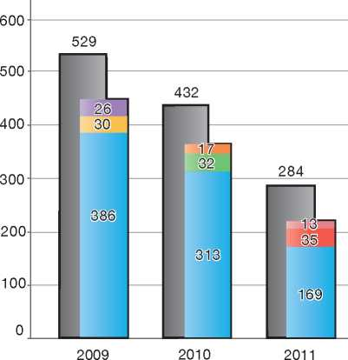

|  |  |
| --- | --- |
| **Country of Origin:** | |
| | Afghanistan | | Algeria |
| Iran | Iraq |
| Libya | Somalia |
| Syria |  |

Decisions

If the Immigration Service assesses that a UAM does not have the required level of maturity to undergo the asylum procedure, he or she will be granted a residence permit without his or her asylum application being processed.

If the asylum claim is refused, the minor may still be granted a residence permit, if it is determined that the minor would in fact be placed in an emergency situation if returned to the country of origin, owing to the lack of an adequate support network in the form of family or public assistance. Minors granted

permission to stay on these grounds rather than having been granted refugee status will have their permit revoked once they turn 18.

If a UAM is granted asylum, he or she receives a residence permit valid initially for a period of seven years. The permit is renewable. If a UAM under 15 years old is granted any other type of residence permit, the permit is valid until the UAM becomes 15. For UAMs aged 15 and older, this permit is initially valid for a period of one year and is renewable.

Appeal

If the appeal against the decision not to grant a residence permit under section 9 c (3) of the Aliens Act is submitted less than seven days after the Immigration Service's decision, the UAM may stay in Denmark during the appeal procedure. However, if the appeal is submitted after this time period has elapsed, it will be processed accordingly, but the date of removal will not be affected.

* + 1. Temporary Protection

Denmark does not have in place a regime for granting temporary protection.

* + 1. Stateless Persons

The risk of persecution facing stateless asylum applicants is determined by assessing whether the applicant is indeed stateless, followed by an assessment of the risk of persecution in the applicant's country of former habitual residence. Stateless persons who are found not to be in need of protection may be returned to the country of former habitual residence.

1. Decision-Making and Status
   1. Inclusion Criteria
      1. Convention Refugee

In order to be granted asylum in Denmark, an applicant must qualify for refugee status under the 1951 Convention.

* + 1. Protected Status

In conformity with its international obligations under ECHR and CAT, Denmark grants protected status to persons who are at risk of the following if returned to the country of origin:

* Death penalty
* Torture
* Inhuman or degrading treatment or punishment.
  1. The Decision

Decisions taken at the first instance are reasoned and given in writing. The decisions are translated into the applicant's mother tongue whenever possible. In certain cases, including when a claim has been made by an unaccompanied minor or when the applicant is illiterate, the asylum-seeker is notified of the decision orally by the Police with the assistance of an interpreter.

* 1. Types of Decisions, Status and Benefits Granted

The Immigration Service may take one of the following decisions on an asylum claim:

* Grant Convention refugee status
* Grant protected status
* Refuse to grant Convention refugee status and/ or refuse to grant other types of protection
* Refuse to consider asylum claims made by a person who can be refused entry and removed to a safe third country
* Refuse to consider an application made by a person who is to be transferred to another country responsible for examining his or her application, pursuant to the Dublin II Regulation.

Negative decisions are accompanied by a decision on whether the applicant can - in line with Denmark's international obligations[72] - be returned by force to his or her country of origin, if he or she does not leave Denmark voluntarily.

Convention refugees and persons granted protected status obtain the same rights and benefits, including assistance pursuant to Danish social legislation, cash benefits, housing subsidies, education, family reunification, and the possibility to apply for a permanent residence permit. These benefits correspond to the benefits available to Danish citizens and permanent residents.

* 1. Exclusion

An asylum-seeker cannot be issued a residence permit as a refugee or as a person with protection status under any one of the following circumstances:

* The person is deemed a danger to national security
* The person is deemed a serious threat to public order, safety or health
* The person is deemed to fall within Article 1F of the 1951 Convention.

Unless particular reasons, including regard for family unity, make it appropriate, as a rule a foreign national cannot be issued a residence permit as a refugee or a person with protection status, if:

* The person has been convicted abroad of an offence that could lead to expulsion (in accordance with the provisions on expulsion for crimes, etc.), if his or her case had been heard in Denmark
* There are serious reasons for assuming that the person has committed an offence abroad that could lead to expulsion (in accordance with the provisions on expulsion for crimes, etc.)
* Circumstances otherwise exist that could lead to expulsion (in accordance with Part IV of the Danish Aliens Act dealing with expulsion)
* The person is not a national of a Schengen country or a Member State of the European Union, and an alert has been entered in the Schengen Information System in respect of the person for the purpose of refusal of entry pursuant to the Schengen Convention, or
* Because of a communicable disease or serious mental disorder, the person must be deemed potentially to represent a threat or cause substantial inconvenience to those around him or her.

Decisions to exclude a person from refugee or protected status are taken by the Immigration Service and may be appealed to the Refugee Appeals Board. While the Immigration Service does not issue removal orders, the excluded person must leave Denmark, unless there are other grounds for allowing the person to remain in Denmark.

* 1. Cessation

A residence permit issued to a refugee or person with protected status lapses only when the person has settled in his or her country of origin or has, of his or her own free will, obtained protection in a third country.

A residence permit may no longer be valid if the person has resided outside of Denmark for six months, or 12 months, if the person has lived for more than two years in Denmark.

A person whose residence permit would lapse for one of the reasons stated above may make an application to the Immigration Service to retain his or her residence permit. The Immigration Service may make a determination in favour of the person, depending on the individual circumstances.

Decisions regarding cessation are taken by the Immigration Service and may be appealed to the Refugee Appeals Board.

* 1. Revocation

The Immigration Service may revoke or refuse to extend a residence permit granted to a recognised refugee or person with protected status for one of the following reasons:

* The basis on which the permit was granted is no longer applicable. For example, there is no longer a risk of persecution in the applicant's country of origin
* Evidence of fraud committed at the time of application has since been uncovered (in other words, if the residence permit would not have been issued except for the fraudulent reasons, the permit may be revoked)
* The person is considered a threat to national security, public order, safety or health
* The person is a war criminal, or has committed a serious non-political crime outside Denmark
* The person has been convicted of a crime that would warrant removal if committed in Denmark
* The person has returned to his or her country of origin.

When assessing whether a residence permit should be revoked, the Immigration Service must take the following factors into consideration:

* The person's ties to Danish society, including the duration of residence in Denmark
* The person's age, health, and other personal circumstances
* The person's connection to the country of origin.

A person whose residence permit is the subject of a decision to revoke may appeal the decision to the Refugee Appeals Board.

* 1. Support and Tools for Decision-Makers

A decision-maker at the Immigration Service is supported in his or her task by a number of tools, including the UNHCR Handbook on Procedures and Criteria for Determining Refugee Status, country of origin information (COI) services, the jurisprudence of the Refugee Appeals Board, reports on human rights produced jointly by the Refugee Appeals Board and the Immigration Service, and language analysis, age determination tests, and medical reports, where required. COI support services and language analysis tools are highlighted below.

* + 1. Country of Origin Information

The Country of Origin Information Division of the Danish Immigration Service is responsible for the collection of information on conditions in asylum­seekers' countries of origin or countries of habitual residence. The division consists of country advisors responsible for various geographical regions.

As part of its research methodology, the Country of Origin Information Division undertakes several fact-finding missions every year. The purpose of undertaking fact-finding missions is to obtain valid, detailed and up-to-date information that is not available from existing written sources. Fact-finding missions are usually undertaken in cooperation with national partners, such as the Danish Refugee Council or sister organisations in other countries.

During fact-finding missions, the country advisors consult a wide range of sources, including national and international NGOs, international organisations and national authorities. Every effort is made to ensure that the information gathered on fact-finding missions is accurate, current and obtained from reliable and well-informed sources on the ground. Great care is taken to ensure that a varied range of sources is consulted in order to provide balanced country of origin information to decision-makers. The fact-finding reports consist of statements from sources that have been given the opportunity to comment on, correct and approve the information they have provided before publication[73].

* + 1. Language Analysis

Language analysis is a service provided by external consultants to decision-makers at the National Commissioner of the Police or at the Immigration Service who may decide that it is necessary to use language analysis in order to assist with the determination of an asylum-seeker's nationality or region of origin.

1. Efficiency and Integrity Measures
   1. Technological Tools
      1. Fingerprinting

Asylum-seekers aged 14 or older are always fingerprinted.

The fingerprints are stored in a special database under the responsibility of the National Police. The purpose of taking fingerprints is first and foremost to enable the authorities to check whether an applicant has made a claim for asylum in another State bound by the Dublin II and Eurodac Regulations. In addition, fingerprints are also used to establish the identity of asylum­seekers or, if necessary, are used in connection with applications for travel documents (such as to facilitate the return of an asylum-seeker who has received a final negative decision on his or her claim).

* + 1. DNA Tests

DNA tests may be carried out at the request of decision-makers of the Immigration Service if such tests would assist in establishing the identity of an asylum-seeker or his or her family ties.

* + 1. Forensic Testing of

Documents

Documents may be sent to the Police for forensic testing if Immigration Service decision-makers believe doing so would assist in authenticating documents submitted by asylum-seekers in support of their claims.

* + 1. Database of Asylum Applications/Applicants

The Danish immigration authorities have in place a database *(Udl^ndingeregister)* containing information on foreign nationals who either have a case or have had a case considered under the Danish Aliens Act.

* + 1. Visa Information System

The National Commissioner of Police has access to the visa case-handling systems (visa cases are not stored in the above-mentioned *Udl&ndingeregister)* and through those systems may be able to find out whether an applicant has lodged a visa application at a Danish diplomatic post beforehand. With the roll-out of the Visa Information System (VIS), this control mechanism will become more valuable, as biometric data will be entered into the systems, and the Police will be able to search for visa dossiers from all Schengen States through access to the C-VIS database.

* 1. Length of Procedures

There is no time limit imposed on persons to make an application for asylum after their arrival in Denmark.

The length of the asylum procedure is not regulated by law and often varies according to the number of applicants and other factors. In 2011 the average length of the asylum procedure for all cases (normal and expedited procedure) was approximately 90 days.

Adopting "Lean" Production Principles

One measure that was taken by the Immigration Service to improve the efficiency of its asylum procedure was to adopt "lean" production principles. The "lean" production practice considers the expenditure of resources to achieve an objective other than the creation of value for the end customer to be wasteful, and thus a target for elimination.

In other words, "lean" production adheres to the notion of achieving more value with less work. Lean production is a generic process management philosophy derived mostly from the Toyota Production System (TPS), which came to prominence under the term "lean" in the 1990s. The adoption of this and other measures has assisted the Immigration Service to meet its goal of processing asylum claims more efficiently.

The Handheld Procedure mentioned above is a practical example of how lean principles can lead to shorter processing times.

* 1. Pending Cases

As at 30 September 2012, there were 811 pending cases at the Immigration Service[74].

Each year, the Immigration Service enters into an agreement with the Ministry of Justice in which certain goals and objectives are specified. The agreement also includes specific goals in relation to the number of asylum cases to be processed and the quality standard to be achieved.

* 1. Information Sharing

The National Commissioner of the Police and the Immigration Service engage in practical cooperation and information sharing during the asylum procedure.

Cooperation with third countries such as EU Member States occurs primarily in the context of determining whether Denmark has responsibility for examining the claim under the Dublin II Regulation. Moreover, specific information may be requested from other third States, including copies of the file of an asylum-seeker who has previously made an asylum application in a third country.

Such sharing of information with other organisations or authorities takes place within the rules on protection of personal data set out in the Danish Act on Personal Data and the Act on Administrative Affairs.

* 1. Single Procedure

Applications for asylum under the 1951 Convention are also treated as applications for subsidiary protection (protected status) and are examined in the same procedure.

1. Assistance and Reception Benefits for Asylum-Seekers
   1. Procedural Support and Safeguards



Asylum Information Film

The Danish Immigration Service and the Danish National Police developed an information film to inform asylum-seekers about the asylum procedure and about the rights and duties they have as an asylum-seeker in Denmark.

The film is divided into chapters so that the relevant chapter can be shown before each step of the asylum procedure. With this tool, the asylum-seeker receives a limited amount of targeted information at the right time, which helps him or her to process all the information.

The film has been recorded in 25 different languages.

* + 1. Legal Assistance

An asylum-seeker may be represented by counsel at the first instance and has the right to legal counsel at the appeal stage.

While asylum-seekers are not entitled to legal aid at the first instance, legal aid is provided to those appearing before the Refugee Appeals Board. Legal aid is also offered to unaccompanied minor asylum-seekers as soon as the Immigration Service channels the application into the manifestly unfounded procedure.

* + 1. Interpreters

Interpreters are available for those asylum-seekers who require interpretation services, both at the first-instance interviews and during hearings before the Refugee Appeals Board.

* + 1. UNHCR

The UNHCR Regional Office, which is located in Stockholm, Sweden, may respond to inquiries from asylum-seekers during the procedure and may be of assistance by providing information on the procedure, legal counsel and any relevant organisations that may be of further assistance.

The UNHCR Regional office plays no formal role in refugee status determination in Denmark. However, upon the request of a party in the procedure, UNHCR may provide updated country of origin information (COI), legal advice or UNHCR's recommendations and guidelines. In exceptional precedent-setting cases, the UNHCR may submit *amicus curiae* to the last instance body. The UNHCR regional office in Stockholm may request access to a particular asylum application, usually for advocacy purposes.

* + 1. NGOs

Upon making an application for asylum, a person will be informed of his or her rights and obligations during the procedure, including the possibility to contact the implementing partner of UNHCR in Denmark, namely the Danish Refugee Council. This information is provided in the context of an asylum­seeker “course”, in leaflets at the reception centre and through the presence of representatives of the Danish Refugee Council at the reception centre.

The Danish Refugee Council is a private, independent humanitarian organisation, which may take on an advocacy role on behalf of asylum-seekers.

As mentioned above, decisions on applications considered to be “manifestly unfounded” are transmitted by the Immigration Service to the Danish Refugee Council for review. If the Danish Refugee Council disagrees with the Immigration Service regarding whether a particular case should be treated as manifestly unfounded, the case will be handled through the normal asylum procedure, that is, with automatic appeal to the Refugee Appeals Board.

* 1. Reception Benefits
     1. Accommodation

Asylum-seekers in Denmark typically reside at an accommodation centre while their case is being processed.

It is the responsibility of the Immigration Service to provide accommodation. The day-to-day operation of these accommodation centres is carried out with several partners.

The Danish Red Cross operates and administers most accommodation centres in Denmark. Other asylum centre operators include Thisted, Langeland and Jammerbugt municipalities.

Upon entry, asylum-seekers reside first at a reception centre, and are then moved to an accommodation centre, where they reside until a final decision has been taken.

In certain cases, the Immigration Service will grant applicants permission to stay outside the accommodation centre. This is of particular relevance to asylum-seekers who have family or friends living in Denmark with whom they would like to stay during the application process.

In the case of non-subsidised private accommodation during the asylum procedure, the Immigration Service only covers the cost of transport to and from meetings with immigration authorities and the cost of necessary health treatment.

Subsidised private accommodation will be available for the duration of the asylum procedure when there are compelling health-related or psycho-social reasons that warrant private accommodation. While in subsidised private accommodation outside the accommodation centre, the asylum-seeker can still receive cash allowances. The Immigration Service will also cover the cost of transport to and from meetings with immigration authorities as well as any necessary medical treatment.

UAMs are placed in the Unaccompanied Minors Centre run by the Danish Red Cross and Thisted Municipality.

* + 1. Social Assistance

Asylum-seekers receive a cash allowance from the Immigration Service to cover their expenses. This does not apply, however, to applicants who are married to a Danish citizen or a person holding a Danish residence permit. In such cases, the spouse is expected to support the applicant.

The basic allowance is DKK 51.48 (e 7) per day per adult. If an applicant is living with his or her spouse, registered partner or cohabiting partner, both will receive DKK 40.76 (e 5.50) per day per adult. The basic allowance is paid in advance every other Thursday.

While an application is in its initial phase - when it has yet to be determined whether the application will be processed in Denmark or elsewhere - the supplementary allowance is DKK 8.59 (e 1.15) per day. If it is decided that the application is to be processed in Denmark, the supplementary allowance will be increased to DKK 30.04 (e 4) per day. The supplementary allowance is paid every other Thursday, at the end of each 14-day period.

The caregiver allowance for the first and second child, during the initial phase, is DKK 60.07 (e 8) per child per day. If it is decided that the application is to be processed in Denmark, the supplementary allowance will be increased to DKK 81.52 (e 11) per child per day. For asylum-seekers living at centres where free meals are served, the caregiver allowance is DKK 8.59 (e 1.15) per child per day for asylum-seekers in the initial phase and DKK 30.04 (e 4) per child per day for asylum-seekers who have their application processed in Denmark. The reduced caregiver allowance for the third child and fourth child is DKK 42.91 (e 5.75) per child per day. For asylum-seekers living at centres where free meals are served, there is no caregiver supplement for the third or fourth child. Both types of caregiver allowances are paid in advance every other Thursday.

Asylum-seekers whose cases are processed according to the expedited version of the manifestly unfounded procedure do not receive cash allowances if they are staying in an accommodation centre where free meals are served.

* + 1. Health Care

Asylum-seekers are not covered by the Danish National Health Service. Instead, expenses for their healthcare and dental care are covered by the Immigration Service.

Asylum-seekers under the age of 18 are entitled to the same health care as children who are Danish residents. In the case of adult asylum-seekers, the Immigration Service covers the expenses for health care provided it is necessary, urgent or pain­relieving. The Danish Immigration Service may decide that an asylum-seeker who has sufficient means of his or her own will not have his or her expenses and necessary health care defrayed by the Danish Immigration Service.

* + 1. Education and Activities

Asylum-seekers over the age of 18 must agree to a contract with the asylum centre where they are accommodated. The contract states which courses and activities the asylum-seeker is to participate in and which tasks he or she will be responsible for at the centre. If an asylum-seeker refuses to comply with the terms of the contract, the Immigration Service can decide to impose sanctions, such as reducing the cash allowance.

Education

Asylum-seekers who have not received a final rejection of their application for asylum must participate in courses designed to maintain and improve both their general skills as well as their entrepreneurial or professional skills. The courses are held at, or in association with, the accommodation centre.

Newly arrived asylum-seekers take part in an introductory course at the centre. When the initial case review is completed and it has been decided that the asylum application is to be processed in Denmark, the applicant will be offered courses that will prepare him or her for reintegration in his or her country of origin, such as English-language courses, language courses in his or her own mother tongue, or vocational training to help find employment or start a business in the country of origin.

Children between the ages of six and 17 will be offered special courses either at, or in affiliation with, the accommodation centre. Children will be taught Danish, English, and other subjects taught in the Danish primary school (*Folkeskole*). The number of class hours per week will correspond to that of the equivalent class in the Danish primary school. Children who possess the necessary academic and language skills may be enrolled in regular public or private schools.

Activities inside Reception Centres

All asylum-seekers aged 18 or older are obliged to assist with daily tasks at their centre, such as cleaning their own rooms and common areas. They may also help personnel with routine office work and maintenance work inside the centre. Cash allowances may be reduced if tasks have not been performed.

Activities outside Reception Centres

Applicants may also participate in unpaid job­training programmes at an organisation that is not affiliated with the reception centre. They may also participate in unpaid humanitarian work or any other form of volunteer work. However, rejected asylum-seekers who do not cooperate on their departure may not participate in job­training activities and volunteer work outside of the reception centre.

* + 1. Access to Labour Market

Asylum-seekers do not have the right to work.

Asylum-seekers may apply for a residence and work permit under the “Positive List”, irrespective of whether they entered Denmark through legal channels. The Positive List is a list of professions and fields currently experiencing a shortage of qualified workers. Persons who have been offered a job in one of these professions or fields will see their application for a work permit processed according to faster and simplified procedures.

* + 1. “Food Allowance” Programme for Asylum-Seekers

If an asylum-seeker does not live up to the obligations specified in the Aliens Act, the Immigration Service can place him or her, as well as his or her family members, on the “food allowance” programme.

The programme is primarily intended for cases where an asylum-seeker has received the final rejection of his or her application for asylum, has not left the country by the set deadline, and is refusing to co­operate with the Police over his or her departure.

Being placed on the programme means that supplementary allowances earned through such activities as educational courses and job-training activities will cease to be paid. The caregiver allowance for asylum-seekers with children will also be reduced. This means that applicants will only receive the basic allowance for food.

Families with children under the age of 18 will receive a child package every 14 days per child, regardless of the age. The child package contains fruits, soft drinks and a few sweets.

The Immigration Service may remove rejected asylum-seekers from the food allowance programme if they cooperate with the Police on return, if their return date is postponed, or if the claim is re-opened. In such cases, the asylum­seekers receive once again the benefits and allowances to which they were entitled during the procedure, until the date of departure or resolution of the re-opened claim.

1. Status and Permits Granted Outside the Asylum Procedure
   1. Humanitarian Grounds

Upon application, a residence permit on humanitarian grounds can be issued to a foreign national who is registered with the Immigration Service as an asylum-seeker in Denmark and finds himself or herself in such a situation that significant humanitarian considerations warrant a residence permit.

Every case is decided based on its own merits. Possible situations that could lead to a residence permit are:

* The asylum-seeker suffers from an illness of a serious nature and cannot receive the necessary treatment in his or her country of origin
* A family with children below the age of 18 faces the possibility of returning to a country in a state of war.

Decisions on applications for humanitarian status are final and cannot be appealed.

* 1. Obstacles to Return

In cases where a rejected asylum-seeker has not been returned to the country of origin, the National Police may forward the file to the Immigration Service for the possibility of issuing a temporary residence permit. For such a permit to be issued, the following three conditions must be met (section 9 c (2) of the Aliens Act):

* The Police have attempted without success to remove a rejected asylum-seeker for at least 18 months
* The asylum-seeker has been cooperative on the return arrangements, and
* Return remains improbable.

The residence permit is valid for an initial period of 12 months and can be renewed, provided that the return remains improbable.

* 1. Consequence Status

Where persons are not eligible for refugee status or protected status (subsidiary protection), a residence permit may be granted if close family ties exist with a person who has been granted refugee status. The Immigration Service may decide to grant such persons “consequence status” and grant them the same type of residence permit as the family member with refugee status. Spouses and minor children of a refugee are usually eligible for this type of status.

If the persons did not enter the country at the same time as the person who has obtained refugee status, the question of whether or not to grant a residence permit on the basis of “consequence status” is determined after an examination of the individual application.

In order for a person to be granted consequence status, the conditions in the country of origin that gave rise to the grounds for granting protection to the person whose family members are applying for consequence status must still prevail.

In addition, the length of time between the applicants' claims and the reasons behind the persons in question not entering the country at the same time are also factors that are considered in connection with the examination of a case.

* 1. Stateless Persons

While Denmark has ratified the 1961 UN Convention on the Reduction of Statelessness and the 1989 Convention on the Rights of the Child (which contains provisions regarding statelessness), there are no procedures outside the asylum procedure to regularise the status of stateless persons.

1. Return
   1. Pre-departure Considerations

When an asylum-seeker receives a final negative decision on a claim, he or she must leave Denmark. When the Immigration Service or the Refugee Appeals Board hands down a final negative decision, the Service or Board forwards all documents to the National Police, which then determines the practical arrangements for implementing return.

* 1. Procedure

The Danish Immigration Service has in place voluntary return assistance programmes for asylum-seekers who wish to leave Denmark either during the procedure or following a negative decision on their claim. In general, a rejected claimant has seven days to opt for voluntary return upon issuing of a negative decision.

Assistance with Return: Pending Applications

A person with a pending asylum application in Denmark who has been refused a residence permit or has waived an application for such a permit in Denmark, may, if he or she does not have sufficient means, be granted assistance to travel to a third country where, after entry into Denmark and before expiry of a time-limit for departure, the person has been issued an entry and residence permit by the third country.

This assistance covers the following costs:

• Transportation tickets

* Expenses necessary for transportation of personal belongings
* No more than DKK 5,000 (e 670) per family for transportation of equipment needed for the trade of the person or family in the third country in question
* Other expenses incidental to the journey.

Assistance with Return after a Final Decision

An asylum-seeker who has received a negative decision on a claim from the Immigration Service or the Refugee Appeals Board may be granted assistance to return to his or her country of origin or former country of residence, if the person assists with departure without undue delay.

This assistance covers the following costs:

* Transportation tickets
* Expenses necessary for transportation of personal belongings
* No more than DKK 5,000 (e 670) per family for transportation of equipment needed for the trade of the person or family in the third country in question
* Other expenses incidental to the journey.

Additional assisted voluntary return schemes have been set up on a temporary basis for certain groups of asylum-seekers. As of 1 August 2012, a 12-month assisted voluntary return scheme is in place for Afghans. This scheme is set up in cooperation with the International Organization for Migration (IOM).

* 1. Freedom of Movement/ Detention

Asylum-seekers who have obtained a final negative decision on their claim and who are uncooperative on the implementation of their return are placed in one of two departure centres run by the Danish Red Cross and the Immigration Service.

A number of conditions apply at the departure centres:

* Residents on the food allowance programme are given money only to buy food
* There are extra guards and police officers to ensure order is maintained
* Adult residents do not have access to training courses or work activities[75] [76]
* Residents may not relocate unless the Immigration Service permits them to do so.
  1. Readmission Agreements

Denmark has entered into bilateral readmission agreements or arrangements with the following countries or autonomous regions: Albania, Afghanistan, Armenia, Bosnia and Herzegovina, Iraq, Kosovo, the Former Yugoslav Republic of Macedonia (FYROM), Montenegro, Russia, Serbia, Somaliland, Sri Lanka, and Ukraine. Several of these agreements are drafted on the basis of EU readmission agreements, as Denmark cannot legally take part in EU readmission agreements as a result of its reservation applicable to the area of Justice and Home Affairs.

1. Integration

According to the Danish Integration Act, recognised refugees and newly arrived foreign nationals reunited with a family member must be offered an integration programme11. Persons eligible for this programme must be 18 years of age or older. The programme aims at assisting immigrants to become financially self-sufficient, to learn the Danish language and to constructively exercise their citizenship. A key objective is to facilitate access to the labour market and to relevant education.

The expected duration of the integration programme is three years. The scope and content of the integration programme for each person are outlined in an integration contract, which remains valid until the person obtains a permanent residence permit.

The integration contract is prepared by the local authority in cooperation with the immigrant or refugee in question within one month of the date when the local authority takes over responsibility for the person's integration. The contract must be elaborated taking into account the person's abilities and background.

The duration of the full programme is 37 hours per week, preparation time included. The programme includes:

* Danish language courses, which the local authority must offer within a month of taking over responsibility for the person's integration. Adults are entitled to up to three years of Danish language education
* A course on Danish society, culture and history, which the local authority must offer within four months of taking over responsibility for the person's integration. The course includes 40 lessons of 45 minutes each
* “Offers of Active Involvement”, including counselling sessions, job training, employment with a wage supplement and other measures aimed at facilitating participation in the labour market.

As a main rule, foreign nationals receiving social assistance must be offered a full, compulsory integration programme. However, local authorities are obliged to also provide the “Offers of Active Involvement” to foreign nationals who are self­sufficient (and hence do not receive social assistance), if they request this. This initiative aims at strengthening the integration of migrants, and especially migrant women, into the labour market and is expected - as a positive side­effect - to contribute to the enlargement of the workforce as a whole.

Apart from the above-mentioned integration programme for refugees and persons reunited with a family member, local authorities are also obliged to offer an introduction course to other new arrivals, namely, labour migrants and EU nationals. The introduction course is a lighter version of the integration programme. It contains the same elements, but there is no integration contract. In order to facilitate the integration of immigrants into the labour market, the municipality must also provide employment support to those persons who are supported by their spouses.

In order to receive a permanent residence permit, the refugee or immigrant must pass a Danish language test and - as a rule - sign an integration declaration.

1. Annexes
   1. **Asylum Procedure Flow Chart**

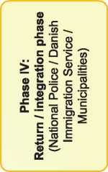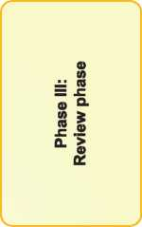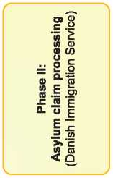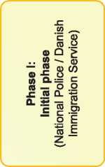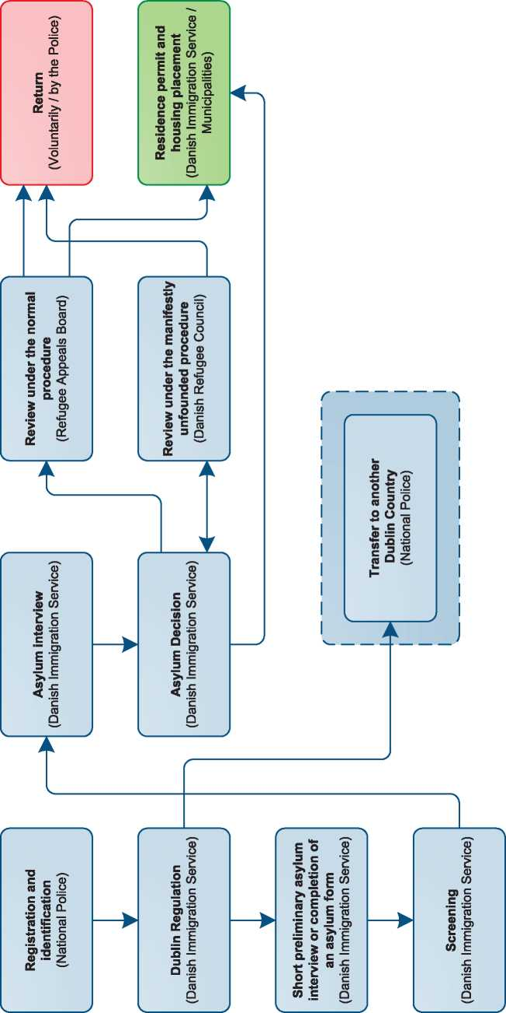

* 1. Additional Statistical Information

|  |  |  |  |  |  |  |  |  |  |  |
| --- | --- | --- | --- | --- | --- | --- | --- | --- | --- | --- |
| **Figure 4: Asylum Applications from Top 10 Countries of Origin in 2009, 2010, 2011 first half of 2012** | | | | | | | | | **and** |  |
|  | | **2009** |  | **2010** |  | **2011** |  | **Jan-Jun 2012** | |  |
|  | **1** | Afghanistan | 1,059 | Afghanistan | 1,512 | Afghanistan | 906 | Somalia | 472 |  |
|  | **2** | Syria | 383 | Syria | 832 | Iran | 462 | Syria | 368 |  |
|  | **3** | Russia | 341 | Iran | 614 | Syria | 429 | Afghanistan | 290 |  |
|  | **4** | Iran | 334 | Russia | 358 | Russia | 300 | Iran | 226 |  |
|  | **5** | Iraq | 309 | Iraq | 254 | Serbia | 192 | Russia | 208 |  |
|  | **6** | Somalia | 179 | Serbia | 247 | Kosovo | 128 | Serbia | 94 |  |
|  | **7** | Serbia | 151 | Kosovo | 162 | Iraq | 116 | Iraq | 71 |  |
|  | **8** | Kosovo | 124 | Somalia | 114 | Somalia | 113 | Stateless | 66 |  |
|  | **9** | Palestinian Stat. | 92 | Palestinian Stat. | 110 | Algeria | 104 | Algeria | 65 |  |
|  | **10** | Sri Lanka | 62 | Algeria | 51 | Palestinian Stat. | 69 | Nigeria | 60 |  |
|  | |  |  |  |  |  |  |  |  |  |

**Figure 5: Decisions Taken at the First Instance in 2009, 2010 and 2011**

|  |  |  |  |  |  |  |  |  |  |
| --- | --- | --- | --- | --- | --- | --- | --- | --- | --- |
|  | **Geneva Convention** | | **Subsidiary/**  **Complementary**  **Protection and**  **Humanitarian Status** | | **Rejections** | | **Withdrawn, Closed,**  **Abandoned Cases** | | **Grand**  **Total** |
| **Number** | **%** | **Number** | **%** | **Number** | **%** | **Number** | **%** | **1,574** |
| **2009** | 351 | 22% | 345 | 22% | 878 | 56% | 0 | 0% |
| **2010** | 666 | 21% | 514 | 16% | 1,939 | 62% | 0 | 0% | **3,119** |
| **2011** | 735 | 22% | 384 | 11% | 2,281 | 67% | 0 | 0% | **3,400** |

**Figure 6.a: Positive [77] First- and Second-Instance Decisions,Top Countries of Origin in 2009**

**Rate out of Total Decisions [78]**

|  |  |  |  |  |
| --- | --- | --- | --- | --- |
|  | | **Total Positive** | **Total Decisions** | **Rate** |
| 1 | Afghanistan | 193 | 361 | 53.5% |
| 2 | Syria | 132 | 192 | 68.8% |
| 3 | Iran | 130 | 206 | 63.1% |
| 4 | Iraq | 87 | 187 | 46.5% |
| 5 | Russia | 69 | 95 | 72.6% |
| 6 | Somalia | 17 | 33 | 51.5% |
| 7 | Palest. Stateless | 14 | 45 | 31.1% |
| 8 | Sudan | 6 | 14 | 42.9% |
| 9 | D.R. Congo | 6 | 14 | 42.9% |
| 10 | Myanmar | 5 | 10 | 50.0% |

Total Positive Decisions by Status

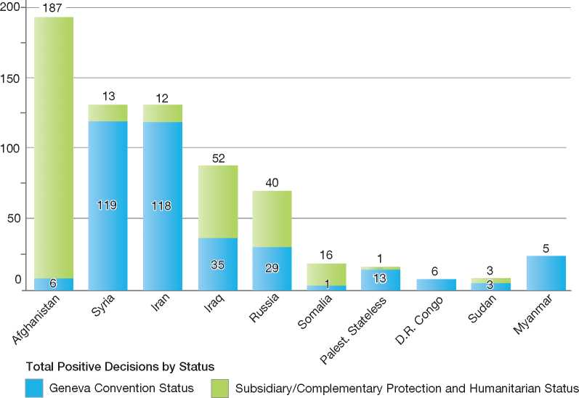

**Figure 6.b: Positive [79] First- and Second-Instance Decisions,Top Countries of Origin in 2010**

**Rate out of Total Decisions [80]**

|  |  |  |  |  |
| --- | --- | --- | --- | --- |
|  | | **Total Positive** | **Total Decisions** | **Rate** |
| 1 | Afghanistan | 412 | 1,009 | 40.8% |
| 2 | Syria | 344 | 594 | 57.9% |
| 3 | Iran | 208 | 329 | 63.2% |
| 4 | Russia | 99 | 153 | 64.7% |
| 5 | Somalia | 22 | 69 | 31.9% |
| 6 | Iraq | 21 | 93 | 22.6% |
| 7 | Eritrea | 14 | 23 | 60.9% |
| 8 | Azerbaijan | 9 | 19 | 47.4% |
| 9 | D.R. Congo | 8 | 21 | 38.1% |
| 10 | Myanmar | 7 | 19 | 36.8% |

Total Positive Decisions by Status

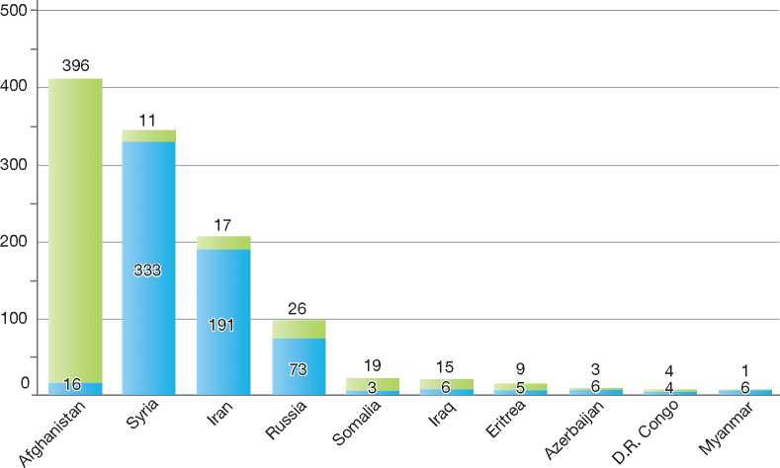

**Total Positive Decisions by Status**

Geneva Convention Status | | Subsidiary/Complementary Protection and Humanitarian Status

**Figure 6.c: Positive [81] First- and Second-Instance Decisions,Top Countries of Origin in 2011**

**Rate out of Total Decisions [82]**

|  |  |  |  |  |
| --- | --- | --- | --- | --- |
|  | | **Total Positive** | **Total Decisions** | **Rate** |
| 1 | Syria | 345 | 540 | 63.9% |
| 2 | Afghanistan | 297 | 1,146 | 25.9% |
| 3 | Iran | 249 | 519 | 48.0% |
| 4 | Russia | 97 | 215 | 45.1% |
| 5 | *Stateless | 65 | 104 | 62.5% |
| 6 | Iraq | 11 | 87 | 12.6% |
| 7 | Sudan | 9 | 20 | 45.0% |
| 8 | Eritrea | 7 | 15 | 46.7% |
| 9 | Sri Lanka | 5 | 24 | 20.8% |
| 10 | Somalia | 5 | 23 | 21.7% |
| 11 | North Korea | 5 | 5 | 100.0% |

Total Positive Decisions by Status

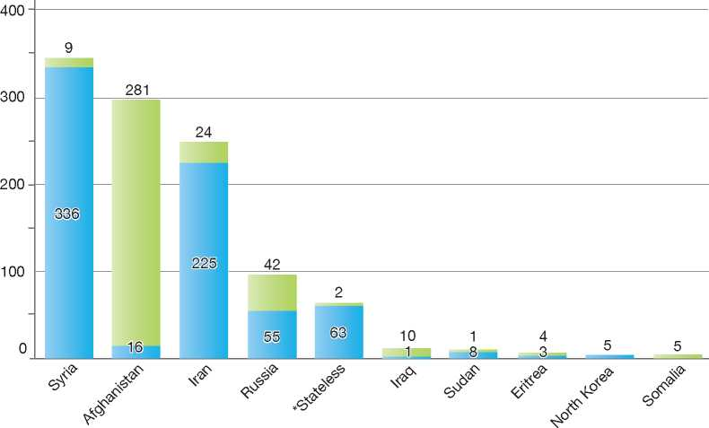

**Total Positive Decisions by Status**

| Geneva Convention Status | | Subsidiary/Complementary Protection and Humanitarian Status

1.

2.

3.

4.

5.

6.

7.

8.

9.

10.

11.

12.

Finland



BackGRound: MajoR asyluM tRends and developMents 153

national leGal FRaMewoRk 154

institutional FRaMewoRk 155

pRe-entRy MeasuRes 156

asyluM pRoceduRes 156

decision-MakinG and statuses 164

eFFiciency and inteGRity MeasuRes 167

assistance and Reception BeneFits FoR asyluM-seekeRs 169

status and peRMits GRanted outside the asyluM pRoceduRe 172

RetuRn 172

inteGRation 174

annexes

175



1. Background: Major Asylum Trends and Developments

Asylum Applications

Until the end of the 1980s, Finland received only a few asylum applications per year. However, the numbers started to increase significantly in 1990, when Finland received over 2,700 claims. In 1992 claims peaked at more than 3,600 applications. In 1993 the claims decreased to around 2,000 and dropped even further between 1994 and 1997, when Finland received fewer than 1,000 claims per year. In 1998 the number of claims increased again to over 1,000 and in 1999 and 2000 to over 3,000.

In 2001, the number of claims was around 1,500. Between 2002 and 2005, asylum applications numbered over 3,000. After that the annual inflow decreased to around 2,000 in 2006 and around 1,500 in 2007. The trend in 2008 and 2009, however, was one of an upward climb, with the number of claims reaching 4,035 and 5,910 respectively. This was then followed by another decrease in 2010 to 4,018 and in 2011 to 3,088.

Union (EU) candidate countries as Poland, the Slovak Republic and the Czech Republic. Since 2000, the majority of asylum-seekers have originated from Iraq, Russia, Somalia, Afghanistan, the former Yugoslavia and, prior to their membership in the European Union, from Bulgaria, Romania and the Slovak Republic.

Important Reforms

A number of important legislative and institutional reforms were introduced after the 1980s:

* The creation of the Directorate of Immigration in 1995 as the competent authority for making decisions on asylum claims at the first instance
* The transfer of responsibility for the asylum appeal procedure from the Asylum Appeals Board to the Helsinki Administrative Court in 1998
* The introduction of accelerated procedures for certain types of claims in 2000
* The transfer of responsibility for asylum interviews from the Police to the Directorate of Immigration in 2003

Figure 1: Total Asylum Applications by Quarter, January 1992 - June 2012

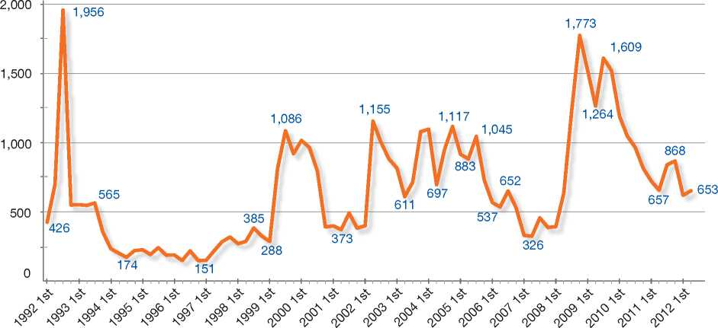

Top Nationalities

In the 1990s, the majority of asylum claims were made by nationals from Somalia, Russia and the former Yugoslavia. Towards the end of the 1990s, however, a large number of asylum­seekers came to Finland from such European • The introduction in 2007 of a legislative provision for tracing family members of unaccompanied minor asylum-seekers, to be undertaken in cooperation with the International Social Service.

While a new Aliens Act came into force in 2004, the asylum procedure remained largely unchanged.

In 2008, the Directorate of Immigration was renamed the Finnish Immigration Service and an Advisory Board for the Service was established. From 2010 to 2012, the Advisory Board was composed of representatives of both authorities and organisations, for a total of 16 interest groups. The Chair of the Advisory Board is the Director-General of the Finnish Immigration Service.

The 1951 Convention relating to the Status of Refugees and the European Convention on Human Rights (ECHR) have been transposed into Finnish law. The Government's asylum policy is committed to the full application of the 1951 Convention.

The requirements for granting asylum under the Aliens Act are virtually identical to those in

**Figure 2: Asylum Applications received from Top 5 Countries of Origin in 2009, 2010 and 2011**

2009

Volumes

42/

2010

Volumes

2011

Volumes

W W

20% 100/0

14%

12%

Distribution

|  |
| --- |
| **Country of Origin:** |
| Afghanistan Bulgaria Iran Iraq  | Russia Somalia Others |

12%

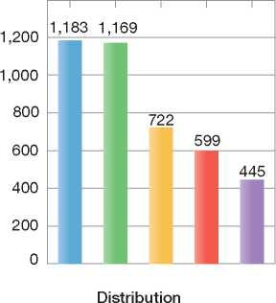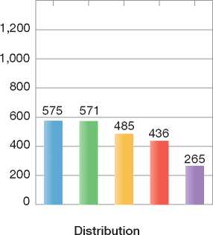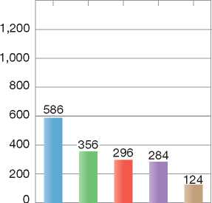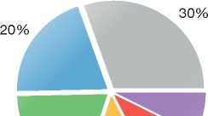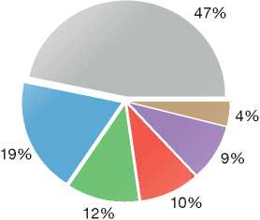

1. National Legal Framework
   1. Legal Basis for Granting Protection

The asylum procedure and the competencies of asylum institutions are governed by the Aliens Act (2004). The Act provides grounds for granting international protection as well as other, non-protection-related grounds for a residence permit, which must be considered during a single asylum procedure. the 1951 Convention. The Asylum Procedures Directive (2005/85/EC)1 came into effect on 1 June 2009. Also the Qualification Directive (2004/83/ EC)[83] [84] was transposed on 1 June 2009 through a legislative amendment to the Finnish Aliens Act. In transposing the Qualification Directive, thescope of the previous national legal provision for granting subsidiary protection was narrowed to meet the definition of subsidiary protection contained in the Directive. However, in order to retain the level of protection granted in Finland, a new third protection category (“humanitarian protection”) was introduced.

An overhaul of the Act on the Integration of Immigrants and Reception of Asylum-seekers (493/1999) took place, with the aim to differentiate integration from reception via two separate Acts.

The reception of asylum-seekers is governed by the Act on the Reception of Persons applying for International Protection, which came into effect on 1 September 2011. The Act entitles asylum­seekers to the safeguarding of basic needs such as accommodation, subsistence, social assistance, health care and other basic services. The Act also stipulates that persons applying for international protection and beneficiaries of temporary protection are provided with information about the reception services, rights and duties, legal aid and organisations providing assistance.

The new Integration Act entered into force on 1 September 2011 and now concerns all immigrants in Finland, not just refugees. The focus lies on the initial stages of integration. All immigrants are now provided with information about Finnish society, working life and citizens' rights and responsibilities.

* + 1. Pending Reforms

In line with the Programme of the Finnish Government presented in June 2012, the “Future of Immigration 2020” strategy is currently being updated with the aim to ensure a managed labour market and equal rights for all employees. These two elements of the reform are particularly important considering the increasingly international character of the labour market. The Government endeavours to increase the employment rate of immigrants, make integration policy more effective, accelerate the processing of asylum applications, and intensify the prevention of discrimination.

A government proposal to prohibit the detention of unaccompanied minor asylum-seekers was to be submitted in autumn 2012. Alternatives for detention will be explored in a project running until the end of 2013.

A project will be implemented to establish an assisted voluntary return system in Finland. The Act on the Reception of Persons applying for International Protection (746/2011) will be amended accordingly.

A permanent cooperation structure will be established to accelerate cooperation between the Finnish Immigration Service, the Police and the Border Guard. The objective is to speed up the processing of applications for international protection and to intensify the prevention of illegal migration, trafficking in human beings and evasion of entry provisions.

A project has been set up to increase the profitability of migration management, aiming at maximising the migration authorities' activities to achieve the savings required in the state administration's expenditure estimate.

1. Institutional Framework
   1. Principal Institutions

The Ministry of the Interior is responsible for Finland's migration policy, including issues of international protection, and the drafting of relevant legislation. Responsibility for integration affairs was transferred from the Ministry of the Interior to the Ministry of Employment and Economy on 1 January 2012.

The Finnish Border Guard receives asylum applications for international protection at points of entry and establishes the identity, travel route and means of entry of asylum-seekers. The District Police do the same for in-country applications for international protection. In addition, personal data on the applicant's family members and other relatives is collected. The Police or the Border Guard is responsible for the enforcement of decisions on refusal of entry or deportation, including the implementation of the decisions based on the application of the Dublin II Regulation[85]. The Border Guard is also mandated to make decisions on refusal of entry.

The District Police issue fixed-term and permanent residence permits to aliens, including beneficiaries of international protection or temporary protection.

The Finnish Immigration Service is the competent authority for examining and subsequently making a decision on asylum applications at the first instance, as well as granting residence permits to (resettled) quota refugees. The Finnish Immigration Service also determines refusals of entry and deportation and grants aliens' passports and travel documents for refugees. As of January 2010, competence and responsibility for the steering of reception centres has been handed over to the Service. The Finnish Immigration Service participates in international co-operation in its field of operation.

An appeal against a decision on international protection issued by the Finnish Immigration Service may be lodged before the Administrative Court of Helsinki.

The Supreme Administrative Court, provided it gives leave to appeal, hears appeals against decisions of the Helsinki Administrative Court.

The Ombudsman for Minorities may provide an opinion on an asylum case. The opinion of the Ombudsman is non-binding on the decision-making authorities. The Ombudsman must be notified when any decision is made on an asylum claim under the Finnish Aliens Act, when there is a refusal of entry into Finland, or when a removal order is issued. The Ombudsman must also be notified without delay of any decision to place a foreign national in detention. Furthermore, the Ombudsman must be notified, upon its request, of any other decision made under the Finnish Aliens Act.

1. Pre-entry Measures
   1. Visa Requirements

The entry of foreign nationals into Finland is subject to the provisions of the Finnish Aliens Act and the Schengen Acquis. As a rule, foreign nationals who need an entry visa are requested to apply for one at the Finnish mission that represents Finland in their home country. In countries where Finland does not have a mission, another Schengen country can represent Finland in visa matters.

* 1. Carrier Sanctions

Obligations and financial penalties on carriers are laid down in Chapter 11 of the Aliens Act. Carriers violating the obligations (obligation to report and obligation to provide information) are subject to a fine. The financial penalty may be annulled if the foreign national is granted permission to remain in Finland on protection grounds.

* 1. Interception

Finland does not carry out pre-departure clearance in countries of origin or transit.

1. Asylum Procedures
   1. Application Possibilities and Requirements, Procedures and Legal Remedies

All asylum-seekers have the right to enter the territory and to remain in Finland for the duration of the asylum procedure, and until an enforceable decision on refusal of entry has been made. Asylum-seekers have the right to be heard during the procedure and to enjoy basic legal guarantees such as interpretation and legal assistance.

Information on the procedures regarding international protection available to asylum­seekers (and the public at large) can be found in a number of different languages on the website of the Finnish Immigration Service, at <http://www.migri.fi/asylum_in_finland>.

* + 1. Outside the Country Applications at Diplomatic Missions

It is not possible to make an asylum application at or through Finnish diplomatic missions abroad. Nor is it possible to make an asylum application from abroad in writing, by post or electronic mail.

Resettlement/Quota Refugees

Finland has in place an annual resettlement programme to admit persons recognised as refugees by the United Nations High Commissioner for Refugees (UNHCR) and other persons in need of international protection, in accordance with section 90 of the Aliens Act. The annual quota is confirmed each year in the State budget. Since 2001, the resettlement programme has operated with an annual quota of 750 refugees.

The grounds for issuing a residence permit under the Finnish refugee quota are as follows:

* The person is in need of international protection with regard to the situation in his or her home country
* The person is in need of resettlement from the first country of asylum
* The requirements for admitting and integrating the person into Finland have been assessed
* There are no obstacles under section 36 of the Aliens Act (General requirements for issuing residence permits) to issuing a residence permit.

The selection of quota refugees is usually based on documentary information received from the UNHCR and interviews carried out during selection missions conducted under the direction of the Finnish Immigration Service at refugee camps or local UNHCR offices. Integration experts and representatives from the Finnish Security Intelligence Service also participate in interviews. The Finnish Immigration Service grants residence permits to refugees under the refugee quota after the quota selection mission.

One-tenth of the annual quota is reserved for emergency cases and persons whom the UNHCR has assessed to be in need of urgent resettlement. Finland selects these emergency cases without a personal interview on the basis of UNHCR documents.

In recent years, Finland has accepted Congolese from Rwanda, Iraqis from Syria and Jordan, Burmese from Thailand and Afghans from Iran under the quota refugee scheme.

* + 1. At Ports of Entry

An application for international protection may be lodged in person with the Police or with border control authorities (Finnish Border Guard) upon entry into the country or at police stations inside the territory immediately after entry.

* + 1. Inside the Territory

An application for international protection may be filed later than upon arrival in Finland under the following circumstances:

* The circumstances in the foreign national's home country or country of permanent residence have changed during his or her stay in Finland
* The person was not able to present a statement in support of his or her application any earlier
* Other reasonable grounds for making an application at a later time are applicable as per section 95 of the Aliens Act.

Responsibility for Processing the Claim

The Dublin System

*Application and Procedure*

Under the Dublin system, an asylum application filed in Finland may be transferred to be processed in another State party to the Dublin II Regulation[86].

Where another State party to the Dublin II Regulation is responsible for the examination of the asylum application, the Finnish Immigration Service will issue a decision to refuse the applicants entry into Finland and to transfer him or her to another State party.

*Freedom of Movement/Detention*

The grounds for detention outlined in the Aliens Act are applicable to all foreign nationals in Finland, including those who may be subject to a transfer according to the Dublin II Regulation. These grounds include reasons to believe that the person may prevent the carrying out of transfer or removal [87].

If there are no grounds for detention, persons whose claims are processed under the Dublin system enjoy freedom of movement.

*Conduct of Transfers*

The Police or Border Guard are responsible for the enforcement of decisions on refusal of entry or deportation, including the implementation of the decisions based on the application of the Dublin II Regulation.

*Suspension of Dublin Transfers*

An asylum-seeker who has received a decision of transfer of his or her application to another Dublin State may appeal the decision before the Helsinki Administrative Court to prevent the implementation of the decision to refuse entry. The administrative court can prevent the implementation of the decision or order that it be suspended.

In January 2011, the Finnish Immigration Service made a decision to stop returning asylum-seekers to Greece for an indefinite period on the basis of the Dublin Regulation. The decision was motivated by a ruling issued by the European Court of Human Rights on 21 January 2011 in the case of *M.S.S versus Belgium and Greece*. According to the ruling, Belgium violated the European Convention on Human Rights by returning asylum-seekers to Greece. The reasons given in this ruling included the deficiencies in the Greek asylum system, the country's poor reception conditions, and finally, inadequate detention and reception facilities.

*Review/Appeal*

Decisions on non-entry based on the Dublin II Regulation may be appealed before the Helsinki Administrative Court. A decision on refusal of entry may be implemented regardless of whether an appeal has been made, unless otherwise ordered by the Administrative Court.

Application and Admissibility

According to section 103 of the Aliens Act, the Finnish Immigration Service may deem an asylum application to be inadmissible under one of the following circumstances:

* The applicant has arrived from a safe country of asylum where he or she enjoyed or could have enjoyed protection and where he or she may be returned6
* The applicant may be sent to another State which, under the Dublin II Regulation, is responsible for processing the asylum application.

In such instances, the Finnish Immigration Service issues a decision on refusal of entry.

A decision of the Finnish Immigration Service on refusal of entry concerning an alien who has applied for a residence permit on the basis of international or temporary protection may not be enforced until a final decision has been issued on the matter, unless otherwise provided in the Aliens Act.

A decision on refusal of entry issued on the basis of the application of the Dublin II Regulation can be enforced as soon as the decision has been served on the applicant, unless otherwise ordered by the administrative court. This applies also to decisions made on the basis of a subsequent application or cancellation of an application for international protection.

A decision on refusal of entry concerning an alien who has arrived from a safe country of asylum or origin, or a decision on refusal of entry concerning an alien whose application is considered manifestly unfounded, may be enforced at the earliest on the eighth day from service of the decision on the applicant, unless otherwise ordered by an administrative court. Before the enforcement, it shall be ensured that the eight-day period contains at least five working days.

Accelerated Procedures

Asylum applications may be processed under either the normal procedure or an accelerated procedure. The Finnish Immigration Service is competent for making a decision on which procedure is applied in each case. The Police or the Border Guard may inform the Immigration Service if they have identified reasons for handling the application in an urgent fashion.

Applying an Accelerated Procedure

An asylum application may be examined under an accelerated procedure in one of the following instances:

* The applicant comes from a safe country of origin, as defined in section 100 of the Aliens Act, where he or she is not at risk of treatment referred to in section 87 or 88 and where he or she may be returned7
* The application is considered to be manifestly unfounded
* The applicant has filed a subsequent application that does not contain any new grounds for remaining in Finland that would influence the decision on the matter.

According to section 104 of the Aliens Act, where the safe country of origin or safe country of asylum principle is applicable, the Finnish Immigration Service must make a determination on the claim within seven days of the date upon which the minutes of the interview were completed and the information on their completion entered into the Register of Aliens.

While asylum-seekers whose applications are being examined under an accelerated procedure



have the same rights and obligations as other asylum-seekers, in the case of subsequent applications, a decision may be issued without organising an asylum interview[88].

Manifestly Unfounded Applications

The Finnish Immigration Service may decide that an application is manifestly unfounded if the application does not raise grounds for protection related to serious human rights violations or the application has been made with an obvious misuse of the asylum process.

While manifestly unfounded cases are subject to an accelerated procedure, there is no time limit for the authorities to make a decision. In the guidelines concerning asylum procedures, it is stated that, *inter alia*, applications considered manifestly unfounded must be processed urgently. Usually a decision to reject an application on the basis that it is manifestly unfounded is a decision of refusal of entry.

An application may be rejected as manifestly unfounded in one of the following instances:

* No grounds for protection or against *refoulement* have been presented
* The claims presented in the application are clearly implausible
* The applicant clearly intends to abuse the asylum procedure:
* by deliberately giving false, misleading or deficient information on matters that are essential to the decision on the application
* by presenting forged documents without an acceptable reason
* by impeding the establishment of the grounds for his or her application in another fraudulent manner
* by filing an application after a procedure for removing him or her from the country has begun, to prolong his or her unfounded residence in the country
* The applicant comes from a safe country of asylum or origin where he or she may be returned, and the Finnish Immigration Service has, for serious reasons, not been able to issue a decision on the application within the time limit (of seven days) laid down in section 104 of the Aliens Act.

Normal Procedure

After the Police or Border Guard has established the identity, travel route and means of entry of the asylum-seeker, the asylum application is examined by the Finnish Immigration Service.

The Immigration Service conducts an interview with the asylum-seeker[89]. The purpose of the interview is to determine whether there are protection-related or non-protection-related grounds for granting a residence permit. Thereafter, a written report of the interview is provided to the applicant.

The requirements for issuing a residence permit are assessed individually for each applicant by taking into account both the applicant's statements on his or her circumstances as well as relevant country of origin information.

Upon request, the Ombudsman for Minorities has the right to be heard in an individual matter concerning an asylum applicant. The Finnish Immigration Service may, on a case-by-case basis, set a reasonable deadline for the issuing of an opinion by the Ombudsman for Minorities.

Review/Appeal of Finnish Immigration Service Decisions

Helsinki Administrative Court

A decision of the Finnish Immigration Service may be appealed before the Administrative Court of Helsinki if the decision pertains to:

* Rejection of an application for a residence permit on the basis of asylum, subsidiary protection or humanitarian protection
* Rejection of an application for temporary protection
* Removal from the country, prohibition of entry or cancellation of a travel document issued in Finland, and the decision relates to a rejection under the asylum procedure or procedure related to temporary protection
* Withdrawal of refugee status and cancellation of refugee travel document or withdrawal of subsidiary protection status and cancellation of alien's passport

• Cancellation of refugee status and refugee travel document or cancellation of subsidiary protection status and alien's passport.

The time limit for making an appeal is 30 days following the initial decision served on the applicant. The decision becomes legally valid when the appeal period expires.

Supreme Administrative Court

The decision of the Administrative Court may be appealed to the Supreme Administrative Court if the latter gives leave to appeal. A leave to appeal may be granted if the decision is important to other similar cases, for either the sake of consistency in legal practice or for another compelling reason for granting leave.

Freedom of Movement during the Normal Procedure

According to section 7 of the Constitution of Finland and section 41 of the Aliens Act, foreign nationals residing legally in Finland have the right to move freely within the country and to choose their place of residence. According to section 40 of the Aliens Act, an asylum-seeker may reside legally in the country while his or her application is being processed and until there has been a final decision on the claim or an enforceable decision on his or her removal from the country.

If an asylum-seeker leaves Finland during the asylum procedure and does not inform the authorities, the application may be regarded as implicitly withdrawn.

Detention

*Grounds for Detention*

Alternatives to detention must be considered before a decision is made on whether or not to detain an asylum-seeker. Measures such as reporting requirements, handing over travel documents to authorities and paying a financial guarantee[90] [91] equivalent to the cost of accommodation or return may be considered as valid alternatives.

The Police and Border Guard are competent for making a decision on placing a foreign national in detention. The official responsible for a decision to place a foreign national in detention or, exceptionally, in police detention facilities, must, without delay and no later than the day after the person was placed in detention, notify the District Court of the municipality where the person is being detained. The District Court must hear a matter concerning the detention of a foreign national without delay and no later than four days following the date when the person was placed in detention. In the case of a person being placed in a police detention facility, the matter must be heard without delay and no later than 24 hours after the Court has received the notification of detention.

According to section 121 of the Aliens Act, a foreign national may be detained under one of the following circumstances:

* Taking into account personal and other circumstances, there are reasonable grounds to believe that the person will prevent or considerably hinder the implementation of a decision to remove him or her from Finland
* Holding a person in detention is necessary for establishing his or her identity11
* Taking into account the person's personal and other circumstances, there are reasonable grounds to believe that he or she will commit an offence in Finland.

Asylum-seekers may be detained in detention units or Police or Border Guard detention facilities, in accordance with the Aliens Act. Persons are detained in Police or Border Guard facilities[92] only if detention units are at full capacity or there are practical impediments to holding the person in a detention unit. A minor may be placed in a Police or Border Guard detention facility only if his or her legal guardian or other adult member of the family is being held in the same detention facility.

The detained person or his or her legal representative must be informed of the grounds for detention. In the case of a minor under the age of 18, the representative of social welfare authorities may be heard before a decision on detention is made.

As described under section 2.2, the detention of unaccompanied minor asylum-seekers will be prohibited and alternatives for detention will be put in place.

On 1 April 2011, the Finnish Aliens Act was amended in accordance with the Return Directive[93]. The amendments stipulate that a foreigner may be kept in detention for a maximum of six months. This term may be extended up to 12 months in cases where the removal operation is likely to last longer, due to a lack of cooperation by the detained third- country national concerned or to delays in obtaining the necessary documentation from third countries.

*Judicial Review*

Judicial review of a decision to detain an asylum­seeker is enshrined in the Aliens Act. If the release of a detained person has not been ordered, the District Court will, at its own initiative, always rehear the matter concerning the detention no later than two weeks after the initial decision made by the District Court to prolong the detention.

Reporting

*General Reporting Requirements*

The Aliens Act stipulates that a person whose case is being processed by the authorities must provide them with his or her contact information and any changes to such information.

An asylum-seeker living in private accommodation must inform the reception centre of his or her address and any changes to this address. If the reception centre does not know the correct address, payment of living allowances cannot be made.

*Specific Reporting Requirements*

A foreign national may be required to report to the Police or Border Guard authorities at regular intervals in one of the following cases:

* Reporting is necessary in order to establish that he or she meets the requirements for entry into the country
* Reporting is necessary in order to prepare or ensure the enforcement of a decision on removing the person from the country, or for otherwise supervising the foreign national's departure from the country.

The reporting requirement is in force until it has been established that the person meets the requirements for entry, a decision on removal has been enforced, or the processing of the matter has otherwise ended. However, the reporting requirement must come to an end when it is no longer necessary for ensuring the issuance or enforcement of a decision.

Subsequent Applications

A subsequent application is an application for international protection made by a foreign national still residing in Finland, after his or her previous application was rejected by the Finnish Immigration Service or an administrative court. A subsequent application can also be filed by a foreign national who has left the country for a short time following a negative decision on his or her previous claim.

If a new application is filed while the matter is still being processed, the information given by the applicant is submitted to the authorities processing the matter and is to be considered a new statement in the matter.

According to the Aliens Act, a decision on a subsequent application may be issued without an asylum interview. A subsequent application which does not contain any new grounds for remaining in Finland that would influence the decision on the matter may be processed in an accelerated procedure. A decision on refusal of entry may be enforced immediately, unless otherwise ordered by an administrative court.

1. Safe Country Concepts
2. Safe Country of Origin

When making a decision on an asylum application, the Finnish Immigration Service may determine that the asylum-seeker's country of origin is a safe country of origin - that is he or she is not at risk of persecution or serious human rights violations in that particular country.

When assessing whether a country may be considered a safe country of origin, the following aspects must be taken into account:

* Whether the state has a stable and democratic political system
* Whether the state has an independent and impartial judicial system and the administration of justice meets the requirements for a fair trial, and

• Whether the state has signed and adheres to the main international conventions on human rights, and no serious violations of human rights have taken place in the state.

Procedure

If the applicant is considered to come from a safe country of origin, a decision on the application must be made within seven days of the date when the minutes of the interview were completed and the information regarding their completion was entered into the Register of Aliens.

A list of safe countries does not exist. The assessment is always made individually for each applicant. The grounds presented by the applicant and all specific factors implying that the country concerned might not be safe for the applicant are taken into consideration when deciding on the case.

When the decision on the application has been made on the basis of the notion of a safe country of origin, the decision on refusal of entry can be enforced eight days after serving the decision on the applicant. An appeal to the Administrative Court of Helsinki will not suspend the enforcement, unless it is otherwise ordered by the Court.

Asylum Applications Made by Citizens of the European Union

Finland observes the Protocol on Asylum for Nationals of Member States of the European Union annexed to the Treaty of Amsterdam and therefore presumes that, as the Protocol states, EU Member States are considered to be safe countries of origin.

Nevertheless, according to Finnish law, all applications made by EU citizens are examined on their merits, under an accelerated procedure.

The Finnish Immigration Service must notify the Ministry of the Interior immediately of any application for asylum made by a citizen of the European Union, if it does not consider the state in question to be a safe country of origin for the applicant and if it does not apply sections 103(2) (1) and 104 of the Aliens Act to a decision on the application. The Ministry of the Interior then notifies the Council of the European Union of the matter.

1. Safe Country of Asylum

The criteria and procedure for the application of the notion of “safe country of asylum” are laid down in the Aliens Act. The notions of “first country of asylum” and “safe third country” are not found in the Act. However, the notion of “safe country of asylum” covers both situations since a reference is made in the definition to a country in which an asylum-seeker enjoyed or could have enjoyed protection and where he or she may be returned.

When deciding on an application in the asylum procedure, a state may be considered to be a safe country of asylum for the applicant if it is a signatory, without geographical reservations, to the Convention relating to the Status of Refugees, the International Covenant on Civil and Political Rights and the U.N. Convention against Torture and Other Cruel, Inhuman or Degrading Treatment or Punishment and it adheres to them.

Procedure

An application for international protection may be dismissed if the applicant has arrived from a safe country of asylum. The Finnish Immigration Service has to make a decision on the application within seven days of the date when the minutes of the interview were completed and the information on their completion was entered in the Register of Aliens.

There are no lists of safe countries. The assessment is always made individually for each applicant. The grounds presented by the applicant and all specific factors implying that the country concerned might not be safe for the applicant are taken into consideration when deciding on the case.

When the decision on the application has been made on the basis of the notion of a safe country of asylum, the decision on refusal of entry can be enforced eight days after serving the decision on the applicant. An appeal to the Administrative Court of Helsinki will not suspend the enforcement, unless otherwise ordered by the Court.

1. Special Procedures
2. Unaccompanied Minors

All unaccompanied minor asylum-seekers have access to the asylum procedure.

In any decision issued under the Aliens Act that concerns a minor under 18, special attention must be paid to the best interests of the child and to circumstances related to the child's development and health. Before a decision is made concerning a child who is at least twelve years old, the child shall be heard unless such hearing is manifestlyunnecessary. The child's views shall be taken into account in accordance with his or her age and level of development. A younger child may also be heard if he or she is sufficiently mature to have his or her views taken into account. Matters concerning minors shall be processed with urgency. The Act on the Reception of Persons Applying for International Protection also pays special attention to the best interests of the child and to matters concerning his or her development and health.

The Finnish Immigration Service has produced interview guidelines for unaccompanied minor asylum-seekers. Unaccompanied minor asylum­seekers are interviewed and their applications are investigated by specially trained personnel of the Finnish Immigration Service.

Since the legislative amendment of the Aliens Act in 2007, the Finnish Immigration Service aims to trace without delay an unaccompanied minor asylum-seeker's parents or legal guardians.

Legal Representation

According to the Act on the Reception of Persons Applying for International Protection, a representative is appointed without delay for a child who is applying for international protection, for a child granted temporary protection status and for a child victim of trafficking in human beings. The representative is appointed by the district court in the judicial district of the reception centre where the child is registered.

The representative's task is to supervise the interests of the child during the asylum procedure. It is not the representative's function to look after the daily or other care or upbringing of the child. A representative is always present at the interview of an unaccompanied minor asylum-seeker.

Age Determination

A medical age assessment may be carried out at the request of the Police, Border Guard or Finnish Immigration Service to establish the age of an applicant, if there are reasonable grounds for suspecting the reliability of the information the applicant has provided on his or her age. While participation is voluntary, anyone who refuses to undergo an examination is treated as an adult, if there are no reasonable grounds for refusal. A refusal to undergo an examination may not as such constitute grounds for rejecting an application for international protection.

1. 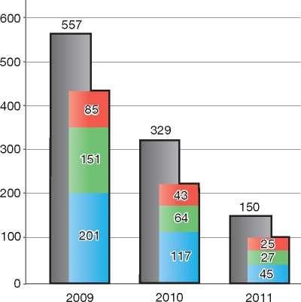Temporary Group-Based

| **Figure 3: Asylum Applications by Unaccompanied Minors in 2009, 2010 and 2011** | | | |
| --- | --- | --- | --- |
|  | **2009** | **2010** | **2011** |
| Total Asylum Applications | 5,910 | 4,018 | 3,088 |
| of which Unaccompanied Minors | 557 | 329 | 150 |
| Percentage | 9% | 8% | 5% |

Country of Origin:

Afghanistan Iraq J Somalia

Protection

The Aliens Act was amended in 2002 in order to implement the essential provisions of the EU Temporary Protection Directive[94]. Temporary protection may be given to persons who need international protection and who cannot return safely to their home country or country of permanent residence because there has been a massive displacement of people in the country or its neighbouring areas as a result of an armed conflict, some other violent situation or an environmental disaster. Providing temporary protection requires that the need for protection be considered to be of short duration.

Temporary protection lasts for a maximum of three years in total. Foreign nationals in need of temporary protection are issued a residence permit for a maximum of one year at a time.

1. Stateless Persons

Stateless persons may make asylum applications in Finland according to the same procedures as other asylum-seekers.

Finland recently ratified the UN Convention on the Reduction of Statelessness and the European Convention on Nationality. In the asylum procedure, statelessness is taken duly into account when assessing whether the applicant can receive protection in another country. If no such country exists for this particular applicant, he or she will be given the appropriate status in Finland. According to the Aliens Act, alien's passports may be issued to individuals without citizenship. Stateless persons who are granted refugee status are issued a refugee travel document.

1. Decision-Making and Statuses
   1. Inclusion Criteria
      1. Convention Refugee

Section 87 of the Aliens Act sets out the criteria for granting asylum in line with the criteria laid out in Article 1A (2) of the 1951 Convention.

Asylum is defined in section 3 of the Aliens Act to mean a residence permit issued to a refugee under the asylum procedure. A person acknowledged as a refugee is granted refugee status.

* + 1. Complementary Forms of Protection

If an asylum-seeker does not meet the criteria for refugee status, he or she may be granted a complementary form of protection: either subsidiary protection or humanitarian protection.

Subsidiary protection may be granted where there are substantial grounds to believe that the person concerned, if returned to his or her country of origin or country of former habitual residence, would face a real risk of being subjected to serious harm, and is unable, or owing to such risk, unwilling to avail himself or herself of the protection of that country. Serious harm is defined as:

* The death penalty or execution
* Torture or other inhuman or degrading treatment or punishment
* Serious and individual threat as a result of indiscriminate violence in situations of international or internal armed conflict.

An alien residing in Finland is issued with a residence permit on the basis of humanitarian protection, if there are no grounds for granting asylum or providing subsidiary protection, but he or she cannot return to his or her country of origin or country of former habitual residence as a result of an environmental catastrophe or a serious security situation which may be due to an international or internal armed conflict or a poor human rights situation.

* + 1. Non-Protection-Related Statuses

As Finland applies a single procedure, all grounds - both protection and non-protection-related - are examined when determining whether an asylum­seeker may be granted a residence permit. The most common non-protection-related grounds for the issuance of a residence permit are as follows:

* Compassionate grounds - According to section 52 of the Aliens Act, foreign nationals residing in Finland may be issued a continuous residence permit if refusing a residence permit would be manifestly unreasonable in view of their health, their ties to Finland or other compassionate grounds, particularly in consideration of their vulnerable position or the circumstances they would face in their home country
* Cases where foreign nationals cannot be removed from the country - Persons residing in Finland are issued with a temporary residence permit if they cannot be returned to their home country or country of permanent residence for temporary reasons of health or if they cannot actually be removed from the country (i.e. there are practical impediments to the removal)
* Family ties in Finland
* Ongoing studies undertaken in Finland
* Ongoing employment or self-employment in Finland.
  1. The Decision

The requirements for issuing a residence permit are assessed individually for each applicant by taking account of the applicant's statements regarding his or her circumstances in the State in question and of current country of origin information obtained from various sources.

After considering the merits of the claim, the Finnish Immigration Service caseworker submits a proposal for a decision to his or her supervisor (the Head of Section), who will make the final decision. The decision is always made in writing. The reasons, both in fact and in law, are stated in the decision. Furthermore, information on how to challenge a negative decision is given in writing. The decision is then sent to the Police in the asylum-seeker's place of residence, who are responsible for serving the decision to the applicant.

The applicant is entitled to receive the decision concerning his or her application in his or her native language or in a language that the applicant can be presumed to understand. The notification of a decision will be made through interpretation or translation.

If the application is rejected, a decision on refusal of entry or deportation is issued at the same time, unless special reasons have arisen for not enforcing a decision on removing the applicant from the country.

The Ombudsman for Minorities is notified of any decision under the Aliens Act on issuing a residence permit on the basis of international or temporary protection, on refusing an applicant entry or on finally deporting the applicant.

* 1. Types of Decisions, Statuses and Benefits Granted

The Finnish Immigration Service may take one of the following decisions:

* Grant Convention refugee status (Aliens Act, section 87)
* Issue a residence permit on the basis of subsidiary protection or humanitarian protection (Aliens Act, sections 88 and 88a)
* Grant a residence permit on other non­protection-related grounds
* Reject the application with a refusal of entry.

The Immigration Service may reject an application for protection with a refusal of entry if the following is applicable:

* The application does not present merits for granting asylum or a complementary form of protection
* The situation in the asylum-seeker's country of origin or country of permanent residence does not warrant the need for international protection, and

• The applicant cannot be granted a residence permit on any non-protection-related ground.

Benefits

Persons who have been granted international protection are allowed to work and have access to social assistance, health care and accommodation. Their integration into Finnish society is supported by local authorities. Finally, they also have the right to family reunification for nuclear family members[95].

Duration of residence permits

Residence permits issued in Finland are either fixed-term or permanent. Fixed-term permits are further broken down into two categories: temporary and continuous. Initial fixed-term residence permits are in most cases issued for one year, although for no longer than the validity period of the travel document. In certain cases, an initial fixed-term residence permit may be issued for a period longer or shorter than one year. These situations are regulated in section 53 of the Aliens Act.

Recognised refugees and beneficiaries of complementary forms of protection are first issued a fixed-term continuous residence permit (type A). A residence permit on the basis of refugee status or subsidiary protection is issued for four years while a residence permit on the basis of humanitarian protection is issued for one year. A new fixed-term residence permit is issued if the grounds for issuing the initial fixed-term residence permit are still valid.

All foreign nationals may become eligible for a permanent residence permit (type P) after having resided legally in Finland for a continuous period of four years, and if the grounds for issuing a continuous residence permit remain valid and there are no obstacles to issuing a permanent residence permit under the Finnish Aliens Act.

A refugee travel document is issued to a person who has been granted refugee status. A person who has been issued a residence permit on the basis of subsidiary protection is issued an Alien's passport.

* 1. Exclusion

The Finnish Immigration Service considers Article 1F of the 1951 Convention when examining a claim for both Convention refugee status and complementary forms of protection. Exclusion clauses are included in sections 87 (2), 88 (2) and 88a (2) of the Aliens Act.

According to the Aliens Act, foreign nationals residing in Finland who are not granted asylum or a residence permit on the basis of subsidiary protection or humanitarian protection because they have committed, or there are reasonable grounds to suspect that they have committed, an act referred to in Article 1F of the 1951 Convention, are issued a temporary residence permit for a maximum of one year at a time, if they cannot be removed from the country because they are under threat of the death penalty, torture, persecution or other treatment violating human dignity. The residence permit can be renewed and can become permanent.

* 1. Cessation

According to section 107 of the Aliens Act, a person's refugee status may be withdrawn if he or she meets one of the criteria set out in Article 1C of the 1951 Convention. Subsidiary protection status may be withdrawn if circumstances which led to the granting of subsidiary protection have ceased or changed to such an extent that protection is no longer needed. Cessation requires that the change of circumstances be significant and non-temporary.

When considering a withdrawal of refugee status or subsidiary protection status, an individual investigation shall be conducted.

When cessation of asylum is decided, the refugee or beneficiary of subsidiary protection may defend his or her case. The decision of the Finnish Immigration Service may be appealed to the Administrative Court of Helsinki and further to the Supreme Administrative Court, if leave is granted.

* 1. Revocation

According to the Aliens Act (section 108), refugee status and subsidiary protection status are cancelled if the applicant has, when applying for international protection, deliberately or knowingly given false information that has affected the outcome of the decision, or concealed a fact that would have affected the outcome of the decision.

A fixed-term or permanent residence permit may be cancelled if false information on the person's identity or other matters relevant to the decision was knowingly given when the permit was applied for, or if information that might have prevented the issue of the residence permit was concealed. A fixed-term residence permit may also be cancelled if the grounds on which the permit was issued no longer exist.

In addition, a fixed-term or permanent residence permit may be cancelled if the person has moved out of the country permanently or has continuously resided outside Finland for two years for permanent purposes.

There is no time limit for the application of revocation.

* 1. Support and Tools for Decision-Makers
     1. Country of Origin Information

The Country Information Service is a subunit of the Legal Service and Country Information Unit within the Finnish Immigration Service. The Country Information Service produces thematic reports and answers to individual country information requests, primarily for use by caseworkers but also by asylum policy-makers and appeal bodies. In addition, the Country Information Service has undertaken a small number of fact-finding missions in recent years and has experimented with other efficient types of information gathering, such as cooperation with the offices of the International Organization for Migration (IOM) in the field. The information is compiled by impartial researchers who obtain the information independently of individual decisions concerning international protection.

The TELLUS Country of Origin Information database maintained by the Country Information Service is available to all decision-makers at the Finnish Immigration Service as well as to various external stakeholders, including the local register offices, police departments across the country, and administrative courts. A project co-sponsored by the European Refugee Fund intends to integrate the TELLUS Country of Origin Information database of the Finnish Immigration Service into the European Union's Country of Origin Information portal by the end of 2012.

The Country Information Service also manages the up-to-date collection of the Migration Library, which is accessible to all Immigration Service staff. The Country Information Service is also involved in training decision-makers and new Finnish Immigration Service staff on the use of country of origin information.

* + 1. Other Support Tools

If there is a special need for a common policy on how to handle claims of certain refugee groups, the Legal Service within the Finnish Immigration Service can provide such guidance. Their general recommendations are guidelines for decision­makers, but they must be checked in each situation to determine whether or not this general guidance is applicable to a particular case.

Training of decision-makers takes place on a variety of aspects of the work, including interview techniques and legal issues.

Decision-makers have access to an electronic database, Legis, where all key cases are stored. The UNHCR Handbook on Procedures and Criteria for Determining Refugee Status is made available to every decision-maker, while UNHCR's Refworld website of all asylum- and refugee-related documentation also remains in general use.



Training on Vulnerable Groups

The officers of the Finnish Immigration Service asylum unit receive training on vulnerable groups based on EAC (European Asylum Curriculum) and ELENA (European Legal Network on Asylum) courses. In addition, the Finnish Association for Sexual Equality has trained immigration officers with regard to problems encountered by individuals who are persecuted because of their sexual orientation. The training is focused on sexual orientation issues, basic concepts concerning sexual identity and appropriate interview practices.

If during the asylum process there are grounds to believe that the applicant in reality originates from elsewhere than the claimed area of origin, a language analysis may be conducted. This can occur when, for example, the information the applicant gives on the claimed place of origin is insufficient or false. For the language analysis, external service providers from Sweden are contracted. These service providers employ qualified linguists, interpreters and mother-tongue speakers in their analysis. A few hundred analyses are conducted every year.

1. Efficiency and Integrity Measures
   1. Technological Tools
      1. Fingerprinting

According to the Aliens Act, for the purposes of identification and registration, the Police or Border Guard take fingerprints and a photograph and record other personal descriptions of each applicant.

* + 1. DNA Tests

The Finnish Immigration Service may provide the person with an opportunity to undergo a DNA analysis, if no other adequate evidence of family ties is available. DNA testing is suggested only where there are no reliable documents to prove family ties. Usually, the applicant and the family member are first heard either in writing or in person. After the hearing, the Finnish Immigration Service decides whether or not DNA analysis is needed.

* + 1. Forensic Testing of

Documents

If a document is suspected to be false or forged, it can be sent to the Crime Laboratory of the National Bureau of Investigation (Police). The Police will undertake an analysis and provide a statement about the authenticity of the documents.

* + 1. Database of Asylum Applications/Applicants

Personal distinguishing marks (such as fingerprints) taken by the Police or Border Guard are registered in the Police identification register.

The Finnish Immigration Service maintains the Register of Aliens, which contains, among other things, the following information:

* Identification data regarding the applicant
* Data regarding the application, declaration or inquiry
* Data collected while processing the application
* Decisions and grounds for the decisions
* Contact information for family members or sponsors.

The UMA Electronic Case Management System

UMA is the new electronic case-management system for all immigration processes, including asylum. The cross- administrative UMA system handles affairs pertaining to applications for citizenship, residence permits and asylum, as well as affairs pertaining to removal and interim measures.

UMA shortens processing times, lowers costs and reduces overlapping processes by enabling incoming information to be recorded only once. As the various administrative bodies share the same system, the process consequently promotes both transparency and accuracy. Steering and monitoring of the tasks handled jointly by various authorities creates a more manageable breakdown of tasks. Finally, the electronic handling of documents saves postage and stationery costs and thus proves to be environmentally friendly.

Through UMA, opportunities are being created for customers to electronically submit certain applications and to complete and monitor them via the internet. At the moment these services are only available to students applying for their first residence permit, but the electronic services are being extended gradually.

The Umarek register for reception of asylum-seekers

The Umarek system is a register of persons residing in reception centres and private accommodation that allows all services (social, healthcare, detention, and services for victims of trafficking) to be processed electronically. While separate in terms of functions, legislative basis and user rights, the Umarek register is technically integrated into the UMA system.

The Register of Aliens contains six sub-registers, the main controllers of which are the Finnish Immigration Service and the Ministry for Foreign Affairs. The register is also maintained and used by the Police, the Border Guard, the Reception Centres, the Customs authority, the Employment and Economic Development Centres, the Employment Offices, the Prison Administration Authority and the Ombudsman for Minorities.

The Register of Aliens has now been integrated in the electronic case management system called UMA.

* + 1. Others

Finland makes use of other pre-entry technology, including a system to detect fraudulent documents and a fingerprint-check system, as well as registers to trace stolen documents.

The Finnish Border Guard and the Crime Laboratory of the National Bureau of Investigation (Police) possess a large reference system on fraudulent documents.

* 1. Length of Procedures

There are no time limits for submitting an asylum application. In principle, an application must be made upon entry into the country or as soon as possible after entry. Section 95(2) of the Aliens Act lays down situations in which an application may be filed at a later date.

Asylum applications may be processed under either the normal procedure or an accelerated procedure. If the applicant is considered to come from a safe country of asylum or origin, a decision on the application must be made within seven days of the date when the minutes of the interview are completed and the information on their completion is entered in the Register of Aliens. Otherwise, there are no time limits for processing asylum applications laid down in the Aliens Act[96].

In 2011, the average time for processing an asylum application was 263 days. The average time for processing an asylum application under the normal procedure was 370 days and 97 days under the accelerated procedure. An asylum application lodged by an unaccompanied minor was processed in 298 days.

The Finnish Immigration Service prioritises the examination of certain asylum applications (such as those from unaccompanied minors and other vulnerable persons) based on its internal instructions.

* 1. Pending Cases

As at 30 September 2012, there were 1,963 pending asylum cases at the Finnish Immigration Service.

* 1. Information Sharing

According to the Act on the Openness of Government Activities (621/1999), documents concerning a refugee or an asylum-seeker are treated as secret, unless it is obvious that access will not compromise the safety of the refugee, the applicant or a person closely involved with them. An authority may provide access to a secret official document if there is a specific provision on such access or on the right of such access in an Act, or if the person whose interests are protected by the secrecy provision consents to the access.

The Act on the Openness of Government Activities contains provisions on the right of access to officialdocuments in the public domain, officials' duty of non-disclosure, document secrecy, and any other restrictions on access that are necessary for the protection of public or private interests, as well as on the duties of the authorities for the achievement of the objectives of this Act. The Act does not include provisions concerning information exchange on asylum-seekers. Instead, it sets the general framework for activities of the authorities.

Information can be shared in accordance with the Dublin Regulation.

UNHCR and legal counsellors are provided access to the file of an asylum-seeker when the applicant has given consent.

* 1. Single Procedure

Finland applies a single asylum procedure. According to section 94 of the Aliens Act, granting the right of residence is also investigated and decided on other emerging grounds (complementary forms of protection or non­protection-related grounds) in conjunction with the asylum procedure.

1. Assistance and Reception Benefits for Asylum-Seekers
   1. Procedural Support and Safeguards
      1. Legal Assistance

Asylum-seekers are allowed to use the services of a legal counsel throughout the asylum process. However, there is no obligation in the national legislation to provide a legal counsel. In practice, authorities provide asylum-seekers with assistance in contacting a legal counsel. The reception centres inform asylum-seekers regarding the possibility of using legal counsel and free legal aid. Asylum­seekers may also contact the Ombudsman for Minorities for advice on legal assistance.

An asylum-seeker's right to legal aid is laid down in the Legal Aid Act. According to the Act, applicants are eligible for free legal aid only at the appeal stage. Legal aid may be given if the person has a matter to be heard before a Finnish court of law. Legal aid is provided by Legal Aid Offices as well as other law firms and attorneys that are listed with the reception centre as providers of legal aid services for asylum-seekers. A court may grant legal aid to asylum-seekers without requiring a statement on their financial situation. The legal aid is paid out of state funds.

* + 1. Interpreters

The Aliens Act stipulates that interpretation or translation shall be provided if the foreign national does not understand the Finnish or Swedish language, or if he or she, because of a disability or an illness, cannot be understood. Interpretation is provided at all stages of the asylum procedure. The person has the right to be notified of a decision concerning him or her in his or her mother tongue or in a language which - on reasonable grounds - he or she can be expected to understand. A decision is given through interpretation or translation.

* + 1. UNHCR

The UNHCR Regional Office for the Baltic-Nordic Region, located in Stockholm, has no formal role in the asylum procedure. However, upon the request of a party in the procedure, the UNHCR may provide updated country of origin information, legal advice or UNHCR recommendations and guidelines. In exceptional precedent-setting cases, the UNHCR may submit *amicus curiae* to the last instance body. In line with Article 35 of the 1951 Convention, asylum-seekers have access to the UNHCR, which is entitled to request and obtain information on individual applications (based on the consent of the asylum-seeker) and to present its views on individual claims to the decision-making authorities.

* + 1. NGOs

The main non-governmental organisation offering legal aid and advice to asylum-seekers in Finland is the Finnish Refugee Advice Centre. Lawyers of the Refugee Advice Centre are available to provide legal advice and assistance to asylum-seekers at different stages of the asylum procedure. They also offer information to asylum-seekers on the asylum procedure and the rights of asylum-seekers in Finland. They often assist the asylum-seekers at asylum interviews and represent the applicants at the appeal stage. Similar to the UNHCR, this NGO is allowed to have access to asylum-seekers, to have information on individual applications (based on the consent of the asylum-seeker) and to present its views on individual applications[97].

* 1. Reception Benefits

According to the Act on the Reception of Persons Seeking International Protection, reception services cover accommodation, a reception allowance, a spending allowance, social services, health services, interpretation and translation services and work and study activities. Meals may also be included in the reception services.

* + 1. Accommodation

An asylum-seeker may reside either in a reception centre with basic facilities or in private accommodation. Private accommodation may be arranged by the asylum-seeker at his or her own cost. All reception centres are funded by the Government. Reception centres are run either by the state, the municipalities or the Finnish Red Cross.

Some of the reception centres are transit centres, from which, following the asylum interview, the asylum-seeker is transferred to another reception centre where he or she resides until a final decision is made on the asylum application.

Unaccompanied minor asylum-seekers are always initially placed in group homes established in connection with the reception centres. The group homes are responsible for the accommodation, daily care and upbringing of the unaccompanied minor asylum-seekers they house.

The number of reception centres depends on the number of asylum-seekers. In July 2012, there were a total of 20 reception centres and twelve units for minor asylum-seekers.

Finland maintains only one dedicated facility for holding immigrants in administrative detention, the Metsala Detention Unit for Aliens in Helsinki.

* + 1. Social Assistance

According to the Finnish Constitution, persons who cannot obtain the means necessary for a life of dignity have the right to receive financial assistance and care.

An asylum-seeker is entitled to a reception allowance, if he or she is in need of support and cannot secure his or her own means of support with gainful employment, with other income or assets, with the care provided by a person liable to support him or her or in any other way.

The basic monthly amount of the reception allowance is as follows:

* For single persons and single parents, € 290; at reception centres providing meal services, € 85
* For persons over the age of 18 that are not referred to in paragraph 1, € 245; at receptions centres providing meal services, € 70
* For children living with their families, € 185; at reception centres providing meal services, € 55.

The basic amount of the reception allowance covers clothing expenses, minor health care expenses, expenses arising from the use of telephone and local public transport and other similar expenses that are part of the daily means of support of a person and a family, and food expenses if the reception centre does not provide a meal service. The supplementary reception allowance thus covers expenses arising from the needs and conditions specific to a person or a family that are deemed necessary.

In the case of unaccompanied minors, if the reception centre provides full board that includes the expenses covered with the basic amount of the reception allowance and supplementary reception allowance referred to above, as well as significant health care expenses, unaccompanied minors are provided with a spending allowance instead of a reception allowance.

The monthly spending allowance of an unaccompanied minor under the age of 16 is roughly € 25 and the monthly spending allowance on an unaccompanied minor older than 16 is about € 45. Furthermore, the spending allowance may be lower if this is justified in view of the age and development level of the child.

* + 1. Health Care

According to the Act on Reception of People Seeking International Protection, persons applying for international protection and victims of trafficking in human beings who do not have a municipality of residence in Finland are entitled to emergency health care services and to other health care services that are deemed necessary by health care professionals.

Beneficiaries of temporary protection and children applying for international protection and victims of trafficking in human beings who have children and who do not have a municipality of residence in Finland are provided with health care services on the same basis as persons who have a municipality of residence in Finland.

* + 1. Education

Asylum-seekers older than 17 can study in special classes for adults, at secondary schools for adults, at evening classes, at folk high schools, or in classes organised by the reception centre. Study activities may include courses in Finnish or Swedish, familiarisation with Finnish society and customs, as well as basic computer skills. However, there is no obligation for asylum-seekers over the age of 17 to study. Studies can be replaced by work activities arranged by the reception centre.

Children below Age 17

According to the Finnish Constitution, everyone has the right to basic education free of charge. However, municipalities are not obliged to provide education for school-aged asylum-seekers. Therefore the practice regarding school-aged asylum-seekers' access to primary or preparatory education varies to some extent depending on the reception centre location. However, apart from some exceptions, minor asylum-seekers between 7 and 17 usually receive basic compulsory education at primary schools.

Minor asylum-seekers attend special classes for immigrant children. There is a teaching period of 500 hours, during which children are taught mainly the Finnish language. At this stage, children can be integrated into classes of their own age in certain subjects, such as music, drawing, sports. Children can also be taught their native language for two hours per week, if there are at least four pupils in the same group.

As is the case for all children in Finland, once a minor asylum-seeker has completed compulsory basic education, he or she may have access to secondary school.

* + 1. Access to Labour Market

An asylum-seeker has a right to gainful employment without a residence permit once three months have passed since submitting the asylum application, provided that he or she has a valid travel document. If the applicant is not in possession of such a document, he or she may engage in gainful employment once six months have passed since submitting the application. The right to work is granted to asylum-seekers directly by law and is not subject to a separate application. Asylum-seekers are entitled to gainful employment until a final decision on the application has been made and become legally valid. An employer must verify that a foreign employee has the required employee's residence permit or that he or she needs no residence permit. The employer may ask the employee to provide a certificate stating the right of employment issued by the Finnish Immigration Service.

* + 1. Family Reunification

Family reunification is not possible during the asylum procedure.

* + 1. Access to Integration Programs

Access to integration programmes is not possible during the asylum procedure.

* + 1. Access to Benefits by Rejected Asylum-Seekers

According to the Act on the Reception of Persons applying for International Protection, reception services cover accommodation, reception allowance, spending allowance, social services, health care, interpretation and translation and work and study activities, as provided in Chapter 3 of the Act. Meals may also be included in reception services. Full board may be provided in group homes and supported housing units intended for unaccompanied minors. After the refusal of the applicant's residence permit or withdrawal of his or her temporary protection status, an alien who had access to reception services before this decision will continue to have access to these services until he or she has left the country.

Limitations on reception services for citizens of Member States of the European Union, Iceland, Liechtenstein, Norway and Switzerland for international protection came into effect in July 2010. These persons are provided with reception services only until the decision of the Finnish Immigration Service on the refusal of their application for international protection has been made. If they agree to leave the country under supervision or if they agree to an arrangement under which the decision on the refusal of entry is enforced before 30 days have elapsed from serving the decision, they may be provided with reception services for a maximum of seven days until they leave the country. The director of the reception centre may decide that such persons will be provided with reception services for a reasonable period for a special personal reason.

1. Status and Permits Granted Outside the Asylum Procedure

Finland applies a single asylum procedure. This means that all grounds for granting the right of residence are investigated and decided upon in conjunction with the asylum procedure.

Nevertheless, there are other types of statuses that may be granted outside the asylum procedure, such as temporary protection (Aliens Act, section 109) or other humanitarian and immigration grounds (Aliens Act, section 93).

* 1. Humanitarian Grounds

Outside the asylum procedure, there is a system for admitting foreign nationals into Finland on special humanitarian grounds or to fulfil international obligations. There is no application procedure. The decision-making process begins when the Ministry of the Interior, the Ministry for Foreign Affairs and the Ministry of Employment and the Economy prepare a joint proposal for a government decision on whether or not to grant a permit upon these grounds. The final decision is made by the Government in plenary sessions, and the residence permit, if granted, is issued by the Finnish Immigration Service. Witnesses who have appeared at international criminal tribunals have been granted residence permits on special humanitarian grounds.

* 1. Temporary Protection

As noted above, temporary protection may be given to persons who need international protection and who cannot return safely to their home country or country of permanent residence because there has been a massive displacement of people in the country or its neighbouring areas as a result of an armed conflict, some other violent situation or an environmental disaster. Providing temporary protection requires that the need for protection be considered to be of short duration. Temporary protection lasts for a maximum of three years in total. Foreign nationals in need of temporary protection are issued a residence permit for a maximum of one year at a time.

The Government decides in a plenary session which population groups may be given temporary protection and the period during which residence permits may be issued on the basis of temporary protection.

* 1. Regularisation of Status of Stateless Persons

There are no special procedures in place to regularise the status of stateless persons in Finland.

1. Return
   1. Pre-departure Considerations

An asylum-seeker who has received a negative decision on his or her claim before the Finnish Immigration Service has a right of appeal and may file a petition with the Helsinki Administrative Court for the suspension of the enforcement of a decision on refusal of entry. The principle of *non­refoulement* is always taken into account in the enforcement of decisions.

* 1. Procedure

The Police and the Border Guard are responsible for the enforcement of the decisions on refusal of entry or removal. Responsibility for coordinating the decisions on refusal of entry enforced by the Police has been given to the Immigration Police of Helsinki.

According to the Aliens Act, a decision on refusal of entry or deportation sets out a time limit of at least seven days and a maximum of thirty days within which the alien may leave the country voluntarily. The time limit for voluntary return is counted from the day the decision is enforceable. The time limit may be extended for certain reasons.

No time limit for voluntary return is set if the alien is refused entry immediately after crossing the border or if the alien is refused entry or deported because he or she is subject to a criminal penalty.

In addition, no time limit for voluntary return is set out if there is a risk of absconding, if the person is considered a danger to public order or security, if the residence permit application has been refused on the basis of an evasion of provisions on entry or if, pursuant to section 103 of the Aliens Act (see Application and Admissibility), an application for international protection has been dismissed or an accelerated procedure has been applied.

* 1. Freedom of Movement/ Detention

The same provisions regarding freedom of movement and detention apply to asylum-seekers and rejected asylum-seekers, as described in the section on Asylum Procedures above.

* 1. Readmission Agreements

Finland has bilateral readmission agreements with Estonia, Lithuania, Latvia, Bulgaria, Romania and Switzerland. The EU has concluded readmission agreements with several third countries. The Convention on the waiver of passports at intra­Nordic frontiers includes readmission clauses.

A readmission agreement with Kosovo was signed in November 2011 and the Government Proposal concerning the national implementation of the readmission agreement was to have been sent to Parliament in autumn 2012. A government proposal concerning the national implementation of the Readmission Protocol with Russia was to have been sent to Parliament in summer 2012.

Developing Assisted Voluntary Return in Finland

Since 1 January 2010, assisted voluntary return has been implemented mainly in the framework of the project "Developing Assisted Voluntary Return in Finland”. IOM Helsinki is the coordinator of the project and as such is responsible for the implementation of all activities. The work is however done in close partnership with the Finnish Immigration Service and other partners. The project provides information on return possibilities coupled with a financial incentive of € 1,500 for adults and € 1,000 for children. The project is expected to continue until 31 December 2012.

Within the framework of the project, the following persons are eligible: 1) Asylum-seekers withdrawing their asylum application; 2) Rejected asylum-seekers; 3) Asylum-seekers with a EURODAC hit who decide to cancel their procedure in Finland and return to the country of origin; 4) Persons with a valid residence status for protection reasons; 5) Victims of trafficking; and 6) Certain groups of persons with an expired residence status.

However, the eligibility of a person is always based on an individual application. The eligibility rules for the project may change, so persons interested in assisted voluntary return are encouraged to check with IOM whether they are eligible. Furthermore, persons who do not want to return voluntarily are also not eligible for support. If a person does not cooperate on the return arrangements, IOM may consider that the person is not voluntarily returning and thus reject the application.

Between 1 January 2010 and 31 May 2012, 677 third country nationals returned to their country of origin within the framework of the project.

1. Integration

Provisions for integration support are laid down in the Act on the Promotion of Integration (1386/2010).

Right to an Integration Plan

According to the Act on the Promotion of Integration, an immigrant has the right to an integration plan if he or she is unemployed and registered as a job-seeker at an employment and economic development office under the Act on the Public Employment Service, or if he or she is receiving social assistance under the Act on Social Assistance on a non-temporary basis. An integration plan may also be drawn up for other immigrants if, on the basis of the initial assessment, they are deemed to be in need of a plan promoting their integration.

The integration plan is drawn up jointly by the municipality and/or the employment and economic development office, and the immigrant. The municipality draws up an integration plan with a minor if circumstances specific to the minor in question so require. An integration plan is always drawn up for an unaccompanied minor who has been issued a residence permit.

The first integration plan shall be drawn up no later than three years after issuing the first residence permit or residence card or the registration of the right of residence. The first integration plan is drawn up for a maximum period of one year. This permit, in turn, may be extended if there are grounds for doing so.

Integration Plan

An integration plan is a personalised plan drawn up for an immigrant covering measures and services aimed at supporting him or her in acquiring a sufficient command of the Finnish or Swedish language, as well as other skills and knowledge required in society and working life, and promoting his or her opportunities to play an active role as an equal member of society. In addition to Finnish or Swedish studies, it may also be agreed that the integration plan include teaching of the immigrant's mother tongue, studies familiarising the immigrant with society, the teaching of reading and writing skills, studies complementing basic education, integration training and other personalised measures facilitating integration.

12 Annexes

12.1 Asylum Procedure Flow Chart

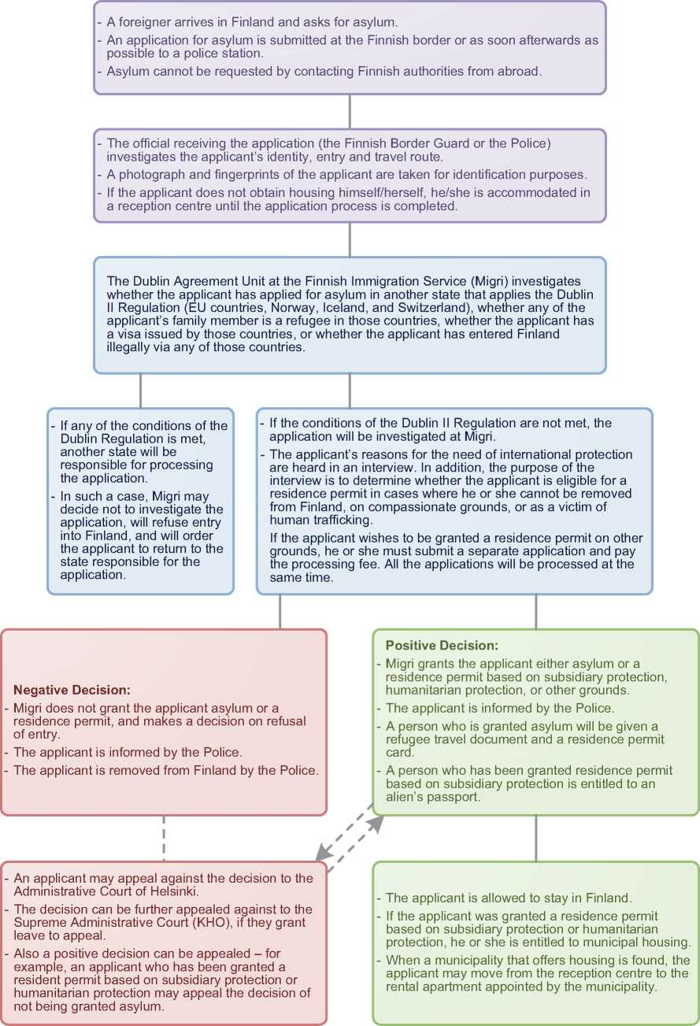

1. Additional Statistical Information

Figure 4: Asylum Applications from Top 10 Countries of Origin in 2009, 2010, 2011 and first half of 2012 [98]

**2009 2010 2011 Jan-Jun 2012**

|  |  |  |  |  |  |  |  |  |
| --- | --- | --- | --- | --- | --- | --- | --- | --- |
| **1** | Iraq | 1,183 | Iraq | 575 | Iraq | 586 | Iraq | 317 |
| **2** | Somalia | 1,169 | Somalia | 571 | Somalia | 356 | Russia | 99 |
| **3** | Bulgaria | 722 | Bulgaria | 485 | Russia | 296 | Afghanistan | 84 |
| **4** | Russia | 599 | Russia | 436 | Afghanistan | 284 | Syria | 80 |
| **5** | Afghanistan | 445 | Afghanistan | 265 | Iran | 124 | Somalia | 73 |
| **6** | Kosovo | 280 | Serbia | 173 | Syria | 110 | Serbia | 45 |
| **7** | Iran | 159 | Kosovo | 148 | Nigeria | 105 | Kosovo | 42 |
| **8** | Turkey | 140 | Iran | 142 | Belarus | 84 | Nigeria | 39 |
| **9** | Nigeria | 130 | Turkey | 117 | Kosovo | 83 | Algeria | 38 |
| **10** | Sri Lanka | 100 | Romania | 94 | Serbia | 72 | Iran | 33 |

Figure 5: Decisions Taken at the First and Second Instances in 2009, 2010 and 2011

|  |  |  |  |  |  |  |  |  |  |
| --- | --- | --- | --- | --- | --- | --- | --- | --- | --- |
|  | **Geneva Convention** | | **Subsidiary/**  **Complementary**  **Protection and Humanitarian Status** | | **Rejections** | | **Withdrawn, Closed, Abandoned Cases** | | **Grand**  **Total** |
| **Number** | **%** | **Number** | **%** | **Number** | **%** | **Number** | **%** | **4,335** |
| **2009** | 116 | 3% | 1,257 | 29% | 2,568 | 59% | 394 | 9% |
| **2010** | 181 | 3% | 1,603 | 27% | 3,429 | 59% | 624 | 11% | **5,837** |
| **2011** | 169 | 5% | 1,102 | 31% | 1,890 | 53% | 406 | 11% | **3,567** |

**Figure 6.a: Positive [99] First- and Second-Instance Decisions,Top Countries of Origin in 2009**

**Rate out of Total Decisions [100]**



|  | | **Total Positive** | **Total Decisions** | **Rate** |
| --- | --- | --- | --- | --- |
| 1 | Somalia | 548 | 1,219 | 45.0% |
| 2 | Iraq | 495 | 933 | 53.1% |
| 3 | Afghanistan | 95 | 239 | 39.7% |
| 4 | Russia | 73 | 224 | 32.6% |
| 5 | Iran | 31 | 112 | 27.7% |
| 6 | D.R. Congo | 13 | 28 | 46.4% |
| 7 | Turkey | 13 | 52 | 25.0% |
| 8 | Stateless | 12 | 19 | 63.2% |
| 9 | Sri Lanka | 10 | 26 | 38.5% |
| 10 | Angola | 9 | 12 | 75.0% |

Total Positive Decisions by Status

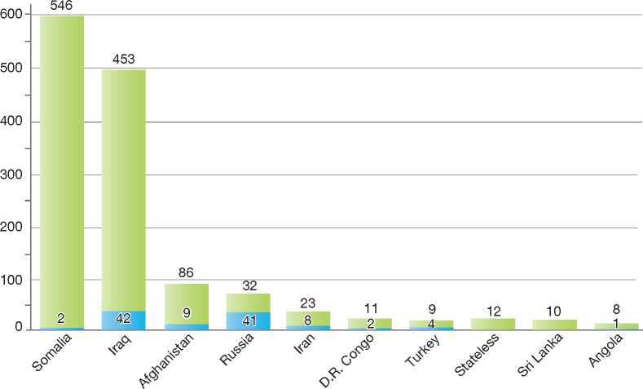

**Total Positive Decisions by Status**

| Geneva Convention Status | | Subsidiary/Complementary Protection and Humanitarian Status

**Figure 6.b: Positive [101] First- and Second-Instance Decisions,Top Countries of Origin in 2010**

**Rate out of Total Decisions [102]**

|  |  |  |  |  |
| --- | --- | --- | --- | --- |
|  | | **Total Positive** | **Total Decisions** | **Rate** |
| 1 | Somalia | 653 | 1,012 | 64.5% |
| 2 | Iraq | 607 | 1,081 | 56.2% |
| 3 | Afghanistan | 196 | 438 | 44.7% |
| 4 | Russia | 61 | 409 | 14.9% |
| 5 | Iran | 58 | 161 | 36.0% |
| 6 | Nigeria | 22 | 117 | 18.8% |
| 7 | Angola | 21 | 50 | 42.0% |
| 8 | D.R. Congo | 21 | 46 | 45.7% |
| 9 | Sri Lanka | 20 | 66 | 30.3% |
| 10 | Kosovo | 19 | 196 | 9.7% |

Total Positive Decisions by Status

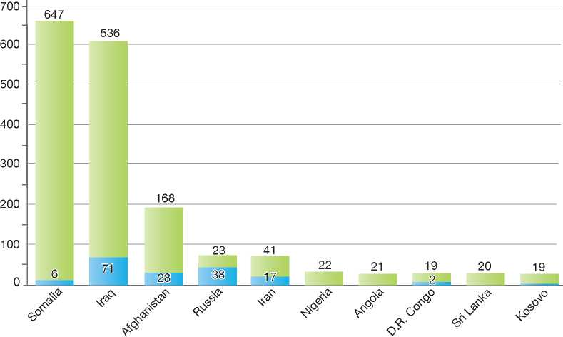

**Total Positive Decisions by Status**

| Geneva Convention Status | | Subsidiary/Complementary Protection and Humanitarian Status

**Figure 6.c: Positive [103] First- and Second-Instance Decisions,Top Countries of Origin in 2011**

**Rate out of Total Decisions [104]**



|  | | **Total Positive** | **Total Decisions** | **Rate** |
| --- | --- | --- | --- | --- |
| 1 | Iraq | 396 | 671 | 59.0% |
| 2 | Somalia | 266 | 491 | 54.2% |
| 3 | Afghanistan | 180 | 380 | 47.4% |
| 4 | Russia | 116 | 324 | 35.8% |
| 5 | Iran | 55 | 107 | 51.4% |
| 6 | Syria | 35 | 48 | 72.9% |
| 7 | Angola | 31 | 35 | 88.6% |
| 8 | D.R. Congo | 20 | 32 | 62.5% |
| 9 | Nigeria | 17 | 114 | 14.9% |
| 10 | Turkey | 16 | 78 | 20.5% |

Total Positive Decisions by Status

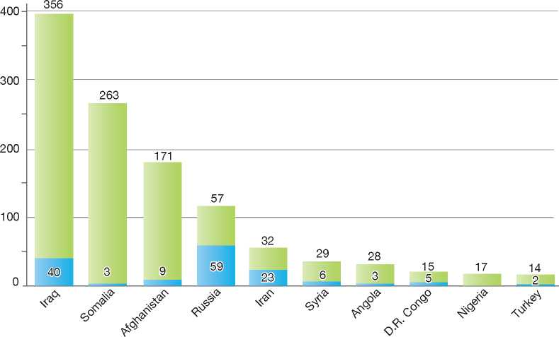

**Total Positive Decisions by Status**

| Geneva Convention Status | | Subsidiary/Complementary Protection and Humanitarian Status

1.

2.

3.

4.

5.

6.

7.

8.

9.

10.

11.

12.

France

BackGRound: MajoR asyluM tRends and developMents 183

FA

national leGal FRaMewoRk 184

institutional FRaMewoRk 185

pRe-entRy MeasuRes 186

asyluM pRoceduRes 186

decision-MakinG and statuses 191

eFFiciency and inteGRity MeasuRes 194

assistance and Reception BeneFits FoR asyluM-seekeRs 195

status and peRMits GRanted outside the asyluM pRoceduRe 198

RetuRn 200

inteGRation 201

annexes

202

**LFRA**

1. Background: Major Asylum Trends and Developments

Asylum Applications

In the early 1980s, France was receiving approximately 20,000 asylum applications per year (minors excluded). The numbers started to increase in the mid-1980s, however, reaching a peak of 61,000 in 1989. Annual applications decreased considerably from 1990 to 1996, when numbers reached a low of 21,000. In 1999 numbers began to increase again and peaked in 2003 and 2004 at over 60,000 annual applications. After a decrease in 2006 and 2007, applications increased again by 60 per cent between 2007 and 2011: 40,464 first asylum applications were received in 2011 (57,337 with minors and repeated applications).

for those persons deemed to be not eligible for refugee status but who could not be removed to their country of origin due to a risk of treatment prohibited by Article 3 of the European Convention on Human Rights (ECHR). Territorial asylum claims were processed by the *prefectures****[105] [106]*** and decisions were made by the Ministry of Interior, after consultation with the Ministry of Foreign Affairs.

Under the Asylum Act 2003-1176 of 10 December 2003, territorial asylum was replaced by subsidiary protection within the meaning of Council Directive 2004/83/EC of 29 April 2004[107], which was subsequently adopted. Subsidiary protection, implemented by the French Office for the Protection of Refugees and Stateless Persons *(Office franqais pour la protection des refugies et apatrides*, OFPRA) in a single procedure, incorporated such new concepts included in the Qualification Directive as internal flight alternative

Figure 1: Total Asylum Applications by Quarter, January 1992 - June 2012 1

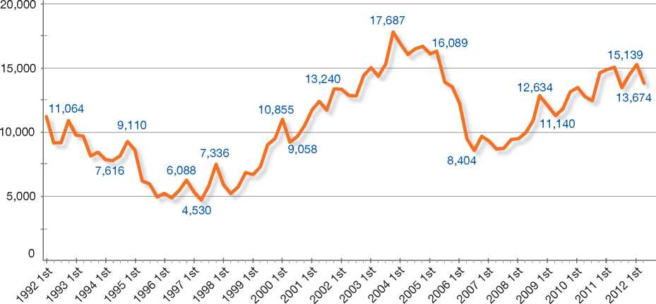

Top Nationalities

Top nationalities for asylum claims in 2010 were Kosovo, Bangladesh, the Democratic Republic of Congo, Russia and Sri Lanka. In 2011, the top countries of origin were Bangladesh, the Democratic Republic of Congo, Armenia, Sri Lanka and Russia.

Important Reforms

Act 98-349 of 11 May 1998 on entry, residence and asylum in France created a form of alternative protection called territorial asylum (*asile territorial*) and safe countries of origin as well as the concept of non-state agent of persecution, within the scope of asylum. The introduction of these new concepts reversed the well-established jurisprudence

**Figure 2: Asylum Applications Received from Top 5 Countries of Origin in 2009, 2010 and 2011**

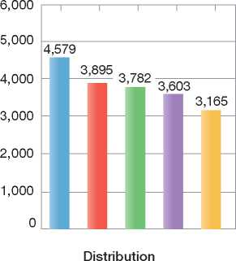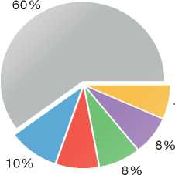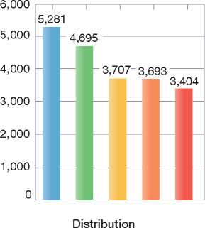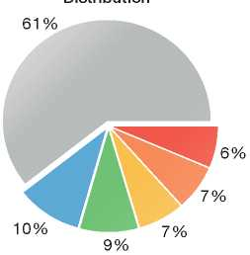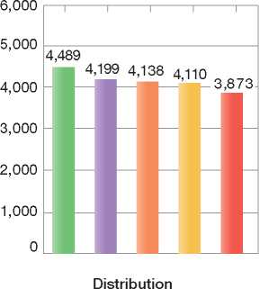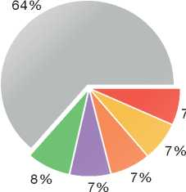

2009

Volumes

2010

Volumes

2011

Volumes

|  |
| --- |
| **Country of Origin:** |
| Armenia Bangladesh D.R. Congo Kosovo  Russia J Sri Lanka Others |

of the competent Courts (the Refugee Appeal Commission - *Commission de Recours des*

*Refugies,* and Council of State - *Conseil d’Etat)* that had been in effect since 1952.

The Law of 20 November 2007 (*Loi Hortefeux*) regulating immigration, residence and naturalisation introduced the following reforms to the asylum procedure:

* A new appeal procedure, with suspensive effect, for negative decisions on entry at the border in order to claim asylum
* A transfer of institutional responsibility for OFPRA, the agency in charge of examining asylum claims, from the Ministry of Foreign Affairs to the Ministry of Immigration, Integration, National Identity and Development (in 2010, OFPRA was subsequently placed under the authority of the Ministry of Interior)

• At the appeal level, the Refugee Appeal Commission (*Commission de Recours des Refugies*) was renamed the National Court of Asylum Law (*Cour Nationale du Droit d’Asile*, CNDA). The time limit for asylum-seekers who have received a negative decision on their claim to make an appeal before the CNDA remained unchanged at one month.

1. National Legal Framework
   1. Legal Basis for Granting Protection

The procedure for examining asylum claims and the granting of asylum are laid down in the Code on Entry and Stay of Foreign Nationals and the Right to Asylum of 24 November 2004 (*Code de l’entree et du sejour des etrangers et du droit d’asile,* CESEDA) modified by Law 2007-1631 of 20 November 2007[108].

Since the French legal system is a monist[109] one, international treaties and conventions such as the 1951 Convention relating to the Status of Refugees (1951 Convention) and its 1967 Protocol, as well as other relevant international instruments (e.g. the UN Convention against Torture and other Cruel, Inhuman or Degrading Treatment or Punishment - CAT, and the International Covenant on Civil and Political Rights - ICCPR) are directly applicable.

All EU Council Directives have been transposed into national legislation. The asylum-related directives were incorporated into national legislation mainly through the Asylum Act of 10 December 2003, the remaining provisions having been transposed under other pieces of legislation and by-laws.

* 1. Recent Reforms

The Law of 16 June 2011 (*Loi Besson*) on immigration, integration and nationality contains the following key points:

* New conditions for the creation of a waiting area to review the situation of persons who have just arrived at the border
* New regulations concerning removal, incorporating the EU Return Directive. These include new unified removal rulings, the possibility of voluntary departure within 30 days (excluding fraudulent cases, risk of absconding or threats to public order), the possibility of placing individuals served with an expulsion order under house arrest for a period of 45 days (renewable once) as an alternative to detention, extending the period of administrative detention to 45 days, and prohibition of return as a sanction in a removal ruling. An administrative judge now decides on the legality of the removal procedure, with the ordinary judge ruling on the extension of detention periods.

The new Minister of Interior issued a circular dated 6 July 2012 to the *prefectures*. This text recommends that, under strict conditions, priority should be given to house arrest (for 45 days, renewable once) rather that administrative detention in the case of irregular migrant families. It also recommends implementing a voluntary return programme.

1. Institutional Framework
   1. Principal Institutions

The Ministry of Interior has overall responsibility for immigration policy, integration and enforcement. Within this Ministry, the General Secretariat for Immigration and Integration (SGII) is responsible for the asylum service.

The French Office for the Protection of Refugees and Stateless Persons *(Office Franqais de Protection des Refugies et Apatrides*, OFPRA) is the competent authority for the examination of asylum claims and the granting of refugee status at the first instance. Located near Paris, OFPRA also has a permanent office located in Basse­Terre (island of Guadeloupe), which is competent for the assessment of claims received in the French West Indies.

The National Court of Asylum (*Cour Nationale du Droit d’Asile*, CNDA) hears appeals of decisions made by OFPRA.

The French Office for Immigration and Integration (OFII) has, among other tasks, the responsibility for coordinating the reception of asylum-seekers, implementing returns, and providing reintegration assistance to those returning voluntarily to their country of origin.

The *prefecture* is responsible, *inter alia*, for registering asylum applications and making a decision on whether an asylum-seeker may obtain a provisional stay authorisation in order to pursue his or her claim before OFPRA. It also issues residence permits and travel documents to refugees and beneficiaries of subsidiary protection.

The Police and the Gendarmerie, both under the authority of the Ministry, are in charge of detention centres and of escorting detainees to their interview at OFPRA.

* 1. Cooperation between Government Authorities

Given the above-mentioned distribution of tasks, the responsibility for dealing with an asylum­seeker shifts between the *prefecture* and OFPRA depending on the stage of the procedure. OFPRA informs the *prefecture* of any decision made. OFPRA also informs the OFII of its decisions, for the purpose of managing reception, and informs the service in charge of paying unemployment and other social benefits *(Pole Emploi)* for the purpose of managing the payment of the Temporary Allowance (*allocation temporaire d'attente*, ATA) granted to asylum-seekers who have not yet obtained accommodation at a reception centre.

1. Pre-entry Measures
   1. Visa Requirements

To enter France, foreign nationals must be in possession of the necessary travel and identity documents and visas, where applicable, as set out in international conventions and relevant regulations. Foreign nationals must also provide a proof of accommodation and proof of medical insurance for the duration of their stay.

* 1. Carrier Sanctions

Carriers are liable to a maximum fine of €e 5,000 if they are found to have brought onto French territory an undocumented non-European Union (EU) national. This sanction is applicable in cases where France is the final destination as well as in instances of transit through the national territory.

Sanctions do not apply in the following cases:

* The foreign national has been admitted into the territory in order to make an asylum claim that is not deemed to be manifestly unfounded
* The carrier is able to establish that the required travel documents were presented at boarding time and that these did not appear to be fraudulent.
  1. Interception

The Border Police *(Police aux Frontieres,* PAF) are responsible for undertaking checks on travellers at ports of entry.

* 1. Immigration Liaison Officers

France has immigration liaison officers posted in a number of countries. These officers provide technical support to local border authorities, through such activities as document checks on passengers bound for France at an international airport abroad.

1. Asylum Procedures
   1. Application Possibilities and Requirements, Procedures and Legal Remedies

Foreign nationals arriving in France at airports, seaports or international train terminals may indicate their wish to enter the country in order to apply for asylum at border control posts. Once a person has been allowed to enter the territory, an asylum application may be made at a local administrative office (*prefecture*).

* + 1. Outside the Country

Applications at Diplomatic Missions

There is an informal possibility to make a claim for asylum at French diplomatic missions in countries of origin or third countries. There is no provision in French law that governs this procedure, which means that asylum applications at diplomatic missions are dealt with on an exceptional basis.

When a claim is made, the applicant may be asked to provide further information, either by appearing for an interview with a French diplomatic official or by mailing the information to the mission. The diplomatic mission will then decide whether or not to allow the application to proceed or to refer it to the United Nations High Commissioner for Refugees (UNHCR) or the local authorities.

Both grounds for the asylum application as well as identity issues are discussed during the first interview at the embassy/consulate. The visa request will then be sent to the Ministry of Interior (Visas directorate) alongside the interview report. The case is then examined by the Ministry of Interior, which may include a consultation with OFPRA. Finally, the Visas directorate then decides whether or not to issue an asylum visa. The person still needs to go through the regular asylum procedure after arriving in France to benefit from international protection in France.

If the decision is negative, an appeal may be made with the Visa Appeal Commission. The appeal must be submitted within two months of the notification of a negative decision. In addition to making an appeal with the Commission, the applicant may also approach the head of the diplomatic mission with a request to reconsider the decision or subsequently submit a written request to change the decision to the Ministry of Foreign Affairs.

Resettlement/Quota Refugees

France recently put in place a resettlement policy. It made a commitment to resettling vulnerable Iraqi refugees from countries of first asylum in the region of origin. The French Government consequently signed a framework agreement with the UNHCR on 4 February 2008 whereby the UNHCR will submit dossiers of 100 refugees per year from all parts of the world to the Government. The French quota for 2011 amounted to 142 cases. Parallel to this scheme, a relocation operation was also conducted in the context of the European Pact on Immigration and Asylum in 2009, which involved the resettlement of 95 third country nationals who obtained protection in Malta. Another 93 refugees were accepted in 2010 under this operation.

* + 1. At Ports of Entry

A foreign national arriving in France by air, sea or train may indicate to customs or police officials at border control his or her wish to enter the territory in order to apply for asylum. The officials will make a decision to either allow or deny entry. If entry is refused, OFPRA officials will interview the foreign national and provide their opinion to the Ministry of Interior. If permission to enter is granted by the Ministry, the person will enter the country in order to make his or her asylum claim.

A negative decision on entry may be made only when the claim is regarded as “manifestly unfounded”.

An application is deemed to be manifestly unfounded when its motives fall outside the scope of asylum (e.g. issues of poverty, debts), when the story provided by the applicant is inconsistent or contradictory or cannot be reconciled with established facts, or when there are obvious elements of bad faith regarding identity, nationality or forged documents.

The foreign national may make a request before the administrative tribunal to annul a negative decision on entry within 48 hours of the decision. The tribunal is required to make its decision within 72 hours of the request. If the negative decision is annulled, the person is granted an entry pass (*sauf-conduit*) valid for eight days, during which he or she has to appear at a local administrative office *(prefecture)* to make an application for asylum.

Freedom of Movement

If border officials do not make an immediate decision to allow entry, the foreign national may be placed in a “waiting area” (*zone d'attente*) according to a decision of the head of border control at the port of entry. The person remains in this “waiting area” until a decision is made on entry. Waiting areas are distinct from detention zones and are located in the vicinity of disembarkation points at airports and border posts.

A person may remain in the waiting area for a maximum of four days under the administrative decision mentioned above. If the stay in the waiting area exceeds four days, the judge for liberties and detention (JLD) must be informed of the matter, in order to determine whether the stay should be prolonged for a maximum of eight days or stopped. After the eight-day period has ended, the stay may be extended only once more. Persons kept in the waiting area are free to depart at any time for any country outside of France to which they are admissible. The European Court of Human Rights ruling in the case of *Gebremedhin* (26 April 2007), in relation to appeals at the border made by persons wishing to claim asylum, led to a new system of appeal being introduced under the Act of 20 November 2007. Appeals of negative decisions on entry at the border now have suspensive effect. Asylum-seekers may appeal a negative decision before the administrative tribunal within 48 hours. The tribunal must then rule on the appeal within 72 hours.

* + 1. Inside the Territory

Responsibility for Processing the Claim

The Dublin System

*Application and Procedure*

A stay authorisation may be denied if it is found that, under the Dublin II Regulation[110], another EU Member State is responsible for examining the asylum claim. The *prefecture* is responsible for determining responsibility under the Regulation when registering the application and before issuing OFPRA's application form to the applicant.

The asylum-seeker may indicate if a member of his or her family is a refugee or has applied for asylum in one of the EU Member States. He or she may join his or her family member in that country under the conditions laid down in the Dublin II Regulation. The local administrative office (*prefecture*) will then approach the country to ask whether it will take responsibility for his or her case. The local administration will issue the asylum-seeker a document valid for the duration of stay (*convocation*) while awaiting transfer.

FA

*Freedom of Movement/Detention*

An asylum-seeker is not detained for the mere fact of being subject to a transfer to another State under the Dublin II Regulation.

*Conduct of Transfers*

Applicants may either travel voluntarily to the Member State responsible or be transferred under escort.

*Suspension of Dublin Transfers*

The prefect *(prefet)* may decide to suspend the transfer of an asylum-seeker to another State or to cancel the decision to transfer the person on medical or other humanitarian grounds.

*Review/Appeal*

A decision to make a transfer under the Dublin II Regulation may be appealed to the administrative tribunal. The appeal does not have suspensive effect.

Application and Admissibility

Provisional Stay Authorisation

Once entry onto the territory has been granted or if the person entered without proper authorisation, the foreign national may apply for asylum at a local administrative office (*prefecture*). Upon registering the application, the local administrative office must decide within 15 days whether or not a provisional stay authorisation (*autorisation provisoire de sejour,* APS) may be granted to the person. If the office grants provisional stay, the person is entitled to proceed to OFPRA for the asylum procedure.

An APS is valid for one month and entitles the person to pursue an asylum claim before OFPRA. The local administration will also provide the person with an asylum application form, which he or she must complete and submit to OFPRA within 21 days.

The local administrative office may decide to refuse to grant an APS in the following cases:

• The asylum claim is found to be the responsibility of another State under the Dublin system (see above)

* The person holds citizenship of a country with regard to which OFPRA, in consultation with the UNHCR, has declared the applicability of Article 1C(5) of the 1951 Convention, following a lasting change in circumstances
* The person is from a safe country of origin as set out in the list of the Management Board of OFPRA
* The person is considered to be a danger to the public or a threat to national security
* The claim is fraudulent or was made in order to delay or thwart measures to remove the person from France, or was made in an overseas territory while a claim is also pending in another EU Member State. Since the Law of 16 June 2011 (*Loi Besson*), the claim is also considered fraudulent if the person conceals information from the authorities or gives false indications regarding his or her identity, nationality or the terms of his or her arrival in France for purposes of misleading authorities.

In each of these cases, the asylum claim is routed to the “priority procedure”, which is described below.

Accelerated Procedures: The Priority Procedure

An asylum claim may be routed to an accelerated procedure called the priority procedure if the local administration refuses the application for a provisional stay authorisation and the claim is not subject to the Dublin procedure. A higher priority is given to processing applications from asylum­seekers detained in administrative holding centres. Unlike claims under the normal procedure, the local administrative office is responsible for forwarding to OFPRA the application forms for priority procedure claims and other documents that the applicants have deposited in a sealed envelope.

Under the priority procedure, OFPRA is responsible for making a determination on the claim within 15 days. However, OFPRA has 96 hours to make a decision on claims made by an asylum-seeker being held in a closed centre (*centre de retention*). The asylum-seeker cannot be removed from France until OFPRA has made its decision. In the case of complex asylum claims, OFPRA may exceed the timeframe stipulated under regulation in coming to a decision. Applicants under the priority procedure are interviewed, except under certain circumstances that are described below (see the section on Normal Procedure).

The conditions for making an appeal following a negative decision by OFPRA under the priority procedure are the same as those for appeals of decisions made under the normal procedure, as described below. However, under the priority procedure, appeals to the CNDA have no suspensive effect.

Interviewing Asylum-Seekers via Videoconference

In a number of cases, OFPRA uses videoconferencing to conduct interviews with asylum-seekers. Developed in 2006 and used on an experimental basis, the practice now officially applies in two cases: first, when the asylum-seeker resides in certain overseas departments or secondly, in specific detention centres that have the necessary equipment.

In 201 1, 1,540 interviews were conducted via videoconferencing. This means that the procedure represents 4.7 per cent of all total interviews conducted by OFPRA in that year. The vast majority (more than 1,400) concerned asylum applications registered overseas. Furthermore, OFPRA designated two mainland detention centres for videoconference interviews.

In parallel with the above development, OFPRA drew up a charter establishing the principles of interviewing asylum-seekers via videoconference. This document governs the conduct of these interviews, which are subject to safeguards regarding information and confidentiality. OFPRA remains the sole judge of whether or not to conduct the interview via videoconference, whereas the protection officer (caseworker) is in control of technical operations. Finally, the protection officer may, at his or her discretion, request a traditional face-to-face interview.

Normal Procedure

If a foreign national is granted a provisional stay authorisation, he or she may obtain an asylum application form from the local administrative office *(prefecture).* The application form must be completed in French and returned to OFPRA within 21 days, along with all relevant identity and travel documents. OFPRA will provide the asylum­seeker an official receipt (*lettre d'enregistrement*) as proof that an asylum application has been made. This receipt enables the holder to exchange his or her APS for a so-called receipt of an application for a residence permit (*recepisse de demande de carte de sejour*) valid for three months and renewable until a final decision on the claim has been made by OFPRA or the CNDA.

OFPRA will interview the asylum-seeker except under the following circumstances:

* The claim will result in the granting of status
* The asylum-seeker hails from a country to which Article 1C(5) of the 1951 Convention applies
* The medical or health condition of the asylum­seeker prevents the asylum-seeker from appearing at the interview
* The claim is manifestly unfounded.

OFPRA will then examine the claim first in relation to the criteria for Convention refugee status and, if the criteria are not met, in relation to subsidiary protection[111].

Review/Appeal of Asylum Decisions

Appeal

Appeals of negative decisions by OFPRA may be made before the National Court of Asylum Law (CNDA) within 30 days of receipt of the decision. All appeals must be made in writing, in French, and sent by registered mail.

Upon receipt of the appeal, the CNDA informs OFPRA, which has 15 days to send its own files on the claim to the CNDA. The asylum-seeker appears at a hearing to present his or her case orally. The CNDA will provide an interpreter if necessary, and the asylum-seeker may be assisted by a lawyer. Hearings are generally open to the public, unless the presiding judge decides otherwise.

Except for appeals of decisions made under the priority procedure, appeals before the CNDA have suspensive effect.

If the decision of OFPRA is annulled, the CNDA may grant either refugee status or subsidiary protection to the asylum-seeker. The asylum­seeker is granted an official receipt for a request for a renewable residence permit initially valid for three months. The permit grants the person the same benefits to which other refugees or beneficiaries of subsidiary protection are entitled.

If the CNDA rejects the appeal, a refusal of stay will generally be issued by the local administrative office, along with a request to leave the country within one month of the decision.

Final Appeal

A rejected asylum-seeker may make a final appeal on points of law (*pourvoi en cassation*) before the Council of State within two months of the CNDA decision. The final appeal does not have a suspensive effect, unless the local administrative office decides otherwise.

Freedom of Movement during the Asylum Procedure

Detention

Asylum-seekers are not detained during the normal procedure. All detained asylum-seekers' applications are channelled into the priority procedure.

Reporting

Asylum-seekers have an obligation to apply within the same department *(departement)* in which they reside. Any changes of address must be reported to the local administration and to OFPRA.

Repeat/Subsequent Applications

Re-examination

Persons whose asylum claims have been rejected in a final decision may submit a request for a review (*demande de reexamen*) by OFPRA and eventually the CNDA. To be eligible for a re-examination, asylum-seekers must present new elements that have emerged since the final negative decision was given.

To begin a re-examination process, asylum­seekers must make a request to the local administrative office for a provisional stay authorisation. Once this authorisation is obtained, they may then make their request for a re­examination at OFPRA within eight days.

A negative decision on the re-examination request may be appealed before the CNDA within 30 days of the decision.

* 1. Safe Country Concepts

The concepts of first country of asylum and safe third country are not applicable in the French system, as they are not compatible with paragraph 4 of the Preamble to the1946 French Constitution. The preamble states that, “any man persecuted in virtue of his action in favour of liberty has the right to enjoy asylum on the territories of the Republic”. The only exceptions to this rule are the Dublin II Regulation and Dublin-like agreements as provided for in Article 53(1) of the Constitution of the Fifth Republic (4 October 1958).

* + 1. Safe Country of Origin

The Management Board of OFPRA maintains a list of safe countries of origin. In principle, any member of the Board may take the initiative of adding or removing a country. In practice, the initiative has been taken by the Ministry of Interior and/or OFPRA. Both have jointly prepared country dossiers for consideration by members of the Board. The Board organises a vote following deliberation.

Currently, the countries included in the list are as follows: Armenia, Bangladesh, Benin, Bosnia- Herzegovina, Cape Verde, Croatia, Ghana, India, the Former Yugoslav Republic of Macedonia (FYROM), Mali (for men only), Mauritius, Moldova, Mongolia, Montenegro, Senegal, Serbia, Tanzania and Ukraine.

Asylum Claims Made by EU Nationals

Since there is no admissibility procedure for asylum applications, all applications made by EU citizens are forwarded to OFPRA by the local administrative office, usually under the priority procedure. OFPRA will consider the application as manifestly unfounded unless the applicant is able to refute that assumption.

* 1. Special Procedures
     1. Unaccompanied Minors

Persons under the age of 18 may make an application for asylum at the local administration. However, no stay authorisation is provided to them as they cannot be returned from French territory. The local administration notifies OFPRA and the state prosecutor of the asylum­seeker's claim, after which the state prosecutor will assign an *ad hoc* administrator to assist the person with his or her claim.

If a minor is granted refugee status or subsidiary protection, he or she will obtain a residence permit upon turning 18 (or 16, if the minor wishes to work). If the asylum claim is rejected, the minor will not be subject to removal before turning 18.

* + 1. Stateless Persons

There are no special procedures in place for examining the asylum claims of stateless persons. All applications are treated in the same way. There is a separate procedure for the recognition of statelessness, which is described below.

|  |  |  |  |
| --- | --- | --- | --- |
| **Figure 3: Asylum Applications by Unaccompa­nied Minors in 2009, 2010 and 2011[112]** | | | |
|  | **2009** | **2010** | **2011** |
| Total Asylum Applications | 47,686 | 52,762 | 57,337 |
| of which Unaccompanied Minors | 447 | 610 | 595 |
| Percentage | 1% | 1% | 1% |

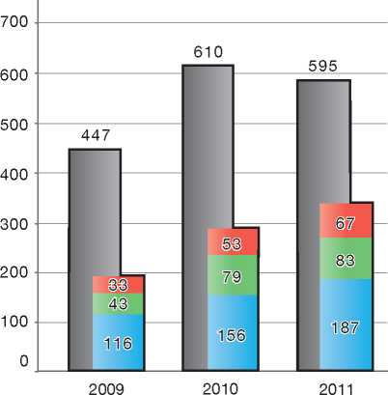

Country of Origin:

| Afghanistan D.R. Congo Guinea (Conakry)

1. Decision-Making and Status

In coming to a decision on an asylum claim, OFPRA will first consider whether the criteria for Convention refugee status are met, and failing that, whether the criteria for subsidiary protection are met.

* 1. Inclusion Criteria
     1. Convention Refugee

OFPRA may grant Convention refugee status on the basis of one of four sets of criteria:

• The applicant has been placed under the mandate of the UNHCR (in accordance with Articles 6 and 7 of the Statute of the Office of the UNHCR)

* Criteria set out in Article 1A(2) of the 1951 Convention
* Criteria set out in paragraph 4 of the 1946 French Constitution, which states that “any man persecuted because of his actions for liberty has the right to enjoy asylum on the territories of the Republic”
* Family unity.

The granting of refugee status on the principle of family unity was introduced as a general principle in refugee law in 1994 by the Council of State. The basis for the family unity rule is in the protection granted to the refugee under the 1951 Convention, which, to be full and complete, must encompass the protection of his or her family. However, case law has limited the application of this rule to the refugee's immediate family, that is, to his or her spouse on the proviso that he or she has the same nationality as the refugee and that marriage or the beginning of cohabitation occurred prior to the date on which the asylum application was made. The refugee's children under the age of majority also benefit from the application of this family unity rule on the proviso that they are under the age of majority at the date of entry into France.

* + 1. Subsidiary Protection

Subsidiary protection may be granted to any person who does not fulfil the conditions for refugee status and who has established that he or she would be exposed to the following serious threats in the country of origin:

* Death penalty
* Torture or inhuman or degrading treatment
* Under Article L.712-2 c of the CESEDA, if someone is a civilian, “a serious, direct and individual threat against his or her life or person because of generalised violence resulting from an internal or international armed conflict”.
  1. The Decision

All asylum-related decisions are made by OFPRA and the CNDA. Asylum-seekers are notified of the decisions in writing by registered mail. Decisions contain reasoning in fact and law.

**LFRA**

1. Types of Decisions, Status and Benefits Granted

Types of Decisions and Status

OFPRA may make one of the following decisions on an asylum claim:

* Grant Convention refugee status or subsidiary protection
* Reject a claim for asylum.

A claim for asylum may be rejected by OFPRA, *inter alia*, if the alleged facts are not established or if exclusion clauses apply. The law also provides that an asylum claim may be rejected if it can be reasonably expected that the asylum-seeker could return to the country of origin and seek an internal flight alternative . However, in practice, this provision is rarely implemented.

Benefits

Recognised refugees are entitled to the following benefits:

* A 10-year residence permit, renewable unless the refugee leaves France for more than three years or is found to have engaged in polygamy
* Right to work
* Travel documents valid for a period of two years, issued by the *prefecture*
* Family reunification for spouses and children of refugees who meet criteria set out in the Law of 20 November 2007
* Temporary accommodation in a Temporary Accommodation Centre (*Centre provisoire d'hebergement*, CPH) for a renewable period of six months
* Right to apply for French citizenship without any minimum statutory time period (5 years is the rule).

Spouses of recognised refugees are entitled to the same residence permit if the marriage took place before refugee status was granted and they have lived together continuously. Dependants under the age of 18 may obtain the same residence permit upon turning 18 (or 16, if they wish to work).

Beneficiaries of subsidiary protection are entitled to the following benefits:

* A one-year residence permit (labelled “private life and family”), which may be renewed on a yearly basis, if the reasons that led to the granting of subsidiary protection remain
* Right to work
* Family reunification for spouses and children, within the same rules which apply to families of refugees (see above)
* Travel documents issued upon request to the local administrative office, if it is not possible to request travel documents from the authorities of the country of origin
* Right to apply for French citizenship without any minimum statutory time period (5 years is the rule).

Refugees and beneficiaries of subsidiary protection are also entitled to social benefits (*revenu minimum d'insertion/revenu de solidarite active*) immediately, without having to fulfil the requirement of 5 years' residence that applies to other foreign nationals.

1. Exclusion

Exclusion clauses apply to both Convention refugee status and subsidiary protection. The criteria used are those, respectively, of the 1951 Convention and the Qualification Directive. Exclusion is applied only in cases in which the applicant is found to have a well-founded fear as set out in the relevant legal texts. Where this is not the case, the claim is rejected on the basis of non­established facts.

Decisions to exclude a person from protection may be appealed in the same manner as are other negative asylum decisions[113]. Exclusion does not automatically entail removal of the person from France.

1. Cessation

Refugee status may be terminated by OFPRA if it appears that the refugee who has legally received refugee status no longer requires the protection of the Convention for one of the reasons provided for in Article 1C of the 1951 Convention.

Subsidiary protection may be terminated under the conditions provided in the Qualification Directive.

A decision to cease status may be appealed before the CNDA in the same manner as are other negative asylum decisions[114].

1. Revocation

When the circumstances of the case reveal that the application on the basis of which the status was granted was fraudulent, OFPRA may withdraw the status or request the CNDA to revise its ruling.

A decision to withdraw status may be appealed before the CNDA in the same manner as are other negative asylum decisions[115].

In a ruling dated 21 May 1997, the Council of State concluded that Article 33(2) of the 1951 Convention does not constitute a legal ground for withdrawing refugee status. As a result, France cannot apply the provisions found in Article 14(4) of the Qualification Directive, which states that persons for whom there are reasonable grounds to consider a danger to national security or persons who have committed a particularly serious crime, may have their status revoked or terminated.

In another decision later the same year, the Council of State ruled that OFPRA may not withdraw refugee status on the basis of information it has obtained showing that that person was granted status as a result of fraud or untrue declarations, if the decision to grant status was made by the Appeals Board, which has force of *res judicata.* This ruling led to the creation of a new form of appeal before the CNDA, whereby OFPRA may apply for a review of the Court's decision within two months of evidence of fraud coming to light.

1. Support and Tools for Decision-Makers
2. Country of Origin Information

The Division of Information, Documentation and Research (*Division de l'Information, de la Documentation et des Recherches*, DIDR) provides country of origin information (COI) services to decision-makers as well as to the support units of OFPRA (Legal affairs division, Protection division and the European and International affairs unit). Little more than half of the requests for information made by decision-makers are in relation to African countries. In addition to answering these requests for information, the DIDR also undertakes the publication of major studies, documentation packages and chronologies for specific countries of origin. In the past year, the DIDR has responded to a growing number of research requests within shorter timeframes.

Flora, a new COI Database

Flora is a new database available to OFPRA caseworkers since early 2012 that offers several features to facilitate research on the countries of origin of asylum-seekers. This new tool is compatible with and connected to the Common European Portal which is managed by the European Asylum Support Office (EASO).

This means that agents now have at their disposal a more powerful search engine enabling them to access all indexed references quickly. Features such as the full text search option mean that a wealth of data is accessible instantaneously. Furthermore, the Flora database allows caseworkers to direct questions to the research staff of the Division of Information, Documentation and Research (DIDR). Finally, caseworkers can now create custom alerts informing them of new data stored in Flora regarding countries or topics of interest.

The DIDR participates in fact-finding missions in cooperation with other colleagues of OFPRA that may be conducted in conjunction with other EU Member States.

RA

1. Training

As part of continuous training, caseworkers may attend conferences on geopolitical issues chaired by researchers working on the main countries of origin of asylum-seekers.

Initial Training Plan

New caseworkers *(officiers de protection)* joining OFPRA attend a two-month-long training organised around three pillars. First, an awareness-raising cycle is carried out internally and concerns the general environment in which the asylum application is made. This enables new caseworkers to familiarise themselves with operations and thus acquire the necessary knowledge on asylum law, procedures and typology of asylum applications. In this context, new employees may visit reception centres for asylum-seekers and engage in dialogue with NGOs or other institutional actors in charge of the reception system.

In addition to the above initiative, new protection officers receive training - via e-learning and face-to-face seminars - based on one of the European Asylum Curriculum (EAC) modules, such as “Interview Techniques" or “Inclusion”.

Finally, a senior protection officer mentors the new caseworkers throughout the two-month training process. This partnership, in turn, allows new employees to deepen their understanding of application assessments and interview procedures.

They also have the opportunity to receive training on legal issues, such as refugee and/or alien law. OFPRA has also incorporated eight modules of the European Asylum Curriculum (EAC) in its training plan. Regular EAC national training sessions are offered to caseworkers, COI researchers, legal officers and management.

Complementary training sessions in foreign languages or in office automation skills are regularly offered to all OFPRA personnel, including administrative and support staff.

1. Efficiency and Integrity Measures
   1. Technological Tools
      1. Fingerprinting

Fingerprints of all applicants over the age of 14 are taken, as provided for in the Eurodac Regulation[116].

* + 1. DNA Tests

No DNA tests are carried out for the purposes of the asylum procedure.

* + 1. Forensic Testing of Documents

OFPRA does not have the capacity to undertake forensic testing of documents.

* + 1. Database of Asylum Applications/Applicants

Applicants are registered in the overall database of foreign nationals maintained by the Ministry of Interior and in the OFPRA database.

* 1. Length of Procedures

Under the normal procedure, the application form is to be sent to OFPRA no later than 21 days after the issuance of a provisional stay authorisation (APS).

Under the priority procedure, OFPRA must make a decision on an asylum claim within 15 days of application. This time limit may be reduced to four days (96 hours) when the applicant is in detention.

In 2011, the average length of the normal procedure at first instance was 174 working days.

The Digitisation of the Procedure

OFPRA began updating the asylum procedure in 2007. Two years later, these reforms inspired the creation of the central bureau for the registration of asylum applications *(Mission accueil, enregistrement etnumerisation,* MEAN). After an initial technical test run in 2009 and 2010, the systematic digitisation of asylum applications became effective on 1 June 2010.

This process, however, goes beyond mere scanning of paper documents within the asylum dossier. Instead, it also enables an optimal work flow and consequently ensures the traceability of all actions performed during the asylum procedure.

Thanks to digitisation, OFPRA caseworkers have direct and immediate access to the application regardless of its original storage location. Furthermore, staff members can quickly identify and consult related applications. Finally, since the end of 2010, the digital application is now the only legally binding file and consequently all digitised asylum applications are electronically forwarded to the appeal jurisdiction, the National Court of Asylum Law (CNDA).

* 1. Pending Cases

Beginning in 2003, OFPRA was granted additional financial and human resources. OFPRA was thus able to successfully implement reforms and reduce its backlog from 22,900 applications (as at 31 December 2003) to a normal working reserve equivalent to three months of activity by the end of 2008. At the same time, OFPRA shortened the average length of the examination of applications, from 184 working days in 2003 to 91 days in 2008. But the significant increase of applications created an enormous backlog. By December 2010 there were 22,474 unexamined cases. As a result, in January 2011, the French Government increased the number of staff, who subsequently processed 4,600 more decisions than in 2011. Yet, given the number of applications received in France, this measure is still proven to be insufficient.

As at 30 September 2012, there were approximately 23,904 pending asylum cases at OFPRA[117].

13 Excluding unaccompanied minors.

**FA**

* 1. Information Sharing

The exchange of information on individual asylum applicants among EU Member States, Norway and Iceland is undertaken according to conditions laid down in Article 21 of the Dublin II Regulation.

* 1. Single Procedure

When making an asylum claim, asylum-seekers are not required to specify which type of protection they are requesting. Claims are processed within a single procedure. OFPRA will examine the application first in relation to refugee status, and, if criteria are not met, in relation to subsidiary protection.

* 1. Other Measures

As indicated above, OFPRA and the CNDA obtained additional staff in order to reduce their backlog and improve the efficiency with which they examine applications. An effort was also made to expand the capacities of the COI unit at OFPRA.

Applicants under the priority procedure are not entitled to benefits normally granted to asylum­seekers (accommodation in a reception centre or temporary allocation). This stipulation may have a deterrent effect on asylum-seekers from those countries listed as safe countries of origin from making a claim in France.

The Contract of Objectives and Means

The OFPRA and the relevant Ministries signed a Contract of Objectives and Means (COM) on 9 December 2008 as part of their modernisation initiative.

Established for a period of three years, this contract defines a global project for the OFPRA based on a projected activity for that time period. It sets out quantitative targets for the different departments as well as qualitative objectives for the assessment of asylum applications and support services. In return, the Government guarantees a certain level of budgetary resources over the three-year timeframe.

Most of the objectives had been achieved by the end of the first contract in 2011. For the first time, this tool enabled the measurement of activities related to the quality of the assessment of asylum applications (country of origin information, staff training, etc.) and consequently led to their improvement. Some quantitative targets, however, were not met due to the unforeseen increase in asylum applications.

1. Assistance and Reception Benefits for Asylum-Seekers
   1. Procedural Support and Safeguards
      1. Legal Assistance
      2. Legal Aid

Up until a change in law in 2007, persons appealing an OFPRA decision were eligible for legal aid if they had entered France through legal channels, had no means of financial support exceeding a ceiling fixed by law each year, and had made a claim for asylum that was not deemed manifestly unfounded.

Beginning on 1 December 2008, the Law of 20 November 2007 provides for universal legal aid irrespective of the conditions of entry or residence of the asylum-seeker.

To obtain legal aid, the asylum-seeker must make a request in writing to the Office of Legal Assistance (*Bureau d'Aide Juridictionnelle*, BAJ), located within the CNDA. The asylum-seeker must, as before, meet a fixed ceiling for financial need.

Asylum-seekers may be assisted by a lawyer during the procedure before the CNDA.

Asylum-seekers may choose to be assisted by a lawyer at the first instance. OFPRA, however, is under no obligation to allow the lawyer to be at the interview, since it is an administrative procedure and not a judicial one. Observations by the counsel may be heard after the individual interview.

* + 1. Interpreters

Interpreters are provided by the administration for interviews at OFPRA and hearings of the CNDA. During the procedure at OFPRA, the need for the services of an interpreter is usually established when planning the interview.

* + 1. Cooperation with UNHCR

The UNHCR in France has a representative sitting as an observer on the Management Board of OFPRA who may make observations on all subjects under consideration or examination. At the CNDA, a UNHCR representative sits, with voting rights, on the board responsible for appointing adjudicators to panels that hear asylum appeals at the Court.

The presence of the UNHCR representative on the CNDA board is one of the innovative features of the French asylum system. The CNDA is the only court in France where a representative of an international organisation sits and is entitled to speak and vote.

The UNHCR has access to waiting zones (*zones d'attente)* at airports where undocumented arrivals are held. A UNHCR implementing partner ensures that those who wish to seek asylum have access to the procedure.

The UNHCR in France maintains contact with the Ministry of Interior and takes part in consultations with the Government on various asylum-related matters.

* + 1. NGOs

NGOs play a crucial role in helping asylum­seekers throughout the asylum procedure, such as by providing legal advice. However, they do not have access to individual asylum case files during the procedure.

* 1. Reception Benefits

The French Office for Immigration and Integration *(Office Franqais de 1’Immigration et de 1’Integration,* OFII) is the government agency responsible for coordinating the national plan of action for the reception of asylum-seekers (*Dispositif national d’accueil des demandeurs d’asile*, DNA).

The Department for Refugees and Reception of Asylum-Seekers within the Ministry of Interior deals with, among other things, questions related to social benefits and related measures for asylum­seekers. In this regard, the Department is in charge of the formulation and follow-up on standards concerning the reception of asylum-seekers. The Department ensures the strategic management of the DNA and the implementation of regulations on the Temporary Allowance (ATA), and works with the reception centres for asylum-seekers (CADA), in close cooperation with OFII.

Asylum-seekers whose applications are examined under the priority procedure (according to Article L. 741-4 of CESEDA) receive neither the APS nor a receipt from the local administrative office. They are, therefore, not entitled to specific social benefits (e.g. CADA, temporary allowance, Universal Health Insurance Coverage).

* + 1. Accommodation

Accommodation at a Reception Centre

The French reception system, which is made up of centres scattered over the whole national territory, is accessible only to persons who have applied for asylum. This system is financed by the French State and generally managed by NGOs. There are two types of accommodation centres where asylum­seekers may be accommodated: transit centres and reception centres for asylum-seekers (*Centres d’Accueil pour Demandeurs d’Asile*, CADA).

Transit centres are intended for asylum-seekers at the beginning of the procedure (who have at a minimum been issued a summons by the local administrative office). Asylum-seekers may be accommodated there for a few weeks while waiting for accommodation in a CADA.

In order to be eligible for accommodation at a Reception Centre for Asylum-Seekers (CADA), an asylum-seeker must be in possession of the one-month Provisional Residence Authorisation (*Autorisation Provisoire de Sejour,* APS) or the three-month receipt (*recepisse).* Accommodation is provided for the duration of the procedure, including any subsequent appeal before the CNDA[118].

Usually, an admission commission will examine the possibility for accommodating an asylum­seeker at a CADA and will make determinations on accommodation depending on the number of places available over the whole French territory. Accommodation is not always offered in the same department in which applicants have made their asylum claims.

Unaccompanied minors are housed separately from adults, both upon arrival at the airport, as well as when their claim is being processed. A specialised centre, called the Reception and Orientation Centres for Unaccompanied Minors (COAMIDA), exists for this purpose.

If, after having applied for accommodation, the asylum-seeker refuses the place offered as part of the State social aid, the *Pole Emploi* may suspend the payment of the Temporary Allowance. Whatever accommodation centre asylum-seekers are admitted to, they will benefit from administrative support (asylum application, legal advice), social services (health, schooling forchildren), and financial aid for sustenance, which cannot be added to the amount of the integration benefit (*allocation d'insertion*).

Accommodation outside a Centre

The CADA's reception capacity is far below the number of requests for accommodation, so application for accommodation may not be successful. Asylum-seekers who are not accommodated as part of the State social aid can receive financial aid (Temporary Allowance) only if they have not declined an accommodation offer or this offer was not possible.

Emergency Accommodation

Asylum-seekers, in particular those who have been denied an APS, can obtain accommodation at various centres for the homeless. These centres receive people only on a nightly basis and do not, in principle, provide meals. The accommodation period may vary according to the centres but is fairly short.

* + 1. Social Assistance

Asylum-seekers who are not accommodated at a reception centre can receive financial assistance (the Temporary Allowance, ATA) on the condition that they have not refused an offer of accommodation or that this is not possible[119].

To receive the ATA, asylum-seekers must be in possession of the one-month APS or the three- month receipt. They must then apply to the *Pole Emploi* by providing a copy of the registration letter issued by OFPRA, as well as a document certifying that they do not have any means of support or that they cannot benefit from accommodation as part of the State social aid. This temporary waiting allowance of about € 300 per month and per adult (there is no increase for dependent children) is paid throughout the asylum application procedure.

If asylum-seekers cannot be accommodated in a reception centre and if they lack financial means, the General Council *(Conseil general,* the local executive assembly) of their department of residence or the social services of their municipality can grant them financial assistance on an exceptional basis.

Unaccompanied Minors

Unaccompanied minors are not eligible for the temporary social assistance allocation during the asylum procedure. French law considers UAMs to be a vulnerable group, and makes no distinction between foreign and French children. The child welfare services are legally responsible for assisting unaccompanied foreign minors. Minors may be referred to the public prosecutor's office by the child welfare services, the Police or specialised NGOs.

* + 1. Health Care

Universal Health Insurance Coverage

Asylum-seekers may benefit from Universal Health Insurance Coverage (*Couverture maladie universelle*, CMU). This coverage is offered to asylum applicants as soon as they have filed their asylum claim, upon the presentation of evidence of either an appointment, a summons or the APS (or receipt), accompanied by a proof of residence. The CMU covers all medical and hospital expenses as well as those of his or her spouse and minor children. If asylum-seekers have no civil status documents certifying family ties, they are required to fill out a sworn declaration. The same procedure must be followed if the asylum-seekers have no documents proving their financial need.

To benefit from the CMU, asylum-seekers must contact the Social Security offices of their place of residence or certain associations. Once their application has been registered, they will receive a certificate of support. Then applicants will be issued a one-year certificate, which entitles them to the mutual insurance (*CMU complementaire*) and a temporary registration number.

Emergency Healthcare

While waiting to benefit from the CMU, applicants have access to hospitals where there is a Health Care Access Service *(Permanences d’Acces aux Soins de Sante*, PASS). Doctors will examine them, and medication will be delivered free of charge.

In addition, there are certain NGOs that offer access to dental care, ophthalmological care, and psychological care to those who do not have health care insurance coverage.

The local authorities usually provide services for a follow-up of medical treatment of children, such as vaccinations, without requiring health care insurance coverage. There are also Centres for Family Planning and Education for women at the local level that provide such services as information on maternity care.

**FA**

As mentioned above, if an asylum-seeker's application is subject to the priority procedure, the asylum-seeker will benefit from the State health care benefit on the condition that he or she be present in France for three months. A request is to be made to the Social Security services of his or her place of residence or to a hospital PASS. The person then has access to hospitals, city doctors and pharmacies.

* + 1. Education

From the age of three years, asylum-seekers' children may be sent to nursery school, although the school is under no obligation to receive them. However, in France, schooling is free and compulsory for children between 6 and 16 years of age.

To enrol their children in primary school, asylum­seekers must show a document proving the relationship or lineage. If they do not have any documents from their homeland, they must show a document issued by the French administration that states the relationship (for instance, a CMU certificate). They must also give a proof of address and prove that their child has received all the necessary vaccinations. Enrolment takes place at the town hall closest to the place of residence.

For secondary schools, asylum-seekers must enrol their children at the school corresponding to the area of their place of residence.

* + 1. Access to Labour Market

An asylum-seeker is not entitled to take up paid work during the procedure. However, if OFPRA has not rendered a decision on his or her application within a one-year period or if an appeal decision is pending, an asylum-seeker may apply for a work permit to the Directorate of Labour, Employment and Professional Development *(Direction departementale du travail, de 1’emploi et de la formation professionnelle*) at his or her place of residence.

* + 1. Family Reunification

Asylum-seekers do not have a right to family reunification*.* However, under the Dublin II Regulation, asylum-seekers may be reunited with their family as follows:

* When the asylum-seeker has a family member who has been allowed to reside as a refugee in a Member State, that Member State will be responsible for examining the asylum application
* Where the asylum-seeker has a family member whose asylum application is being examined under a normal procedure in a Member State, that Member State will be responsible for examining the asylum application.
  + 1. Access to Integration Programmes

Asylum-seekers are not entitled to benefit from integration programmes.

* + 1. Access to Benefits by Rejected Asylum-Seekers

Rejected asylum-seekers are not entitled to any specific social benefits.

1. Status and Permits Granted outside the Asylum Procedure
   1. Humanitarian Grounds

An asylum-seeker who has received a final negative decision on his or her claim may make an application for a temporary residence permit to the *prefecture* if, in accordance with Article 313-14 of the CESEDA, exceptional grounds of a humanitarian nature exist. To be eligible for a residence permit on humanitarian grounds, the applicant must not be in a polygamous relationship or pose a threat to public order. If the applicant has resided in France for more than ten years, the local administrative office (*prefecture*) will seek the advice of the Departmental Commission for Residence Permits (*Commission departementale du titre de sejour*).

Persons who have received a final negative decision on their asylum claim may also be eligible for an exceptional residence permit if, in accordance with Article 313-11-7 of the CESEDA, they present such personal or family ties in France and levels of integration and participation in French society that a refusal of a residence permit would have a disproportionate effect on the respect of family and private life of the person.

A residence permit granted on humanitarian grounds is valid for a period of one year and is renewable. Holders of this permit have access to the labour market.

* 1. Withholding of Removal/ Risk Assessment

The decision to return a person who has received a final negative decision on an for asylum application is made separately from the asylum decision. Before issuing a removal order, the *prefecture,* under the oversight of the administrative judge, must verify that there are no obstacles to return arising from risks present in the country of origin. This risk assessment is in line with France's obligations under Article 3 of the European Convention on Human Rights (ECHR). The authorities must also determine whether obstacles to return exist in relation to Article 8 ECHR (respect of private and family life) or any practical obstacles preventing the implementation of return.

Persons who cannot be returned to the country of origin or to another country may be granted a designation of place of residence *(assignation a residence*). This decision is a stay of removal with a restriction on freedom of movement rather than a residence permit. Beneficiaries must reside in a pre­determined location and report periodically to the Police. The designation of place of residence is valid until such time as return to a third country or to the country of origin becomes possible. It may entitle the holder to a work permit if this is necessary for the person to support himself or herself. A decision to grant a designation of place of residence may be taken by the Minister of Interior or by the *prefecture*, depending on the case.

Annulment of Removal Order

A person who has been served a removal order and is not subject to detention or a designation of place of residence may request an annulment of the removal order within five years of the removal order being served. The Law of 26 November 2003 allows a systematic re-examination of removal orders every five years. The Commission for Removal (*Commission d'expulsion*) examines any changes in the applicant's personal and family situation and any possible professional or social guaranties for integration into French society. For that purpose, the applicant may submit written observations.

* 1. Temporary Protection

Temporary protection may be granted to displaced persons who are unable to return to their country of origin in a case of mass influx, as provided for in the Temporary Protection Directive[120]. Following the designation of a specific group of persons in need of temporary protection by the European Union, and internally by the Minister of Interior and the Minister of Foreign Affairs, temporary permits valid for an initial period of six months are issued. In some cases, the permit may be accompanied by work authorisation. The permits are renewable for a maximum period of three years and are issued by the *prefecture*.

Persons who pose a threat to public order or who are believed to have committed crimes against humanity, war crimes or other serious crimes or acts contrary to the principles of the United Nations (UN) may be excluded from temporary protection. Temporary protection may be withdrawn or refused if the beneficiary has obtained temporary protection in another EU Member State or has obtained refugee status or subsidiary protection in France.

Regularisation of Status over Time

There are no possibilities for regularising the status of a person on the sole basis of that person's length of residence in France. The Law of 24 July 2006 abolished the provision[121] that granted a temporary residence permit to persons who were habitually resident in France for more than 10 years.

As noted above, asylum-seekers who have received a final negative decision on their application may be granted a residence permit on the grounds of family or personal ties to France.

* 1. Regularisation of Status of Stateless Persons

Stateless persons may apply to OFPRA to have their stateless status recognised. Applications must be made in writing and an official form completed. An interview is usually conducted with the applicants. Applicants are not granted a stay authorisation for the duration of this procedure, and may be returned before a final decision is made.

Persons over the age of 18 whose stateless status is recognised by OFPRA will be issued a stateless person's card and a temporary residence permit (labelled “private and family life”) valid for one year. The permit is renewable and allows holders to access the labour market. Children under the age of 18 are entitled to the same permit upon reaching the age of majority (or age 16, if they wish to work).

**FA**

A refusal of an application for stateless status may be appealed within two months of the decision before the administrative tribunal where the person resides. The appeal has no suspensive effect.

1. Return
   1. Pre-departure Considerations

Following a negative decision by OFPRA or the CNDA, an asylum-seeker loses his or her right of stay in France and must, in principle, leave the country. The *prefecture,* after having checked that the person is not entitled to residence on other grounds, and that there are no obstacles to his or her return - and in particular no breach of ECHR provisions - will issue an order to leave French territory within one month. If the foreign national is found to be in an irregular situation in France after the termination of this one- month period, the *prefecture* may implement the order by detaining the person and arranging for departure under escort.

All removal orders may be appealed at the local Administrative Tribunal with suspensive effect.

France will not return a rejected asylum-seeker if an administrative judge rules that return would be in violation of Article 3 ECHR.

The Minister of Interior may give instructions to the *prefecture* in order to waive a removal order or grant a residence permit.

* 1. Procedure

Return and Reintegration Assistance

Reintegration assistance for persons returning to their country of origin is administered by the OFII and exists in the form of two mechanisms: Assisted Voluntary Return (AVR) and Assisted Humanitarian Return (AHR).

AVR is available to non-EU nationals who have been refused residence and ordered to leave the country. It consists of the following:

* Material aid for return, covering travel costs from France to the country of origin and onward travel in the country of origin for the asylum­seeker and his or her family
* Administrative aid to prepare for departure (such as obtaining any necessary documents for returning to the country of origin)
* Financial assistance amounting to € 2,000 per adult, € 3,500 per couple and € 1,000 per minor child (€ 500 from the fourth child onwards)
* Assistance with reintegration, including advice and support with seeking work for persons in a state of serious need.

AHR is available to EU nationals in a state of destitution or serious need, persons subject to an unexecuted exclusion order, and any non-national not covered by AVR. It consists of the following:

* Organisation of return, under the same terms as for AVR
* Financial assistance amounting to € 300 per adult and € 100 per minor child.

Reintegration assistance for setting up projects in countries of origin is available both under AVR and AHR. In exceptional cases, non-funded assisted return is available to persons in a situation of destitution or serious need, who are not eligible for AVR or AHR, and unaccompanied minors in the process of family reunification in either France or their country of origin.

Sanctions

A person who has received a removal order may face a sentence of up to three years of imprisonment as well as a ten-year ban on accessing the French territory if he or she absconds and the removal order cannot be enforced. The same penalties may apply if the person does not present all necessary travel documents to the administration or give the necessary information to facilitate his or her removal.

* 1. Freedom of Movement/ Detention

In cases where an asylum-seeker has received a final negative decision, is under a removal order but cannot be returned to the country of origin or to a third country, designation of place of residence *(assignation a residence)* or other restrictions on freedom of movement may apply.

Designation of Place of Residence

The *prefecture* or the Minister of Interior may decide to designate a place of residence to a person awaiting the enforcement of a removal order. Freedom of movement is thus restricted.

Administrative Detention

A decision to hold a person in administrative detention pending removal may be made by the *prefecture* and communicated to the Prosecutor General. Administrative detention is initially valid for a period of 48 hours or for the time necessary for removal to be implemented. Administrative detention may be extended to fifteen days but cannot exceed 32 days. Extensions of detention must be authorised by a judge handling questions of freedom and detention (*Juge des libertes et de la detention,* JLD). A recent ruling by the ECHR found that placing families with children in detention amounted to inhuman and degrading treatment under Article 3 ECHR. As previously mentioned, a circular dated 6 July 2012 recommends that, under strict conditions, priority should be given to house arrest rather that administrative detention in the case of irregular migrant families.

**FA**

1. Integration

Refugees and beneficiaries of subsidiary protection are entitled to a Reception and Integration Contract (*Contrat d'accueil et d'integration).* This contract includes the following:

* A medical check-up
* An introduction to French institutions and the core values of the Republic as well as to the political and administrative organisation of the country
* An information session about daily life in France and public services
* Where necessary, French language lessons enabling a prescribed level of fluency.

12 Annexes

12.1 Asylum Procedure Flow Chart

OFPRA- CNDA

ASYLUM PROCEDURE

r

I—-►

I—►

Normal Procedure (NP) Priority Procedure (PP) CNDA Phase

Dublin Procedure  *J*

Registration of the application

OFPRA

IF NP: application directly to the OFPRA within 21 days If PP: application via the prefecture within 15 days

Scrutiny and interview

ew

CNDA:

Appeal within one month (Non-suspensive for PP)

Decision

I

I

I

I

I

I

I

I

I

I

I

1

I

I

I

I

1

I

I

I

If NP: 3-month asylum-seekers' application

-|-► acknowledgement renewable throughout the asylum procedure

I

I

I

I

I

PREFECTURE

RESIDENCE OF ASYLUM-  
SEEKERS AND REFUGEES

**Prefecture**: Authorisation of  
Residence

**x.**

**\*—**

( X

**Temporary  
residence  
permit** valid  
for one month.  
Asylum  
application  
form given  
**S >**

( X

**Temporary  
residence  
permit  
refused**:  
Placed in  
Priority  
Procedure  
(PP). Asylum  
Application  
form given.

< /

**7**

~ V

**Dublin II  
Regulation**:  
«Dublin  
document»  
until immigrant  
is transferred  
to another  
Member State  
**or** asylum  
application in  
France

Rejection

Acceptance:

Refugee or Subsid. Prot.

' X I

x

10 year residence permit (if refugee)

1-year temporary residence permit (SP)

. /

**"x**

Voluntary return

Notice to leave French territory (OQTF)

**. z**

Acknowledgement of  
appeal

Scrutiny and hearing

I *c*

I v

I

I

I

x

If NP: Renewable 3-month asylum-seeker's  
acknowledgement

|  |  |  |  |  |
| --- | --- | --- | --- | --- |
| Refugee or |  | <— | 10-year residence permit | X |
| Subs. Prot. yl |  | < | 1-year temporary residence permit | / |

**\*x**

Decision

Rejection

Voluntary return

Notice to leave French territory

* Note: For a case assessed under priority procedure the case should be assessed within 15 days; the appeal is not suspensive (removal remains possible during the second instance procedure).

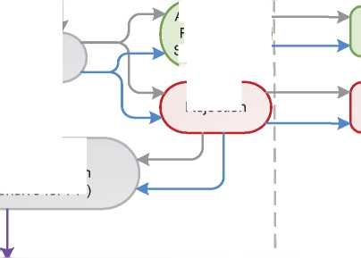

1. Additional Statistical Information

Figure 4: Asylum Applications from Top 10 Countries of Origin in 2009, 2010, 2011 and first half of 2012 [122]

| **1** | Kosovo | 4,579 | Kosovo | 5,281 | Russia | 4,489 | D.R. Congo | 2,866 |
| --- | --- | --- | --- | --- | --- | --- | --- | --- |
| **2** | Sri Lanka | 3,895 | Russia | 4,695 | Armenia | 4,199 | Russia | 2,645 |
| **3** | Russia | 3,782 | D.R. Congo | 3,707 | Bangladesh | 4,138 | Sri Lanka | 2,147 |
| **4** | Armenia | 3,603 | Bangladesh | 3,693 | D.R. Congo | 4,110 | Armenia | 1,432 |
| **5** | D.R. Congo | 3,165 | Sri Lanka | 3,404 | Sri Lanka | 3,873 | Turkey | 1,283 |
| **6** | Turkey | 2,610 | Haiti | 2,298 | Kosovo | 3,246 | China | 1,280 |
| **7** | Bangladesh | 1,912 | Guinea (Co.) | 2,204 | China | 2,283 | Georgia | 1,227 |
| **8** | Guinea (Co.) | 1,891 | Armenia | 2,156 | Haiti | 2,245 | Kosovo | 1,181 |
| **9** | Haiti | 1,832 | Turkey | 1,974 | Guinea (Co.) | 2,206 | Haiti | 1,114 |
| **10** | China | 1,631 | China | 1,969 | Turkey | 2,205 | Bangladesh | 1,068 |

**2009 2010 2011 Jan-Jun 2012**

**LFRA**

Figure 5: Decisions Taken at the First Instance in 2009, 2010 and 2011

|  |  |  |  |  |  |  |  |  |  |
| --- | --- | --- | --- | --- | --- | --- | --- | --- | --- |
|  | **Geneva Convention** | | **Subsidiary/**  **Complementary**  **Protection and Humanitarian Status** | | **Rejections** | | **Withdrawn, Closed, Abandoned Cases** | | **Grand**  **Total** |
| **Number** | **%** | **Number** | **%** | **Number** | **%** | **Number** | **%** | **35,331** |
| **2009** | 3,907 | 11% | 1,141 | 3% | 30,283 | 86% | 0 | 0% |
| **2010** | 4,081 | 11% | 1,015 | 3% | 32,571 | 86% | 0 | 0% | **37,667** |
| **2011** | 3,355 | 8% | 1,275 | 3% | 37,619 | 89% | 0 | 0% | **42,249** |

**Figure 6.a: Positive [123] First- and Second-Instance Decisions,Top Countries of Origin in 2009 [124]**

**Rate out of Total Decisions 21**

|  |  |  |  |  |
| --- | --- | --- | --- | --- |
|  | | **Total Positive** | **Total Decisions** | **Rate** |
| 1 | Sri Lanka | 634 | 2,636 | 24.1% |
| 2 | Mali | 574 | 877 | 65.5% |
| 3 | Iraq | 439 | 535 | 82.1% |
| 4 | D.R. Congo | 343 | 2,419 | 14.2% |
| 5 | Russia | 311 | 2,032 | 15.3% |
| 6 | Guinea (Conakry) | 301 | 1,675 | 18.0% |
| 7 | China | 179 | 1,391 | 12.9% |
| 8 | Sudan | 138 | 503 | 27.4% |
| 9 | Afghanistan | 135 | 362 | 37.3% |
| 10 | Eritrea | 135 | 194 | 69.6% |

Total Positive Decisions by Status

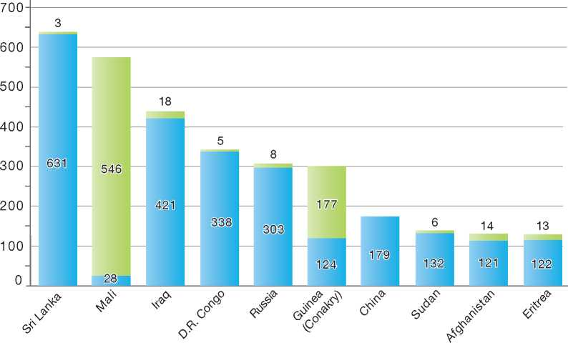

**Total Positive Decisions by Status**

| Geneva Convention Status | | Subsidiary/Complementary Protection and Humanitarian Status

**Figure 6.b: Positive [125] First- and Second-Instance Decisions,Top Countries of Origin in 2010 [126]**

**Rate out of Total Decisions 21**

|  | | **Total Positive** | **Total Decisions** | **Rate** |
| --- | --- | --- | --- | --- |
| 1 | Sri Lanka | 585 | 2,872 | 20.4% |
| 2 | Mali | 427 | 572 | 74.7% |
| 3 | Russia | 374 | 2,653 | 14.1% |
| 4 | Eritrea | 288 | 513 | 56.1% |
| 5 | D.R. Congo | 257 | 2,085 | 12.3% |
| 6 | Guinea (Conakry) | 255 | 1,563 | 16.3% |
| 7 | Iraq | 249 | 336 | 74.1% |
| 8 | Somalia | 189 | 273 | 69.2% |
| 9 | Iran | 184 | 263 | 70.0% |
| 10 | Afghanistan | 156 | 453 | 34.4% |

**LFRA**

Total Positive Decisions by Status

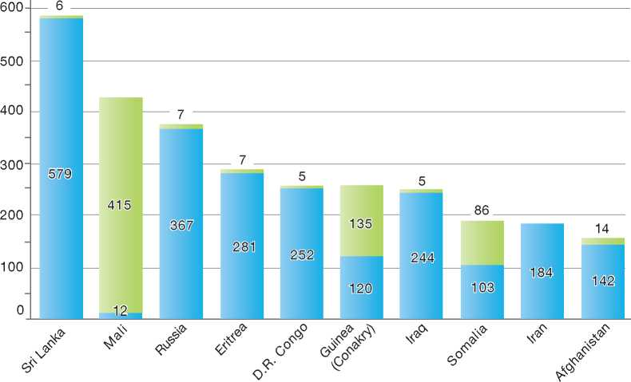

**Total Positive Decisions by Status**

| Geneva Convention Status | | Subsidiary/Complementary Protection and Humanitarian Status

**Figure 6.c: Positive [127] First- and Second-Instance Decisions,Top Countries of Origin in 2011 [128]**

**Rate out of Total Decisions 21**

|  |  |  |  |  |
| --- | --- | --- | --- | --- |
|  | | **Total Positive** | **Total Decisions** | **Rate** |
| 1 | Mali | 387 | 522 | 74.1% |
| 2 | Eritrea | 365 | 920 | 39.7% |
| 3 | Sri Lanka | 347 | 3,158 | 11.0% |
| 4 | Russia | 343 | 2,746 | 12.5% |
| 5 | D.R. Congo | 307 | 2,634 | 11.7% |
| 6 | Guinea (Conakry) | 302 | 1,545 | 19.5% |
| 7 | Somalia | 253 | 649 | 39.0% |
| 8 | Afghanistan | 187 | 491 | 38.1% |
| 9 | China | 156 | 2,088 | 7.5% |
| 10 | Iraq | 155 | 242 | 64.0% |

Total Positive Decisions by Status

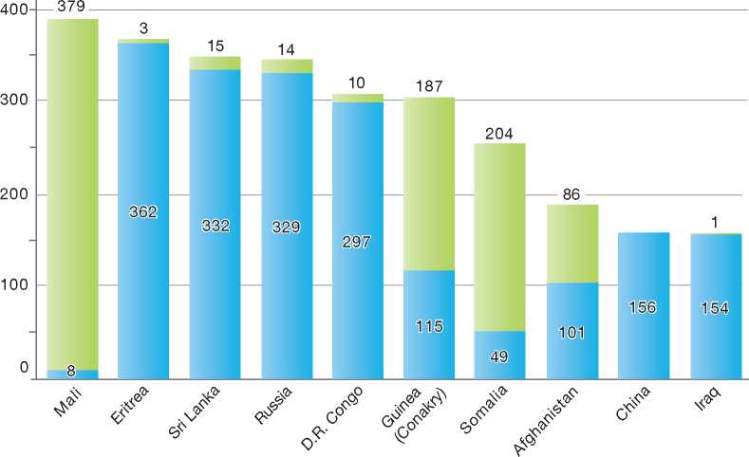

**Total Positive Decisions by Status**

| Geneva Convention Status | | Subsidiary/Complementary Protection and Humanitarian Status

1.

2.

3.

4.

5.

6.

7.

8.

9.

10.

11.

12.

Germany

BackGRound: MajoR asyluM tRends and developMents 209

national leGal FRaMewoRk 211

institutional FRaMewoRk 211

pRe-entRy MeasuRes 211

asyluM pRoceduRes 212

decision-MakinG and statuses 217

eFFiciency and inteGRity MeasuRes 222

assistance and Reception BeneFits FoR asyluM-seekeRs 223

status and peRMits GRanted outside the asyluM pRoceduRe 225

RetuRn 227

inteGRation 228

annexes

229



1. Background: Major Asylum Trends and Developments

Asylum Applications

In 1980, for the first time in German history, the country registered more than 100,000 asylum­seekers in a single year. Although figures went down again in the following years, there was a steady increase from the mid-1980s onward, which culminated in the peak figure of 438,000 asylum­seekers in 1992. The fall of the Iron Curtain on one hand and the relatively generous benefits granted to asylum-seekers on the other represented the main factors accounting for the significant increase in asylum-seekers. By late 1992 there was an accelerated increase of claims, with up to 50,000 applicants per month, the majority of whom did not present a need for international protection.

At that point, the German parliament decided on a comprehensive reform of the asylum system, which impacted virtually all asylum-related laws, including the Constitution. The measures took effect in the course of the first half of 1993 and had an almost instant impact. They resulted in a significant and continuous decrease of asylum-seekers in the following years. Since 2008, however, numbers have been on the rise again. While 22,085 first applications were filed in 2008, 41,332 applications for asylum were made in 2010 and 45,739 in 2011.**1**

Top Nationalities

In the early 1990s, most claims came from the former Yugoslavia, Romania, Bulgaria and Turkey. In 2008 by far the largest group of asylum-seekers came from Iraq, followed by Turkey, Vietnam and Kosovo. In 2011, the top five countries of origin were Afghanistan, Iraq, Iran, Serbia and Syria.

Important Reforms

The Asylum Procedure Act of 16 July 1982 introduced provisions aimed at accelerating the asylum procedure while safeguarding the right to asylum. Further attempts at achieving more efficient procedures were made in 1987, with the coming into force of the Act to Amend the Regulations Governing Legal Questions of Asylum Procedure, Work Permits and Foreigners Law. Germany joined the Dublin system and the Schengen area in 1990.

Throughout the 1990s, legislation governing asylum was the subject of important reforms, including the implementation of provisions in the Act on the Reorganisation of Asylum Procedures between 1992 and 1993, the so-called “asylum compromise” or agreement of political parties on a Joint Concept Regarding Asylum and Migration in 1992, and changes to the reception benefits regime for asylum-seekers.

In 2005, a new Immigration Act, which included several important amendments to the asylum law,

Figure 1: Total Asylum Applications by Quarter, January 1992 - June 2012 1

1 Data refer to first applications only.

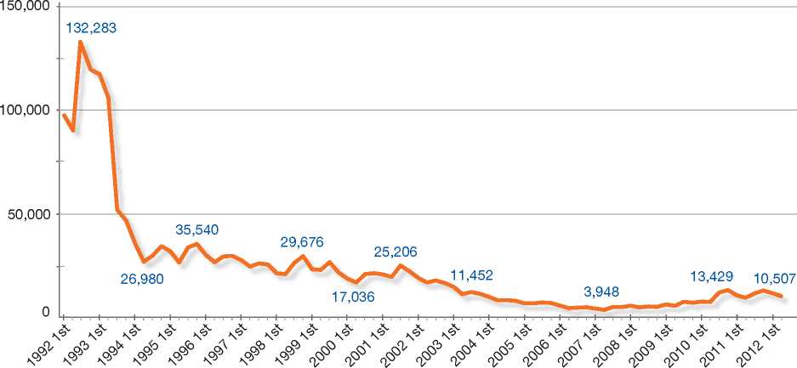

**Figure 2: Asylum Applications Received from Top 5 Countries of Origin in 2009, 2010 and 20113**

2009

Volumes

2010

Volumes

2011

Volumes

50%

4%

5%

24%

13% 10%

|  |  |  |  |
| --- | --- | --- | --- |
| **Country of Origin:** | | | |
| Afghanistan FYROM | Iran | Iraq | Kosovo |
| Turkey | Serbia | Syria | Others |  |

12%

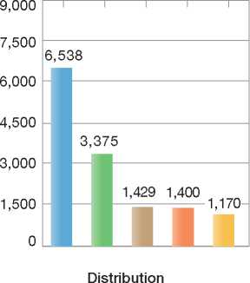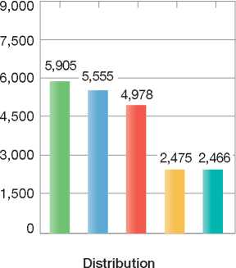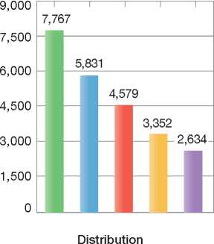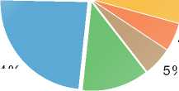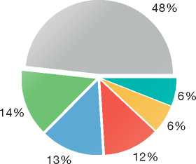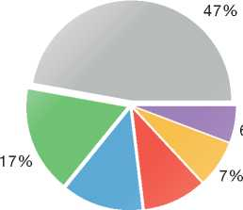

came into force, marking an overhaul of the German migration system. The Act provided for, *inter alia*, improved status rights for Convention refugees and for beneficiaries of subsidiary protection. Under this Act, gender-related persecution and persecution by non-state agents were henceforth to be considered to constitute grounds for granting refugee status.

More recently, the entry into force of the Act on the Implementation of Residence and Asylum-Related Directives of the European Union (19 August 2007) marked the transposition into German law of all relevant Council directives on asylum[129].

The recent visa liberalisation with regard to Balkan countries caused a large influx in applications from Serbia and the Former Yugoslav Republic of Macedonia (FYROM) in 2010 and 2011. One of the measures put in place to deal with this increase in applicants was to limit voluntary return assistance. Applicants predominantly consisted of members of the Roma ethnic group invoking precarious living conditions in their countries of origin.3

3 Data refer to first applications only.

1. National Legal Framework
2. Institutional Framework



1. Legal Basis for Granting Protection

German asylum law provides for two types of refugee status:

* Asylum status granted in accordance with Article 16a para. 1 of the Constitution (known as the Basic Law for the Federal Republic of Germany)
* Refugee Status granted in accordance with Section 3 para. 4 of the Asylum Procedure Act, which reproduces the 1951 Convention relating to the Status of Refugees (1951 Convention) inclusion criteria.

Both asylum and refugee status are granted according to a similar interpretation of the term “refugee”. However, with the transposition of the Qualification Directive into German law, these interpretation practices are changing, in part because the Qualification Directive applies only to Convention status but not to asylum status, as understood in German asylum law.

German law also includes provisions for granting complementary forms of protection (subsidiary protection) on the basis of the Qualification Directive (Section 60 para. 2, 3 and 7, sentence 2 of the Residence Act), the European Convention of Human Rights (ECHR; Section 60 para. 5 of the Residence Act), the Convention against Torture and Other Cruel, Inhuman or Degrading Treatment or Punishment (CAT; Section 60 para. 2 of the Residence Act), and on a national basis (Section 60 para. 7, sentence 1 of the Residence Act and Section 60a para. 2 of the Residence Act).

The granting of Convention refugee status and asylum is governed by the Asylum Procedure Act. An application for asylum is an application for both asylum status and refugee status. Under the single procedure, a person who does not meet criteria for asylum or refugee status may be granted a complementary form of protection.

1. Pending Reforms

There are currently no significant reforms to asylum procedures pending in Germany.

1. Principal Institutions

The Federal Office for Migration and Refugees *(Bundesamt fur Migration und Fluchtlinge,* BAMF) under the Ministry of Interior is the competent authority for assessing asylum claims. It decides on the granting of refugee status and on the granting of subsidiary protection within a single procedure.

The Aliens Offices, which fall under the responsibility of each federal state, determine applications for subsidiary protection, if these applications are made separately from applications for asylum. The Aliens Offices are also responsible for examining and making determinations on applications for subsidiary protection under the terms of Section 60a para. 2 of the Residence Act[130].

The states are also responsible for the accommodation of asylum-seekers. For this they must provide reception centres. In these facilities, the applicants are provided with in-kind livelihood support as well as a cash grant for daily personal needs. After the Federal Office has made a decision on an asylum claim, the granting of residence permits regulating the further stay of the alien lies in the competence of the federal states and the local immigration authorities.

The administrative courts are responsible for hearing appeals of decisions made by the BAMF or by the Aliens Offices.

The Federal Police receive requests for asylum at the border, and decide whether the asylum­seeker should be transferred to a reception facility or denied entry. The Federal Police are also responsible for transferring persons under the “airport” or Dublin procedures.

1. Pre-entry Measures

To gain entry into Germany, a foreign national must have a valid passport or passport substitute, unless he or she is exempt from this obligation by virtue of a statutory instrument. Exemptions to the passport requirement may be granted by the BAMF before entry or by the Federal Police upon entry. Both bodies are authorised by the Federal Ministry of Interior[131].

* 1. Visa Requirements

For a majority of foreign nationals, a visa is required in order to enter and remain in Germany. The issuance of visas rests with the Ministry of Foreign Affairs.

* 1. Carrier Sanctions

A carrier may only transport foreign nationals into Germany if they are in possession of a passport and a residence title (i.e. a visa or a residence permit). Violations of this obligation will subject the carrier to a fine. The fine ranges from € 1,000 to € 5,000 for each foreigner. Legal actions against the imposition of the fine have no suspensive effect.

If a foreign national is refused entry, the carrier who transported him or her to the border will be required to transport him or her from Germany. This obligation applies for a period of three years with regard to foreign nationals without a passport, passport substitute or a residence permit. It does not apply to individuals who were allowed entry because they cited grounds for refugee status or subsidiary protection. The obligation to remove the foreign national from German territory expires if he or she has been granted a residence permit pursuant to the Aliens Act.

* 1. Interception

The Federal Police are the competent authority for border control. Their tasks include, *inter alia* intercepting undocumented migrants at the border, within a 30-kilometre area inside the German border, and at international airports and seaports. The Federal Police Force also ensures the security of borders on the country's railway systems and on trains. As a rule, the Federal Police will return persons who entered illegally to the state where they came from. This does not apply if the return would amount to a violation of the *non-refoulement* principle and, in the case of asylum-seekers, if Germany is responsible for processing their claims.

1. Asylum Procedures
   1. Application Possibilities and Requirements, Procedures and Legal Remedies

Foreign nationals may make a request for asylum with border guards at the border or at an airport or seaport. Asylum requests may be filed inside the territory with any federal state or central government authority, such as the Police or an Aliens Office. The authorities will refer the foreign national to a reception centre for asylum-seekers.

The BAMF is the responsible authority for determining asylum claims. It is composed of a central office located in Nuremberg and 22 branch offices nationwide. As a rule, the branch offices are responsible for accepting formal asylum applications and for processing the claims. Reception centres are always located near a branch office of the BAMF.

Access to Information

The BAMF instructs all asylum applicants about the course of the procedure and about their rights and duties. In addition, the reception centres will provide them with information on their rights and duties regarding social assistance and medical care, as well as on who could provide counselling on legal and other issues.

* + 1. Outside the Country Applications at Diplomatic Missions It is not possible to apply for asylum from abroad. Resettlement/Quota Refugees

Germany adopted a regular resettlement program for a quota of 300 persons per year from 2012 to 2014. Before 2012, Germany engaged in resettlement of refugees on an *ad hoc* basis. In the years 2009-2010, Germany resettled 2,501 Iraqi nationals from Jordan and Syria in cooperation with the United Nations High Commissioner for Refugees (UNHCR) and as part of a collective European Union (EU) initiative. In 2010 and 2011, Germany also admitted refugees from Malta in 2010 and 2011 and 50 refugees from Iran.

Under the resettlement scheme, the UNHCR submits cases to the BAMF for consideration. Cases are accepted after interviews during a selection mission. In exceptional cases there can be a decision on a dossier-basis. Decisions on eligibility for resettlement are taken by the BAMF, and departures are organised in cooperation with the International Organization for Migration (IOM). Upon arrival in Germany, the BAMF determines the area of residence for the refugees. All resettled refugees are granted humanitarian status, with benefits similar to those given to persons who obtain refugee status.

* + 1. At Ports of Entry

At the Border

Asylum applications may be made at border guard posts. These applications are then referred to the competent or nearest asylum-seeker reception centre for examination under the normal procedure, as described below.

At Airports

In certain cases, asylum applications at international airports may be processed prior to the entry of the applicant into Germany. The airport procedure is an accelerated procedure, as there are deadlines for each procedural step. In cases where the authorities are not able to meet these deadlines, the asylum applicant is entitled to enter Germany and to have his or her claim processed inside the country.

The airport procedure applies in the following cases:

* When an asylum-seeker does not have valid identity documents, or
* When an asylum-seeker hails from a safe country of origin (EU Member States, Ghana or Senegal).

Asylum-seekers whose applications are streamed under the airport procedure are accommodated at a reception centre at the airport. The branch office of the BAMF located inside or close to the airport will examine his or her claim. Immediately after the interview, the asylum-seeker will be given the opportunity to contact a legal adviser of his or her choice.

If the BAMF makes a negative determination on the claim on the basis that the application is manifestly unfounded[132], the asylum-seeker is not entitled to enter Germany, and removal may be implemented. If the BAMF is not able to arrive at a decision within two days or if the claim is not deemed to be manifestly unfounded, the applicant will be permitted to enter Germany.

If the asylum application and the application for entry are rejected, the applicant can file an urgent motion with the Administrative Court, in order to temporarily suspend his or her removal. The motion must be filed within three days. If it is filed in time, the applicant cannot be removed prior to the Court's decision. The Administrative Court must decide on the application within two weeks. If the Administrative Court does not come to a decision within the two weeks, the applicant will be allowed to enter Germany. The Court decision cannot be appealed.

* + 1. Inside the Territory

Requests for asylum inside the territory are usually made with the Police or an Aliens Office. The authorities will refer the foreign national to the nearest reception centre for asylum-seekers. This reception centre will receive the person or refer him or her to the competent reception centre. Reception centres are always located near a branch office of the BAMF where a foreign national can formally apply for asylum. Prior to making the formal application for asylum, the foreign national is not considered an asylum applicant.

Responsibility for Processing the Claim

The Dublin System

*Application*

There are two cases in which Council Regulation (EC) No. 343/2003 (Dublin Regulation) applies.

The BAMF applies the Dublin Regulation to cases where a person has been arrested because of an illegal stay in Germany and it is proven that he or she had already applied for asylum in another State party to the Regulation. The BAMF also applies the Dublin Regulation once an asylum claim has been registered and the BAMF considers that another State is responsible for examining the application.

Procedure

The BAMF requests the responsible State to take the applicant back. After the responsible State has accepted the request, the application for asylum in Germany is deemed inadmissible (Section 27a of the Asylum Procedure Act) and the asylum-seeker will be ordered to leave Germany. He or she will be issued a *laissez-passer* in order to travel to the responsible State.

Freedom of Movement/Detention

Persons who make an asylum application in Germany are not usually detained during the asylum procedure. If a person has been arrested because of an illegal stay in Germany and it is proven that he or she had already applied for asylum in another State party to the Dublin Regulation, the person can be held in detention until transfer to the responsible State takes place.

*Conduct of Transfers*

As a rule, transfers are carried out on the basis of a mutual agreement between the States concerned. The German authorities (the Aliens Office or the Federal Police) will implement the transfer to the State.

*Review/Appeal*

Transfer decisions under the Dublin II Regulation may be appealed before the administrative courts. Appeals usually do not have suspensive effect unless administrative courts grant it.

In response to a decision of the European Court of Human Rights on 21 January 2011 (*M.S.S. v Belgium and Greece*), all States party to the Dublin Regulation suspended transfers to Greece effective January 2011. In its decision, the Court determined that transferring an applicant to another State cannot be allowed if there is a risk of inhuman or degrading treatment.

Application and Admissibility

Once an application for asylum has been registered with the BAMF, the identity of the applicant is established. The applicant is obliged to submit identity documents, if there are any. Fingerprints and photographs are taken. This information is then compared against data contained in the Central Register of Aliens and identity records stored by the Federal Criminal Police Office. The information is also compared against data in the EURODAC database in order to find out whether Germany is responsible for processing the claim under the Dublin Regulation.

Before interviewing the claimant, the branch office of the BAMF will determine whether the application is a first application, a repeat application or a multiple application. First applicants will receive official permission to reside in Germany with a specific residence permit for the duration of the procedure. The asylum-seekers are also informed of their rights and obligations under the asylum procedure.

The German asylum system does not comprise of an admissibility procedure in the strict sense of the term.

Accelerated Procedures

Besides the airport procedure, described earlier, above, there are no accelerated asylum procedures in Germany.

Normal Procedure

A caseworker of the BAMF will interview the asylum applicant either on the same day or within a few days of the asylum-seeker having made the application. Caseworkers are specialised according to specific countries of origin. Some caseworkers are also specially-trained in handling claims from specific vulnerable groups, such as unaccompanied minors or victims of gender-based persecution, victims of torture and traumatised applicants. The interview is not open to the public. It may be attended by representatives of the Federation, the federal states or the UNHCR. Other individuals may attend, if permitted by the head of the BAMF or his or her deputy.

It is up to the applicant to present the facts justifying his or her fear of persecution and to provide the necessary details.

The applicant will be provided with a copy of the minutes of the interview.

The caseworker will clarify the facts of the case and compile the necessary evidence. To this end, he or she will use country of origin information (COI) from a number of sources, including foreign-service reports, and publications from non-governmental organisations (NGOs) and the UNHCR.

Claims that are considered to be unfounded or manifestly unfounded are examined further by the BAMF to determine whether there exist grounds for granting complementary (subsidiary) protection.

A claim may, for example, be deemed manifestly unfounded in the following circumstances:

* The criteria for granting asylum status or refugee status are clearly not met
* It is clear that an asylum application has been made in order to gain entry into Germany for economic or other, non-protection-related reasons
* The person meets the criteria for exclusion as set out in Articles 1F and 33(2) of the 1951 Convention.

Review/Appeal of the Normal Procedure

A negative decision on an asylum claim may be appealed before an administrative court. There are three stages of appeal, before the Administrative Court, the High Administrative Court and the Federal Administrative Court. The Administrative Court and the High Administrative Court review decisions on points of fact and law, while the Federal Administrative Court considers points of law only.

The courts examine the claims without being bound by evidence presented by the parties. The court proceedings will normally comprise an oral hearing. The court proceedings depend on whether a claim has been rejected as “unfounded” or “manifestly unfounded”.

Unfounded Claims

Where the BAMF has determined a claim to be “unfounded”, an appeal may be lodged within two weeks of the decision. In this case, the appeal has suspensive effect.

If the court rules in favour of the asylum-seeker, the BAMF decision will be annulled and the BAMF will be requested to grant refugee status. If the court upholds the decision of the BAMF, the asylum-seeker will be required to leave Germany unless he or she has been granted complementary (subsidiary) protection.

The asylum-seeker and the BAMF may, under certain conditions, appeal the decision of the Administrative Court before the Higher Administrative Court. As a rule, appeals may be made with leave of the Administrative Court or - on special request - with leave of the Higher Administrative Court.

The decision of the Higher Administrative Court may be appealed before the Federal Administrative Court, provided that leave is granted either by the Higher Administrative Court or by the Federal Administrative Court. Usually, leave is granted in one of the following circumstances:

* The appeal invokes a breach of federal law
* The decision of the Higher Administrative Court is not compatible with the jurisprudence of the Federal Administrative Court, or
* The decision of the Higher Administrative Court is based on a legal issue of fundamental importance.

Manifestly Unfounded Claims

A decision to reject an application on the basis that it is “manifestly unfounded” may be appealed within one week of the decision of the BAMF. The appeal has no suspensive effect, and the applicant may be removed from Germany before the Administrative Court has decided on the appeal. However, the applicant may file an urgent motion, also within one week of the decision of the BAMF, in order to temporarily suspend removal proceedings.

If the Administrative Court rules in favour of the applicant, the BAMF decision is entirely or partly reversed and the Federal Office is obliged to determine refugee status or any other protection status.

If the Court rejects the appeal as manifestly unfounded, the applicant will be required to leave Germany. The decision to reject an appeal as manifestly unfounded cannot be appealed beyond the Administrative Court.

*Freedom of Movement during the Procedure*

Detention

Asylum-seekers are not detained for merely having applied for asylum and have freedom of movement during the procedure, although this movement is geographically restricted to the district of the competent Aliens Office. Some federal states have loosened this geographic restriction.

Reporting

Asylum-seekers must inform the authorities of any change of address.

Repeat/Subsequent Applications

Repeat applications are subject to specific procedures. Applications are considered to be repeat applications if the asylum-seeker makes an asylum claim after having obtained a final negative decision on a previous claim or after withdrawing a previous claim.

An assessment of the merits of a repeat application will take place only if the applicant presents new facts or evidence, which through no fault of the applicant was not presented during a previous asylum procedure. A repeat application must be made within three months of these new facts or evidence coming to light.

If an asylum-seeker fails to produce new facts or evidence or fails to make a repeat application within the time limit, no new asylum procedure will be conducted. In such a case, removal is possible, once the BAMF has informed the Aliens Office that there will be no assessment on the merits of the claim. Removal can be effected even before a written decision on the claim has been served on the applicant.

If after the final conclusion of a previous procedure, an applicant substantiates a subsequent application with facts or circumstances which are the result of the applicant's own decisions, as a rule refugee status cannot be given. Nevertheless, the granting of subsidiary protection will be considered. This interpretation of Article 5 paragraph 3 of the Qualification Directive results from a decision of the Federal Administrative Court.

The applicant can appeal a negative decision on a repeat application before the Administrative Court. The appeal does not have suspensive effect. The applicant may file an urgent motion in order to stop the implementation of the removal order.

* 1. Safe Country Concepts
     1. Safe Country of Origin

The legal basis for the safe country of origin principle is Article 16a (3) of the Constitution, in line with Section 29a of the Asylum Procedure Act. Safe countries of origin are countries in which, on the basis of law, implementation practices and general political conditions, it can safely be concluded that neither political persecution nor inhuman or degrading punishment or treatment exists.

Safe countries of origin are specified by law. The current list of safe countries of origin includes EU Member States, Senegal and Ghana. Claims made by persons from a safe country of origin are examined on their merits. However, there is a refutable presumption that an asylum-seeker from such a country is not persecuted. If the asylum-seeker can refute the presumption by demonstrating that he or she is persecuted, refugee status will be granted. Otherwise, claims made by persons from a country considered to be a safe country of origin will be deemed manifestly unfounded and rejected on that basis.

* + 1. First Country of Asylum

Section 27 of the Asylum Procedure Act stipulates that an asylum-seeker who benefited from protection in another country will not be granted refugee status. If an asylum-seeker holds a travel document issued by a safe third country or by another third country pursuant to Article 28 of the 1951 Convention, it is presumed that he or she was safe from persecution in that country. The same applies to asylum-seekers who lived for more than three months in another country where they were safe from persecution. However, the asylum­seeker may rebut the presumption of safety by demonstrating that *refoulement* to a country where he or she would face a risk of persecution could not be ruled out with reasonable certainty.

The decision regarding the first country of asylum principle can be appealed before the Administrative Court. The appeal does not have suspensive effect.

* + 1. Safe Third Country

German law stipulates that any foreign national who arrives at the border and claims asylum will not be allowed to enter the territory if he or she is arriving from a safe third country.

The safe third country rule does not apply under the following circumstances:

* The foreign national held a residence permit for Germany at the time he or she entered the safe third country
* Germany is responsible for processing claims based on European Community law or an international treaty with the safe third country
* The foreign national has been admitted by the Federal Ministry of Interior on humanitarian grounds, for reasons of international law or in the political interest of Germany.

The list of safe third countries includes the Member States of the European Union, Norway and Switzerland. Currently, the safe third country rule has little practical effect as the Dublin II Regulation supersedes it.

The decision to apply the safe third country rule can be appealed to the Administrative Court. The appeal does not have suspensive effect.

* 1. Special Procedures
     1. Unaccompanied Minors

German asylum law distinguishes between minor asylum-seekers below the age of 16 and minors aged 16 and 17.

Asylum-seekers aged 16 and above are considered to have the full legal capacity to make an asylum claim on their own and to undergo each step of the procedure.

According to German law, a guardian must be appointed for all unaccompanied minors. No asylum interview can be held before the guardian is appointed. The guardian may be a family member or a representative from the local Youth Office, if the minor does not have relatives in Germany. The guardian will be given the opportunity to attend the interview. If the guardian does not attend the interview, it can be held in his or her absence. In this case the minor can be accompanied by another adviser or counsel.

The branch offices of the BAMF employ specially trained caseworkers to deal with unaccompanied asylum-seekers in order to ensure that the child's level of maturity and development will be taken into account.

Some federal states have in place special reception arrangements for unaccompanied minors. Clearing agencies look after the unaccompanied minors, provide assistance with accommodation and try to obtain information on the whereabouts of their parents or legal guardians.

* + 1. Stateless Persons

The asylum application of a stateless person is treated in the same manner as an application made by any other asylum-seeker. The risk of persecution or risk to life or to the person will be examined against conditions in the country of former habitual residence. As a rule, this is the last country of residence.

A stateless asylum-seeker who has received a negative decision on a claim may be removed to the country of former habitual residence or to a third country where there is no risk of persecution.

1. 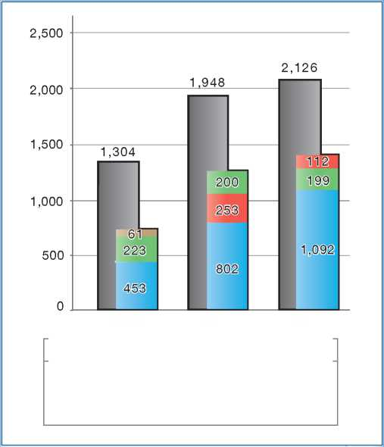Decision-Making and Status

| **Figure 3: Asylum Applications by Unaccompanied Minors in 2009, 2010 and 2011** | | | |
| --- | --- | --- | --- |
|  | **2009** | **2010** | **2011** |
| Total Asylum Applications | 27,649 | 41,332 | 45,739 |
| of which Unaccompanied Minors | 1,304 | 1,948 | 2,126 |
| Percentage | 5% | 5% | 5% |

| 2009 | 2010 2011 |
| --- | --- |
| **Country of Origin:** |  |
| Afghanistan | Iraq |
| | Somalia | Vietnam |

* 1. Inclusion Criteria
     1. Convention Refugee

As noted above, there are two types of refugee status granted in Germany:

* Asylum status granted in accordance with Article 16a para. 1 of the Constitution (known as the Basic Law for the Federal Republic of Germany)
* Refugee status granted in accordance with Section 3 para. 4 of the Asylum Procedure Act, which reproduces the 1951 Convention inclusion criteria.

The criteria that have to be met for either status are similar, although asylum status is more narrowly construed. Asylum status cannot be granted in cases where an asylum-seeker arrives in Germany via a safe third country or where the claim is based on post-flight events for which the asylum-seeker is responsible. In contrast, refugee status on the basis of the 1951 Convention is not precluded where the safe third country rule or post-flight events are applicable.

The Qualification Directive (Council Directive 2004/83/EC) is applicable only to refugee status granted under the 1951 Convention and not to asylum status. Thus, it is expected that with the transposition of the Directive into German law, the differences in inclusion criteria between the two types of status will widen. The Federal Constitutional Court determines the criteria for granting asylum status.

* + 1. Subsidiary Protection

An asylum-seeker is granted complementary (“subsidiary”) protection if he or she is not entitled to asylum but cannot be removed for one of the following reasons:

Subsidiary protection based on Article 15 of the “Qualification Directive”:

* A risk of the death penalty or execution
* A risk of torture or inhuman or degrading treatment or punishment, or
* A serious and individual threat to a civilian's life or person by reasons of indiscriminate violence in situations of international or internal armed conflict.

Subsidiary protection based on other legal criteria*:*

* A breach of rights under Article 3 of the ECHR, or
* Other substantial and concrete dangers to life, limb or liberty, such as natural disasters or risks arising from the particular situation of the applicant.
  1. The Decision

Both positive and negative decisions of the BAMF are made in writing. Negative decisions are reasoned and are accompanied by a fact sheet outlining the possibilities for appealing the decision. Decisions are always served on the asylum-seeker or his or her representative.

Asylum Case Law: Granting Subsidiary Protection

In a 24 June 2008 decision in the case of *BVerwG 10 C 43.07****8*** , the Federal Administrative Court set out criteria that have to be met in order to be granted subsidiary protection on the basis of Article 15(c) of Council Directive 2004/83/EC (the Qualification Directive).

The Court ruled that the concept of international and internal armed conflict is to be construed as taking international humanitarian law into account, in particular the Geneva Conventions and the Additional Protocols of 1977. An internal armed conflict need not extend through the entire territory of a country. However, its existence does not in and of itself suffice to make a person eligible for subsidiary protection. Instead, the conflict must be such that it poses a danger to the entire population on the territory. This danger of a general nature can be made more serious by individual circumstances, including circumstances arising from a person's membership in a group.

In the decision of the Tenth Division of 14 July 2009 *(BVerwG 10 C 9.08)****[133]*** the Federal Administrative Court developed the above concept further. The headnote reads:

“1. A substantial individual danger to life or limb within the meaning of Section 60 (7) Sentence 2 of the Residence Act that also satisfies the equivalent requirements of Article 15 (c) of Directive 2004/83/ EC (Qualification Directive) may also arise from a general danger to a large body of civilians within a situation of armed conflict if the danger is concentrated in the person of the foreigner.

1. Such a concentration, or individualisation, may result from circumstances specific to the foreigner’s person that increase risk.
2. By exception, it may also arise irrespectively of such an individualisation in an extraordinary situation that is characterised by such a high degree of risk that practically any civilian would be exposed to a serious individual threat solely on account of his or her presence on the relevant territory (concurring, European Court of Justice judgment of 17 February 2009 - *C465/07 - Elgafaji).*

2. If an armed conflict with such a degree of risk does not exist nationwide, as a rule an individual threat will come under consideration only if the conflict extends to the foreigner's region of origin, to which he or she would typically return.”

1. The full text of the decision, in English, may be found on the website of the Federal Administrative Court: [www.bundesverwaltungsgericht.de](http://www.bundesverwaltungsgericht.de).



* 1. Types of Decisions, Status and Benefits Granted

The BAMF may make one of the following decisions on an asylum claim:

* Grant asylum status in line with Article 16a para. 1 of the Constitution and refugee status in line with the 1951 Convention
* Grant only refugee status in line with the 1951 Convention
* Grant subsidiary protection
* Deny asylum status, refugee status and subsidiary protection
* Determine that the claim should not be processed as the asylum-seeker entered Germany via a safe third country - thus, the claim is not examined on its merits.

Claims may be rejected on the basis that they are unfounded, manifestly unfounded or that they are irrelevant because it is obvious that the foreign national was already safe from persecution in another country (first country of asylum).

Claims that are considered to be unfounded may be rejected as manifestly unfounded, *inter alia*, in the following cases:

* Key aspects of the reasons invoked in the application have not been substantiated, are contradictory, do not correspond to the facts or are based on fraudulent evidence
* The person has concealed or provided misrepresentations of his or her identity or nationality
* The person has made another asylum application using different personal information
* The claim was made in order to avoid an imminent termination of a residence permit and the person had ample opportunity to make the claim at an earlier date.

Applicants with claims deemed irrelevant will normally be returned to the country where they had been safe from persecution. If it is not possible to return the person within three months, the asylum procedure will be resumed.

Convention Refugee or Asylum Status

Persons granted asylum status or refugee status are entitled to the following benefits:

* A residence permit which is valid for three years and renewable
* The same (unrestricted) access to the labour market as nationals
* The same social welfare benefits as nationals (including housing)
* The same health care as nationals
* Integration measures, including language training and cultural orientation.

Members of the nuclear family (spouse and unmarried minor children) of a refugee residing in Germany are generally entitled to asylum status or refugee status as well without the need to show persecution. Members of the nuclear family (spouse, unmarried minor children, parents who are legal guardians of minor children) who are not residing in Germany are as a rule entitled to family reunification[134] [135].

As a rule, a refugee becomes eligible for a permanent residence (“unlimited settlement”) permit after three years, unless there are reasons for withdrawing his or her asylum or refugee status. To this end, all positive decisions will be re-examined by the BAMF no later than three years after the decision became final and non-appealable.

If the prerequisites for granting refugee status are still met, refugee status will be upheld, and the refugee will be granted a permanent residence permit. If not, refugee status will be withdrawn. Once this decision has become final and non-appealable, the competent Aliens Office will decide whether to withdraw the residence permit. The latter is a discretionary decision and will depend on a number of factors, *inter alia*, the degree of integration of the individual into German society, the length of stay in the territory, the length of absence from the country of origin, any criminal record, and family ties.

Beneficiaries of Subsidiary Protection

Beneficiaries of subsidiary protection are entitled to the following benefits:

* A residence permit valid for at least one year and renewable
* Access to the labour market, subject to a labour market test11
* Access to the same core social welfare benefits as nationals (including housing)
* Access to the same core health care as nationals
* Integration measures (on a discretionary basis).

Close family members (spouse, unmarried minor children, and parents who are legal guardians of minor children) of beneficiaries of subsidiary protection are granted family reunification under certain conditions (e.g. secured livelihood and adequate accommodation space).

Beneficiaries of subsidiary protection may obtain a permanent residence permit after seven years, upon a decision by the competent Aliens Office.

Negative Decisions

An asylum-seeker whose claim is determined to be “unfounded” is given a notification of return along with the negative decision. The person must leave Germany within one month of the decision if he or she does not appeal the decision[136]. The appeal has suspensive effect.

An asylum-seeker whose claim is determined to be “manifestly unfounded” is given a notification of return along with the negative decision. The person must leave Germany within one week of the decision. The appeal against the decision does not have suspensive effect, unless the asylum­seeker files an urgent motion to this end and the urgent motion is successful.

Asylum-seekers who are found to have arrived through a safe third country are required to return to the safe third country.

* 1. Exclusion
     1. Refugee Protection

The Counter-Terrorism Act of 9 January 2002 introduced grounds for excluding persons from refugee status in line with Article 1 F of the 1951 Convention. Prior to that date, exclusion clauses were not applied during the asylum procedure.

In addition to Article 1 F cases, refugee status will not be granted in cases where there are serious reasons for considering that the asylum-seeker constitutes a risk to national security or to the public because he or she has been sentenced to a prison term of at least three years for a criminal offence. In accordance with a ruling by the European Court of Justice on 9 November 2010[137], there is no automatic exclusion on the sole grounds of belonging to an organisation that uses terrorist methods. Instead, an appraisal of the factual circumstances in each case must be made.

* + 1. Complementary Protection

Exclusion clauses, as outlined below, are applicable when considering the granting of complementary protection. Complementary protection is construed as an absolute right of protection against removal, as there are no other protection provisions in German law. Thus, while a person as such cannot be excluded from complementary protection, the relevant status rights can be denied.

If a person who meets the criteria for complementary protection is also subject to the exclusion clauses, the person will be granted neither a residence permit nor other rights and benefits attached to complementary protection status. He or she will be obliged to leave Germany. If his or her removal cannot be effected, he or she will have the same status rights as an asylum-seeker.

The applicable exclusion clauses, based on Article 17 of the Qualification Directive, are as follows:

* There are serious reasons to believe the person has committed a crime against peace, a war crime or a crime against humanity in line with Article 1F(a) of the 1951 Convention
* There are serious reasons to believe the person has committed a serious non-political crime in line with Article 1F(b) of the 1951 Convention
* There are serious reasons to believe the person has been guilty of acts contrary to the purposes and principles of the United Nations as set out in the Preamble and Articles 1 and 2 of the Charter of the United Nations (Article 1F(c) of the 1951 Convention)
* There are serious reasons to believe the person constitutes a danger to the community or to national security (Article 33 para. 2 of the 1951 Convention).

In addition to the exclusion clauses above, a person who meets the criteria for complementary protection on the basis of non-European Union law may be excluded for the following additional reasons:

* It is possible and reasonable for the applicant to reside in another State or
* The applicant has repeatedly or grossly breached duties to cooperate with the authorities.
  1. Cessation

Germany applies the cessation clauses of Article 1 C of the 1951 Convention.

The cessation of refugee protection status has to be examined no later than three years after the decision has become non-appealable.

In cases pursuant to Article 1 C (5) and (6) of the 1951 Convention (ceased circumstances clauses) the BAMF will inform the refugee in writing about the possibility of his or her status being withdrawn. The refugee will be given due process. The BAMF may request that the refugee provide a written comment within one month. If the refugee fails to do so, the decision will be taken on the basis of the record as it stands. The decision will be served upon the person in writing. The person can appeal the decision. As a rule, the appeal has suspensive effect.

Subsidiary protection status may be withdrawn if the person no longer meets criteria for being granted protection. The same procedural rules apply as in cases pursuant to Article 1 C (5) and (6). The decision can be appealed. As a rule, the appeal has suspensive effect.

In all cessation cases it is up to the competent Aliens Office to decide whether the residence permit should be withdrawn as well. The decision is discretionary and will be based on a number of criteria, *inter alia,* integration of the individual in Germany, length of stay, any criminal record and family ties.

* 1. Revocation

Asylum status, refugee status or subsidiary protection status may be revoked if the granting of protection status was incorrect. This applies in cases where the decision was based on false information provided by the asylum-seeker (e.g. a false identity or a false country of origin) or on the concealment of essential facts. The same rules of procedure and legal remedies apply as in cessation cases, as described above.

The revocation of status will also normally lead to the revocation of the residence permit (*ex tunc*).

* 1. Support and Tools for Decision-Makers

In addition to a country of origin information service and a language analysis tool, the BAMF provides its decision-makers with policy guidelines regarding the situation in countries of origin and the interpretation of the law.

* + 1. Country of Origin Information

The Information Centre for Asylum and Migration (*Informationszentrum Asyl und Migration*, IZAM) of the BAMF is responsible for storing and producing country of origin information (COI). The IZAM COI collection comprises information from a wide range of sources, such as Foreign Service reports published by Germany and other countries, information from the UNHCR, from human rights organisations, NGOs, academics, and from liaison officers deployed in a number of EU Member States. The information made available to asylum decision-makers is regularly updated.

The IZAM conducts research and produces reports on countries of origin as well as on specific subjects, such as political organisations or the situation of particular groups in countries of origin. The IZAM also compiles legal information, in particular decisions by courts.

All the research produced and gathered by the IZAM is made available on the database MILo (Migration-Information-Logistics), which is fully accessible to BAMF staff as well as to administrative judges who are dealing with Asylum and Aliens Law. Parts of MILo are made available to the public on the Internet. The IZAM also operates a central reference desk, which responds to caseworkers' queries for COI and edits an asylum gazette.

* + 1. Language Analysis

If the reasons for the request for asylum or the knowledge of the claimed country of origin are doubtful and if the applicant cannot provide personal documents, speech and text analysis can be undertaken. To this end, the Federal Office will make an audio recording of the oral statements of the asylum-seeker. Under the supervision of an asylum official, an interpreter will ask the applicant important questions about the claimed country of origin, his or her social background, education, occupation and daily life. Recordings may be made only if the asylum-seeker is informed beforehand. The audio records will be sent to the responsible section of the Federal Office, which will select the suitable linguist to check the quality of the recording and undertake an analysis.

While the analysis mostly focuses on language, the knowledge of the claimed country will also be considered. The Federal Office works with independent linguists who have the necessary qualifications (academic training that qualifies them in certain language areas) as well as expert country knowledge.

All language analysis proceedings are done anonymously. In accordance with German data protection legislation, the name of the applicant is never disclosed to the expert. Likewise, the name of the expert will not appear on the report; only a coded ID and information on the expert's qualifications will be provided.

The goal of the expert report is to establish (with a certain degree of probability) a person's main socialisation rather than the citizenship. The result of this report is one element that is considered when making a decision on the asylum application.

The entire procedure of speech and text analysis undergoes regular reviews and improvements to meet the standards requested by the German administrative courts.

1. Efficiency and Integrity Measures

BAMF involvement in projects related to quality issues

The “Asylum Systems Quality Assurance and Evaluation Mechanism” (ASQAEM) Project was implemented in Austria, Bulgaria, Germany, Hungary, Poland, Romania, the Slovak Republic and Slovenia between 2008 and 2010. The UNHCR received European Union funding for regional projects in this area. The project identified strengths and weaknesses in national processes and helped to introduce improvements. Overall, the project highlighted the importance of a systematic approach to quality control in asylum procedures.

This work has continued in Central and Southern Europe with a new EU-funded project entitled “Further Developing Asylum Quality” (FDQ). Member States involved in this project are Cyprus, Greece, Italy, Portugal and Central European states, with Austria, Germany and the United Kingdom also sharing their experience. Conducted between April 2010 and September 2011, FDQ consolidated progress made in countries involved in the ASQAEM project and launched quality-related action structures in Southern European countries.

The project's main objectives included raising the quality, fairness and effectiveness of the asylum procedure.

Under the ASQAEM project, Germany focused on unaccompanied minors, including 16 and/or 17-year-olds. This particular subset of vulnerable persons not only places high demands on the asylum procedure but also garners more public attention. The project, in turn, inspired the creation of two new advanced training modules for specialised decision-makers and the issue was also addressed at regular decision-maker conferences.

Within FDQ, Germany was assigned as counsellor to assist selected countries in setting up their quality divisions. Other counsellors came from Austria and England.

The participation in these quality-related projects enabled the Federal Office for Migration and Refugees to present its long­standing quality standards in several international conferences and thus gain an inside view on the development and states of play in other European countries.

* 1. Technological Tools

The identity of any asylum-seeker will be established by means of identification measures unless he or she is less than 14 years of age. Only photographs and prints of all ten fingers may be taken. Fingerprinting is crucial for identifying asylum-seekers who have already applied for asylum in other EU countries, and for determining whether the application is a first or repeat application.

* + 1. Fingerprinting

Fingerprints are taken from all asylum-seekers aged 14 and older. Fingerprints are stored in a central database with the Federal Criminal Police Office. They will be compared with fingerprints of other asylum-seekers included in the database in order to establish whether an asylum-seeker is making a first or repeat or a multiple application for asylum. The information will also be compared against data in the EURODAC database and identity records stored by the Federal Criminal Police Office and obtained from such sources as criminal investigations.

The fingerprints taken are also stored in the EURODAC database, which facilitates the comparison of fingerprints of asylum-seekers and persons without permits in EU countries, in order to determine the State responsible for processing a claim under the Dublin Regulation.

In response to a recent practice among some asylum-seekers of fingertip mutilation that makes identification by fingerprinting impossible, a procedure was put in place whereby applicants presenting such mutilations are instructed toreappear for identification, or risk having their application withdrawn and asylum procedure closed. This practice has led to a sharp decrease in the number of applicants with mutilated fingertips.

* + 1. DNA Tests

There are no possibilities for undertaking DNA tests during the asylum procedure.

* + 1. Forensic Testing of Documents

In order to check the authenticity of identity documents or other documents, forensic tests are used.

* + 1. Database of Asylum Applications/Applicants

Data on application of all asylum-seekers is stored at a centralised database at the BAMF, called the Maris database. In addition, personal data of asylum-seekers is entered into the Central Aliens Register. The Central Aliens Register is a centralised, national file containing personal data, *inter alia*, of foreign nationals who are staying in the Federal territory for longer than three months, and foreign nationals who are in Germany on special residence grounds, such as asylum­seekers. The Central Aliens Register is also maintained by the BAMF.

* + 1. Biometric Data Checks

In order to check the authenticity of an asylum­seeker's document or identity, biometric data and other data stored electronically in his or her passport or other identity documents may be read, and the necessary biometric data may be obtained from the asylum-seeker and compared with the biometric data from the document. Biometric data may include only fingerprints, photographs and iris scans.

* 1. Length of Procedures

While there are no time limits for making a first asylum application, a person who has delayed in making an application for asylum after arriving in Germany may find his or her credibility assessment affected. Repeat applications must be made within three months of the day the person becomes aware of the grounds for the new application. Otherwise the repeat application will be rejected.

* 1. Pending Cases

As at 30 September 2012, there were a total of 44,766 pending cases at the BAMF.

* 1. Information-Sharing

Information-sharing agreements exist with States under the Dublin II Regulation. The UNHCR is provided with anonymised copies of all asylum decisions.

* 1. Single Procedure

If an asylum-seeker asks for asylum and/or refugee status, the BAMF will automatically also decide on the granting of subsidiary protection in cases where asylum and refugee status was denied. In that sense, there is a single procedure.

However, if a foreign national applies for subsidiary protection only, the decision rests with the Aliens Office. In order to ensure consistency in decision­making, the Aliens Office consults the BAMF before making a decision on the application.

1. Assistance and Reception Benefits for Asylum-Seekers
   1. Procedural Support and Safeguards
      1. Legal Assistance

There is no requirement for asylum-seekers to have legal representation or assistance during the asylum procedure at the BAMF. Nor is legal counsel required for appeals before the Administrative Court. Legal representation is obligatory for appeals before the High Administrative Court and the Federal Administrative Court.

At the first instance, asylum-seekers have access to free legal counselling but not free legal representation. At the appeal stage, an asylum­seeker may be granted free legal aid that includes legal representation, provided that there are sufficient prospects for success of the appeal and the appellant is lacking in financial resources.

* + 1. Interpreters

During the asylum procedure at the BAMF, an interpreter, translator or other linguist is made available during the interview if the applicant

does not have sufficient command of the German language.

1. UNHCR

According to Section 9 of the Asylum Procedure Act, every asylum-seeker in Germany may contact the UNHCR. The office may present its views regarding individual applications for asylum to the BAMF. The UNHCR also has access to persons in detention and in airport transit zones.

1. NGOs

NGOs are not involved in the asylum procedure. However, there is a wide range of NGOs and private initiatives engaged in counselling and support work for asylum-seekers and refugees.

1. Reception Benefits

The Federal States have overall responsibility for the reception of asylum-seekers.

1. Accommodation

Asylum-seekers are accommodated in asylum reception centres run by the federal states during the first three months of the procedure. Thereafter, asylum-seekers will be transferred to local asylum centres, which are also run by the federal states or local authorities. The obligation to reside in a reception centre may be terminated for reasons of public health, for other reasons of public security and order or for other compelling reasons, including humanitarian reasons.

Unaccompanied minor asylum-seekers under the age of 16 are provided accommodation in special reception centres run or supervised by the Youth Welfare Services. In a number of federal states, this type of accommodation is also available to unaccompanied minors above the age of 16.

1. Social Assistance

Asylum-seekers are entitled to government aid if they have no income or assets of their own. The Asylum-Seekers Benefits Act defines the scope and form of assistance granted to asylum-seekers. As a rule, in-kind benefits have priority over financial aid. In-kind benefits comprise of, *inter alia*, accommodation, heating, electricity, furniture and appliances. Everyday items can be purchased using coupons or credit cards loaded with fixed credit amounts.

Following a ruling of the Federal Constitutional Court on 18 July 2012, asylum-seekers receive monthly financial aid based on one of six “requirement levels”:

* Level 1: Single person or single parent: € 212 standard benefit, € 134 pocket money, € 346 in total
* Level 2: Spouse or life partner: € 191 standard benefit, € 120 pocket money, € 311 in total
* Level 3: Adult household members: € 170 standard benefit, € 107 pocket money, € 277 in total
* Level 4: Children between the ages of 15 and 18: € 192 standard benefit, € 79 pocket money, € 271 in total
* Level 5: Children between the ages of 7 and 14: € 152 standard benefit, € 86 pocket money, €238 in total
* Level 6: Children under the age of seven: € 127 standard benefit, € 78 pocket money, € 205 in total.

Additional benefits may be granted in special situations, such as to accommodate the special needs of children and infants, the costs of school materials, the costs of field trips or the special needs of pregnant women.

1. Health Care

Asylum-seekers are entitled to medical and dental care if they suffer from an illness requiring treatment. Unless there is an emergency, asylum­seekers must receive approval from the Social Services Office prior to visiting a doctor. Medical treatment may be refused if it is not absolutely necessary or it can be performed at a later date.

Additional health care services may be granted if they are necessary for the overall health of the asylum-seeker. Asylum-seekers are entitled to regular medical examinations and essential vaccinations.

Children under the age of six can undergo special paediatric medical exams, including dental examinations. Pregnant women and mothers with infants may have access to a wider range of health care services.

Asylum-seekers who have resided in Germany for more than 48 months (four years) while awaiting a decision on their claim will generally be granted health care based on the benefits granted to German nationals.

1. Education

Responsibility for granting access to education rests with the federal states. Thus, there is no uniform policy regarding access to education. In some federal states, school attendance for minor children of asylum-seekers with pending asylum applications is compulsory, while in other States minors have the possibility to attend school but are not obliged to do so.

1. Access to Labour Market

After having resided in Germany for a year while awaiting a decision on their claim, asylum-seekers may take up employment. However, a person's access to a specific job is subject to a labour market test. Asylum-seekers will be considered for a position only if there are no competing German or EU citizens qualified for the job.

1. Access to Integration Programmes

Asylum-seekers are not entitled to participate in state-run integration programmes pending a decision on their claim. However, there are numerous social programmes designed to assist asylum-seekers in their everyday life. These cover a wide range of issues, including legal counselling and joint activities with the local communities.

1. Access to Benefits by Rejected Asylum-Seekers

Asylum-seekers who have obtained a negative decision on their claim continue to be entitled to benefits for asylum-seekers until their departure from Germany.

1. Status and Permits Granted Outside the Asylum Procedure
   1. Subsidiary Protection

Applications for subsidiary protection claims are examined by the Aliens Office if the applicant does not apply for asylum at the same time. These applications are considered separately from the asylum procedure.

The Aliens Office is also responsible for examining applications for subsidiary protection if the application raises issues related to the person's situation, such as health issues or lack of fitness to travel. Such applications are usually made after a negative decision on an asylum claim by the BAMF.

Any negative decision taken by the Aliens Office on an application for subsidiary protection may be appealed. The appeal has suspensive effect.

All beneficiaries of subsidiary protection, regardless of whether it was granted by the Aliens Office outside the asylum procedure or by the BAMF, are entitled to the same benefits described above.

* 1. Humanitarian Grounds

The Aliens Office may grant on a discretionary basis temporary residence for humanitarian reasons or for reasons related to public interest. The temporary residence permit is valid for a maximum period of six months.

**Decisions by the Commissions for Hardship**

**Cases *(Hartefallkommission)***

Federal states may issue a residence permit to a person who is subject to a removal order, if a Commission for Hardship Cases determines that there are compelling reasons for doing so. Commissions for Hardship Cases exist in all federal states. For example, a person who has been integrated into German society and has resided in the country for many years may be eligible for a residence permit. Persons who have been convicted of a serious crime are excluded from consideration.

The Commission's decisions are recommendations and non-binding on authorities. Hence, a person cannot appeal the decision of the Commission.

If a residence permit is granted on the basis of the Commission's recommendation, the person is entitled to the same rights as any other legally residing foreign national.

* 1. Temporary Protection

Temporary protection is granted on a group basis outside the asylum procedure, in accordance with Section 24 of the Residence Act, which gives effect to Council Directive 2001/55/EC[138]. Temporary protection is limited to a maximum of two years. If beneficiaries of temporary protection apply for asylum, the decision on the asylum claim will be suspended until temporary protection comes to an end.

Beneficiaries of temporary protection are settled in Germany on a voluntary basis. It is not possible for foreign nationals to apply for temporary protection or to make an appeal against a decision not to grant temporary protection.

Beneficiaries of temporary protection are entitled to rights and benefits similar to those of beneficiaries of subsidiary protection.

* 1. Group-Based Protection

While refugee status is granted within the asylum procedure on an individual case-by-case basis, if mere affiliation with an ethnic, religious or other, well-defined group of persons is the basis for persecution (group-based persecution), it is possible to grant refugee status to members of the group collectively. Thus, individual applicants do not need to prove they are specifically targeted for persecution but rather, that they are a member of that particular group.

This form of group-based protection is granted by the Interior Ministries of the federal states outside the asylum procedure for humanitarian or political reasons. This is done on a discretionary basis, and it requires the consent of the central Ministry of Interior.

In addition, the central Ministry of Interior in coordination with the federal states has the discretion to accept a group of persons from specific States, if this is in the specific political interest of Germany[139].

Decisions of the Supreme *Land* Authorities

Under German law, the supreme *Land* authorities (Ministries of Interior of the *Lander)* have the possibility, in consultation with the central Ministry of Interior, to grant residence permits to foreign nationals both inside and outside Germany who originate from specifically designated countries or are members of specifically designated groups. The decisions are based on international law or humanitarian or foreign-policy considerations.

* 1. Obstacles to Return

An asylum-seeker who has received a negative decision on a claim or any other foreign national who has an obligation to leave Germany may be eligible for a residence permit on humanitarian grounds if removal cannot be implemented for reasons of fact or law and the obstacle to removal is not likely to cease in the foreseeable future.

If a suspension of removal (“tolerated status” or “*Duldung*”) has lasted for 18 months, a residence permit will generally be granted. This does not apply in cases where the foreign national obstructed removal efforts.

The residence permit entails rights and benefits similar to those granted to beneficiaries of subsidiary protection.

* 1. Regularisation of Status over Time

There have in the past been temporary, *ad hoc* regularisation programmes to grant residence permits to foreign nationals under tolerated status (*Duldung*). The Act on the Implementation of Residence and Asylum-Related Directives of the European Union of 19 August 2007 includes a legal regularisation programme for foreign nationals who, *inter alia*, have been continuously resident in the Federal territory for a minimum of eight years on 1 July 2007 and fulfil certain integration requirements[140].

In case of a suspension of a removal, a person may - if a number of requirements are met - receive a residence permit after a period of time has elapsed, as described above.

* 1. Regularisation of Status of Stateless Persons

Germany has ratified the 1954 Convention relating to the Status of Stateless Persons and the 1961 Convention on the Reduction of Statelessness. A stateless person whose application for asylum has been rejected and who cannot return to the country of habitual residence may regularise his or her stay in Germany, provided certain conditions are met.

Identification and Protection of Victims of Human Trafficking in the Asylum System

In cooperation with the International Organisation for Migration and the UN High Commissioner for Refugees, the Federal Office for Migration and Refugees carried out a ground-breaking project on "Identification and Protection of Victims of Human Trafficking in the Asylum System”, which was co­funded by the European Refugee Fund.

The project, which included an analysis of (particularly Nigerian) asylum cases, systematically assessed the links between the asylum procedure and the protection of trafficked persons. During regionally organised two-day seminars, adjudicators from all 22 branch offices of the BAMF were sensitised on human trafficking issues. These training seminars highlighted the international commitments of the 1951 Geneva Convention and the European Convention on Human Rights (ECHR) regarding trafficked persons, as well as the international and national protection obligations towards trafficked persons. During the seminars, local support structures for trafficked persons, such as specialised counselling centres for trafficked persons and police units specialising in trafficking in human beings, presented their work and responsibilities. The aim of this was to inform adjudicators about protection possibilities for trafficked persons not only within the framework of the asylum procedure, but also for persons whose asylum claim is deemed unfounded. Workshops allowed participants to discuss procedural issues and develop concrete courses of action for appropriately handling trafficked persons within the asylum procedure.

Based on the recommendations that resulted from the project, the Federal Office has taken different measures to improve the identification of trafficked persons in the asylum procedure and safeguard their protection. *Inter alia,* all adjudicators have been sensitised on issues relating to trafficking in human beings and have been provided with concrete suggestions on how to proceed when a specific asylum case also appears to be a case of trafficking in human beings. They are advised to contact a specialised counselling centre for trafficked persons and to approach a specific section within the BAMF dealing with security and safety issues. In addition, focal points for trafficking in human beings have been introduced within each branch office of the Federal Office for Migration and Refugees, who liaise with local support structures.

All parties involved evaluated the project positively, and considered it a real step forward in the protection of trafficked persons[141].

* 1. Victims of Trafficking

The Aliens Office may, on a discretionary basis, grant a temporary residence to victims of human trafficking, provided that a court or prosecutor has requested them to give testimony in a court case. The permit is valid for an initial period of six months and is renewable. The benefits and entitlements attached to this temporary permit are similar to those available to beneficiaries of subsidiary protection.

By way of derogation from Section 11 (1), a foreign national who has been the victim of a criminal offence pursuant to Sections 232 (Human Trafficking for the Purpose of Sexual Exploitation), 233 (Human Trafficking for the Purpose of Work Exploitation) or 233a (Assisting in Human Trafficking) of the Criminal Code may also be granted a residence permit for a temporary stay, even if he or she is required to leave the federal territory. The residence permit may only be issued if:

* The public prosecutor's office or the criminal court considers his or her temporary presence in the federal territory to be appropriate in connection with criminal proceedings relating to the said criminal offence, because it would be more difficult to investigate the facts of the case without his or her information, and
* He or she has broken off contact with the persons accused of having committed the criminal offence, and
* He or she has declared his or her willingness to testify as a witness in the criminal proceedings relating to the offence.

1. Return
   1. Pre-departure

Considerations

An unsuccessful asylum-seeker will be requested to leave Germany within a specific timeframe. The decision regarding removal will be served on the asylum-seeker together with the negative decision on the asylum claim.

Returnees are encouraged to return voluntarily. There are a number of programmes that provide financial support to those returnees without the financial means to return on their own.

* 1. Procedure

Voluntary Return

The REAG (Reintegration and Emigration Programme for Asylum-Seekers in Germany) and GARP (Government Assisted Repatriation Programme) are two combined programmes to assist voluntary return and emigration. They are organised by IOM on behalf of the Ministry of Interior and the competent federal state ministries, in coordination with the local authorities, welfare organisations and the UNHCR. The programmes are conditional on returnees not having sufficient funds to meet the cost of return and emigration. Nationals of European countries that are not EU Member States and do not require a visa to enter Germany may only have their travel expenses covered, without additional financial incentives.

The BAMF has set up a database *(Zentralstelle fur Informationsvermittlung zur Ruckkehrforderung,* ZIRF) with relevant data related to voluntary return, such as conditions in the country of origin, and promotional programmes such as those mentioned above.

While REAG provides return assistance in the form of transport costs and travel subsidies, GARP grants reintegration assistance. The GARP assistance is allocated to each person, with the amount adjusted according to the person's age and destination country.

Assisted returns also take place under programmes of the European Return Fund.

Forced Return

Returns may be enforced if the person is not willing to leave Germany after the deadline for departure has passed. The execution of forced returns is the responsibility of the *Lander.*

* 1. Freedom of Movement/ Detention

Detention pending deportation may be ordered for up to six months. A non-cooperative returnee may be detained for a maximum duration of 18 months, if there are indications that his or her removal would otherwise become difficult or impossible. This may be the case, if, for example, the returnee has obstructed removal efforts before, or if there are indications that he or she would abscond.

A returnee will be released from detention if a removal cannot be implemented through no fault of his or her own (e.g. because the country of destination is not accessible). Detention may be ordered only by a judge.

* 1. Readmission Agreements

Germany has in place readmission agreements with a number of states, but none of them is dedicated to specific groups of asylum-seekers. An implementation protocol between Germany and Moldova is also in force to supplement the EU readmission agreement with Moldova.

1. Integration

Beneficiaries of asylum status or refugee status are entitled to participate in integration courses. Integration courses comprise basic and advanced language courses that provide an adequate knowledge of the language and an orientation course to impart knowledge of the legal system, culture and history of Germany. The aim is to provide refugees with the knowledge and tools necessary to live independently.

Integration courses are coordinated and implemented by the BAMF. To this end, the BAMF enlists the services of private or public organisations.

Beneficiaries of subsidiary protection are not entitled to integration courses but may take part in them, depending on the available resources.

Integration courses are complemented by additional integration measures organised by the Federation and the federal states, in particular social education and migration-specific counselling services.

Federally-funded migration counselling for adults is aimed at new immigrants and immigrants already living in the country. The aim of the individual counselling in more than 600 locations nationwide is to initiate an autonomous integration process. In addition, the Federal Government is funding projects to integrate youth and adult immigrants.

Finally, there are many NGO-based integration programmes and private initiatives throughout Germany, which support refugees and others in their integration efforts.

1. Annexes
   1. Asylum Procedures Flow Chart

**Registration as potential asylum-seeker**

x

v

/ ;

Registration in competent **reception centre**(after distribution to the federal state)

X.

Filing **asylum application** at BAMF

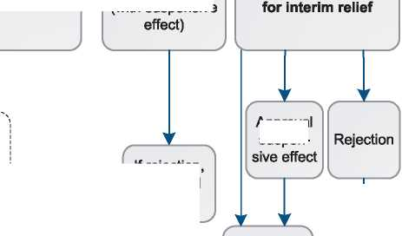

Grant of refugee  
status

Where applicable  
and in addition to  
the refugee status:

**Asylum**according to  
German Basic law

**x.**

**Rejection** of  
refugee status

**Rejection** of  
refugee status

**Rejection** of  
refugee status

**Grant of  
subsidiary  
protection**(according to EU  
law)

**Rejection of  
subsidiary  
protection**(according to EU  
law)

**Rejection of  
subsidiary  
protection**

x.

**Grant of  
subsidiary  
protection**(according to  
national law)  
X J

**Announcement of  
enforced  
repatriation/  
deportation**(departure within  
30 days)

x.

X.

**Appeal** within two weeks  
(to improve status)

I *Note:*

I *procedure; not all possible variations are displayed; ; Dublin procedure is not included in this chart.*

*Simplified presentation of the*

***O*** *Federal States*

*Federal Office for Migration and Refugees (BAMF)* I

*; Administrative Courts*

*C >*

**Rejection** of the  
application as  
**manifestly  
unfounded**

**Rejection of  
subsidiary  
protection**

**Announcement of  
enforced  
repatriation/  
deportation**(departure within  
one week)  
x , /

■x

*national*

( \

Appeal within two weeks

(with suspensive

*c *

Appeal within one week and request

If rejection, no appeal possible X /

If rejection, no appeal possible X_

Approval  
suspen-

Announcement of enforced return/ deportation executable after expiration of time limit for departure.

/ \

Residence permit

(at least 3 years)

< /

* 1. Additional Statistical Information

Figure 4: Asylum Applications from Top 10 Countries of Origin in 2009, 2010, 2011 and first half of 2012 [142]

**2009 2010 2011 Jan-Jun 2012**

|  |  |  |  |  |  |  |  |  |
| --- | --- | --- | --- | --- | --- | --- | --- | --- |
| **1** | Iraq | 6,538 | Afghanistan | 5,905 | Afghanistan | 7,767 | Afghanistan | 3,423 |
| **2** | Afghanistan | 3,375 | Iraq | 5,555 | Iraq | 5,831 | Iraq | 2,409 |
| **3** | Turkey | 1,429 | Serbia | 4,978 | Serbia | 4,579 | Serbia | 1,894 |
| **4** | Kosovo | 1,400 | Iran | 2,475 | Iran | 3,352 | Iran | 1,828 |
| **5** | Iran | 1,170 | FYROM | 2,466 | Syria | 2,634 | Syria | 1,593 |
| **6** | Vietnam | 1,115 | Somalia | 2,235 | Pakistan | 2,539 | Pakistan | 1,531 |
| **7** | Russia | 936 | Kosovo | 1,614 | Russia | 1,689 | Russia | 898 |
| **8** | Syria | 819 | Syria | 1,490 | Turkey | 1,578 | FYROM | 727 |
| **9** | Nigeria | 791 | Turkey | 1,340 | Kosovo | 1,395 | Turkey | 703 |
| **10** | India | 681 | Russia | 1,199 | FYROM | 1,131 | Kosovo | 701 |

Figure 5: Decisions Taken at the First Instance in 2009, 2010 and 2011

|  |  |  |  |  |  |  |  |  |  |
| --- | --- | --- | --- | --- | --- | --- | --- | --- | --- |
|  | **Geneva Convention** | | **Subsidiary/**  **Complementary**  **Protection and Humanitarian Status** | | **Rejections** | | **Withdrawn, Closed, Abandoned Cases** | | **Grand**  **Total** |
| **Number** | **%** | **Number** | **%** | **Number** | **%** | **Number** | **%** |  |
| **2009** | 8,115 | 28% | 1,611 | 6% | 11,360 | 39% | 7,730 | 27% | **28,816** |
| **2010** | 7,704 | 16% | 2,691 | 6% | 27,255 | 57% | 10,537 | 22% | **48,187** |
| **2011** | 7,098 | 16% | 2,577 | 6% | 23,717 | 55% | 9,970 | 23% | **43,362** |

**Figure 6.a: Positive [143] First- and Second-Instance Decisions,Top Countries of Origin in 2009 [144]**

**Rate out of Total Decisions [145]**



|  | | **Total Positive** | **Total Decisions** | **Rate** |
| --- | --- | --- | --- | --- |
| 1 | Iraq | 5,727 | 7,356 | 77.9% |
| 2 | Afghanistan | 952 | 1,374 | 69.3% |
| 3 | Iran | 597 | 931 | 64.1% |
| 4 | Sri Lanka | 458 | 532 | 86.1% |
| 5 | Eritrea | 423 | 442 | 95.7% |
| 6 | Turkey | 221 | 1,239 | 17.8% |
| 7 | Russia | 185 | 504 | 36.7% |
| 8 | Somalia | 178 | 190 | 93.7% |
| 9 | Syria | 156 | 590 | 26.4% |
| 10 | Ethiopia | 84 | 158 | 53.2% |

Total Positive Decisions by Status

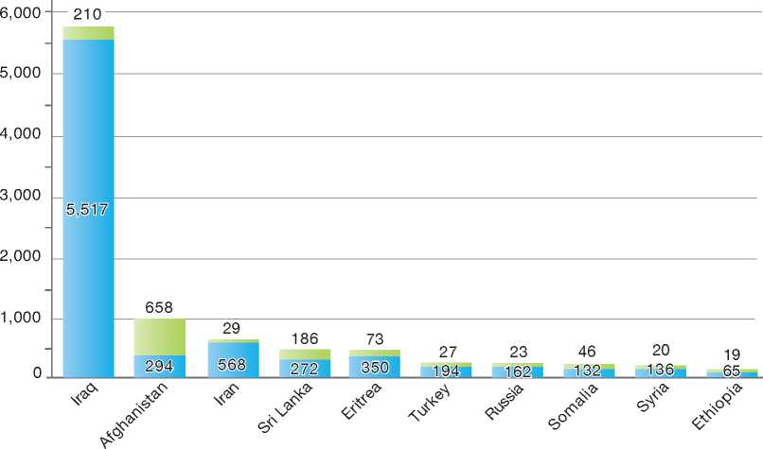

**Total Positive Decisions by Status**

Geneva Convention Status | | Subsidiary/Complementary Protection and Humanitarian Status

**Figure 6.b: Positive [146] First- and Second-Instance Decisions,Top Countries of Origin in 2010 [147]**

**Rate out of Total Decisions [148]**

|  |  |  |  |  |
| --- | --- | --- | --- | --- |
|  | | **Total Positive** | **Total Decisions** | **Rate** |
| 1 | Iraq | 3,434 | 5,920 | 58.0% |
| 2 | Afghanistan | 2,195 | 4,577 | 48.0% |
| 3 | Iran | 1,472 | 2,331 | 63.1% |
| 4 | Somalia | 464 | 509 | 91.2% |
| 5 | Syria | 370 | 1,454 | 25.4% |
| 6 | Eritrea | 334 | 344 | 97.1% |
| 7 | Russia | 334 | 1,070 | 31.2% |
| 8 | Sri Lanka | 323 | 523 | 61.8% |
| 9 |  | 276 | 1,568 | 17.6% |
| 10 |  | 109 | 351 | 31.1% |

Total Positive Decisions by Status

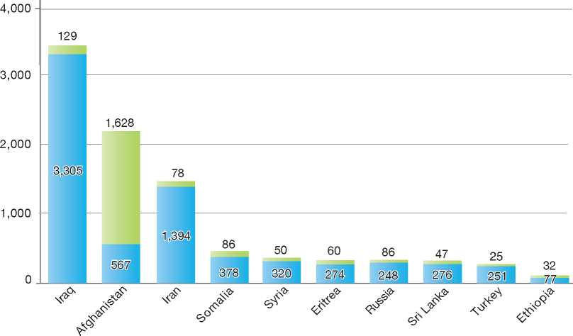

**Total Positive Decisions by Status**

| Geneva Convention Status | | Subsidiary/Complementary Protection and Humanitarian Status

**Figure 6.c: Positive [149] First- and Second-Instance Decisions,Top Countries of Origin in 2011 [150]**

**Rate out of Total Decisions [151]**



|  | | **Total Positive** | **Total Decisions** | **Rate** |
| --- | --- | --- | --- | --- |
| 1 | Iraq | 2,877 | 4,867 | 59.1% |
| 2 | Afghanistan | 2,258 | 6,095 | 37.0% |
| 3 | Iran | 1,432 | 2,345 | 61.1% |
| 4 | Somalia | 764 | 795 | 96.1% |
| 5 | Syria | 429 | 792 | 54.2% |
| 6 | Eritrea | 302 | 318 | 95.0% |
| 7 | Russia | 177 | 690 | 25.7% |
| 8 | Pakistan | 158 | 1,028 | 15.4% |
| 9 | Turkey | 157 | 1,314 | 11.9% |
| 10 | Sri Lanka | 142 | 324 | 43.8% |

Total Positive Decisions by Status

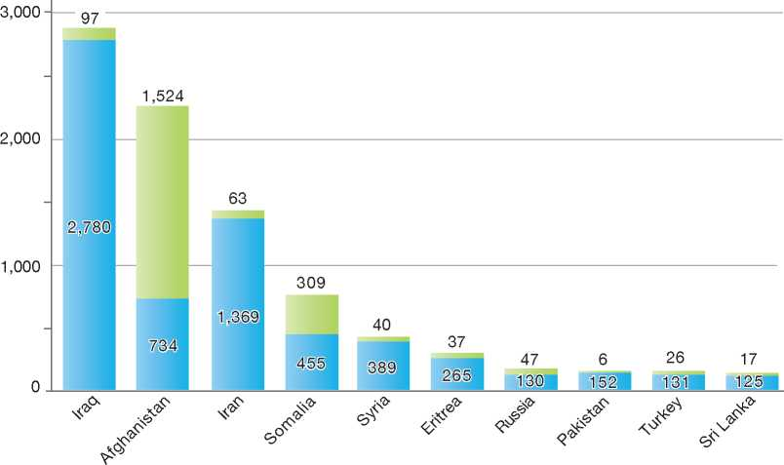

**Total Positive Decisions by Status**

| Geneva Convention Status | | Subsidiary/Complementary Protection and Humanitarian Status

1.

2.

3.

4.

5.

6.

7.

8.

9.

10.

11.

12.

Greece

BackGRound: MajoR asyluM tRends and developMents 237

national leGal FRaMewoRk 238

institutional FRaMewoRk 239

pRe-entRy MeasuRes 240

asyluM pRoceduRes 240

decision-MakinG and statuses 243

eFFiciency and inteGRity MeasuRes 244

assistance and Reception BeneFits FoR asyluM-seekeRs 245

status and peRMits GRanted outside the asyluM pRoceduRe 246

RetuRn 246

inteGRation 246

annexes

247

1. Background: Major Asylum Trends and DevelopmentsIn August 2010, the Greek Government adopted the Greek Action Plan on Migration Management and Asylum Reform, which includes structural

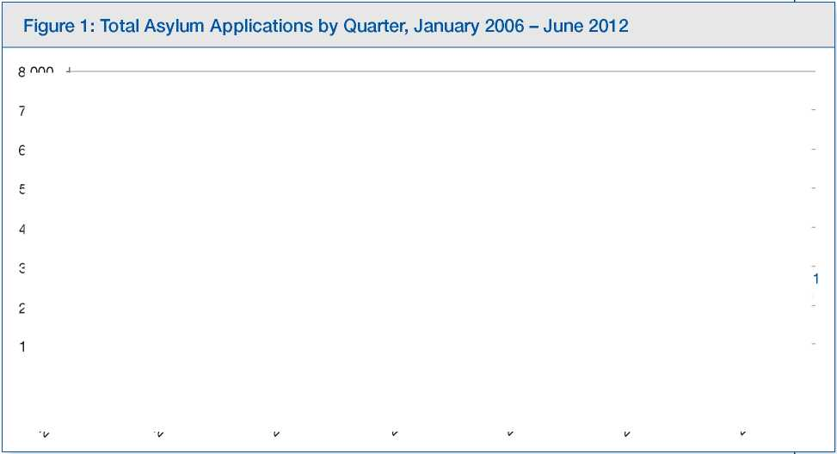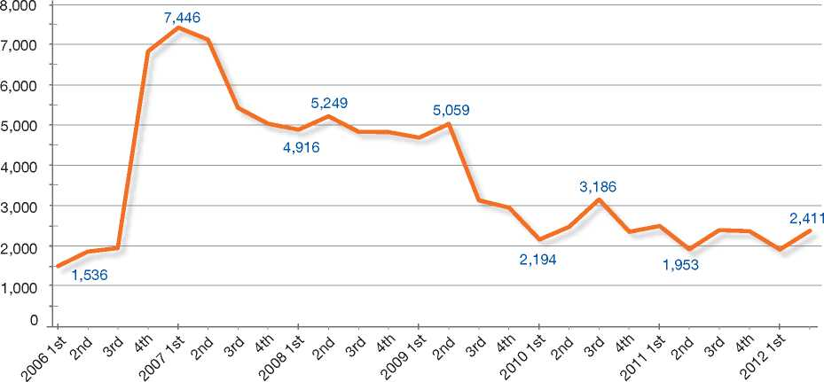

Due to its geographical situation on the external borders of the European Union (EU), at the crossroads of three continents (Europe, Africa and Asia), Greece became one of the main gateways to the European Union for hundreds of thousands of people seeking international protection or simply a better way of life. In the second half of the last decade, the influx into Greece significantly increased due to major social, economic and political upheaval in parts of Asia, Africa and Europe, and possibly due to the shift in irregular migratory routes after the conclusion of trans­national agreements between Spain and Morocco and between Italy and Libya.

reforms in the field of asylum and international protection.

The key components of the Greek Action Plan consist of:

The reform of the asylum procedures

The creation of a new Asylum Service, an Appeals Authority and a First Reception Service

Improving facilities in reception centres

Improving existing pre-removal centres and creating new pre-removal centres

Improving return policies.

As the majority of migrants entering Greece moved on to other EU Member States, the pressure on the Greek migration system was further exacerbated by the implementation of the Dublin II Regulation. As a result, Greece became responsible for processing the majority of international protection claims of migrants entering the EU[152].

In order to deal with the particular pressures resulting from these large inflows, a new and more effective strategy was needed for the management of mixed migratory flows.

**Figure 2: Asylum Applications Received from Top 5 Countries of Origin in 2009, 2010 and 2011**

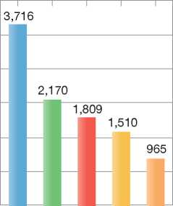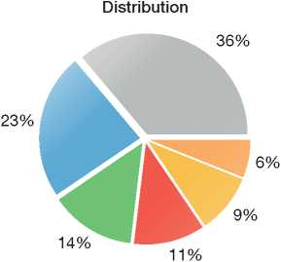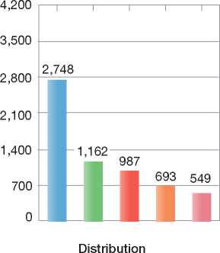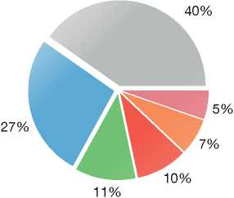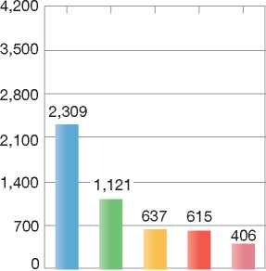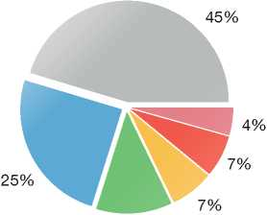

2009

**Volumes**

2010

**Volumes**

2011

**Volumes**

4,200

3,500

2,800

2,100

1,400

700

0

Distribution

12%

**Country of Origin:**

| | Afghanistan | | Albania | Bangladesh China

| Georgia J Pakistan | | Syria | | Others

1. National Legal Framework
   1. Legal Basis for Granting Protection

The legal framework for international protection consists of:

* The 1951 Convention relating to the Status of Refugees and its 1967 Protocol
* Council Directive 2004/83/EC [153], transposed into national law by Presidential Decree 96/2008
* Council Directive 2003/9/EC[154], transposed into national law by Presidential Decree 220/2007
* Council Directive 2005/85/EC[155], transposed into national law by Presidential Decree 114/2010
* Council Directive 2003/86/EC[156], transposed into national law by Presidential Decree 131/2006 and Presidential Decree 167/2008



• Council Directive 2001/55/EC [157], transposed into national law by Presidential Decree 80/2006.

Greece has ratified the European Convention on Human Rights (ECHR) and the U.N. Convention against Torture and Other Cruel, Inhuman or Degrading Treatment or Punishment (CAT).

* 1. Recent Reforms

The Greek Action Plan on Migration Management and Asylum Reform includes two major reforms concerning the legal framework for asylum procedures, as described below.

Presidential Decree 114/2010

This main legal instrument on international protection procedures in Greece repealed Presidential Decrees 61/1999, 90/2008 and 81/2009 and introduced a number of reforms in the asylum procedure for a transitional period. This transitional period will remain until the new Asylum Service and the Appeals Authority take charge of the asylum procedure.

Entry into Force of Law No. 3907/2011

With the entry into force of Law No. 3907/2011, the Asylum Service (first instance) and the Appeals Authority (second instance) were established. The mandate of the new services is to develop and maintain a high-quality procedure in the field of international protection as delivered by the Greek State.

1. Institutional Framework
   1. Principal Institutions

According to Presidential Decree 114/2010, the Ministry of Public Order and Citizen Protection is the competent authority responsible for the asylum procedure in Greece, as described below.

The new services, that is, the Asylum Service, the Appeals Authority and the First Reception Service, which are not yet operational, also fall under the competency of the Ministry of Public Order and Citizen Protection.

The New Asylum Service

The Asylum Service was established under Law No. 3907/2011. It is the first autonomous structure in Greece in charge of the examination of asylum and international protection claims. The Service falls under the responsibility of the Ministry of Public Order and Citizen Protection.

The Asylum Service, as part of its mission, will be responsible for the following tasks:

* Supporting the planning and drafting of a national policy on granting asylum or other forms of international protection, as well as monitoring and evaluating the implementation of this policy
* Receiving, examining and deciding upon international protection claims at the first instance
* Informing international protection claimants about the examination process of their claims, as well as their rights and obligations during that process
* Collecting and evaluating information regarding the economic, social, and political situation in countries of origin of third country nationals, as well as continuously monitoring any developments occurring in these countries, in cooperation with national and other authorities, pursuant to international agreements
* Supplying international protection claimants and beneficiaries of international protection with all necessary legal and travel documents as provided by law
* Processing refugee family reunification claims
* Facilitating access by claimants to in-kind reception benefits, in collaboration with co-responsible actors
* Preparing legal texts and administrative acts on issues under its competence
* Cooperating with local actors, independent authorities and non-governmental organisations, EU bodies and organisations, as well as international organisations in order to accomplish its mission in the most efficient way.

Finally, the Asylum Service provides administrative support to the Appeals Authority, which was also established by Law No. 3907/201 1.

The Hellenic Police is responsible for receiving and examining international protection claims and issuing all relevant decisions during the transitional period, until the new Asylum Service (Law No. 3907/2011) becomes operational.

Six Appeals Committees, based in Athens, are currently working on pending cases (appeals which were pending before 2010) on the basis of Presidential Decrees 61/1999 and 90/2008. Four more Committees are responsible for cases examined on the basis of the new Presidential Decree 114/2010.

Appeals Committees consist of:

* A civil servant from the Ministry of Interior, Decentralisation and e-Governance or the Ministry of Justice, Transparency and Human Rights (President of the Committee)
* A representative of the UNHCR
* A legal expert appointed by the National Committee for Human Rights (NCHR).

The Second Instance Administrative Court is an independent body that hears appeals in cassation (i.e. appeals of the highest instance) of negative decisions on asylum claims taken by the Appeals Committee.

In July 2012, competences relating to the reception of asylum-seekers were transferred from the Ministry of Health and Social Solidarity to the Ministry of Labour.

1. Pre-entry Measures

To enter Greece, non-EU nationals must meet the following requirements:

* Be in possession of valid travel documents
* Be in possession of a valid visa (if required)
* Justify the purpose and conditions of their intended stay and show sufficient means of subsistence for the duration of the stay
* Not be registered on the National List of Undesired Aliens or in the Schengen Information System (SIS)
* Not be considered a threat to public safety, internal security, public health or the international relations of any of the Member States*.*

1. Visa Requirements

Persons who are subject to visa requirements to enter Greece (Schengen visa or national visa) may apply at the competent consular authority of his or her place of residence, or in exceptional cases with the competent border authorities upon arrival in Greece.

Holders of a Schengen visa are allowed to travel throughout the Schengen area for a period of three months within a timeframe of six months.

1. Carrier Sanctions

Sanctions may be imposed on carriers transporting foreign nationals into Greece who are not in possession of valid travel documents.

According to Law No. 3386/2005 as it was amended by Law No. 3772/2009, carriers are liable to a fine amounting e 10,000 per person, and up to e 700,000 per person and imprisonment ranging from a minimum of five years to a life sentence.

1. Asylum Procedures
   1. Application Possibilities and Requirements, Procedures and Legal Remedies

Applications for asylum may be made at ports of entry, such as airports, seaports and land border posts, or at any police directorate responsible for receiving asylum applications.

Information on the asylum procedure and on the rights and obligations of asylum-seekers is available on the website of the Ministry of Public Order and Citizen Protection in four languages, including Greek.

Furthermore, all competent police authorities have a leaflet for asylum-seekers with basic information in 15 languages, including Greek.

* + 1. Outside the Country

Applications at Diplomatic Missions

Greece does not accept asylum applications from abroad.

Resettlement/Quota Refugees

Greece does not operate a quota refugee programme, nor has it accepted quota refugees on an *ad hoc* basis.

* + 1. At Ports of Entry

Asylum applications can be made at ports of entry - airports, seaports and land border posts - and are subject to an accelerated procedure.

* + 1. Inside the Territory

Responsibility for Processing the Claim

The Dublin System

*Application and Procedure*

The Hellenic Dublin Unit, part of the Asylum Section of the Aliens Division of the Hellenic Police Headquarters, receives and transmits requests for transfers, in close cooperation with other Dublin Units and in accordance with Regulation 343/2003/EC[158].

*Freedom of Movement/Detention*

An asylum-seeker may be detained during the Dublin procedure.

*Conduct of Transfers*

The Dublin Unit is responsible for all transfers conducted under the Dublin II Regulation.

*Review/Appeal*

A decision concerning the transfer of an asylum­seeker on the basis of the Dublin II Regulation may be appealed.

Application

Claimants are required to apply for international protection in person, either at a port of entry or at the closest police directorate responsible for receiving asylum applications.

The claimant may submit an application on behalf of his or her family members. Adult members are required to give their written consent and will be interviewed individually.

As soon as the registration of the asylum application is complete, an interview date is set. Authorities issue an “individual asylum application card” valid until the interview date, and renewed for a period of three to six months, depending on whether the claim is examined under the accelerated or the normal procedure, until the final decision is made.

Asylum claims are subject either to the accelerated procedure or to the normal procedure.

Accelerated Procedures

According to Presidential Decree 114/2010, an asylum claim is dealt with in the accelerated procedure under one of the following circumstances:

* The asylum claim was made at a port of entry
* The asylum claim is determined as manifestly unfounded (reasons claimed are irrelevant to refugee or subsidiary protection status; claim stated for abusive/misleading purposes)
* The applicant comes from a safe third country or a safe country of origin.

Normal Procedure

Under the normal procedure (but also under the accelerated procedure), the claimant is interviewed by a police officer under conditions that ensure confidentiality. Precautions are taken so that interpretation is available and sufficient time is given to the claimant to prepare himself or herself for the interview or to seek legal advice. Special attention is given when interviewing female applicants, minors or vulnerable persons.

A representative of the UNHCR may be present during the interview and is allowed to ask questions to the claimant. A legal representative or other counsellor may also be present.

An interview may be omitted in cases where a positive decision can be reached on the basis of available evidence, or when the claimant is medically or psychologically unable to be interviewed.

A written report containing basic information presented during the interview, approved and signed by the claimant, is forwarded to the competent police director, who is responsible for decision-making.

Review/Appeal of the Normal Procedure

A negative decision on a claim examined under the normal procedure may be appealed within 30 days of the notification of the decision. The appellant has the right to appear in person and with his or her lawyer or counsellor before the Appeals Committee to support his or her claim. The proceedings are recorded in writing. The decision of the Committee, taken by majority and properly reasoned, is given to the applicant and may be appealed before the Second Instance Administrative Courts.

Freedom of Movement during the Asylum Procedure

Unless explicitly stated otherwise, asylum applicants enjoy freedom of movement.

As soon as the registration of the asylum claim is complete, asylum-seekers are issued an “individual asylum application card”, which can be renewed until a final decision is made.

Detention

A claimant may be detained for one of the following reasons:

* He or she is deemed a threat to national security and/or public order
* The application is examined under the accelerated procedure
* The application is determined to be manifestly unfounded
* It is necessary to identify the country of origin.

The length of detention may vary, but cannot exceed a period of one year.

Provisions are taken so that:

* Women are detained in separate facilities from those of men
* Detention of minors and unaccompanied minors is avoided
* Detention of pregnant women or nursing mothers is avoided
* Detainees have access to legal aid.

Reporting

Asylum-seekers have an obligation to report any change of residence to the police authorities.

Repeat/Subsequent Applications

An asylum-seeker may submit a subsequent application.

A subsequent application is examined in connection with the former application (or appeal).

Where new substantial evidence is presented, the application is examined further.

* 1. Safe Country Concepts
     1. Safe Country of Origin

Safe countries of origin can be those included on:

* The common list of safe countries of origin adopted by the Council of the EU
* The national list of safe countries of origin, kept for the purpose of examining applications for international protection. This list is to be reviewed on an annual basis taking into account information from EU Member States and international organisations, such as the UNHCR, and is submitted to the European Commission.

As a general rule, a country is considered to be a safe country of origin if its citizens - in a general and consistent manner - are not subject to persecution as defined in Article 9 of Presidential Decree 96/2008, or to torture, inhuman or degrading treatment or punishment, and are not exposed to indiscriminate violence caused by an international or internal armed conflict.

Additionally, the following elements are taken into account:

* The extent of legal protection available against persecution or mistreatment
* Compliance with the European Convention on Human Rights (L.D. 53/74-A 256), the International Covenant on Civil and Political Rights and the Convention Against Torture (Law No. 1782/1988 O.J A/116/1988)
* Respect of the principle of *non-refoulement*
* The provision of a system of effective remedies against violations of fundamental rights and freedoms.
  + 1. First Country of Asylum

A country may be considered a first country of asylum if the asylum-seeker has previously been granted refugee status there, and he or she can still avail himself or herself of that protection or otherwise enjoys sufficient protection of that country, including protection from *refoulement,* provided that he or she will be re-admitted to that country.

* + 1. Safe Third Country

According to Presidential Decree 114/2010, a country is considered a safe third country for an applicant when all of the following conditions are fulfilled:

* The applicant's life and freedom are not threatened on account of race, religion, nationality, membership of a particular social group or political opinion
* The principle of *non-refoulement* is respected
* The applicant is not at risk of suffering serious harm
* The prohibition of removal to a third country, where he or she may be in danger of suffering torture and cruel, inhuman or degrading treatment, is respected
* The applicant has access to asylum procedures and may be granted protection in accordance with the 1951 Convention
* The applicant has a link to this country which would reasonably allow him or her to move there.
  1. Special Procedures
     1. Unaccompanied Minors

Figure 3: Asylum Applications by Unaccompanied Minors

No data available.

According to Presidential Decree 220/2007, in order for an asylum claim by an unaccompanied minor to be examined, authorities must appoint a guardian, who will be responsible for the minor throughout the asylum procedure. Asylum claims by unaccompanied minors are examined under the normal procedure on a priority basis. Special provisions are taken so that the interview is conducted by specially trained officers.

1. Decision-Making and Status
   1. Inclusion Criteria
      1. Convention Refugee

A person will be granted Convention refugee status if he or she meets the criteria outlined in the 1951 Convention and the 1967 Protocol.

* + 1. Complementary Forms of Protection

Subsidiary Protection

If the criteria for refugee status are not met, subsidiary protection may be granted if the applicant would be subjected to “serious harm” upon return to his or her country of origin. “Serious harm” refers to the threat of the death penalty, torture or other inhumane or degrading treatment, as well as serious threats to life or physical integrity as a result of indiscriminate violence during an armed conflict.

Humanitarian Status

An asylum-seeker who is not granted refugee status or subsidiary protection may be granted a residence permit on humanitarian grounds, as stated in Article 3 of the ECHR or Article 3 of the CAT, or if return is impossible due to *force majeure* (e.g. serious health problems or a situation of civil conflict and violation of human rights in the country of origin).

* 1. The Decision

The decision on an asylum claim is based on an assessment of the merits of the claim, which includes consideration of the oral and documentary evidence provided by the claimant, as well as country of origin information.

Decisions are made in writing. Negative decisions include information on the right of appeal and the right to make a subsequent application.

* 1. Types of Decisions, Status and Benefits Granted

Types of Decisions

Examination of an asylum claim may lead to the following types of decision:

* Grant of refugee status
* Grant of subsidiary protection
* Grant of a residence permit on humanitarian grounds
* Rejection of the asylum claim.

Asylum-seekers whose claims are rejected and who do not exercise their right to appeal are required to leave Greece within a set timeframe.

Benefits

Beneficiaries of subsidiary protection and Convention refugees are entitled to the following benefits, which are equivalent to those enjoyed by Greek nationals:

* Access to the labour market
* Access to education
* Social welfare assistance
* Health care benefits.

Convention refugees are granted a residence permit valid for five years while beneficiaries of subsidiary protection receive a renewable residence permit valid for two years. The five-year residence permit for refugees may be renewed for an additional period of five years. Refugees are also granted a “Refugee Identity Card”.

For reasons of family reunification, recognised refugees have the right to request, at any given time, the entry and residence of their family members.

An applicant granted humanitarian status receives a one-year residence permit, which is renewable if return remains impossible. Humanitarian status holders may apply for a work permit.

* 1. Exclusion

Exclusion clauses as stated in Article 1F of the 1951 Convention are taken into consideration during the examination of an international protection claim.

* 1. Cessation

Cessation clauses of the 1951 Convention are taken into consideration.

* 1. Revocation

According to Presidential Decree 114/2010, international protection status may be revoked if new elements regarding the case contradict the grounds in the relevant provisions of Presidential Decree 96/2008. The person concerned is entitled to a hearing or a written statement. The decision is made in writing, is fully reasoned and provides information on the right to appeal.

* 1. Support and Tools for Decision-Makers
     1. Country of Origin

Information (COI)

The UNHCR, in cooperation with the Ministry of Public Order and Citizen Protection, provides COI to the first and second instance bodies.

* + 1. Training

Staff involved in the different stages of the asylum procedure are provided with specific training programmes developed in conjunction with the UNHCR and NGOs.

Staff of the new Asylum Service will also be trained using modules of the European Asylum Curriculum.

1. Efficiency and Integrity Measures
   1. Technological Tools
      1. Fingerprinting

For identification purposes, asylum-seekers are fingerprinted by the Police upon making an asylum claim. Minor asylum-seekers younger than 14 are not fingerprinted.

* + 1. Database of Asylum Applications/Applicants

A nationwide electronic data-processing application system was created to record all asylum applications and their progress through each stage of the procedure.

* 1. Length of Procedures

Accelerated Procedures

Decisions on asylum claims made at ports of entry should be reached within a period of four weeks.

Decisions on asylum claims determined as manifestly unfounded or made by applicants coming from a safe third country or a safe country of origin should be reached within a period of three months.

Normal Procedure

Decisions on an asylum claim processed under the normal procedure should be reached within a period of six months.

* 1. Pending Cases

An increase in the number of asylum applications over the past years has led to a significantly longer average processing period. In order to address the backlog, the number of caseworkers at the first instance has been increased and a number of Appeals Committees have been established to work specifically on pending appeals.

1. Assistance and Reception Benefits for Asylum-Seekers
   1. Procedural Support and Safeguards
      1. Legal Assistance

According to national legislation, asylum-seekers have the right to consult a lawyer and/or seek legal representation - at their own cost - during the asylum procedure. Legal aid is available for appeals before the courts, provided the appeal is not determined, in the judge's estimation, to be manifestly inadmissible or groundless.

* + 1. Interpreters

Efforts are being made to cover the needs for interpretation at all stages of the procedure, in cooperation with non-governmental organisations (NGOs).

* + 1. UNHCR

According to Presidential Decree 114/2010, the Office of the UNHCR in Greece must be notified of all decisions to grant or revoke international protection (refugee status/subsidiary protection status).

Measures are taken to ensure the UNHCR has access to the asylum procedure, the detention centres and all relevant statistical data.

The UNHCR provides assistance to asylum­seekers in Greece primarily through funding of implementing partners, such as the Greek Council for Refugees, and through cooperation with operational partners. The UNHCR is also engaged in EU-funded projects aimed at addressing the reception of migrants at the border and facilitating access to asylum procedures.

The UNHCR has an active role in providing training on international protection issues and offers support to the new asylum services.

* + 1. NGOs

NGOs provide asylum-seekers with legal assistance and interpretation services during the asylum procedure and are actively involved in the field of integration.

* 1. Reception Benefits

In July 2012, competences relating to the reception of asylum-seekers were transferred from the Ministry of Health and Social Solidarity to the Ministry of Labour.

* + 1. Accommodation

Asylum-seekers may be accommodated in (open) refugee reception centres staffed by specially trained personnel, including doctors and social workers.

Unaccompanied minors may be accommodated in a reception centre or guest house specifically geared toward minors. Siblings are generally accommodated in the same location.

* + 1. Social Assistance

According to Article 12 of Presidential Decree 220/2007, asylum-seekers may be granted material reception benefits to ensure a standard of living that covers health care and other necessities.

* + 1. Health Care

Asylum-seekers have access to the public health care system, including medical, pharmaceutical and hospital care.

Vulnerable persons, such as victims of trauma, may seek the assistance of medical experts and specialised organisations for treatment.

* + 1. Education

Children have access to public education under the same conditions as Greek citizens.

Adults have the right to free language classes and vocational training.

* + 1. Access to Labour Market

Asylum-seekers have access to the labour market and may be granted temporary work permits valid throughout the asylum procedure.

* + 1. Access to Benefits by Rejected Asylum-Seekers

Rejected asylum-seekers continue to have access to benefits during the appeal procedure.

1. Return

The New First Reception Service

The First Reception Service was established in January 2011 by Law 3907/11, in compliance with the Action Plan on Migration and Asylum Management adopted by the Greek Government in August 2010.

The main mission of the Service is:

* To register and screen all third country nationals who are arrested for illegal entry or residence in Greece
* To guarantee that registering and screening are done in conditions that ensure human rights and dignity, in accordance with Greece's international and EU obligations
* To ensure the immediate living needs of immigrants.

In order to do the above, the First Reception Service plans to build at least 14 new First Reception Centres throughout the country by the end of 2016.

The following procedural steps will be followed in the First Reception Centres:

* Arrival of the immigrants at the Centre, where they will be transferred to a waiting area and provided with an immediate needs kit and information on the procedures to follow
* Initial identification of vulnerable persons (to be given priority)
* Security check at the start of the registration procedure
* Initial registration with the support of intercultural translators: all necessary personal data (name, age, etc.) is recorded, a photo is taken digitally and finally, a unique number is given as proof of registration
* Fingerprinting and bio-data collection for the EURODAC/ Dublin II System
* Medical examination and, if necessary, psycho-social support provided to vulnerable persons and all those in need
* Clean clothing and linen provided by the Logistics Office, after which the asylum-seekers are given beds in one of the appropriate wings of the centre, depending on their status (single men, single women, unaccompanied children, families, etc.).

1. Pre-departure Considerations

An asylum-seeker is not subject to removal if the asylum procedure has not been completed.

The principle of *non-refoulement* is respected.

1. Procedure

A decision to remove a third country national must be issued according to Article 76 of Immigration Law 3386/05.

1. Freedom of Movement/ Detention

A decision to remove a third country national may or may not involve detention.

1. Readmission Agreements

Readmission agreements may not be applied to rejected asylum-seekers, as readmission deadlines tend to expire before a final decision has been taken on the asylum claim.

1. Integration

Persons who are granted refugee status in Greece have access to a range of integration services and programmes developed by the Greek authorities under the multi-annual programme of the European Refugee Fund (ERF).

1. Status and Permits Granted Outside the Asylum Procedure
   1. Humanitarian Grounds

If refugee status or subsidiary protection status cannot be granted, *force majeure* grounds and the application of Article 3 of the ECHR and Article 3 of the CAT are taken into consideration.

If such grounds are applicable, a residence permit is granted and is valid for one year and renewable upon application.

1. Annexes
   1. Flowchart of the Asylum Procedure

A flowchart of the asylum procedure in Greece is not available as at this writing, while the Greek asylum system goes through a transition.

* 1. Additional Statistical Information



| **Figure 4: Asylum Applications from Top 10 Countries of Origin in 2009, 2010, 2011 and first half of 2012** | | | | | | | | | |  |
| --- | --- | --- | --- | --- | --- | --- | --- | --- | --- | --- |
|  |  | **200£** | **1 2010** | | **1 2011** | | **Jan-Jun 2012** | | |
|  | **1** | Pakistan | 3,716 | Pakistan | 2,748 | Pakistan | 2,309 | Pakistan | 953 |
| **2** | Georgia | 2,170 | Georgia | 1,162 | Georgia | 1,121 | Georgia | 495 |
| **3** | Bangladesh | 1,809 | Bangladesh | 987 | Afghanistan | 637 | Bangladesh | 430 |
| **4** | Afghanistan | 1,510 | Albania | 693 | Bangladesh | 615 | Afghanistan | 262 |
| **5** | Syria | 965 | China | 549 | China | 406 | Domin.Rep. | 199 |
| **6** | Iraq | 886 | Afghanistan | 524 | Senegal | 375 | Albania | 195 |
| **7** | Nigeria | 780 | Nigeria | 393 | Nigeria | 362 | Senegal | 193 |
| **8** | Albania | 517 | India | 381 | Syria | 352 | China | 130 |
| **9** | China | 391 | Senegal | 381 | Egypt | 306 | Iran | 122 |
| **10** | Senegal | 336 | Iraq | 342 | Albania | 276 | Iraq | 122 |
|  |  | | | | | | | | |  |

**Figure 5: Decisions Taken at the First Instance in 2009, 2010 and 2011**

|  |  |  |  |  |  |  |  |  |  |
| --- | --- | --- | --- | --- | --- | --- | --- | --- | --- |
|  | **Geneva Convention** | | **Subsidiary/**  **Complementary Protection and Humanitarian Status** | | **Rejections** | | **Withdrawn, Closed,**  **Abandoned Cases** | | **Grand**  **Total** |
| **Number** | **%** | **Number** | **%** | **Number** | **%** | **Number** | **%** |  |
| **2009** | 36 | 0% | 130 | 1% | 14,189 | 99% | 0 | 0% | **14,355** |
| **2010** | 91 | 3% | 52 | 1% | 3,348 | 96% | 0 | 0% | **3,491** |
| **2011** | 199 | 2% | 272 | 3% | 8,507 | 95% | 0 | 0% | **8,978** |

**Figure 6.a: Positive [159] First- and Second-Instance Decisions,Top Countries of Origin in 2009**

**Rate out of Total Decisions [160]**

|  |  |  |  |  |
| --- | --- | --- | --- | --- |
|  | | **Total Positive** | **Total Decisions** | **Rate** |
| 1 | Iraq | 31 | 909 | 3.4% |
| 2 | Iran | 30 | 328 | 9.1% |
| 3 | Afghanistan | 18 | 1,598 | 1.1% |
| 4 | Central African Rep. | 8 | 9 | 88.9% |
| 5 | Nigeria | 8 | 718 | 1.1% |
| 6 | Sudan | 8 | 126 | 6.3% |
| 7 | Turkey | 8 | 56 | 14.3% |
| 8 | Uzbekistan | 8 | 15 | 53.3% |
| 9 | Bangladesh | 7 | 1,677 | 0.4% |
| 10 | Somalia | 7 | 134 | 5.2% |

Total Positive Decisions by Status

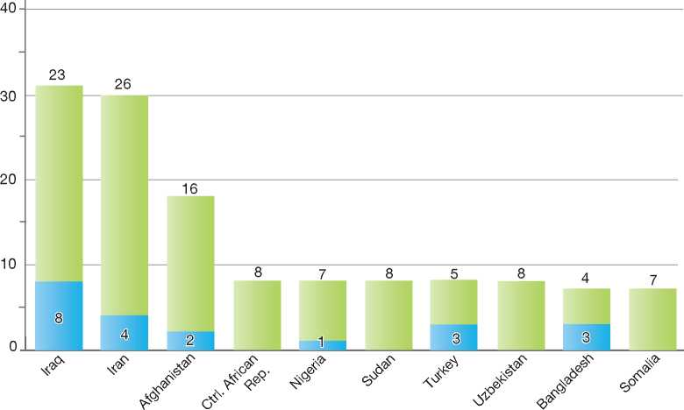

**Total Positive Decisions by Status**

Geneva Convention Status | | Subsidiary/Complementary Protection and Humanitarian Status

**Figure 6.b: Positive 8 First- and Second-Instance Decisions,Top Countries of Origin in 2010**

**Rate out of Total Decisions 9**

|  |  |  |  |  |
| --- | --- | --- | --- | --- |
|  | | **Total Positive** | **Total Decisions** | **Rate** |
| 1 | Iran | 64 | 108 | 59.3% |
| 2 | Afghanistan | 17 | 208 | 8.2% |
| 3 | Iraq | 14 | 145 | 9.7% |
| 4 | Nigeria | 10 | 149 | 6.7% |
| 5 | Turkey | 10 | 37 | 27.0% |
| 6 | Ethiopia | 4 | 11 | 36.4% |
| 7 | Somalia | 4 | 32 | 12.5% |
| 8 | Russia | 3 | 40 | 7.5% |
| 9 | Congo (Brazzaville) | 2 | 4 | 50.0% |
| 10 | Libya | 2 | 3 | 66.7% |
| 11 | Pakistan | 2 | 847 | 0.2% |
| 12 | Syria | 2 | 101 | 2.0% |

Total Positive Decisions by Status

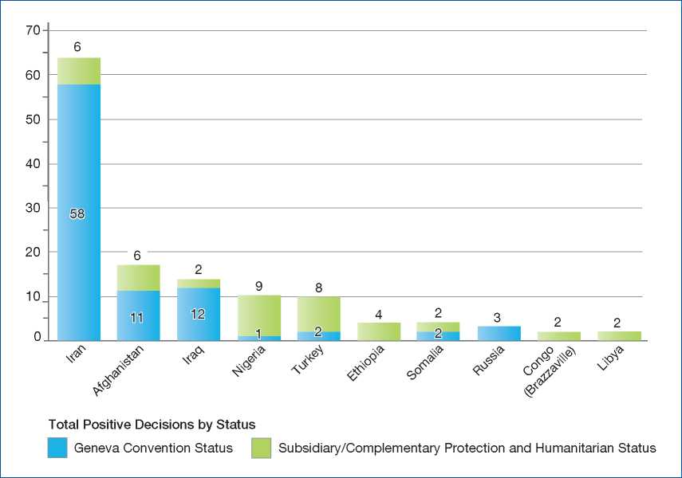

**Figure 6.c: Positive [161] First- and Second-Instance Decisions,Top Countries of Origin in 2011**

**Rate out of Total Decisions [162]**

|  |  |  |  |  |
| --- | --- | --- | --- | --- |
|  | | **Total Positive** | **Total Decisions** | **Rate** |
| 1 | Iraq | 154 | 372 | 41.4% |
| 2 | Afghanistan | 139 | 424 | 32.8% |
| 3 | Iran | 28 | 130 | 21.5% |
| 4 | Somalia | 14 | 55 | 25.5% |
| 5 | Georgia | 13 | 1,294 | 1.0% |
| 6 | Stateless | 11 | 24 | 45.8% |
| 7 | Turkey | 10 | 15 | 66.7% |
| 8 | Uzbekistan | 10 | 13 | 76.9% |
| 9 | Guinea (Conakry) | 9 | 34 | 26.5% |
| 10 | Pakistan | 9 | 2,636 | 0.3% |
| 11 | Sudan | 9 | 37 | 24.3% |

Total Positive Decisions by Status

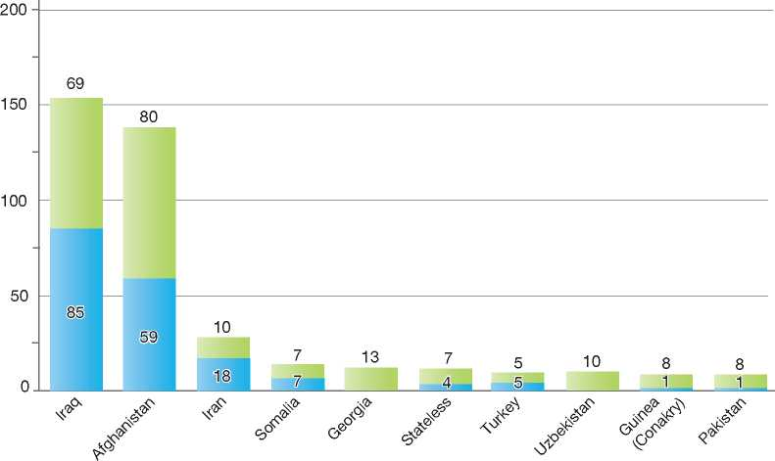

**Total Positive Decisions by Status**

Geneva Convention Status | | Subsidiary/Complementary Protection and Humanitarian Status

1.

2.

3.

4.

5.

6.

7.

8.

9.

10.

11.

12.

Ireland

272

|  |  |
| --- | --- |
| BackGRound: MajoR asyluM tRends and developMents | 253 |
| national leGal FRaMewoRk | 254 |
| institutional FRaMewoRk | 255 |
| pRe-entRy MeasuRes | 256 |
| asyluM pRoceduRes | 257 |
| decision-MakinG and statuses | 262 |
| eFFiciency and inteGRity MeasuRes | 265 |
| assistance and Reception BeneFits FoR asyluM-seekeRs | 266 |
| status and peRMits GRanted outside the asyluM pRoceduRe | 268 |
| RetuRn | 270 |
| inteGRation | 271 |

annexes

1. Background: Major Asylum Trends and Developments

Asylum Applications

Ireland began to receive asylum applications in the early 1990s. Annual inflows increased dramatically in the late 1990s, reaching a peak of over 11,600 in 2002. Numbers have decreased significantly since 2003, with 1,939 asylum applications received in 2010 and 1,290 applications in 2011.

Other institutions with a role in asylum procedures were also created. The Reception and Integration Agency (RIA) was established in 2001 to coordinate accommodation and other support needs of asylum-seekers. RIA operates a system of direct provision, whereby asylum applicants are provided with bed and board and other benefits in kind rather than cash for the duration of the asylum procedure.

In 2005, the Irish Naturalisation and Immigration Service (INIS) was set up within the Department of Justice and Equality and has, among other things,

Figure 1: Total Asylum Applications by Quarter, January 1997 - June 2012

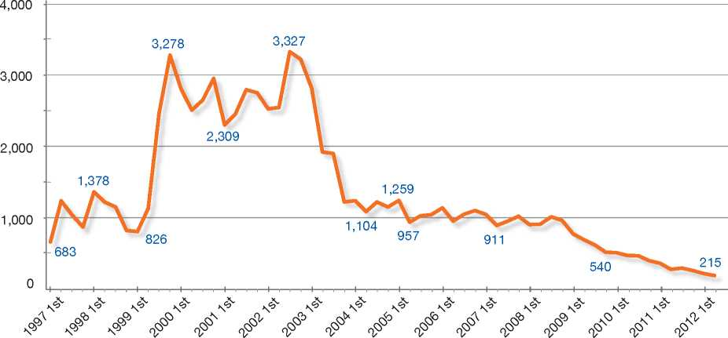

Top Nationalities

In the early 1990s, the number of asylum-seekers was low and the majority of applicants originated from Romania, Cuba and the former Yugoslavia. In the late 1990s, the top countries of origin were Nigeria, Romania and the Democratic Republic of Congo. The top five countries for 2011 were Nigeria, Pakistan, China, the Democratic Republic of Congo and Afghanistan.

Important Reforms

In the late 1990s, the procedural and institutional framework for refugee status determination was significantly reformed. The main change was the establishment of two independent offices responsible for the examination of claims: the Office of the Refugee Applications Commissioner (ORAC), set up to consider applications at first instance, and the Refugee Appeals Tribunal (RAT), which hears appeals of ORAC recommendations. responsibility for making decisions on subsidiary protection claims and for determining whether any other grounds exist for granting a failed protection applicant permission to reside in the State.

The aforementioned developments led to a significant increase in the number of staff working in the asylum area at the time.

As well as the measures introduced to improve the processing and support of asylum applications, initiatives were also undertaken to tackle abuses in the asylum system. One such initiative was the introduction of the Habitual Residence Condition (HRC) in 2004, which required asylum-seekers to meet certain criteria in order to be eligible for social assistance or child benefit payments.

**Figure 2: Asylum Applications Received from Top 5 Countries of Origin in 2009, 2010 and 2011**

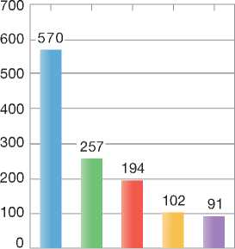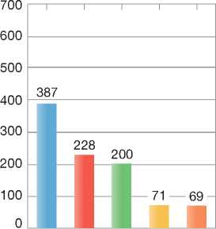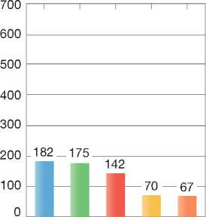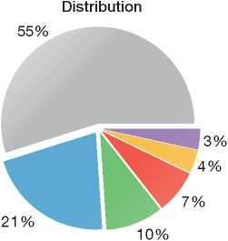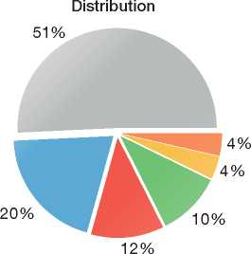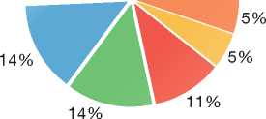

2009

Volumes

2010

Volumes

2011

Volumes

Distribution

|  |  |
| --- | --- |
| **Country of Origin:** | |
| Afghanistan China  Pakistan Zimbabwe | D.R. Congo Nigeria  Others |

The Immigration Act 2003 introduced carrier liability relating to the transportation to Ireland of foreign nationals who did not meet entry requirements.

Prior to 2005, the foreign-national parents of Irish- born children were granted permission to remain in the State on the basis of their child's Irish citizenship. Ireland's laws in relation to citizenship were changed following an amendment to the Irish Constitution and the enactment of the Irish Nationality and Citizenship Act 2004. As a result of this change to the law, citizenship is no longer an automatic entitlement for all children born in Ireland. Beginning in 2005, foreign-national parents of Irish-born children have had to follow new procedures to apply for permission to remain in the State.

1. National Legal Framework
   1. Legal Basis for Granting Protection

The domestic legislation dealing with refugees and asylum-seekers is the 1996 Refugee Act (as amended), which entered into force in 2000. The 1996 Act has been amended by the Immigration Act 1999, the Illegal Immigrants (Trafficking) Act 2000 and the Immigration Act 2003.

The Act incorporates the 1951 Convention relating to the Status of Refugees. It provided for the establishment of the Office of the Refugee Applications Commissioner as well as the Refugee Appeals Tribunal. Additionally, it sets out a framework for the determination of asylum applications and family reunification applicationsand includes provisions for the admission of persons for resettlement and temporary protection[163].

The European Communities (Eligibility for Protection) Regulations 2006 (Statutory Instrument No. 518 of 2006) came into force on 10 October 2006. These Regulations gave effect to Council Directive 2004/83/EC of 29 April 2004 (Qualification Directive).

Irish law and practice is in line with the EU Procedures Directive (2005/85/EC). Statutory Instruments [European Communities (Asylum Procedures) Regulations 2011 and the Refugee Act 1996 (Asylum Procedures) Regulations 2011)] were introduced in 2011 to give further effect to the Directive in Irish law.

* 1. Pending Reforms

A new Immigration, Residence and Protection (IRP) Bill is to be published in 2012. The Bill will introduce comprehensive reforms that will simplify and make the asylum procedure more efficient. The Bill envisages a single procedure to investigate all grounds for protection put forward by applicants. The investigation of such applications will include the consideration of whether a person who is not entitled to protection should be otherwise permitted to remain in the State. Under the Bill, the functions currently carried out by the ORAC will be carried out by the Minister for Justice and Equality.

The introduction of a single procedure will result in procedural changes to the asylum appeals process. The existing Refugee Appeals Tribunal will be replaced by a Protection Review Tribunal. The new tribunal will have an expanded remit to consider appeals against decisions not to grant refugee status and subsidiary protection as defined in the Qualification Directive.

Other changes to be introduced by the IRP Bill in the area of protection include provision for the appointment of a Registrar to the Protection Review Tribunal. The Registrar shall be responsible, *inter alia*, for assigning appeals to members of the Tribunal and may also re-assign appeals. The Registrar shall also be responsible for managing and generally controlling the staff and administration of the Tribunal.

The IRP Bill makes provision for the introduction of an admissibility procedure for protection applications, which will allow the Minister to determine an application as inadmissible if certain prescribed circumstances apply.

The IRP Bill also makes provisions for the publication of decisions of the Protection Review Tribunal.

1. Institutional Framework
   1. Principal Institutions

The Office of the Refugee Applications Commissioner (ORAC) is the first instance decision-making body. The ORAC is required to investigate each asylum application filed in Ireland and to make recommendations to the Minister for Justice and Equality in relation to whether a person should be granted refugee status. It is also responsible for investigating applications made by refugees for family reunification.

The Refugee Appeals Tribunal (RAT) hears appeals against negative first-instance recommendations and decides whether the first-instance decision should be upheld or the person should be granted refugee status.

On recommendation of the ORAC or the RAT, the Minister for Justice and Equality makes the decision to either grant or refuse an asylum claim.

The Reception and Integration Agency (RIA) is responsible for coordinating the reception services provided to asylum-seekers.

The Irish Naturalisation and Immigration Service (INIS) considers subsidiary protection applications and decides whether there are any other reasons why a person should be permitted to remain in the State2. The INIS is part of the Department of Justice and Equality.

The Garda National Immigration Bureau (GNIB), which is an agency of *An Garda Siochana* (Irish Police Force), is responsible for the enforcement of immigration policies, including the enforcement of Deportation Orders, Dublin

2 Other grounds for obtaining a residence permit are found under section 3 of the Immigration Act 1999.

II Transfer Orders and Removal Orders[164] issued by the Minister.

The Office for the Promotion of Migrant Integration (OPMI) is part of the Department of Justice and Equality and has a cross-departmental mandate to develop, lead and co-ordinate integration policy across other government departments, agencies and services. The functions of the OPMI include the promotion of the integration of legal immigrants into Irish society, the management of the resettlement of refugees admitted as part of the United Nations Resettlement Programme and the administration of funding from national and EU sources to promote integration.

1. Cooperation between Government Authorities

In accordance with its obligations under the 1951 Convention, Ireland places a high priority on maintaining an asylum process that is both fair and transparent and that is geared towards providing protection to those in genuine need of such protection, as quickly as possible. A key element of this work involves ongoing and essential liaison among all the various agencies and offices listed above and any other authorities that have a part to play in the process, for example, the Health Service Executive and the Department of Social Protection.

1. Pre-entry Measures

To enter Ireland, all foreign nationals (with the exception of United Kingdom citizens travelling from within the Common Travel Area) must have a valid travel document, such as a passport, and in certain cases, a visa issued by Ireland.

* 1. Visa Requirements

The Irish Naturalisation and Immigration Service is responsible for Irish visa policy[165]. All foreign nationals who are visa required must have a valid visa to travel to Ireland. A visa is merely a pre­entry clearance to seek permission to enter the State - no automatic right of entry or residence is conferred. Whether the person is permitted to enter is a matter for the Immigration Officer at the port of entry.

* 1. Carrier Sanctions

Carrier liability was introduced in the Immigration Act 2003. Carriers are required to check that individuals have appropriate documentation before allowing them to board a vehicle. They are required to check that all persons on board disembark in compliance with directions given by Immigration Officers, and that all persons are presented to Immigration Officers. Any carrier in breach of these requirements may be fined € 3,000 for each foreign national found to be in contravention of these provisions.

* 1. Interception

If a person, who is not entitled to enter the State, is intercepted at a border control point or is encountered within the State having illegally entered the State in the preceding 3 months, that person may be refused leave to land by an Immigration Officer under Section 5 of the Immigration Act 2003. Unless a person seeks to make an application for asylum, he or she will be refused leave to land and may be detained and removed from the State.

When the Garda National Immigration Bureau (GNIB) becomes aware of, or encounters, any person who is illegally present within the State, it will request that a Deportation Order be issued for the person under Section 3(4) of the Immigration Act 1999.

In collecting information on those persons who are refused leave to land, the GNIB identifies routes being used by persons attempting to enter the State illegally.

Airline Liaison Officers

The GNIB has trained members to be Airline Liaison Officers (ALOs). ALOs aim to prevent persons from entering the State illegally. These officers work in conjunction with airline carriers and with immigration authorities of other jurisdictions.

1. Asylum Procedures
   1. Application Possibilities and Requirements, Procedures and Legal Remedies

An individual who arrives at the border and seeks asylum is legally entitled to be given leave to enter the State and make an asylum application with an Immigration Officer. Inside the territory, asylum applications may be made at the Office of the Refugee Applications Commissioner (ORAC) in Dublin. Applications may also be accepted from persons in detention.

Children of asylum-seekers may have their asylum claims processed with those of their parents. Persons over the age of 18 must file their own asylum claims.

Access to Information

Applicants are given a number of documents as well as advice when they make their initial application, including:

* An information leaflet on the asylum procedure and refugee status in Ireland (available in 25 languages)
* A questionnaire in connection with their application for a declaration
* A Refugee Legal Service information leaflet on the availability of legal advice services
* A Change of Address form, and
* Advice on their right to consult a legal representative and the United Nations High Commissioner for Refugees (UNHCR).

1. Outside the Country

Applications at Diplomatic Missions

Section 8 of the Refugee Act 1996 provides that any person seeking asylum at the frontiers of the State or while in the State may apply to the Minister for Justice and Equality for a declaration of refugee status. On this basis, applications for asylum may not be made from outside the State.

Resettlement/Quota Refugees

Ireland continues to participate in the UNHCR-led resettlement programme. In recent years, Ireland has focused on offering resettlement to a small number of medical cases whose medical needs cannot be met except through resettlement. Ireland has also responded to appeals from the UNHCR to resettle persons displaced during the Arab Spring. For example, Ireland accepted cases from Choucha camp in Tunisia. In an effort to support the Government of Malta, Ireland participated in the relocation of persons with international protection status from Malta to Ireland.

Persons are referred for resettlement by the UNHCR and must have a resettlement need. In exceptional circumstances, Ireland may enter into bilateral arrangements with other Governments.

Resettled refugees are not required to undergo a full refugee status determination post-arrival.

1. At Ports of Entry

A person who arrives at the frontiers of Ireland seeking asylum may make an application for refugee status. The Immigration Officer will interview the applicant as soon as is practicable, take the initial details of his or her asylum claim and fingerprint the applicant. A copy of this interview is provided to the applicant and another copy is forwarded to the ORAC. The applicant is informed that he or she is entitled to consult a legal representative and the UNHCR.

Ireland does not operate an application determination process at ports of entry. Applicants are provided with information in relation to the asylum application process, and arrangements are made for their transfer to the ORAC. Persons seeking asylum outside of normal office hours are guided to a reception centre for overnight accommodation before being transferred to the ORAC during the next working day.

1. Inside the Territory

Responsibility for Processing the Claim

The Dublin System

*Application and Procedure*

A decision on the responsibility of another State party to the Dublin II Regulation[166] to process an asylum claim may be made at any time during the asylum procedure.

The Refugee Act 1996 and Statutory Instrument No. 423 of 2003 (known as the (section 22) Order) supports the operation of the Dublin II Regulation. Under the Order, if it appears that the claim should be dealt with in another State, the ORAC informs the applicant of the Dublin II process and refers the applicant to the Refugee Legal Service. The applicant is given an opportunity to submit reasons as to why his or her case should be dealt with in Ireland.

The ORAC makes a determination on the case, which is issued to the applicant and his or her legal representative. The determination contains the following information:

* A summary of the legal position in relation to the Dublin Regulation
* A summary of the proof that the person has been in another Member State
* A brief outline of the applicant's case
* An outline of the decision referencing the article and proofs required and supplied, and
* A statement of the determination.

The file is then forwarded to INIS and a Transfer Order is drawn up in accordance with national legislation in order to effect the transfer of the applicant from the jurisdiction.

*Review/Appeal*

An asylum-seeker may appeal the determination of the ORAC to the Refugee Appeals Tribunal (RAT) within 15 working days of the date of the ORAC's determination. Any appeal to the RAT will not suspend the transfer of the asylum-seeker to another State participating in the Regulation.

If the RAT overturns the determination of the ORAC, the application will be returned to the ORAC for examination. If the asylum-seeker has already been transferred to another country, arrangements will be made for his or her return to Ireland.

*Freedom of Movement/Detention*

If it is suspected that a person who has been served with a Transfer Order intends to avoid removal from the State, he or she may be arrested and detained without further notice for the purposes of his or her removal.

*Conduct of Transfers*

The transfer of the asylum-seeker is arranged by the Department of Justice and Equality. The transfer takes place as soon as is practicably possible and at the latest within six months of the date of acceptance by the other Regulation State.

Application and Admissibility

There are no formal admissibility arrangements in place for asylum applications. All applications for asylum made in Ireland are examined on their merits, with some applications prioritised accordingly. Exceptions to this rule include the following:

* Asylum applications made by nationals of Member States of the European Union. Under the EU Treaty Protocol on Asylum, Ireland does not accept asylum applications from nationals of EU Member States
* Accompanied minors whose application is processed together with the application of their parent or guardian, unless they indicate that they wish to have their application processed separately to that of their parent or guardian
* Persons who have already made an asylum application and who have already received a decision on the application. Such persons may not make a further application for asylum without first seeking the consent of the Minister under section 17(7) of the Refugee Act 1996 (as amended).

Prioritised Procedures

Section 12 of the Refugee Act 1996 (as amended) allows the Minister for Justice and Equality to prioritise certain classes of applications based on one or more of the following criteria:

* The grounds of the application
* The country of origin or habitual residence of applicants
* Any family relationship between applicants
* The ages of applicants
* The dates on which applications were made
* Considerations of national security or public policy
* The likelihood that the applications are well- founded
* Special circumstances regarding the welfare of applicants or the welfare of family members of applicants
* Lack of grounds for contention that the applicant is a refugee
* False or misleading representations in relation to a person's application
* Prior applications for asylum in another country
* The making of an application at the earliest opportunity after arrival in the State
* Being a national of or having a right of residence in a country of origin designated as safe, and
* Being someone to whom paragraph (a), (b) or (c) of section 2 of the Refugee Act 1996 (as amended) applies.

Under section 12(4) of the Refugee Act 1996, the Minister may, after consultation with the Minister for Foreign Affairs, designate a country as a safe country of origin[167].

Certain specific categories of applications are also given priority, for example, applications from asylum-seekers in detention.

Prioritised applications are generally examined and processed within a median processing time of 30 working days from the date of application, except where medical or other compelling reasons may prevent this. This time limit aside, the examination process follows the normal procedure.

Normal Procedure

Preliminary Interview

When an asylum application is made, a preliminary interview with the applicant is conducted. The purpose of this interview is to establish whether the person wishes to make an application for a declaration of refugee status and if so, the general grounds upon which the application is based, the person's identity and nationality and the route taken to the State. The interview is conducted in the presence of an interpreter where necessary.

If the asylum-seeker made the application at a port of entry, an initial interview will be carried out by an immigration officer at the port. The applicant will subsequently be referred to the ORAC.

Application Form

Following the preliminary interview, the applicant completes and signs a standard form (ASY1 Form). An application must be accompanied by original travel and identity documents in the asylum­seeker's possession, and if appropriate, those of his or her children who are under 18 years old.

Questionnaire

The asylum-seeker is given a detailed questionnaire in which he or she is to provide biographical details and the reasons for seeking asylum. The completed questionnaire must be returned to the ORAC within seven days of the preliminary interview (within six days for prioritised cases). All applicants are photographed and those over 14 years of age are also fingerprinted in the ORAC. They are then issued with a Temporary Residence Certificate/Card as evidence that they have applied for asylum.

Asylum-seekers are then referred to the Reception and Integration Agency (RIA), where arrangements will be made for them to be taken to a Reception Centre in the Dublin Area. Applicants can also make their own accommodation arrangements.

Substantive Interview

An asylum-seeker is invited to an interview carried out by an ORAC caseworker, with the assistance of an interpreter where required. Applicants are also entitled to have their legal representative present at the interview. In exceptional circumstances, if the Commissioner deems it necessary for the investigation, the interview may take place with other family members of the applicant present.

Recommendation

**Quality Assurance at the ORAC**

All non-priority cases (and 10 per cent of priority cases) are checked by a supervisor. A Quality Assurance Team checks random cases on a monthly basis, and reports to Office of the Refugee Applications Commissioner management. Relevant findings are provided to caseworkers.

Also appeal and overturn rates are analysed to assess the quality of decisions, and interpretations and translations are quality- reviewed on a regular basis.

On the basis of the findings of the preliminary interview, the completed questionnaire, the substantive interview and any relevant information, including country of origin information, the caseworker prepares a report on the application. The report incorporates a recommendation of whether or not refugee status should be granted as well as the reasons for the recommendation. If the recommendation is to refuse refugee status, a copy of the report is given to the applicant and his or her legal representative on completion of the application process. If no recommendation has been made within six months of the date of the application, the applicant may request an indication of the timeframe within which a recommendation may be made.

Review/Appeal of the Normal Procedure

Applicants who receive a negative recommendation following their interview with the ORAC may appeal the recommendation before the Refugee Appeals Tribunal (RAT) within 15 working days of the sending of the notice by the ORAC. The appeal has suspensive effect. The RAT has the power to affirm the ORAC recommendation or to set it aside and grant refugee status.

Asylum-seekers are entitled to request an oral hearing for this appeal.

The timeframe to make an appeal on a negative recommendation is reduced to 10 working days if the ORAC's recommendation includes in its findings one of the following elements, which are contained in section 13(6) of the Refugee Act 1996:

* The application showed either no basis or a minimal basis for the contention that he or she is a refugee
* The applicant made statements or provided information in support of the application of such a false, contradictory, misleading or incomplete nature as to lead to the conclusion that the application is manifestly unfounded
* The applicant, without reasonable cause, failed to make an application as soon as reasonably practicable after arrival in the State
* The applicant had made a prior application for asylum in another State party to the 1951 Convention (whether or not that application had been determined, granted or rejected), and
* The applicant is a national of, or has a right of residence in, a safe country of origin for the time being so designated by the Minister.

Any such appeal will be dealt with by the Tribunal without an oral hearing.

In all instances the Tribunal provides the applicant with the reasons for its recommendation, including the material which was relied upon in coming to that recommendation.

When an application is withdrawn or deemed withdrawn, there is no possibility of an appeal.

Freedom of Movement during the Procedure

Detention

There is no systematic detention of asylum applicants for the purpose of processing applications. However, under section 9(8) of the Refugee Act 1996 (as amended), applicants may be detained if it is suspected that they:

* Pose a threat to national security or public order in the State
* Have committed a serious non-political crime outside the State
* Have not made reasonable efforts to establish their true identity
* Intend to avoid removal from the State in the event of their application for asylum being transferred under the Dublin II Regulation
* Intend to leave the State and enter another state without lawful authority
* Without reasonable cause have destroyed their identity or travel documents or are in possession of forged identity documents.

A person detained under these provisions must be brought before a judge of the district court as soon as is practicable. The judge may:

* Commit the person concerned to be detained for up to 21 days
* Release the person, or
* Release the person subject to certain reporting requirements.

Any persons detained may have their period of detention extended for further periods, each period not exceeding 21 days, pending the determination of their application. These provisions are not applicable to minors.

Under section 10 of the Refugee Act, the Commissioner or the Tribunal shall ensure that the application for asylum of a person detained shall be dealt with as soon as may be possible and, if necessary, before any other application of a person who is not detained.

Reporting

An applicant shall not attempt to leave the State without the consent of the Minister. He or she is also obliged to inform the Commissioner of his or her address and of any change of address as soon as possible. An asylum-seeker may make arrangements for his or her own accommodation at the start of the asylum procedure and must provide the address within five working days of making an asylum application. If the address is not reported to the authorities within the time limit, the asylum application will be deemed to be withdrawn.

An applicant may be required to reside or remain in particular districts or places in the State, or report at specified intervals to an Immigration Officer or persons authorised by the Minister or a member of *An Garda Siochana. A* person failing to comply with any imposed reporting conditions may also be detained.

Repeat/Subsequent Applications

Under section 17(7) of the Refugee Act 1996 (as amended), it is not possible for a person who has been refused refugee status to make a further application under the Refugee Act without the consent of the Minister. A subsequent application is only accepted if an applicant submits new information that was not previously submitted or available to the ORAC, and if there are genuine reasons for the applicant not to have been able to submit that information at an earlier stage. If accepted, subsequent applications follow the same procedure as first instance applications.

* 1. Safe Country Concepts
     1. Safe Country of Origin

Under section 12(4) of the Refugee Act 1996 (as amended) and the provisions of Statutory Instrument No. 51 of 2011, the Minister may, by order, designate certain countries as safe countries of origin. If it appears to the ORAC that the asylum-seeker is a national of, or has a right of residence in, a country designated by the Minister as a safe country of origin, then the asylum-seeker is presumed not to be a refugee, unless he or she can provide evidence to the contrary.

In deciding whether to designate a country as a safe country of origin, the following considerations must be taken into account:

• Whether the country is a party to, and generally complies with, obligations under the Convention Against Torture and Other Cruel, Inhuman or Degrading Treatment or Punishment (CAT), the International Covenant on Civil and Political Rights (ICCPR), the European Convention on Human Rights (ECHR) and, where appropriate:

* Whether the country respects the principle of *non-refoulement*
* Whether the country has a democratic political system and an independent judiciary that ensures effective remedies against violations of rights and freedoms, and
* Whether the country is governed by the rule of law.

Croatia and South Africa have been designated as safe countries of origin and therefore, applications made by persons from these countries are prioritised.

* + 1. First Country of Asylum

The Refugee Act 1996 (as amended) provides that where it becomes apparent that an applicant, who has made a prior application for protection in another State party to the 1951 Convention and they receive a negative recommendation at the ORAC, they have 10 working days to appeal that determination to the RAT.

Such appeals are determined without an oral hearing.

* + 1. Safe Third Country

The Minister may, by order after consultation with the Minister for Foreign Affairs, designate a country with which an agreement is in place as a safe third country. An asylum applicant may be transferred to a safe third country to have his or her asylum application considered, if he or she has reasonable connections with that country.

The criteria for designating a safe country are as follows:

* Life and liberty are not threatened on account of race, religion, nationality or membership of a particular social group
* The principle of *non-refoulement* is respected
* The possibility exists to request refugee status and receive protection under the 1951 Convention.

No country has been designated as a safe third country to date.

* 1. Special Procedures
     1. Unaccompanied Minors

Under section 8(5) of the Refugee Act 1996 (as amended), where an unaccompanied child under the age of 18 (a minor) arrives at a port of entry or at the ORAC, the Health Service Executive (HSE) must be informed and the child placed in its care. The HSE decides if and when it is in the best interests of the minor to make an application for asylum on his or her behalf.

In the event that an application is made, the HSE then assists the minor throughout the procedure, including accompanying the child to the interview.

The following features are specific to the examination of asylum applications made by unaccompanied minors (UAMs):

|  | **2009** | **2010** | **2011** |
| --- | --- | --- | --- |
| Total Asylum Applications | 2,689 | 1,939 | 1,290 |
| of which Unaccompanied Minors | 56 | 37 | 26 |
| Percentage | 2% | 2% | 2% |

**Figure 3: Asylum Applications by Unaccompanied**

**Minors in 2009, 2010 and 2011**

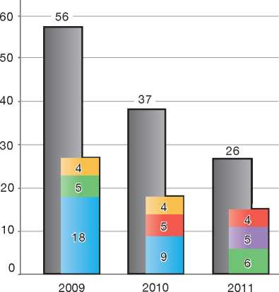

|  |  |
| --- | --- |
| **Country of Origin:** | |
| Afghanistan | | D.R. Congo |
| Nigeria | Somalia |
| Zimbabwe |  |

* All UAMs are interviewed by experienced ORAC caseworkers who have received additional specialised training
* UAMs' applications are prioritised
* There is greater emphasis on certain objective factors, such as country of origin information, in determining the application of the UAM
* HSE representatives are always in attendance at interviews.

Minors over the age of twelve years are placed in a residential intake unit for four to six weeks, where their needs are assessed by social workers and psychologists. Following this period, they are placed in foster care. Children under the age of 12 are placed directly in foster care. There were 26 UAM applications in 2011.

* + 1. Temporary Protection

Ireland participates in Council Directive 2001/55/ EC (Temporary Protection Directive) and the Refugee Act 1996 provides the legislative framework for the transposition of this measure, specifically section 24.

* + 1. Stateless Persons

Where the ORAC is satisfied that an individual is stateless, it will accept an asylum application from the person and process it according to the normal determination procedure.

1. Decision-Making and Status

The decision to grant or refuse refugee status is a matter for the Minister for Justice and Equality upon receipt of the recommendations of the ORAC and the RAT.

* 1. Inclusion Criteria

Refugee status is granted if an applicant meets the requirements set out in section 2 of the Refugee Act 1996, which incorporates criteria set out in Article 1(A) 2 of the 1951 Convention.

Section 1 of the Refugee Act 1996 (as amended) explicitly states that “social group” can include membership of a trade union or a group of persons whose defining characteristic is their gender or particular sexual orientation.

* 1. The Decision

The Minister for Justice and Equality is responsible for granting an asylum-seeker a determination of refugee status.

Where a recommendation to grant refugee status is made by the ORAC or where the RAT overturns a negative recommendation of the ORAC, the Minister shall grant refugee status. However, under section 17(2)(a) of the Refugee Act 1996 (as amended), if the Minister considers that issues of national security or public policy arise, he or she may refuse to grant refugee status.

Where a recommendation to refuse refugee status has been made by the ORAC and where the RAT does not overturn that recommendation, the Minister may refuse to grant refugee status.

* 1. Types of Decisions, Status and Benefits Granted

The ORAC may make the following recommendations:

* Grant refugee status
* Refuse on the basis of the application having been withdrawn, or deemed to be withdrawn
* Refuse (substantive)
* Refuse with additional section 13(6) findings[168].

An applicant granted refugee status receives a statement in writing declaring that he or she is a refugee. Refugee status is granted on an indefinite basis, subject to the power of the Minister to revoke a declaration under section 21 of the Refugee Act 1996 (as amended). Refugees are required to register with the Garda National Immigration Bureau (GNIB) and are issued a residence permit. A refugee may apply for a 1951 Convention Travel Document. Under section 3 of the Refugee Act 1996 (as amended), persons granted refugee status are entitled to the following benefits, on the same basis as Irish citizens:

* Right to travel
* Access to the courts
* Access to the labour market
* Right to form or be a member of a trade union
* Access to medical care
* Social welfare benefits, and
* Access to education and training.

A recognised refugee may apply for Irish citizenship three years after having made an application for refugee status. A refugee is also entitled, upon application to the Minister, to family reunification[169].

* 1. Exclusion

The definition of a refugee does not apply if Article 1F of the 1951 Convention applies:

* The person has committed a crime against peace, a war crime, or a crime against humanity, as defined in the international instruments drawn up to make provision in respect of such crimes
* The person has committed a serious non­political crime outside the State prior to his or her arrival in the State
* The person has been guilty of acts contrary to the purposes and principles of the United Nations.

In addition, under section 17(2) (a) of the Refugee Act 1996 (as amended), the Minister may provide that the right to be granted leave to enter the State for the purposes of making an asylum application, to be entitled to the rights afforded to a recognised refugee or to be entitled to family reunification may be withheld, if it is considered that issues of national security or public policy arise. Furthermore, such a person may be required to leave the State and may be temporarily detained for this purpose.

Under the Refugee Act, a person who is the subject of such a removal cannot be removed until at least 30 days after the making of such an order and the Minister is required to notify the UNHCR and the individual's legal representative. An applicant can appeal this decision to the High Court.

* 1. Cessation

Under sections 21(e) and (f) of the Refugee Act 1996 (as amended), if the circumstances giving rise to an applicant being recognised as a refugee cease to exist, his or her declaration (refugee status) may be revoked. The terms applicable to cessation are covered together with other grounds for revocation of refugee status, set out below.

* 1. Revocation

Under section 21 of the Refugee Act 1996 (as amended), the Minister may revoke a person's refugee status if the person:

1. Has voluntarily re-availed himself or herself of the protection of the country of his or her nationality
2. Having lost his or her nationality, has voluntarily re-acquired it
3. Has acquired a new nationality (other than the nationality of the State) and enjoys the protection of the country of his or her new nationality
4. Has voluntarily re-established himself or herself in the country that he or she left or outside which he or she remained owing to fear of persecution
5. Can no longer, because the circumstances in connection with which he or she has been recognised as a refugee have ceased to exist, continue to refuse to avail himself or herself of the protection of the country of his or her nationality
6. Being a person who has no nationality, is able to return to the country of his or her former habitual residence, because the circumstances in connection with which he or she has been recognised as a refugee have ceased to exist
7. Is a person whose presence in the State poses a threat to national security or public policy, or
8. Is a person to whom a declaration has been given on the basis of information given to the Commissioner or, as the case may be, the Tribunal, which was false or misleading in a material particular.

A revocation order will not be made in respect of grounds (e) and (f) above if the refugee can demonstrate that there are compelling reasons arising from previous persecution for refusing to avail oneself of protection of his or her nationality or for refusing to return to the country of his or her former habitual residence.

Where the revocation of refugee status is being considered, the applicant, his or her legal representatives, and the UNHCR are notified and are invited to submit written representations within 15 working days. Documentation received is considered and a submission outlining the case is made to the Minister. The decision to revoke rests with the Minister. A revocation order detailing the reasons for the revocation is issued in writing to the person.

If a person seeks to contest the revocation, he or she may make an appeal to the High Court within 15 working days of the decision of the Minister. The appeal has suspensive effect.

* 1. Support and Tools for Decision-Makers
     1. Country of Origin Information (COI)

ORAC caseworkers rely on a number of support tools to assist in the refugee status determination process. The Refugee Documentation Centre (RDC) is utilised for country of origin information (COI) research services, and within the ORAC there is also a small team of COI researchers to assist caseworkers in retrieving and collecting information on countries of origin that may be relevant in specific asylum cases.

The Refugee Documentation Centre was established in 2000 as an independent service operating under the Legal Aid Board.

The role of the Centre is as follows:

* Provide a research and query service for key organisations involved in the asylum process
* Build and maintain a collection of objective and up-to-date COI, asylum, immigration, legal and human rights documentation for general access
* Provide training on country of origin information research
* Undertake other research activities and provide a lending and research library service
* Cooperate with similar agencies elsewhere to enhance knowledge of the country of origin research area.

The RDC publishes a comprehensive COI newsletter (“The Researcher”) twice yearly, which is posted on the Legal Aid Board website. Contributors include asylum agencies, the UNHCR, non-governmental agencies (NGOs), academics and COI researchers.

While responsibility for the European Asylum Curriculum (EAC) has been transferred to the European Asylum Support Office, the RDC continues to be involved in the development of the EAC COI module and delivery of the programme.

A comprehensive COI document management system (E-Library) was launched in September 2007. This system gives end-users access to the RDC online collections of journals, COI documents and anonymised query responses. This system enables the RDC to maintain an up-to-date and accurate knowledge base for country of origin information and permits the addition of new collections as required. Planned upgrades of the E-Library COI system will incorporate federated searching where possible, and connection to the European COI Portal.

The RDC has also recently developed Country Information Packs (reference documents for high- priority countries on a broad range of COI topic areas, including subsidiary protection), which are available to all end-users. Information Packs on marriage and adoption have also been created. Library bulletins and alerts are also issued to end­users to highlight available resources.

Members of the public and other agencies may also use the RDC to conduct their own research.

* + 1. Language Analysis

Following an ORAC pilot project on the use of language analysis in the asylum procedure, language analysis is now utilised where required to assist in the assessment of complex cases.

* + 1. Other Support Tools

All caseworkers are provided with specific training that has been developed in conjunction with the UNHCR.

Formal policies and procedures on specific asylum- related matters are also available to caseworkers, while the office of the Attorney General is available to advise on matters of a legal nature.

Work Cycles

In the Office of the Refugee Applications Commissioner, the working year is divided in five- week cycles. Caseworkers dedicate four of those weeks to interviews and decision-making; the fifth week is used for finalising reports, training, and attending meetings.

1. Efficiency and Integrity Measures
   1. Technological Tools
      1. Fingerprinting

Currently all asylum-seekers over 14 years of age are fingerprinted using an Automated Fingerprint Identification System (AFIS). AFIS provides an enhanced fingerprint capacity for the ORAC with better capability for exchange of information with EURODAC.

* + 1. DNA Tests

While DNA tests are not normally used by the ORAC, they have been used in the context of child protection procedures and in relation to the establishment of a biological family relationship in the context of the determination of applications for family reunification.

* + 1. Forensic Testing of Documents

The ORAC and the INIS occasionally make requests to *An Garda Siochana* (Irish Police Force) to verify identity documents when there are doubts about their authenticity. The need for forensic testing rarely arises in the case of asylum applications, as the majority of asylum-seekers claim not to have identity documents.

* + 1. Database of Asylum Applications/Applicants

All asylum applications and the subsequent decisions taken are registered in a database that is maintained by the ORAC.

* 1. Length of Procedures

Prioritised applications are normally scheduled for interview within 9 to 12 working days from the date of application and completed within a median processing time of 30 working days from the date of application.

All other cases (including cases which could not be processed for medical or other compelling reasons) were processed to completion within a median processing time of 11.7 weeks for most of 2011. In the final quarter of 2011, the median processing times were 9.6 weeks.

* 1. Pending Cases

At the end of September 2012, of the 199 cases on hand, just 25 applications were over six months old.

* 1. Information Sharing

Apart from the information-sharing arrangements under the Dublin II Regulation, no information on an asylum-seeker may be released to a third country, unless the asylum-seeker consents to it.

* 1. Single Procedure

Ireland does not currently operate a single procedure. Under the provisions of a new Immigration, Residence and Protection Bill, the functions currently carried out by the ORAC will be taken over by the Minister for Justice and Equality. Thereafter, the consideration of refugee status, subsidiary protection and all other grounds for remaining in the State advanced by the applicant will be assessed in a unified application process or single procedure.



Customer Service at the ORAC

The ORAC developed a Customer Charter in 2004, which sets out the standards of service customers can expect and which outlines how customers or their queries have to be dealt with.

A centralised Corporate and Customer Service Centre in the ORAC monitors and develops customer service structures and supports the Commissioner with statutory and other duties: e.g. enquiries from applicants or from the public, replies to correspondence, replies to briefing requests, preparing material for Parliamentary Questions, and replies to press queries. The Corporate and Customer Service Centre produces documents and information leaflets, answers phone inquiries, manages written correspondence and provides information before, during and after the asylum interview.

The Irish model with a centralised Customer Service function allows front-line units to concentrate purely on processing work and allows for a consistent approach in dealing with customers.

The Customer Service system in the ORAC also includes a written complaints mechanism, a Consultation and Customer Service Liaison Panel for NGOs, regular customer surveys, strict rules on confidentiality and an up-to-date website.

1. Assistance and Reception Benefits for Asylum-Seekers
   1. Procedural Support and Safeguards
      1. Legal Assistance

The Refugee Legal Service (RLS) is an office established by the Legal Aid Board to provide low-cost, independent and confidential legal services to asylum-seekers and refugees. The RLS provides assistance to applicants at the various stages of the asylum process and also assists applicants at the Subsidiary Protection and Leave to Remain stages. The RLS can also provide legal representation before the RAT.

The RLS staff comprises legal representatives and caseworkers who have been trained in refugee status determination.

Asylum-seekers are also free to arrange for legal advice at their own expense.

* + 1. Interpreters

The ORAC and the RAT use independent interpreters for interpretation into English during asylum interviews. Translators are also available to translate documents or declarations submitted by the asylum-seeker.

* + 1. UNHCR

The UNHCR is notified of developments affecting applicants throughout the refugee determination process and is afforded the opportunity to make submissions at various stages. However, the UNHCR does not play an active role in the determination of individual asylum applications.

According to current legislation, the UNHCR must be notified in writing of the making of an asylum application. This notice includes the applicant's name and his or her country of origin. The UNHCR may make a request to attend an interview being conducted by the ORAC or receive a copy of the interview record and any other documents relied on. In addition, the UNHCR can make representations on behalf of an applicant, and on request is informed of the recommendation of the ORAC on the claim.

Similarly, the RAT is required to notify the UNHCR of any appeals made and on request is obliged to provide the UNHCR with all documents relating to the application. The UNHCR may, upon request, be present at appeal hearings and make submissions on behalf of the appellant. The UNHCR is also informed of the decision reached by the RAT.

The UNHCR is also notified of applications for family reunification, revocation of status, decisions to detain, changes of location of detention and detention for the purposes of removal from the State.

* + 1. NGOs

The ORAC liaises with non-governmental organisations (NGOs) directly and via its Customer Liaison Panel. This panel provides a forum for consulting on a wide range of issues and for providing information to relevant NGOs on developments in the asylum process in Ireland.

* 1. Reception Benefits

The Reception and Integration Agency (RIA) is a non-statutory agency of the Department of Justice and Equality, which is responsible for the accommodation of asylum-seekers in Ireland in accordance with the Government policy of “direct provision” and ”dispersal”.

* + 1. Accommodation

Direct provision is a policy whereby asylum­seekers can avail themselves of full-board accommodation and certain ancillary services free of charge while their asylum application is being processed. The policy of dispersal ensures that there is a distribution of the demand on State services accessed by asylum-seekers.

After an asylum-seeker makes his or her application for asylum at the ORAC, the RIA offers accommodation in a reception centre in Dublin for a period of between 10 and 14 days. During this period, asylum-seekers are given access to health, legal and welfare services. Asylum-seekers whose applications are not prioritised are then relocated to an accommodation centre outside the Dublin area.

* + 1. Social Assistance

Asylum-seekers are provided with State support through the system of direct provision. This is a largely cashless system based on the benefit-in- kind of free accommodation, health, education and other supports. Asylum-seekers in direct provision receive a nominal weekly payment of €19.10 per week for adults and € 9.60 for children. In addition, asylum-seekers receive Exceptional Needs Payments and Urgent Needs Payments to cover the costs of essential and urgent needs.

These payments are administered by the Community Welfare Service on behalf of the Department of Social Protection (DSP). The DSP introduced a Habitual Residence Condition (HRC) with effect from 1 May 2004. Under the HRC, applicants for social assistance or child benefit payments must satisfy certain conditions before they are entitled to any payments[170].

* + 1. Health Care

Health care in Ireland is provided through the Health Services Executive (HSE). All asylum­seekers can access the public health service in the same way as do Irish citizens. In addition, asylum­seekers generally qualify for a medical card that entitles them to free medical services offered by a general practitioner, and to free medication. In addition, asylum-seekers in need of psychological treatment can access a dedicated asylum-seekers' psychological service through the HSE in Dublin.

* + 1. Education

Asylum-seekers can access free primary and secondary education (up to age 18). In addition, English-language supports are provided to adult asylum-seekers.

* + 1. Access to Labour Market

Asylum-seekers are not able to access the labour market in Ireland for the duration of the application procedure.

* + 1. Family Reunification

No possibilities for family reunification exist for asylum-seekers awaiting a final decision on their claim.

* + 1. Access to Integration Programmes

Asylum-seekers have access to local services such as primary and secondary education, primary health care, and sports organisations in the same way as do Irish citizens. Asylum-seekers may become involved in voluntary activities at a local level. These opportunities allow for interaction and integration at some level.

* + 1. Access to Benefits by Rejected Asylum-Seekers

Asylum-seekers retain access to direct provision support, as described above, until a final determination is made on their application and any other grounds on which permission to remain in the State are sought, including subsidiary protection.

1. Status and Permits Granted outside the Asylum Procedure
   1. Subsidiary Protection

Procedure

The decision-making authority for the determination of applications for subsidiary protection is the Minister for Justice and Equality. Where an application for subsidiary protection is received, a case processor (or caseworker) in the Repatriation Division of INIS will examine the application. The case processor has access to the applicant's entire asylum file.

The application is considered on the basis of the facts and circumstances, including the grounds for serious harm claimed by the applicant, all relevant facts relating to the country of origin, all documentation submitted by and on behalf of the applicant, whether internal protection would appear to be available to the applicant and the applicant's overall credibility. Following the examination of the application, the case processor compiles a written submission, which includes a recommendation on whether or not the applicant is eligible for subsidiary protection in the State.

The submission and recommendation are reviewed by a more senior official in the Repatriation Division of INIS who makes the final decision on the application.

Decision

The European Communities (Eligibility for Protection) Regulations 2006 govern applications for subsidiary protection. Under the Regulations, a person is eligible to apply for subsidiary protection if they:

* Have applied for and failed to be granted refugee status and have applied in writing to specifically seek subsidiary protection
* Demonstrate a credible, real risk of suffering serious harm, as defined in Article 15 of the Qualification Directive, and do not meet the criteria for exclusion, as defined by Article 17 of the Qualification Directive.

Decisions on subsidiary protection applications are conveyed in writing to the applicant and are copied to the applicant's legal representative, if applicable. A copy of the submission and a copy of any country of origin information relied upon in arriving at the decision are also sent to the applicant and to the legal representative.

Benefits

A person eligible for subsidiary protection is entitled to the same rights as Convention refugees, except that the permission to remain in the State granted is for a renewable three-year period and he or she is not entitled to a 1951 Convention Travel Document[171].

Appeal

There is no statutory appeal procedure against negative subsidiary protection decisions.

Exclusion

Under sections 13(1) and (2) of the European Communities (Eligibility for Protection) Regulations 2006, a person is excluded from being eligible for subsidiary protection where there are serious grounds for considering that one of the following is applicable:

* The person has committed a crime against peace, a war crime, or crime against humanity, as defined in the international instruments drawn up to make provision in respect of such crimes
* The person has committed a serious crime
* The person has been guilty of acts contrary to the purposes and principles of the United Nations as set out in the Preamble and Articles 1 and 2 of the Charter of the United Nations
* The person constitutes a danger to the community or to the security of the State.

An applicant is also excluded if he or she instigates or otherwise participates in the commission of the aforementioned crimes or acts.

In addition, under section 13(3) of that Regulation, a person may be excluded from being eligible for subsidiary protection if he or she has, prior to his or her entry into Ireland, committed one or more crimes, outside the scope of the aforementioned crimes or acts, which would be punishable by imprisonment had they been committed in the State, and left his or her country of origin solely in order to avoid sanctions resulting from these crimes.

There is no statutory appeal procedure against subsidiary protection decisions where an applicant is “excluded” from being eligible for subsidiary protection in the State.

Cessation

Section 14(1)(a) of the European Communities (Eligibility for Protection) Regulation 2006 provides for the cessation of subsidiary protection where the circumstances that led to the granting of the permission have ceased to exist or have changed to such a degree that protection is no longer required. The terms for revocation of subsidiary protection on cessation grounds are described below.

Revocation

Subsidiary protection may be revoked if the person is excluded from being a person eligible for subsidiary protection under section 13(1) and (2) of the European Communities (Eligibility for Protection) Regulations 2006, as outlined above, or where the misrepresentation or omission of facts resulted in the granting of subsidiary protection status.

In addition, subsidiary protection may be revoked where the circumstances which led to the granting of the permission have ceased to exist or have changed to such a degree that protection is no longer required, so long as the change of circumstances referred to is of such a significant and non-temporary nature that the person granted subsidiary protection no longer faces a real risk of serious harm.

Subsidiary protection may also be revoked if the person is excluded from being a person eligible for subsidiary protection under Section 13(3) of the European Communities (Eligibility for Protection) Regulations 2006, as outlined above.

* 1. Temporary Leave to Remain

Leave to remain is a status granted at the discretion of the Minister for Justice and Equality to, *inter alia*, persons whose claims for asylum or subsidiary protection have been rejected but who cannot be returned for humanitarian or other compelling reasons. This provision is set out in section 3 of the Immigration Act 1999 (as amended). The key considerations are set out as follows:

* The age of the person
* The duration of residence in the State
* The person's family and domestic circumstances
* The nature of the person's connection with the State, if any
* The employment (including self-employment) record of the person
* The employment (including self-employment) prospects of the person
* The character and conduct of the person both within and (where relevant and ascertainable) outside the State (including any criminal convictions)
* Humanitarian considerations
* Any representations duly made by or on behalf of the person
* The common good, and
* Considerations of national security and public policy.

Persons granted temporary leave to remain in the State are entitled to the following benefits:

* A residence permit (normally for one or two years, renewable at the end of the stated period)
* The right to work, and
* Access to social security on the same level as Irish citizens.
  1. Risk Assessment

Before a person is issued with a deportation order[172], a risk assessment is conducted to take account of *refoulement* or any ECHR considerations.

The risk assessment consists of a detailed consideration of the applicant's case under Section 3 (6) of the Immigration Act 1999 (as amended) (described above) and Section 5 of the Refugee Act 1996 (as amended) on the prohibition of *refoulement*. The competent authority is the Minister for Justice and Equality. Any perceived risk to the applicant would be identified through an objective examination of the security, political and human rights conditions prevailing in the country of origin at the time the decision is made. Where such a risk is identified, no steps would be taken to deport the applicant at that time and, instead, the applicant may be granted temporary leave to remain in the State for a defined period.

* 1. Obstacles to Return

If, after a detailed consideration of a case prior to removal, it has been determined that there are no *refoulement* issues arising, but where obstacles to effecting return exist, such cases are kept under ongoing review. Such obstacles may include difficulty obtaining travel documents to facilitate the removal of the individual.

* 1. Regularisation of Status over Time

INIS may regularise the status of a rejected asylum-seeker by, where deemed appropriate, granting temporary leave to remain in the State on a case-by-case basis, as described above.

* 1. Regularisation of Status of Stateless Persons

Ireland is a signatory to the 1954 Convention Relating to the Status of Stateless Persons and the 1961 Convention on the Reduction of Statelessness. Every rejected asylum applicant, whether stateless or not, is afforded the opportunity to apply to the Minister for leave to remain in the State, and each case is considered on its individual merits. However, Ireland does not operate a statelessness determination procedure.

1. Return

The INIS and the Garda National Immigration Bureau (GNIB) are responsible for the formulation and implementation of return procedures.

* 1. Pre-departure Considerations

When an asylum-seeker has been given a negative decision, he or she receives a written notification advising him or her of the option of voluntary return and is advised that assistance, if required, may be provided by the International Organization for Migration (IOM).

* 1. Procedure

Voluntary Return

Following the receipt of a negative decision, a rejected asylum-seeker is given a period of 15 working days in which to notify the Minister of his or her decision to either voluntarily return to his or her country of origin or avail himself or herself of one of the other options open to him or her, that is, consent to deportation or apply for subsidiary protection. Once the person has notified INIS that he or she will make a voluntary return, he or she is allowed a reasonable timeframe in which to make the practical arrangements for his or her departure. In most cases a period of up to one month is considered reasonable. INIS and GNIB coordinate assisted voluntary return schemes with the IOM.

Enforced Return

The Immigration Act 1999 (as amended) provides for a system of voluntary compliance in relation to the removal of persons served with a Deportation Order, following the rejection of their asylum claims or after they become otherwise illegally present in the State. Where such persons are served with a Deportation Order, they are legally obliged to comply with that Order, which essentially means that they must leave the State and thereafter remain out of the State. However, where persons served with such an Order fail to comply with the Order, they are liable to arrest and detention pending their removal from the State. Where a person is subject to a Transfer Order in accordance with the Dublin II Regulation, arrangements are made by INIS and GNIB for his or her transfer to the relevant State.

* 1. Freedom of Movement/ Detention

Where an Immigration Officer or a member of *An Garda Siochana* (the Irish Police Force), with reasonable cause, suspects that a person, against whom a Deportation Order (section 5(6) (a) of the Immigration Act 1999) is in force, has failed to comply with a requirement put on him or her, or suspects that the person may abscond to avoid removal, he or she may arrest and detain that person. The person may be detained for a period not exceeding eight weeks pending his or her removal from the State. This eight-week period of detention applies for any removal.

Under Article 40 of the Irish Constitution, any person detained may challenge the validity of his or her detention.

* 1. Readmission Agreements

Ireland and Nigeria have operated a readmission agreement since 2001 affecting both rejected asylum-seekers and persons found to be illegally present in the State.

1. Integration

Ireland adopts a mainstream policy of service provision in the integration area while recognising the need for targeted initiatives to meet specific short-term needs. The Office for the Promotion of Migrant Integration (OPMI) is responsible for the promotion and coordination of integration measures for legally resident immigrants. The mainstream approach emphasises effective and equitable provision of core services and sees the responsibility for planning, delivery and for making services more accessible to migrants as resting with mainstream departments. Government departments continue to make their services more accessible through implementing intercultural strategies, providing specific information to migrants, translating documentation into different languages and through the provision of interpretation and translation services.

The National Adult Refugee Programme is an English language and social integration programme open to resettled refugees, persons granted refugee status, subsidiary protection and persons with family reunification status. It is provided by local Vocational Education Committees (local educational authorities) in a number of locations throughout the country and provides integration assistance through upskilling English language, providing assistance in assessing study and work opportunities and through social activities. Participation in the Programme is available for up to one year, 20 hours per week (approx. 920 hours).

Vocational Educational Committees (VECs) throughout Ireland also have a key role to play in the provision of English-language classes. A range of other statutory and non-statutory bodies are involved in initiatives to provide social support, information and English-language training to migrants.

Resettled Refugees

The status accorded to resettled refugees is “programme refugees”. A programme refugee has the same rights and entitlements as a person granted status under the 1951 Convention relating to the Status of Refugees. A register of programme refugees is maintained, as provided for in the Refugee Act 1996 (as amended).

The resettlement programme is co-ordinated at a national level by the Resettlement Unit of the OPMI. It is implemented at a local level by the local authorities, in cooperation with local service providers and the community and voluntary sector, supported by the Resettlement Unit.

The structure of the resettlement programme is based on a partnership approach using a mainstream model of service provision.

Resettled refugees admitted as a group are generally accommodated in a reception centre post arrival, where they receive an orientation and training programme to prepare them for independent living before being resettled into the community. Health screening is offered and the resettled refugees are put in contact with various service providers. Services are provided using a mainstream model while taking account of the need for targeted services in exceptional circumstances. The OPMI works in partnership with local authorities and the voluntary and community sector to develop actions at a local level to promote the long-term integration of resettled refugees. Receiving communities also receive training and information to ensure that they are aware of, and can prepare for, refugees with special needs.

Language training for up to 20 hours per week is provided for resettled refugees for a period of up to one year.

1. Annexes
   1. Asylum Procedure Flow Chart

Application for asylum at frontier of the State

Permission to Enter & Remain

Interview by Immigration Officer

Applicant sent to Office of the Refugee  
Applications Commissioner (ORAC)

Person arrives at ORAC - has  
not applied at frontier to the  
State

t

Application for a Declaration of Refugee Status at  
ORAC

X

EURODAC Check

t

Completion of ASY1 FORM

t

Completion of Asylum Questionnaire



Positive  
Recommendation  
Section 13(1)  
Refugee Act 1996

Refusal

Section 13(5) Refugee  
Act 1996

Refusal

Section 13(4) Refugee Act  
1996

7

Refusal (Withdrawn or  
deemed withdrawn)  
Section 13(2)  
Refugee Act 1996

t

Appeal to Refugee Appeals Tribunal (RAT) (Oral)

**t**Appeal to Refugee  
Appeals Tribunal (RAT)  
(Paper-based appeal)

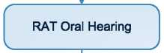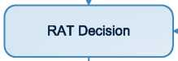

ORAC decision  
Affirmed

ORAC decision Set Aside

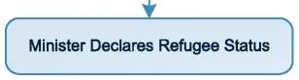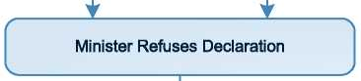

/ \

Minister proposes Deportation

V /

* 1. Additional Statistical Information

Figure 4: Asylum Applications from Top 10 Countries of Origin in 2009, 2010, 2011 and first half of 2012

**2009 2010 2011 Jan-Jun 2012**

|  |  |  |  |  |  |  |  |  |
| --- | --- | --- | --- | --- | --- | --- | --- | --- |
| **1** | Nigeria | 570 | Nigeria | 387 | Nigeria | 182 | Nigeria | 83 |
| **2** | Pakistan | 257 | China | 228 | Pakistan | 175 | Pakistan | 60 |
| **3** | China | 194 | Pakistan | 200 | China | 142 | South Africa | 24 |
| **4** | D.R. Congo | 102 | D.R. Congo | 71 | D.R. Congo | 70 | D.R. Congo | 18 |
| **5** | Zimbabwe | 91 | Afghanistan | 69 | Afghanistan | 67 | Zimbabwe | 17 |
| **6** | Georgia | 88 | Ghana | 57 | Zimbabwe | 66 | Albania | 16 |
| **7** | Moldova | 86 | Cameroon | 56 | Algeria | 48 | Malawi | 16 |
| **8** | Somalia | 84 | Moldova | 56 | South Africa | 46 | Algeria | 15 |
| **9** | Ghana | 82 | Georgia | 53 | Albania | 34 | Bangladesh | 14 |
| **10** | Iraq | 76 | South Africa | 53 | Moldova | 28 | Moldova | 14 |

Figure 5: Decisions Taken at the First Instance in 2009, 2010 and 2011 [173]

|  |  |  |  |  |  |  |  |  |  |
| --- | --- | --- | --- | --- | --- | --- | --- | --- | --- |
|  | **Geneva Convention** | | **Subsidiary/**  **Complementary**  **Protection and Humanitarian Status** | | **Rejections** | | **Withdrawn, Closed, Abandoned Cases** | | **Grand**  **Total** |
| **Number** | **%** | **Number** | **%** | **Number** | **%** | **Number** | **%** | **3,108** |
| **2009** | 97 | 3% | 0 | 0% | 3,011 | 97% | 0 | 0% |
| **2010** | 24 | 2% | 0 | 0% | 1,573 | 98% | 0 | 0% | **1,597** |
| **2011** | 61 | 5% | 0 | 0% | 1,293 | 95% | 0 | 0% | **1,354** |

**Figure 6.a: Positive [174] First- and Second-Instance Decisions,Top Countries of Origin in 2009**

**Rate out of Total Decisions [175]**

|  |  |  |  |  |
| --- | --- | --- | --- | --- |
|  | | **Total Positive** | **Total Decisions** | **Rate** |
| **1** | **Iraq** | 21 | 132 | 15.9% |
| **2** | **Sudan** | 16 | 107 | 15.0% |
| **3** | **Somalia** | 12 | 149 | 8.1% |
| **4** | **Eritrea** | 8 | 65 | 12.3% |
| **5** | **Pakistan** | 6 | 296 | 2.0% |
| **6** | **Iran** | 5 | 53 | 9.4% |
| **7** | **Zimbabwe** | 5 | 112 | 4.5% |
| **8** | **China** | 3 | 86 | 3.5% |
| **9** | **Ethiopia** | 3 | 18 | 16.7% |
| **10** | **Uganda** | 3 | 41 | 7.3% |
| **11** | **W. Bank & Gaza S.** | 3 | 26 | 11.5% |

Total Positive Decisions by Status

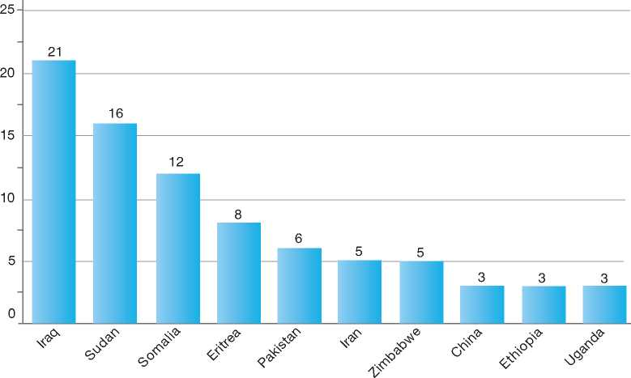

**Total Positive Decisions by Status**

| Geneva Convention Status

**Figure 6.b: Positive [176] First- and Second-Instance Decisions,Top Countries of Origin in 2010**

**Rate out of Total Decisions [177]**

|  |  |  |  |  |
| --- | --- | --- | --- | --- |
|  | | **Total Positive** | **Total Decisions** | **Rate** |
| **1** | **Somalia** | 7 | 67 | 10.4% |
| **2** | **China** | 3 | 53 | 5.7% |
| **3** | **Afghanistan** | 2 | 70 | 2.9% |
| **4** | **Lebanon** | 2 | 2 | 100.0% |
| **5** | **Zimbabwe** | 2 | 44 | 4.5% |
| **6** | **Angola** | 1 | 13 | 7.7% |
| **7** | **Burundi** | 1 | 8 | 12.5% |
| **8** | **D.R. Congo** | 1 | 51 | 2.0% |
| **9** | **Eritrea** | 1 | 22 | 4.5% |
| **10** | **Ethiopia** | 1 | 10 | 10.0% |
| **11** | **Sri Lanka** | 1 | 3 | 33.3% |
| **12** | **Sudan** | 1 | 32 | 3.1% |
| **13** | **W. Bank & Gaza S.** | 1 | 21 | 4.8% |

Total Positive Decisions by Status

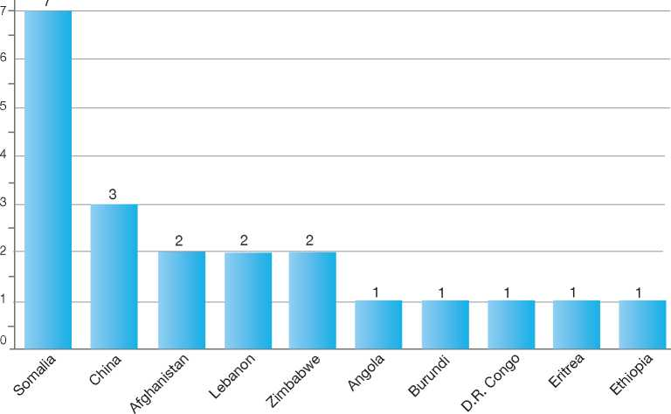

**Total Positive Decisions by Status**

| Geneva Convention Status

**Figure 6.c: Positive [178] First- and Second-Instance Decisions,Top Countries of Origin in 2011**

**Rate out of Total Decisions [179]**

|  |  |  |  |  |
| --- | --- | --- | --- | --- |
|  | | **Total Positive** | **Total Decisions** | **Rate** |
| **1** | **Pakistan** | 12 | 204 | 5.9% |
| **2** | **Iran** | 9 | 35 | 25.7% |
| **3** | **Afghanistan** | 6 | 69 | 8.7% |
| **4** | **W. Bank & Gaza S.** | 5 | 11 | 45.5% |
| **5** | **Kyrgyzstan** | 4 | 8 | 50.0% |
| **6** | **Russia** | 3 | 18 | 16.7% |
| **7** | **Somalia** | 3 | 24 | 12.5% |
| **8** | **Iraq** | 2 | 26 | 7.7% |
| **9** | **Nigeria** | 2 | 249 | 0.8% |
| **10** | **Sudan** | 2 | 14 | 14.3% |
| **11** | **Swaziland** | 2 | 4 | 50.0% |
| **12** | **Uganda** | 2 | 17 | 11.8% |
| **13** | **Zimbabwe** | 2 | 69 | 2.9% |

Total Positive Decisions by Status

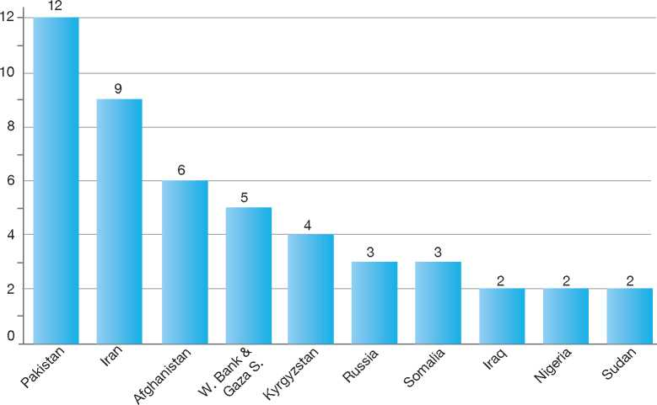

**Total Positive Decisions by Status**

| Geneva Convention Status

1.

2.

3.

4.

5.

6.

7.

8.

9.

10.

11.

12.

Netherlands

299

|  |  |
| --- | --- |
| BackGRound: MajoR asyluM tRends and developMents | 279 |
| national leGal FRaMewoRk | 280 |
| institutional FRaMewoRk | 282 |
| pRe-entRy MeasuRes | 282 |
| asyluM pRoceduRes | 284 |
| decision-MakinG and statuses | 290 |
| eFFiciency and inteGRity MeasuRes | 294 |
| assistance and Reception BeneFits FoR asyluM-seekeRs | 294 |
| status and peRMits GRanted outside the asyluM pRoceduRe | 296 |
| RetuRn | 297 |
| inteGRation | 298 |

annexes

1. Background: Major Asylum Trends and Developments

Asylum Applications

In the late 1980s, the number of new asylum applications began to increase significantly, reaching a peak of over 52,500 in 1994. Between 1995 and 2001, annual applications fluctuated between 30,000 and 45,000. Beginning in 2002, the number of applications decreased significantly, reaching a level of 7,000 in 2007. It should be noted, however, that from 2007 onwards only first applications are included in the statistics. In 2009 the numbers rose significantly to 14,905 applications. Finally, in recent years, the number of applications has decreased again, with 13,333 in 2010 and 11,590 in 2011.**[180]**

Important Reforms

Twice since the beginning of the 1990s, the legal framework for asylum procedures in the Netherlands has undergone significant reforms, with amendments to the Aliens Act taking effect in 1994 and 2001. Measures taken during that period were aimed at streamlining asylum procedures and reducing processing times. Part of the streamlining effort included the introduction of a single procedure whereby asylum-seekers needed to make only one application for Convention refugee status or a residence permit based on humanitarian grounds. As well, during this time dedicated application centres were created.

Since 2005, major reforms have been introduced. Under these reforms, a residence permit may be granted following the procedure in the application centres.

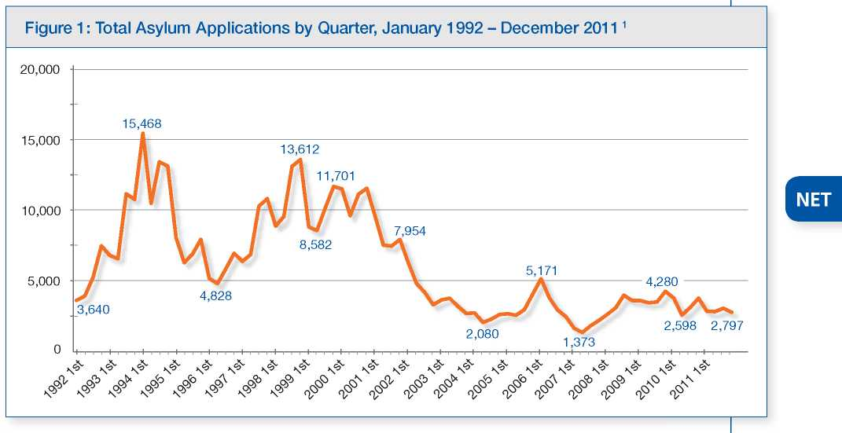

Top Nationalities

In the 1990s, the majority of asylum-seekers originated from the former Yugoslavia, Bosnia Herzegovina, Somalia, Iraq, Iran and, beginning in 1995, Afghanistan. In the period between 2000 and 2003 Angola, Afghanistan and Sierra Leone were the top three countries of origin. Since 2003, the majority of asylum-seekers are arriving from Iraq, Somalia and Afghanistan.

In May 2007, the former State Secretary of Justice and the Netherlands Association of Municipalities (*Vereniging van Nederlandse Gemeenten*, VNG) reached an agreement that brought into force a process to regularise the situation of persons who had made asylum applications under the previous Aliens Act, and had stayed in the country non-stop without receiving a final decision. The regularisation scheme resulted in approximately 28,000 persons receiving a residence permit, and was terminated on 1 January 2009.

**Figure 2: Asylum Applications Received from Top 5 Countries of Origin in 2009, 2010 and 2011[181]**

2009

**Volumes**

2010

**Volumes**

2011

**Volumes**

Distribution

|  |
| --- |
| **Country of Origin:** |
| | Afghanistan Armenia Eritrea Iran  Iraq Somalia Others |

11%

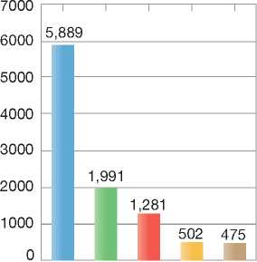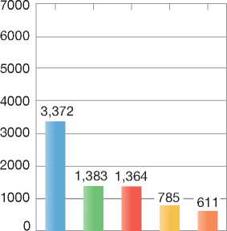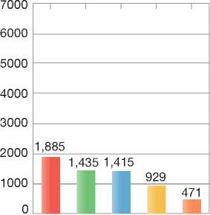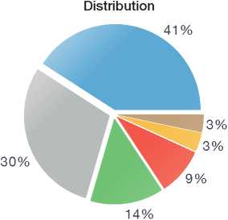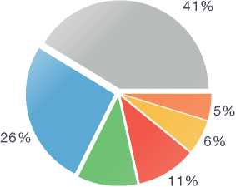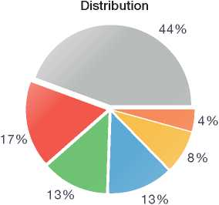

1. National Legal Framework
   1. Legal Basis for Granting Protection

Council Directives relating to Temporary Protection[182] and Reception Conditions[183] were transposed into Dutch law in 2005, while the Directives on Qualification[184] and Asylum

Admission to the Netherlands and the granting of asylum are regulated by the Aliens Act 2000 (*Vreemdelingenwet*), which entered into force on 1 April 2001.**2**

Procedures[185] gained force of law in the Netherlands in 2008 and 2007, respectively. The Return Directive[186] entered into force in 2011.

The recast of the Qualification Directive[187] will have to be implemented in Dutch law before 21 December 2013.

The European Convention on Human Rights (ECHR) and the Convention against Torture and Other Cruel, Inhuman or Degrading Treatment or Punishment (CAT) are given effect in Dutch law.

* 1. Recent/Pending Reforms

The Dutch Government implemented an improved asylum procedure on 1 July 2010. The new procedure enables asylum-seekers to gain more clarity about the outcome of the procedure earlier in the process. In addition, the reforms envision a decrease in both repeat asylum applications and regular applications submitted by former asylum­seekers, and a higher number of rejected asylum­seekers actually leaving the Netherlands.

The new asylum procedure works as follows: after a rest and preparation period of a minimum of six days, the asylum-seeker is admitted to the “general asylum procedure” for a period of eight (working) days. If no decision is reached within the eight-day time limit, the application will be decided within the “extended asylum procedure”. Further details on this new procedure, the procedure at Schiphol International Airport, appeal procedures and repeated applications can be found in section 5 below.

On 5 November 2012, a new government was formed. Migration policy became the responsibility of the Minister for Immigration, whose office forms part of the Ministry of Security and Justice.

Pending Reforms

Proposals exist to abolish the unaccompanied minor permit[188] as the availability of such a permit is thought to send out a contradictory signal to minors. Return of unaccompanied minors would still only be possible if there is adequate reception in the country of origin.

The proposed reform should offer unaccompanied minors clarity about possible outcomes: either he or she is allowed to stay in the Netherlands on the grounds of international protection, or the minor is prohibited from residing in the Netherlands and must leave. The return of unaccompanied minors would still remain conditional on the availability of adequate reception in the country of origin.

Despite this proposal, public opinion in the Netherlands is now pressuring the Government for further changes to provisions for unaccompanied minor asylum-seekers. Currently, unaccompanied minors are allowed to stay in the Netherlands until the age of 18, when they then may be returned to their country of origin. Many Dutch citizens believe that those who arrived as children and settled in the Netherlands should be allowed to stay past the age of 18. As a result, this policy might be changed under the new government.

A comprehensive reassessment of the improved asylum procedure in the Netherlands is planned for 2013. The evaluation shall determine whether the measures taken in the new procedure produced the desire effect. Furthermore, the Netherlands is assessing the possibilities to further shorten the procedural timeframes. This involves the creation of a single asylum procedure, in which all grounds for protection are assessed, both related to asylum and other grounds (e.g. humanitarian, medical or family-related). By aligning the Dutch grounds for protection with the provisions of the Qualification Directive, this reform would also bring the Dutch policy closer to the policy of other EU Member States. The procedure for Dublin cases would also be made faster and more efficient.

The reform will also include an accelerated procedure for subsequent applications. Determining the existence of new facts or circumstances will have to take place within one day. If no new facts or circumstances are found, the application will be rejected immediately. If further investigation is required, the application will be processed normally. Files of rejected asylum-seekers will be transferred directly to the Repatriation and Departure Service. To try and discourage unnecessary re-applications, a differentiated rate of legal aid for subsequent applications is under consideration.

Other plans include putting an end to the policy offering temporary protection to specific groups or categories of asylum-seekers.

1. Institutional Framework
   1. Principal Institutions

The Minister for Immigration is responsible for all areas pertaining to asylum. The Minister's office is part of the Ministry of Security and Justice, which is responsible for the following agencies dealing with different aspects of asylum:

* The Immigration and Naturalisation Service (*Immigratie en Naturalisatiedienst*, IND), an autonomous agency under the political responsibility of the Minister for Immigration, is responsible for processing asylum applications and implementing the Aliens Act.
* The Central Agency for the Reception of Asylum­Seekers (*Centraal Orgaan Opvang Asielzoekers*, COA), an independent administrative body funded by the Ministry of Security and Justice, provides reception facilities to asylum-seekers.
* The Repatriation and Departure Service *(Dienst Terugkeer en Vertrek*, DT&V) is an organisation of the Ministry of Security and Justice and is responsible for the supervision and return of rejected asylum-seekers and persons residing illegally in the Netherlands to their country of origin.
* The Aliens Police, which is in charge of registration of personal data and checks of places of residence
* The Legal Aid Foundation (*Raden voor Rechtsbijstand*, RvR), which provides legal assistance to the asylum-seeker
* The Ministry of Foreign Affairs, which provides information on conditions in countries of origin for use by asylum decision-makers and policy­makers

• The Dutch Council for Refugees (*VluchtelingenWerk Nederland*, VWN), a non­governmental organisation (NGO) that provides assistance to asylum-seekers during the procedure.

1. Pre-entry Measures

To enter the Netherlands, foreign nationals must meet the following requirements:

* Be in possession of valid travel documents or documents authorising entry
* Be in possession of a valid visa pursuant to Regulation 539/2001/EC, Annex I, or a valid residence permit, issued by a State party to the Schengen Agreement
* Justify the purpose and conditions for their intended stay and show sufficient means of subsistence for the duration of the stay
* Not be included in the Schengen Information System alert system for the purposes of being refused entry, and
* Not be a threat to public safety, internal security, public health or international relations of a Member State of the European Union.

The Ministry of Social Affairs is responsible for matters pertaining to integration.

1. Cooperation between Government Authorities

Throughout the asylum procedure, the IND collaborates with a number of other partner agencies and organisations, as follows:

* The Repatriation and Departure Service (see above)
* The Royal *Marechaussee,* which is responsible for border control activities and examines the validity of travel documents

A person who does not fulfil these conditions is refused entry into the Netherlands, unless it is considered necessary to derogate from that principle on humanitarian grounds, on grounds of national interest, or because of international obligations.

1. Visa Requirements

Holders of a Schengen visa are allowed to enter the Netherlands. The visa is valid for travel throughout the Schengen area for a maximum period of three months within a six-month timeframe.

The Netherlands provides for exceptions to the requirement for a Schengen visa in certain cases, such as for holders of diplomatic passports,within the Benelux framework. Persons who are subject to the visa requirement may apply for a visa at a diplomatic mission of the Ministry of Foreign Affairs[189] [190].

1. Carrier Sanctions

Sanctions may be imposed on carriers transporting into the Netherlands foreign nationals who are not in possession of valid travel documents. Carriers may be charged with costs related to the removal of the foreign national from, or their stay in, the Netherlands. Fines may also be imposed when carriers do not act according to other legal obligations, such as making copies of travel documents if so required or taking back a foreign national on a flight.

1. Interception

The Netherlands undertakes a variety of interception activities, in accordance with the Schengen Borders Code and the Dutch policy of identifying unauthorised movements of persons and goods before they reach Dutch borders11. Border controls are carried out at border crossing points in the Netherlands to determine whether persons, vehicles and the goods they are carrying may enter or leave the Netherlands. Border patrols also take place away from the border crossing points in order to prevent persons from evading border checks.

Border control activities are carried out by various agencies, as follows:

* The Royal *Marechaussee* (KMar) carries out border control activities at airports and seaports[191]
* The Seaport Police *Zeehavenpolitie,* ZHP) of the regional Rotterdam-Rijnmond police force supervise adherence to, and carrying out of, the legal provisions on border control in this region. ZHP officers patrol (mobile) border crossing points at the port of Rotterdam, including designated mooring sites (at sea), and carry out other border control activities in coastal and internal waters within this area
* The border control authorities carry out border control at all external border crossings and along the maritime coastline by gathering a variety of data, including pre-arrival information and biometric data. This practice is, amongst others, aimed at the heightened influx of (single minor) foreign nationals who may fall victim to human trafficking and is intended to prevent human trafficking.
* At the Coast Guard Centre in Den Helder, the Coast Guard gathers information from various services with regard to enforcement in the North Sea and border surveillance.

1. Immigration Liaison Officers

The Netherlands has immigration liaison officers (ILOs) stationed around the world[192] to provide advice to carriers and local authorities as to whether or not to take passengers. ILOs also act as advisors to visa departments at Dutch missions abroad in the case of dubious applications. Upon request of local border authorities or carrier staff, they provide training on documentation and Schengen-related legislation and regulations. They also exchange information with liaison officers from other countries. Besides prevention, ILOs are also tasked with return issues. At an operational level, ILOs collaborate with the DT&V on the repatriation of persons to their country of origin.

In addition to their advisory and trainer role, ILOs collect information on travel routes, trends in illegal immigration and human trafficking, and help to develop risk profiles. ILOs investigate the possibilities for repatriation to the country of origin and transit countries using their network, monitoring the involvement of particular organisations, investigating the repatriation policies of other Western countries and identifying reception facilities.

Liaison officers of the Royal *Marechaussee* seconded abroad are deployed mainly for the purpose of achieving a better position on migration-related crime. The KMar liaison officers report, analyse and advise on developments in (illegal) migration to and through the Netherlands and map out illegal migration patterns and their potential relationship to terrorism.

1. Asylum Procedures
   1. Application Possibilities and Requirements, Procedures and Legal Remedies

Persons may apply for asylum at Schiphol airport in Amsterdam and in-country at an Immigration and Nationality Service (IND) application centre. There are two IND application centres: one at Schiphol Airport for persons who are refused admission at the border and for unaccompanied minors, and one in Ter Apel. Applications can be processed in four locations: the two application centres mentioned above, as well as two centres in Den Bosch and Zevenaar. Finally, applications for asylum may also be made by persons in detention.

The Dutch Refugee Council will inform all asylum­seekers of their rights and what they can expect during the asylum procedure. As part of this information, asylum-seekers are told of the possibility to request a female interpreter, and of the importance of disclosing all possible relevant facts.

* + 1. Outside the Country

Applications at Diplomatic Missions

Since 11 September 2003, it is no longer possible to submit an application for provisional sojourn (*Machtiging tot voorlopig verblijf*, MVV) at diplomatic missions in the country of origin or in a third country, for the purpose of making an asylum claim in the Netherlands. It is no longer possible, in other words, to make a formal application for asylum outside the Netherlands.

Any Dutch diplomatic mission, however, can offer protection on a temporary basis to a person who, according to Dutch diplomatic authorities, is facing an acute emergency (diplomatic asylum). In exceptional cases, when the protection offered is not sufficient, the Minister of Foreign Affairs can make a proposal to the Minister of Security and Justice to allow the foreign national to travel to the Netherlands.

Resettlement/Quota Refugees

The Netherlands has in place a resettlement programme that currently accepts 2,000 refugees over a four-year period. Refugees are selected during, on average, four selection missions each year, as well as on the basis of dossiers prepared by the United Nations High Commissioner for Refugees (UNHCR). Selection missions are usually carried out by the Immigration Service (IND) and the Central Agency for the Reception of Asylum­Seekers and Refugees (COA) of the Ministry of Security and Justice. The IND organises interviews with the refugees and makes a final decision on selection with the input of COA. The Netherlands places particular importance on the strategic use of resettlement. Together with other European resettlement countries, the Netherlands promotes resettlement in order to increase the number of resettlement places offered within the EU.

* + 1. At Ports of Entry

A person who does not fulfil the conditions to enter the Netherlands will be refused entry into the territory. If this person states that he or she wants to apply for asylum, he or she will be brought to the Application Centre at Schiphol Airport (AC Schiphol). The applicant must stay in a place secured against unauthorised departure to prevent the person from entering the Netherlands. The procedure at AC Schiphol is the same as in the other application centres[193]. Applicants at Schiphol, however, are not granted the six-day rest and preparation period.

* + 1. Inside the Territory

Responsibility for Processing the Claim

The Dublin System

*Application and Procedure*

If an asylum-seeker falls within the scope of the Dublin Regulation[194] and has made his or her asylum application in the Netherlands, the IND conducts a first interview with the asylum-seeker. This Dublin interview does not cover the reasons for applying for asylum, but instead focuses on the transfer. During the Dublin interview, the asylum-seeker is informed that the Netherlands might or already has filed a Dublin claim with another State party to the Regulation, and he or she receives the opportunity to explain why the Netherlands should process his or her asylum application instead. After receiving an intended decision for refusal, the asylum-seeker and his or her legal representative can respond to this intended decision. If the IND decides not to change the intended decision, the asylum-seeker can make an appeal before a judge.

When the identification procedures indicate that the asylum-seeker has already made an application in another State, a request to “take charge” and to “take back” on the basis of the Dublin II Regulation can already be initiated during the initial six-day rest and preparation period.

*Freedom of Movement/Detention*

In the interests of public order or national security, Dutch authorities are entitled to detain a foreign national. Asylum-seekers who are subject to a decision of transfer under Council Regulation (EC) No. 343/2003 are usually detained prior to the transfer. The order imposing the detention measure or the continuation of detention is submitted to a periodic judicial review by the District Court. If the court holds that too little has been done to have the foreign national transferred, or that the person has been kept in detention for too long, he or she will be released. These assessments are made on a case-by-case basis.

*Conduct of Transfers*

If the country agrees with the referral or return request of the IND, the asylum-seeker is transferred within six months. The transfer is conducted by the DT&V.

*Suspension of Dublin Transfers*

Dublin transfers may be temporarily suspended for medical reasons or due to a pending procedure at the higher or lower court.

*Review/Appeal*

The asylum-seeker may appeal the decision of the IND before the District Court. The court must decide whether the IND's decision was correct or incorrect. Following the judgment, the person may make a further appeal to the Council of State. The latter will verify whether or not the formalities in the proceedings have been correctly observed, and whether the court has correctly applied the law.

Application and Admissibility

Making an Asylum Application

Prior to making a formal asylum application, all asylum-seekers are allowed a rest and preparation period of a minimum of six days. During this period, there can be no contact between the IND and the asylum-seeker. Preliminary investigation, however, of travel and identity documents can be conducted during this time. This period is meant to improve the overall quality of the asylum procedure.

Once an asylum-seeker states his or her intent to apply for asylum, the applicant is referred to the central reception centre in Ter Apel, where asylum-seekers stay for a period of approximately two days. After an intake interview (which should not be confused with the asylum interview), the authorities will start examining the authenticity of the applicant's documents. At this stage, preparations for a request to “take charge” and “take back” on the basis of the Dublin II Regulation may be initiated. All guarantees and provisions of the relevant European Union legislation are applicable as of this moment.

Soon after the intake, the asylum-seeker will be transferred to a regular reception centre, where he or she will stay for the remainder of the rest and preparation period and the general asylum procedure. The reception centres are situated in Ter Apel, Den Bosch and Zevenaar, located near the application centre.

During the remainder of the rest and preparation period, the following activities take place: a medical check, information provision by the Dutch Refugee Council, and legal assistance provision.

*Medical Check*

All asylum-seekers have the possibility to receive a medical check. This allows their general physical and mental condition to be taken into account during the asylum procedure. When, for instance, a medical condition affects their ability to tell their story in a coherent and consistent manner, the interview procedure can be adjusted accordingly.

In addition, any evidence of medical problems can be a reason for the IND to start a separate procedure, parallel to the asylum procedure, to ascertain whether these medical problems in and of themselves are a justification for granting leave to remain. This procedure prevents a situation in which a rejected asylum-seeker applies for residence on medical grounds after going through the entire asylum procedure.

*Information Provision by the Dutch Refugee Council*

The Dutch Refugee Council informs all asylum­seekers about the asylum procedure and their rights. They are also informed about the possibility to ask for a female interpreter and the importance of disclosing all relevant facts.

*Legal Assistance*

All asylum-seekers have a right to free legal assistance. The maximum amount of legal assistance provided for during the rest and preparation period plus the general asylum procedure is twelve hours. On average, eight hours will be granted. In the extended procedure, an additional five (up to a maximum of seven) hours of legal assistance are available. Whenever possible, the asylum-seeker will have the same legal aid worker throughout the procedure.

Procedures

Procedure at the Application Centre

As a rule, all asylum-seekers first enter the general asylum procedure. This involves an eight-working-day process in which all necessary procedural steps are taken in order to come to a decision, with full consideration given to the obligations of the Netherlands under the 1951 Convention relating to the Status of Refugees (1951 Convention) and other legal instruments.

By placing all procedural steps in which the presence of the asylum-seeker is required and gathering the main body of evidence upfront, processing times can be significantly shortened, not only within the general eight-day asylum procedure, but also in cases that require further investigation through an extended asylum procedure.

This new procedure provides more time for preparation than was previously available to the asylum-seeker and his or her legal representative: three of the eight days are set aside for their use.

Under the eight-day general asylum procedure, an extensive detailed interview is conducted in all cases with the assistance of an interpreter (if necessary) and in the presence of the legal representative. This detailed interview focuses on the reasons for departure from the country of origin and, if necessary, on the outcome of investigations into the identity, nationality and travel route of the asylum-seeker.

While in general a detailed interview relating to the reasons for asylum will be conducted under the new asylum procedure, exceptions may occur: for example, when an interview is not possible or desirable for medical reasons, or in cases concerning an unaccompanied minor younger than twelve years old.

Also the corrections and additions to the report of the detailed interview are handled at the application

The General Eight-day Asylum Procedure

Day 1: Formal lodging of application for asylum and

first interview on identity and travel route

Day 2: Asylum-seeker discusses the first interview and prepares for the second interview with his or her legal aid worker

Day 3: Second in-depth interview on the reasons

for applying for asylum

Day 4: Asylum-seeker discusses the second interview with his or her legal aid worker. Corrections and additions can be made to the report of the second interview with the legal aid worker

Day 5: IND informs the asylum-seeker of its

intention. If the IND intends to accept the asylum application, the procedure stops here. If the intention is to reject the asylum application, the procedure continues. At this moment, the IND can also decide that further investigation is necessary and redirect the application to the extended asylum procedure

Day 6: The asylum-seeker and the legal aid worker draw up a response to the intention of the IND to reject the asylum application

Day 7-8: The IND will (1) make the decision to reject the asylum claim, (2) make the decision to grant international protection, or (3) decide that further investigation is necessary and redirect the application to the extended asylum procedure.

centre during the general procedure. This means that all stages of the process that are necessary to make a decision with regard to the asylum application can be completed within eight days.

If the IND exceeds the deadlines, the asylum­seeker will be sent to a reception centre and the decision regarding asylum will be taken within the extended asylum procedure.

The IND can actively decide to proceed to the extended procedure after receiving the corrections and additions of the detailed interview and after receiving the applicant's view on the intended decision.

Extended Procedure at a Processing Office

As described above, the IND may decide to forward an asylum application to the extended procedure after several key steps: the initial interview,the detailed interview, or following receipt and consideration of the asylum-seeker's view on the intended decision made at the application centre. A decision to apply the extended procedure is usually made if the IND believes further examination of the claim is required.

If the extended procedure is applicable, the asylum claim is forwarded to a processing office of the IND, and the asylum-seeker moves from the application centre to a reception centre. Asylum-seekers whose applications are being examined in the extended procedure at Schiphol can be accommodated at the detention centre near Schiphol.

If a detailed interview has not yet been conducted, this will take place at the processing office. If a detailed interview has already taken place during the general procedure, an additional interview may be granted, and the applicant may provide additional information, correct statements, or provide further documents supporting his or her claim.

The asylum-seeker has four weeks to submit his or her corrections and additions to the interview report, after which an intended decision is made. The asylum-seeker has an additional four weeks to submit his or her view on the intended decision. These last four weeks are reduced to two weeks if the asylum-seeker is in a detention centre.

Review/Appeal of Asylum Decisions

The competent authority for appeal is the District Court (*Rechtbank*) and for further appeal, the Council of State (*Raad van State*).

Appeals may be made against decisions of the IND following either the general asylum procedure at the application centre or the extended procedure. Following the general asylum procedure, appeals may be made within one week of the decision, while under the extended procedure appeals may be made within four weeks of the decision.

Appeals in the extended procedure have suspensive effect, while appeals under the general asylum procedure do not. However, the asylum­seeker can ask the Court for a provisional ruling.

Both the asylum-seeker and the Minister for Immigration can lodge a higher appeal to the Council of State against the verdict of the Court. The higher appeal does not have suspensive effect.

In a move to reduce the number of repeat asylum applications, new facts or circumstances as well as policy amendments may now be taken into account in appealing an IND decision. Previously, new facts could only be examined in a new application.

Freedom of Movement during the Asylum Procedure

Detention

*Procedure at Schiphol Airport*

Asylum-seekers who are refused entry to the Netherlands are transferred to a closed application centre at Schiphol airport. If the application is rejected, the asylum-seeker remains in (border) detention. The (border) detention of families with children can last a maximum of four weeks after the final rejection of the asylum application (including the appeal before the Administration Court).

*In-Country Procedure*

There is no restriction on freedom of movement during the asylum procedure at the application centre or the processing office. Detention occurs if it is expected that the application will be rejected and public order or national security is at risk. In that case, the asylum-seeker is placed in a detention centre.

*Procedure in Detention*

Foreign nationals may also make an application for asylum while in detention. In that case, detention of an asylum-seeker who is allowed to await the outcome of an asylum application in the Netherlands cannot last longer than six weeks. The detention of families with children who apply for asylum can last for a maximum of two weeks.

*Appeal*

Decisions to detain may be appealed before the Administrative Court. The IND has to inform the Administrative Court of the detention measure within 28 days, unless the decision to detain has been appealed by the foreign national.

Reporting

Asylum-seekers are required to report weekly to the Aliens Police during the asylum procedure, by means of a fingerprint recognition system. If they do not report for two consecutive weeks without having a good reason, the asylum procedure is terminated, along with any reception benefits.

During the procedure in the application centre, the asylum-seeker is given an instruction based on

Article 55 of the Aliens Act to stay at the application centre from 7:30 a.m. till 10 p.m. After 10 p.m. the asylum-seeker may leave the centre, but he or she has to report back at 7:30 the following morning. The asylum-seeker also has the option of spending the night at the reception centre, in which case he or she has to respect the centre's house rules. In case the IND or the Legal Aid Foundation (RvR) decides that his or her presence is no longer required that day for the assessment of his or her asylum application, he or she is also allowed to leave the application centre during the daytime.

Repeat/Subsequent Applications

Asylum-seekers who have received a negative decision on their original claim may make a subsequent application. An appointment must first be made by telephone for the asylum-seeker to deposit his or her subsequent application at an IND application centre. The person is required to submit all new documents, translated into Dutch, which will be entered in the application.

The procedure that applies to subsequent applications is a simplified procedure that is faster than the eight-day standard procedure. Only new evidence or information will be considered in the examination of a subsequent claim.

1. Safe Country Concepts
2. Safe Country of Origin

The concept of safe country of origin is laid down in the Aliens Act 2000. While the Netherlands does not maintain a list of safe countries, the Minister for Immigration is responsible for determining which countries may be considered safe on the basis of a set of criteria, namely, the ratification of the following instruments:

* The 1951 Convention, and
* The ECHR, and/or
* The Convention against Torture.

If the person originates from a country of origin considered to be safe and cannot demonstrate that this country does not comply with the obligations of these instruments, it is presumed that the asylum­seeker will not be persecuted or run a real risk of being subjected to treatment described in Article 3 ECHR. The burden of proof rests with the asylum­seeker. However, if there is common knowledge that a country does not comply with the obligations of the aforementioned conventions, it will not be presumed to be a safe country of origin.

Asylum Claims Made by EU Citizens

The Netherlands considers itself party to the Spanish Protocol annexed to the Treaty of Amsterdam and enforces the provisions of the Protocol. European Union (EU) Member States are considered safe countries of origin.

1. First Country of Asylum

The Netherlands does not have a policy of first country of asylum, but instead has a policy of country of former residence. This principle is laid down in the Aliens Act 2000.

An asylum application can be rejected on the basis of the country of former residence principle if the asylum-seeker meets the following criteria:

* The asylum-seeker has not travelled to the Netherlands directly from his or her country of origin and, before coming to the Netherlands, received sufficient protection against *refoulement*
* The asylum-seeker has resided, or could have resided, in that country in conditions that are not uncommon in that country, and
* It is clear that this country will readmit the person until he or she has found enduring protection elsewhere.

1. Safe Third Country

The concept of safe third countries is laid down in the Aliens Act 2000. Similar to the principle of safe countries of origin, the Netherlands does not maintain a list of safe third countries. Instead, the State Secretary of Justice is responsible for determining which countries may be considered safe on the basis of a set of criteria, namely, the ratification of the following instruments:

* The 1951 Convention, and
* The ECHR, and/or
* The Convention against Torture.

If the alien has resided in a safe third country and cannot demonstrate that this country does not comply with the obligations laid down in these instruments, it is presumed that the person will not be persecuted or run a real risk of being subjected to treatment described in Article 3 ECHR. The burden of proof rests with the asylum-seeker. However, if there is common knowledge that a country does not comply with the obligations from the aforementioned conventions, it will not be presumed to be a safe third country.

The concept of safe third country is applicable only if the asylum-seeker has resided in the third country and not merely travelled through it. As a guideline, it is presumed the person has resided in a country if he or she has stayed there for two weeks or longer, unless it is clear from facts and circumstances that he or she had intended to travel to the Netherlands. If the person stayed for less than two weeks in the third country, it is presumed that he or she had the intention of travelling to the Netherlands, unless facts and circumstances make clear that there was no such intention.

1. Special Procedures
2. Unaccompanied Minors

Procedures

When an unaccompanied minor (UAM) applies for asylum in the Netherlands, the authorities will first assess whether he or she qualifies for a residence permit according to the normal (in-country) asylum procedure. UAMs are interviewed by specially trained staff and are assigned a guardian who will assist them throughout the procedure. Under the new Improved Asylum Procedure, a longer period of rest and preparation lasting three weeks instead of six days is available to UAMs.

If the UAM does not meet the criteria for obtaining international protection in the Netherlands, the authorities will determine whether it is possible to return the child to familiar surroundings; that is,to his or her parents and family or to a reception centre in the country of origin. If return to the country of origin is not possible, then the IND may issue a residence permit for a year, which can be extended twice, each time for a period of one year. As soon as the child turns 18 or no longer satisfies all conditions, the UAM residence permit ends and will not be extended further.

After a three-year stay with a UAM permit, an asylum-seeker who has not reached the age of 18 will - in principle - be issued a permanent residence permit, provided that no adequate reception can be found in the country of origin. When a child turns 18 and has at that point been in the Netherlands for less than three years on a UAM permit, he or she must return to the country of origin. In some exceptional cases the former UAM will be issued a permit for continued residence.

Age Assessment

If a minor has no documents proving his or her age and there is doubt about the stated minority, an age assessment can be offered to the UAM. X-rays are taken of the joint between the hand and the wrist, and - if the hand-wrist bone is completely fused - of the collarbones. The x-rays are examined by independent radiologists, who assess whether the bones are completely fused or not, or whether the result is unclear. The Dutch Forensic Institute bases its conclusion on the findings of the radiologists. Results of the age assessment may be as follows:

* The UAM is possibly a minor (not proven a major); the given age is accepted by the INS
* The person is an adult; the person is considered 20 years or older (because completely fused collar bones have never been found on a person aged younger than 20).

| **Figure 3: Asylum Applications by Unaccompanied Minors in 2009, 2010 and 2011** | | | |
| --- | --- | --- | --- |
|  | **2009** | **2010** | **2011** |
| Total Asylum Applications | 14,905 | 13,333 | 11,590 |
| of which Unaccompanied Minors | 1,039 | 701 | 484 |
| Percentage | 7% | 5% | 4% |

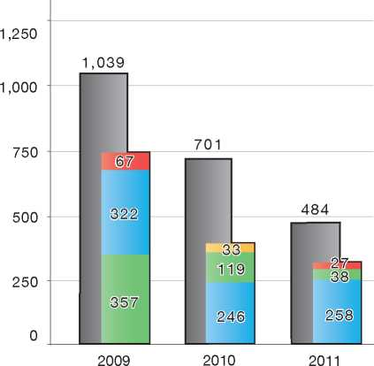

|  |  |
| --- | --- |
| **Country of Origin:** | |
| | Afghanistan | | Iraq |
| Guinea (Co.) | Somalia |

1. Temporary Protection

The Aliens Act stipulates that a temporary residence permit for asylum can be granted to a foreign national for whom, in the opinion of the Minister for Immigration, return to the country of origin would pose a particular hardship as a result of the overall situation in that country. Grounds for granting asylum under Article 29 of the Aliens Act 2000 must be met.

Unlike the granting of protection under the asylum procedure, however, the decision to grant temporary protection is based on whether the person belongs to a category or group of persons to whom the policy of temporary protection is being applied.

In determining whether a group of persons may be designated as being in need of temporary protection, the following aspects of the country situation are examined:

* The nature of the violence in the country of origin, in particular the seriousness of the violations of human rights and the law of war, the extent of the arbitrariness of the violations, the extent of the violence and the geographical spread of the violence
* The activities of international organisations, as far as they are a measure of the position of the international community with respect to the situation in the country
* The policy in other countries of the European Community with regard to the country.

A proposal for new legislation has been presented to Parliament in spring 2012 to delete this form of Temporary Protection from the Aliens Act.

1. Stateless Persons

The same asylum procedures and policies are applicable to all asylum-seekers, including those who are stateless. In the case of a stateless person making an asylum claim, the IND will usually examine the claim against conditions in the country of former habitual residence. In determining the country of former habitual residence, the IND will assess the length and nature of the person's stay in that country and the ties he or she has to the country. One determining factor is whether the person has had close ties (work, residence and family) in the country.

1. Decision-Making and Statuses
   1. Inclusion Criteria

There is a single procedure in place for the examination of asylum claims. The IND first determines whether the asylum-seeker is a Convention Refugee and if not, whether other protection-related grounds exist for granting a permit. A single residence permit for asylum is granted on the basis of Convention refugee and other protection grounds.

* + 1. Convention Refugee

Article 29, section 1 of the Aliens Act provides that a person will be granted Convention refugee status if he or she meets the criteria outlined in the 1951 Convention (and the 1967 New York Protocol).

* + 1. Complementary Forms of Protection

Article 29, section 1 of the Aliens Act also provides the grounds for granting a residence permit to persons who do not meet the criteria for Convention refugee status but who are in need of protection. These grounds are as follows:

* The person faces a real risk of being subjected to torture or to inhuman or degrading treatment or punishment
* There are compelling grounds of a humanitarian nature connected to the reasons for the person's flight from the country of origin that make return unreasonable
* Return to the country of origin would, in the opinion of the Minister for Immigration, constitute an exceptional hardship for the person in connection with the overall situation there (this ground must be met in the case of temporary protection)
* The person is the spouse or minor child of a Convention refugee or a person who meets one of the three grounds described above, has the same nationality as the spouse or parent, and has entered the Netherlands either at the same time as the person or within three months of the date on which the spouse or parent was granted a residence permit.

Humanitarian Grounds

As noted above, there may be compelling grounds of a humanitarian nature that may make return unreasonable and lead to the granting of an asylum residence permit. There are three categories of humanitarian grounds that may form the basis for the asylum residence permit:

* The person displays (mental) trauma as a result of events that took place in the country of origin
* There are humanitarian reasons beyond those related to the advanced age of the person, his or her health or the overall situation in the country of origin that come to light following a case-by-case assessment
* The person belongs to a specific group that, according to a decision of the Minister, can be granted residence on this ground.
  + 1. Non-Protection-Related Permits

Within the asylum procedure, it is also possible to grant a “regular” residence permit to persons who do not need international protection. As described above, unaccompanied minor asylum-seekers may in certain cases obtain a regular residence permit if return to the country of origin is not possible.

In addition, persons whose return cannot be implemented for reasons beyond their control may be granted a regular residence permit. It is presumed that all persons can return to their country of origin. Nevertheless, in extraordinary situations when a person cannot leave the Netherlands, for example because he or she is not able to obtain the necessary documents for return and there is no doubt about his or her identity and nationality, a residence permit can be granted. This can be the case if the person is stateless and he or she cannot return to his or her country of former habitual residence.

* 1. The Decision

The decision-making authority is the Immigration and Naturalisation Service (IND). The IND makes a written decision on whether to grant a residence permit or to refuse the application for asylum. All negative decisions are reasoned.

* 1. Types of Decisions, Status and Benefits Granted

There are four types of decisions that can be taken by the IND following an assessment of an asylum claim:

* The asylum-seeker meets the criteria set out in Article 29, section 1 of the Aliens Act and is granted a residence permit for asylum
* The asylum-seeker does not meet the criteria set out in Article 29, section 1 of the Aliens Act and is refused a residence permit for asylum
* The asylum-seeker is refused a residence permit for asylum but is granted a regular residence permit, because he or she satisfies the conditions as an unaccompanied minor, or because evidence is provided that he or she cannot be held accountable for not being able to leave the Netherlands
* The asylum-seeker does not satisfy the conditions and is refused a residence permit for asylum and refused a regular residence permit.

Benefits

There is a single type of residence permit - the residence permit for asylum - that is granted to persons who are Convention refugees and to persons who meet the other grounds for protection outlined in Article 29, section 1 of the Aliens Act.

Beneficiaries of a residence permit for asylum are entitled to the following benefits:

* A travel document for refugees
* Social benefits
* Health care benefits
* Access to the labour market
* Access to family reunification.

The residence permit for asylum is valid for five years. After five years, the person can apply for a permanent residence permit for asylum, if the grounds for granting the residence permit for asylum remain valid.

Holders of a regular residence permit who cannot obtain a passport from their own authorities can apply for a travel document for aliens. They are entitled to social benefits according to their residence permit and to health care. The regular resident permit is valid for five years. After this time, the person can apply for a permanent residence permit, if the grounds for granting the residence permit for asylum still exist.

Quality Assurance at the IND

Random checks are carried out of IND caseworker decisions, which are reviewed against checklists of common mistakes. The checklists are used to identify needs and develop specific actions to improve the quality of caseworker products. External feedback is also provided by lawyers, the Dutch Refugee Council, the UNHCR, NGOs, judges, as well as by asylum-seekers through a follow-up of their complaints.

* 1. Exclusion

The grounds for exclusion are prescribed in the Qualification Directive (Directives 2004/83/EG and 2011/95/EU).

A person who meets the criteria set out in Article 1F of the 1951 Convention will not be granted a residence permit. The Minister must be able to demonstrate, but not “prove” in the sense of the evidence standard applied in the context of criminal law, that there are ”serious grounds” upon which to presume the person meets the exclusion criteria. If a foreign national was aware, or ought to have been aware, of having committed the offence or offences in question (“knowing participation”) and he or she personally took part in these offences (“personal participation”), it is possible to invoke Article 1F of the Convention.

Where it has been established that Article 3 of the ECHR constitutes an obstacle to the person's repatriation to his or her country of origin, a residence permit can in exceptional circumstances be granted if the excluded person has resided in the Netherlands for a period of ten years and cannot return to his or her country of origin or to a third country. This residence permit is valid for one year and may be renewed.

Family Members

Family members of persons excluded from the 1951 Convention can be granted a residence permit for asylum if one of the grounds set out in Article 29, paragraph 1(a), (b) and (c) of the Aliens Act 2000 applies to them personally.

A residence permit may not be granted to family members if considerations of public order override other concerns. However, if the ties between a family member and a person excluded from the 1951 Convention have been broken (for instance, as a result of divorce or in the case of a child who has reached the age of maturity and moved out of his or her family home), the family member may be granted a residence permit subject to certain conditions.

Furthermore, if after having resided in the Netherlands for a period of ten years or more without a residence permit, family members of a person excluded from the 1951 Convention make an application for a residence permit, the person's exclusion from the 1951 Convention will have no bearing on the examination of the application of those family members. The attitude of the family members towards their own departure process will also be taken into account.

* 1. Cessation

The IND may apply the cessation clauses of the 1951 Convention and the Qualification Directive to both Convention refugees and beneficiaries of subsidiary protection, if changes in the country of origin warrant it. However, the IND will not apply the cessation clauses to persons who have obtained a permanent residence permit after five years of holding a permit for asylum.

A change in circumstances in the country of origin may be said to have occurred if the situation in the country of origin improves in such a manner that the fear of persecution is no longer present (e.g. the removal of a repressive regime and the establishment of a new one based on respect for basic human rights).

If the IND makes a decision to evoke the cessation clauses, the person has the right to appeal the decision to the District Court and further on to the Council of State.

* 1. Revocation

The IND may revoke the status granted to a Convention refugee or to a beneficiary of subsidiary protection in one of the following circumstances:

* On cessation grounds
* On exclusion grounds
* On evidence of fraud
* If the person is found to pose a danger to security and community.

Where cessation and exclusion clauses apply, the IND cannot revoke the person's status if he or she has obtained a permanent residence permit.

To revoke a residence permit because of breaches of public order and criminal offences, theNetherlands has a policy of “the sliding scale” - the longer the person has resided in the Netherlands, the graver the breach has to be to constitute a ground for revoking the residence permit.

The IND sends an intended decision to the asylum­seeker. The asylum-seeker then has six weeks to present his or her view. After this, the person will be interviewed about his or her opinion.

The possibilities for appeal are the same as they are for the asylum procedure[195].

As long as no final decision has been made to revoke a residence permit, the holder of the permit retains his or her right to work.

* 1. Support and Tools for Decision-Makers
     1. Country of Origin Information

There are two offices within the Dutch administration that are responsible for producing country of origin information (COI) used by decision-makers in the asylum procedure. One is located within the Ministry of Foreign Affairs, and one within the IND.

The Asylum and Migration Affairs Division, part of the Department of Movement of People and Aliens Affairs within the Ministry of Foreign Affairs, publishes around 35 reports each year on the human rights, security and political situation in countries of origin, for use by asylum decision­makers and policy-makers. The Asylum and Migration Division may be requested by OCILA, the COI office at the IND, to produce more specific reports on countries of origin, and may undertake fact-finding missions for information-collection purposes. OCILA plays a role in the production of the country reports by coordinating the input for the Terms of Reference (ToR) for each report[196].

OCILA is part of the Centre for Knowledge, Advice and Development within the IND. OCILA itself is divided into two subdivisions: the Country Subdivision (which itself is divided into a front office made up of four regional offices and a back office at headquarters) and the Language Analysis Subdivision.

The Country Subdivision produces country­specific and thematic reports and country analysis reports for use by asylum decision-makers and other officials of the IND. It produces about 45 reports each year. Apart from writing reports, the Country Subdivision organises workshops for decision-makers on relevant topics or countries of origin. Another activity is answering specific COI questions of decision-makers. Each year there are about 1,700 of these.

OCILA is an active partner in European and international information-sharing and cooperative activities in the field of COI. OCILA participated in recent projects, such as the European COI Sponsorship (ECS) project, and was involved in the development of a European training programme for decision-makers (European Asylum Curriculum). It also actively contributes to the development of COI-related activities of the European Asylum Support Office.

* + 1. Language Analysis

The Language Analysis Subdivision of OCILA records and analyses the speech of asylum­seekers, first to be able to confirm or deny the country or region from which the asylum-seeker claims to originate. If the results of a language analysis test indicate that the country of origin is not the one claimed by the asylum-seeker, further analysis may be carried out to determine the actual country or region of origin of the person.

Language-analysis plays an important role in determining the identity and origin of asylum­seekers. It has proved to be a useful instrument for decision-makers. Language analysis is an efficient way of assisting the IND in determining the identity of large numbers of asylum-seekers claiming to originate from a country or region for which the IND applies a policy of subsidiary protection. This tool has also been found by the high court to be a professional and reliable means of assisting decision-makers in their work. For these reasons, language analysis has gained in importance in recent years. OCILA produces about 600 language analysis reports annually.

1. Efficiency and Integrity Measures
   1. Technological Tools
      1. Fingerprinting

Rolled fingerprints of all asylum-seekers aged four years and older are taken and stored. The fingerprints are taken for identity verification purposes.

In the near future, scanned fingerprints of all foreign nationals who come into contact with the Dutch authorities will be taken and stored for identity verification purposes.

* + 1. DNA Tests

DNA tests are used for verification purposes in the identification process for foreign nationals. Several laboratories carry out the DNA tests.

* + 1. Forensic Testing of Documents

All source documents that are submitted by asylum-seekers at the start or during the course of the procedure undergo technical as well as tactical examination. This may involve the use of the online database, DISCS (Document Information System of Civil Status). Any findings arising from the examination of the document may be taken into consideration when making a final decision on the request for asylum.

* + 1. Database of Asylum Applications/Applicants

All asylum applications and subsequent decisions are registered in an IND database (Indis), which is linked to a Central Shared Database with basic information on applicants. The Central Shared Database is the central system used by government agencies involved in the immigration process.

* 1. Length of Procedures

There is no time limit for filing an application for asylum. However, the asylum-seeker has a maximum of one week to make an appeal in the case of a rejected claim in the general asylum procedure, and four weeks in the extended procedure. There are also time limits for authorities to examine and make a determination on an asylum application: eight days in the general asylum procedure and six months in the extended procedure.

* 1. Pending Cases

No recent data on the number of pending cases is available.

* 1. Information Sharing

The only information-sharing agreements to which the Netherlands is party are those that take effect under the Dublin II Regulation, including an agreement with Switzerland for this purpose. Thus, specific information on asylum-seekers can be released to other EU Member States, in accordance with Article 21 of the Dublin Regulation. No information on asylum-seekers can be released to a third country, unless the asylum­seeker gives permission.

1. Assistance and Reception Benefits for Asylum-Seekers
   1. Procedural Support and Safeguards
      1. Legal Assistance

Legal aid is available to asylum-seekers at the first instance and at the appeal stage of the procedure. The role of the legal representative at first instance is to assist the asylum-seeker in preparing for the detailed interview and to be present at the interview. The legal representative may also write, on behalf of the asylum-seeker, his or her view on an intended decision to refuse an asylum claim.

Case Responsibility at the IND

In order to improve the customer service at the organisation, the IND assigns each asylum case to a case manager. The applicant and his or her legal representative are given the name of this case manager at an early stage and can, at any given time, contact the case manager to request information. The case manager thus serves as a direct contact point, manages the process and content of the application, and has the responsibility to ensure that a decision is made within the statutory decision-making period.

* + 1. Interpreters

Interviews at the IND take place in Dutch and therefore an independent and impartial interpreter is also present to assist the asylum­seeker. Translators are also available to translate documents or declarations submitted by the asylum-seeker.

* + 1. UNHCR

The UNHCR in the Netherlands has a general monitoring function, and does not have a direct role in the determination of individual cases. The Regional Office of the UNHCR for the Benelux countries at times provides advice and information to NGOs and lawyers who have direct contact with asylum-seekers.

* + 1. NGOs

The Council for Legal Aid and the Dutch Council for Refugees provide assistance to asylum-seekers during the procedure. The Council for Legal Aid is responsible for finding a lawyer to assist asylum­seekers during the procedure. The Dutch Council for Refugees provides advice on a variety of legal and practical questions.

* 1. Reception Benefits

Reception benefits are available to asylum­seekers awaiting a decision on their claim. Once a removal order is given, asylum-seekers have four weeks to leave, in which time they are offered accommodation.

* + 1. Accommodation

The Central Agency for the Reception of Asylum­Seekers (COA) is responsible for the reception of asylum-seekers during the asylum procedure. With the exception of persons who have made an asylum application at the border, following registration, asylum-seekers are accommodated at a temporary reception centre with basic facilities, before making their application at an application centre.

Persons who make an asylum application at Schiphol airport are placed in a closed centre if entry into the country has been refused and the application is being examined at the Schiphol application centre.

In case the decision on the asylum application cannot be made within the general asylum procedure at the application centre, the asylum­seeker is placed in a regular reception centre.

Special accommodation arrangements are made for unaccompanied minors. Children under the age of 12 are generally placed with foster parents; children between the ages of 12 and 15 are usually placed in a small unit with 24-hour supervision. In the majority of cases, the reception of UAMs consists of regular housing. The houses are financed by the central government. Children over the age of 15 are placed in special reception centres that offer specialised care, or in small units (houses).

* + 1. Social Assistance

The Central Organisation for the Reception of Asylum-Seekers (COA) provides the asylum-seeker with financial assistance for food and pocket­money. The Dutch Refugee Council helps the asylum-seeker socially and in the asylum procedure throughout his or her stay in the reception centre.

If necessary, an asylum-seeker may consult a social worker.

* + 1. Health Care

The asylum-seeker has the right to the same health care package that Dutch residents have, with the exception of a few medical procedures. Children get their regular dentist expenses covered as well, until the age of 18.

* + 1. Education

Asylum-seekers below the age of 18 receive education in regular schools, pursuant to the Compulsory Education Law. Adults receive some training as well. They learn the Dutch language and acquire some background information on Dutch society in a reception centre. Adults can pursue any education, provided they pay for it.

* + 1. Access to Labour Market

Work is permitted six months after the application for asylum. Asylum-seekers have the right to work during 24 weeks in a year. A work permit must be obtained first.

Asylum-seekers may also take part voluntarily in activities, such as garden work and minor maintenance jobs at the reception centres. They receive a small amount of money in return.

Reception centre house rules state that the asylum­seeker has to perform tasks that are mandatory and unpaid, such as cleaning of common rooms and showers. If the asylum-seeker does not comply with an obligation to perform tasks at the reception centre, the COA invokes house rules, which contain sanctions varying from a warning to the withholding of pocket money.

* + 1. Access to Integration Programmes

If no final decision has been taken on the asylum application, the integration principally consists of learning Dutch and acquiring knowledge of Dutch society. After receiving a positive decision, the asylum-seeker can start an integration course that is usually financed by the Dutch Government.

* + 1. Access to Benefits by Rejected Asylum-Seekers

Free legal aid, social assistance and reception are available during an appeal at the return stage. After the first negative decision, the asylum-seeker is no longer eligible for Dutch language training.

After a first negative decision, asylum-seekers can receive vocational training relevant to skills needed upon return to the country of origin. Rejected asylum-seekers can also apply for assistance from the International Organization for Migration (IOM) in arranging return to the country of origin, including (in some cases) a financial contribution.

A combination of in-cash and in-kind reintegration assistance is also possible since 1 January 2012.

Grant Policy for Migration and Development

On 5 December 2011, the former Minister for Immigration, Integration and Asylum informed the Parliament of changes made in the grant policy with regard to the voluntary, sustainable return and reintegration of former asylum-seekers. The main change concerns the possibility to combine in­kind assistance (up to a maximum of € 1,500) and financial (cash) assistance.

This grant policy forms part of the “Migration and Development Programme 2012” of the Ministry of Foreign Affairs. The new grant policy runs from 1 January to 31 December 2012. During this period international organisations and non-governmental organisations (NGOs) in the Netherlands can apply for the grant by submitting project proposals to the DT&V.

The grant applications are evaluated by the Voluntary Return Steering Committee (represented by the Migration and Asylum Division, DCM/MA) and the Ministry of Interior and Kingdom Relations (represented by the Immigration Policy Department, DMB, and the DT&V).

In 2012, seven projects have been awarded grants by the Voluntary Return Steering Committee.

1. Status and Permits Granted Outside the Asylum Procedure
   1. Humanitarian Grounds

The Minister for Immigration may, at his or her discretion and in exceptional cases, grant a residence permit to a foreign national, such as a rejected asylum-seeker, who does not otherwise meet the criteria for a permit. Such a decision may be taken in instances where not granting a residence permit would cause undue hardship to the person. The type of permit granted and the attendant benefits are determined on a case-by-case basis. As of 2010, failed applicants who apply for leave to remain based on health reasons receive, under certain conditions, shelter while the determination on whether to grant a permit is made.

* 1. Obstacles to Return

A regular residence permit valid for one year (with the possibility of renewal) may be issued to foreign nationals when objective evidence is provided that they cannot be held accountable for being unable to return to their country of origin. This is the case, for instance, when a person can document a failed attempt to obtain travel documents, either made by the person himself or herself, by requesting the assistance of IOM, or by submitting a request for mediation to DT&V. In these cases, if the person cannot obtain permission to return to the country of origin on a voluntary basis from authorities there, the DT&V will give a mandatory advice to the IND. Each request will be assessed and judged on its own merits.

* 1. Regularisation of Status of Stateless Persons

The Netherlands is a party to the 1954 Convention relating to the Status of Stateless Persons. This, however, does not constitute a right for stateless persons to reside in the Netherlands, inside or outside the asylum procedure. Stateless persons can obtain a travel document for stateless persons.

1. Return
   1. Pre-departure

Considerations

Return is implemented by the Repatriation and Departure Service of the Ministry of Security and Justice together with the Royal *Marechaussee*. The Royal *Marechaussee* is responsible for escorting foreign nationals to their country of origin, if there are indications that they will resist departure.

The time limit for a person who has received a final negative decision on an asylum application to voluntarily leave the Netherlands is within 28 days of the notification of the decision. For asylum-seekers who have not finalised their departure within these 28 days, this period can in principle be extended by a maximum of twelve weeks. A measure of restricted movement in accordance with Article 56 and a duty to report in accordance with Article 54 of the Dutch Aliens Act will be imposed. Intensive case management will be conducted by the DT&V in order to implement departure (voluntarily or non- voluntarily). A situation of uncertainty in countries of origin may result in a temporary stop on removals to these countries of origin.

* 1. Procedure

Once an asylum claim has been rejected, the person is given a departure period of 28 days, during which he or she is provided with accommodation.

The return process can begin after the person has received a negative decision from the IND in the general asylum procedure.

The IOM and a number of NGOs in the Netherlands provide voluntary return assistance to asylum­seekers who are subject to a removal decision.

Several forms of assistance are available:

* The REAN (Return and Emigration of Aliens from the Netherlands) programme, financed by the DT&V and implemented by IOM office in The Hague, includes practical support (e.g. pre-departure counselling, purchasing flight ticket) and modest financial support
* The Return and Reintegration Regulation (*Herintegratie Regeling Terugkeer*, HRT), financed by the Ministry of Foreign Affairs, provides financial assistance to (former) asylum-seekers in particular
* Several Assisted Voluntary Return and Reintegration (AVRR) programmes, financed by the Ministry of Foreign Affairs and the European Return Fund, provide additional in­kind assistance (e.g. medical care, housing, schooling, on-the-job training), in addition to the REAN and HRT
* Post-Arrival Assistance (PAA) projects have been set up by the DT&V in several third countries in order to implement non-voluntary return
* The AVRD (Assisted Voluntary Return from Detention) provides assistance to persons held in detention who wish to return voluntarily.
  1. Freedom of Movement/ Detention

After the initial 28 days of the departure period and for a maximum period of twelve weeks (in principle), rejected asylum-seekers can be placed in a centre with restricted movement where they receive guidance on return. On a case-by-case basis, rejected asylum-seekers are persuaded to return, under the supervision of the DT&V. Based on individual considerations, an asylum-seeker may be transferred to a detention centre to await his or her final departure, such as when the person frustrates the return process by not providing the necessary information on his or her identity and nationality.

While there is no specific detention period laid down in the law, detention must be as short as possible; it should be used only if needed for securing removal, and if removal cannot be achieved with less drastic measures (the “ultimate remedy” principle). Two special pre-removal centres have been set up at the airports of Amsterdam and Rotterdam for persons who are expected to be removed within a short period and who are not willing or able to leave the Netherlands on their own initiative.

* 1. Readmission Agreements

The Ministry of Interior and Kingdom Relations and the Ministry of Foreign Affairs are responsible for negotiating readmission agreements. These are implemented by the Repatriation and Departure Service of the Ministry of the Interior and Kingdom Relations. The Netherlands implements readmission agreements concluded between the European Union and countries such as Russia, Ukraine, Moldova and Georgia. The Benelux (Belgium, the Netherlands and Luxembourg) jointly negotiate Implementing Protocols to EU readmission agreements, as well as Benelux readmission agreements (most recently with Kosovo and Kazakhstan).

1. Integration

Persons who are granted a residence permit for asylum are obliged to follow a programme of civic integration in accordance with the Civic Integration Act. During their (continued) stay in a reception centre and prior to being assigned to a municipality for accommodation, holders of a residence permit for asylum may participate in civic integration activities on a voluntary basis.

The Central Agency for the Reception of Asylum­seekers (COA) runs a number of programmes as preparation for civic integration in a municipality. These are as follows:

* Dutch language training and courses on Dutch society, intended as preparation for the civic integration programme provided in the municipalities
* A more advanced language programme (above the A1 minimum level provided in the initial language training described above). Participants may follow a course of advanced language lessons at their own level of learning on a voluntary basis while awaiting assignment to a municipality. The Central Agency for the Reception of Asylum-Seekers (COA) is responsible for managing this programme.
* As from 2013, both language programmes will be combined into one single programme, called “*Voorbereiden op Inburgering*” (Preparing for Integration). This new programme will better prepare refugees for the next phase, during which they alone will become responsible for taking up a civic integration course in order to fulfil their integration duty.

Until 1 January 2013, all individuals who hold a residence permit for asylum and leave the reception centre to reside in a municipality, will be offered a programme of civic integration by the relevant municipality. In 2013, the revised Law on Integration will come into force and municipalities will no longer offer these civic integration courses. Recognised refugees will then become fully responsible for their own integration process. This new policy is still under development.

12 Annexes

12.1 Asylum Procedure Flow Chart

**Intention to Apply For Asylum**

|  |  |
| --- | --- |
| *Steps in the Procedure* | *Reception* |
| The asylum-seeker states his or her intention | Reception centre (central |
| to apply for asylum in Ter Apel | reception location) of the |
| The Aliens Police identifies the asylum-seeker, | Central Agency for the |
| registers personal data, takes fingerprints, | Reception of Asylum- |
| checks documents, etc. | Seekers (COA) in Ter Apel |
| The asylum-seeker undergoes a Tuberculosis | IND location at Schiphol |
| test | Airport |

/"

i

**Rest and Preparation Period**

**(R&P, min. 6 days including intention to apply for asylum, max. around 3  
weeks)**

*Steps in the Procedure*

Dutch Refugee Council informs the asylum­seeker on the asylum procedure

A nurse (and if necessary a doctor) examines the asylum-seeker to check and make sure that it is possible to interview the asylum­seeker (medical check)

A legal aid worker (lawyer) prepares the asylum-seeker for the procedure

\_

*Reception*

Reception centre of COA near one of the application centres of the IND (Den Bosch, Schiphol, Ter Apel, Zevenaar)

i

**General Asylum Procedure (GA) (max. 8 days)**

*Steps in the Procedure*

The IND investigates whether the asylum­seeker is eligible for a residence permit

Day 1: First interview

Day 2: Preparation of second interview

Day 3: Second interview

Day 4: Corrections & additions

Day 5: Positive decision or intention to reject

Day 6: Opinion on intention to reject

Day 7: Making decision

Day 8: Hand out decision to asylum-seeker

*Reception*

Reception centre of COA near one of the application centres of the IND (Den Bosch, Schipol, Ter Apel, Zevenaar)

Positive Decision

The asylum­seeker receives a residence permit

*Reception*

The asylum­seeker is transferred to a house in a municipality

**t   
Extended Asylum Procedure  
(EA) (max. 6 months)**

**Negative Decision**

When further investigation that cannot be finalised within 8 days is required, the application for asylum is handled in the extended asylum procedure

*Reception*

Reception centre of COA

The asylum-seeker is given a period of 4 weeks to work on his or her return. He/she can make an appeal at the Administrative Court for aliens

The Departure and Return Service makes a «return plan» together with the asylum-seeker and helps him/her to arrange the return

*Reception*

Reception centre of COA (max. 4 weeks)

/



1. Additional Statistical Information

**Figure 4: Asylum Applications from Top 10 Countries of Origin in 2009, 2010, 2011 [197]**

|  |  |  |  |  |  |  |
| --- | --- | --- | --- | --- | --- | --- |
|  | **200!** | **9 201 (** | | **0 201** | | **1** |
| **1** | Somalia | 5,889 | Somalia | 3,372 | Afghanistan | 1,885 |
| **2** | Iraq | 1,991 | Iraq | 1,383 | Iraq | 1,435 |
| **3** | Afghanistan | 1,281 | Afghanistan | 1,364 | Somalia | 1,415 |
| **4** | Iran | 502 | Iran | 785 | Iran | 929 |
| **5** | Eritrea | 475 | Armenia | 611 | Armenia | 471 |
| **6** | Georgia | 412 | Georgia | 587 | Eritrea | 458 |
| **7** | Armenia | 349 | Eritrea | 392 | Russia | 451 |
| **8** | China | 303 | FYROM | 389 | China | 276 |
| **9** | Mongolia | 237 | China | 300 | FYROM | 266 |
| **10** | Guinea (Co.) | 235 | Guinea (Co.) | 230 | Belarus | 256 |

Figure 5: Decisions Taken at the First Instance in 2009, 2010 and 2011

|  |  |  |  |  |  |  |  |  |  |
| --- | --- | --- | --- | --- | --- | --- | --- | --- | --- |
|  | **Geneva Convention** | | **Subsidiary/**  **Complementary**  **Protection and Humanitarian Status** | | **Rejections** | | **Withdrawn, Closed, Abandoned Cases** | | **Grand**  **Total** |
| **Number** | **%** | **Number** | **%** | **Number** | **%** | **Number** | **%** |  |
| **2009** | 695 | 4% | 7,209 | 44% | 8,453 | 52% | 0 | 0% | **16,357** |
| **2010** | 812 | 5% | 6,754 | 39% | 9,577 | 56% | 0 | 0% | **17,143** |
| **2011** | 712 | 5% | 6,116 | 39% | 8,963 | 57% | 0 | 0% | **15,791** |

**Figure 6.a: Positive [198] First- and Second-Instance Decisions,Top Countries of Origin in 2009 [199]**

**Rate out of Total Decisions [200]**

|  |  |  |  |  |
| --- | --- | --- | --- | --- |
|  | | **Total Positive** | **Total Decisions** | **Rate** |
| 1 | Somalia | 3,536 | 5,461 | 64.8% |
| 2 | Iraq | 1,843 | 4,353 | 42.3% |
| 3 | Afghanistan | 285 | 876 | 32.5% |
| 4 | Eritrea | 241 | 390 | 61.8% |
| 5 | Iran | 229 | 508 | 45.1% |
| 6 | China | 114 | 266 | 42.9% |
| 7 | Sierra Leone | 106 | 236 | 44.9% |
| 8 | Guinea (Co.) | 99 | 286 | 34.6% |
| 9 | Libya | 95 | 111 | 85.6% |
| 10 | Myanmar | 93 | 108 | 86.1% |

Total Positive Decisions by Status

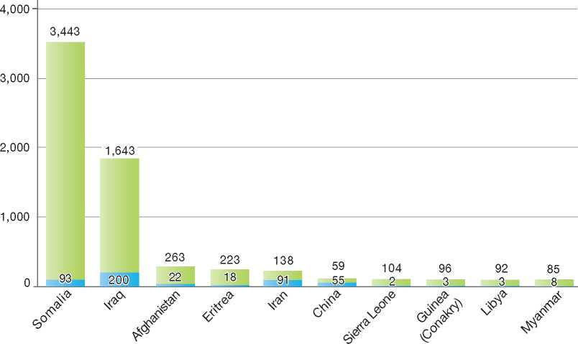

**Total Positive Decisions by Status**

| Geneva Convention Status | | Subsidiary/Complementary Protection and Humanitarian Status

**Figure 6.b: Positive [201] First- and Second-Instance Decisions,Top Countries of Origin in 2010 [202]**

**Rate out of Total Decisions [203]**

|  |  |  |  |  |
| --- | --- | --- | --- | --- |
|  | | **Total Positive** | **Total Decisions** | **Rate** |
| 1 | Somalia | 3,346 | 5,187 | 64.5% |
| 2 | Iraq | 1,191 | 2,221 | 53.6% |
| 3 | Afghanistan | 606 | 1,847 | 32.8% |
| 4 | Iran | 397 | 803 | 49.4% |
| 5 | Eritrea | 298 | 574 | 51.9% |
| 6 | China | 191 | 354 | 54.0% |
| 7 | Myanmar | 149 | 167 | 89.2% |
| 8 | Armenia | 118 | 518 | 22.8% |
| 9 | Sri Lanka | 104 | 229 | 45.4% |
| 10 | Guinea (Co.) | 97 | 274 | 35.4% |

Total Positive Decisions by Status

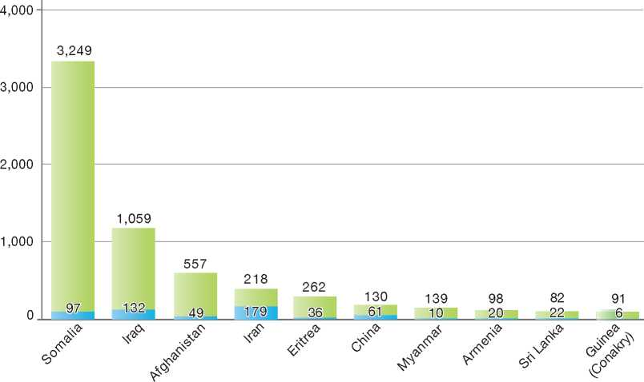

**Total Positive Decisions by Status**

Geneva Convention Status | | Subsidiary/Complementary Protection and Humanitarian Status

**Figure 6.c: Positive [204] First- and Second-Instance Decisions,Top Countries of Origin in 2011 [205]**

**Rate out of Total Decisions [206]**

|  |  |  |  |  |
| --- | --- | --- | --- | --- |
|  | | **Total Positive** | **Total Decisions** | **Rate** |
| 1 | Somalia | 1,673 | 2,623 | 63.8% |
| 2 | Iraq | 1,244 | 2,272 | 54.8% |
| 3 | Afghanistan | 1,056 | 2,509 | 42.1% |
| 4 | Iran | 534 | 1,140 | 46.8% |
| 5 | Eritrea | 431 | 612 | 70.4% |
| 6 | China | 184 | 361 | 51.0% |
| 7 | Myanmar | 138 | 148 | 93.2% |
| 8 | Ethiopia | 121 | 182 | 66.5% |
| 9 | Sri Lanka | 112 | 237 | 47.3% |
| 10 | Sudan | 108 | 225 | 48.0% |

Total Positive Decisions by Status

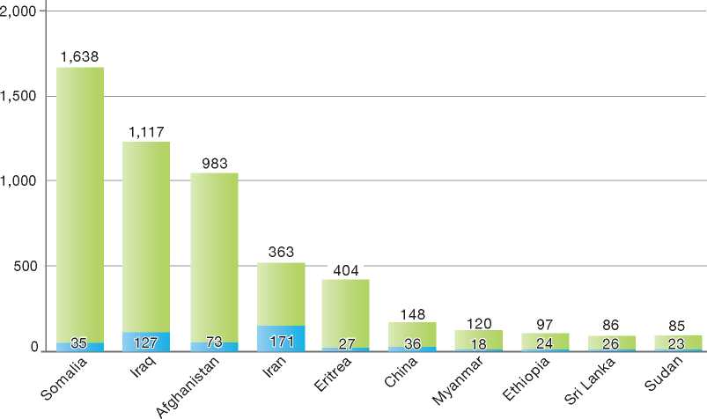

**Total Positive Decisions by Status**

Geneva Convention Status | | Subsidiary/Complementary Protection and Humanitarian Status

1.

2.

3.

4.

5.

6.

7.

8.

9.

10.

11.

12.

New Zealand

BackGRound: MajoR asyluM tRends and developMents 307

national leGal FRaMewoRk 308

institutional FRaMewoRk 309

pRe-entRy MeasuRes 310

asyluM pRoceduRes 311

decision-MakinG and statuses 316

eFFiciency and inteGRity MeasuRes 321

assistance and Reception BeneFits FoR asyluM-seekeRs 323

status and peRMits GRanted outside the asyluM pRoceduRe 324

RetuRn 325

inteGRation 326

annexes

327

1. Background: Major Asylum Trends and Developments

Asylum Applications

In the late 1990s, the number of asylum applications made in New Zealand began to increase significantly compared to previous years. In 1997, for example, over 2,600 claims were received. Numbers peaked in 1998 at over 2,700. However, the number of new applications decreased significantly from 2002 onwards. The average number of asylum claims received from 2007 to 2011 has been just over 300 claims per year.

independent tribunal, the Refugee Status Appeals Authority (RSAA).

The Immigration Amendment Act 1999 incorporated the 1951 Convention relating to the Status of Refugees (1951 Convention) and its 1967 Protocol into the Immigration Act 1987. This law reform gave statutory recognition to the RSAA and created the Refugee Status Officer (RSO) position to decide refugee claims made in New Zealand at the first instance.

Also in 1999, the current policy of granting recognised refugees the right to apply for permanent residence permits was introduced.

Figure 1: Total Asylum Applications by Quarter, January 2007 - June 2012

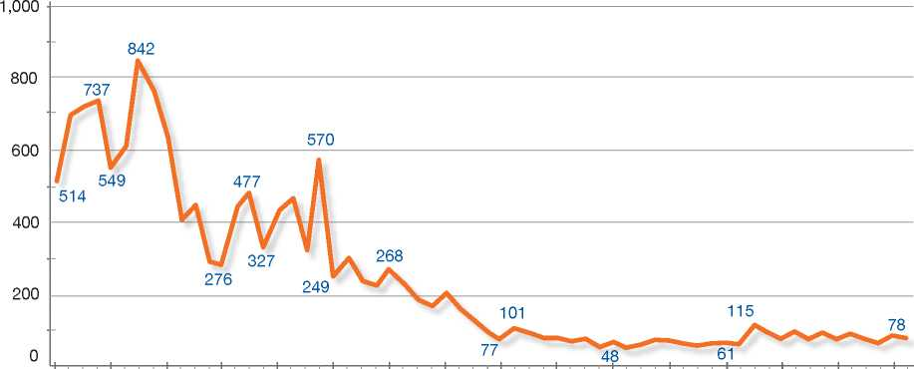

Top Nationalities

In the late 1990s, most claimants came from China, Indonesia, Thailand, and India. From 2000 to 2004, the majority of claimants originated in Thailand, Iran, India and China. From 2004 to 2008, the top claiming nationalities were Iran, Iraq, China and Sri Lanka. From 2009 to 2011, the top claiming nationalities were Fiji, Iran, China and Sri Lanka.

Important Reforms

From the early 1980s, asylum claims were decided by the Interdepartmental Committee on Refugees (ICOR). In 1991, non-statutory terms of reference were issued by the Cabinet to set in place a “two-tiered” determination system. First- instance decisions were made by Immigration Officers, and *de novo* appeals were made to the In 2001, the Mangere Refugee Resettlement Centre (MRRC) began to be used in part as a low-security detention centre for some asylum­seekers. Use of MRRC and remand facilities for higher-security detention remains the exception to the policy of issuing asylum-seekers open work visas that allow freedom of movement, the ability to work or access to unemployment benefit.

Since 2004, RSOs have undertaken a small caseload of refugee status cancellation cases.

The Immigration Act 2009 came into force on 29 November 2010. It contained significant reforms of New Zealand immigration law, including visa, asylum, detention and deportation processes. The Act incorporated a new complementary protection regime, which gave effect to New Zealand's immigration-related obligations under the UN

**Figure 2: Asylum Applications Received from Top 5 Countries of Origin in 2009, 2010 and 2011**

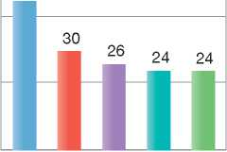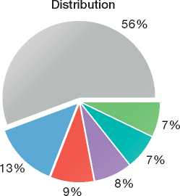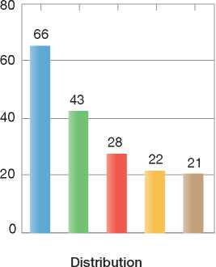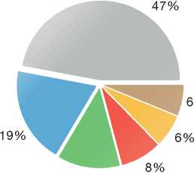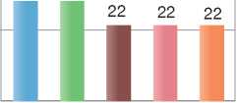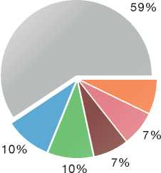

80

60

40

20

0

2009

**Volumes**

45

2011

**Volumes**

2010

Volumes

13%

80

60

40

20

0

29 29

Distribution

|  |  |  |  |  |  |
| --- | --- | --- | --- | --- | --- |
| **Country of Origin:** | | | | | |
| | Bahrain | China | Egypt | Fiji | | India | Iran |
| Iraq | Pakistan | | Sri Lanka | South Africa | Others |  |

Convention against Torture and Other Cruel, Inhuman or Degrading Treatment or Punishment (CAT) and Articles 6 and 7 of the International Covenant on Civil and Political Rights (ICCPR). All first-instance claims to refugee status and complementary protection are now decided by Refugee and Protection Officers (RPOs).

The 2009 Act also created a single immigration appeals body, the Immigration and Protection Tribunal (IPT). The IPT jurisdiction includes that of the previous bodies, the RSAA, the Removal Review Authority, the Deportation Review Tribunal and the Residence Review Board.

1. National Legal Framework
   1. Legal Basis for Granting Protection

The asylum procedures and the competencies of asylum institutions are governed by the Immigration Act 2009, which replaced the Immigration Act 1987 as amended by the Immigration Amendment Act 1999. The Immigration Act 2009 incorporates and codifies the 1951 Convention and its 1967 Protocol.

The Immigration Act 2009 also codifies certain obligations under the CAT and the ICCPR to which New Zealand is a party.

* 1. Recent Reforms

The Immigration Act 2009 introduced a number of changes to immigration matters in New Zealand. With regard to asylum and refugee protection, the main changes are as follows:

* In deciding whether claimants are to be recognised as refugees on the basis of the 1951 Convention and 1967 Protocol, designated case officers also, in a single procedure, determine whether grounds for preventing removal exist under Article 3 of the CAT and Article 7 of the ICCPR. The Bill does not apply the 1951 Convention exclusion clauses to CAT and ICCPR protection but specifies tests similar to Articles 1F and 1E. If a protected person is found to be a person to whom the 1F equivalent test applies, then their final immigration status is determined by the Minister
* A single immigration appeals tribunal, the Immigration and Protection Tribunal (IPT), hears all immigration appeals, including refugee and protection appeals
* Classified security information may be relied on in certain circumstances, including in refugee or protection claims.

The Act does not address the level of economic and social rights that refugees and other protected persons enjoy. There is currently no intention to alter the existing policy of granting permanent residence to a high majority of refugees and protected persons.

In February 2012 the New Zealand Government announced that the Department of Labour, of which Immigration New Zealand (INZ) is a part, would be merged with three other government departments[207] to form a new Ministry of Business, Innovation and Employment. The new ministry came into existence on 1 July 2012.

* 1. Pending Reforms

The Immigration Amendment Bill 2012 was introduced in Parliament on 30 April 2012, passed its first reading on 3 May 2012 and was referred to the Transport and Industrial Relations Committee for consideration. The select committee reported back to the House on 28 August 2012.

The Bill proposes amendments to the Immigration Act 2009 relating to persons who arrive in New Zealand as part of a mass arrival group. The proposed amendments include:

* Defining mass arrival groups as 11 or more persons
* Providing the courts with the ability to issue group warrants for mandatory detention purposes
* The review of the refugee and protection status of persons in a mass arrival after three years prior to a decision on the granting of permanent residency
* The Minister of Immigration will have the ability to suspend the processing of classes of refugee and protection claims
* Restricted family sponsorship rights for persons approved refugee and protection status who arrived as part of a mass arrival.

The Bill also includes some additional amendments, specifically the extension of the jurisdictional bar for subsequent refugee claims to subsequent protection claims, changes to when the IPT may or must provide an oral hearing and changes to the availability of judicial review in matters not yet finally determined by the IPT (See Repeat/ Subsequent Applications below).

1. Institutional Framework
   1. Principal Institutions

Immigration New Zealand (INZ)

Immigration New Zealand (INZ) is a service of the Ministry of Business Innovation and Employment and sits within the Labour Group of the Ministry. The Refugee Division of INZ contains the Refugee Status Branch (RSB), the Country Research Branch (CRB) and the Refugee Quota Branch (RQB). Refugee Division sits within a wider Settlement, Protection and Attraction (SPA) division. Within INZ, amongst other services, there are also the Visa Services and Intelligence, Risk & Integrity divisions.

As noted above, the new Ministry of Business, Innovation and Employment was created on 1 July 2012 when the Department of Labour was merged with other ministries. At this stage no significant structural changes to INZ have resulted from this merger, and INZ has been transferred with its current structure intact into the new ministry.

Refugee and Protection Officers (RPOs) of the RSB decide refugee claims against the 1951 Convention and protection claims against CAT and ICCPR. RPOs do not make decisions on removal, visa matters, or any other decision of a humanitarian nature.

The Refugee Quota Branch facilitates the entry of United Nations High Commissioner for Refugees (UNHCR) mandated “quota” refugees for resettlement in New Zealand and operates New Zealand's low-security detention facilities for detained refugee and protection claimants.

Visa Services staffed by Immigration Officers decides applications for temporary and permanent visas and permits, including applications by recognised refugees for permanent residence permits.

The Intelligence, Risk and Integrity Division (IRID) has, among other things, responsibility for the detention of refugee claimants when appropriate and the removal of failed refugee claimants.

The Immigration and Protection Tribunal

The IPT was set up by the 2009 Immigration Act, and is administered by the Ministry of Justice. It has replaced the four previously existing appeals bodies[208], to streamline the appeals procedure by providing a single hearing on all bases of appeal. However, it issues separate decisions on different classes of appeal.

* 1. Cooperation between Government Authorities

All INZ branches fully cooperate in the provision of relevant information, while decision-making is delegated and isolated to specific areas.

The Intelligence, Risk and Integrity Division works closely with other border security agencies, including the Customs Service and the Ministry for Primary Industries. In relation to detention in penal institutions, the Intelligence, Risk and Integrity Division works with New Zealand Police and the Department of Corrections.

INZ works with the Child, Youth and Family service of the Ministry of Social Development in relation to issues of child welfare, particularly with regard to unaccompanied minors.

1. Pre-entry Measures
   1. Visa Requirements

INZ manages New Zealand's visa system. Transit, temporary entry and resident's visas are the main classes of visa. Certain classes of person are deemed to hold a visa (for example, air crew).

Non-citizens must hold a visa to travel to and remain in New Zealand lawfully. A visa allows a person to travel to or remain in New Zealand, but entry permission may or may not be granted at the time the visa is issued.

On arrival in New Zealand, all non-citizens must present a valid passport, and may be required to provide further proof of the bona fide nature of their purpose for travelling to New Zealand. For example, persons entering on visitor visas may be required to show that they have tickets for onward travel, sponsorship or sufficient funds for living expenses.

* 1. Carrier Sanctions

The Immigration Act 2009 requires that the carrier or the person in charge of any craft en route to New Zealand or that berths, lands or arrives in New Zealand is responsible for ensuring all persons boarding the craft have the appropriate immigration documentation. The Immigration Regulations 2010 (Carrier's Information Obligations) prescribe the immigration documentation, which includes:

* A valid passport or certificate of identity (unless exempt), and
* A visa (if required) or an endorsement indicating New Zealand citizenship.

The check for a visa or endorsement is not required if the carrier or person in charge of a commercial craft obtains the Advance Passenger Processing information (see Interception below) from every person who intends to board the craft for the purpose of travelling to New Zealand and provides that information to the immigration authorities.

A carrier or person in charge of a commercial craft who, without reasonable excuse, fails to ensure that all persons boarding the craft have the appropriate immigration documentation, except where a person is exempt under regulation 11(3) of the Immigration (Visa, Entry Permission, and Related Matters) Regulations 2010 from holding certain documentation, commits an offence and may:

* Incur an infringement fee
* Be prosecuted, or
* Have other action taken against him or her utilising any appropriate enforcement tools in order to encourage compliance.
  1. Interception

Airline Liaison Officers

New Zealand has an Airline Liaison Officer (ALO) programme to assist airlines in meeting carrier requirements under immigration legislation, prior to aircraft departure for New Zealand. ALOs travel to various ports in the Asia-Pacific area.

Advance Passenger Processing System

New Zealand also has Advance Passenger Processing (APP), a system which assesses travel permission electronically. Travel permission, including requirements and authenticity, are checked upon boarding a carrier. If there is a problem with boarding permission, then the passenger and INZ staff may speak by telephone, and the passenger may be denied boarding.

Regional Movement Alert System

New Zealand is part of an APEC (Asia-Pacific Economic Cooperation) initiative known as the Regional Movement Alert System (RMAS). The objective of RMAS is to strengthen the collective capacity of participating APEC economies to detect lost, stolen and otherwise invalid travel documents and to prevent them from being used illegally. The USA, Australia and New Zealand have been participating in this initiative since March 2006.

A key component of RMAS is the RMAS Broker. It acts like a switchboard for routing queries and answers to and from border systems and the passport databases of participating economies. No data is stored in the RMAS Broker, which means that data is accessed and not exchanged, and each economy controls how much information is made available to another economy. This approach also ensures that only the most up-to- date data is accessed.

A vital part of RMAS is the contact between each economy's operational centres (which are open 24 hours a day, seven days a week) in order to clarify details and ensure lawful travellers are not inconvenienced when a participating economy receives a RMAS notification.

1. Asylum Procedures
   1. Application Possibilities and Requirements, Procedures and Legal Remedies

Asylum claims can be made in person or in writing to a police officer or official of the Department of Labour, either at ports of entry after landing, or immediately prior to removal. Departmental officials include Immigration Officers and RPOs, and also officers of New Zealand Customs Service at ports of entry. There is no time limit for making a claim.

Every person, including children, must make a separate claim. However, adults may provide evidence in support of their children's claims.

Access to Information

When a claim is made, the RSB provides the claimant with information, in English, concerning his or her rights and obligations. This information is tailored to persons detained and to those living in the community. An interpreter is available to communicate this information to asylum-seekers in detention. Legal aid may be available for claimants to have a lawyer and an interpreter explain this information to the client.

* + 1. Outside the Country

Applications at Diplomatic Missions

It is not possible to make a claim for asylum in New Zealand at a diplomatic mission abroad.

Resettlement/Quota Refugees

New Zealand accepts UNHCR-referred refugees for resettlement under a resettlement programme that aims to admit approximately 750 UNHCR- mandated refugees and family reunification cases per year.

All submissions for mandated refugee resettlement are made by the UNHCR in accordance with UNHCR resettlement priorities.

The RQB may consider submissions on a dossier basis, but only where a selection mission is not possible or practicable. All other cases are scheduled for interview during an RQB selection mission.

Individual refugees submitted by the UNHCR for resettlement to New Zealand must meet the following criteria:

* They must be recognised by the UNHCR as refugees
* They must be referred for resettlement by the UNHCR in accordance with UNHCR resettlement guidelines and priorities
* They must fall within the regional and global priorities of the Government of New Zealand (with exceptions for emergency and family reunification cases), as set out in the Quota Composition established each year
* They must be assessed as admissible under relevant immigration policy and procedures
* They must be otherwise admissible under New Zealand law.

The reasons an individual may be inadmissible for resettlement to New Zealand include past criminal activity, security, settlement or credibility grounds.

* + 1. At Ports of Entry

The same application procedure applies at airports as at other border posts.

As noted earlier, refugee claims may be made at New Zealand borders to the Police or officials of the Department of Labour. Persons presenting claims to Customs or Police will be referred to INZ Immigration Officers at the border.

Immigration Officers, with the assistance of an interpreter, will interview claimants to determine their means of arrival and identity. The Immigration Officer will also make a decision whether or not to issue a permit or whether it is necessary to place the claimant in detention[209].

From that point, the standard refugee determination procedure is applicable.

* + 1. Inside the Territory

Responsibility for Processing the Claim

New Zealand decides all refugee claims made by eligible persons within her territory (see below on Eligibility). New Zealand does not have in place a process for determining which State may be responsible for examining an asylum claim. However, the Immigration Act 2009 provides for the possibility for an international arrangement with one or more countries on processing refugee claims. If there was such an international arrangement, and the client failed to take an opportunity to make a claim in the relevant signatory state, their claim would not be considered in New Zealand. Section 134(5) of the Immigration Act requires the Minister of Immigration to be satisfied that the relevant signatory state has a satisfactory refugee and complementary protection regime before making an international arrangement or agreement.

Application and Eligibility

A refugee claim is made as soon as a person expresses a wish to seek asylum in New Zealand, either orally or in writing, to a representative of the Department of Labour or to a member of the Police. This application must then be confirmed in writing, by completing a “Confirmation of Claim to Refugee and Protection Status” form.

Eligibility

Any person in New Zealand is entitled to make a claim for asylum except under one of the following circumstances:

* The asylum-seeker is the holder of a residence visa for New Zealand. Present regulations place citizens of Australia in this category
* He or she is a New Zealand citizen
* He or she is exempt from having to hold a visa.

Refusal to Examine Claims

A recent change to the asylum system has incorporated the condition, already developed in case law, whereby if an asylum claim is entered in bad faith, consideration of the claim can be declined. This means that the RPO may refuse to examine a claim if it is manifestly unfounded, clearly abusive, or a repeat of a previous claim. If a claim is declined on these grounds there is no right of appeal to the IPT; however, judicial review may be available.

A refugee claim must also be declined for consideration if the officer is satisfied that the person acted otherwise than in good faith in order to create grounds for recognition as a refugee.

The applicant has a right to appeal this decision before the IPT.

Accelerated Procedures

Procedure for Detained Asylum-Seekers

The Refugee Status Branch prioritises claims made by refugee claimants in detention. RPOs operate to stricter time limits. Otherwise, the processing and determination of these cases do not differ from claims in the normal procedure.

Detained refugee claimants must confirm their claim in writing within five calendar days of signalling their intention to claim. This period of time may be shorter if the claim is a subsequent claim. Although the RPO is not obliged to give a detained refugee claimant an interview, the officer will always endeavour to conduct one. The interview, almost always carried out with the assistance of an interpreter, takes place approximately 20 days after the completed application form is received. The RPO prepares an interview report, and the claimant is given ten working days in which to comment on the report.

If a refugee claim is rejected by the RPO, the decision may be appealed to the IPT within five working days of notification of the decision.

Normal Procedure

In making a claim for asylum, all applicants must confirm their claim in writing by completing the form, “Confirmation of Claim to Refugee and Protection Status in New Zealand”. Refugee and protection claimants must also provide evidence of their identity (including a recent photograph), such as travel documents and a birth certificate, and of their country of origin. If such documents are not available, they must provide a statutory declaration outlining their personal details to the RSB. Applicants may also be required to provide biometric information in the form of fingerprints and a photograph.

The refugee claimant must provide the RPO with all information relevant to his or her claim, including a written statement, ideally at least five working days before the interview. The written statement must include the following elements:

* Any evidence supporting the fact or likelihood of persecution
* If available, documents indicating the alleged agent of persecution or claimed persecution and the reason for that persecution
* Details of persons who may be contacted to support or verify the claim.

The RPO conducts an interview with the asylum­seeker in the presence of his or her legal representative and an independent interpreter. A record of the interview is made in writing and by digital audio recording. The RPO usually completes a summary report of the interview. This report is sent to the claimant or his or her legal representative. The report may also contain prejudicial information or other questions for the claimant to comment on. This report is not a requirement of the process, but is usually used as it assists the claim process by confirming understanding of the claim and ensuring fairness. Classified information may be used in decision­making if a summary of allegations can be provided to the individual concerned. This ensures that the individual is aware of the allegations against him or her and has the opportunity to respond to them.

Following receipt of final submissions from the claimant and his or her counsel, the RPO will make a decision whether or not to recognise Convention refugee status. If the person is not recognised as a refugee, the same RPO will also consider if they qualify for protected person status under CAT or the ICCPR.

Review/Appeal of Asylum Decisions

The Immigration Act 2009 has set up a single Immigration and Protection Tribunal that hears all matters relating to refugee and protection claims, deportations, and appeals. Appeals may be lodged against negative decisions, refusals to consider claims, cancellation and cessation.

Appeals must be made within 10 working days of the decision, or 5 days for detained persons. Leave may be requested to make appeals outside this timeframe, and may be granted if this is warranted by the circumstances. Under this unified system, appellants are no longer able to make more than one appeal to different bodies. Different grounds for appeal must be made together.

Proceedings for appeals relating to refugee and protection status are oral. The IPT conducts a *de novo* enquiry into the merits of the claim. Appeals to the IPT have suspensive effect on removal of the appellant. The IPT process, like that at first instance, is inquisitorial, not adversarial. Any appeal against deportation (or prospective deportation) on humanitarian grounds must be made concurrently with the appeal on refugee or protected person determination.

The Tribunal may uphold or reverse the decision of the Refugee and Protection Officer.

Applications for judicial review of IPT decisions in the High Court must be made within 28 days. Appeals may also be made to the High Court on points of law. On application to the court, leave may be granted to appeal High Court decisions to the Court of Appeal and subsequently the Supreme Court. Appeals to the courts do not automatically have suspensive effect on removal, but a request to that effect may be made by the appellant. Courts have the power to return cases to decision­makers, RPOs or the IPT when a reviewable fault has been found.

Freedom of Movement during the Asylum Procedure

People who enter New Zealand on a visa and then make a refugee claim before they are subject to a deportation order are usually granted a visa to allow them to remain in New Zealand while their claim is being assessed. Visas are less likely to be issued if a subsequent claim is made.

Detention

Refugee and protection claimants who claim at the border and who have not been issued a visa to be in New Zealand may be placed in detention if concerns exist regarding their identity, whether or not their refugee claim is assessed as being made in good faith, and whether or not any risk to national security or public order is identified. These concerns must be balanced against the person's right to freedom of movement, and any issues of well-being related to their individual circumstances (i.e. a person's status as a minor).

Persons detained pending removal from New Zealand may also claim refugee status. This detention is brought about in the course of proceedings to effect their removal, and may persist despite the refugee claim.

Safeguards

Persons subject to immigration detention may be detained for a maximum of 96 hours by a police officer without a warrant. Following this time a court-issued warrant of commitment is required to sustain the detention.

The court, or an Immigration Officer, may decide to release a detainee, keep him or her in detention for up to 28 days, or release the person on reporting conditions.

There is a six-month limit on immigration detention following the final decline of a refugee or protection claim, except for cases in which a foreign national hinders his or her own departure and there are no exceptional circumstances that favour release. This is intended to avoid the use of refusals to cooperate to secure release from immigration detention.

Claimants in detention will be detained in a penal institution, or in a low-security area in which detainees may apply for day release, or in an accommodation centre, at which the claimant is not detained as such but remains on reporting conditions. Most frequent is detention in the low- security centre, with the possibility to move to the open accommodation centre, if the refugee claimant is detained for a significant period and is deemed low-risk.

If the detained asylum-seeker is granted refugee or protection status by the RPO or IPT, INZ-IRID are then notified, and the INZ-IRID arrange for the refugee or protected person to be released from custody.

Reporting

All refugee and protection claimants have an obligation to inform the RPO of their current address. Those residing in the accommodation centre must report on a daily basis to the accommodation centre staff.

Repeat/Subsequent Applications

Subsequent claims for refugee or protection status may be made by a failed asylum-seeker.

To be accepted for consideration by an RPO, a subsequent claim must pass a statutory test. This test is complex and under consideration for review.

Section 140(1) of the Immigration Act currently provides differing jurisdictional criteria for subsequent refugee claims and subsequent complementary protection claims, despite the fact that they are considered together. A subsequent refugee claim (but not a subsequent protection claim) must not be accepted for consideration unless there has been a significant change in circumstances material to the claim since the previous claim was determined. The change in circumstances must not have been brought about by the claimant acting otherwise than in good faith, that is, merely to procure recognition as a refugee in New Zealand.

Refusal to accept a subsequent refugee claim under Section 140(1) may be appealed to the IPT. The subsequent refugee and protectionclaimant must be given the opportunity to attend an interview either at first instance or on appeal. Interviews are usually offered at first instance. If the subsequent claim is accepted for substantive consideration either at first instance or on appeal, then it will be determined whether or not the claimant is a refugee or a protected person.

A subsequent protection claim may only be refused for consideration under Section 140(3), which applies to both subsequent refugee and/or protection claims. Under this Section, subsequent refugee or protection claims that are manifestly unfounded, clearly abusive, or a repetition of a previous claim may not be accepted for consideration by an RPO. A decision to refuse to accept a subsequent claim on this basis cannot be appealed to the IPT. However, judicial review in the ordinary courts may be available.

As a result, it is possible that a set of facts asserted for a subsequent claim may not meet the jurisdictional bar for the subsequent refugee claim but will nevertheless be considered under the complementary protection mechanism. One of the reforms contained in the Immigration Amendment Bill currently being considered is a new Section 140(1) that would make protection claims subject to the same jurisdictional bar as refugee claims.

Legal aid may be available on subsequent claims, provided the claim is not considered to be without prospects of success by the agency that administers legal aid payments[210].

Subsequent claims may be made by anyone eligible to claim, whether in detention or living in the community.

* 1. Safe Country Concepts

New Zealand does not observe any safe country policy and will consider an application for asylum that is made in New Zealand by any non-citizen (see section on Eligibility).

Asylum Claims Made by European Union (EU) Nationals

All claims are dealt with on a case-by-case basis, with no claims to refugee status rejected outright based on country of origin. Membership of all new Member States in the EU is considered to have improved the general human rights situation. In addition, the availability of EU-level protection mechanisms is considered to bolster the level of state protection available to claimants from EU states. However, this has not led to all claims by these nationals being considered unfounded.

* 1. Special Procedures
     1. Unaccompanied Minors

Representative

An Immigration Officer or RPO must designate a responsible adult to act in the best interest of the unaccompanied minor (UAM) claiming refugee status. If no more suitable person is available to act as the responsible adult, a Child, Youth and Family (CYF) social worker may be appointed as the responsible adult.

**Figure 3: Asylum Applications by**

**Unaccompanied Minors**

No data available.

Procedures

UAMs claiming refugee or protection status benefit from the following safeguards during the asylum procedure:

* The designation of a responsible adult and a legal representative who are present during the interview
* A flexible approach to interviews, whereby interviews are scheduled for UAMs who have been assessed by an officer to be sufficiently mature to undergo the interview
* If the minor is under the age of 14, the interview lasts no longer than two hours; for UAMs between 14 and 17 years old, the time limit is three hours.

Age Assessment

If there is doubt as to the age of the UAM, the responsible adult is informed that the UAM may be requested to undergo formal medical age assessment through either a dental examination or an x-ray. The consent of the UAM and his or her responsible adult is required for any medical test.

Family Unity

New Zealand engages the assistance of the International Committee of the Red Cross (ICRC) and any other relevant agency to assist in locating the UAM's family.

Removal

If the UAM's refugee claim fails, then an assessment is made as to whether or not to remove him or her. Efforts will be made to have the child removed in a sensitive manner, making attempts to locate his or her guardian(s) in the home country.

* + 1. Temporary Protection

While it is not New Zealand's policy to provide temporary protection to recognised refugees, a small number of cases have occurred in which identity or criminality issues were not found sufficient to withhold recognition of refugee status but were sufficient to deny a resident's visa. These persons were issued temporary (usually three- year) work permits.

* + 1. Stateless Persons

New Zealand is not a signatory to the 1954 Convention relating to the Status of Stateless Persons. However, the New Zealand Citizenship Act 1977 allows the Minister of Internal Affairs (not the Minister of Immigration) to grant citizenship to a person who is stateless. This is a discretionary power that is rarely exercised.

Also, New Zealand refugee jurisprudence recognises that stateless persons may also be refugees. All other elements of the refugee definition being satisfied, a key consideration is the nexus between the persecution the stateless refugee claimant might suffer and the reasons for that persecution. It is recognised that some, but not all, situations of statelessness occur because of grounds outlined in Article 1(A) of the 1951 Convention.

1. Decision-Making and Status
   1. Inclusion Criteria
      1. Convention Refugee

The Immigration Act 2009 requires that refugee claims are decided in accordance with the 1951 Convention and its 1967 Protocol.

Case Law on Determination Practices

New Zealand's refugee determination case law is most developed at the Refugee Status Appeals Authority (RSAA), with courts having mainly upheld RSAA judgments.

Cases from the late 1980s saw the RSAA and the New Zealand courts interpreting the 1951 Convention seeking assistance from UNHCR publications, especially the Handbook on Procedures and Criteria for Determining Refugee Status, Australian and Canadian jurisprudence, and academic work[211].

With regard to credibility, New Zealand courts have maintained that only the highest standards of fairness suffice in refugee matters[212]. Courts have also directed that while a person claiming refugee status has the burden of establishing the elements of the claim, that rule should not be applied mechanically[213].

A "well-founded fear of being persecuted" is considered to require a "real chance" of serious harm and a failure of state protection. New Zealand has followed the test, as formulated by the High Court of Australia in *Chan v. Minister for Immigration and Ethnic Affairs* (1989) 169 CLR 379[214]. Core norms of international human rights law are used to define the forms of serious harm amounting to persecution[215].

State protection analysis has drawn on the Canadian case of Ward[216] and required that the protection be effective protection that is sufficient to reduce the risk of being persecuted to below that of a real chance.

"Being persecuted" is read as focusing on the consequences to the victim, rather than the state of mind of the agent of persecution. Moreover, that agent need not be a state11. Importantly, there is no requirement for the refugee to avoid the risk of harm where doing so is an exercise of a protected right[217].

The reasons for a person being persecuted need not be solely or mainly Convention grounds (for example, religion) to qualify as Convention-related. The persecution will be "for reasons of" a Convention ground if Convention-related factors are found by the decision-maker to be a "contributing cause" to the claimant's well-founded fear of being persecuted[218].

New Zealand has interpreted "particular social group" using an *ejusdem generis* approach[219]. The meaning assigned to "particular social group" takes into account the underlying themes of respect for human rights and anti-discrimination that underpin international refugee protection[220]. Three possible categories can be identified:

* Groups defined by an innate or unchangeable characteristic
* Groups whose members voluntarily associate for reasons so fundamental to their human dignity that they should not be forced to forsake the association, and
* Groups associated by a former voluntary status, unalterable due to its historical permanence.

The first category includes persons fearing persecution on the basis of gender, linguistic background and sexual orientation, while the second encompasses, for example, human rights activists. The third branch is included more because of historical intentions, although it is also relevant to the anti-discrimination influences, in that one's past is an immutable part of the person5 6 7 8 9 10 [221] 12 13 14 15 [222].

Claims concerning "generalised violence” or civil war were addressed by the RSAA in *Refugee Appeal No. 71462/99* (27 September 1999), where it was noted that equality of risk of harm must not be confused with the equality of reason for that harm. The well-foundedness element (i.e. the risk of persecution) is a separate inquiry to that of the "for reason of” element (i.e. the nexus issue). Assessing the well-foundedness of claims originating in civil war situations involves consideration of two fundamental issues:

* Whether the anticipated state-tolerated harm is of sufficient gravity to constitute persecution
* Whether there is a connection between the risk faced and a Convention reason for the imposition of that harm.

Internal Protection / Flight / Relocation has recently been re-examined by the RSAA. The Canadian approach based in protection was reaffirmed as the preferred New Zealand approach, rather than those of the UK, Australia and the European Union, which were characterised as looking to the question of risk rather than the existence of protection[223].

Regarding claims to refugee status by stateless persons, the New Zealand approach has been that stateless persons may be refugees if they face a well- founded fear of being persecuted for a Convention reason, but are not automatically per se refugees[224]. Turning from the Convention's inclusion clauses, the New Zealand approach to exclusion under Article 1F has been to predominantly follow Canadian approaches, including *Sivakumar, Ramirez,* and *Mugasera.* However, there is no balancing exercise undertaken between the acts committed by the claimant and the threat to their life and security should they return to their home country[225].

Complementary Protection910111213141516171819

The Immigration Act 2009 requires that when a refugee or a protection claim is made, the RPO must decide whether the claimant is a refugee, and if not, whether he or she is a protected person. A protected person is defined as a person for whom there are substantial grounds for believing that he or she would be in danger of being subjected to arbitrary deprivation of life or to torture, cruel, inhuman or degrading treatment or punishment, if deported from New Zealand. This definition aims to adhere closely to the *non-refoulement* obligation contained in the CAT, and Articles 6 and 7 ICCPR. However, section 131 of the Immigration Act 2009 stipulates that the impact on the person due to the inability of a country to provide health or medical care, or health or medical care of a particular type or quality, is not to be treated as arbitrary deprivation of life or cruel, inhumane or degrading treatment.

The IPT have interpreted the Act to mean that if refugee status is recognised, then the attainment of protection status is precluded because the person is no longer at risk of being deported from New Zealand[226].

The IPT have also found that persons at risk of torture, cruel, or inhuman treatment who are unable to access state protection preventing such harm, also face a risk of being persecuted[227]. This implies that protected persons will only be persons who: a) face being persecuted for reasons other than race, religion, nationality, membership of a particular social group or political opinion or

b) for whom there are serious reasons to consider have committed serious non-political crimes.

* 1. The Decision

Following receipt of final submissions from the claimant and his or her counsel, the RSB provides a reasoned written decision to the claimant.

Information on IPT appeal rights is provided by RPOs when claims are declined.

When it is safe and in the public interest to do so, RPO or IPT decisions may be made public. Usually this is by way of anonymised publication for research purposes of IPT decisions.

If an RPO recognises the claimant as a refugee or a protected person, the successful applicant is provided information on applying for residence in New Zealand and other settlement-related information.

* 1. Types of Decisions, Status and Benefits Granted

Decisions

Persons recognised as either refugees or protected persons, whether by an RPO or the IPT, may apply for a permanent resident's visa.

Benefits

Refugees and protected persons are generally granted permanent residence unless the client has committed significant crimes in New Zealand or elsewhere. If the Permanent Residence application is refused, the refugee or protected person is issued temporary visas that allow him or her to remain and work in New Zealand.

Permanent resident's visas allow a person to access a range of rights near equal to those of a citizen. Travel to and from New Zealand does not require further visas; residents may vote in national and general elections; work wherever they like, and so on.

Refugees may apply for a refugee travel document. However, New Zealand passports are only issued to citizens. After five years in New Zealand as a resident visa holder, the person may apply for citizenship.

Recognised refugees and protected persons may apply for accommodation assistance on the same basis as all New Zealanders.

Refugees and protected persons can access health care on the same basis as New Zealand citizens.

Recognised refugees or protected persons may sponsor their spouse and dependent children to come to New Zealand during the course of their resident's visa application. Unaccompanied minor refugees may sponsor their parents. Refugees and protected persons without any immediate family may sponsor more distant family members under the Refugee Family Support Category. This policy uses a ballot system that provides 300 places a year for family members of refugees who are without family other than dependent children in New Zealand.

* 1. Exclusion
     1. Refugee Protection

The exclusion clause is applied in refugee claims and may lead to a claim being declined. RPOs and members of the IPT consider grounds for exclusion provided for in Article 1F of the 1951 Convention in every case in which they are relevant. If a claim is declined by an RSO on the grounds of Article 1F, the appeal to IPT is considered afresh regarding questions of inclusion and exclusion.

* + 1. Complementary Protection

With regard to the consideration of exclusion issues in relation to protection status under CAT and ICCPR, the Immigration Act 2009[228] stipulates that successful protected person claimants must be assessed in relation to a test that is analogous to Article 1F of the Refugee Convention. As the language of the statutory provision is identical to Article 1F and the intent has clearly been to adopt the same test, the same approach is adopted when making the assessment for refugee status.

In cases where the exclusion provisions of Article 1F apply to a protected person, then the person's final immigration status is determined by the Minister of Immigration[229]. The Minister's decision cannot be appealed to the IPT but judicial review is available.

* 1. Cessation

Cessation of refugee and protection status is rarely utilised in New Zealand. The application of cessation is used in exceptional cases due to New Zealand's policy of providing refugees, and now protected persons, access to permanent residence and citizenship to promote settlement in NewZealand. Therefore, while cessation provisions exist in New Zealand law, they have been applied only in a small number of cases.

In order to determine refugee status cessation, an RPO must determine that the refugee no longer requires international protection because of the reasons given in Article 1C of the 1951 Convention. With regard to the cessation of protected person status, the RPO must assess whether there are no longer substantial grounds for believing they will be subjected to torture, cruel, inhuman or degrading treatment or punishment, or to arbitrary deprivation of life should they be deported.

Before reaching such a decision, the RPO must notify the person concerned that the matter is to be considered and provide to him or her information on which he or she intends to base this decision. An interview may be requested by the subject. If cessation is applied, then the decision may be appealed to the IPT.

* 1. Cancellation

The Act specifies two different cancellation procedures based on whether the person has since become a New Zealand citizen and whether they were recognised as a refugee by the IPT or by an RPO.

For non-New Zealand citizens, refugee and protection status may be cancelled by an RPO if the original decision to grant status was made by an RPO or the IPT.

For persons who since their recognition as a refugee became New Zealand citizens, an RPO may only cancel the refugee status of those who were recognised as a refugee by an RPO.

For New Zealand citizens who were recognised as refugees by the IPT (or the RSAA), the RPO must make an application to the IPT. In making an application, the RPO serves on the IPT the evidence, indicating cancellation is appropriate and asking it to reconsider its decision.

All cancellation decisions made by an RPO are appealable to the IPT.

Refugee status cancellation may apply in one of the following cases:

• Refugee and protection status may have been obtained by fraud, forgery, false or misleading representation, or by concealment of relevant information

* In any case where the matters dealt with in Articles 1E or 1F of the 1951 Convention were not properly considered for any reason, including fraud, forgery, false or misleading representation, or by concealment of relevant information
* The person has been convicted of an offence where it is established that they acquired recognition as a refugee or a protected person by fraud, forgery, false or misleading representation, or concealment of relevant information.

On receipt of new information to indicate fraud or such events, an RPO conducts a brief investigation and issues one of the following recommendations:

* Status quo: the evidence is irrelevant, insubstantial or insufficient to cancel refugee status
* Further investigation required: the evidence is compelling but cannot stand alone to cancel refugee status
* Proceed to cancellation: the evidence is strong enough to cancel refugee status.

The recommendation is then considered by the Cancellation Assessment Panel that decides how to proceed on the case. If the decision is to proceed, the RPO sends a Notice of Intended Determination concerning loss of refugee or protected person status, outlining the reasons why the person is being considered for cancellation. The Notice includes copies of the evidence that the RSB holds relevant to the intended cancellation. The respondent has the right to request an interview within 20 days of being notified.

The enquiry into cancellation is a two-stage process, in which it is first determined whether refugee status was procured by fraud and the like, and secondly, whether there is any fresh reason to consider the subject is a refugee or protected person: that is, whether despite the fraud, there is nevertheless reason to consider the person is a refugee or protected person. Thus, the outcome of the case will be one of the following decisions:

* The determination of refugee or protected person status was properly made, and is retained
* The determination of refugee or protected person status was improperly made, but the respondent is nevertheless a refugee or protected person, so his or her status is retained
* Refugee or protected person status was improperly made and the respondent is not a refugee or protected person, so refugee or protected person status is cancelled.

In the last outcome, the decision may be appealed to the IPT.

As noted above, in the case of refugees recognised as such by the Refugee Status Appeals Authority or IPT and who are now New Zealand citizens, the RPO can apply to the IPT to reconsider the decision. In such a case, an RPO serves documentation concerning the matter on the IPT which, provided they believe there is a case to answer, will then notify the “refugee” of the cancellation enquiry. From that stage, the IPT will follow a process in considering whether cancellation is appropriate, similar to that outlined for RPOs. Thus, whether on appeal or by way of application to the IPT, the case is then dealt with in the same two-stage manner as outlined above.

When refugee status is cancelled by the IPT, the person may be subject to removal or may face revocation of visas, including the permanent residence visa, and thus be subject to removal. If the person is a New Zealand citizen, it is possible to remove citizenship if it is established that the citizenship was also procured based on fraudulent information.

1. Support and Tools for Decision-Makers
2. Country of Origin Information

The Country Research Branch (CRB)[230], located within INZ, provides open-source country of origin information (COI) that is used by decision-makers and legal advisers to obtain an understanding of the political, social, cultural, economic and human rights situations in countries of origin. The branch comprises researchers based in Auckland and Wellington.

Auckland researchers mainly focus on refugee status determination. The team provides research for context and specific detail around “well founded fear of persecution”. Domestic violence information requests also come to this team. Auckland core customer groups include the RSB, RQB, the IPT and Visa Officers.

Wellington researchers mainly focus on immigration risk and border security. The team provides research for context and specific detail around “potential harm to New Zealand's international reputation” the Research looks into evidence of war crimes and gross human rights violations. Core customer groups include Risk Assessment Team, Immigration Profiling Branch (IPB) and the Intelligence and Risk Unit.

The branch is also responsible for keeping core customers up to date on country information broadly (for example, providing country presentations to IPB in Wellington, or discussions with RQB staff prior to selection missions in Auckland), but most day-to-day research is in response to specific cases in support of refugee status determination or immigration risk assessments.

In supporting general information needs, the branch produces several current awareness bulletins, and provides seminars to decision­makers and other officials on selected countries or themes as well as on the use of COI resources. Thematic resource guides, country background packs, fact sheets and major COI reports are made available on the Intranet so staff have easy access to the material at all times.

Developments to INZ's COI Service

The CRB was established in 1996 in Auckland as the Nicholson Library to serve the information needs of officials making decisions on asylum claims. In 2005, Wellington-based research roles were created to provide parallel information services to INZ officials making decisions relating to immigration risk, in particular potential risk to New Zealand's international reputation.

From July 2010 to May 2012, CRB was transferred from INZ to the Information Management Division in the Business Services Group. This was part of the Department's Corporate Model initiative, which sought to bring similar functions together and create a whole-of-department approach to research and information services. However, following a review of the Information Management Division, it was decided the CRB should move back to INZ, as it provides a specialist research service (COI research), rather than a general corporate service applicable to wider groups within the Department.

Between 1997 and 2012, the staffing level of the CRB has increased and the nature of research requests made by decision-makers has become increasingly complex. The CRB is committed to the delivery of highest quality research outputs and maintains these through regular review of process and quality assurance practices as well as keeping in close contact with international counterparts.

1. Contacts Abroad

RPOs have access to verification services by contracted agencies, such as IOM, in foreign countries, and, where applicable, they may ask New Zealand government staff in diplomatic embassies or consulates or Immigration branches to provide verification assistance.

In cases where claimants have a travel or immigration history in a third country, RPOs may request that the country provide information on the claimant, particularly in relation to travel, refugee claim information, immigration status or serious criminal information.

New Zealand is also a party to the Five Country Conference (FCC)[231] through which biometric information is shared with partner countries. In the event of a match, RPOs may request immigration-related information on a person from the partner country.

1. Contacts inside New Zealand

If the claimant has been in New Zealand for a significant period of time, the RPO may request information from third parties or other government departments that may be relevant to deciding the claim.

1. Language Analysis

Language analysis has been carried out under contract with an agency, but is very rarely used. The reliability of language analysis has been criticised by the RSAA.

1. Quality Check

All decisions on asylum claims made by the RPO must pass a thorough second-person check, and this can involve assistance to an RPO by a peer or a more experienced RPO on the individual case.

1. Efficiency and Integrity Measures
   1. Technological Tools
      1. Fingerprinting and Biometric Information

RPOs have the power under section 149(1)(e) of the Immigration Act 2009 to require refugee and protection claimants to provide their fingerprints and photograph. Offshore persons seeking resettlement in New Zealand under the UNHCR refugee programme are fingerprinted and photographed with their consent under section 60(1). The RSB and RQB are equipped with electronic biometric enrolment stations for this purpose. All ten fingerprints are taken as plain impressions using “livescan”. Fingerprints can be taken directly by the RPO or by their designated representative. Fingerprints of undocumented border arrivals who claim refugee and protection status at the border are taken by INZ Border Operations using section 111(1). Refugee and protection claimants may refuse to provide biometric information; however, it is open to the RPO to reject the credibility of the claimant with regard to any such refusal.

The collection of biometric information may be used by RPOs to assist in establishing a claimant's identity or nationality. Fingerprints may be checked against the New Zealand Police fingerprint database or that of foreign jurisdictions, particularly the databases of Five Country Conference (FCC) States, with whom Memorandums of Understanding (MoUs) have been signed for the exchange of information. In the event of a match with a partner State, the RPO may request from that State further immigration information relating to the person in question. INZ is also considering the use of fingerprints to check refugee and protection applicants against the Interpol biometric database.

Besides English, INZ provides multi-lingual pamphlets in Farsi, Arabic, Chinese, Tamil, French, Spanish, Samoan, Tongan, Punjabi and Hindi that explain the biometric-information collection process to claimants.

* + 1. DNA Tests

DNA tests are not routinely undertaken, but have been carried out to determine family links, with the refugee and protection claimant's consent. These tests may be requested, but it is not mandatory for asylum-seekers to comply. The testing is carried out by a contracted medical company.

* + 1. Forensic Testing of Documents

RPOs have access to forensic document examination experts within INZ, who will examine documents as required. This service is rarely used as documentation in refugee-producing countries is usually considered to be of limited value given the ease with which fraudulently issued genuine documents may be obtained.

* + 1. Database of Asylum Applications/Applicants

The RSB has an Access database of refugee claimants for case management rather than decision-making. The RSB Access database records procedural and other information related to the refugee claimant or possible cancellation subject. The database supports the RSB information needs of the centralised INZ case management database, known as the Application Management System (AMS).

Currently INZ is working on a new Immigration Global Management System (IGMS) that will replace all current databases across the organisation, principally INZ's current AMS system. It is planned that the new system will be implemented across INZ in stages, with implementation for asylum claims scheduled for 2015.

* 1. Length of Procedures

As noted above, there are no time limits for applications for refugee status at first instance. The appeal timeframe is within 15 days of decline, or 10 days in the case of a detained refugee claimant. However, the IPT may allow an out-of-time appeal if it sees fit to do so.

There is no time limit in law for deciding cases. However, the Department of Labour expects claims to be decided within 20 weeks. The average time from application to decision for 2010 and 2011 was 19 weeks at first instance and 20 weeks on appeal.

* 1. Pending Cases

New Zealand does not have a backlog of cases at present. As of 30 September 2012, there were 104 claims on hand at first instance.

Around the year 2000, there was a significant backlog of cases, such that decision times were approaching three years at first instance. In response to this, claims made before a specified date were backlogged and allocated to a specific team, while newly incoming cases were immediately allocated for determination. Since the backlog has been cleared, claim numbers have remained low.

* 1. Information Sharing

New Zealand currently has an information-sharing agreement in place with the FCC countries. This relates to the matching of biometric information, and in the event of a match the RPO may request immigration-related information from those countries.

Third parties outside New Zealand requesting information must comply with section 305 of the Immigration Act 2009, and if the information concerns a refugee, they must comply with the Act's section 151.

Section 151 allows confidential information regarding a refugee claim to be disclosed for the following reasons:

* To a person necessarily involved in the determination of the relevant refugee claim
* To an officer or employee of a New Zealand government department or Crown agency whose function requires knowledge of the particulars of a refugee claim
* For the purposes of the maintenance of the law, including for the prevention, investigation, and detection of offences in New Zealand or elsewhere
* A representative of the UNHCR.

Information concerning a refugee claim may be disclosed to other persons only if there is no serious possibility that the safety of the person would be endangered. The IPT may publish depersonalised decisions on refugee and protection claims as long as it is published in a manner that is unlikely to allow identification of the person concerned.

* 1. Single Procedure

In the Immigration Act 2009, New Zealand adopted a single procedure for considering refugee and protection claims. Prior to this Act, there had been no formalised procedure for complementary protection. Now asylum-seekers need only to make one application for international protectionand this will automatically be considered under both the 1951 Convention and the complementary protection mechanisms. The RPO, or the IPT on appeal, first considers whether claimants meet the criteria for refugee status before proceeding to consider whether they are eligible for complementary protection. Under New Zealand jurisprudence, if a claimant is recognised as a refugee, this precludes subsequent recognition as a protected person.

1. Assistance and Reception Benefits for Asylum-Seekers
   1. Procedural Support and Safeguards
      1. Legal Assistance and Interpretation Services

Asylum-seekers are entitled to the advice of a lawyer or immigration advisor prior to making a claim, and during the claim's processing.

Independent interpreters are available as needed for interactions between claimants, their legal representatives, RPOs and on appeal. Interpreters are provided and funded by the government agency the claimant is interacting with, be it Immigration, Ministry of Justice or another department.

The Immigration Advisors Act, introduced in 2007, requires immigration advisors who work on behalf of would-be immigrants and refugee claimants to be registered with a regulatory body. The Act also sets out criteria for anyone wishing to practise as an immigration advisor, and stipulates a code of conduct for advisors. An oversight body, the Immigration Advisor's Authority, has been established to investigate and take action on breaches of the advisor's conduct provisions, including banning persons from working as advisors. Lawyers are exempt from the provisions of this Act and their conduct is regulated by their own professional bodies.

In the case of *Legal Services Agency (LSA) v. Hosseini* (CIV 2005-404-743, NZHS 21 February 2006), it was found that legal aid must be made available in refugee status matters. To be eligible for legal aid, the refugee claimant must satisfy national requirements that there be a reasonable prospect of success for his or her case and that he or she has a low annual income.

Legal aid to pay the expenses of a lawyer is available for refugee claims and appeals. Legal aid is provided on the basis of the asylum-seeker's income (it must be below NZD 42,000 annually) and the claim's prospects of success. If the claim is considered by the Ministry of Justice (MoJ) to be unfounded, then legal aid will be denied. This decision is made by the MoJ after receipt of an application for a grant of legal aid by the refugee claimant's lawyer, usually at the beginning of the asylum procedure. Decisions to deny legal aid may be appealed to LSA peer review and to the independent Legal Aid Tribunal.

Legal aid is also available in matters of cancellation of refugee status, subject to the requirements of a prospect of success for the subject, and the financial circumstances test. Other immigration applications are not eligible for legal aid.

* + 1. UNHCR

All refugee claimants are provided the contact details of the UNHCR regional office. UNHCR submissions in refugee cases and deportation are rare. Allowance is made in the Immigration Act 2009 for a UNHCR representative to sit as a member of the IPT in refugee and protection appeals, although this provision has not been utilised since the 1990s.

Quality Assurance

The UNHCR undertakes an annual review of first-instance (RPO) decisions on refugee and protection claims. The UNHCR selects a sample of first-instance RSB decisions to review. The UNHCR then provides written qualitative feedback on the reviewed cases with a view to achieving ongoing systemic improvements in the quality of case processing and decision-making in accordance with UNHCR best practice standards. The UNHCR and the RSB also have annual meetings to facilitate ongoing feedback and discuss any issues. Feedback is predominantly positive.

* + 1. NGOs

Non-governmental organisations (NGOs) in New Zealand working with refugees are engaged with the immigration authorities in a number of fora, providing an avenue for policy consultation and feedback. A range of NGOs receive government funding to provide refugee settlement services and asylum-seeker support services. For example, the Auckland Refugee Council runs an accommodation hostel for asylum-seekers while the Shakti Asian Women's Safe House Inc. provides shelter and support to asylum-seekers and other persons without permanent residence who are victims of domestic violence.

* 1. Reception Benefits

Asylum-seekers who have been placed in a low- security detention (accommodation) centre are not issued visas to remain in New Zealand, and therefore cannot legally work in New Zealand, but have their basic needs met by the accommodation centre and are provided a small weekly allowance.

* + 1. Accommodation

Asylum-seekers who are not subject to detention for the duration of the procedure may make their own arrangements for accommodation. Charitable support is accessed by some asylum-seekers: notably, the Auckland Refugee Council provides accommodation to a small number of refugee claimants and failed asylum-seekers.

* + 1. Social Assistance

Asylum-seekers may apply for unemployment benefits (“income assistance”) on the same basis as permanent residents and citizens, who have work rights but cannot obtain employment.

Refugee claimants detained in the low-security Mangere Refugee Resettlement Centre have their basic needs provided for and receive a weekly stipend depending on their age.

Persons who have claimed refugee status on arrival in New Zealand, and who have been denied a visa but released into the community, are provided a living allowance of NZD 85 per week to cover food and necessities other than accommodation.

Persons who are detained to facilitate their removal from New Zealand, who then claim refugee status and are subsequently released into the community (usually by the courts), are not able to access social assistance payments.

* + 1. Health Care

Refugee and protection claimants have access to New Zealand's full range of health care on the same basis as citizens.

Refugee claimants are encouraged to undertake free health screening at the beginning of the asylum procedure. The screening covers a range of health tests, including tests for general health and communicable diseases.

* + 1. Education

Schooling for any child aged five to 16 is mandatory, regardless of immigration status. Child refugee claimants are thus issued student permits allowing them to attend school.

* + 1. Access to Labour Market

All adult refugee and protection claimants may apply for a work visa while waiting for a decision. If they are unable to find employment, and are otherwise unable to support themselves, they may claim the “income assistance” benefit, as may all New Zealanders who are unemployed.

* + 1. Access to Integration Programmes

Asylum-seekers detained in low-security centres have access to integration or settlement information, English lessons and recreational activities. Once recognised as such, all refugees or protected persons have access to a range of settlement assistance (see Section 11 on Integration below).

* + 1. Access to Benefits by Rejected Asylum-Seekers

Rejected asylum-seekers are unable to access benefits, unless or until their immigration status is regularised by other means. In some cases, based on humanitarian grounds, consideration may be given to grant failed asylum-seekers temporary work visas until such time as the barrier to departure no longer exists. This is based on a case-by-case approach, and rejected asylum­seekers have no entitlement or right to apply for a visa (Immigration Act 2009 section 150).

Failed refugee claimants may have access to government funding for emergency health care services. The children of rejected asylum-seekers who remain in New Zealand are able to attend public schools.

1. Status and Visas Granted Outside the Asylum Procedure
   1. Humanitarian Grounds

Appeals against deportation on humanitarian grounds are considered together with the refugee and protection status appeal. Leave to remain on humanitarian grounds is granted when thereare exceptional circumstances of a humanitarian nature that would make it unjust or unduly harsh for the person to be returned to his or her country of origin. His or her stay in New Zealand may not be contrary to the public interest. Determining whether or not allowing a person to remain is in the public interest generally requires an assessment of the person's criminal history, and as a result, of whether he or she poses a threat to public safety.

Compliance Officers within INZ's Intelligence, Risk and Integrity Division will consider these grounds. In addition, the Minister of Immigration may consider these factors when deciding whether or not to prevent a removal.

If a Compliance Officer considers that there are no “exceptional circumstances of a humanitarian nature”, this matter may be raised in an appeal to the independent Removal Review Authority.

* 1. **Policy Grounds (Bona Fide Migrants)**

While Immigration Officers, including Compliance Officers, may issue a permit to a rejected asylum­seeker, it is not possible for rejected asylum­seekers to apply for a permit. Persons who have not been granted refugee status but who would otherwise qualify for a work or residence permit under current immigration policy (based on qualifications, skills and work experience) may be issued a permit to remain in New Zealand by INZ provided they meet the policy criteria, including character and health requirements[232].

* 1. **Temporary Withholding of Removal/Risk Assessment**

As noted, the assessment of humanitarian leave to remain is a risk-based assessment for both the failed refugee claimant and New Zealand society (public interest test). There may be a stay on removal of nationals from particular states because of generalised violence in those states. The Minister of Immigration and INZ Compliance Officers are guided by UNHCR return advisories in this regard, and a case-by-case decision-making process is applied.

* 1. **Obstacles to Return**

If there are obstacles to return, there will be a case-by-case assessment of whether the person's status should be regularised in New Zealand. There is no policy regarding stateless persons outside of the refugee process. However, as removal may be impossible, regularisation on a case-by-case basis may be considered. The general principle is that persons not entitled to remain in New Zealand have a responsibility to effect their own departure.

* 1. **Temporary Protection**

As noted above, temporary protection may be provided by INZ by way of long-term visas issued to a failed refugee claimant whose removal from New Zealand was stopped by obligations under the CAT.

* 1. **Regularisation of Status over Time**

There is no group-based protection procedure in place, as every case is individually assessed. However, as noted, removal decisions will take into account UNHCR advisories. Temporary protection (stay of removal) may also be extended to groups in cases of natural disasters or other regional catastrophes.

* 1. **Regularisation of Status of Stateless Persons**

As noted above, the New Zealand Citizenship Act 1977 allows the Minister of Internal Affairs (not the Minister of Immigration) to grant citizenship to a person who is stateless. This is a discretionary power that is rarely exercised. Also, New Zealand refugee jurisprudence recognises that stateless persons may also be refugees.

1. Return

The section of INZ's Intelligence, Risk and Integrity Division called Compliance Operations is responsible for the return and removal of failed asylum-seekers.

* 1. **Pre-departure Considerations**

New Zealand's Immigration laws provide for the removal of both failed refugee claimants and refugees on grounds of national security.

* 1. Procedure

The New Zealand procedure for removal includes service of a Deportation Liability Notice on persons liable for deportation, and then service of a Deportation Order to compel deportation. Humanitarian circumstances and circumstances relevant to New Zealand's international and human rights obligations may be raised by the client with a Compliance Officer, who will take such concerns into account when considering whether to cancel the deportation order. Deportation liability may be appealed by some persons on the facts and/or on humanitarian grounds.

* 1. Freedom of Movement/ Detention

Those whose claims have been finally rejected are required to leave New Zealand. In general, voluntary departure is promoted and is achieved with the cooperation of the person. If a person refuses to cooperate, or absconds and is later located, that person may be detained. The courts have determined that indefinite detention is not consistent with New Zealand law. Thus, after a period of some months, a failed claimant who is detained and cannot be removed may be released.

* 1. Readmission Agreements

New Zealand has not signed any readmission agreements with countries of origin or third countries.

before they arrive in New Zealand. They initially undergo a six-week orientation course at the Mangere Refugee Resettlement Centre, following which they have access to work, education, health, benefits and welfare on the same basis as all New Zealanders. They can also access all services offered through the Settlement Division. The Comprehensive Resettlement Plan/Pathways Project was introduced in 2010 and is intended to further aid the integration and employability of resettled refugees.

1. Integration

With approximately one-third of New Zealand citizens born abroad, the New Zealand settlement strategy aims at integrating all newcomers, including refugees, with mainstream services. Immigration New Zealand has a dedicated integration section, called the Settlement Division, the role of which is to assist all newcomers to integrate or settle in New Zealand. Newcomers are defined as those who have been in New Zealand for less than two years. The INZ's Settlement Division funds organisations, both government and private, to assist newcomers to find work, housing, education opportunities, health services and language courses, and to develop their own communities.

UNHCR-mandated refugees brought to New Zealand under its quota programme (resettled refugees) start the integration process earlier. Such refugees apply for and receive residence permits

1. Annexes
   1. **Asylum Procedure Flow Chart**

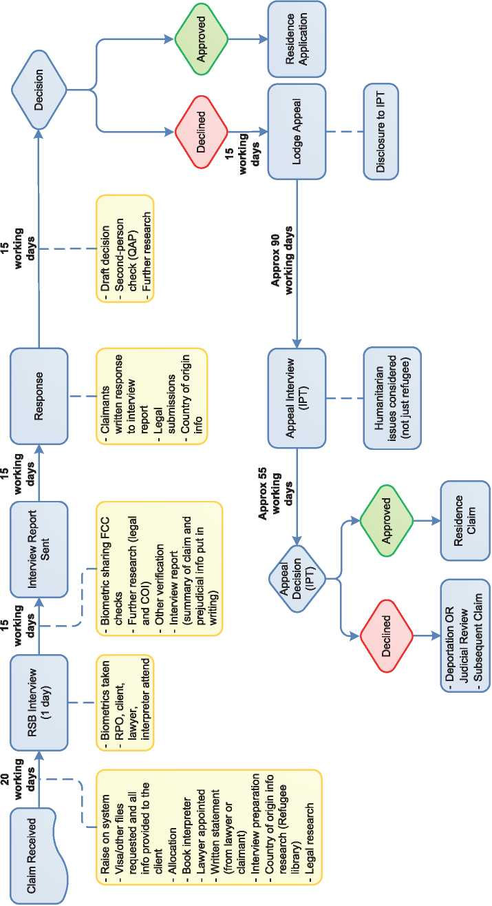

* 1. Additional Statistical Information

Figure 4: Asylum Applications from Top 10 Countries of Origin in 2009, 2010, 2011 and First Half of 2012

**2009 2010 2011 Jan-Jun 2012**

|  |  |  |  |  |  |  |  |  |
| --- | --- | --- | --- | --- | --- | --- | --- | --- |
| **1** | Fiji | 45 | Fiji | 66 | Fiji | 29 | Iran | 25 |
| **2** | Sri Lanka | 30 | Iran | 43 | Iran | 29 | China | 22 |
| **3** | Iraq | 26 | Sri Lanka | 28 | Bahrain | 22 | Fiji | 19 |
| **4** | India | 24 | China | 22 | Egypt | 22 | Pakistan | 15 |
| **5** | Iran | 24 | South Africa | 21 | Pakstan | 22 | Sri Lanka | 8 |
| **6** | Czech Rep | 23 | Saudi Arabia | 16 | China | 20 | Syria | 7 |
| **7** | China | 20 | Czech Rep | 14 | Sri Lanka | 19 | Czech Rep | 6 |
| **8** | Pakistan | 18 | Iraq | 12 | South Africa | 14 | U.A.Emirates | 6 |
| **9** | Slovakia | 13 | Pakistan | 8 | Afghanistan | 11 | Turkey | 5 |
| **10** | South Africa | 9 | Zimbabwe | 8 | Iraq | 11 | Egypt | 4 |

**Figure 5: Decisions Taken at the First Instance in 2009, 2010 and 2011**

|  |  |  |  |  |  |  |  |  |  |
| --- | --- | --- | --- | --- | --- | --- | --- | --- | --- |
|  | **Geneva Convention** | | **Subsidiary/**  **Complementary**  **Protection and Humanitarian Status** | | **Rejections** | | **Withdrawn, Closed, Abandoned Cases** | | **Grand**  **Total** |
| **Number** | **%** | **Number** | **%** | **Number** | **%** | **Number** | **%** |  |
| **2009** | 66 | 23% | 0 | 0% | 219 | 77% | 0 | 0% | **285** |
| **2010** | 72 | 22% | 0 | 0% | 252 | 78% | 0 | 0% | **324** |
| **2011** | 85 | 25% | 0 | 0% | 249 | 75% | 0 | 0% | **334** |

**Figure 6.a: Positive [233] First- and Second-Instance Decisions,Top Countries of Origin in 2009**

**Rate out of Total Decisions [234]**

|  |  |  |  |  |
| --- | --- | --- | --- | --- |
|  | | **Total Positive** | **Total Decisions** | **Rate** |
| **1** | **Iraq** | 15 | 19 | 78.9% |
| **2** | **China** | 14 | 22 | 63.6% |
| **3** | **Sri Lanka** | 13 | 22 | 59.1% |
| **4** | **Iran** | 5 | 26 | 19.2% |
| **5** | **Zimbabwe** | 5 | 6 | 83.3% |
| **6** | **Belarus** | 2 | 2 | 100.0% |
| **7** | **Pakistan** | 2 | 7 | 28.6% |
| **8** | **Russia** | 2 | 2 | 100.0% |
| **9** | **Afghanistan** | 1 | 2 | 50.0% |
| **10** | **Bangladesh** | 1 | 12 | 8.3% |
| **11** | **Eritrea** | 1 | 1 | 100.0% |
| **12** | **Fiji** | 1 | 28 | 3.6% |
| **13** | **Nepal** | 1 | 3 | 33.3% |
| **14** | **Mexico** | 1 | 1 | 100.0% |
| **15** | **Saudi Arabia** | 1 | 4 | 25.0% |
| **16** | **Syria** | 1 | 10 | 10.0% |

Total Positive Decisions by Status

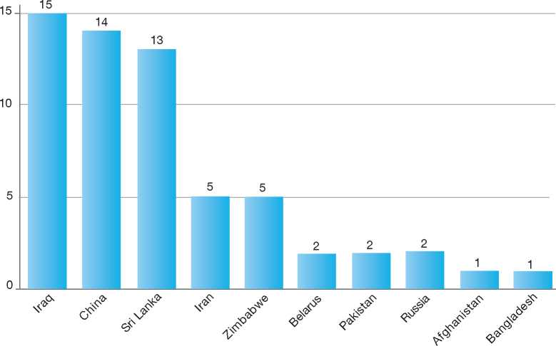

**Total Positive Decisions by Status**

Geneva Convention Status

**Figure 6.b: Positive [235] First- and Second-Instance Decisions,Top Countries of Origin in 2010**

**Rate out of Total Decisions [236]**

|  |  |  |  |  |
| --- | --- | --- | --- | --- |
|  | | **Total Positive** | **Total Decisions** | **Rate** |
| **1** | **Iraq** | 13 | 16 | 81.3% |
| **2** | **China** | 9 | 22 | 40.9% |
| **3** | **Pakistan** | 8 | 17 | 47.1% |
| **4** | **Iran** | 7 | 25 | 28.0% |
| **5** | **Saudi Arabia** | 5 | 10 | 50.0% |
| **6** | **Madagascar** | 4 | 4 | 100.0% |
| **7** | **Sri Lanka** | 4 | 31 | 12.9% |
| **8** | **W. Bank & Gaza S.** | 4 | 5 | 80.0% |
| **9** | **Zimbabwe** | 4 | 6 | 66.7% |
| **10** | **Egypt** | 2 | 10 | 20.0% |
| **11** | **Kuwait** | 2 | 3 | 66.7% |
| **12** | **Lebanon** | 2 | 2 | 100.0% |

Total Positive Decisions by Status

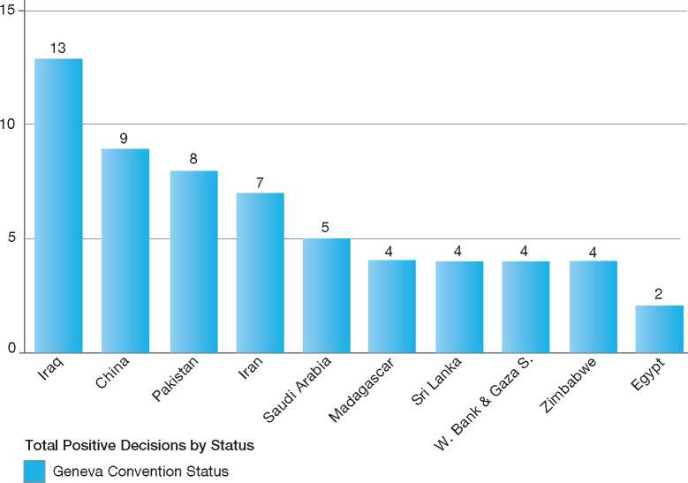

**Figure 6.c: Positive [237] First- and Second-Instance Decisions,Top Countries of Origin in 2011**

**Rate out of Total Decisions [238]**

|  |  |  |  |  |
| --- | --- | --- | --- | --- |
|  | | **Total Positive** | **Total Decisions** | **Rate** |
| **1** | **Bahrain** | 15 | 20 | 75.0% |
| **2** | **China** | 10 | 24 | 41.7% |
| **3** | **Afghanistan** | 8 | 12 | 66.7% |
| **4** | **Iran** | 8 | 45 | 17.8% |
| **5** | **Czech Republic** | 6 | 17 | 35.3% |
| **6** | **Iraq** | 6 | 13 | 46.2% |
| **7** | **El Salvador** | 4 | 4 | 100.0% |
| **8** | **Fiji** | 4 | 27 | 14.8% |
| **9** | **Saudi Arabia** | 3 | 12 | 25.0% |
| **10** | **Sri Lanka** | 3 | 20 | 15.0% |
| **11** | **Kuwait** | 2 | 2 | 100.0% |
| **12** | **Pakistan** | 2 | 14 | 14.3% |
| **13** | **Zimbabwe** | 2 | 8 | 25.0% |

Total Positive Decisions by Status

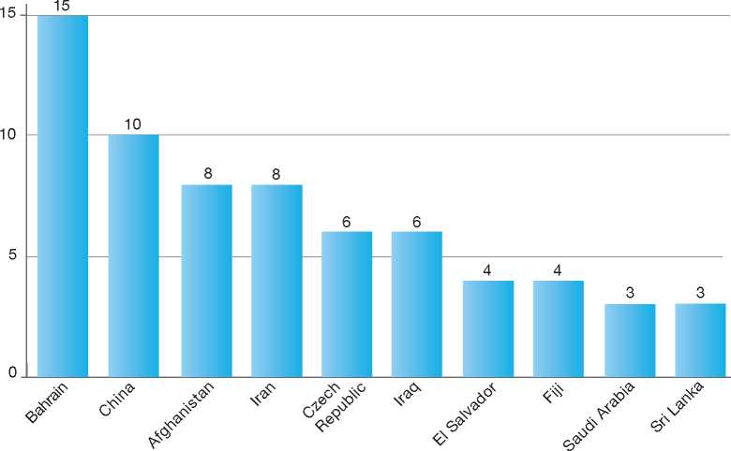

**Total Positive Decisions by Status**

| Geneva Convention Status

1.

2.

3.

4.

5.

6.

7.

8.

9.

10.

11.

12.

Norway

BackGRound: MajoR asyluM tRends and developMents 335

national leGal FRaMewoRk 337

institutional FRaMewoRk 337

pRe-entRy MeasuRes 338

asyluM pRoceduRes 338

decision-MakinG and statuses 345

eFFiciency and inteGRity MeasuRes 348

assistance and Reception BeneFits FoR asyluM-seekeRs 350

status and peRMits GRanted outside the asyluM pRoceduRe 352

RetuRn 352

inteGRation 353

annexes

355

1. Background: Major Asylum Trends and Developments

Asylum Applications

In the early 1980s, asylum applications made in Norway were in the hundreds per year. The numbers started to increase in 1986, reaching a first peak of 12,800 in 1993. Numbers decreased significantly from 1994 to 1997, and increased again in the late 1990s to reach a second peak of 17,500 in 2002. The intake of asylum applications began to decline in 2003, reaching a low of some 5,300 in 2006. In the second half of 2007, the number started to increase, reaching more than 6,500 that year. In 2008 there were 14,431 applications and in 2009 17,226 applications. In 2010, there was a sharp decrease in the number of asylum-seekers, down to 10,064 applicants. In 2011 the numbers decreased even further to 9,053 persons.

Important Reforms

The Act concerning the Entry of Foreign Nationals into the Kingdom of Norway and their Presence in the Realm (Immigration Act of 1988) replaced the Immigration Act of 1956 and established the Norwegian Directorate of Immigration (*Utlendingsdirektoratet*, UDI) on 1 January 1988. This new body represented a reorganisation of responsibility for immigration policy and immigration-related activities.

Prior to the creation of the UDI, responsibility for immigration policy had been spread among several ministries. Since then, the UDI has grown considerably, both in the range of its responsibilities and in the level of human resources. The Directorate took over responsibility for interviewing asylum­seekers in 2000, a task previously performed by the Police. In January 2006, the responsibility for integration and inclusion was assigned to a separate directorate, the Directorate of Integration and Diversity (*Integrerings- og mangfoldsdirektoratet*, IMDi).

Figure 1: Total Asylum Applications by Quarter, January 1992 - June 2012

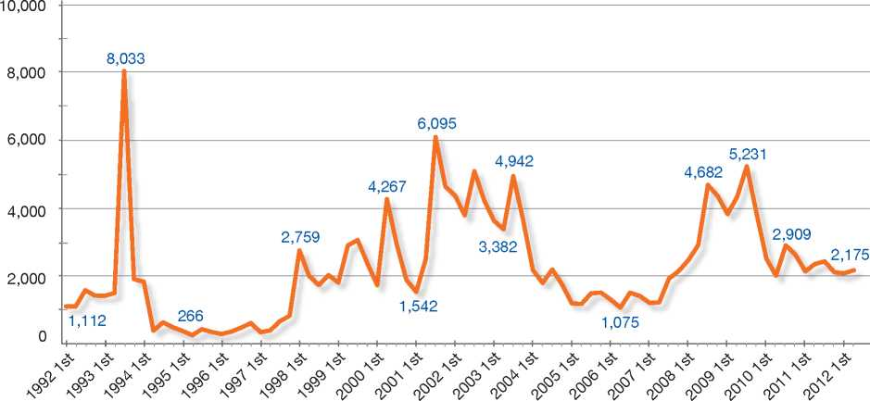

Top Nationalities

In the 1990s, the highest number of applicants came from the former Yugoslavia, Somalia, Sri Lanka, Iran, and Iraq. Since 2000, countries of origin accounting for the greatest number of applicants have included the former Yugoslavia, Iraq, Eritrea, Afghanistan, Somalia, and Russia. The top three countries of origin in 2011 were Somalia, Eritrea and Afghanistan.

Further changes included the transfer of the Migration Department (*Innvandringsavdelingen*) from the Ministry of Labour and Social Inclusion (*Arbeids- og inkluderingsdepartementet*, AID) to the Ministry of Justice and Police in 1 January 2010[239]. The UDI is under the authority of the Ministry of Justice and Public Security since June 2012.

The Norwegian Immigration Appeals Board (*Utlendingsnemnda*, UNE), an independent, quasi­judicial body, was established in 2001 to hear appeals against decisions made by the UDI. Prior to the creation of the Board, the Ministry of Justice was responsible for hearing appeals. convention to which Norway is a party. The most important of these is the European Convention on Human Rights (ECHR). Every person who has the right to international protection in accordance with Norway's international obligations will be granted refugee status and given the rights and benefits

**Figure 2: Asylum Applications Received from Top 5 Countries of Origin in 2009, 2010 and 2011**

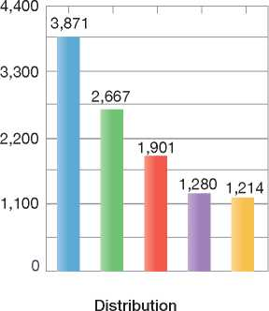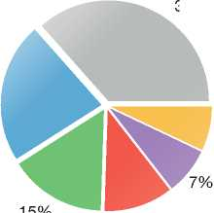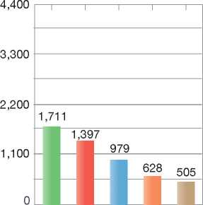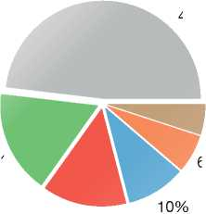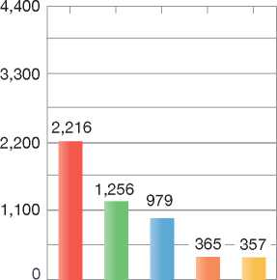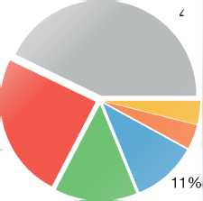

2009

Volumes

37%

22%

7%

11%

2010

Volumes

Distribution

48%

5%

17%

6%

14%

2011

Volumes

Distribution

43%

4%

4%

24%

14%

**Country of Origin:**

J Afghanistan Eritrea | | Ethiopia | | Iraq

| | Russia J Somalia J Stateless | | Others

The Immigration Act of 1988 was replaced by the Immigration Act of 15 May 2008. This Act, as had the previous ones, regulates the entry of foreign nationals into Norway and their right to residence and work. The Act and the corresponding Immigration Regulation came into force on 1 January 2010. There were no significant changes to the Act and the Regulation in 2010 and 2011.

The new Act establishes that the term “refugee” includes persons who meet the criteria in Article 1A of the 1951 Convention relating to the Status of Refugees as well as other applicants covered by the *non-refoulement* provisions of any international corresponding to this status. This also means that more persons have the right to family reunification without the requirement of future income, whereas in the Immigration Act of 1988 this only applied to those falling within the definition of the 1951 Convention. The revised Act also strengthens refugee children's right to family reunification.

The new Act includes clauses directly incorporating the 1951 Convention criteria for refugee status, exclusion from refugee status, and a clause referring to Article 35 of the Convention, thereby formalising the requirement to cooperate with the United Nations High Commissioner for Refugees (UNHCR). The normative weight of UNHCR recommendations has also been emphasised in the Regulations accompanying the Act.

The revised Immigration Act includes a new and stronger provision concerning *pro forma* marriages (marriages of convenience) and the Government has presented several new initiatives to combat forced marriages. In addition, changes regarding removal and expulsion have enhanced the possibility for authorities to react to breaches of the Immigration Act[240]. According to the new Immigration Act, a foreign national should not be able to invoke the extended protection against removal, even if he or she was granted a residence permit at the time the sentence was imposed, if the criminal offence was committed before the permit was granted.

1. National Legal Framework
   1. Legal Basis for Granting Protection

The asylum procedure and the competencies of asylum institutions are governed by the Norwegian Immigration Act of 2008 (and the Immigration Regulations based on the Act). The 1951 Convention (section 16, para.1) and ECHR (section 3) are incorporated in the Immigration Act by reference. An asylum-seeker who does not meet the criteria for asylum may be granted a residence permit on humanitarian grounds.

According to section 3 of the Immigration Act, the Act shall be applied in accordance with the international rules by which Norway is bound, when these are intended to strengthen the position of a foreign national.

* 1. Pending Reforms

There are no important reforms pending.

1. Institutional Framework
   1. Principal Institutions

The Ministry of Justice and Public Security (JD)

The Ministry of Justice and Public Security (*Justis- og Beredskapsdepartementet*, JD) has overall responsibility for refugee and immigration policies. The Migration Department within the Ministry is responsible for formulating and coordinating legislation and policies on immigration, asylum­seekers and refugees. The Ministry supervises the Directorate of Immigration (UDI) and the Norwegian Immigration Appeals Board (UNE) through acts, regulations, budgets and letters of budgetary allocation. The Ministry, however, may not instruct the Board on interpretations of the law, the exercise of discretion or decision-making in individual cases.

The Directorate of Immigration (UDI)

The UDI implements provisions in the Immigration Act by processing applications for various types of residence and work permits, and ensuring that refugees receive protection through the asylum application consideration process. The UDI also gives professional input into the development of policies and regulations. In addition, the UDI is responsible for running the different reception centres for asylum-seekers.

The Norwegian Immigration Appeals Board (UNE)

The Norwegian Immigration Appeals Board (UNE) is an independent, quasi-judicial appeals board that handles appeals of negative decisions made by the Directorate of Immigration (UDI), pursuant to the Immigration Act. A special body within the UNE, a Grand Board, reviews cases on issues of principle, cases with wide-ranging economic and social consequences, as well as cases in which the board's practice varies. Decisions of the Grand Board are precedent-setting for other cases.

Police

The National Police Immigration Service and the 27 police districts are responsible for a range of tasks in the field of immigration, both in asylum cases and in other cases. This includes border control, registration, and identity checks in asylum cases. The Police also handle the removal of asylum­seekers who have had their applications rejected.

The Police report to the Ministry of Justice and Public Security (JD).

The Ministry of Children, Equality and Social Inclusion

The Ministry of Children, Equality and Social Inclusion has responsibility for integration policies. It supervises the Directorate of Integration and Diversity.

The Directorate for Children, Youth and Family Affairs is responsible for the Child Welfare Service, which is responsible for accommodating unaccompanied minor asylum-seekers under the age of 15. The UDI has responsibility for those between the ages of 15 and 18.

The Directorate of Integration and Diversity (IMDi)

The IMDi was established on 1 January 2006 to act as a centre of excellence and a driving force for integration and diversity. The Directorate cooperates with immigrant organisations or groups, municipalities, government agencies, and the private sector. It provides advice and implements government policy. The IMDi's goal is to contribute to equality in living conditions and diversity through employment, integration, and participation.

1. Pre-entry Measures

In order to enter Norway, foreign nationals must have a valid travel document, such as a passport. In addition, some foreign nationals must have a visa issued by Norway or one of the other States parties to the Schengen Agreement.

* 1. Visa Requirements

The Directorate of Immigration (UDI) is the competent authority for issuing visas. However, this authority has been delegated to a majority of Norwegian diplomatic missions. Where there is no Norwegian diplomatic presence in a host country, the authority for issuing visas is delegated to the diplomatic mission of another country. If a diplomatic mission has rejected an application for a visa, the applicant is entitled to appeal the decision to the UDI. If the UDI has rejected the application in the first instance, the decision may be appealed to the Immigration Appeals Board (UNE).

* 1. Carrier Sanctions

Carrier sanctions are applicable to airplanes and ships when crossing the Schengen border. According to the Immigration Act, administrative fines may be imposed on private or public carriers if it is found that they have transported into Norway passengers who are not in possession of a valid travel document.

* 1. Interception

Norway does not engage in interception activities.

1. Asylum Procedures
   1. Application Possibilities and Requirements, Procedures and Legal Remedies

Applications for asylum may be made at airports, at seaports, at the border and in-country at a police station. Applicants at these locations are sent to the National Police Immigration Service (PU) in Oslo for registration. The UDI conducts a short arrival interview regarding the reasons for seeking asylum and schedules the asylum interview. Subsequently, applicants are accommodated at a transit centre.

Persons who are 18 or older must file their own asylum claims, while a parent or an appointed guardian may make a claim for children under the age of 18. A separate claim may be made for a child born to a mother who is awaiting a decision to her own claim for asylum in Norway.

Access to Information

The Police will inform the applicant about his or her rights and duties, the asylum process, and his or her obligation to cooperate with the Norwegian immigration authorities during the procedure.

Applicants are informed that forced marriages are illegal in Norway, while asylum-seekers from certain nationalities are also informed that female genital mutilation (FGM) is illegal and punishable under Norwegian law.

The UDI is responsible for providing additional information while the applicants are accommodated in transit reception centres. The applicants are given information on the asylum process in Norway, their rights and obligations, and the importance of giving complete and correct information to the UDI on their reason(s) for applying for asylum. Furthermore, the applicants are informed of the consequences of the different outcomes, including the right to appeal if the application is rejected and their duty to leave the country after a final rejection. They are also informed of the possibility of benefiting from assisted voluntary return through the International Organization for Migration (IOM), and given information on involuntary (forced) return conducted by the Police.

The UDI has published leaflets in a number of different languages regarding the normal asylum procedure and the accelerated procedures. The UDI has also produced three informational videos in up to 25 different languages: one on the general asylum procedure, one on unaccompanied minors and another on the accelerated 48-hour procedure. Furthermore, leaflets on the Dublin procedure are available in 13 languages, while those on unaccompanied minor asylum-seekers **(**UMAs) have been produced in 14 languages, and the leaflets on the general asylum procedure are available in 25 languages. The Norwegian Organisation for Asylum-Seekers (*Norsk*

*Organisasjon for Asyls0kere,* NOAS), a non­governmental organisation (NGO), is responsible for distributing this information on behalf of the UDI. Representatives from NOAS organise viewings of the films and are available for one- on-one conversations with each applicant in order to provide information tailored to each person, answer any questions they may have, and prepare them for the interview with the UDI.

Representatives of IOM are also present at the transit centre and provide information on assisted return to rejected asylum-seekers who wish to return voluntarily to the country of origin.

* + 1. Outside the Country

Resettlement/Quota Refugees

Norway has in place an annual resettlement programme. The Ministry of Justice and Public Security allocates the annual quota taking into account the advice of the UNHCR and Norwegian government agencies, notably the Ministry of Foreign Affairs, the Norwegian Directorate of Immigration (UDI), the Ministry of Children, Equality and Social Inclusion, and the Directorate of Integration and Diversity (IMDi). The UDI is responsible for the selection of refugees for resettlement. The decision is not subject to appeal. IMDi is responsible for the placement and integration of resettled refugees.

The size of the quota has been 1,200 places during the last few years. In 2012, the resettlement quota was increased by 250 places as a direct result of the crisis in Libya.

Resettlement selection is made on a dossier basis and through selection missions. An entry visa and a residence or work permit are issued prior to departure for Norway. In dossier cases, status determination is made following entry. In the case of selections made following a selection mission, determination is made prior to arrival.

The following considerations are applied to the decisions:

* The need for international protection
* The need for resettlement. Prospects for other durable solutions are also considered both in the short-term as well as in the long-term perspective
* Norway gives priority to women-at-risk cases. A substantial proportion of available resettlement places is reserved for women and girls
* Persons of known criminal behaviour or heavy drug users will, as a rule, not be offered resettlement in Norway
* Persons to whom the exclusion clauses of the 1951 Convention apply shall, as a rule, not be offered resettlement in Norway
* Norway will not accept persons who may constitute a threat to national security
* The capacity of settlement services to cater to resettled refugees with special needs.

Resettlement allocations also include sub-quotas. Norway has 20 places available each year for medical cases. Norway applies exactly the same criteria as those outlined under section 4.1.1 of the UNHCR Resettlement Handbook[241] when assessing the severity of the health condition and possible improvement after resettlement.

The yearly quota for cases with emergency priority has varied between 75 and 80 places between 2008 and 2011. Such cases are to be processed within 48 hours. Furthermore, the sub-quota for unallocated places has been 175 since 2009.

* + 1. At Ports of Entry

Persons arriving at a border post who wish to make a claim for asylum are usually directed to the National Police Immigration Service (PU) in Oslo. When an asylum application is submitted to the PU, the PU registers the application and conducts a short interview with the applicant. The aim of the interview is to establish the person's family background, including whether he or she has any relatives or friends in Norway, and the travel route to Norway. UDI caseworkers conduct an arrival interview regarding the reasons for seeking asylum. If the applicant is judged to be 14 years of age or older, the Police take the applicant's fingerprints, which are registered and checked in EURODAC, and try to obtain any other information regarding ties to states parties to the Dublin II Regulation.

* + 1. Inside the Territory

Responsibility for Processing the Claim

The Dublin System

*Application and Procedure*

Norway applies Council Regulation (EC) No. 343/2003[242] in cases where asylum-seekers first submitted their application or were granted a residence permit or a Schengen visa by a State party to the Dublin II Regulation.

When an asylum application is submitted to the National Police Immigration Service (PU), the PU registers the application and takes the applicant's fingerprints, which are registered and checked in EURODAC, and obtains any other information regarding any ties the asylum-seeker may have to States party to the Dublin II Regulation.

The case is then sent to the Directorate of Immigration (UDI), which decides whether Norway or another State is responsible for processing the asylum application, pursuant to the Dublin II Regulation and national legislation.

If the UDI determines that another State is responsible for the application, it rejects the asylum application and the applicant must leave Norway. When the application is rejected, legal counsel is appointed for the applicant if he or she is not already represented. The applicant may appeal the decision within three weeks of notification, and may submit a petition for suspensive effect within 48 hours of the decision being served. PU gives the applicant a *laissez-passer* travel document and arranges for the applicant to be transferred to the responsible State.

*Freedom of Movement/Detention*

Asylum-seekers whose applications fall under the Dublin II Regulation may, as a rule, decide whether they wish to stay at an asylum reception centre or at a private address while the UDI processes their case.

It is the applicant's duty to be available at the registered address. If the applicants are staying at an asylum reception centre, they must give notice of where they will be staying if they are to be away for more than three days. There are otherwise no limitations on applicants' freedom of movement.

Detention may be implemented in the following cases:

* The applicant refuses to state his or her identity or there are reasonable grounds for suspecting that the person has given a false identity. This applies to applicants who, for example, present a false passport or if, during registration, are found to have tampered with their fingerprints. The detention period cannot exceed 12 weeks, except on special grounds
* The person has evaded the implementation of the Dublin II Regulation decision, and detention is necessary in order to secure implementation. In such cases, the detention period may last up to two weeks. Detention may be extended only twice, which means a maximum period of six weeks' detention.

As a rule, persons detained on these grounds are placed in an immigrant detention centre.

*Suspension of Dublin Transfers*

The Directorate receives and processes petitions for suspensive effect. The main rule for Dublin cases is that suspensive effect is not granted. A petition for suspensive effect may be granted by the Appeals Board (UNE) in special cases, particularly when the applicant is able to show that he or she is unfit for travel.

At times, Norway has refrained from transferring certain vulnerable groups from individual countries, on the basis of a concrete evaluation of the circumstances. Furthermore, transfers may be postponed or stopped if there is information that suggests that the applicant will be subject to *refoulement* if he or she is returned to the responsible State.

Dublin transfers to Greece are currently suspended, and these cases are being processed in Norway.

*Review/Appeal*

When the UDI has decided to transfer an applicant to the responsible State, the applicant has the right to appeal within three weeks of the decision. The UDI prepares the appeal before it is forwarded to the Immigration Appeals Board.

Application and Admissibility

When registering an application for asylum, the Police must determine whether the application fulfils the criteria for the normal procedure, the Dublin procedure or the accelerated procedures (the three-week procedure and the 48-hour procedure).

All applications, with the exception of those which are processed under the accelerated procedures, are then considered by the Directorate's Dublin unit. The remaining applications are sent to the coordination unit for determining whether the application will be processed under the three- week procedure, before being distributed to the responsible country unit.

Applications made by persons with a criminal record, repeat applications made within a year of a final rejection, and applications presented in order to delay the enforcement of an earlier or pending decision that would result in removal are transferred to an accelerated procedure. During this procedure, the UDI considers information given to the Police during an extended registration process.

Accelerated Procedures

Forty-Eight-Hour Procedure

On 1 January 2004, Norway introduced the 48­hour procedure.

The Directorate has developed a list of countries[243] for which the Directorate has sufficient information on the general security and human rights situation and from which the majority of applications have often been found to be manifestly unfounded. An asylum-seeker from one of these countries will initially have his or her application processed on its individual merits under the 48-hour procedure. Following an examination of the claim, those applications that are not found to be manifestly unfounded will be removed from the 48-hour procedure. The list of countries to which the 48­hour procedure applies is reviewed and updated on a regular basis.

Applicants in this procedure are accommodated at a transit reception centre in the Oslo area while awaiting removal.

Three-Week Procedure

The three-week procedure was introduced in June 2005. Under this procedure, the UDI processes the applications within three weeks of their registration by the Police.

Asylum applications are processed under the three-week procedure if the applicant hails from one of the following countries: Armenia, Bangladesh, Belarus, Georgia, India, Kosovo (minorities excepted), Nepal and Russia (ethnic Russians). These are countries from which the UDI rejects a high number of applications. Information on the security and human rights situation in these countries of origin is considered to be thorough, and little or no further investigation or verification is required following the interview.

There is also an accelerated procedure for asylum­seekers with a criminal record, who are not in need of protection and who can be returned to the country of origin.

Appeals

Asylum-seekers whose claims are rejected under the accelerated procedure may make an appeal before the Immigration Appeals Board (UNE). A petition for suspensive effect may be granted, except where the claim for protection was considered by the UDI to be manifestly unfounded. When a case is processed within the 48-hour procedure, the asylum-seeker must submit a petition for suspensive effect within three hours of notification of the UDI decision.

Cases processed within the three-week procedure shall be given priority in appeal.

Normal Procedure

After the asylum-seeker has been registered with the Police and had a short interview with a UDI caseworker regarding the reasons for seeking asylum, he or she is sent to a transit reception centre.

Interviews are held on UDI premises or at the transit reception centre. Unaccompanied minor asylum-seekers can be interviewed at a care centre for children. The interviews are conducted by specially trained UDI asylum caseworkers. The information is recorded in writing, and the transcript of the interview is read to the applicant. After the interview has been conducted, the asylum-seeker is moved to a reception centre while the case is being processed.

Children have the right to be heard. Usually, the caseworker has a short interview with the child in the presence of one or both parents, although children may be also be heard without parental consent in order to assess whether they have independent protection needs.

Following the interview, caseworkers assess the merits of the claim in order to come to a decision. The following aspects of the case are examined in particular:

* Information obtained during the asylum interview, from the registration form completed with the Police and from the arrival interview conducted by the UDI caseworker
* Any language tests, age examinations and other checks (such as enquiries made to diplomatic missions abroad)
* Any other information provided by an organisation, the applicant or a representative of the applicant (including a legal representative, if one has been appointed).

Review/Appeal of Asylum Decisions

Immigration Appeals Board

An asylum-seeker whose claim is rejected by the Directorate of Immigration is assigned a legal representative and given the option of appealing the decision before the Immigration Appeals Board (UNE) within three weeks of notification of the decision. The asylum-seeker may apply for an extension on the time limit for making an appeal by stating the reasons for such an extension. The asylum-seeker also has the option of making a request to re-open the claim, if the deadline for appeal has passed.

The appeal is first processed by the UDI to determine whether there are any new elements in the case. If the UDI does not amend its original decision, the appeal is forwarded to the UNE. The appeal has suspensive effect unless the case was found by the UDI to be manifestly unfounded.

Appeals may be decided either according to a paper-based process (i.e. without a hearing) or following a hearing held with the appellant and his or her legal representative, or following an *ad hoc* hearing without the appellant present.

The UNE hearings are chaired by a board leader who is assisted by two lay board members. The Board leaders are usually qualified magistrates. Cases submitted to the hearing process are decided by a majority vote.

Decisions made in individual cases cannot be reversed by the Ministry, the Government or UNE's administration but may be appealed through the regular judicial system.

The Grand Board

A Grand Board located within the UNE may review cases that involve issues of principle, cases with wide-ranging economic and social consequences, and cases in which the UNE's practice has been found to vary. Three board leaders and four lay board members sit on the Grand Board.

Decisions of the Grand Board are precedent­setting.

Freedom of Movement during the Asylum Procedure

Detention

Section 106 (1) of the Immigration Act provides that an asylum-seeker may be detained by the Police at the border if, upon arrival, he or she refuses to state his or her identity or there are reasonable grounds to suspect that he or she has given a false identity. The detention period cannot exceed twelve weeks, except on special grounds. Detained asylum-seekers are held in an immigration detention centre or regular prisons. According to section 106 of the Immigration Act, detention may also be enforced if deemed necessary to ensure implementation of a final negative decision on an asylum claim.

Reporting

Asylum-seekers are obliged to report their whereabouts to the Police, who will register a new address in the immigration authorities' data system. If an asylum-seeker is absent from the reception centre for more than three days without notice, he or she will be registered as having moved to an unknown address.

The Police may also, as a substitute to detention, decide that an asylum-seeker must report to them on a regular basis6.

Repeat/Subsequent Applications

A repeat asylum application may be made if the asylum-seeker provides the authorities with new information that he or she believes may affect the outcome of the asylum claim. The UNE decides whether the applicant will be allowed to remain in the country while his or her application is being processed.

If a person re-applies after receiving a final rejection on an initial claim, the UNE is responsible for processing the claim. However, if the applicant has been in the country of origin or outside Norway before re-applying, the UDI will process the application, and the applicant has the right to appeal the UDI's decision to the UNE.

* 1. Safe Country Concepts

Apart from implementing the Dublin II Regulation and applying accelerated procedures for asylum claims from specific countries of origin[244], Norway does not have safe country policies in place.

* 1. Special Procedures
     1. Unaccompanied Minors

A special unit at the UDI handles applications made by unaccompanied minor asylum-seekers (UMAs). The caseworkers in this unit are specially trained to interview UMAs and to assess their applications.

There is no minimum age for a person to seek asylum in Norway. Those claiming to be UMAs are registered by the Police and placed under the care of the State Child Welfare programme, if they are under 15 years of age. Minors of that age group are accommodated in a centre run by specially trained staff. Those aged between 15 and 18 are offered accommodation in separate reception centres while the asylum claim is being processed.

Upon arrival, all minors are assigned a guardian who provides assistance during the asylum procedure. The minor applicant is also given the assistance of a lawyer free of charge.

Age Assessment

Age assessment in the form of dental and wrist x-rays is carried out if there is doubt about the stated age of a minor. Staff at reception centres, guardians, a lawyer, and teachers may also be asked to provide an opinion on the age of the minor.

Age assessment is voluntary and will not be carried out unless the asylum-seeker confirms in writing that he or she agrees to take the test. Consent for age testing is obtained during the arrival interview, and the regular interview is not conducted until the results of the age assessment are clear.

6 Section 105 of the Immigration Act.

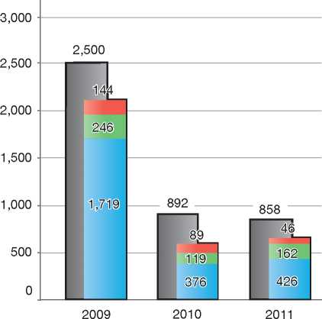

| **Figure 3: Asylum Applications by Unaccompanied Minors in 2009, 2010 and 2011** | | | |
| --- | --- | --- | --- |
|  | **2009** | **2010** | **2011** |
| Total Asylum Applications | 17,226 | 10,064 | 9,053 |
| of which Unaccompanied Minors | 2,500 | 892 | 858 |
| Percentage | 15% | 9% | 9% |

Country of Origin:

J Afghanistan Eritrea J Somalia

* + 1. Collective Protection

Collective protection may be granted in cases of mass influx of displaced persons as a result of conflict. According to provisions in the law, the Government may decide if and when to grant protection to a specific group and when this protection will cease to apply.

A foreign national who is already in Norway may make an application to be granted protection on a group (collective) basis if he or she is affected by the group designation. Persons granted protection on this basis are entitled to a residence or work permit, which does not lead to permanent residence.

The permit may be renewed or extended for a period not exceeding three years from the date the applicant received a permit for the first time. Thereafter, a new permit may be granted that may constitute a basis for permanent residence (a settlement permit). A settlement permit may be granted one year following the renewal of the protection-based permit, provided that the conditions that led to the grant of the permit remain applicable.

Any application for asylum made by a person who has subsequently been granted a permit under collective protection may be suspended for a period not exceeding three years from the date the applicant received a permit for the first time. When the application of group protection has ceased, or a period of three years has elapsed since the applicant received a permit for the first time, the person must inform the authorities whether he or she wishes to pursue the asylum claim. Any decision to grant a permit and to suspend an application for asylum is made by the Directorate of Immigration, which may also delegate these tasks to the Police.

* + 1. Temporary Protection

Under the single asylum procedure, the UDI may grant temporary protection to persons who do not meet the criteria for Convention status or protection against *refoulement* but who have other compelling reasons to be granted a permit. Depending on the circumstances of the case, the permit granted may be issued with or without possibilities of renewal, family reunification or permanent residence (settlement).

Persons who are granted temporary protection are entitled to the same rights and benefits as those who are granted ordinary permits, but they are not eligible for the integration programme. The length of stay will correspond to the period of need, the minimum length usually being six months.

* + 1. Stateless Persons

Asylum applications made by stateless persons are considered in the same manner as all other asylum applications. The only unique consideration made is an assessment of whether the status of statelessness gives rise to humanitarian considerations, if the person is found to not be in need of international protection. Persons who have no rights of residence in their host country and therefore are stateless in the true meaning of the word, and who cannot be returned to the host country, will be given a residence permit based on humanitarian grounds by the UDI[245].

1. Decision-Making and Status
   1. Inclusion Criteria

Under the single procedure, the UDI will first consider whether a person meets criteria for Convention refugee status, then for protection against *refoulement*, and finally for a permit on humanitarian grounds[246].

* + 1. Convention Refugee Status

According to Section 28 a of the Immigration Act, Convention refugee status is granted if the following conditions are met:

* The cause of persecution is connected to one of the grounds set out in Article 1A(2) of the 1951 Convention
* The persecution is of an individual nature
* Fear of persecution is the reason the applicant does not wish to return to his or her country of origin.

Gender-based persecution and persecution due to sexual orientation may also provide grounds for asylum.

* + 1. Protection against Refoulement

According to section 28b of the new Immigration Act, a person entitled to international protection based on the provisions of any international agreement to which Norway is a party, will be covered by the definition of “refugee” and will be granted all corresponding rights and benefits.

In other words, even if an applicant does not meet the inclusion criteria for Convention refugee status, he or she will be granted a residence permit on protection grounds and will be recognised as a refugee, if there is a risk of torture or other inhuman or degrading treatment or a situation of general unrest that may lead to life-threatening danger if he or she is returned to the country of origin.

* + 1. Humanitarian Status

Section 38 of the Immigration Act states that, if a person does not meet the criteria for Convention refugee status or another form of protection, decision­makers must determine whether the asylum-seeker may be granted a permit on humanitarian grounds. Examples of circumstances that may lead to a humanitarian status are: unaccompanied minors without proper care if returned; the existence of compelling health circumstances; social or humanitarian circumstances relating to return; and victims of human trafficking.

In cases concerning children, fundamental consideration is given to the best interests of the child. Children may be granted a residence permit even if the situation is not so serious that a residence permit would have been granted to an adult in the same situation.

According to the Immigration Act, importance may be attached to considerations relating to immigration control when assessing whether or not to grant a permit. These considerations include:

* Possible consequences for the number of applications based on similar grounds
* Social consequences
* The need for control, and
* Respect for other provisions in the law.

When there is doubt regarding the identity of the foreign national, when the need is temporary, or when other particular grounds so dictate, it may be determined that:

* The permit shall not provide the basis for a permanent residence permit
* The permit shall not provide the basis for residence permits pursuant to chapter 6 of the Act for the foreign national's family members
* The permit may not be renewed, or
* The validity period of the permit shall be shorter than one year.
  1. The Decision

The UDI caseworker, after having considered all information pertinent to the asylum claim, presents a proposal for a decision to a senior caseworker. Both caseworkers then sign the decision.

Decisions (positive or negative) are always given in writing. Negative decisions are sent to an appointed lawyer, who will inform the applicant. If the decision is positive, the UDI sends the decision to the Police, who will inform the applicant in writing. Negative decisions are reasoned.

Quality Assurance at the UDI

Apart from almost full supervision of all draft decisions by a senior caseworker, annual quality checks of each caseworker are carried out by the Head of Unit, based on one or two decisions selected at random.

The UDI conducts one more annual quality check: 25 samples from two or three caseloads (for instance asylum decisions concerning Somali asylum seekers) are selected randomly and checked against quality standards by specially trained senior caseworkers. If there are serious deviations from UDI standards, 15 additional samples are checked.

* 1. Types of Decisions, Status and Benefits Granted

The UDI may make the following types of decisions:

* Grant Convention refugee status
* Grant refugee status - protection against *refoulement*
* Grant humanitarian status
* Grant limited residence permit to unaccompanied asylum-seeking minors aged 16 or older due to the lack of proper care if returned
* Grant a residence permit according to the 15-month rule. This applies when the asylum claim has been in the procedure for more than 15 months, the applicant is not to blame for the delay, and the identity of the applicant was established at an early stage in the procedure
* Grant a temporary permit for medical reasons or on humanitarian grounds in the absence of an established identity
* Reject a claim that is not manifestly unfounded
* Reject a manifestly unfounded claim.

Benefits

Beneficiaries of refugee status are entitled to the following:

* A provisional residence permit, usually valid for three years, and with the right of renewal. The person is entitled to apply for a permanent residence permit after three years
* Right to work
* Right to family reunification, usually for a spouse or co-habitant (over the age of 18) and/or children under the age of 18 without a spouse or co-habitant. If the family was established before the refugee applied for asylum in Norway, the ability to provide economic support for his or her family is not a criterion
* Social benefits: refugees are entitled to health care, child benefits and education.

Beneficiaries of collective protection are entitled to the following:

* A provisional residence permit
* Right to work
* Some social benefits
* Right to education

Beneficiaries of suspension of removal have the right to work during the period of suspension, if the conditions for this are fulfilled.

* 1. Exclusion

A provision on exclusion is incorporated in section 31 of the Immigration Act. Exclusion may be applied both to refugees and to beneficiaries of subsidiary protection. Exclusion does not, as such, apply to leave to remain on humanitarian grounds, but in these cases the excludable act will be weighed against humanitarian considerations. The grounds for exclusion are those laid down in Article 1F of the 1951 Convention.

In addition to the exclusion grounds prescribed in the 1951 Convention, exclusion may also apply to a person eligible for protection status based on the *non-refoulement* obligations under Article 3 of the ECHR (subsidiary protection), if there are grounds to believe that the person constitutes a threat to national security.

Excluded persons may be granted a six-month residence permit if they cannot be returned to the country of origin. This permit does not allow for travel documents, family reunification or permanent status.

The UDI considers Article 1F of the 1951 Convention when examining an asylum claim and has a special unit responsible for assessing exclusion cases.

If an asylum-seeker has been excluded, he or she has the right to lodge an appeal within three weeks of notification of the decision. If the UDI does not amend the decision before the case proceeds to appeal, the UNE has the authority to confirm, change or annul the decision. A person who has been excluded also has the right to ask the determining body to review its decision, if the right to appeal is no longer possible. However, the determining body is not required to consider the request.

According to its obligations under the ECHR and CAT, Norway does not forcibly return excluded persons if this would constitute a breach of the *non-refoulement* principle.

An excluded person is not entitled to a residence permit, but may be granted a special residence permit, as stipulated above. The applicant may re­apply for a similar permit as long as international obligations under the ECHR and CAT pose an obstacle to return.

* 1. Cessation

The cessation clauses of the 1951 Convention are applied in individual cases of expulsion and revocation of status, as well as when circumstances have changed before asylum applications have been decided. Article 1C of the Convention is incorporated in section 37 of the Immigration Act.

The cessation clauses do not apply to subsidiary protection under current Norwegian legislation.

Cessation considerations may be triggered in such instances as when the Police forward to the UDI information concerning trips taken by refugees to their country of origin or when information comes to light during applications for permit renewals.

Each case is considered individually and no concept of automatic cessation is applied. The main rule, however, is that return to the country of origin is seen as grounds for cessation, and the refugee must provide a credible explanation for requiring international protection. Prior consent from authorities, such as participation in a voluntary return programme, would normally not lead to cessation considerations. Because of the relatively strict interpretation of Article 1C (1) (re-availment), Article 1C (4) (re-establishment) is rarely invoked.

According to Norwegian Law, the refugee claimant in question will be notified in advance that the Directorate of Immigration is considering cancellation of status on the basis of cessation, and will have the opportunity to object before a decision is made.

Cessation of refugee status does not automatically lead to loss of the legal right to stay.

* 1. Revocation

In addition to the application of the cessation clauses of the 1951 Convention, according to Norwegian law, the UDI may revoke or withdraw status if it comes to light that the refugee provided false information or concealed information that had or would have had an important effect on the decision to grant protection.

The UDI will notify the person in advance if the Directorate is considering revocation of a person's residence permit, and he or she will have the opportunity to object before a decision is made.

Refugees who receive a decision to revoke status may appeal within three weeks of notification of the UDI's decision. If the UDI does not amend the decision before it proceeds to appeal, the UNE has the authority to confirm, change or annul the decision. An asylum-seeker also has the right to ask the determining body to review its decision if the right of appeal is no longer possible.

* 1. Support and Tools for Decision-Makers
     1. Country of Origin Information (COI)

The Norwegian Country of Origin Information Centre, Landinfo, was established on 1 January 2005. Although administratively attached to the Norwegian Directorate of Immigration, Landinfo is an independent body within the Norwegian immigration authorities, meaning that neither the UDI nor the Immigration Appeals Board can give instructions to Landinfo regarding its research and analyses.

Landinfo is responsible for collecting, analysing and presenting objective and up-to-date country of origin information for various actors among the immigration authorities. Landinfo also provides information to the Norwegian Ministry of Justice and Public Security. Its core users, the decision­makers within the Directorate and the Appeals Board, use the information for making decisions in residence and asylum cases.

Landinfo does not participate in the actual decision-making process, and does not express an opinion on whether it is safe for someone to return to a specific country or area. Landinfo does not give advice on the outcome of a case, nor does it interfere in the interpretation of the information provided against applicable legislation.

Landinfo is staffed by COI analysts who, in addition to undertaking fact-finding missions, may be called on to provide expert testimony in asylum court proceedings, and to engage in COI training activities for immigration and asylum authorities.

* + 1. Exclusion Unit

On 1 January 2009, the UDI unit handling cases involving exclusion and security risks was established[247].

* + 1. Language Analysis

The Police or UDI may conduct a language test by recording its conversations with asylum-seekers, upon the asylum-seekers' consent. The recordings are sent to a contracted language analysis firm, which will make a determination on the country or region of origin of the applicant. The conclusions of the language analysis are considered among one of many elements that may determine the final decision of the UDI.

* + 1. Support Units

The UDI has established its own education unit, *UDI-skolen*, with the aim of enhancing the competence of its staff through tailored training courses.

In addition, the Asylum Department has a Legal Unit which provides guidance to the Director of the Asylum Department. This unit follows up on issues related to refugee law, including international developments and practice in this area, legal issues in general, and interview techniques. Furthermore the unit has responsibility for coordinating practises in the Asylum Department and acts as a support unit for the entire department. It can cooperate with the education unit to provide necessary training for the staff.

Caseworkers are trained to conduct asylum interviews using a professional and structured interview method. In order to obtain high-quality information from the applicant, the method focuses on important communication principles, such as the establishment of a good rapport between interviewer and interviewee, a clear description of the aim of the interview, and an open-ended questioning style.

All interviewers receive one week of initial training on conducting the interview. They are also offered additional training in relevant topics such as questioning techniques, intercultural communication and credibility assessment.

* + 1. National Identity and Documentation Centre

The National Identity and Documentation Centre (NID) is an independent administrative body subordinated to the Police Directorate. NID's purpose is to strengthen the work of the immigration authorities and the Police in establishing the identity of foreign nationals applying for residence, and of those arriving in or residing in Norway. NID's counselling within the identity process will contribute to strengthening efforts to return persons without a residence permit in Norway. Furthermore, NID helps to establish a solid basis for focused efforts against crime, based on an overall resource-efficient identity and documentation work characterised by high and consistent quality.

The tasks of the National Identity and Documentation Centre include the following:

* Assisting and providing advice both in a general capacity and in individual cases
* Collecting and processing information
* Developing and sharing expertise
* Coordinating the development of subjects and methods related to the identity and documentation work, and
* Evaluating the immigration authorities' identity and documentation work.

1. Efficiency and Integrity Measures
   1. Technological Tools
      1. Fingerprinting

All foreign nationals, including asylum-seekers, arriving in Norway have an obligation to provide information on their identity. To assist with establishing the identity of asylum-seekers and to determine whether the Dublin II Regulation is applicable, the National Police Immigration Service in Oslo takes fingerprints at the time of registration. Only asylum-seekers over the age of 14 are fingerprinted.

* + 1. DNA Tests

While rare, the UDI may request a DNA test in asylum cases. Such tests may be used to establish family ties, if doing so is important for making a humanitarian status determination. DNA tests are used much more frequently in cases concerning family reunification.

* + 1. Forensic Testing of Documents

The UDI may make a request to the Police to verify identity documents when there are doubts about their authenticity. The documents are sent to the police department that specialises in fraudulent documents. Forensic testing of documents is rarely undertaken in the asylum procedure as most asylum-seekers claim not to be in possession of identity documents.

* + 1. Database of Asylum Applications/Applicants

All foreign applicants and their applications for asylum or residence permits in Norway are registered in a dedicated database. All government agencies concerned, such as the Police, UDI and UNE, regularly update and use the information in the database.

Electronic Processing System

A complete electronic processing system has been in place since 2010. This includes electronic filing of all documents, service for users, and communication with other government departments. In the joint electronic archive, each case has a single electronic file that is accessible at all times to all agencies that are processing the case in question.

* 1. Procedures

Lean Processing Methods

The Lean method aims to increase efficiency by optimising workflow. Caseworkers process one case at a time, and cases are differentiated at an early stage. Lean processing also involves checking at an early stage whether there is enough information to make a decision, whether more information is needed from the applicant, and whether it is necessary to verify the information.

As noted above, there are time limits for turn TD around of decisions in the 48-hour procedure and the three-week procedure. The claims of unaccompanied minors are handled on a priority basis. There are no formal time limits for asylum­seekers to lodge their applications or for the turn TD around of decisions under the normal procedure.

Norway is currently seeking to further shorten processing times, focusing on optimising case flow in the majority of cases dealt with under the normal procedure.

* 1. Pending Cases

**Asylum Screening Unit**

Norway is now aiming to finalise first TD instance asylum decisions in 60 days. A first pilot project was successful. In June 2011, an Asylum Screening Unit was established in the office of the Immigration Police. This unit conducts short initial interviews at the arrival stage, provides information to asylum TD seekers, differentiates cases and arranges asylum interviews.

As at 30 September 2012, there were 3,027 cases pending at the first instance.

* 1. Information Sharing

Norway is a party to the Dublin II Regulation. Specific information on asylum-seekers may therefore be released to other States party to the Regulation in accordance with Article 21 of the Regulation. Information on an asylum-seeker cannot be released unless the asylum-seeker consents to it.

* 1. Single Procedure

Asylum-seekers need make only one application for international protection for the Norwegian authorities to assess whether they will be granted Convention refugee status, protection against *refoulement* or a permit on humanitarian grounds.

Both the UDI and UNE have full authority to deal with every aspect of a particular case. The UDI and UNE will, if asylum or protection against *refoulement* is not granted, also take into account and examine the case for the existence of “humanitarian” reasons (such as unaccompanied minors without proper care if returned, victims of trafficking or persons with serious health problems) or other immigration grounds (such as the existence of a particular connection or ties with Norway) for granting a residence permit. All of these grounds will be considered during a single procedure, if they are raised by the applicant or considered by decision-makers to be relevant to the case.

1. Assistance and Reception Benefits for Asylum-Seekers
   1. Procedural Support and Safeguards
      1. Legal Assistance

Access to legal counsel is regulated through the Legal Assistance Act, which applies to every person in Norway, regardless of residence status. Asylum-seekers are given additional rights through the Immigration Act and the Administrative Regulation on Fee Rates for Legal Advisors.

Legal counsel is available to asylum-seekers at the applicant's expense. Legal aid is provided by authorities in the first instance to unaccompanied minor asylum-seekers and applicants who are found to pose a threat to national security, to whom exclusion clauses may apply or whose claims may affect diplomatic relations. In addition, asylum-seekers who have received a negative decision on their claim are provided the services of a legal counsel for a certain number of hours at the UDI's expense.

Legal counsel in other matters is available to asylum-seekers at the applicant's expense. General free legal aid regulations may apply and are available to asylum-seekers.

* + 1. Interpreters

Asylum-seekers have access to the services of an interpreter and may have any necessary documents translated throughout the process and at appeal. The UDI Asylum Department has a separate unit that provides interpretation, translation, and other language services. Interpreters, language analysts and translators are hired from outside the UDI Asylum Department. The UNE has access to the same pool of interpreters.

* + 1. UNHCR

The UNHCR Regional Office in Stockholm responds to inquiries from asylum-seekers and refugees and provides general information about the asylum procedure, contact details of legal counsellors as well as contact details of relevant national institutions. The UNHCR office also provides training, advice and information to NGOs and lawyers who have direct contact with asylum-seekers.

The UNHCR has no formal role in the Norwegian asylum procedure. However, upon the request of a party in the procedure, the UNHCR may provide updated country of origin information (COI), legal advice or UNHCR recommendations and guidelines. In exceptional precedent-setting cases, the UNHCR may submit *amicus curiae* to the last instance body.

The 2010 reform of the Immigration Act formalises cooperation with the UNHCR and increases the normative weight of UNHCR guidelines. All Norwegian practice in conflict with these guidelines will now, as a rule, be referred to the Grand Board of the Immigration Appeals Board.

* + 1. NGOs

The Norwegian Organisation for Asylum-Seekers (NOAS) aims to advance the interests of asylum­seekers in Norway. According to NOAS' principle, the organisation provides legal aid or general welfare to persons who seek and/or who have been granted protection in Norway.

The services of NOAS, including legal aid, information provision, academic and political efforts, aim that asylum-seekers have the appropriate judicial and welfare assistance during the procedure. NOAS may also act as legal counsel for some asylum-seekers.

* 1. Reception Benefits

The Ministry of Justice and Social Security has overall responsibility for the reception of asylum­seekers.

* + 1. Accommodation

Transit Centres

Asylum-seekers are initially accommodated in transit centres where they undergo medical exams and an interview. Asylum-seekers whose cases are being handled within the accelerated procedure (48-hour or three-week) or who are subject to the Dublin II Regulation are accommodated in transit centres for the duration of the procedure. Families with children are offered accommodation in regular asylum centres.

Asylum Centres (Reception Centres)

When the applicant has concluded an asylum interview, he or she is transferred to an asylum centre, where he or she is accommodated, until the final decision on the application is implemented (grant of permit, voluntary return or forced return).

Asylum-seekers must take up residence in asylum centres in order to receive financial support. Alternative accommodation arrangements may be made in special cases, such as for those suffering from an illness. They may stay with family members or be temporarily settled while their case is being processed.

Asylum-seekers must participate in activities such as cleaning their own rooms and shared facilities, and in outdoor tasks while they are being accommodated at asylum centres.

* + 1. Social Assistance

Asylum-seekers residing at a reception centre receive a cash allowance from the UDI. The amount of this allowance varies according to the type of reception centre (transit or regular) and whether these centres include canteens. The allowance for adults who receive a final rejection on their application for protection is reduced.

* + 1. Health Care

Asylum-seekers have access to the same health care benefits as do other residents of Norway.

* + 1. Education

Asylum-Seekers Aged 6 to 16

Asylum-seeking children, whether accompanied or not, have the right and obligation to attend primary and secondary school until the age of 16.

Asylum-Seekers Aged 16 to 18

The municipalities are responsible for vocational education for asylum-seekers between 16 and 18 years of age. Persons in this age group may have access to vocational education, which is necessary for pursuing further education. The State is responsible for providing secondary education, to which asylum-seekers have access. Asylum­seekers may also apply for financial support to pursue this education.

Adult Asylum-Seekers

Adult asylum-seekers are entitled to receive Norwegian language training once they are transferred to regular reception centres.

* + 1. Access to Labour Market

Asylum-seekers may be granted a temporary work permit until their case has been decided. The following conditions must be met:

* The asylum interview has taken place
* There is no doubt about the identity of the asylum-seeker
* There is no question of rejecting the applicant or of requesting that another country take back the applicant
* He or she is above the age of 15. The legal guardian's consent is necessary if the asylum­seeker is between 15 and 18 years old.

An asylum-seeker has to present an approved travel document or national identity card to be granted a permit to take up employment under section 94 of the Act. Exemptions are made for applicants from countries that do not issue travel documents or national identity cards.

The permit is valid until a final decision is issued and if the appeal following a negative decision at the first instance is given suspensive effect. Temporary work permits are not granted to persons who may return voluntarily. The decision to not grant a temporary work permit cannot be appealed.

* + 1. Family Reunification

No possibilities for family reunification exist for asylum-seekers awaiting a final decision on their claim.

* + 1. Access to Integration Programmes

As noted above, asylum-seekers are offered Norwegian language classes at reception centres while they await a final decision on their claim.

All asylum-seekers must take part in an information programme on Norwegian society upon their arrival in reception centres. They can also participate in sports and cultural activities. The costs of these activities for children may be covered by the UDI.

UDI can provide funding for activities organised for children in reception centres. Recipients of grants may include reception centres, NGOs, non­commercial operators and municipalities.

1. Access to Benefits by

Rejected Asylum-Seekers

Asylum-seekers who have received a final negative decision on their claim will still have the right to be accommodated in a regular reception centre, and are provided with a cash allowance. Rejected asylum-seekers have access to emergency health care but are required to cover all other medical expenses. They are also eligible for emergency social assistance. Children under the age of 16 have the right to continue to attend school.

1. Status and Permits Granted Outside the Asylum Procedure
   1. Humanitarian Grounds

The Immigration Appeals Board, upon request for the reversal of a decision, may grant a residence permit under section 38 of the Act to an asylum­seeker whose application has been rejected.

The following conditions must be met:

* It has been three years since the case was opened, the negative decision has not been implemented, and it is unlikely that it will be possible to implement the decision
* There is no doubt as to the identity of the applicant. As a general rule, the applicant must have cooperated with clarifying his or her identity when applying for asylum
* The applicant has contributed to making his or her return possible, including helping to procure a travel document issued by his or her country of origin.

If legal proceedings have begun for expulsion under section 66 of the Act, no permit may be granted until the question of expulsion has been clarified, except in cases where the ground for expulsion is an overstay of the time limit for departure.

Unless there are special grounds that warrant doing so, a permit shall not be granted until one year has passed since the final rejection and the process of clarifying the asylum-seeker's identity and issuing a travel document have been completed.

Before a permit is granted, a statement needs to be procured from the Police containing an assessment of whether the applicant has assisted in clarifying his or her identity and contributed to making his or her return possible, and whether the process of clarifying his or her identity and issuing travel documents has been completed.

Such a permit may form the basis for a permanent residence permit. Family reunification may be granted for residence permits on humanitarian grounds, on the condition that the person is able to support his or her family financially.

* 1. Withholding of Removal/ Risk Assessment

Once a negative decision on an appeal has been reached by the UNE, a rejected asylum-seeker may be removed from Norway. However, in special cases and on a case-by-case basis, the UNE may be contacted by the Police before removal for a reconsideration of the case. This may be warranted if the situation in the country of return has changed since the rejection of the application.

* 1. Temporary Protection

Temporary permits on humanitarian grounds may be granted in cases in which the person requires specific medical treatment or attention in Norway.

* 1. Collective Protection

As described above, the Government may grant collective protection in situations of mass influx. The residence or work permit is temporary (section 34 of the Immigration Act).

1. Return
   1. Pre-departure Considerations

Rejected asylum-seekers who are accommodated in reception centres are given information on the voluntary return programme (VARP), which is implemented by the IOM. Mandatory individual counselling with the aim of encouraging return is a central part of return preparatory activities in the centres. The UDI combines counselling on return with training and education. The UDI also conducts outreach information campaigns directed at persons without a residence permit who are staying outside the reception centres.

The amount the beneficiary will receive in cash support in the voluntary return programme depends on when the application is submitted. Those who apply for voluntary return prior to the departure deadline will receive € 2,650, whereas € 2,000 is given to those who apply up to two months after the departure deadline, and € 1,350 to those who wait longer than two months after their departure deadline to apply. This support is not available to applicants whose claims were processed under the 48-hour procedure.

For Afghan, Iraqi, Ethiopian and Somali (Somaliland) nationals, Norway offers a special return and reintegration programme that includes specific information and career planning prior to departure. Beneficiaries of these programmes receive reintegration support in cash as well as in kind after return.

The UDI has developed new information practices, procedures and instruments to improve the provision of return information, the effect of which is now being evaluated.

* 1. Procedure

If the Norwegian authorities reject an application for asylum, and there are no grounds for granting a residence permit on protection or humanitarian grounds, the asylum-seeker must leave the country as per Article 41 of the Immigration Act. He or she must contact the Police for an agreement on voluntary return. Alternatively, the asylum-seeker may apply to the IOM for assistance with his or her voluntary return. The application must then be approved by the UDI. If the person does not leave the country voluntarily, the Police may escort him or her to the country of origin.

* 1. Freedom of Movement/ Detention

Detention may be implemented if the applicant refuses to state his or her identity or if there are reasonable grounds for suspecting that the person has given a false identity. This condition applies to applicants who, for example, present a false passport or are found during registration to have tampered with their fingerprints. The detention period cannot exceed 12 weeks, except on special grounds.

Detention may also be implemented if doing so is necessary for securing implementation of a final rejection. In such cases, the detention period is a maximum of two weeks. Detention may be extended only twice, which means a maximum period of detention of six weeks. The National Police Immigration Service makes the decision to detain someone pending removal.

* 1. Readmission Agreements

Norway has completed readmission agreements with the following countries of origin: Afghanistan (tripartite agreement), Algeria (oral agreement), Albania, Armenia, Bosnia, Bulgaria, Burundi, Croatia, Czech Republic, Estonia, Ethiopia, the Former Yugoslav Republic of Macedonia (FYROM), Georgia, Hong Kong, Iraq, Kosovo, Latvia, Lithuania, Moldova, Montenegro, Romania, Russia, Serbia, Slovakia, Slovenia, Sweden, Switzerland, Tanzania, Ukraine and Vietnam.

1. Integration

Established by the Introductory Act of 2005, the right and obligation to take part in the introductory programme and Norwegian language classes are important measures in the Norwegian integration policy. Refugees, persons granted humanitarian status, persons who have obtained group-based protection, and their family members between 18 and 55 years of age have a statutory right and obligation to take part in the programme.

The purpose of the programme is to provide basic Norwegian language skills, basic insight into Norwegian society, and preparation for participation in work life and/or education. Participants receive an introduction benefit that is equivalent to twice the basic amount from the National Insurance Scheme. The duration of the programme may be up to two years, with an extension in the case of an approved absence. Municipalities offer programmes to immigrant residents as soon as possible after arrival and no later than three months after arrival. Monitoring and evaluation indicate that the effects of the programmes are positive and that the main elements in the Introductory Act have to a large extent been implemented in the municipalities.

Since 2005, it is compulsory for certain newly arrived adult immigrants to take 300 lessons in Norwegian language and social studies. For those getting their first residence permit after 1 January 2012, this period has been increased to 600 hours. Beyond the compulsory instruction, those who have further need for instruction will have the opportunity to take additional classes (up to 3,000 lessons, depending on the needs of the individual). This system applies to refugees, persons granted

humanitarian status, persons granted collective protection, and their family members. Persons who come from outside of the European Economic Area/European Free Trade Area (EEA/EFTA) and have a work permit are entitled to take part in 300 lessons, but have no legal right to take the courses free of charge. People from the EEA/EFTA have no legal obligation to take part in language courses.

Assistance with housing is also provided to newly arrived refugees, both resettled persons and successful asylum-seekers. Municipalities provide refugees with housing through government funding.

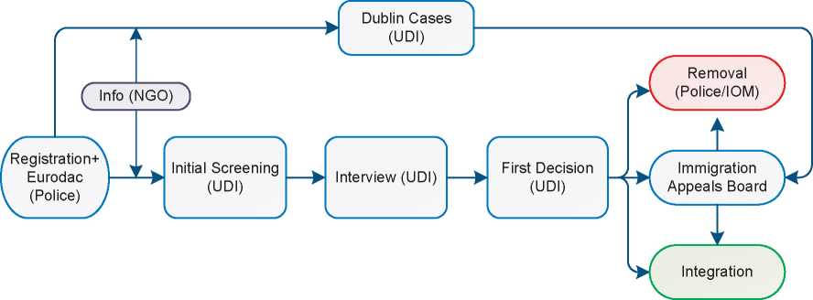

0-5 days

10-40 days

Aim: 60 days

—

1. Annexes
   1. Asylum Procedures Flow Chart

**The Normal Asylum Procedure and the Three-Week  
Procedure**

**Normal asylum  
procedure**

**C Three-week procedure**

0-5 days

5-15 days

Aim: 21 days

**The 48-Hour Procedure**

0-1 day

48 hours

**C48-hour procedure**

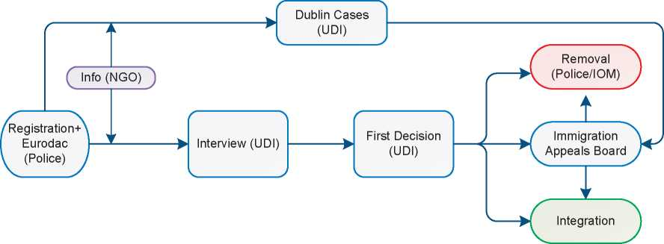

* 1. Additional Statistical Information

Figure 4: Asylum Applications from Top 10 Countries of Origin in 2009, 2010, 2011 and first half of 2012

**2009 2010 2011 Jan-Jun 2012**

|  |  |  |  |  |  |  |  |  |
| --- | --- | --- | --- | --- | --- | --- | --- | --- |
| **1** | Afghanistan | 3,871 | Eritrea | 1,711 | Somalia | 2,216 | Somalia | 1,070 |
| **2** | Eritrea | 2,667 | Somalia | 1,397 | Eritrea | 1,256 | Afghanistan | 464 |
| **3** | Somalia | 1,901 | Afghanistan | 979 | Afghanistan | 979 | Eritrea | 349 |
| **4** | Stateless | 1,280 | Russia | 628 | Russia | 365 | Iran | 172 |
| **5** | Iraq | 1,214 | Ethiopia | 505 | Iraq | 357 | Nigeria | 148 |
| **6** | Russia | 867 | Iraq | 460 | Iran | 355 | Sudan | 147 |
| **7** | Ethiopia | 706 | Stateless | 448 | Ethiopia | 293 | Bangladesh | 137 |
| **8** | Nigeria | 582 | Iran | 429 | Stateless | 262 | Russia | 136 |
| **9** | Iran | 574 | Nigeria | 354 | Nigeria | 240 | Stateless | 122 |
| **10** | Kosovo | 291 | Kosovo | 244 | Sudan | 209 | Belarus | 111 |

**Figure 5: Decisions Taken at the First Instance in 2009, 2010 and 2011**

|  |  |  |  |  |  |  |  |  |  |
| --- | --- | --- | --- | --- | --- | --- | --- | --- | --- |
|  | **Geneva Convention** | | **Subsidiary/**  **Complementary**  **Protection and Humanitarian Status** | | **Rejections** | | **Withdrawn, Closed, Abandoned Cases** | | **Grand**  **Total** |
| **Number** | **%** | **Number** | **%** | **Number** | **%** | **Number** | **%** |  |
| **2009** | 1,753 | 11% | 2,755 | 18% | 10,251 | 65% | 927 | 6% | **15,686** |
| **2010** | 2,974 | 18% | 2,357 | 14% | 10,212 | 62% | 912 | 6% | **16,455** |
| **2011** | 2,810 | 27% | 1,240 | 12% | 5,691 | 54% | 752 | 7% | **10,493** |

**Figure 6.a: Positive 11 First- and Second-Instance Decisions,Top Countries of Origin in 2009**

**Rate out of Total Decisions [248] [249]**

|  |  |  |  |  |
| --- | --- | --- | --- | --- |
|  | | **Total Positive** | **Total Decisions** | **Rate** |
| 1 | Eritrea | 1,380 | 2,118 | 65.2% |
| 2 | Afghanistan | 979 | 2,791 | 35.1% |
| 3 | Somalia | 646 | 1,502 | 43.0% |
| 4 | Stateless | 428 | 980 | 43.7% |
| 5 | Iraq | 367 | 2,261 | 16.2% |
| 6 | Ethiopia | 217 | 496 | 43.8% |
| 7 | Iran | 168 | 605 | 27.8% |
| 8 | Sudan | 53 | 131 | 40.5% |
| 9 | Russia | 52 | 725 | 7.2% |
| 10 | China | 43 | 53 | 81.1% |

Total Positive Decisions by Status

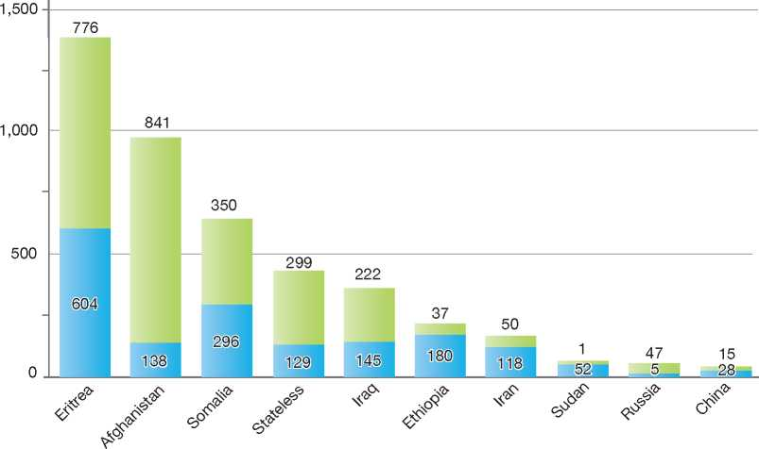

**Total Positive Decisions by Status**

Geneva Convention Status | | Subsidiary/Complementary Protection and Humanitarian Status

**Figure 6.b: Positive 11 First- and Second-Instance Decisions,Top Countries of Origin in 2010**

**Rate out of Total Decisions [250] [251]**

|  |  |  |  |  |
| --- | --- | --- | --- | --- |
|  | | **Total Positive** | **Total Decisions** | **Rate** |
| 1 | Eritrea | 1,603 | 2,371 | 67.6% |
| 2 | Somalia | 1,246 | 1,953 | 63.8% |
| 3 | Afghanistan | 1,032 | 2,822 | 36.6% |
| 4 | Iraq | 382 | 1,277 | 29.9% |
| 5 | Stateless | 194 | 937 | 20.7% |
| 6 | Ethiopia | 181 | 548 | 33.0% |
| 7 | Iran | 134 | 666 | 20.1% |
| 8 | Sudan | 118 | 192 | 61.5% |
| 9 | China | 99 | 120 | 82.5% |
| 10 | Myanmar | 59 | 71 | 83.1% |

Total Positive Decisions by Status

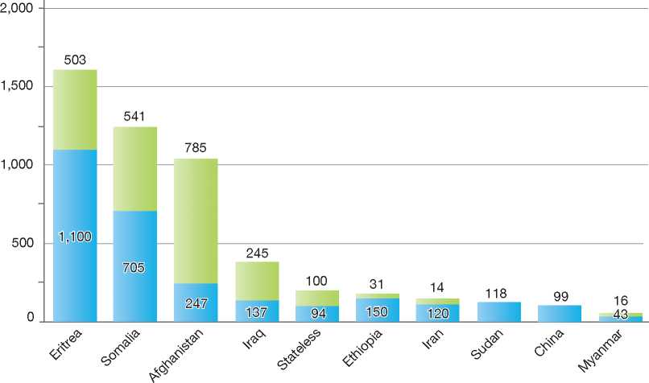

**Total Positive Decisions by Status**

| Geneva Convention Status | | Subsidiary/Complementary Protection and Humanitarian Status

**Figure 6.c: Positive 11 First- and Second-Instance Decisions,Top Countries of Origin in 2011**

**Rate out of Total Decisions [252] [253]**

|  |  |  |  |  |
| --- | --- | --- | --- | --- |
|  | | **Total Positive** | **Total Decisions** | **Rate** |
| 1 | Somalia | 1,205 | 1,704 | 70.7% |
| 2 | Eritrea | 1,143 | 1,603 | 71.3% |
| 3 | Afghanistan | 541 | 1,269 | 42.6% |
| 4 | Ethiopia | 195 | 458 | 42.6% |
| 5 | China | 185 | 228 | 81.1% |
| 6 | Sudan | 148 | 193 | 76.7% |
| 7 | Iraq | 147 | 447 | 32.9% |
| 8 | Iran | 134 | 485 | 27.6% |
| 9 | Stateless | 122 | 387 | 31.5% |
| 10 | Myanmar | 29 | 50 | 58.0% |

Total Positive Decisions by Status

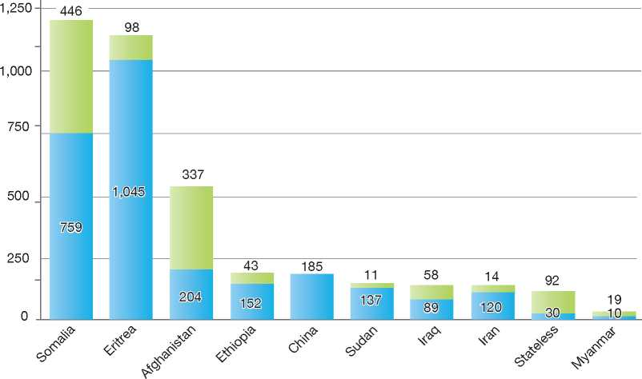

**Total Positive Decisions by Status**

| Geneva Convention Status | | Subsidiary/Complementary Protection and Humanitarian Status

1.

2.

3.

4.

5.

6.

7.

8.

9.

10.

11.

12.

Spain

378

|  |  |
| --- | --- |
| BackGRound: MajoR asyluM tRends and developMents | 363 |
| national leGal FRaMewoRk | 365 |
| institutional FRaMewoRk | 365 |
| pRe-entRy MeasuRes | 366 |
| asyluM pRoceduRes | 366 |
| decision-MakinG and statuses | 370 |
| eFFiciency and inteGRity MeasuRes | 372 |
| assistance and Reception BeneFits FoR asyluM-seekeRs | 373 |
| status and peRMits GRanted outside the asyluM pRoceduRe | 375 |
| RetuRn | 376 |
| inteGRation | **37^^^HSPA** |

annexes

1. Background: Major Asylum Trends and Developments

Asylum Applications

From the early to mid-1980s, Spain received between 1,000 and 2,500 asylum applications per year. The numbers increased significantly to 4,500 in 1988 and peaked at over 12,600 in 1993. From 1995 onwards, numbers decreased significantly. Annual inflows in more recent years have been between 5,000 and 9,000. In 2008, Spain received a total of 4,476 asylum claims, a drop from the previous year. A further drop in applications was registered in 2009, with 3,007 asylum applications made, dropping slightly again to 2,739 in 2010. Numbers picked up again in 2011, with 3,415 applications made by the end of the year.

Top Nationalities

In the 1990s, the majority of asylum-seekers originated from Romania, Nigeria, Algeria and Cuba. Since 2000, the top countries of origin have been Colombia, Nigeria, Algeria, Mali, Guinea (Conakry), Ivory Coast and Cuba. In 2010, the top five countries of origin were Cuba, Nigeria, Algeria, Guinea (Conakry) and Cameroon. In 2011, Ivory Coast was the top country of origin, followed by Cuba, Nigeria, Guinea (Conakry) and the Palestinian Territories (West Bank and Gaza Strip).

Figure 1: Total Asylum Applications by Quarter, January 1994 - June 2012

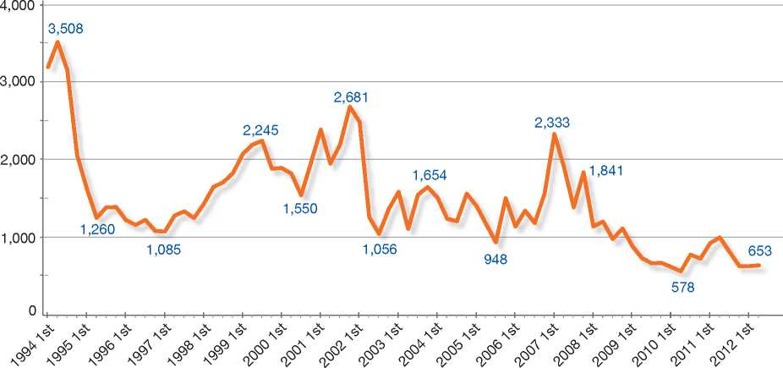



Important Developments

Law 5/1984 regulating the Right to Asylum and Refugee Status underwent significant reforms in 1994[254], a reflection of Spain's preoccupation with safeguarding the integrity of the asylum system against abuse while also ensuring better protection for refugees. Key changes included the elimination of dual status (refugee status and asylum status), the introduction of an admissibility procedure (screening phase) for all asylum claims made in-country or at the border, and the possibility of obtaining a residence permit on humanitarian grounds.

In addition, the border procedure became an accelerated procedure, whereby the Ministry of Interior had four days from the time of application to decide whether the claim was admissible, and rejected asylum-seekers had a right of appeal within 24 hours, which would then be resolved in two days. Manifestly unfounded claims or claims made by persons subject to a transfer under the Dublin II Regulation could be deemed inadmissible. Under Law 1/1996 (10 January), asylum-seekers became entitled to free legal assistance if they lacked financial resources.

Between 2003 and 2007, further reforms to the asylum procedure were introduced and included the following:

**Figure 2: Asylum Applications Received from Top 5 Countries of Origin in 2009, 2010 and 2011**

**2009**

**Volumes**

**2010**

**Volumes**

**2011**

**Volumes**

Distribution

Distribution

56%

4%

6%

15%

9%

13%

|  |  |  |  |
| --- | --- | --- | --- |
| **Country of Origin:** | | | |
| Algeria | Cameroon | Colombia J Cuba | Guinea (Co.) |
| Ivory Coast | Nigeria | | W. Bank & Gaza S. | Others |

10%

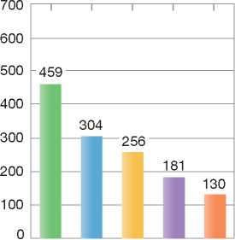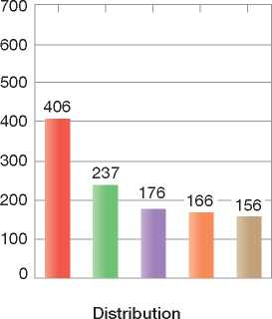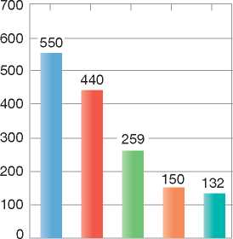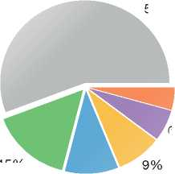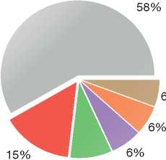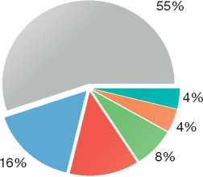

* The transposition into national law of Council Directive 2001/55/EC on Temporary Protection[255] and Council Directive 2003/9/EC on Reception Conditions[256]
* The introduction of grounds for granting complementary protection to persons who do not meet the criteria for Convention refugee status but who run a serious risk to life or physical integrity if returned to the country of origin
* The granting of a work permit to asylum-seekers who are awaiting a decision on their claim at the first instance six months after having made the application for asylum

• Organic law 3/2007, introduced to regulate gender equality, such that persons claiming gender-based persecution could be recognised as Convention refugees.

The Spanish international protection system underwent a global revision in 2009, resulting in Law 12/2009 regulating the Right to Asylum and Subsidiary Protection (Asylum Law).

This new law transposes EU Council Directives 2004/83[257] and 2005/85[258] into Spanish law, thus

completing the implementation of the first phase of the Common European Asylum System (CEAS) in Spanish legislation, as well as the inclusion of some elements of the second phase of the CEAS. With these changes, Spanish legislation is now in line with that of other EU Member States.

Law 12/2009 also incorporates new interpretations and criteria derived from international doctrine and jurisprudence of European tribunals, such as the Court of Justice of the European Union (ECJ) and the European Court of Human Rights (ECHR).

The overall aim of the new legislation is to improve procedural safeguards for asylum-seekers and beneficiaries of international protection. In order to increase the transparency of administrative procedures, the procedure for granting international protection has been accelerated. Moreover, the new law aims to guarantee access to the asylum procedure, and makes it easier for asylum-seekers to move through the different stages of the procedure. Law 12/2009 emphasises the important role of the United Nations High Commissioner for Refugees (UNHCR) within the asylum procedure.

The most important changes introduced by Asylum Law 12/2009 are as follows:

* The introduction of a uniform international protection status, including both refugee status and subsidiary protection status
* The reinforcement of procedural safeguards for the granting of international protection
* The recognition of sexual orientation or gender as a ground for persecution in addition to the ones listed in the 1951 Convention
* The role assigned to the UNHCR during the international protection procedure
* The possibility for family members to apply for international protection outside of the family reunification regime
* The introduction of special safeguards for minors (including unaccompanied minors) and other vulnerable persons during the procedure
* The commitment of the administration to train civil servants and other staff dealing with asylum-seekers on aspects related to international protection
* The introduction of an annual resettlement programme.

1. National Legal Framework
   1. Legal Basis for Granting Protection

The granting of asylum and refugee status in Spain is governed by Law 12/2009 regulating the Right to Asylum and Subsidiary Protection (Asylum Law).

* 1. Pending Reforms

While the new Asylum Law was passed in late 2009, the regulation implementing the Asylum Law is pending.

1. Institutional Framework
   1. Principal Institutions

The Asylum and Refugee Office (*Oficina de Asilo y Refugio*, OAR), which falls under the responsibility of the Ministry of Interior, receives asylum applications and examines all international protection claims made with the Spanish authorities.

The Inter-ministerial Asylum and Refugees Commission *(Comision Interministerial de Asilo y Refugio*, CIAR) comprises one representative from the Ministry of Interior, the Ministry of Foreign Affairs and Cooperation, the Ministry of Justice, the Ministry of Employment and Social Security, and the Ministry of Health, Social Benefits and Equality. UNHCR acts in a consultative capacity. The CIAR has the task of drawing up proposals for decisions on asylum claims, and submitting them to the Ministry of Interior for a formal decision.

The Ministry of Interior makes formal decisions on asylum applications at the first instance and is responsible for undertaking administrative review of negative decisions on asylum claims upon request.

The General Commissariat of Aliens and Borders (Police) is responsible for issuing documents to asylum-seekers for the duration of the asylum procedure, and for carrying out transfers under the Dublin II Regulation and returns of rejected asylum-seekers to their countries of origin.

The Ministry of Employment and Social Security is responsible for the reception and integration of asylum-seekers.

* 1. Cooperation between Government Authorities

The various ministries cooperate at a practical level throughout the asylum procedure. As mentioned above, there are high levels of cooperation between the Ministry of Interior, the Ministry of Foreign Affairs and Cooperation, the Ministry of Justice, the Ministry of Employment and Social Security, the Ministry of Health, Social Benefits and Equality, and finally the Police.

1. Pre-entry Measures
   1. Visa Requirements

To enter Spain, foreign nationals must comply with the conditions established in Article 5 of the Schengen Borders Code. Visa requirements follow the rules established by Council Regulation 539/2001 listing the third countries whose nationals must be in possession of visas when crossing the external borders and those whose nationals are exempt from that requirement.

* 1. Carrier Sanctions

According to the Aliens Law, carrier sanctions are applicable to carriers that are found to have transported onto Spanish territory foreign nationals who are not in possession of valid travel documents and visas, if required.

* 1. Interception

The Spanish Civil Guard, a law enforcement agency dependent on the Ministry of Interior and the Ministry of Defence, is in charge of border surveillance and intercepts migrants attempting to access Spanish territory by land or by sea without proper authorisation. The purpose of the Integrated System for External Surveillance (*Sistema Integrado de Vigilancia Exterior*, SIVE*)*, which is implemented along most of the coast of Spain, is to detect activities relating to both unauthorised migration and drug trafficking.

1. Asylum Procedures
   1. Application Possibilities and Requirements, Procedures and Legal Remedies

Applications for asylum may be made at border posts (airports and seaports) and in-country. In­country applications may be made as follows:

* At the Asylum and Refugee Office (OAR) in Madrid
* At any Aliens Office
* At designated police stations
* At detention centres *(Centro de Internamiento de Extranjeros*, CIE).

An application for asylum may be made at any time during a person's authorised stay in Spain. Persons who enter Spain without proper authorisation should apply for asylum within one month of their arrival. However, persons who wish to make a claim for asylum on the basis of facts that arose after their leaving the country of origin may apply for asylum within one month of the time that these facts arose.

Access to Information on Procedures

Information on the asylum procedure is made available in the form of a leaflet published in eleven different languages. The leaflet provides an overview of the application and determination process, as well as the types of status and benefits conferred on persons in need of protection. Upon making an asylum claim, asylum-seekers have access to the assistance of a social worker of the Ministry of Employment and Social Security, who will provide information on reception benefits.

1. Outside the Country

Applications at Diplomatic Missions

Since the Asylum Law 12/2009 entered into force, it is no longer possible to make a claim for asylum at a Spanish diplomatic mission in a third country.

Resettlement/Quota Refugees

Spain has in the past engaged in *ad hoc* resettlement of refugees.

By adopting Asylum Law 12/2009, the Spanish Government established an annual resettlement programme. In provision No.1 supplementing theAsylum Law, the Council of Ministers approved the Spanish resettlement programme for the year 2011. The 2011 programme comprised the resettlement of 82 refugees from Sudan, Eritrea, Ethiopia, and the Shousha camps in Tunisia.

1. At Ports of Entry

The Border Procedure

The same procedure is applied at both airports and seaports.

Persons arriving at ports of entry without the required documentation to enter Spain must approach the Police and sign a declaration stating their wish to apply for asylum. This declaration is then forwarded to the OAR. After submitting the formal application, the asylum-seeker is entitled to legal assistance and the services of an interpreter. The asylum-seeker must submit all relevant identity and travel documents, as well as all other documentation supporting his or her claim.

All asylum applications are shared with the UNHCR, which can provide its opinion on the claim. On the basis of all the information gathered, the OAR must determine within four days whether or not the claim is admissible. This time limit may be extended to a maximum of 10 days in exclusion cases, upon reasoned request by the UNHCR. In case of a negative decision on admissibility, the applicant may, within two days of notification of the decision, make a request for re-examination. The OAR, in turn, must then come to a decision regarding the admissibility of the claim within two days.

During the border procedure, the applicant remains at the port of entry. To this end, adequate accommodation at the port of entry is provided.

If the decision of the administrative appeal is negative, the asylum-seeker is required to leave Spain, although he or she may make a further appeal to the Tribunal. These appeals do not have suspensive effect.

The border procedure applied at airports or sea­ports also applies to protection claims made by persons held in detention centres (*Centro de Internamiento para Extranjeros*, CIE), which are processed under the urgency procedure6.

1. Inside the Territory

Responsibility for Processing the Claim

The Dublin System

*Application and Procedure*

During the admissibility phase of the asylum procedure, the Dublin Unit of the OAR will determine which European Union (EU) Member State is responsible for the claim, according to the terms of the Dublin II Regulation. If it is found that the asylum-seeker travelled through another State party to the Regulation before arriving in Spain, a request for readmission will be made. Otherwise, the asylum claim proceeds to the normal procedure.

*Freedom of Movement/Detention*

Asylum-seekers are not detained while awaiting a transfer under the Dublin procedure.

*Conduct of Transfers*

Once a request for re-admission has been granted, the Police are responsible for ensuring the transfer of the asylum-seeker.

*Suspension of Transfers*

The OAR may decide, on basis of Article 15 of the Dublin II Regulation, to suspend the transfer of an asylum-seeker to another Member State.

*Review/Appeal*

A decision to transfer an asylum-seeker under the Dublin II Regulation is a negative decision on the admissibility of the claim. It can therefore be appealed in the same manner as other negative decisions on admissibility made in-country. The Tribunal may suspend the transfer upon the request of the asylum-seeker, on a case-by-case basis[259].

Application and Admissibility

In-Country Applications

Applications for asylum must be made in person within one month of the person's arrival in Spain, or within one month of the time when the facts on which the fear of persecution or serious harm is based have occurred. During an interview,

6 The urgency procedure is described below.

the applicant receives information on how to complete the application.

The fingerprints of the asylum-seeker are taken and the asylum-seeker is issued with an initial document that identifies the person as having applied for asylum in Spain.

During the procedure, legal assistance and interpretation may be provided, if necessary.

Once the application has been made, the applicant cannot be returned, expelled or extradited until a decision on the admissibility of the application has been issued.

Admissibility

The OAR must make a recommendation on the admissibility of the claim (admissible, non- admissible or rejected) within one month of the application. All recommendations for a negative decision on admissibility are communicated to the UNHCR office in Spain, which has 10 days to deliver an opinion on the case to the OAR. The formal decision on admissibility is then taken by the Ministry of Interior.

If the go-ahead is given (i.e. the claim is found admissible), the asylum-seeker is issued a six- month stay permit, which is renewable until a final decision on the claim is made. The case is then further processed under the normal procedure.

If a negative decision on admissibility is issued, the asylum-seeker has an obligation to leave Spain.

Review/Appeal

Any decision on admissibility may be the subject of an administrative appeal before the Ministry of Interior. The appeal must be made within one month of the notification of the decision. The Ministry then has one month to confirm or change its decision.

The asylum-seeker may also appeal the decision before Administrative-Contentious Courts (*Contencioso Administrativo*). The asylum­seeker may make an appeal of the decision on inadmissibility or a negative decision following the administrative appeal before the Central Administrative Court within two months of the negative decision.

The decisions of the Central Administrative Court may be appealed before the National High Court within two months of the decision.

Administrative requests for review and appeals do not have suspensive effect. However, the asylum-seeker may include in the appeal a request to remain in Spain until a final decision on the claim is made.

Normal Procedure

For all international protection applications that are deemed admissible, the Ministry of Interior initiates the (normal) procedure for determining eligibility for protection, which involves several procedural steps, including - if necessary - an in­depth interview.

The Asylum Law 12/2009 differentiates between two types of procedures for processing admissible international protection claims: the normal procedure has a targeted processing time of six months, whereas in the urgency procedure the time limit is reduced to three months.

After examination of the claim, the OAR sends its recommendation to the CIAR for its consideration. The CIAR will then forward its own recommendation to the Ministry of Interior for a final decision.

Urgency Procedure

Asylum Law 12/2009 allows for certain applications to be prioritised for processing. The normal procedure will apply to those applications, but the timeframe for decision-making, in the urgency procedure is reduced from six to three months.

Cases may be transferred to the urgency procedure because of the applicant's vulnerability, or because the outcome of the application is already evident.

Review/Appeal of Asylum Decisions

Administrative Review

Any decision taken by the Ministry of Interior on an asylum claim at the first instance may be appealed to the Ministry of Interior. This administrative appeal may be made within one month of the decision. The Ministry can either confirm the decision taken or annul the decision and grant the asylum-seeker international protection. The Ministry must make its decision within one month of the request for review. If the Ministry does not make a decision on the appeal within this timeframe, the asylum­seeker may appeal directly to the courts.

Judicial Review

A rejected asylum-seeker may request judicial review before the National High Court (*Audiencia Nacional*). Upon receiving the request, the High Court must notify the OAR. The OAR will then provide the Court with the asylum-seeker's file. The National High Court may take the following decisions:

* Annul the decision and grant international protection or another form of protection
* Uphold the decision
* Return the case to the OAR when there has been a procedural error.

A negative decision by the High Court may be appealed in “cassation” before the Supreme Court (*Tribunal Supremo*), which examines the legality of the High Court's decision but not the facts of the case. The Court may uphold or overrule the judgment of the National High Court in part or in whole.

Reviews and appeals do not have suspensive effect. However, at each stage of the review or appeal process, the asylum-seeker may make a request to remain in Spain until a final decision is made. A decision to allow an asylum-seeker to remain in Spain during an appeal is made on a case-by-case basis.

A person may appeal the decision to grant subsidiary protection in order to obtain Convention refugee status. Appellants maintain subsidiary protection status during the judicial procedure. A rejection of the appeal has no consequences on the appellant's status.

Freedom of Movement during the Asylum Procedure

Detention

Asylum-seekers are not detained for the fact of having applied for asylum.

Reporting

During the asylum procedure, asylum-seekers have an obligation to communicate their exact place of residence and any changes of address to the OAR.

Repeat/Subsequent Applications

Repeat applications are not entered into the admissibility phase of the asylum procedure, unless new information pertaining to changed circumstances in the country of origin is being put forward, and this new information represents a significant change from the original application.

An asylum-seeker who has obtained a negative decision on his or her original claim may also make a request for a reconsideration of his or her original application, if there is new evidence presented supporting the original claim.

* 1. Safe Country Concepts
     1. Safe Country of Origin

Spain does not have list of safe countries of origin. All asylum applications are examined on their individual merits on a case-by-case basis, taking into account conditions in the country of origin.

Asylum Claims Made by EU Nationals

Spain applies the Protocol on Asylum for Nationals of Member States of the European Union annexed to the Treaty of Amsterdam. Thus, asylum applications made by nationals of Member States of the European Union are deemed unfounded and are not processed.

* + 1. First Country of Asylum

According to the Asylum Law, if a person has already obtained asylum, or has the right to reside or to obtain asylum in a third country, and no danger to the person's life or a threat of torture or degrading treatment exists in that country (that is, there is no risk of *refoulement*), the Ministry of Interior may issue a negative decision on the asylum claim or find the claim to be inadmissible. In such cases, the person is required to leave Spain.

* + 1. Safe Third Country

Spain does not have a list of safe third countries for use in the asylum procedure. However, the Asylum Law foresees the possibility of declaring a claim inadmissible to the normal procedure if the asylum-seeker comes from a country where he or she can seek protection and no danger to the person's life or a threat of torture or degrading treatment exists in that country (that is, there is no risk of *refoulement*).

* 1. Special Procedures
     1. Unaccompanied Minors and Vulnerable Persons

According to the Asylum Law, the specific situation of applicants in a vulnerable situation should be taken into consideration during the examination of asylum claims. Vulnerable persons include:

* Minors
* Unaccompanied minors asylum-seekers (UAMs)
* Pregnant women
* Persons with incapacities
* Single parents with minor children
* Victims of torture or other trauma
* Other persons with special vulnerability.

Figure 3: Asylum Applications by Unaccompanied Minors

No data available.

The OAR decides asylum claims made by unaccompanied minor asylum-seekers (UAMs) under the urgency procedure. In addition, specific procedural standards apply to the examination of minors' claims. For example, UAMs are usually interviewed a second time and are assigned a legal guardian who is always invited to attend the interview. Psychologists, social workers and relatives may also be present at the interview(s). In addition, the OAR may request that the minors undergo a medical test to assist in the determination of the person's age.

New Provisions Applying to Unaccompanied Minor Asylum-Seekers

The Asylum Law 12/2009 puts in place a series of provisions applying to UAMs aimed, *inter alia,* at preventing the irregular migration of unaccompanied minors and ensuring their return, where practicable. The Law also allows minors to intervene in the processes regarding them. Before any return proceedings are instituted, a report is sought from the diplomatic mission of the minor's country of origin to establish what the family circumstances are.

Minors with "sufficient understanding" may take part in proceedings. Minors over the age of 17 may intervene or be represented. Those under the age of 17 may be heard if they express an opinion different from that of their guardian.

Concerning returns, the Law now refers to the Convention on the Rights of the Child and the principle of the "best interests of the child". In most situations, it is deemed to be in the best interests of the child to be reunited with his or her family and social environment of origin.

* + 1. Stateless Persons

Stateless persons may apply for asylum and have their claims processed in the same manner as other asylum claims.

1. Decision-Making and Status
   1. Inclusion Criteria

When considering the merits of a claim, the OAR must first consider whether the criteria for granting refugee status are met. If this is not the case, the OAR will then consider whether the asylum-seeker meets the criteria for subsidiary protection.

* + 1. Convention Refugee

Persons with a well-founded fear of persecution as set out in the 1951 Convention and its 1967 Protocol are granted refugee status.

* + 1. Subsidiary Protection

According to Article 10 of the Law 12/2009, persons who do not meet the criteria for Convention refugee status but for whom return to the country of origin may pose a serious risk to life or a risk to physical integrity may be granted subsidiary protection.

* 1. The Decision

Following a preliminary examination of the asylum claim by the OAR, the dossier is submitted to the Inter-ministerial Asylum and Refugee Commission (CIAR).

Following deliberation, the CIAR forwards its recommendation to the Ministry of Interior, which decides whether to grant asylum or subsidiary protection, or to reject the application.

Decisions on asylum claims are provided in writing, and negative decisions are reasoned. Negative decisions contain information on options for review or appeal as well as a notification that the person must leave Spanish territory.

Quality Assurance at the OAR

In 2011, certain measures were adopted to improve the procedure for granting international protection, and more specifically the in-depth motivation for rejecting applications.

The Asylum Office has disseminated among case­workers the UNHCR's Asylum Systems Quality Assurance and Evaluation Mechanism (ASQAEM) summary[260] to be used in every step of the procedure.

* 1. Types of Decisions, Status and Benefits Granted

Upon the recommendation of the CIAR, the Ministry of Interior may make one of the following decisions on an asylum claim:

* Grant Convention refugee status
* Grant subsidiary protection
* Reject the application for asylum
* Grant authorisation of residence on humanitarian grounds.

Status and Benefits

There is no difference between Convention refugee status and subsidiary protection status. Both Convention refugees and beneficiaries of subsidiary protection are eligible for the following benefits:

* Authorisation of residence, with the possibility of applying for citizenship after five years
* Authorisation to take part in professional and commercial activities
* The necessary travel and identity documents
* Family reunification
* Social assistance benefits.
  1. Exclusion

The OAR must consider Article 1F of the 1951 Convention when examining asylum claims under the normal procedure. Article 1F is applicable to both Convention refugee status and subsidiary protection. If the exclusion clauses are found to apply to a claim, the OAR will recommend to the CIAR that the claim for asylum be denied. Persons may also be denied refugee status or subsidiary protection if they pose a threat to national security or public order.

Persons excluded from protection have an obligation to leave Spanish territory. They may appeal the decision in the same manner that all other final negative decisions on asylum claims would be appealed[261].

Excluded persons who cannot be returned to their country of origin may remain in Spain. However, no official status is granted.

* 1. Cessation

According to Articles 42 and 43 of the Asylum Law, refugee status ceases automatically in one of the following circumstances:

* The refugee explicitly requests it
* The refugee has obtained Spanish citizenship, or has acquired the nationality of a third country and availed himself or herself of the protection offered by this country
* The refugee voluntarily accepts the protection of his or her country of origin
* The refugee has settled voluntarily in another country, including his or her country of origin.

Subsidiary protection ceases when:

* The protected person so requests
* The protected person has taken up residence in a third country.

When there has been a significant change in circumstances in the country of origin, cessation may be applied by the asylum authorities, in consultation with the UNHCR office in Spain.

The OAR may start a procedure for cessation of status after a final decision on an asylum claim has been taken at the first instance. The refugee or beneficiary of subsidiary protection is informed of the decision to pursue cessation and will be given an opportunity to provide evidence or reasons for which his or her status should not be cancelled. The OAR takes into account any evidence provided by the person before making a recommendation to the CIAR on whether or not to cancel status.

Under the terms of the Aliens Law, a person whose status has been ceased may remain in Spain. He or she may appeal the decision of the CIAR by following the same procedure followed for negative decisions on asylum claims at the first instance, as described above.

* 1. Revocation

According to Article 44 of Law 12/2009, refugee status or subsidiary protection, along with all attendant benefits, may be cancelled if it emerges that the asylum application was based on falsified information that had a bearing on the granting of asylum. Cases of serious criminality, as well as cases where a person constitutes a threat to national security or public safety, may also lead to cancellation of status in accordance with Articles 1F and 33(2) of the 1951 Convention.

The same procedure is applied for cancellation of status as for cessation of status, which is described above. The UNHCR is always informed of decisions to cancel status.

The decision to revoke status is taken by the Council of Ministers.

* 1. Support and Tools for Decision-Makers
     1. Country of Origin Information (COI)

The Documentation Unit at the OAR provides caseworkers with information on countries of origin of asylum-seekers. The main products offered include profiles of the top countries of origin and reports focusing on areas and countries affected by armed conflict.

The Documentation Unit also maintains a database that stores links to the most important Internet resources on country information.

In addition to gathering country of origin information (COI), the Documentation Unit is responsible for organising all training activities - both on COI and on other practical asylum-related matters - for caseworkers and other staff of the OAR involved in the asylum procedure. The Documentation Unit takes active part in international training activities, such as the European Asylum Curriculum (EAC) training organised by the European Asylum Support Office (EASO), and plans to use the Common COI Portal.

* + 1. Language Analysis

The OAR does not use language analysis for the purposes of examining asylum claims.

* + 1. Other Support Tools

In addition to country information provided by the Documentation Unit, decision-makers have access to reports produced by Spanish diplomatic missions on specific countries of origin or in response to a request for information on a specific asylum case.

Training on Gender and Sexual Orientation

The Spanish Asylum Office, together with the State Secretary of Equality, organises, regular training sessions on gender and sexual orientation for the personnel of the Asylum Office. Relevant NGOs and experts in gender and sexual orientation issues also participate in these training sessions.

1. Efficiency and Integrity Measures
   1. Technological Tools
      1. Fingerprinting

Fingerprints of asylum-seekers aged 14 years and older are taken by the Police at the time the asylum application is made. One of the purposes of taking fingerprints is to assist the OAR in determining the State responsible for examining the asylum claim, in accordance with the Dublin II Regulation and the EURODAC Regulation.

* + 1. DNA Tests

DNA tests are rarely required and may be requested in cases in which a family member was not initially included on an asylum application, and alleged family links need to be verified, as referred to in Article 40 of the Asylum Law.

* + 1. Forensic Testing of Documents

The OAR may make a request to the Police for authentication of identity documents, in cases where there are doubts about the authenticity of these documents.

* + 1. Database of Asylum Applications/Applicants

The Police authorities involved in the asylum procedure have access to the Central Aliens Registry, which contains data on all foreign nationals who have come into contact with government authorities.

The OAR maintains a database with all files of asylum-seekers.

* 1. Length of Procedures

An application for asylum may be made at any time during a person's authorised stay in Spain. Persons who enter Spain without proper authorisation may apply for asylum within one month of their arrival in the country.

Decisions on admissibility (rejection or non­admissibility) at the border must be taken within eight days of the application[262].

Admissibility decisions on applications made in­country must be issued within a time limit of one month of the application being made.

The length of the eligibility procedure, as stipulated by law, is six months for the normal procedure and three months for the urgency procedure.

Faster Processing at the OAR

In addition to the implementation of standard timeframes for different procedural steps, the OAR may resort to *ad hoc* measures to accelerate the processing of asylum applications.

In the summer of 2011, in the context of massive inflows of asylum-seekers in certain regions, the Asylum Office made use of videoconferencing in order to speed up the processing of asylum applications.

In 2010, the Spanish Asylum Office hired additional decision-makers on a temporary basis for a six- month period to reduce the backlog.

* 1. Pending Cases

As at 30 September 2012, the number of pending cases before the OAR stood at 2,590.

* 1. Information Sharing

Under Spanish law, the OAR is required to share information on individual asylum claims with the UNHCR office in Spain. This procedure is described in the section below on cooperation with the UNHCR.

Within the Government, information on asylum matters may be shared by the OAR with other Ministries and administrative units that deal with asylum matters.

The only information-sharing agreements to which Spain is party are the Dublin II Regulation and the agreements with Denmark, Norway, Iceland and Switzerland that extend the application of the Dublin II Regulation to those States. Specific information on asylum-seekers may be released to other EU Member States, in accordance with Article 21 of the Dublin II Regulation.

* 1. Single Procedure

A single procedure for considering whether an asylum-seeker meets the criteria for Convention refugee status or subsidiary protection is in place. The OAR must consider both sets of criteria when making a proposal for a decision to the CIAR.

1. Assistance and Reception Benefits for Asylum-Seekers
   1. Procedural Support and Safeguards
      1. Legal Assistance and Interpretation

Article 18.1 of the Asylum Law and Article 8.4 of the Regulation adopted by Royal Decree 203/1995 (10 February) state that asylum-seekers are entitled to interpretation services and legal assistance during the asylum procedure.

The OAR has full-time interpreters for certain languages at the disposal of asylum-seekers at the time of application. Asylum-seekers may have legal counsel present during the interviews and may continue to benefit from legal aid during the appeal procedure. If they lack the financial means to afford legal counsel, this is provided free of charge.

Asylum-seekers also have access to social workers, who will advise them on their rights as well as any social assistance available to them.

* + 1. UNHCR

Asylum-seekers are free to contact the UNHCR for assistance during the procedure. Asylum applications are forwarded to the UNHCR upon request and the UNHCR can be present at the interviews and share its reports on individual claims with the OAR.

The UNHCR plays a key role in various aspects of the asylum procedure.

As described earlier, the UNHCR office in Spain is involved in providing an opinion on the admissibility of asylum claims made at the border. With regard to in-country asylum claims, the UNHCR must be informed of all negative proposals on admissibility and is given 10 days to provide an opinion on the matter.

A representative of the UNHCR takes part in the Inter-ministerial Asylum and Refugee Commission (CIAR), which makes proposals for decisions on asylum claims at the first instance. In this context, while the UNHCR does not have a right of vote, it analyses all cases sent to the Commission and makes recommendations and provides its opinion as appropriate.

* + 1. NGOs

There are a number of non-governmental organisations (NGOs) in Spain that are involved in the provision of support and assistance to asylum­seekers and refugees. When a person makes a claim for asylum in Spain, he or she is advised on where to obtain information, such as the contact information of relevant NGOs that may be able to assist them during the procedure. The NGOs provide assistance in a variety of areas, including social support, training programmes and legal advice.

* 1. Reception Benefits

The Ministry of Labour and Immigration is responsible for the reception of asylum-seekers in Spain. Upon making an asylum claim, asylum­seekers have access to a social worker, who may provide advice and information on reception and benefits during the asylum procedure.

* + 1. Accommodation

Persons who make asylum claims at the airport are required to remain at airport accommodation facilities, where their basic needs are met. Asylum-seekers are accommodated in this facility for a maximum of seven days, during which time a decision on the admissibility of their claim must be made.

If their claims obtain the administrative go-ahead, the asylum-seekers may seek accommodation at one of the refugee reception centres (*Centros de Acogida a Refugiados*, CAR) if they lack the means to pay for their own accommodation, for a maximum of six months. Asylum-seekers may also choose to reside in private accommodation.

There are four refugee reception centres run by the Ministry of Labour and Immigration. Two are located in Madrid, one in Valencia and one in Sevilla. There are additional CAR across the country, run by the Spanish Red Cross and the NGOs, the Catholic Commission Association for Migration (ACCEM) and the Spanish Commission for Refugee Assistance (CEAR). All reception centres are co-funded by the Ministry and the European Commission European Refugee Fund (ERF).

There is a temporary reception centre (*Centro de Estancia Temporal de Inmigrantes*, CETI) run by the Ministry of Labour and Immigration in each of the Spanish enclaves of Ceuta and Melilla.

Asylum-seekers who are being held at a detention centre (*Centro de Internamiento de Extranjeros*, CIE) on the Canary Islands are transferred to a CAR in Spain if their claims obtain the administrative go-ahead. The maximum detention period in a CIE is 60 days.

Unaccompanied minor asylum-seekers are placed in regular children's homes or residential units until the age of 18, depending on the regional governments. They have access to free schooling, medical care and any other assistance they may need.

* + 1. Social Assistance

Asylum-seekers who are not being accommodated in a refugee reception centre may be eligible for financial assistance if they are in an exceptionally difficult financial situation.

* + 1. Health Care

Before being accommodated at one of the CAR, asylum-seekers must undergo a medical exam performed by the Spanish Red Cross.

Asylum-seekers are entitled to the same health care benefits available to citizens.

* + 1. Education

Asylum-seekers have access to a range of courses, including Spanish language classes and professional training in reception centres. Some municipalities also provide additional training programmes in partnership with NGOs and with funding from the Ministry of Labour and Immigration. The reception centres also organise various leisure activities.

Children under the age of 16 have access to the regular school system.

* + 1. Access to Labour Market

Asylum-seekers are entitled to a work permit six months after making their asylum application, if their asylum claims have been given the administrative go-ahead. The permit is valid until a decision on their claim has been made at the first instance. Asylum-seekers do not have access to the labour market during an appeal that does not have suspensive effect or following a final negative decision on their claim.

* + 1. Access to Integration Programmes

The reception centres are mandated to engage in activities that help local communities to better understand their role. In addition, some municipalities and NGOs have set up programmes and activities that allow local communities to welcome and integrate asylum-seekers.

* + 1. Access to Benefits by

Rejected Asylum-Seekers

Rejected asylum-seekers may seek primary and emergency health-care assistance and shelter by making a request to the municipality in which they are residing. Rejected asylum-seekers are not entitled to a work permit.

1. Status and Permits Granted Outside the Asylum Procedure
   1. Humanitarian Grounds

A temporary residence permit may be granted on the basis of exceptional circumstances. These circumstances may include humanitarian grounds as follows:

* The person is the victim of certain crimes defined in the Spanish Penal Code
* The person suffers from a serious medical condition requiring care that cannot be provided in the country of origin
* The person would be placed in danger if he or she were to return to the country of origin.

These grounds apply if other requirements for obtaining a temporary residence permit are met.

Persons who meet these humanitarian grounds are granted a one-year renewable residence permit under the Aliens Law.

* 1. Withholding of Removal/ Risk Assessment

The Police may decide to withhold removal on a case-by-case basis in order for an assessment to be made regarding Spain's *non-refoulement* obligations.

* 1. Temporary Protection

The Regulation adopted by Royal Decree 1325/2003 of 24 October 2003 incorporates the Temporary Protection Directive for situations of mass influx.

In each case of mass influx, the Council of Ministers deliberates on which specific groups of persons may be accepted under the temporary protection scheme and sets the date from which temporary protection becomes valid. Beneficiaries of temporary protection are granted a residence permit valid for one year, which is automatically renewable for an additional year. Thereafter, the Council of Ministers may decide to renew temporary protection for a maximum of one additional year.

* 1. Regularisation of Status over Time

As noted above, a temporary residence permit may be granted in exceptional circumstances. In addition to the humanitarian grounds described above, there are other grounds that may lead to the granting of temporary residence under the Aliens Law.

* 1. Regularisation of Status of Stateless Persons

Spain is a State party to the 1954 Convention on the Status of Stateless Persons. According to Organic Law 4/2000 (11 January), and the Regulation adopted by Royal Decree 865/2001 (20 July), the Ministry of Interior is the competent authority for determining whether a person meets the criteria for recognition of statelessness as set out in the Convention. The OAR undertakes an examination of the person's situation, after which the General Director of Internal Policy makes a recommendation for a decision to the Ministry of Interior.

Recognition of statelessness entitles the person to a residence permit, family reunification benefits and work rights in Spain. The person is issued a Statelessness Status card as well as travel documents.

1. Return
   1. Pre-departure Considerations

The Police are the competent authority for conducting return procedures and enforcing returns. Asylum-seekers who receive a negative decision on their claim have an obligation to leave Spanish territory within 15 days of the decision, although they may be given up to 90 days under certain circumstances. However, the Ministry of Interior may decide, for reasons of national security, that the person has less than 15 days to leave Spain. After this period, a return procedure for irregular stay may be started. The Ministry may decide that a person whose removal is pending meets criteria set out in the Aliens Law to obtain a permit to remain in Spain.

* 1. Procedure

Expulsion orders are enforced by the Police.

The Ministry of Labour and Immigration provides funds for a voluntary return assistance programme to persons - including rejected asylum-seekers, refugees and other persons who have obtained protection - who wish to return to their country of origin. The funds are disbursed yearly to NGOs, such as ACCEM and the Spanish Red Cross, and to the International Organization for Migration (IOM) to implement the programme. There are other assisted voluntary return programmes in existence, such as the Social Care Voluntary Return Programme. Assistance is also available to set up micro-enterprises in countries of origin.

* 1. Freedom of Movement/

Detention

Persons who do not have authorisation to remain in Spain may be detained pending their return under conditions established by law. Alternatively, they may be required to report to the Police on a regular basis and/or submit their travel or identity documents.

* 1. Readmission Agreements

Spain has bilateral readmission agreements in force with different EU Member States for the return of nationals and third-country nationals.

Spain has also concluded readmission agreements with Algeria, Bosnia and Herzegovina, Cape Verde, Gambia, Ghana, Guinea-Bissau, Guinea (Conakry), Mauritania, the Former Yugoslav Republic of Macedonia (FYROM), Mali, Mauritania, Morocco, Niger and Nigeria. An agreement has also been signed with Senegal to deal with unaccompanied minors, notably relating to their repatriation and social rehabilitation.

The EU readmission agreements with third countries must be added to the above-mentioned agreements.

1. Integration

The Ministry of Employment and Social Security oversees the implementation of integration programmes offered to refugees and beneficiaries of complementary protection in Spain. The Ministry provides funds to a number of NGOs that offer a variety of integration assistance activities. For example, they receive funds in order to offer financial assistance with rental accommodation for a three-month period, run programmes to assist those who wish to become self-employed through financial assistance, provide guidance and legal advice, run a family reunification programme that

offers advice and information on the procedure for reuniting refugees and other protected persons with family members in the country of origin, and provide reunited family members with assistance to travel to Spain and meet their basic needs upon arrival.

The European Commission European Refugee Fund (ERF) also provides funding on a yearly basis to NGOs running integration programmes. Within the framework of the 2012 ERF national implementation plan, the objectives in the field of social inclusion have been:

* Better actions to identify persons in need of help with social inclusion.
* Provide specific attention to the most vulnerable groups (psychological help included)
* Social awareness about asylum, refugees and gender issues
* Family reunification for persons meeting certain conditions.

More broadly, persons who have obtained protection in Spain have access to training courses, Spanish-language classes, and advice on gaining employment.

In particular, the Ministry of Employment and Social Security manages the reception centres for refugees, which are public establishments providing accommodation, meals and social and psychological help. These centres receive refugees and applicants of international protection (whose applications have been accepted for processing) lacking economic resources or employment. The reception centre meets their basic needs and is a first step towards social integration.



12 Annexes

12.1 Asylum Procedure Flow Chart

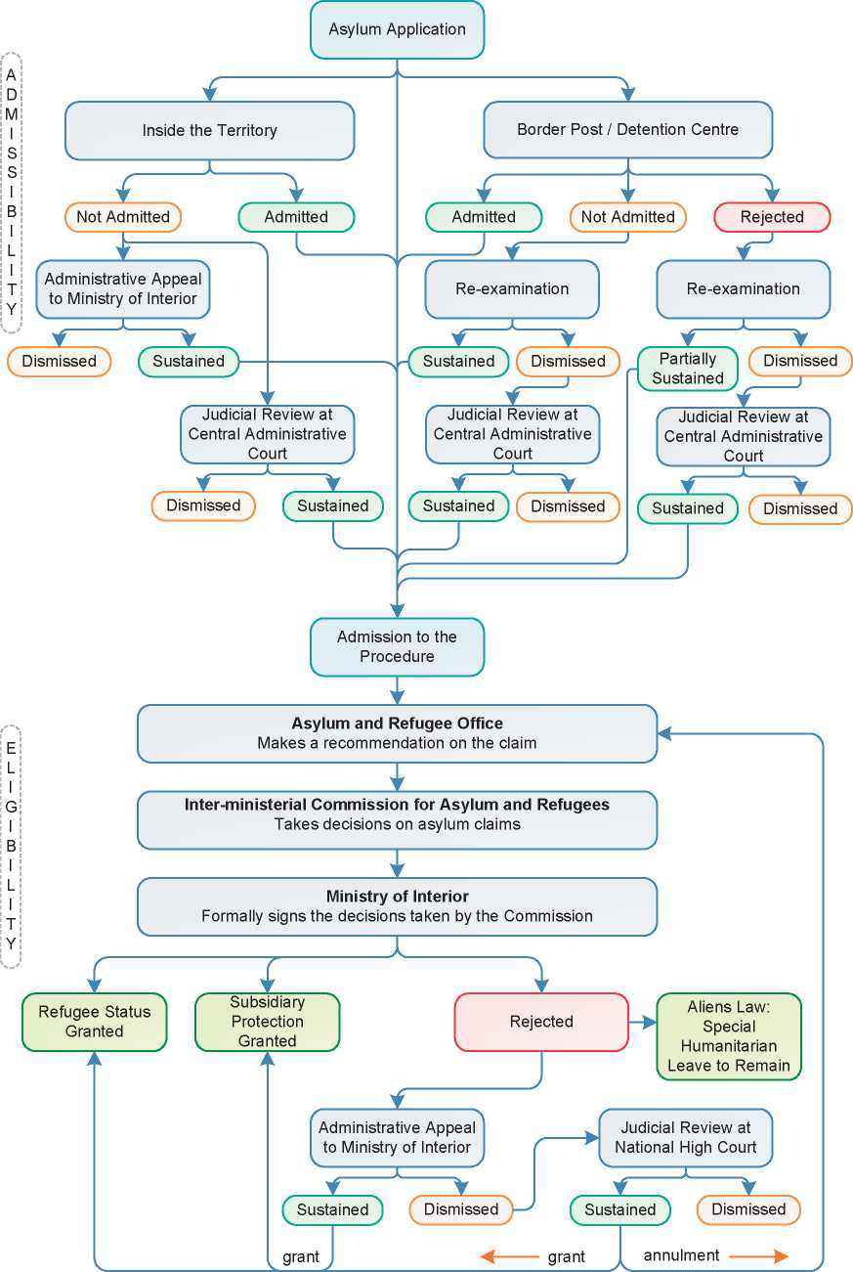

1. Additional Statistical Information

Figure 4: Asylum Applications from Top 10 Countries of Origin in 2009, 2010, 2011 and first half of 2012

**2009 2010 2011 Jan-Jun 2012**

|  |  |  |  |  |  |  |  |  |
| --- | --- | --- | --- | --- | --- | --- | --- | --- |
| **1** | Nigeria | 459 | Cuba | 406 | Ivory Coast | 550 | Nigeria | 114 |
| **2** | Ivory Coast | 304 | Nigeria | 237 | Cuba | 440 | Syria | 100 |
| **3** | Colombia | 256 | Algeria | 176 | Nigeria | 259 | Algeria | 86 |
| **4** | Algeria | 181 | Guinea (Co.) | 166 | Guinea (Co.) | 150 | Cameroon | 67 |
| **5** | Guinea (Co.) | 130 | Cameroon | 156 | W Bank & Gaza S, | 132 | Ivory Coast | 64 |
| **6** | D.R. Congo | 113 | Colombia | 123 | Western Sahara | 131 | Pakistan | 45 |
| **7** | Cameroon | 112 | Ivory Coast | 119 | Cameroon | 129 | Cuba | 42 |
| **8** | Somalia | 104 | Morocco | 114 | Algeria | 122 | Ethiopia | 39 |
| **9** | Cuba | 84 | W Bank & Gaza S. | 90 | Colombia | 104 | D.R. Congo | 38 |
| **10** | Morocco | 72 | D.R. Congo | 87 | Syria | 97 | Sudan | 38 |

**Figure 5: Decisions Taken at the First Instance in 2009, 2010 and 2011**

|  |  |  |  |  |  |  |  |  |  |
| --- | --- | --- | --- | --- | --- | --- | --- | --- | --- |
|  | **Geneva Convention** | | **Subsidiary/**  **Complementary**  **Protection and Humanitarian Status** | | **Rejections** | | **Withdrawn, Closed, Abandoned Cases** | | **Grand**  **Total** |
| **Number** | **%** | **Number** | **%** | **Number** | **%** | **Number** | **%** | **4,441** |
| **2009** | 179 | 4% | 172 | 4% | 4,090 | 92% | 0 | 0% |
| **2010** | 13 | 1% | 3 | 0% | 1,529 | 99% | 0 | 0% | **1,545** |
| **2011** | 1 | 0% | 21 | 2% | 1,185 | 98% | 0 | 0% | **1,207** |



**Figur e 6.a: Positive 11 First-Instance Decisions, Top Countries of Origin in 2009**

**Rate out of Total Decisions [263] [264]**

|  |  |  |  |  |
| --- | --- | --- | --- | --- |
|  | | **Total Positive** | **Total Decisions** | **Rate** |
| 1 | Cuba | 46 | 134 | 34.3% |
| 2 | Iraq | 36 | 44 | 81.8% |
| 3 | ***W.*** Bank & Gaza S. | 33 | 39 | 84.6% |
| 4 | Ivory Coast | 27 | 390 | 6.9% |
| 5 | D.R. Congo | 26 | 126 | 20.6% |
| 6 | Colombia | 24 | 1,028 | 2.3% |
| 7 | Sri Lanka | 24 | 32 | 75.0% |
| 8 | Pakistan | 11 | 63 | 17.5% |
| 9 | Iran | 10 | 69 | 14.5% |
| 10 | Afghanistan | 9 | 56 | 16.1% |
| 11 | Equatorial Guinea | 9 | 31 | 29.0% |
| 12 | Russia | 9 | 79 | 11.4% |

Total Positive Decisions by Status

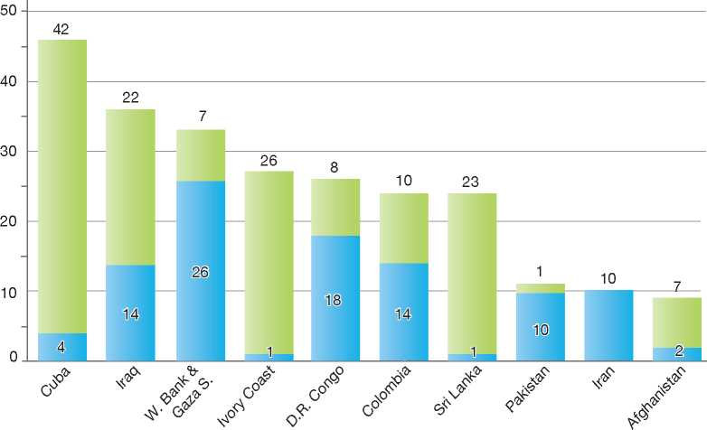

**Total Positive Decisions by Status**

Geneva Convention Status | | Subsidiary/Complementary Protection and Humanitarian Status

**Figure 6.b: Positive 11 First-Instance Decisions, Top Countries of Origin in 2010**

**Rate out of Total Decisions [265] [266]**

|  |  |  |  |  |
| --- | --- | --- | --- | --- |
|  | | **Total Positive** | **Total Decisions** | **Rate** |
| 1 | Colombia | 7 | 359 | 1.9% |
| 2 | Cuba | 4 | 17 | 23.5% |
| 3 | Belarus | 3 | 7 | 42.9% |
| 4 | Equatorial Guinea | 1 | 6 | 16.7% |
| 5 | Morocco | 1 | 31 | 3.2% |

Total Positive Decisions by Status

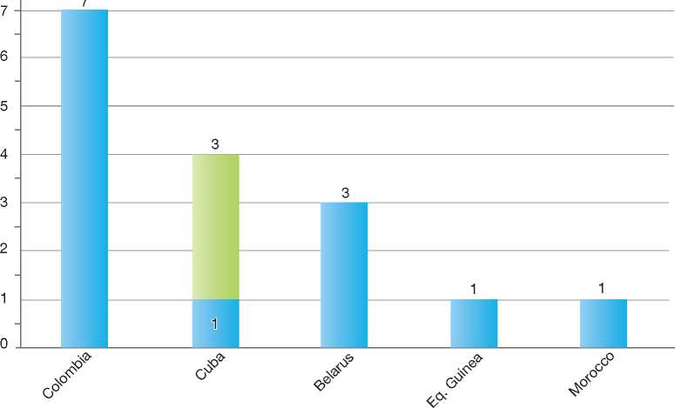

**Total Positive Decisions by Status**

| Geneva Convention Status | | Subsidiary/Complementary Protection and Humanitarian Status



**Figure 6.c: Positive 11 First-Instance Decisions, Top Countries of Origin in 2011**

**Rate out of Total Decisions [267] [268]**

|  |  |  |  |  |
| --- | --- | --- | --- | --- |
|  | | **Total Positive** | **Total Decisions** | **Rate** |
| **1** | **Ivory Coast** | 12 | 110 | 10.9% |
| **2** | **Colombia** | 4 | 257 | 1.6% |
| **3** | **Bangladesh** | 2 | 14 | 14.3% |
| **4** | **Afghanistan** | 1 | 16 | 6.3% |
| **5** | **Algeria** | 1 | 47 | 2.1% |
| **6** | **Liberia** | 1 | 8 | 12.5% |
| **7** | **Uganda** | 1 | 7 | 14.3% |

Total Positive Decisions by Status

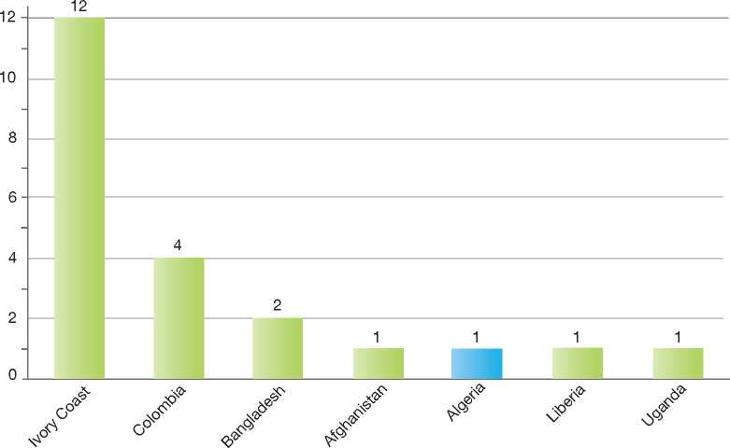

**Total Positive Decisions by Status**

| Geneva Convention Status | | Subsidiary/Complementary Protection and Humanitarian Status

Sweden

1. BackGRound: MajoR asyluM tRends and developMents 385
2. national leGal FRaMewoRk 387
3. institutional FRaMewoRk 387

4. pRe-entRy MeasuRes 388

5. asyluM pRoceduRes 389

1. decision-MakinG and statuses 393
2. eFFiciency and inteGRity MeasuRes 396
3. assistance and Reception BeneFits FoR asyluM-seekeRs 398
4. status and peRMits GRanted outside the asyluM pRoceduRe 400

10. RetuRn 400

11. inteGRation 401

12. annexes

403



1. Background: Major Asylum Trends and DevelopmentsBetween 1 January 2012 and 30 September 2012, 4,297 Syrians sought protection in Sweden, which is more than nine times as many as in the same period in 2011.

Asylum Applications

Important Reforms

The number of annual asylum applications in Sweden increased significantly in the late 1980s, reaching a peak of 84,000 in 1992. However, the number of applications decreased considerably in the late 1990s, then started to increase again in 2001, reaching a peak in 2007 at 36,000 applications. That year, Sweden was the top country of destination for asylum-seekers among IGC Participating States and in the European Union. The number of applicants in 2010 was 31,819 and 29,648 in 2011.

Until 2006, asylum procedures were governed by the Aliens Act 1989:529. In 1992, the Aliens Appeals Board, an independent authority, was created to replace the Government[269] as the second instance decision-making authority. However, the Aliens Appeals Board and the Swedish Migration Board (the first instance decision-making body) could refer individual cases to the Government for a guiding decision taken collectively by the ministers.

Figure 1: Total Asylum Applications by Quarter, January 1994 - June 2012

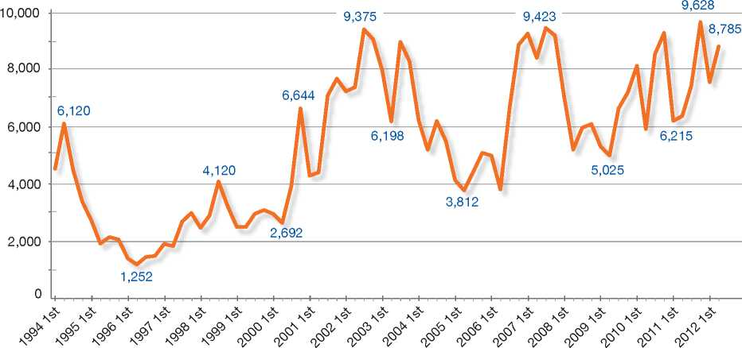

**Top Nationalities**

In 1997, the Aliens Act was the subject of important amendments, including the following:



In the 1990s, Sweden received asylum claims mainly from the former Yugoslavia, Iraq, Somalia and Iran. Since 2000, there has been only a minor shift in the top countries of origin, with asylum­seekers originating mostly from Iraq, Serbia, Russia and Somalia. The top five nationalities of asylum­seekers in 2011 were Afghanistan, Somalia, Iraq, Serbia, and Eritrea. There was a large increase in the number of asylum-seekers originating from the Balkans in 2010 and in 2011, mainly due to the removal of a visa requirement to travel to the EU. In 2012, the number of asylum-seekers from Syria increased rapidly. In September 2012 alone, 1,326 Syrian asylum-seekers arrived in Sweden.

• The concepts of *de facto* refugee and war resister were replaced by specific rules regarding which categories of persons, in addition to Convention refugees, might receive protection. These categories included persons who faced a risk of being subjected to the death penalty, corporal punishment or torture, persons fleeing armed conflicts and persons who risk being subjected to persecution ongender-related grounds or on the ground of sexual orientation

• The possibility for family reunification for persons granted protection was restricted to the nuclear family (spouse, children).

A new Aliens Act was introduced in 2006 with the objective of improving the transparency and efficiency of the asylum procedure. The Act established a new appeals procedure to extend possibilities for an asylum-seeker to obtain an oral hearing on his or her case. The Aliens Appeals Board was abolished and replaced by three Migration Courts and a Migration Court of Appeal. The Government lost the ability to make precedent-setting decisions. Precedent-setting decisions are now made by the Migration Court of Appeal.

Moreover, the 2006 reforms made a clear distinction between grounds for international protection and all other, non-protection-related grounds for granting a residence permit. The article regarding humanitarian grounds in the previous Aliens Act was not transferred to the new Act. If a residence permit cannot be awarded on other grounds, a permit may now be granted on the basis of exceptionally distressing circumstances*.* The grounds for obtaining refugee status were broadened to include gender-related persecution, including persecution based on sexual orientation[270].

In January 2010, certain amendments to the Swedish Aliens Act entered into force that aimed to adapt the Act to the Qualification Directive and the Asylum Procedures Directive. Under the new rules, a refugee or other person in need of protection will now receive a formal declaration

**Figure 2: Asylum Applications Received from Top 5 Countries of Origin in 2009, 2010 and 2011**

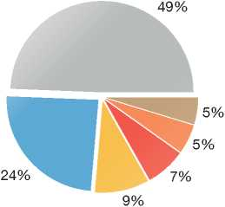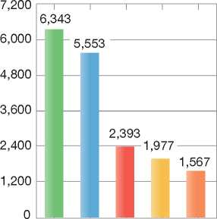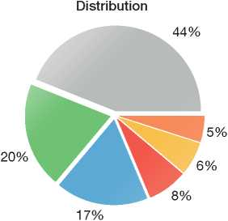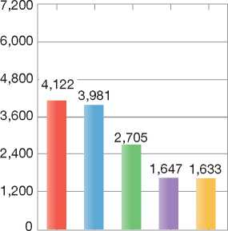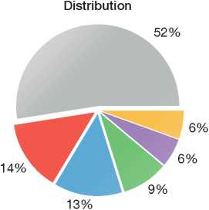

| 6,000  4,800  3,600  2,400  1,200  0 | 5,8 | 374 |
| --- | --- | --- |
|  |  |
|  | 2,297 |
|  | 1,694  ■ 1,239 1,144 |
|  | inn |
|  | **Distribution** |

**2009**

**Volumes**

7,200 —r

2010

Volumes

2011

Volumes

|  |  |  |
| --- | --- | --- |
| **Country of Origin:** | | |
| | Afghanistan Eritrea | Iran | Iraq |
| Kosovo Serbia | Somalia | Others |



confirming his or her status. As a result of the amendments, there are now three categories of persons in need of protection in the Aliens Act: refugees, persons eligible for subsidiary protection, and other persons in need of protection. Refugees and persons eligible for subsidiary protection are covered by the Qualification Directive. The third category, other persons in need of protection, is a national protection category.

1. National Legal Framework
   1. Legal Basis for Granting Protection

The asylum procedure is governed by the Aliens Act (2005:716), the Aliens Ordinance (2006:97), the Reception of Asylum-Seekers and Others Act (1994:137) and the Reception of Asylum-Seekers and Others Ordinance (1994:361). The 1951 Convention relating to the Status of Refugees (along with Council Directive 2004/83/EC[271]) is included in chapter 4, section 1 and chapter 12, section 2 in the Aliens Act. The Convention Against Torture (CAT), the European Convention on Human Rights (ECHR) and Council Directive 2004/83/EC are included in chapter 4, section 2 and chapter 12, section 1 of the Aliens Act.

On the basis of this legal framework, Sweden grants Convention refugee status to persons meeting the criteria set out in the 1951 Convention and subsidiary protection to persons otherwise in need of protection.

* 1. Pending Reforms

In December 2007, the Government established an inquiry to examine the reception of asylum­seekers*.* The inquiry was guided by a set of starting points, namely, that the reception of asylum-seekers should be designed to support an efficient asylum procedure and to facilitate the efficient return of rejected asylum-seekers.

The inquiry was requested to examine the following elements:

* Accommodation facilities at reception centres run by the Migration Board
* The financial benefits available to asylum­seekers during the procedure
* The integration of persons who are granted permits
* The return of rejected asylum-seekers
* Services provided to asylum-seekers with special needs
* Possibilities for improving cooperation between the Migration Board and local councils, municipalities, government agencies, non­governmental organisations and other stakeholders involved in reception in order to improve asylum­seekers' possibilities to support themselves.

A Commission of Inquiry on Detention was established in 2010 to carry out an examination of the legal framework for detention under the Aliens Act, reviewing the current legislation and regulations, as well as presenting any suggestions for improving the current system of detention. The Commission presented its final report in February 2011. In May 2012 the Return Directive[272] was implemented into Swedish legislation, together with parts of the recommendations from the report.

The Swedish Migration Board is also working on increasing efficiency in the asylum process by improving the case handling process, as well as by using an eMigration system that will permit a better determination of a person's identity.

In March 2012, the Swedish Government and the Green Party concluded a framework agreement on migration and asylum policy. Changes foreseen in the agreement include, *inter alia*, a revision of the right to education of children present in the country without a permit, and broadened access to subsidised health and medical care for asylum­seekers, which now also includes rejected asylum­seekers and undocumented persons who did not apply for a residence permit in Sweden.

In 2012, a new commission was established to examine the language and formulations of decisions and judgments in migration cases.

1. Institutional Framework
   1. Principal Institutions

The Swedish Migration Board is an independent body responsible for examining all asylum applications made in Sweden and for the reception of asylum-seekers. The Migration Board assesses questions concerning refugee protection and complementary forms of protection within a single asylum procedure. The Board also provides return assistance to persons returning to the country of origin and is involved in the resettlement of refugees to Sweden.

The Migration Courts process appeals of the Migration Board's decisions on asylum claims. There are three Migration Courts located within the County Administrative Courts in Stockholm, Goteborg and Malmo. Recently it was decided that a fourth Migration Court will be situated in LuleS.

The Migration Court of Appeal, which is situated at the Administrative Court of Appeal in Stockholm, processes appeals of the Migration Courts' decisions when a leave to appeal has been granted.

It is the last instance in regular asylum claims.

The Migration Board can hand over cases concerning the enforcement of returns to the Police.

* 1. Cooperation between Government Authorities

The Migration Courts and the Migration Court of Appeal work independently from the Migration Board and the Government Authorities. When it comes to decision-making, in order to uphold the independence of the Migration Board, there is no consultation between the Migration Board and the Ministry of Justice on individual cases.

1. Pre-entry Measures
   1. Visa Requirements

As of 5 April 2010, the EU Visa Code applies as law in Sweden. Through the Visa Code, the provisions on visas for a period shorter than three months are brought together under one EU Regulation. The Visa Code applies to all Schengen countries. As a result of the Agreement, Schengen countries have abolished border controls for people travelling between these countries. A visa granted by any one of these countries is also valid for visits to the others. In exceptional cases, the visa may only be valid for entry into the issuing country or only for certain countries if the holder's passport is not approved by all the Schengen countries.

A visa entails permission to enter and stay in the Schengen area (including Sweden) for a short period of time. A visa is time-limited and is valid for a maximum of 90 days in any six-month period. Anyone who has spent 90 days in the Schengen zone must therefore leave the area for 90 days before they can be granted a new Schengen visa.

* 1. Carrier Sanctions

Carrier sanctions are applicable to airplanes and ships. According to the Aliens Act, a carrier must check that passengers travelling to Sweden directly from a State that is not covered by the Schengen Acquis are in possession of a passport and the permits required to enter the country. The carrier must also check that the person has funds to pay for the journey home.

At the request of a police authority, a carrier transporting passengers to Sweden by air directly from a State that does not belong to the European Union and has not entered into an agreement on cooperation under the Schengen Convention with States parties to the Convention, must transmit information about arriving passengers as soon as check-in has been completed.

The information referred to consists of:

* The number and type of travel document used
* The nationality
* The full name
* The date of birth
* The border crossing point of entry
* The code of transport
* The departure and arrival time of the transportation
* The total number of passengers carried on the transport, and
* The initial point of embarkation.
  1. Interception

Sweden does not carry out pre-departure clearance in countries of origin or transit. However, Immigration Liaison Officers or Liaison Officers posted abroad may assist local border authorities or airline staff in verifying documents and may upon request organise training on detecting fraudulent documents.

1. Asylum Procedures
   1. Application Possibilities and Requirements, Procedures and Legal Remedies

Asylum applications can be made at the border and in-country at Migration Board application units in Malmo, Goteborg, Stockholm, Gavle and Norrkoping. There is no time limit for applying. Information leaflets on the asylum procedure in Sweden, the Dublin procedure and detention and reporting requirements are available in various languages.

* + 1. Outside the Country Applications at Diplomatic Missions

Applications for asylum made at diplomatic missions are in principle not granted.

Resettlement/Quota Refugees

Sweden has a long-standing tradition of accepting quota refugees and has had a regular, yearly resettlement program in place since the 1950s. The program is carried out in close cooperation with the UNHCR. In recent years, the annual resettlement quota has been around 1,900 persons. A part of the quota is allocated for emergency cases, which are referred to Sweden by the UNHCR. The Swedish Parliament decides upon the size of the annual quota and the Migration Board examines the cases and grants residence permits to persons in need of protection within the program.

Decisions are made on the basis of interviews conducted by the Migration Board abroad or on a dossier basis after referrals by the UNHCR. The quota is only for persons in need of protection. Those who are granted residence permits within the resettlement program receive status either as refugees, persons eligible for subsidiary protection or other persons in need of protection in accordance with the Aliens Act. All those selected receive permanent residence permits. The permit allows a person to live, work and travel freely in Sweden.

* + 1. At Ports of Entry

The Police are responsible for regulating the entry of persons at airports, seaports and border posts. A foreign national arriving in Sweden may state his or her intent to make an asylum application with the Police either at border control or upon being refused entry. Information about such intent is transferred to the Migration Board, where the applicant must lodge his or her asylum application in person.

* + 1. Inside the Territory

Responsibility for Processing the Claim

The Dublin System

*Application and Procedure*

Before an asylum claim can be examined on its merits, the Migration Board must first determine whether Sweden is responsible for processing the claim under the Dublin II Regulation. If another State party to the Regulation is responsible for processing the application, the Migration Board issues a decision to transfer the asylum-seeker to that country. In this instance, the applicant does not have a right to public counsel. However, the Migration Board must conduct an oral interview with the applicant and examine his or her reasons for preferring the asylum procedure to take place in Sweden.

*Freedom of Movement/Detention*

The Migration Board may decide to detain asylum­seekers subject to the Dublin procedure, in accordance with provisions in the Aliens Act that are applicable to all stages of the asylum procedure[273].

*Suspension of Dublin Transfers*

If the asylum-seeker appeals a transfer decision, the Migration Courts or the Migration Court of Appeal may order the transfer to be suspended.

*Review/Appeal*

The asylum-seeker can appeal the Migration Board's decision to transfer the application for processing in another State party to the Dublin II Regulation. The appeal must be made within three weeks of notification of the decision. The grounds for asylum are not examined during the appeal and the asylum-seeker may be forced to leave Sweden during the appeal procedure, unless a suspension of transfer has been ordered by the Court.

Application and Admissibility

An asylum application can only be made if the applicant is physically present. When filing an asylum application, the asylum-seekers are requested to:

* Provide relevant information, such as identity documents and date of arrival (identity documents may be retained by the SMB)
* Have their photographs and fingerprints taken
* Appear at an interview with the Migration Board, if possible on the same day the asylum claim is filed or else as early as possible thereafter.

In addition to determining whether the person is subject to the Dublin II Regulation, as described above, the Migration Board must also determine whether the application is subject to the principle of first country of asylum[274]. In both cases, the asylum­seeker may be transferred to the applicable State for an examination of his or her claim.

The Migration Board undertakes an initial examination of the claim. At this stage, the Migration Board may decide that the claim falls under one of the following categories:

* The claim meets criteria for an accelerated procedure
* The claim is likely to meet criteria for protection; no public counsel is appointed
* The claim does not appear to meet criteria for protection; public counsel is appointed in order to assist the asylum-seeker through the procedure.

Accelerated Procedure

According to the Aliens Act[275], an asylum claim may be assessed under an accelerated procedure if it is deemed by the Migration Board to be manifestly unfounded. Under the accelerated procedure, the Board aims to reach a decision on the claim within three months. The Board may also remove the person from Sweden regardless of whether the decision has gained legal force (that is, all appeal possibilities have been exhausted).

The asylum-seeker may appeal the decision before one of the Migration Courts and further to the Migration Court of Appeal, if leave to appeal is granted. If refugee or other protection reasons are put forward as an impediment to the implementation of a removal order, the Migration Board or the Migration Courts can suspend the removal and the case may be re-examined. The appeal has suspensive effect if it is highly likely that the appeal will be granted, for example, if the asylum-seeker demonstrates that removal would lead to a risk of the death penalty, torture or other cruel treatment.

Normal Procedure

If, during the initial examination, the Migration Board determines that an asylum-seeker will be granted a permit, the case is examined without the appointment of public counsel. For other asylum­seekers, public counsel is appointed to assist applicants with their claim. Every asylum-seeker can contact the Migration Board case officer handling his or her case whenever necessary.

The case officer conducts one or several interviews with the applicant and makes a recommendation on the decision to the decision-making officer.

Review/Appeal of Asylum Decisions

An asylum-seeker who receives a negative decision on his or her claim may, within three weeks of being informed of the decision the decision, lodge an appeal at one of three Migration Courts. Before an appeal is sent to the Court, the Migration Board makes an informal review of the case. If the Migration Board stands by its decision, the appeal moves forward to the Migration Court.

The appeal before the Migration Court is a two- party process, in which the Migration Board is represented by a Litigation Officer and the asylum-seeker by a legal representative. An oral hearing can be conducted when deemed necessary by the Court.

There is a possibility to appeal the decision of the Migration Court before the Migration Court of Appeal after leave (permission) has been granted. A leave to appeal will be granted if the case is determined to contain elements that may benefit from court guidance on the application of the law or if there are other compelling grounds on which to grant the appeal. However, detention cases do not require leave to proceed to appeal before the Migration Court of Appeal.

Freedom of Movement during the Asylum Procedure

Detention

The Swedish Aliens Act (2005:716) explicitly states that the Act must be applied in a way that does not limit the freedom of persons more than necessary in each individual case. As a consequence, whenever possible, supervision shall be used instead of detention. Thus, a detention order is executed only if other, less coercive measures cannot be applied.

According to the Aliens Act, a person aged 18 or older can be detained in the following circumstances:

* If detention is necessary to enable an investigation to be conducted. In this case, the person may not be detained for more than 48 hours
* If the person's identity is unclear, either upon arrival in Sweden or when he or she subsequently applies for a residence permit. If the person cannot provide credible evidence of his or her identity, the person may be taken into detention for up to two weeks
* If it is likely that the person will not be granted a residence permit and/or will be required to leave Sweden, and there is reason to believe that he or she will go into hiding or pursue illegal activities in Sweden. If it is likely that the person will not be allowed to stay in Sweden, the detention period may not exceed two weeks. If a decision has already been issued for the person to leave Sweden, he or she may be detained for up to two months.

Detention periods in the last two cases described above can be extended if there are exceptional grounds for doing so. Since the Return Directive was implemented, a person may not be detained for more than a year unless he or she has been ordered to leave Sweden on account of a criminal conviction. A decision on detention may be appealed to a Migration Court at any time. The responsible authorities are further obliged to re­examine the decision to detain, at regular intervals.

Minors and Families

According to legislation, a minor may be detained in certain circumstances to facilitate his or her removal from Sweden. However, this is rarely done in practice.

A child may not be separated from his or her custodian by detaining either the child or the custodian. A child without a custodian in Sweden may be detained only if exceptional grounds exist for doing so.

A child may not be detained for more than 72 hours or, if exceptional grounds exist, for no longer than an additional 72 hours.

There are areas inside detention facilities designed specifically for children and families. In some parts of Sweden, detention facilities are located next to open accommodation centres. These facilities allow authorities to accommodate a parent and a minor together in the open accommodation centre while another parent is being detained.

Conditions in Detention

Detention facilities run by the Migration Board have been designed to provide surroundings and services similar to those available in regular reception centres. For example, activities, outdoor exercise and visiting privileges are available in detention facilities. The Migration Board cooperates with volunteer organisations, churches and community groups to offer support to detained asylum-seekers.

Supervision

Instead of detaining a foreign national, the Migration Board or the Police may decide that placing the person under supervision is sufficient. Children can also be placed under supervision in certain cases. If the person is under supervision, he or she must report to the responsible authority at specified times and at a specified location. The authorities may impose other reporting conditions as required.

Repeat/Subsequent Applications

There is no possibility to get a repeat application examined or reviewed. However, in a case concerning the enforcement of a refusal-of-entry or expulsion order that has become final and non-appealable, the Migration Board can decide to examine whether new circumstances that have arisen would result in an impediment to the implementation of removal.

If the foreign national invokes new circumstances that can be assumed to constitute a lasting impediment to enforcement, the Migration Board may, if a residence permit cannot be granted without an examination, re-examine the matter of a residence permit and issue an order staying the enforcement case.

A prerequisite to granting a re-examination is that the circumstances could not previously have been invoked by the person, or the person shows a valid reason for not having invoked these circumstances previously. If these conditions are not fulfilled, the Migration Board may decide not to grant a re-examination.

The Migration Board's decision not to grant a re­examination or not to grant a permanent residence permit after a re-examination may be appealed to a Migration Court.

If the Migration Board decides to issue a stay of enforcement order, it may appoint a public counsel if deemed necessary.

* 1. Safe Country Concepts
     1. Safe Country of Origin

Sweden does not apply a general principle of safe country of origin. Every case is assessed on its individual merits.

Asylum Claims Made by EU Nationals

Sweden considers that the Spanish Protocol, which is annexed to the Treaty of Amsterdam, does not limit EU Member States' obligations under the 1951 Convention. When an EU national applies for asylum, the Migration Board must immediately inform the Ministry for Foreign Affairs, which then immediately informs the Council of the European Union. When examining an asylum claim made by an EU national, the Migration Board tries to do the examination in an accelerated procedure. The Board may issue a decision to refuse entry and request that the decision be implemented before the decision becomes final and non-appealable.

* + 1. First Country of Asylum and

Safe Third Country

According to chapter 5, section 1 of the Aliens Act, an asylum application may be dismissed if the applicant has been declared a refugee in another EU State, or has been declared a refugee in a country that is not an EU State but has equivalent protection available. A further requirement is that the applicant be allowed entry into that third country and is protected there against persecution and against being sent to another country where he or she risks persecution.

An asylum application may also be dismissed if the applicant can be sent to a country where he or she does not risk being subjected to persecution, and does not risk the death penalty, corporal punishment, torture or other inhuman or degrading treatment or punishment. The applicant must also be protected in that country against being transferred to a country where he or she does not have equivalent protection or have the opportunity to apply for protection as a refugee. In addition, it must be reasonable for him or her to travel to the country to which he or she is being sent.

However, there may be circumstances under which an application may not be dismissed when the applicant has members of his or her family in Sweden, or he or she has acquired special ties to Sweden because of a previous extended stay in Sweden on a residence permit.

The current rules on First Country of Asylum and Safe Third Country entered into force in January 2010 as a result of amendments that were made to the Swedish Aliens Act aimed at adapting the Act to the Asylum Procedures Directive[276].

* 1. Special Procedures
     1. Unaccompanied Minors

The number of asylum applications made by unaccompanied minors (UAMs) has been increasing in recent years. In 2010 and 2011, the Migration Board received 2,393 and 2,657 applications from UAMs, respectively.

Procedures

The Migration Board prioritises applications made by UAMs and processes these cases within a maximum period of three months. Special procedural arrangements are made as follows:

* A trustee is appointed by the municipality's chief guardian's office to represent the UAM and protect his or her interests
* Asylum interviews are conducted by specially trained staff, who use a special interview guide and adjust the questions to the UAM's age and maturity level
* If a residence permit cannot be awarded on other grounds, a permit may be granted if there are “exceptionally distressing circumstances”. Such circumstances may include health, adaptation to Sweden and the person's situation in the country of origin. Children may be granted residence permits under this section even if the circumstances that come to light do not have the same seriousness and weight that are required for a permit to be granted to adults under the same provision
* A minor is not returned to the country of origin if he or she cannot be received by a member of his or her family or a nominated guardian, or if there are no adequate reception facilities in the State to which he or she is to be returned.

|  |  |  |  |
| --- | --- | --- | --- |
| **Figure 3: Asylum Applications by Unaccompa­nied Minors in 2009, 2010 and 2011** | | | |
|  | **2009** | **2010** | **2011** |
| Total Asylum Applications | 24,194 | 31,819 | 29,648 |
| of which Unaccompanied Minors | 2,250 | 2,393 | 2,657 |
| Percentage | 9% | 8% | 9% |

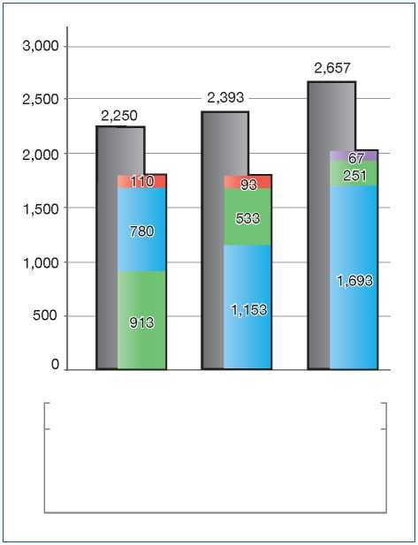Age Assessment

| 2009 | 2010 2011 |
| --- | --- |
| **Country of Origin:** |  |
| Afghanistan | | Iraq |
| | Serbia | Somalia |

The Migration Board makes an initial assessment of the minor's age based on an interview, travel documents and supplementary information (such as information obtained from the municipality where the minor lives). The minor may request or be offered a complementary medical examination to be used when assessing his or her age.

* + 1. Temporary Protection

Chapter 21 in the Aliens Act provides protection according to Council Directive 2001/55/EC[277]. The Swedish Migration Board is responsible for making decisions under this provision. The granting of a temporary residence permit does not exempt a person from the examination of his or her asylum application or an application for a travel document for refugees. Asylum-seekers already in the asylum procedure may be granted temporary protection according to this provision if a residence permit is not granted on other grounds.

* + 1. Stateless Persons

Under the Aliens Act, stateless persons are treated in the same manner as persons with citizenship - that is, stateless persons may apply for asylum as can all other asylum-seekers. The definition of a refugee in the Aliens Act explains that the asylum application of a stateless person is assessed against conditions prevalent in the last country of habitual residence.

After a refusal-of-entry or expulsion order has been served, difficulties in returning a stateless person to the country of former habitual residence may eventually result in a temporary or permanent residence permit being granted (under impediment to enforcement provisions).

1. Decision-Making and Status
   1. Inclusion Criteria

When making a determination on an asylum claim, the Migration Board must first consider whether the person meets criteria for refugee status and, failing that, whether other grounds for protection are met. The Migration Board is also competent to grant permits where no protection-related grounds for a residence permit exists, that is, in cases of exceptionally distressing circumstances or as a result of impediments to the implementation of a removal order.

* + 1. Convention Refugee

The definition of a refugee is provided in chapter 4, section 1 of the Aliens Act. The definition follows the criteria in the 1951 Convention relating to the Status of Refugees. Gender or sexual orientation may determine membership in a particular social group. A person who is a refugee will be granted a status declaration.

* + 1. Subsidiary Protection

Persons who do not qualify for Convention refugee status may meet the criteria for subsidiary protection or for protection as “a person otherwise in need of protection”, a category of protection specific to Sweden.

Subsidiary protection is granted to applicants who are in danger of the following:

* Punishment by death
* Physical punishment, torture or other inhuman and degrading treatment
* As a civilian, a risk to physical integrity because of armed conflict.

Protection as “persons in need of protection”, as covered in chapter 4, section 2a of the Aliens Act, is granted to a person who is outside the country of nationality because he or she:

* Needs protection because of an external or internal armed conflict or because of other severe conflicts in the country of origin
* Feels a well-founded fear of being subjected to serious abuses, or
* Is unable to return to the country of origin because of an environmental disaster.
  + 1. Non-Protection-Related

Status

Exceptionally Distressing Circumstances

According to the Aliens Act, a residence permit may be granted in the case of exceptionally distressing circumstances. Under this provision, the state of health, the level of integration, and the situation in the country of origin of the asylum­seeker are taken into consideration.

Impediment to Enforcement of a Refusal-of- Entry or Expulsion Order

A temporary residence permit may be granted if there is a temporary impediment to the enforcement of a refusal-of-entry or expulsion order. Such a determination may be made following a re-examination of the asylum application after the asylum-seeker has raised issues regarding impediments to removal[278] [279].

If the impediment is permanent in nature, a residence permit may be granted on Convention grounds, on subsidiary protection grounds, or because of exceptionally distressing circumstances.

* 1. The Decision

Decisions are made by the decision-making officers of the Migration Board who examine the merits of the claim. The Legal Affairs unit within the Migration Board supervises the decision-making process in the first instance.

The applicants are notified of the decision orally. All decisions for residence permits or long-term residence status in Sweden must contain the reasons on which the decision is based.

* 1. Types of Decisions, Status and Benefits Granted

Benefits

Recognised refugees and other persons in need of protection are entitled to the same rights and obligations as are all inhabitants of Sweden. Refugees and persons in need of protection obtain the following benefits:

* Right of status
* Permanent residence (PUT) or temporary residence permit valid for at least three years
* Right to work or study
* Right to settle anywhere, and
* Support to find housing in a municipality.

Furthermore, refugees can apply for a travel document valid for all countries except the country of origin, and for a maximum and non-renewable period of five years[280]. Persons benefiting from subsidiary protection may apply for an alien's passport according to chapter 2, sections 12-160 of the Aliens Ordinance (2006:97).

Convention refugees and persons in need of protection may apply for citizenship after having resided in Sweden for four years.

* 1. Exclusion

Article 1F of the 1951 Convention is applicable to refugees and to persons in need of protection. However, persons who have a well-founded fear of being subjected to the death penalty or other cruel punishment if returned to the country of origin -

including those who have been excluded from protection - will not be removed from Sweden.

According to chapter 4, sections 2 b - c, a person is excluded from international protection where there are serious reasons for considering that:

* He or she has committed a crime against peace, a war crime, or a crime against humanity
* He or she has committed a serious non-political crime outside Sweden, or
* He or she has been guilty of acts contrary to the purposes and principles of the United Nations as set out in the Preamble and Articles 1 and 2 of the Charter of the United Nations.

1. Refugee Protection

According to the Aliens Act, a residence permit may be refused to a person who meets the criteria for Convention refugee status but who is found to have previously engaged in terrorist- related activities, genocide and war crimes, or to raise concerns of national security. If the person excluded from refugee status has a well-founded fear of being subjected to the death penalty or other cruel punishment if returned to the country of origin, then he or she may be granted a temporary residence permit. Provisions in the Aliens Act on impediments to enforcement of removal (chapter 12, section 1) are also applicable in this instance.

1. Complementary Protection

A person in need of protection as outlined in chapter 4, section 2 of the Aliens Act may be subject to exclusion if he or she is found to have engaged in criminal activities, terrorist-related activities, genocide or war crimes, or raises concerns of national security. However, if the person has a well-founded fear of being subjected to the death penalty or other cruel punishment if returned to the country of origin, then he or she may be granted a temporary residence permit. Return would not be implemented if provisions relating to impediments to enforcement of removal were applicable.

The Migration Board is responsible for making a decision on exclusion at the first instance. The decision may be appealed to the Migration Courts and to the Migration Court of Appeal.

* 1. Cessation

The Migration Board may make a decision to apply cessation clauses if one of the conditions set out in chapter 4, section 5 (refugees) and section 5 a (persons who otherwise need international protection) of the Aliens Act is met. Only clear, profound and lasting changes in the country of origin or former residence may be taken into consideration. Cessation may arise when a refugee is applying for travel documents or has committed a criminal offence that has resulted in a removal order.

* 1. Revocation

The rules for withdrawal of permits are laid out in chapter 7 of the Aliens Act. Decisions on withdrawals of residence permits are made by the Migration Board.

Residence permits may be withdrawn from a person who has knowingly supplied incorrect information or knowingly suppressed information that was important for obtaining a permit. If the permit holder has resided in Sweden for more than four years when the question of withdrawal is examined, the residence permit may be withdrawn only if there to be taken, are exceptional grounds for such an action as outlined in chapter 7, section 1 of the Aliens Act.

A permanent residence permit may be withdrawn from a person who is no longer resident in Sweden. In the case of a refugee or a person otherwise in need of protection in this country, however, the residence permit may be withdrawn at the earliest two years following the person's departure from Sweden for a country in which he or she previously resided and in which political conditions have changed.

* 1. Support and Tools for Decision-Makers
     1. Country of Origin Information (COI)

The COI unit of the Swedish Migration Board is made up of about 15 persons providing research and information support to caseworkers. The COI unit consists of different geographical teams staffed by COI researchers and analysts.

The COI unit collects relevant information from reliable international and domestic sources. The staff members answer questions from caseworkers and produce reports on different topics. The COI analysts conduct fact-finding missions to countries of origin. These fact-finding missions try to answer different questions and offer a basis for analysis, for example, regarding the situation for a certain minority group in a country. Special efforts have been made since 2011 to collect information of interest concerning unaccompanied minors. This involves possibilities to trace family members of, and the existence and standards prevalent in, orphanages.

One of the elements of the legal reform introduced by the new Aliens Act in 2006 was increased transparency of the asylum process. In order to achieve this, it was decided that the country information gathered by the Swedish Migration Board should, to the greatest possible extent, be publicly accessible. Information from Lifos, the COI database, is publicly available through the Migration Board's website, as are decisions from the Court of Appeal *(Migrationsoverdomstolen),* the European Court of Human Rights, the Court of Justice of the European Union and the Committee against Torture.[281]

Migration Board Beyond Borders, 2009-2010

This project was initiated with the strong support of the Director General of the Swedish Migration Board in early 2009. The project's main actions were knowledge production, knowledge dissemination and communication on asylum issues related to gender, sexual orientation and gender identity. Under the first action, two reports were written by independent consultants. One report examined how norms on sexuality and gender affect laws and practices with regard to migration and asylum (heterosexual interpretations, stereotypes, etc.). Another report focused on the representation of LGBTI12 persons in country of origin information and demonstrated a lack of information regarding sexual orientation and gender-related persecution. The lack of balanced information on gender and sexual orientation leaves room for stereotypes and the misconception that when there is no information there is no risk of persecution.

To disseminate knowledge on sexual orientation issues, training classes were organised for employees of the Swedish Migration Board. After the project was completed, the training material was integrated into the regular training for case officers at the Migration Board.

As a result of the project, the Swedish Migration Board is actively engaged in external communication on LGBTI-related issues, takes part in public debates, and is represented at the Stockholm Pride Festival. For a short period of time, a special Facebook group was used for the project.

After the project ended in December 2010, the Swedish Migration Board aimed to mainstream the outcomes of the project into all aspects of the Swedish asylum system. In order to do this, a new position of Coordinating Officer on gender and LGBTI issues was created. A proposal of how to further mainstream knowledge and awareness of LGBTI and gender issues was developed and was to have been be presented to the Director General in fall 2012.

* + 1. Language Analysis

The Swedish Migration Board may use language analysis as an investigation tool in cases where the asylum-seeker cannot prove his or her identity. Language analysis is not the sole instrument for determining the origin of an asylum-seeker. Questions regarding personal circumstances and knowledge tests on the region of origin are used together with language analysis.

The Swedish Migration Board has a contract with two independent companies that supply analysts through analysers and linguists. Most of the analysis is conducted as a telephone conversation between the analyst and the asylum-seeker, during which the analyst tries to analyse the speech. Sometimes the asylum­seeker's speech is recorded by an official at the Migration Board. The asylum-seeker is always informed before recordings take place, and the asylum-seeker's identity is always kept unknown to the companies and the analysts throughout the whole process. After receiving the recording from the Migration Board, the analyst conducts his or her analysis together with a linguist, who finalises the report of the language or dialect in question. The use of language analysis is not regulated by the Aliens Act or Aliens Ordinance, but the Swedish Migration Court of Appeal has in a precedent case made statements evaluating language analysis as evidence.

1. Efficiency and Integrity Measures
   1. Technological Tools
      1. Fingerprinting

The Swedish Migration Board and the National Police Board have the authority to collect fingerprints from persons over the age of 14. The fingerprints are searched and/or stored in the national fingerprint database as well as in EURODAC and the Visa Information System (VIS) in accordance with national and European legislation.

Since 2010, the Swedish Migration Board is also collecting fingerprints using multi-spectral fingerprint image technology (MSI) in order to secure fingerprints of sufficient quality where mutilation has rendered fingerprints unreadable by standard fingerprint scanners. Through theMSI, the acceptance rate[282] increased from around 85 per cent to over 95 per cent.

* + 1. DNA Tests

In cases concerning residence permits on grounds of family ties, the Migration Board may grant the applicant and the person to whom ties are cited an opportunity to have a DNA analysis performed to confirm the biological relationship cited in their application. A DNA analysis may be performed only if the person to be examined has been informed of the purpose of the DNA analysis and has given his or her written consent.

* + 1. Verification/Examination of Documents

The Swedish Migration Board has a unit for biometrics and document verification. Within this unit, a Document Team specialises in examining documents. This team carries out document training for Swedish Migration Board staff and consular personnel. The Document Team gives support to Swedish embassies and consulates around the world on document-related questions.

* + 1. Database of Asylum Applications/Applicants

All asylum applications and decisions are registered in a database, a registry in which all foreign nationals in Sweden are registered. The Migration Board also maintains a specific statistical database.

* 1. Length of Procedures

Generally, asylum claims must be processed within a six-month period (three months for unaccompanied minors), although the length of the procedure depends on factors such as the number of asylum-seekers who have arrived in Sweden in the months preceding the application and the complexity of the claims.

Lean Principles in the Asylum System

By adopting lean production principles, the Swedish Migration Board intends to reach a final decision on a claim within three months without infringing legal obligations or compromising the case-by-case assessment.

The Swedish interpretation of lean production is process-oriented and focused on the learning aspect. The asylum-seeker is placed at the centre of a client-based approach consisting of four main elements:

* Process efficiency
* Performance management
* Organisation and skills
* Mindsets and behaviours.

The system is beneficial not only to the organisation, but also to the individual asylum-seeker whose legal rights are enhanced. The process is more transparent and the interview takes place early in the process. Improvements are introduced systematically, and in a standardised manner.

**“Shorter Wait" Project**

“Shorter Wait” *(Kortare vantan),* a project applying the Lean method to the processing of asylum cases, is now implemented in all the stages of first instance asylum decision-making. The ideal amount of time for processing an asylum case - including the provision of legal aid - is considered to be three months. In 2011, 47 per cent of all asylum-seekers obtained their decision within that timeframe. 69 per cent of all asylum cases were processed within five months, which corresponds to the goal set by the Swedish Government.

Since the start of *“Kortare vantan",* the Swedish Migration Board has been able to reduce both the average time needed for processing an asylum application and the number of pending cases. By the end of 2008, the average processing time for an asylum application was 267 days, and there were 13,977 cases that had been pending for 160 days on average. At the end of 2009, the average processing time was 203 days, and there were 10,780 open cases that had been pending for 112 days. By the end of 2010, the average processing time had been further reduced and amounted to only 130 days. There were 11,417 open cases that had been pending for 139 days on average. Finally, by the end of the year 2011, the average processing time was 149 days.

* 1. Pending cases

As at 30 September 2012, there were 15,012 pending cases at the Swedish Migration Board.

* 1. Information Sharing

Sweden is party to the Dublin II Regulation and to agreements with Denmark, Norway, Iceland and Switzerland extending the application of the Dublin Regulation to those States. Specific information on asylum-seekers can be released

to other EU Member States, in accordance with Article 21 of the Dublin Regulation. Information about an asylum-seeker can only be released to a third country if the Official Secrecy Act allows this.

* 1. Single Procedure

Sweden has a single asylum procedure. Consequently, an asylum-seeker needs to make only one application for international protection in order to obtain either Convention refugee status or subsidiary protection. The Migration Board first determines whether the applicant meets the criteria for refugee status and, if this is not the case, it will then determine whether grounds exist for granting subsidiary protection.

Quality Assurance:

The Swedish Migration Board currently has a project called “the Learning Organisation", which aims to improve the quality review of asylum decisions. The project, which is co-financed by the European Refugee Fund, is based on the Lean work method. Concrete tools and methodologies are being developed for caseworkers to improve the legal quality of their work and to make the Migration Board a “learning" organisation. Self­reporting is one of the methods used.

1. Assistance and Reception Benefits for Asylum-Seekers
   1. Procedural Support and Safeguards
      1. Legal Assistance

At the first instance, legal assistance is provided in all cases except:

* When it is obvious to the Migration Board after a preliminary review of the case that the applicant will be allowed to remain in Sweden, or
* When the applicant may be sent to a third country for an examination of the alleged grounds for asylum.

Legal assistance is available during an appeal only if the decision that is being appealed has been combined with a removal order. A public counsel will then be appointed, unless it is assumed that legal counsel is not needed.

* + 1. Interpreters

If necessary, asylum-seekers are provided with the services of an interpreter during the asylum procedure.

* + 1. UNHCR

The UNHCR Regional Office for the Baltic-Nordic Region, located in Stockholm, has no formal role in the asylum procedure. However, upon the request of a party in the procedure, the UNHCR may provide updated country of origin information (COI), legal advice or UNHCR's recommendations and guidelines. The UNHCR may also submit *amicus curiae* to the courts.

The UNHCR, along with non-governmental organisations (NGOs), is entitled to provide legal counsel with specific country expertise and to intervene on behalf of an asylum-seeker during the asylum procedure. The Regional Office of the UNHCR for the Baltic-Nordic Region provides training, advice and information to NGOs and lawyers who have direct contact with asylum-seekers.

Due to provisions in the Swedish Secrecy Act, which aim to protect sensitive information regarding asylum-seekers, the UNHCR and NGOs must have a power of attorney in order to have access to information regarding a specific asylum­seeker and his or her case.

* + 1. NGOs

The Swedish Refugee Advice Centre is an NGO that aims to provide refugees and asylum-seekers with professional legal assistance. Advisors at the Centre can act as legal counsel in asylum cases. Current members supporting the Centre include Amnesty International (Swedish section), Caritas, the Swedish Trade Union Confederation, Save the Children, the Swedish Free Church Council, and the Church of Sweden.

* 1. Reception Benefits

The Swedish Migration Board is responsible for overseeing the reception of asylum-seekers. During the asylum procedure, applicants receive a document - the so-called LMA[283] card - identifying them as asylum-seekers.

* + 1. Accommodation

Asylum-seekers awaiting a decision on their claim may choose to arrange their own private accommodation or to stay at one of the Migration Board's reception centres. Over half of asylum-seekers choose to stay at one of the Migration Board's reception centres. The Migration Board also rents apartments to asylum­seekers. These apartments are found throughout Sweden. Unaccompanied minors (UAMs) are accommodated in group housing with specially trained staff.

* + 1. Social Assistance

The Migration Board provides asylum-seekers in need of financial assistance with a daily cash allowance to cover expenses such as food, clothing and personal hygiene. The rate of the daily cash allowance is as follows:

* SEK 71 (e 8) for adults; this is reduced to SEK 24 (e 3) if the asylum-seeker is provided with food by the Migration Board, and to SEK 61 (e 6,50)/ SEK 19 (e 2) for adults who cohabit
* Between SEK 37 (e 4) and 50 (e 5,50) for children, adjusted according to age.

Financial assistance is also provided for some separate expenses, such as prescriptions, eye glasses or provisions for infant care.

Persons who fail to cooperate with authorities during the asylum procedure, such as by missing appointments for scheduled interviews or not cooperating in disclosing their identity, may have their daily allowance cut as a result.

* + 1. Health Care

The municipal administrative board, with funding from the Migration Board, is responsible for covering most of the health care costs of asylum­seekers. For health care services that cost more than what is provided by the Board's funds, the municipal administrative board may apply to the Migration Board for payment of this cost.

Asylum-seekers are entitled to a voluntary medical examination[284] free of charge. They are charged a fee for emergency medical care, dental treatment, and medication. Minors are entitled to medical and dental care on the same terms and conditions as are other children in Sweden.

* + 1. Education

The municipality is responsible for offering education. While education is not mandatory, asylum-seeking children up to the age of 18 who wish to attend school may do so according to the same rules as those governing Swedish citizens.

All asylum-seekers aged between 16 and 65 years of age, regardless of their accommodation arrangements, have an obligation to take part in activities organised by the Migration Board. Examples of activities include Swedish language classes, maintenance tasks and practical placements in the reception centres. The Migration Board may reduce the amount of the daily cash allowance if the asylum-seeker does not take part in these activities.

* + 1. Access to Labour Market

On the condition that they cooperate in establishing their identity, asylum-seekers are exempt from the requirement of a work permit and are able to work without a work permit (the Migration Board issues a document that indicates that the asylum-seeker is exempt from the requirement). The asylum­seeker is then entitled to work until he or she leaves Sweden or is granted a residence permit.

Once a negative decision on the asylum case has gained legal force (that is, all appeal possibilities have been exhausted), the rejected asylum-seeker has an obligation to cooperate with the authorities on the implementation of the removal order. If this requirement is not met, the exemption from the requirement of having a work permit may be revoked.

If the asylum-seeker obtains a job for a period of longer than three months in a town where the Migration Board does not provide accommodation, he or she will be provided with a housing allowance.

New rules on labour migration came into force in 2008 stipulating that asylum-seekers whose applications have been denied may be granted a residence permit if they have been employed continuously for at least six months, and they are offered a position lasting at least one year.

* + 1. Access to Benefits by Rejected Asylum-Seekers

Asylum-seekers are entitled to social assistance, health care, accommodation and education benefits throughout the asylum procedure. Persons who receive a negative decision on their asylum claim continue to have access to these benefits (described above) until their departure from Sweden. Rejected asylum-seekers, however, have an obligation to cooperate with authorities on the implementation of their return to the country of origin, in order to have access to these reception benefits.

1. Status and Permits Granted Outside the Asylum Procedure
   1. Obstacles to Return

A removal order that is final and non-appealable may not be implemented if new information comes to light indicating there may be obstacles to return. Pursuant to chapter 12, section 18 of the Aliens Act, the Migration Board may consider the following circumstances in that case:

* The asylum-seeker risks persecution in the country of origin, or he or she is not likely to be protected from being sent to a country where there is a risk of persecution
* There is a fair reason to assume that he or she may face a danger of being subjected to the death penalty or corporal punishment, torture or inhuman or degrading treatment
* There is reason to assume that the intended country of return will not be willing to accept the person
* There are medical or other special grounds for the removal order not to be implemented.

If there are permanent obstacles to return, the person will be granted a residence permit. If the person risks being subjected to persecution in the country of origin, he or she will be granted asylum.

Temporary suspensions of removal (TSR) may be put in place for certain countries, due to changes in conditions there.

* 1. Regularisation of Status of Stateless Persons

While Sweden has ratified the 1954 Convention relating to the Status of Stateless Persons and the 1961 Convention on the Reduction of Statelessness, there is no possibility for obtaining a legal recognition of stateless status. Travel documents may be issued to a stateless person as well as to refugees.

1. Return
   1. Pre-departure Considerations

A person can choose whether he or she wishes to leave Sweden with the help of the Migration Board (voluntary return) or if his or her return journey will require the intervention of the Police (compelled return).

The Migration Board provides assistance and information to facilitate voluntary returns. In addition to covering the cost of the return journey, the Migration Board may also provide a reintegration allowance to certain groups of returnees. In general, persons whose asylum applications have been rejected, who opt for voluntary return and who are returning to countries with very limited pre-conditions for reintegration are eligible for the voluntary return allowance, which is transferred to the asylum-seeker upon his or her arrival in the country of origin. The allowance amounts to SEK 30,000 (ca. e 2,800) per adult, SEK 15,000 per child, and a maximum of SEK 75,000 per family. The allowance has recently been extended to citizens of 16 African countries, as well as to stateless persons from specific territories.

* 1. Procedure

An asylum-seeker who is refused entry into Sweden has, as a main rule, an obligation to leave the country within two weeks of the decision of non-entry, while a person who has been served a removal order must leave the country within four weeks of the date when the order becomes final and non-appealable, unless otherwise provided in the order.

* 1. Freedom of Movement/ Detention

Persons who have obtained a final negative decision on their asylum claim may be detained prior to removal, in accordance with the Aliens Act[285]. A person may be detained for a maximum of two months if a refusal-of-entry or expulsion order has been issued. The period may, however, be extended if there are exceptional grounds for doing so. The maximum period for detention is twelve months. The vast majority of rejected asylum-seekers are not detained prior to removal.

* 1. Readmission Agreements

As at 1 October 2012, Sweden had 20 bilateral readmission agreements in force[286]. Several of those agreements have, however, been superseded by the EU readmission agreements concluded with the same third countries. A protocol agreement with Russia is in place regarding cooperation in order to establish identity and citizenship and for the issuing of travel documentation.

Furthermore, the Nordic passport exemption agreement for travel in the Nordic region (Denmark, Finland, Iceland, Norway and Sweden) regulates the readmission obligation in force among the Nordic countries.

1. Integration

A new Swedish Introduction Act entered into force on 1 December 2010. This is the first time efforts and responsibilities for the introduction of new arrivals into Swedish society are collectively regulated in a single Act.

Target groups covered by the Act are:

* Refugees or others in need of protection, including family members aged 20 to 64
* Newly arrived youth aged 18 or 19 without parents in Sweden
* Persons eligible for introduction activities in the first two years after having obtained a residence permit.

The main objective of the reform is to underscore the “work first” principle and to help newcomers to learn the Swedish language, find a job and become self-reliant in the shortest possible time.

The important reforms include, *inter alia*:

* The responsibility for coordinating the introduction of new arrivals has been devolved from municipalities to the government agency, Public Employment Service, to place emphasis on the “work first” principle
* A uniform, individual public allowance scheme has been introduced that entitles all new arrivals to the same amount of financial assistance irrespective of where in the country the person chooses to settle
* To be eligible for an allowance, the person is required to participate actively in the customised initiatives supporting his or her introduction
* A new service provider, called “introduction guide”, is being phased in to guide and assist new arrivals during the introduction period. New arrivals are entitled to choose their own introduction guide
* Newly arrived persons with an introduction plan are required to participate in a civic orientation programme regarding basic knowledge of Swedish society's underlying democratic values as well as rules and principles which govern how Swedish society functions.

Responsibility for the various initiatives under the reform is divided among several government agencies and municipalities:

* The Public Employment Service (besides its coordinating responsibilities) is responsible for drawing up a customised introduction plan together with the newly arrived person based on an assessment of his or her educational background, work experience and other relevant credentials. The agency is also responsible for assessing and granting an introduction allowance, providing settlement and accommodation, and for procuring and providing introduction guides based on the person's choice
* Municipalities also retain specified essential responsibilities, including providing Swedish language classes for immigrants (SFI), offering civic orientation programmes and providing access to schools and accommodation. Municipalities receive a state compensation for these operations
* The Swedish Migration Board is responsible for the settlement of quota refugees and new arrivals who are not entitled to an introduction plan. It also decides on and pays state compensation to municipalities and county councils for the reception of newly arrived persons
* To ensure that, under normal circumstances, the need for additional social welfare allowances will not arise, a newly arrived immigrant with a child or children living at home is entitled to an additional introduction benefit. In certain

cases, single persons without children living at home may also be entitled to a special housing allowance. Decisions concerning these additional benefits are made by the Swedish Social Insurance Agency, which is also responsible for making the payments

• The County Administrative Boards are in charge of assessing the readiness and capacity of municipalities to receive new arrivals. They sign reception agreements with the municipalities and encourage regional partnerships between municipalities.

1. Annexes
   1. Asylum Procedure Flow Chart

**( X**

Asylum application

Public counsel

**s >**

Within 2-3 weeks

V

1. **1 X**

Asylum investigation  
Asylum interview

**< /**

**( X**

**NO**

**\?**

|  |  |  |
| --- | --- | --- |
| z | Decision | **X** |
|  | **/** |

y

**( x**

**YES**

**< ?**

The reasons are  
not enough to be  
granted asylum in  
Sweden

Within 5weeks

V

*C*  **X**

Continued asylum  
investigation  
In-depth interview

**< /**

**( ' X**

The person takes  
up residence in  
Sweden

**\?**

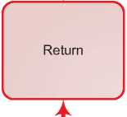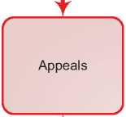

**( x**

**NO**

**\ /**

**k**

**( x**

**YES**

**s /**

Threemonthsfromthe application tothe decision

. \\ >

**( X**

Decision

*< /*

* 1. Additional Statistical Information

Figure 4: Asylum Applications from Top 10 Countries of Origin in 2009, 2010, 2011 and first half of 2012

**2009 2010 2011 Jan-Jun 2012**

|  |  |  |  |  |  |  |  |  |
| --- | --- | --- | --- | --- | --- | --- | --- | --- |
| **1** | Somalia | 5,874 | Serbia | 6,343 | Afghanistan | 4,122 | Somalia | 2,502 |
| **2** | Iraq | 2,297 | Somalia | 5,553 | Somalia | 3,981 | Afghanistan | 2,014 |
| **3** | Afghanistan | 1,694 | Afghanistan | 2,393 | Serbia | 2,705 | Syria | 1,197 |
| **4** | Kosovo | 1,239 | Iraq | 1,977 | Eritrea | 1,647 | Serbia | 1,046 |
| **5** | Iran | 1,144 | Kosovo | 1,567 | Iraq | 1,633 | Albania | 928 |
| **6** | Russia | 1,058 | Eritrea | 1,443 | Kosovo | 1,210 | Bosnia & Herz, | 809 |
| **7** | Eritrea | 1,000 | Iran | 1,182 | Iran | 1,120 | Eritrea | 761 |
| **8** | Stateless | 912 | Stateless | 1,033 | Stateless | 1,109 | Stateless | 626 |
| **9** | Mongolia | 753 | Russia | 988 | Bosnia & Herz. | 981 | Iraq | 616 |
| **10** | Syria | 587 | FYROM | 908 | Russia | 933 | Iran | 569 |

**Figure 5: Decisions Taken at the First Instance in 2009, 2010 and 2011**

|  |  |  |  |  |  |  |  |  |  |
| --- | --- | --- | --- | --- | --- | --- | --- | --- | --- |
|  | **Geneva Convention** | | **Subsidiary/**  **Complementary**  **Protection and Humanitarian Status** | | **Rejections** | | **Withdrawn, Closed, Abandoned Cases** | | **Grand**  **Total** |
| **Number** | **%** | **Number** | **%** | **Number** | **%** | **Number** | **%** |  |
| **2009** | 1,481 | 5% | 6,002 | 22% | 16,887 | 62% | 3,024 | 11% | **27,394** |
| **2010** | 1,936 | 6% | 6,788 | 22% | 19,190 | 61% | 3,342 | 11% | **31,256** |
| **2011** | 2,336 | 8% | 6,752 | 22% | 17,955 | 59% | 3,361 | 11% | **30,404** |

**Figure 6.a: Positive [287] First- and Second-Instance Decisions,Top Countries of Origin in 2009**

**Rate out of Total Decisions [288]**

|  |  |  |  |  |
| --- | --- | --- | --- | --- |
|  | | **Total Positive** | **Total Decisions** | **Rate** |
| 1 | Somalia | 3,620 | 5,293 | 68.4% |
| 2 | Iraq | 1,085 | 4,315 | 25.1% |
| 3 | Eritrea | 720 | 950 | 75.8% |
| 4 | Afghanistan | 645 | 1,133 | 56.9% |
| 5 | Stateless | 340 | 978 | 34.8% |
| 6 | Iran | 181 | 858 | 21.1% |
| 7 | Kosovo | 123 | 1,317 | 9.3% |
| 8 | Russia | 115 | 949 | 12.1% |
| 9 | Uzbekistan | 41 | 501 | 8.2% |
| 10 | Yemen | 40 | 101 | 39.6% |

Total Positive Decisions by Status

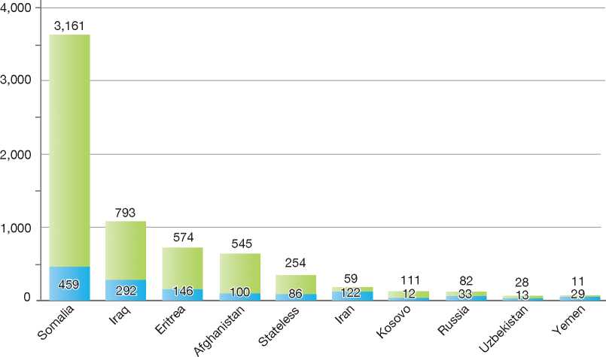

**Total Positive Decisions by Status**

Geneva Convention Status | | Subsidiary/Complementary Protection and Humanitarian Status

**Figure 6.b: Positive [289] First- and Second-Instance Decisions,Top Countries of Origin in 2010**

**Rate out of Total Decisions [290]**

|  |  |  |  |  |
| --- | --- | --- | --- | --- |
|  | | **Total Positive** | **Total Decisions** | **Rate** |
| 1 | Somalia | 4,528 | 6,357 | 71.2% |
| 2 | Afghanistan | 1,039 | 1,807 | 57.5% |
| 3 | Eritrea | 900 | 1,277 | 70.5% |
| 4 | Iraq | 824 | 1,822 | 45.2% |
| 5 | Stateless | 278 | 827 | 33.6% |
| 6 | Iran | 264 | 1,185 | 22.3% |
| 7 | Russia | 100 | 891 | 11.2% |
| 8 | Syria | 97 | 422 | 23.0% |
| 9 | Ethiopia | 65 | 222 | 29.3% |
| 10 | Kosovo | 45 | 986 | 4.6% |

Total Positive Decisions by Status

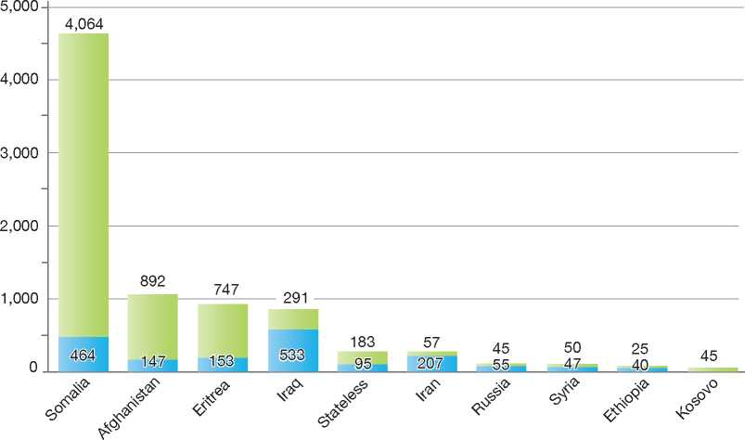

**Total Positive Decisions by Status**

| Geneva Convention Status | | Subsidiary/Complementary Protection and Humanitarian Status

**Figure 6.c: Positive [291] First- and Second-Instance Decisions,Top Countries of Origin in 2011**

**Rate out of Total Decisions [292]**

|  |  |  |  |  |
| --- | --- | --- | --- | --- |
|  | | **Total Positive** | **Total Decisions** | **Rate** |
| 1 | Afghanistan | 2,573 | 3,833 | 67.1% |
| 2 | Somalia | 2,271 | 3,190 | 71.2% |
| 3 | Eritrea | 1,195 | 1,515 | 78.9% |
| 4 | Iraq | 909 | 1,954 | 46.5% |
| 5 | Stateless | 454 | 1,217 | 37.3% |
| 6 | Iran | 403 | 1,226 | 32.9% |
| 7 | Syria | 145 | 531 | 27.3% |
| 8 | Yemen | 143 | 219 | 65.3% |
| 9 | Russia | 78 | 893 | 8.7% |
| 10 | Kosovo | 76 | 1,182 | 6.4% |

Total Positive Decisions by Status

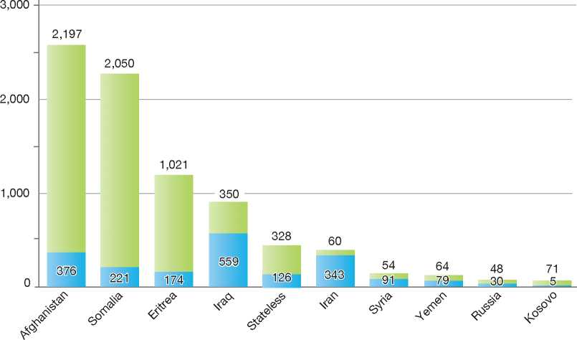

**Total Positive Decisions by Status**

Geneva Convention Status | | Subsidiary/Complementary Protection and Humanitarian Status

Switzerland

1. BackGRound: MajoR asyluM tRends and developMents 411
2. national leGal FRaMewoRk 412
3. institutional FRaMewoRk 414

4. pRe-entRy MeasuRes 414

5. asyluM pRoceduRes 415

1. decision-MakinG and statuses 421
2. eFFiciency and inteGRity MeasuRes 423
3. assistance and Reception BeneFits FoR asyluM-seekeRs 425
4. status and peRMits GRanted outside the asyluM pRoceduRe 427

10. RetuRn 428

11. inteGRation 429

12. annexes

430

1. Background: Major Asylum Trends and Developments

Asylum Applications

In the mid-1980s, the number of asylum applications made in Switzerland stood at less than 10,000 each year. This began to change in the late 1980s, with significant increases in number reaching a peak of 41,600 applications in 1991. This was followed by a sharp drop in applications until 1998 and 1999, when numbers peaked again at 43,000 and 47,000, respectively. Starting in 2000, there was a marked decline in application numbers, with 10,800 in 2007 and 16,600 in 2008. There has been an increase in recent years, with 22,551 applications made in 2011.

introduced a policy of dismissing an application without entering into the substance (DAWES) of the case, based on a set of criteria that included the “safe country of origin” principle[293]. The same year, the Government began to impose certain restrictions on asylum-seekers' access to the labour market.

By the end of the millennium, Swiss asylum legislation had been significantly reformed. The new law of 1999 allowed for the granting of temporary, group-based protection to persons affected by war, but the law also aimed at addressing claims that were clearly abusive of the system by, for example, expanding the criteria for applying the policy of DAWES to include applications made without the submission of required documents.

Figure 1: Total Asylum Applications by Quarter, January 1992 - June 2012

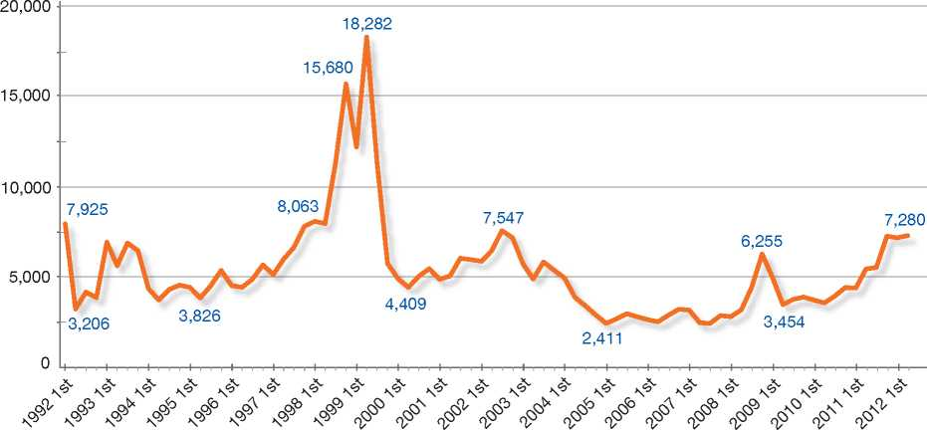

Top Nationalities

In the 1990s, Switzerland received asylum claims mainly from the former Yugoslavia, Sri Lanka, Turkey, and Somalia. Since 2000, the majority of asylum-seekers have continued to originate from the former Yugoslavia, Sri Lanka and Turkey, but also from Eritrea, Nigeria, Iraq, Somalia and China (Tibet).

There were further developments to the DAWES policy in 2003 and 2004. Asylum-seekers whose applications were subject to a dismissal without entering into the substance of the claim were no longer entitled to state welfare benefits, although emergency assistance remained available to them. Meanwhile, the time limit for making an appeal against a decision to not enter into the substance of the claim was reduced.

**Important Reforms**

Further reforms to asylum legislation came into force in 2007 and 2008 and are described below

A number of developments between the 1980s and 2005 have helped to shape the current framework for asylum procedures. In 1990, Switzerland

**Figure 2: Asylum Applications Received from Top 5 Countries of Origin in 2009, 2010 and 2011**

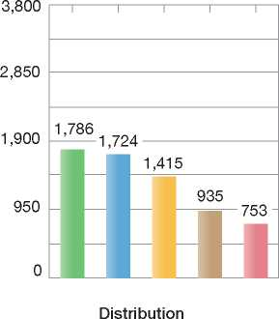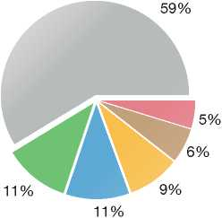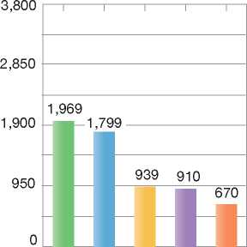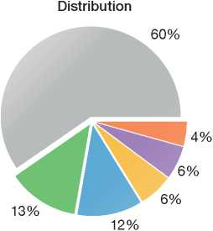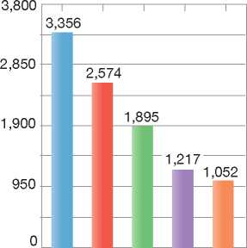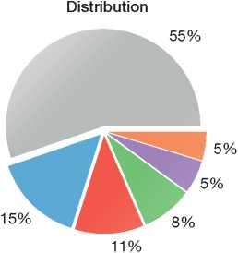

2009

Volumes

Country of Origin:

2010

Volumes

2011

Volumes

| | Afghanistan Eritrea | | Iraq | Nigeria J Serbia

| Somalia | | Sri Lanka | Tunisia | | Others

under Accelerated Procedures. In January 2007, the new Federal Administrative Tribunal (FAT) replaced the Asylum Appeal Commission (AAC) as the second instance decision-making body.

1. National Legal Framework
   1. Legal Basis for Granting Protectionof 16 December 2005. The Asylum Act[294] contains the inclusion, cessation and exclusion clauses of the 1951 Convention relating to the Status of Refugees (1951 Convention), and defines asylum procedures and procedural guarantees. The Aliens Act covers matters related to temporary admission and administrative detention measures.

Articles 3 and 8 of the European Convention on Human Rights (ECHR) are given effect in Swiss legislation.

The asylum procedure and the granting of international protection are governed by the Asylum Act of 26 June 1998 and the Aliens Act

* 1. Recent/Pending Reforms

Recent reforms to the Asylum Act and to the Aliens Act entered into force in 2007 and 2008. Some of the key changes were as follows:

* An expansion of the criteria for applying the DAWES policy to asylum-seekers who do not provide valid identity and travel documents to asylum authorities within 48 hours of application
* The interruption of state welfare benefits for asylum-seekers who have received a negative decision on their claim
* The granting of access to the labour market and to family reunification benefits to persons granted temporary admission
* The introduction of fees for making a second asylum application or for requesting a review of an initial asylum claim
* The introduction of the safe third country principle, including an agreement with the European Union (EU) to apply Council Regulation (EC) No. 343/2003[295]
* The transfer of responsibility for all asylum interviews from the cantons to the Federal Office for Migration (FOM)
* The introduction of a residence permit in cases of hardship.

Pending Reforms

An amendment of the Asylum Act has been passed by the Senate and was to be passed into law by the end of 2012. Changes include:

* Introducing an accelerated procedure with a decision on the substance of the claim to replace the current system of decisions without entering into the merits
* The obligation to disclose all health problems at the start of the asylum procedure, with medical investigations provided for health problems that may have repercussions on the procedure
* A prohibition for asylum-seekers to engage in public political activities during the determination procedure, in order to avoid the creation of grounds for persecution in their home countries while they are in Switzerland
* Accelerated processing of repeat applications and requests for review, with no social welfare assistance and only emergency assistance available for repeat applicants
* Granting priority to the processing of applications from unaccompanied minors (UAMs)
* The creation of a preparation phase prior to the asylum procedure
* Provision of free legal assistance at the appeals stage
* Exchange of information between the Federal Office for Migration (first instance) and the Federal Administrative Tribunal (Appeals) in order to simplify the administrative process.

An amendment of the Asylum Act was approved by Parliament and passed urgently into law on 29 September 2012. Changes include, *inter alia*:

* Removing desertion and conscientious objection as grounds for granting asylum. These applicants must provide evidence of direct persecution
* Removing the possibility of applying for protection at Swiss diplomatic missions abroad
* The creation of specific centres for asylum­seekers who cause a public disturbance. Such persons will be separated from other asylum­seekers and their freedom of movement will be restricted
* The possibility to test fast-track procedures in preparation for the future introduction of a new accelerated asylum system in centralised federal centres (which will include a preparation phase)
* The timeframe for making an appeal against a negative decision by the FOM (after entering into the substance) will be reduced from 30 days to five working days, when the applicant is from a country designated by the Federal Council to be a safe country of origin. Previously this five-working day timeframe was applicable only for appeals against decisions to dismiss the claim without entering into the substance of the claim (DAWES).

1. Institutional Framework
   1. Principal Institutions

The Federal Office for Migration (FOM), which falls within the Department of Justice and Police, is responsible for examining and making determinations on asylum claims. Within the FOM, the Asylum and Return Division deals with all tasks tied to the field of asylum, including determination of claims, and may issue removal orders or a grant of temporary admission if asylum is not granted. The Asylum and Return Division is also responsible for overseeing the initial reception of asylum-seekers in federal reception centres, as well as return assistance and forced return. The FOM was created in 2005 to bring together the functions of the Federal Office for Refugees (FOR) and the Federal Office of Immigration, Integration and Emigration (IMES).

The Federal Council (Swiss Government) determines the safe countries of origin and safe third countries.

The Cantonal Migration Offices, often in consultation with, and with the assistance of, the competent federal authority, are responsible for the removal of rejected asylum-seekers. The cantons are responsible for providing social assistance. In some cantons, this task is delegated to the communal authorities, while in other cantons relief organisations undertake this task. The costs are reimbursed by the Federal Government.

The Federal Administrative Tribunal (FAT) hears appeals of decisions made by the Federal Office for Migration.

1. Pre-entry Measures

In 2004, Switzerland signed an agreement with the European Union to take part in the Schengen Acquis. Switzerland began to apply Schengen rules on 12 December 2008. Being a Schengen Member State implies that Switzerland follows the legal provisions of the Schengen Acquis established in the EU Visa Code[296]. Thus, Switzerland protects its national as well as the Schengen borders in applying the legally and formally standardised visa application process of the Schengen countries. Furthermore, Switzerland also shares the Schengen area's common anti-crime IT systems.

* 1. Visa Requirements

Switzerland grants Schengen visa type C for stays of up to 90 days within a 180-day period. Any visa application to Switzerland must fulfil requirements of locality and date (where and when to be handed in). The application process follows common European standards. Where the European Visa Information System is already implemented, the applicant's identity is ascertained by electronically recording biometric features (photo, fingerprints). Further elements of a valid application are as follows: a valid travel document; sufficient financial means to finance the stay; travel insurance to cover costs in case of accident or health problems; visa fee paid; having no denial by the visa consultation network (VISION); and having no hit in the Schengen Information System (SIS).

Switzerland grants national visa D for stays of over 90 days' duration. This visa also provides the right to travel as a tourist in the Schengen area during 90 days within a 180-day period ; this corresponds with the Schengen visa C.

Switzerland keeps visa statistics and archives all application documents.

* 1. Carrier Sanctions

With the coming into force of the agreement to apply the Schengen Acquis, the Aliens Act introduced requirements for carriers transporting passengers to Switzerland. Carriers must “take all reasonable measures to ensure that only persons possessing the required travel documents to travel through, enter or exit the country are transported”[297]. Companies failing to respect these conditions are obliged to remove the inadmissible passenger and to take care of uncovered costs for maintenance and care. They may be subject to a maximum fine of CHF 1 million. The carrier may be exempted from sanctions if grounds for refusal of entry are not related to a travel document or if a travel document falsification was not detectable.

* 1. Interception

Border control authorities at land border posts and airports carry out interception activities. Interception measures include refusal of entry, removal or removal detention order, if removals cannot be carried out immediately. Entry or access

to the territory may be granted in connection with an asylum request at the border following the airport procedure[298]. Referral to a reception centre may take place following an asylum request at the land border. Entry may also be granted as a consequence of a successful appeal against a refusal-of-entry decision.

* 1. Airline Liaison Officers (ALOs)

By the end of 2012, Switzerland will have started using Airline Liaison Officers (ALOs). The first Swiss ALOs will initially be sent out for a period of six months. They will operate in line with the Code of Conduct established by the IATA/ Control Authorities Working Group (IATA/CAWG) and integrate themselves - where available - into existing local ALO networks.

The Swiss ALOs will be deployed at the following duty stations:

* Dubai (United Arab Emirates)
* Pristina (Republic of Kosovo)
* Nairobi (Kenya).
  1. Immigration Liaison Officers (ILOs)

As provided for in Council Regulation (EC) No. 377/2004[299], Switzerland currently has six Immigration Liaison Officers ILOs deployed at the following locations:

* Ankara (Turkey)
* Pristina (Republic of Kosovo)
* Brussels (Belgium)
* Colombo (Sri Lanka)
* Dakar (Senegal)
* Abuja (Nigeria).

Switzerland will dispatch three additional ILOs to Beirut (Lebanon), Rabat (Morocco) and Khartoum (Sudan) in July 2013.

1. Asylum Procedures
   1. Application Possibilities and Requirements, Procedures and Legal Remedies

Asylum applications may be made at border posts and at the airport. Inside the territory, asylum applications may be made at one of five reception and procedure centres of the FOM. Asylum applications can be made orally or in writing.

The majority of asylum claims in Switzerland are made at the reception centres.

Information leaflets on the asylum procedure are available in different languages at the reception centres.

* + 1. Outside the Country

Resettlement/Quota Refugees

Switzerland does not have in place an annual resettlement programme. However, Article 56 of the Asylum Act provides for an engagement in resettlement activities on an *ad hoc* basis. In recent years, the Department of Justice and Police coordinated the resettlement of two groups of refugees on the basis of United Nations High Commissioner for Refugees (UNHCR) appeals. In 2009, Switzerland resettled one Iraqi from Lebanon and nine Kosovars from the Netherlands (International Criminal Tribunal for the Yugoslavia - ICTY). In 2011, it resettled 29 Iraqis (seven from Jordanian, nine from Syria, four from Iraq and 13 from Lebanon) and four persons with unknown nationality from a camp near Baghdad. In 2012, it resettled nine Somalis, eight Eritreans and one Sudanese from Malta, and one Congolese (Democratic Republic of Congo) from the Netherlands (International Criminal Court - ICC witness).

* + 1. At Ports of Entry

At the Land Border

Since the entry into force of the Dublin II Regulation in December 2008, asylum-seekers at land border posts are automatically authorised to enter the country to make an asylum claim in-country. They are given a *laissez-passer* to travel to the nearest reception centre, where they may make their application[300].

At Airports

An asylum-seeker making a claim at an airport in Zurich or Geneva is initially refused entry into Switzerland. The person is held in the international zone of the airport for a maximum of 60 days, while the Federal Office for Migration examines the asylum claim. The Office must make a decision on the claim within 20 days of the application.

If the FOM rejects the application within the 20­day period, the asylum-seeker may make an appeal to the Federal Administrative Tribunal within five days of the decision. The Tribunal must in principle make a decision on the appeal within five days. If the Court's decision is negative and a return to the country of origin or a third country is judged to be reasonable and technically possible, the asylum-seeker then has to leave the international zone of the airport. The remaining time between the decision at second instance and the expiration of the 60-day timeframe is used for return measures.

If the claim cannot be processed within 20 days or if it is determined that the claim has a reasonable chance of success, the asylum-seeker will be admitted to Swiss territory for further examination of the application. Upon entry, the asylum-seeker is assigned to one of the cantons where he or she will be accommodated.

Under the Dublin system, Switzerland may send a person who has made an asylum application at the airport to another State party to the Dublin II Regulation, if that person had first arrived in the Schengen area through that State before travelling to Switzerland.

1. Inside the Territory

Responsibility for Processing the Claim

The Dublin System

In 2004, Switzerland concluded an agreement with the European Union to take part in the Dublin system. The Dublin rules came into force on 12 December 2008.

*Application and Procedure*

The Federal Office for Migration is the competent authority for applying the Dublin II Regulation and thus determining whether Switzerland is responsible for examining an asylum claim. If the Federal Office for Migration determines another Member State to be responsible for examining the asylum claim, the Office rejects the asylum application and issues an expulsion order to the asylum-seeker. An appeal against this decision must be lodged at the court of appeal within one week, and the court decides within a week whether or not the suspensive effect is to be granted. If the claimant does not appeal to the court, the expulsion order becomes enforceable after one week.

*Freedom of Movement/Detention*

There are no specific detention policies for the enforcement of Dublin transfers. The provisions applicable to subjects of other removal orders are also applicable to Dublin transfers. Usually, transfers to the State responsible are made shortly after the expulsion order is enforceable.

*Conduct of Transfers*

Most of the Dublin transfers from and to Switzerland are made by air. Persons leaving Switzerland for other Member States are escorted to the airplane. Persons arriving from other Member States are received and registered at the international airports and allocated to the district authority responsible. With the neighbouring countries of Switzerland, the Federal Office for Migration aims to transfer people at local border check points. However, this transfer policy is not accepted by Italy. The transportation expenses are covered by the Federal Office for Migration.

*Suspension of Dublin Transfers*

The court of appeal decides within a time limit of five working days whether or not to grant suspensive effect to appealed decisions. If the court grants suspensive effect, the Member State determined responsible is informed immediately about the delayed transfer. If the court does not grant suspensive effect within the given time limit, the expulsion order is enforceable.

*Review/Appeal*

The court of appeal is the Federal Administrative Tribunal. An appeal against a negative decision has to be done in writing, in one of three official languages of Switzerland[301], and has to be filed within five days of notification of the decision. If the court does not grant suspensive effect, the expulsion order is enforceable. In this case, the appellant awaits the results of the proceedings in the other Member State. If an appeal is successful, the FOM examines the asylum application on its merits.

Application and Admissibility

Application at the Reception Centre

Asylum-seekers not holding a valid residence permit for Switzerland and applicants who have been granted entry into the country in order to lodge an asylum claim have to register at a reception centre. At the reception centre, asylum­seekers are asked to declare their particulars and are requested to provide the authorities with valid travel and identity documents within 48 hours of making their application. The asylum-seekers' fingerprints are taken and a medical examination is completed. The Federal Office for Migration (FOM) is responsible for examining claims made at reception centres. The maximum period of stay in a reception centre is 90 days.

During an initial interview with the asylum-seeker, the FOM obtains personal data such as identity and nationality, as well as information on the journey. The asylum-seeker may also briefly explain his or her motives for the application. The asylum-seeker is assisted by an interpreter, if necessary, and is provided with a copy of the interview minutes once the examination process is completed by the FOM.

Usually, the FOM will conduct a second, in-depth interview with the applicant to gather additional information on the claim. This second interview also takes place with claimants who are subject to safe country decisions and safe third country policies. The second interview is held in the reception centre or at the FOM headquarters in Bern, if the asylum-seeker has been assigned to a canton.

The asylum-seeker is interviewed for the second time in the presence of a representative of a non-governmental organisation (NGO) whose role is to monitor the proceedings. The asylum­seeker may request that an official interpreter be present as well. The interview is recorded in writing and the report is translated for the asylum­seeker, who has to sign and to confirm that all statements have been recorded completely and correctly.

With the information gathered, the FOM determines whether to employ the accelerated procedure (DAWES) or the regular procedure. The claim will be streamed through one of these two procedures if Switzerland is determined to be the Member State responsible under the Dublin II Regulation[302].

Applicants whose claims cannot be heard and/or decided within 90 days in the reception centre are assigned to a canton. In these cases, most claims continue to be processed by the FOM headquarters.

Accelerated Procedures

Dismissal of a Claim Without Entering into the Substance (DAWES)

Following the initial interview and often the second interview, the authorities may decide to dismiss the claim without entering into the substance of the claim (DAWES). In such cases, the application is examined on a priority basis under an accelerated procedure.

A dismissal without entering into the substance of the claim is applicable in the following cases:

* The asylum-seeker fails to indicate that he or she has come to Switzerland in search of protection against persecution (after in-depth interview)
* The asylum-seeker fails to provide the necessary identity and travel documents within 48 hours (after in-depth interview)
* The asylum-seeker has made misrepresenta­tions about his or her identity (right to be heard without in-depth interview)
* The asylum-seeker has committed a serious breach of his or her duty to cooperate with authorities on the asylum claim (right to be heard without in-depth interview)
* The asylum-seeker is able to travel to a safe third country where he or she can find protection (after in-depth interview)
* The asylum-seeker is residing illegally in Switzerland and is making an asylum claim in order to defer his or her removal (after in-depth interview)
* The asylum-seeker is from a country designated by the Federal Council to be a safe country of origin (after in-depth interview)

• The temporary protection status granted to the asylum-seeker has been withdrawn and no evidence of risk of persecution has been presented.

With regard to the requirement to provide identity and travel documents within 48 hours, the authorities will not issue a DAWES if the asylum­seeker provides a credible explanation for not producing the required documents or if, based on the interview, refugee status under the provisions of Articles 3 and 7 of the Asylum Act is established. Applicants can also avoid a DAWES if they submit the required documents after the 48-hour deadline but before the Federal Office for Migration has reached a decision on their case. Furthermore, a DAWES is not issued if further clarifications are needed regarding the examination of the asylum claim or regarding any obstacle to the removal.

According to the Aliens Act and Asylum Act, once a decision has been reached to dismiss the claim without entering into the substance, the FOM must examine whether there are any obstacles to the removal of the asylum-seeker to the country of origin or to a third country. If there is an obstacle to return, an asylum-seeker who is the subject of a DAWES decision may be granted temporary admission11.

A decision to dismiss the claim without entering into the substance is usually made while the asylum-seekers are at the reception centres (that is, within the 90-day period of stay), but may in certain cases be made by the FOM headquarters. As a rule, decision-making under the accelerated procedure is made within a shorter timeframe than the normal procedure. In addition, the timeframe for making an appeal on a DAWES decision is shorter[303] [304].

Normal Procedure

Following the second interview, asylum claims may be streamed through the normal procedure at the Federal Office for Migration headquarters (and sometimes at the reception centres). The claims are examined on their merits.

There are three main distinctions between the normal procedure and the accelerated procedure:

* The type of decision that can be made on the application
* The way in which information is taken into consideration, and
* The timeframe for making an appeal.

If, after the second (in-depth) interview, it is obvious to the FOM decision-maker (*collaborateur scientifique*) that the asylum-seeker has not provided credible evidence that he or she meets criteria for refugee status, the FOM may reject the claim without further investigation (Article 40 of the Asylum Act).

However, if the facts presented are incomplete, the FOM must carry out a further examination as far as is relevant, possible and reasonable, including conducting an additional (third) interview with the asylum-seeker or seeking expert opinion on the claim (Article 41 of the Asylum Act).

If the decision-maker determines that the person does not meet the criteria for asylum, the FOM must proceed to an examination of whether the asylum-seeker can be removed from Switzerland. This stage of the normal procedure has three steps:

* First, whether the removal of a person is admissible, that is, in accordance with Switzerland's international obligations
* Second, whether it is reasonable to remove a person to his or her country of origin or a third country considering the general situation in the country in question, and
* Third, whether removal of the person is practicable.

If any one of these three conditions is not fulfilled, the Federal Office for Migration may grant that person temporary admission to Switzerland[305].

Appeal of Asylum Decisions

An appeal before the Federal Administrative Tribunal may be made against any negative decision or decision to not enter into the substance of a claim (DAWES) made by the FOM.

Appeals may be made within 30 days of a negative decision made by the FOM under the normal procedure, while decisions made not to enter

into the substance of the claim (DAWES) may be appealed within five working days.

The appeal is a paper process and will take account of errors of both law and fact. New evidence may be presented. Appeals of decisions made under the accelerated procedure, the normal procedure and at airports have suspensive effect[306].

Freedom of Movement during the Procedure

Detention

As a rule, asylum-seekers whose claims are being examined under the accelerated procedure or the normal procedure will not be detained. The Aliens Police have the authority to detain persons who have entered Switzerland without proper authorisation. Such persons may make an application for asylum while in detention.

Reporting

The competent authorities must be notified of any change of address.

Repeat Applications and Requests for Review of Applications

Under Swiss law, there is a distinction made between repeat applications and requests for review of initial asylum applications.

Repeat Applications

A foreign national whose original asylum application was rejected may make a repeat or subsequent application for asylum. If the person provides credible information that new facts that may lead to refugee protection have emerged since the original asylum application procedure was completed, the application will be examined on its merits. If no new facts are presented in a credible manner, the application may be dismissed without entering into the substance of the claim (DAWES).

Requests for Review of Applications

A request for review of original asylum applications may be made in the following instances:

* New information concerning the content of the original claim has come to light after the completion of the original asylum procedure
* New information concerning obstacles to return has come to light.

To be accepted for review, such requests must meet certain additional criteria related to timeframes, the presentation of sufficiently substantiated information, and the presentation of new information (rather than a new appreciation of already-known facts).

According to the revised Asylum Act, the FOM may impose a fee in the form of an advanced payment for repeat applications and all requests for review. If the fee is not paid, the application or request for review may be rejected. Exceptions for payment of the fee may be made if the applicant does not have the financial means to pay the fee and if it is clear from the outset that the application or request for review will be successful.

Persons whose repeat applications and request for review have been rejected by the FOM may make an appeal before the Federal Administrative Tribunal. Appeals of decisions to reject a request for review do not have suspensive effect but appeals of negative decisions on repeat applications do.

1. Safe Country Concepts
2. Safe Country of Origin

According to Article 34(1) of the Asylum Act, the FOM may dismiss a claim without entering into the substance (DAWES) if the applicant is from a safe country of origin and there are no indications that the claim is not manifestly unfounded. The Federal Council establishes a list of safe countries according to a specific set of criteria. The Federal Council, when considering whether or not to include a country on the safe country list, must take the following criteria into account:

* The political and human rights situation in the country
* The application of human rights standards according to the UN Convention on Civil and Political Rights of 16 December 1966
* Stability of the political situation
* Progress with regard to the human rights situation and admission of monitoring by independent organisations
* Assessment of other western States and the UNHCR
* A large number of asylum claims from applicants of this country being manifestly unfounded.

1. First Country of Asylum

Swiss asylum law does not define or use the term “first country of asylum”. The safe third country policy, as described below, incorporates the principle of first country of asylum.

1. Safe Third Country

Switzerland has in place a safe third country policy in relation to asylum claims. The Federal Council is responsible for issuing an official list of safe third countries and did so most recently in 2008. The list is limited to Member States of the European Union, Norway, Iceland and Liechtenstein. These countries are subject to a general presumption of safety. As a rule, once Switzerland has completed a formal readmission agreement with another country, asylum-seekers may be returned to that country if they had taken up residence there before entering Switzerland. Usually, the application of the safe third country policy results in a decision to dismiss the claim without entering into the substance (DAWES).

The safe third country policy may also be applied to countries that are not included on the Federal Council list. The determination of whether a third country can be considered safe is done on a case- by-case basis. In order for the policy to take effect, the following criteria must be met:

* Either the third country must agree to receive the asylum-seeker if he or she is returned or the asylum-seeker must be in possession of a valid visa to enter the third country
* The third country respects the *non-refoulement* principle and the asylum-seeker is able to find protection there.

If these prerequisites are met, a DAWES decision may be issued, unless the asylum claim is manifestly founded or members of the applicant's family live in Switzerland (Art. 34(3) of the Asylum Act).

1. Special Procedures
2. Unaccompanied Minors

The FOM makes special arrangements for unaccompanied minors seeking asylum in relation to the asylum procedure, reception, and final decisions.

An unaccompanied minor asylum-seeker (UAM) is assigned a representative who will be responsible for looking after the minor's interests during the asylum procedure. When interviewing the minor, the FOM takes account of the child's age and mental development and may adjust the interview method accordingly. The officers conducting the interview may request the assistance of staff within the FOM, such as psychologists and lawyers who have been specially trained to cater to the needs of minors.

If a UAM does not meet the criteria for refugee status, the FOM assesses whether it is reasonably justified for the UAM to return to the country of origin. In deciding whether to return minors, the authorities must take into account the situation in the country of origin, the minor's age, and what solution will be in the child's best interests. This includes an assessment of the minor's level of maturity and independence; the extent of his or her relationships in both the country of origin and in Switzerland; the degree of integration in Switzerland; and the possibilities for a full reintegration in the country of origin.

|  |  |  |  |
| --- | --- | --- | --- |
| **Figure 3: Asylum Applications by Unaccompa­nied Minors in 2009, 2010 and 2011** | | | |
|  | **2009** | **2010** | **2011** |
| Total Asylum Applications | 16,005 | 15,567 | 22,551 |
| of which Unaccompanied Minors | 449 | 213 | 313 |
| Percentage | 3% | 1% | 1% |

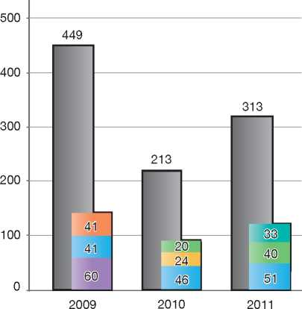

|  |  |
| --- | --- |
| **Country of Origin:** |  |
| | Afghanistan Eritrea Nigeria  Somalia Sri Lanka J Tunisia |
|  |  |

1. Stateless Persons

Applications for asylum made by stateless persons are examined by the FOM in the same manner as are all other asylum applications.



Gender-Sensitive Procedures

The FOM is reflecting on different tracks to improve the gender sensitivity of its procedures:

* Improving the identification process of potential victims of human trafficking within the Dublin procedure and the normal procedure: definition of a position and a strategy for the Asylum and Return Directorate; coordination of the processes and training of staff
* Improving information-provision for persons who are victims of human trafficking in Switzerland (penal provisions and assistance for victims)
* The introduction of anti-female genital mutilation (FGM) measures, which may include a regular medical follow-up for children after recognition of refugee status for reasons of a future fear of FGM, and consequences for parents who disregard the prohibition of FGM after the introduction of a new penal provision in Switzerland which forbids acts of FGM
* The introduction of an information booklet on persecution related to gender, similar to a Belgian model.

1. Decision-Making and Status

The asylum procedure at the first instance is a single procedure. Thus, the Federal Office for Migration considers whether the asylum-seeker meets criteria for refugee status or for temporary admission (a complementary form of protection), and whether it is admissible, reasonable and practicable for persons not in need of protection to be removed from Switzerland (that is, for a removal order to be issued with a negative decision).

* 1. Inclusion Criteria
     1. Convention Refugee

An asylum-seeker is granted refugee status if the FOM determines that he or she meets the criteria set out in Article 3 of the Asylum Act, which reproduces the definition set out in Article 1A (2) of the 1951 Convention. The asylum-seeker's claim must be found to be credible and must not meet criteria for exclusion contained in Articles 53 and 54 of the Asylum Act.

* + 1. Temporary Admission

An asylum-seeker may be granted temporary admission (a complementary form of protection) if he or she does not meet criteria for refugee status, and return to the country of origin or to a third country cannot be implemented for one of the following reasons:

* Return is inadmissible as it would be in breach of Switzerland's obligations under international law, including Article 3 ECHR
* Return is not reasonable because it poses a real risk to the person (including risks associated with civil war or international conflict)
* Return is not practicable (e.g. the country of origin refuses to take back its national). As a rule, at the earliest opportunity 12 months after a final decision on the claim was taken, temporary admission is granted.

The grounds for the impossibility of the execution of removal do not, however, include the uncooperative behaviour of the person subject to a return order.

* 1. The Decision

The decision of the Federal Office for Migration on an asylum claim is made in writing and provided to the applicant or to his or her legal representative via registered mail, except for decisions issued in the reception centres, which may be given directly to the applicant when he or she has no legal representative. If negative (either with a removal order or with a temporary admission), the decision includes reasons for the rejection.

* 1. Types of Decisions, Status and Benefits Granted

The FOM may take one of the following decisions on an asylum claim:

* Grant refugee status with asylum status
* Grant temporary admission with refugee status (usually, in cases where the asylum-seeker meets criteria for refugee status but is subject to exclusion as per Articles 53 and 54 of the Asylum Act)
* Grant temporary admission without refugee status (usually, in cases where the asylum­seeker does not meet criteria for refugee status but cannot be removed for one of the reasons outlined above)
* Reject the claim for asylum
* Dismiss the claim without entering into the substance (DAWES)
* Close the asylum claim (such as after the asylum-seeker has withdrawn his or her claim).

As described above, the FOM must also consider whether removal is admissible, reasonable and practicable if a claim for asylum has been rejected. Thus, the FOM may make decisions at the end of the asylum procedure to either issue a removal order or grant temporary admission, if removal is not possible or practicable.

The FOM is also the competent authority for making decisions on exclusion, termination and revocation of refugee status and temporary admission, as described below.

Benefits for Refugees with Asylum Status

Persons who are granted asylum are entitled to a one-year residence permit, which is renewed yearly. After five years, refugees are eligible for a permanent residence permit. Refugees also have access to the labour market and to social benefits equivalent to benefits available to Swiss citizens. There is a legal right to family reunification.

Temporary Admission

Benefits offered to persons granted temporary admission are determined by the cantonal authorities. Generally, all persons granted temporary admission are eligible for the same benefits asylum-seekers have access to during the asylum procedure[307]. The cantonal authorities may decide which additional benefits to offer. These include the right to obtain a work permit and issue one-year renewable residence permits. After five years, an annual residence permit can be granted by the canton in accordance with the provisions of Article 84 (5) of the Aliens Act.

In accordance with the 1951 Convention, persons granted temporary admission with refugee status are entitled to a travel document. However, other beneficiaries of temporary admission cannot travel outside of Switzerland.

Family reunification is possible after three years on certain conditions.

Asylum-seekers who are not eligible for refugee status and whose removal from Switzerland is admissible, reasonable and practicable, are set a deadline by which they must leave Switzerland.

* 1. Exclusion
     1. Refugee Protection

Switzerland applies the exclusion clauses of Article 1F of the 1951 Convention. Persons who meet the criteria for refugee status but who are subject to the exclusion clauses will not be granted asylum. Such decisions may be appealed before the Federal Administrative Tribunal within 30 days of the decision.

When Article 1F of the 1951 Convention is applicable to a refugee, the Federal Office for Migration will consider whether Article 3 of the ECHR would prevent the implementation of removal.

In addition to Article 1F of the 1951 Convention, persons who meet the criteria for refugee status may be excluded under one of the following conditions:

* They constitute a risk to the security of the country or a danger to the community as a result of a criminal offence committed in Switzerland (Article 53 of the Asylum Act)
* They became refugees in the sense of Article 3 of the Asylum Act after having left the country of origin (Article 54 of the Asylum Act).

In these cases, the person may be granted temporary admission (application of the *non­refoulement* principle of the 1951 Convention).

* + 1. Temporary Admission

Persons who meet the criteria for temporary admission may be excluded from this type of complementary protection if there are grounds to believe the person constitutes a threat to, or has committed a serious violation of, national security and public order. However, the FOM must consider Switzerland's obligations under Article 3 of the ECHR before deciding whether or not to issue a removal order to persons excluded from temporary protection.

* 1. Cessation

Asylum in Switzerland expires if a refugee has lived abroad for more than three years, if he or she has been granted asylum or permission

**Integration of COI Analysts within Country Teams**

COI analysts work within the country teams, rather than in a separate unit. Although they still follow the same guidelines, the Country Team leader orders COI products and sets priorities. The external Coordinator of Country Analysis is responsible for quality management, training and development, and assists country teams where necessary.

to stay permanently in another country, if the refugee renounces asylum, or if an expulsion or a judicial banishment has been executed (Article 64 of the Asylum Act). Furthermore, the refugee status expires, as a rule, if the person concerned has obtained Swiss citizenship.

* 1. Revocation

According to Article 63 of the Asylum Act, refugee status granted in accordance with the 1951 Convention can be revoked under one of the following circumstances:

* If the person has surreptitiously obtained asylum or refugee status by false information or by the concealment of essential facts
* For reasons falling under section 1C, sub­paragraphs 1-6 of the 1951 Convention.

However, revocation does not automatically mean that the person concerned is forced to leave Switzerland, since the right to stay in Switzerland is regulated in the Swiss Aliens Act. It is the responsibility of the cantonal authorities to decide whether the residence permit must also be revoked.

* 1. Support and Tools for Decision-Makers
     1. Country of Origin Information (COI)

The country analysts of the Federal Office for Migration (FOM) collect, analyse, prepare and circulate information on the situation in countries of origin. They produce COI products, such as reports on human rights conditions in countries of origin, relevant to the specific needs of the organisation and its decision-makers.

Any FOM official, including asylum decision­makers, may make an information request to the country analysts. Decision-makers may also search for COI and migration-related documents on the internal database, Artis. COI specialists carry out fact-finding missions in order to improve their knowledge of countries of origin as well as of countries of transit. In case of incompleteness of information, they revert to the services of Swiss embassies in countries of origin.

Analytical independence, transparency and high quality are of utmost importance. The Coordinator of Country Analysis therefore checks all COI products and must approve reports before they are delivered to customers.

With the fusion in 2005 of the former Federal Office for Refugees (FOR) and the Federal Office of Immigration, Integration and Emigration (IMES) into the FOM, both the type of COI customers and the range of COI products changed. The country analysts receive an increasing number of research requests from cantonal migration authorities, mainly regarding medical issues.

In recent years, through the Coordinator of Country Analysis, the FOM has intensified information­exchange partnerships with a large number of European States. These efforts resulted in several public reports, written together with European partners after joint fact-finding missions. In addition, Country Analysis has been very active in the development of the European Asylum Curriculum and the Common European Portal on COI.

* + 1. Language Analysis

The LINGUA section of the FOM provides language analysis services to asylum authorities at all stages of the procedure, including the pre-entry (airport procedure) and appeal stages. The aim of the service is to help decision-makers to establish the primary socio-cultural background of the asylum-seeker, where this is otherwise difficult to determine. By employing independent experts, the linguistic features in the asylum-seeker's speech, as well as his or her knowledge of the region or country of origin, are analysed. The findings of LINGUA are presented in a report and may be used as evidence in the decision-making process.

1. Efficiency and Integrity Measures
   1. Technological Tools
      1. Fingerprinting

When a person makes a claim for asylum, he or she must provide fingerprints, which are

then submitted to the Automated Fingerprint Identification System (AFIS). The AFIS allows the FOM to compare the data against other fingerprints gathered by the FOM, the Federal Police and the Border Guard Corps.

* + 1. DNA Tests

DNA tests may be conducted in cases of family reunification and only with the consent of the applicants who qualify for family reunification. Otherwise, DNA tests are not utilised during the asylum procedure.

* + 1. Forensic Testing of Documents

The country analysts of the FOM conduct testing of identification documents and to a lesser extent judicial and civil status documents from countries of origin as well as countries of transit as far as knowledge and infrastructure allow. The country analysts are provided a basic technical training comparable to the one taught to the border control agents. In order to adequately fulfil their tasks, they resort to basic professional instruments at their disposal (e.g. Docutest) and a broad specimen database for comparison of checked documents.

If the genuineness of any document is in doubt due to lack of evidence, the document in question is analysed in a special forensic cantonal laboratory for criminal investigation.

* + 1. Database of Asylum Applications/Applicants

Following the initial interview at the registration centre, the FOM verifies whether the asylum­seeker is registered in the Central Aliens Register or the RIPOL, the automated central police search system. The asylum-seeker's personal data is also entered and stored in the Central Information System on Migration (SYMIC).

* 1. Length of Procedures

There is no time limit for making an asylum application in Switzerland. The length of the procedure at the first instance varies from a few days to two to three months for DAWES, to about six months on average for cases in the normal procedure.

* 1. Pending Cases

As at 30 September 2012, there were 18,212 pending cases at first instance. Following the increase in the number of asylum claims, the FOM has decided to handle the cases according to the order of priority, with a focus on decisions without entering into the substance and on other decisions accompanied by a removal order. Decisions concerning applicants from safe countries or Dublin decisions have top priority.

In addition, asylum claims made at Swiss diplomatic missions are also being managed according to a sequence of priority, based on the degree of urgency of the claim.

* 1. Information Sharing

Switzerland does not currently have any information-sharing agreements in place with third countries outside of the Dublin system. With the coming into force of the Dublin II Regulation in December 2008, Switzerland now shares relevant data with other States parties.

Article 98 of the Asylum Act provides for the disclosure of specific personal data on asylum­seekers only to third countries and international organisations guaranteeing data protection equivalent to that provided under Swiss law.

Quality Assurance

Quality assurance - understood as an ongoing process of improvement - concerns all FOM activities, products and tools. The aim is to make the whole system at all stages "better", more efficient, and to add improvements systematically. This takes time and effort.

Several persons/units are responsible for the quality assurance of processes, data, COI, interpretation, interviews and decisions, training and so on. It is therefore important that these persons and units cooperate and coordinate their activities, while focusing on pre-defined goals. Instead of constantly monitoring activities and products, random checks take place. Switzerland recently engaged in a specific project with the UNHCR regarding the quality of asylum decisions.

1. Assistance and Reception Benefits for Asylum-Seekers
   1. Procedural Support and Safeguards
      1. Legal Assistance

In principle, there is no free legal aid *ex officio*.

The applicant has the right to retain a legal representative during the entire procedure. The legal representative's role is to act on behalf of the asylum-seeker when necessary. This includes accompanying the person to an interview. However, only the asylum-seeker is entitled to answer questions on his or her claim before the FOM. The applicant will have to issue a written power of attorney to a representative, in order to enable him or her to represent the applicant. If a legal representative demands money for his or her work, the applicant will have to pay it himself.

The legal representative may not be an asylum­seeker who has made a claim in Switzerland.

* + 1. Interpreters

The FOM uses interpreters for German, French and Italian when necessary during interviews. As a rule, the appeal procedure is paper-based and the appeal must be made in one of three official languages of the Swiss Confederation.

* + 1. UNHCR

The UNHCR Liaison Service for Switzerland has no direct role in the determination procedure. However, upon the request of the FOM or another party involved in the procedure, the UNHCR may provide up-to-date country of origin information or UNHCR recommendations and positions. The Liaison Service meets with representatives of the FOM on a regular basis and may issue its opinion on legislative or policy changes. The UNHCR also visits reception facilities and shares its findings and recommendations with the relevant government agency. If approached by asylum-seekers directly, which happens on a daily basis, the UNHCR Liaison Service assesses their situation and takes action according to their individual protection needs.

The Liaison Service responds to written and telephonic inquiries by providing asylum-seekers and refugees with general information about the asylum procedure and the contact addresses of legal organisations and social institutions.

* + 1. NGOs

NGOs that form part of the umbrella organisation, the Swiss Refugee Council, may obtain authorisation from the Federal Department of Justice and Police to obtain access asylum­seekers and to be present at the in-depth asylum interviews, although they do not have a role in the decision-making process.

When a person has made a claim for asylum at an airport or a reception centre, the FOM provides information on, and facilitates contact with, non­governmental organisations that may act as advisors and consultants to the asylum-seeker. NGO representatives acting as advisors have access to reception centres during visiting hours.

Furthermore, some NGOs in Switzerland offer integration activities to asylum-seekers.

* 1. Reception Benefits

According to Article 115 of the Swiss Federal Constitution, the cantons have responsibility for providing social welfare, which must be accorded to any person in need.

The provision of social assistance granted to asylum-seekers is overseen by the cantons and may be delegated to communities, welfare organisations and private businesses. The cantons are reimbursed for social assistance payments to asylum-seekers by the Confederation (central government).

Article 12 of the Swiss Federal Constitution guarantees that a minimum level of social assistance be provided to any person in need. This minimum level of assistance must cover necessities such as food, shelter, clothing and basic medical care. Any reductions in social assistance granted to a person must be made according to the law, and must be justified as being in the public interest and as meeting principles of reasonableness.

* + 1. Accommodation

The majority of asylum-seekers who make an asylum claim at a registration centre will also be accommodated there. If an asylum claim cannot be decided at the centre within a reasonable time, the asylum-seeker will be assigned to one of the cantons according to a distribution key and will be provided with accommodation in that area.

Members of the same family are assigned to the same canton whenever possible.

* + 1. Social Assistance

As noted above, asylum-seekers are entitled to social assistance benefits to cover basic needs. These benefits, however, are provided at a level lower than that accorded to Swiss citizens, refugees, or persons with a residence permit. Asylum-seekers may also be entitled to specific types of social insurance (such as old age pension, disability pension, unemployment pension, and health insurance) if they meet certain criteria. Social assistance may be provided in cash or in kind.

* + 1. Health Care

According to Article 3 paragraph 3 of the Swiss law on health insurance, every person residing in Switzerland must be covered by health insurance. The basic health care insurance is the same for every person living in Switzerland. No difference is made between asylum-seekers, refugees and Swiss residents.

The compulsory basic health insurance scheme covers illness, accidents and maternity, although it covers accidents only when the insured person has no other compulsory or optional coverage. It also covers certain preventive measures. All insurers offering compulsory health insurance must provide the same benefits, which are defined by law.

Social assistance, including health insurance, is primarily covered by the cantons. The costs borne by the cantons in providing such social assistance to asylum-seekers are reimbursed by the Swiss Confederation (federal subsidy based on a fixed sum per person).

* + 1. Education

According to Article 19 of the Swiss Constitution, every child living in Switzerland, regardless of his or her status according to the law concerning foreign nationals, is entitled to free primary education. Thus, children up to the age of 16 claiming asylum in Switzerland have the right to be enrolled in school[308].

According to Article 62 of the Swiss federal Constitution, the cantons are responsible for the school system and for education. They provide primary education that is open to all children. The education is compulsory and is under public direction and control. Each canton has laws and regulations concerning the details of education.

* + 1. Access to Labour Market

Asylum-seekers do not have permission to work in the first three months after an asylum application is made. If the claim is not rejected within those first three months, the responsible cantonal authorities may issue a work permit. The future employer must apply for the permit, which is valid only for this specific position. It is issued only if the conditions of the labour market do not impose limitations on the hiring, and if no Swiss citizen or person with a residence permit applies for the same position.

Asylum-seekers who take up paid employment will have part of their wages (10 per cent) deducted, either to cover the cost of any previous allocation of social assistance, or for any eventual return journey to the country of origin.

* + 1. Family Reunification

Asylum-seekers are not entitled to family reunification for the duration of the asylum procedure.

* + 1. Access to Integration Programs

According to Swiss law, asylum-seekers are not entitled to integration programs offered or paid for by the cantons or the Confederation. As noted above, some Swiss NGOs provide integration activities to asylum-seekers.

* + 1. Access to Benefits by Rejected Asylum-Seekers

Since April 2004, asylum-seekers whose applications are dismissed without entering into the substance of the claim (DAWES) are no longer entitled to welfare benefits. Based on reforms that came into effect in 2008, asylum-seekers who have received a negative decision on their claim are also no longer entitled to welfare benefits accorded to asylum-seekers who are not subject to a DAWES decision during the procedure. However, according to Article 12 of the Swiss Constitution, rejected asylum-seekers remain entitled to a minimum level of support to cover basic needs as required, including medical assistance in the case of an emergency.

1. Status and Permits Granted outside the Asylum Procedure

As explained above, Switzerland applies a single asylum procedure that includes the examination of a claim for the granting of Convention refugee status, and a complementary form of protection known as temporary admission if there are obstacles to return. The following types of status and permits may be granted outside the asylum procedure.

* 1. Temporary Protection

Switzerland may grant temporary protection to groups of persons whose country of origin is in a state of armed conflict resulting in a mass influx of persons arriving in Switzerland. The Federal Council may designate groups of persons who may benefit from temporary protection and may determine which criteria will be used to determine eligibility. The provision for temporary protection was inserted into the Asylum Act in 1999, but has not been applied to date.

* 1. Regularisation of Status of Stateless Persons

According to Swiss law[309], a person is considered to be stateless if he or she meets the definition of a stateless person as laid out in the 1954 Convention on Stateless Persons[310]. While the Convention on Stateless Persons does not entitle stateless persons to admission to a country or to a residence permit, Swiss law takes precedence on this matter. Article 31 paragraph 1 of the Aliens Act stipulates that a person qualifying for the status of statelessness under Swiss law is entitled to an annual residence permit in the canton of his or her legal residence.

A stateless person whose application for asylum has been rejected may make an application for recognition of status as a stateless person to the Federal Office for Migration (FOM).

Between 1 January 2000 and 31 December 2010, the (FOM) processed 207 applications for the status of stateless person. 84 applications were approved, while 117 were rejected. Six more applications have been formally closed.

* 1. Hardship Cases

In 2007, three categories of cases of hardship were introduced in the Asylum Act and the Aliens Act. The criteria for determining the presence of grave hardship are defined in Article 31 of the Decree on Admission, Sojourn and Employment (VZAE) and are applicable to all three categories of hardship. The criteria are based on an assessment of the following:

* The integration of the applicant in Switzerland
* The person's record of respect for law and order
* The person's family situation, with an emphasis on the beginning and the length of the children's schooling
* The person's financial situation and willingness to participate in economic life and education
* The duration of stay in Switzerland
* The person's health situation
* The possibility of reintegration into the country of origin.

As per Article 31 (2) of the VZAE, persons being considered for a residence permit based on grave hardship criteria are required to disclose their identity to the authorities.

The three categories of hardship are as follows:

* Article 14 paragraph 2 of the Asylum Act stipulates that foreign nationals may be granted an annual residence permit upon application to the competent cantonal authority, provided that the applicants have been in Switzerland for a minimum of five years and that repatriation would cause grave hardship. This regulation is applicable, *inter alia*, to persons whose applications for asylum have been rejected. In 2011, 202 persons were granted an annual residence permit on these grounds. Between 1 January 2012 and 30 June 2012, 60 persons were granted the same
* Article 84 paragraph 5 of the Aliens Act stipulates that persons benefiting from temporary admission for at least five years must have their cases examined. This examination aims at establishing whether return to the country of origin would cause the person grave hardship. If return would cause grave hardship, the competent cantonal authorities may grant an annual residence permit with the approval of the Federal Office for Migration. In 2011, 1,866 persons benefited from this legal provision.

Likewise, 852 persons had been granted a permit as at June 2012

• Article 30 paragraph 1 lit. b of the Aliens Act provides that persons who have resided in Switzerland without proper authorisation for a prolonged period of time (so-called “*sans­papiers*”) and whose repatriation would cause grave hardship may be granted an annual residence permit. In 2011, 163 persons benefited from this legal provision. Between January 2012 and June 2012, 168 persons obtained such a permit.

1. Return

The FOM is the competent authority for the formulation and implementation of return policies. The cantons are responsible for the execution of return. The FOM, and more specifically the Centralised Proceedings and Return Division, provides assistance to the cantons by helping to establish the person's identity, to obtain valid travel documents and to organise return by air.

* 1. Procedure

Voluntary Return

The purpose of return assistance is to foster the voluntary and mandatory return of rejected asylum­seekers through a system of benefits. The FOM implements these programmes in conjunction with the Swiss Agency for Development and Cooperation (SDC), the International Organization for Migration (IOM), and the competent cantonal agencies and relief organisations.

Any asylum-seeker may apply for return assistance at return counselling centres in the cantons, at the reception centres and in airport transit areas. Even persons who have been granted refugee status may receive assistance if they would like to return to their home country. However, return assistance is not granted to convicted offenders or to persons who have misused the asylum system either during or after proceedings. Certain groups of persons falling under the category “foreign nationals” also have access to return assistance. These groups include victims and witnesses of human trafficking, and cabaret dancers who are being exploited in Switzerland.

In coordination with the Swiss Agency for Development and Coordination, the FOM can also finance structural aid programmes in the countries of origin that benefit the local population and the returnees alike. Such programmes may include projects to prevent irregular migration (PiM), with the aim of making a short-term contribution to limiting irregular migration.

The return assistance comprises the following components:

* Individual return assistance
* Country-specific programmes
* Return assistance for foreign nationals
* Cantonal return counselling centres
* Return assistance communication
* Social insurance and return
* Structural aid
* Prevention of irregular migration.

Forced Return

People who are in Switzerland illegally must leave the country. If they refuse to return home voluntarily, they risk being deported. The cantons are responsible for enforcing such measures.

The existence of valid travel documents is a pre-requisite for return. If valid travel documents are not available, the FOM, at the request of the cantons, tries to establish identity and nationality before applying to the diplomatic mission of the home country for substitute travel documents.

Once substitute documents have been issued, the concerned canton is informed accordingly. At the request of the canton, the FOM unit responsible for travel arrangements - swissREPAT, located at the airports in Zurich and Geneva - books a flight and organises the return journey. If the person in question refuses to be returned home on a regular flight, the FOM organises a special flight at the request of the cantonal authorities.

* 1. Freedom of Movement/ Detention

Unless other sufficient but less coercive measures can be applied effectively, the cantonal authorities may decide to keep a person who is subject to return procedures in administrative detention in order to prepare the return and/or carry out the removal process, particularly when there is a risk of absconding or if the person avoids or hampers the preparation of the return or the removal process. As such, the cantonal judicial authorities can impose up to 18 months of administrative detention on foreign nationals without proper

authorisation to stay, and whose return cannot be implemented due to a lack of cooperation on their part. Detention is terminated under one of the following conditions:

* Despite the cooperation of the person, an autonomous and mandatory departure is not possible
* The person leaves Switzerland
* An application to the judicial authorities for release is approved.

The administrative detention may be appealed to the Supreme Court (federal tribunal).

* 1. Readmission Agreements

As instruments of return policy, readmission agreements aim at guaranteeing a quick and safe readmission to the country of origin of persons who are illegally present in Switzerland by clearly defining enforcement modalities, procedures and deadlines for Switzerland and the country of origin. The Swiss policy of signing readmission agreements with countries of origin or transit is in line with the policy of the EU and its Member States, which conclude readmission agreements or include return clauses in association and cooperation agreements with many countries of origin and transit in order to more effectively manage irregular migration.

While the obligation to readmit citizens is not contested in principle, its fulfilment often goes against important national interests of the countries of origin. These conflicting interests often make the negotiation process more difficult.

Currently, Switzerland has concluded 47 readmission agreements.

Besides readmission agreements, Switzerland has recently developed various additional instruments, such as migration partnerships, migration dialogues, cooperation agreements on migration as well as the “Protection in the Region” and the “Prevention of Irregular Migration” programmes and assisted voluntary return schemes. developed in August 2007, presenting more than 40 concrete measures focusing on, *inter alia*, language, vocational training, the labour market and urban development. The federal government defines a programme for integration as a programme that aims to support language training and education, professional institutions for integration issues, and pilot projects of national importance.

All migrants who have a legal and long-term stay permit, including persons granted refugee status, are entitled to these integration measures, which are implemented at the cantonal level. The Government financially supports the social, professional and cultural integration of refugees or persons with protection status who have a residence permit or with provisional admission (Article 94 of the Asylum Act). The cantons, communities and third- party organisations have to financially participate in the integration programmes. Also people with provisional admission have, through the new law, better access to the labour market.

1. Integration

The Aliens Act, which was passed in January 2008, defines the policy on integration, its aims, the division of responsibilities, and related measures. A federal action plan on integration policy was

12 Annexes

**12.1 Asylum Procedure Flow Chart**

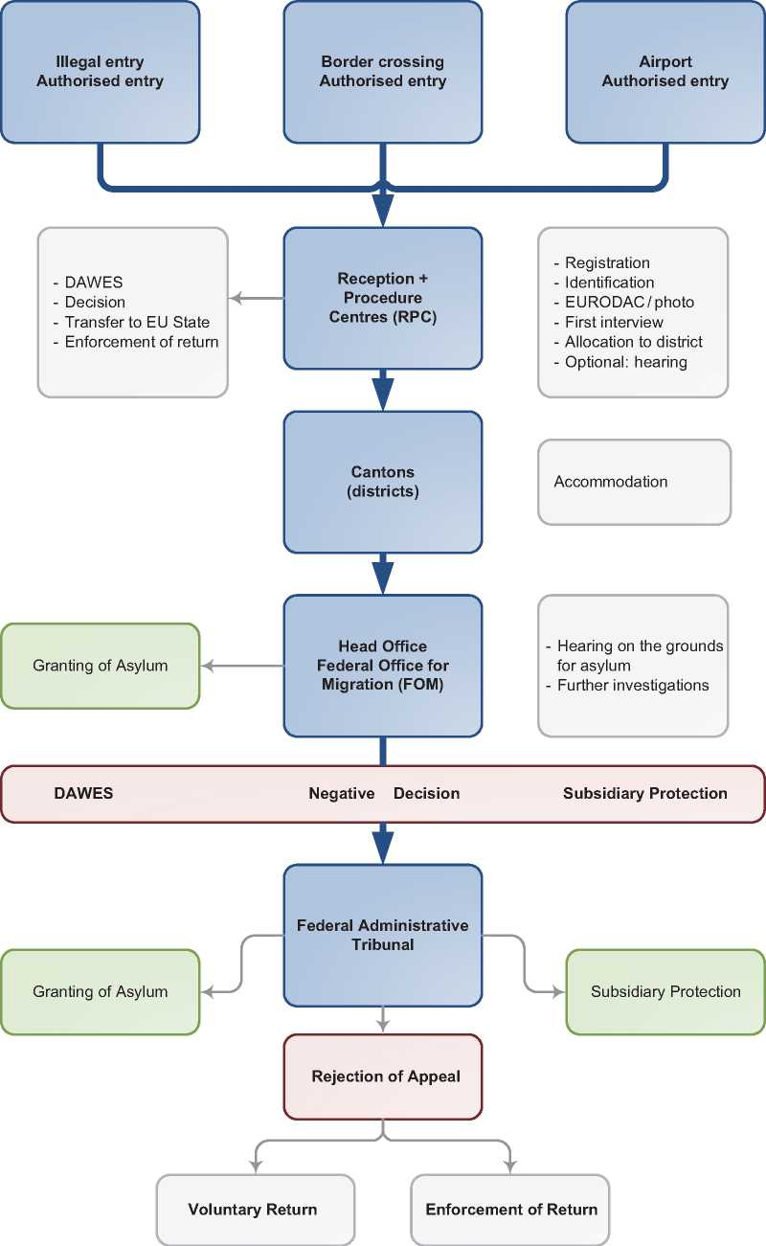

1. Additional Statistical Information

Figure 4: Asylum Applications from Top 10 Countries of Origin in 2009, 2010, 2011 and first half of 2012

**2009 2010 2011 Jan-Jun 2012**

|  |  |  |  |  |  |  |  |  |
| --- | --- | --- | --- | --- | --- | --- | --- | --- |
| **1** | Nigeria | 1,786 | Nigeria | 1,969 | Eritrea | 3,356 | Eritrea | 2,426 |
| **2** | Eritrea | 1,724 | Eritrea | 1,799 | Tunisia | 2,574 | Nigeria | 1,351 |
| **3** | Sri Lanka | 1,415 | Sri Lanka | 939 | Nigeria | 1,895 | Tunisia | 1,275 |
| **4** | Iraq | 935 | Serbia | 910 | Serbia | 1,217 | Serbia | 965 |
| **5** | Somalia | 753 | Afghanistan | 670 | Afghanistan | 1,052 | Afghanistan | 642 |
| **6** | Afghanistan | 751 | Iraq | 659 | FYROM | 926 | FYROM | 585 |
| **7** | Kosovo | 694 | Georgia | 642 | Syria | 826 | Syria | 548 |
| **8** | Georgia | 638 | Kosovo | 602 | China | 696 | Somalia | 500 |
| **9** | Serbia | 575 | Turkey | 530 | Somalia | 636 | Morocco | 424 |
| **10** | Turkey | 559 | Syria | 469 | Kosovo | 634 | China | 393 |

**Figure 5: Decisions Taken at the First Instance in 2009, 2010 and 2011**

|  |  |  |  |  |  |  |  |  |  |
| --- | --- | --- | --- | --- | --- | --- | --- | --- | --- |
|  | **Geneva Convention** | | **Subsidiary/**  **Complementary**  **Protection and Humanitarian Status** | | **Rejections** | | **Withdrawn, Closed, Abandoned Cases** | | **Grand**  **Total** |
| **Number** | **%** | **Number** | **%** | **Number** | **%** | **Number** | **%** | **17,326** |
| **2009** | 2,622 | 15% | 0 | 0% | 5,750 | 33% | 8,954 | 52% |
| **2010** | 3,449 | 17% | 0 | 0% | 6,541 | 32% | 10,700 | 52% | **20,690** |
| **2011** | 3,711 | 19% | 0 | 0% | 4,281 | 22% | 11,475 | 59% | **19,467** |

**Figure 6.a: Positive [311] First- and Second-Instance Decisions,Top Countries of Origin [312] in 2009**

**Rate out of Total Decisions [313]**

|  |  |  |  |  |
| --- | --- | --- | --- | --- |
|  | | **Total Positive** | **Total Decisions** | **Rate** |
| **1** | **Eritrea** | 1,302 | 1,753 | 74.3% |
| **2** | **Turkey** | 303 | 502 | 60.4% |
| **3** | **Sri Lanka** | 170 | 709 | 24.0% |
| **4** | **Iraq** | 161 | 785 | 20.5% |
| **5** | **Syria** | 67 | 332 | 20.2% |
| **6** | **Iran** | 66 | 213 | 31.0% |
| **7** | **Togo** | 56 | 91 | 61.5% |
| **8** | **Somalia** | 50 | 746 | 6.7% |
| **9** | **Ethiopia** | 45 | 167 | 26.9% |
| **10** | **Russia** | 45 | 108 | 41.7% |

Total Positive Decisions by Status

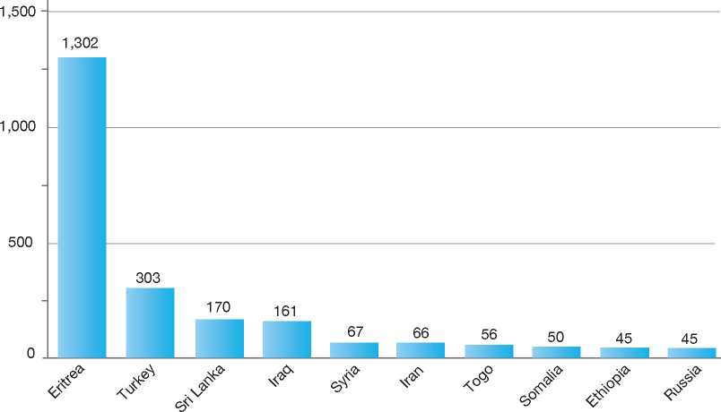

**Total Positive Decisions by Status**

| Geneva Convention Status

**Figure 6.b: Positive [314] First- and Second-Instance Decisions,Top Countries of Origin [315] in 2010**

**Rate out of Total Decisions [316]**

|  |  |  |  |  |
| --- | --- | --- | --- | --- |
|  | | **Total Positive** | **Total Decisions** | **Rate** |
| **1** | **Eritrea** | 2,160 | 2,992 | 72.2% |
| **2** | **Turkey** | 228 | 472 | 48.3% |
| **3** | **Sri Lanka** | 194 | 879 | 22.1% |
| **4** | **Iraq** | 148 | 616 | 24.0% |
| **5** | **Somalia** | 148 | 1,319 | 11.2% |
| **6** | **Iran** | 89 | 256 | 34.8% |
| **7** | **Ethiopia** | 56 | 158 | 35.4% |
| **8** | **Syria** | 46 | 327 | 14.1% |
| **9** | **Afghanistan** | 40 | 464 | 8.6% |
| **10** | **China** | 35 | 336 | 10.4% |

Total Positive Decisions by Status

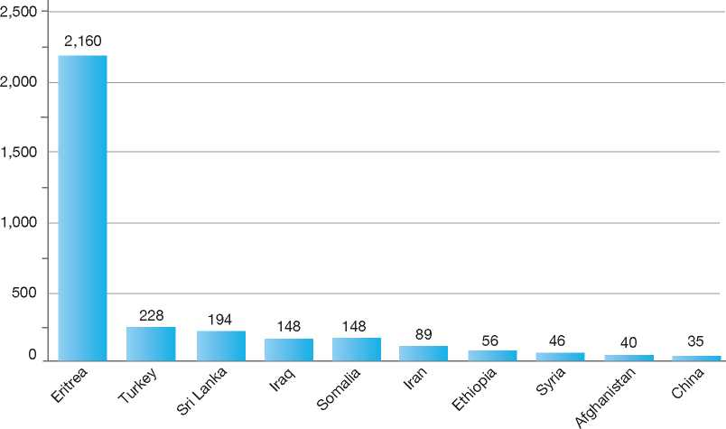

**Total Positive Decisions by Status**

| Geneva Convention Status

**Figure 6.c: Positive [317] First- and Second-Instance Decisions,Top Countries of Origin [318] in 2011**

**Rate out of Total Decisions [319]**

|  |  |  |  |  |
| --- | --- | --- | --- | --- |
|  | | **Total Positive** | **Total Decisions** | **Rate** |
| **1** | **Eritrea** | 2,577 | 2,965 | 86.9% |
| **2** | **Somalia** | 152 | 440 | 34.5% |
| **3** | **Turkey** | 139 | 277 | 50.2% |
| **4** | **Syria** | 115 | 372 | 30.9% |
| **5** | **Sri Lanka** | 90 | 665 | 13.5% |
| **6** | **Iran** | 84 | 172 | 48.8% |
| **7** | **Iraq** | 78 | 296 | 26.4% |
| **8** | **China** | 51 | 427 | 11.9% |
| **9** | **Ethiopia** | 50 | 123 | 40.7% |
| **10** | **Russia** | 49 | 155 | 31.6% |

Total Positive Decisions by Status

3,000

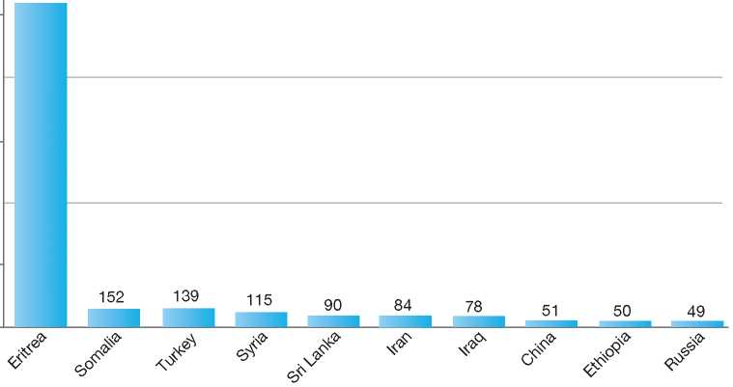

2,000

1,000

0

2,577

**Total Positive Decisions by Status**

| Geneva Convention Status

United Kingdom

1. BackGRound: MajoR asyluM tRends and developMents 437
2. national leGal FRaMewoRk 438
3. institutional FRaMewoRk 439

4. pRe-entRy MeasuRes 440

5. asyluM pRoceduRes 440

1. decision-MakinG and statuses 447
2. eFFiciency and inteGRity MeasuRes 451
3. assistance and Reception BeneFits FoR asyluM-seekeRs 453
4. status and peRMits GRanted outside the asyluM pRoceduRe 456

10. RetuRn 456

11. inteGRation 458

12. annexes

459

1. Background: Major Asylum Trends and Developments

Asylum Applications

In the early 1980s, the United Kingdom (UK) was receiving fewer than 10,000 asylum applications per year. The numbers started to increase in 1990, however, when annual claims reached over 38,000. Numbers peaked in 1991 with 73,400 applications, then fluctuated and reached new peaks from 2000 to 2002, when annual applications ranged between 90,000 and 105,000. Since 2003, numbers have decreased significantly, and in 2011 the UK received 26,000 applications1.[320] [321]

Important Reforms

Beginning in the late 1980s, large numbers of migrants without protection needs were making asylum applications in order to gain entry into the UK. At the time, the asylum procedure was characterised by a slow, bureaucratic system of decision-making and appeals. The UK was also facing practical problems in returning failed applicants to their countries of origin.

Over the years, a number of measures have been taken to address these shortcomings and strengthen the integrity and efficiency of asylum procedures.

At the case-management level, the Home Office introduced changes for a more rigorous

Figure 1: Total Asylum Applications by Quarter, January 1992 - June 2012 2

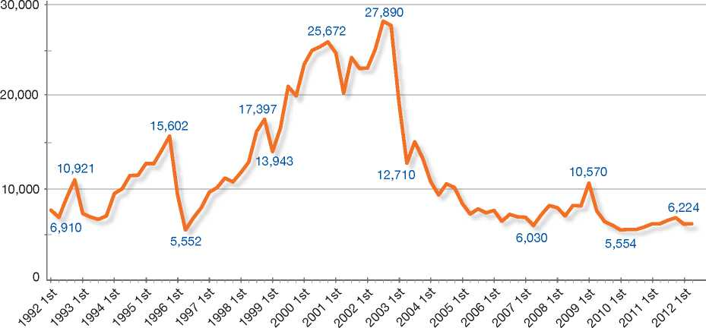



Top Nationalities

In the 1990s, the majority of asylum-seekers arriving in the UK originated from Somalia, the former Yugoslavia, Sri Lanka, Turkey, Pakistan and Nigeria. Since 2000, most claims have tended to originate from Afghanistan, Zimbabwe, Iran, Pakistan, Eritrea, Sri Lanka, China, Iraq, Somalia, Nigeria and Sudan.

examination of each asylum application based on up-to-date country of origin information. Emphasis was also placed on speeding up processing times.

Reforms also addressed fraud within the legal aid system and the immigration advisor profession.

A number of safe country concepts were introduced. Applications from countries of origin designated as safe were certified unfounded and were subject to a fast-track procedure with no right of appeal. In addition, certain countries were designated as safe third countries, and the UK began to apply Council

**Figure 2: Asylum Applications Received from Top 5 Countries of Origin in 2009, 2010 and 2011[322]**

2009

Volumes

45%

25%

12%

2010

Volumes

9% 9%

2011

Volumes

54%

5%

6%

12%

|  |  |  |
| --- | --- | --- |
| **Country of Origin:** | | |
| Afghanistan China | | Iran | Libya |
| Pakistan Sri Lanka | Zimbabwe | Others |

15%

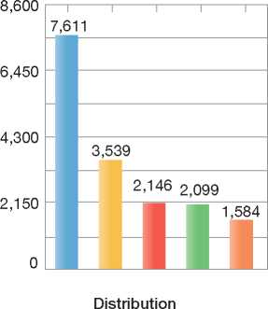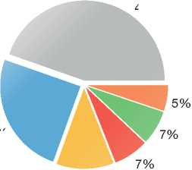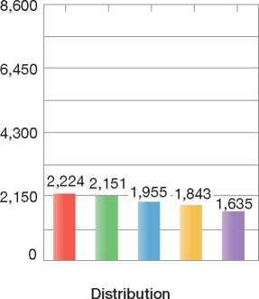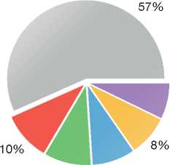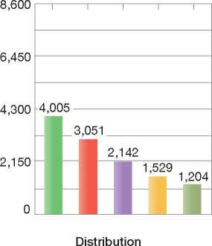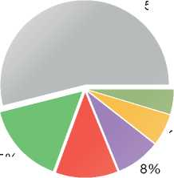

Regulation 3(EC) No. 343/2003[323] as supported by the EURODAC fingerprint database.

New rules were introduced to allow asylum authorities to reject applications made by persons who have committed serious crimes. Meanwhile, rules governing the return of rejected asylum­seekers were amended. For example, those who do not cooperate with authorities on return arrangements lose their entitlement to support. All asylum-seekers are required to present valid travel documents upon arrival in the UK or they may face criminal charges if they do not have a reasonable justification for lack of documentation.

A new operating model began in March 2007 (the New Asylum Model), whereby each new asylum application was to be dealt with by the same person (a UK Border Agency case owner) throughout the process (that is, from application to resolution of the claim). This has remained the case wherever possible, and the case owner remains responsible for the overall management of the application, although in practice asylum applications may be progressed by more than one person.

1. National Legal Framework
   1. Legal Basis for Granting Protection

The 1951 Convention is given effect in British law by references in the Nationality, Immigration and Asylum Act 2002, the Asylum and Immigration Appeals Act 1993, the Refugee and Person in Need of Humanitarian Protection (Qualification) Regulations 2006, and the Immigration Rules.

The concept of subsidiary protection as laid down in Council Directive 2004/83/EC[324] is mandated in the Immigration Rules as Humanitarian Protection. The UK has added “unlawful killing” as an explicit category of serious harm when granting Humanitarian Protection.

Council Directive 2005/85/EC[325] has been implemented by the Asylum (Procedures) Regulations 2007 (SI 3187/2007) and changes to the Immigration Rules.

The European Convention on Human Rights (ECHR) takes effect in British law under the Human Rights Act 1998.

* 1. Recent/Pending Reforms

The new Government of 2010 decided not to pursue plans to simplify through legislation the UK's overall approach to migration and asylum, but has tended to concentrate on targeted changes to specific immigration routes, in particular to reduce net migration to the UK and clarify the UK's approach to family and private life claims to remain in the UK.

In 2011, the UK introduced into the Immigration Rules specific provisions for both post-flight spouses of refugees and extended family members of refugees. This change was designed to clarify the position of these groups and provide them with the opportunity to join the refugee family member in the UK if they were able to satisfy similar rules as those that apply to UK citizens, including requirements to support and accommodate them with recourse to public funds.

With effect from 2 September 2011, all individuals excluded from the protection of the 1951 Convention by virtue of Article 1F but who cannot be immediately removed from the UK due to Article 3 of the European Convention of Human Rights (ECHR) are subject to a new, tighter, Restricted Leave policy (formerly known as Restricted Discretionary Leave). Such individuals should usually only be granted Restricted Leave for a maximum of six months at a time, with some or all of the following conditions:

* Restrictions on the person's employment or occupation in the UK
* Restrictions on where the person can reside
* A requirement to report to an immigration officer or the Secretary of State at regular intervals, and
* A prohibition on the person studying at an educational institution.

The UK is in the process of developing a new route to remain in the UK for stateless persons who do not qualify for refugee status and who have no other country to return to. The intent is to fill a gap in existing arrangements so that those who fulfil the requirements of the relevant UN statelessness conventions can be granted leave to remain in the UK. It is expected that this new policy be implemented in 2013, subject to confirmation that it can be made to work in practice without intolerable risk of abuse.

1. Institutional Framework
   1. Principal Institutions

The UK Border Agency (UKBA), an agency of the Home Office, is responsible for processing asylum claims. The UKBA is responsible for handling all aspects of an asylum claim, from screening to decision-making. The UKBA also has responsibility for overseeing the reception of asylum-seekers. The UKBA implements the return of rejected asylum-seekers and facilitates the integration of recognised refugees and beneficiaries of complementary forms of protection.

Appeals of negative decisions on asylum claims are heard by the Tribunal Service for Immigration and Asylum, which is independent of the UK Border Agency.

* 1. Cooperation between Government Authorities

The UK Border Agency and UK Police Service[326] have signed a Strategic Partnership Agreement whereby police officers work within the UKBA alongside immigration officers. This partnership arrangement recognises the need to “ensure and enforce compliance with (UK) immigration laws, removing the most harmful people first and denying the privileges of Britain to those here illegally”.

Multi-agency Criminal Financial Investigations teams (CFI - Immigration and CFI - Borders) were formed from Local Immigration Crime Teams and operate nationally. These CFI teams bring together the skills and powers of police detectives and immigration staff. The crime teams have targeted those who facilitate human trafficking, who produce and distribute counterfeit documents, who cause economic harm, or who commit various organised criminal offences. Those who commit these offences possibly face both criminal justice and immigration consequences. The CFIs increasingly seize cash and assets of those committing crime.

1. Pre-entry Measures
   1. Visa Requirements

Nationals of certain countries, including European Union (EU) Member States, the European Economic Area and Switzerland, do not need a visa to enter the United Kingdom. A visa is required for entry if the person is a national of one of the countries or territories listed in Appendix 1 of the Immigration Rules[327]. The UK Border Agency is the competent authority for dealing with visa applications.

* 1. Carrier Sanctions

Under the Carrier's Liability legislation, air and sea carriers may be liable for a charge of *£* 2,000 for each person they carry to the UK who is subject to immigration control and who fails to produce either a valid immigration document satisfactorily establishing his or her identity and nationality or a valid visa, if required.

* 1. Interception

The UK Border Agency's strategic aims are to protect UK borders and national interests, tackle border tax fraud, smuggling and immigration crime and to implement fast and fair decisions. Juxtaposed controls have existed at the Channel Tunnel sites in Coquelles and Cheriton since the opening of the Tunnel System in 1994. Currently, the UK Border Agency operates juxtaposed controls in Northern France and Belgium at the seaports of Calais, Boulogne, Coquelles and Dunkerque, as well as the Eurostar ports at Paris Gare du Nord and Gare de Bruxelles-Midi. A treaty signed with the French and Belgian Governments allows for reciprocal arrangements in the control zones in St. Pancras, Ashford, Ebbsfleet, Cheriton and Dover.

The use of juxtaposed controls has dramatically strengthened the cross-channel border and in 2007, the UK Border Agency, together with other agencies and authorities, prevented over 17,500 individual attempts by people to cross the channel illegally.

* 1. Immigration Liaison Managers

The UK Border Agency has an overseas network of Immigration Liaison Managers (ILMs) (previously called Airline Liaison Officers). ILMs have no legal enforcement powers and do not operate pre­clearance but act as document advisors to airlines. Their role is to provide information and training on UK passport and visa requirements and forgery awareness, with a view to preventing the carriage of inadequately documented passengers to the UK and assisting airlines to comply with carrier liability legislation. ILMs are posted with the agreement of the host country and work in accordance with the Code of Conduct for Immigration Liaison Officers issued under the auspices of the International Air Transport Association/Control Authorities Working Group (IATA/CAWG).

UK Immigration Liaison Managers based overseas offer training and advice to carriers on documentary requirements for travel to the UK and on basic forgery detection. This training includes assisting carrier personnel to detect passengers who do not have the required travel documents to enter the UK, those who may be trafficked or smuggled, and those who may pose a security threat.

1. Asylum Procedures
   1. Application Possibilities and Requirements, Procedures and Legal Remedies

Applications for asylum can be made at a point of entry - a seaport or airport - and inside the UK at the asylum screening unit of the UK Border Agency in Croydon. Applications must be made in person.

Information on the UK's asylum procedures is publicly available on the UK Border Agency's website[328]. In addition, the case owner (decision­maker) is responsible for guiding the asylum-seeker through the various stages of the procedure, such as by providing information on legal aid, reception benefits and asylum-seeker rights and obligations.

* + 1. Outside the Country

Applications at Diplomatic Missions

Asylum claims at diplomatic missions are not accepted. The 1951 Convention places no obligation on the UK to consider an asylum application made abroad by a person outside their country of nationality. Neither is there any basis in the Immigration Rules under which an individual may be given prior entry clearance to come into the UK to claim asylum.

Resettlement/Quota Refugees

The UK's formal resettlement plan is known as the Gateway Protection Programme and is managed by the UK Border Agency in cooperation with the UNHCR. It has been operational since 2004. Through this programme, the UK currently accepts an annual quota of 750 refugees for resettlement, on the basis of applications submitted by the UNHCR. Applications cannot be made to British diplomatic posts abroad or to the UK Border Agency directly. Applicants are interviewed by UK Border Agency officials during organised missions, and the final decision is made by the UK Border Agency.

In addition to the resettlement criteria set out in the UNHCR Handbook, the UK requires that applicants cooperate with Agency officials and other organisations involved in the programme, that they not be in a polygamous marriage and that they have not been involved in any fraudulent activity. There are no official sub-quotas within the programme, although the UK Border Agency aims to accept at least 10 per cent of cases falling under the category of Women-at-Risk and resettles Medical Needs cases from each caseload.

The Mandate Scheme allows the UK Border Agency to resettle refugees who have close ties to the UK. This normally means immediate family members. These family members in the UK must have settlement or immigration status leading to settlement in order to be eligible (but they do not themselves have to be refugees). The applicant must have been granted Mandate refugee status by the UNHCR and also demonstrate a resettlement need in accordance with the UNHCR criteria on resettlement. Referrals are made by the UNHCR. Decisions are made by the UK Border Agency on a dossier basis without an interview. Around 60 refugees from around the world are resettled annually through the Mandate Scheme.

* + 1. At Ports of Entry

At a point of entry - a seaport or airport - the asylum-seeker may communicate to the immigration official at passport control that he or she wishes to apply for asylum. A screening process similar to the one at the asylum screening units takes place[329] [330].

Upon completion of the screening process, the applicant may be routed into the Detained Fast­Track procedure or to a regional asylum team at the UK Border Agency for substantive consideration of the asylum claim. He or she may also be routed through Third Country (Dublin) procedures.

* + 1. Inside the Territory

Responsibility for Processing the Claim

The Dublin System

The Third Country Unit (TCU) of the UK Border Agency is responsible for considering asylum claims that come under the Dublin system.

*Application and Procedure*

Once an applicant claims asylum in the UK, his or her fingerprints are taken and transmitted to the EURODAC databases in accordance with Council Regulation (EC) No. 2725/200011. If EURODAC returns a match (“hit”), TCU will examine this evidence to determine if another State party to the Dublin Regulation is responsible for considering the applicant's claim under the terms of the Dublin Regulation. Alternatively if other evidence is available suggesting that another State is responsible for examining the applicant's claim, then this evidence is also considered. Such evidence includes any of the following: visa, residence permit, other reliable documentary evidence (e.g. wage slips or utility bills), information establishing family relationships

(to determine whether family unity or humanitarian provisions apply) and/or credible statements from the applicant.

If TCU considers that another State is responsible for examining the asylum claim under the terms of the Dublin Regulation, TCU will decide whether to detain the applicant or enforce reporting restrictions whilst a formal request is made to the State concerned.

*Freedom of Movement/Detention*

Each third country case is considered for detention and is considered on its individual merits. For detention to be justified, there must be strong grounds for believing that a person will not comply with conditions of temporary admission (TA) or temporary release (TR), and there must also be a realistic prospect of removal within a reasonable period. If a third country case is released on TA or TR, the person will be expected to report to a UKBA Local Enforcement Office or reporting centre weekly, unless the applicant has exceptional reasons for not being able to comply, in which case a less frequent reporting regime may be considered. If an applicant meets the criteria, he or she may also be considered for electronic monitoring.

An immigration officer has the authority to temporarily admit any person to the United Kingdom who is detained or liable to be detained under Immigration Powers. Temporary admission may be given pending the completion of examination, pending the implementation of removal directions, or pending the resolution of an outstanding appeal. The immigration officer may at any time decide to resume detention, for example, if the person fails to observe place of residence, employment or reporting restrictions.

*Conduct of Transfers*

Once another State has accepted responsibility for an applicant, the UK respects the provisions of the Dublin system that govern transfers, namely Articles 19 and 20 of the Dublin II Regulation Dublin II and Chapter III of Commission Regulation (EC) No. 1560/2003[331]. TCU will also ensure that when an applicant is transferred to another State, he or she will arrive in their territory (as far as is practicable) before 2:00 p.m. local time, and not on one of their public holidays or over a weekend.

*Suspension of Dublin Transfers*

The UK does not have a policy whereby transfers under Dublin to a particular State or States are suspended in general. But in practice and as have other EU countries, the UK is not currently seeking to return any cases to Greece under the terms of the Dublin Regulation but is instead exercising its right to consider substantively asylum applications from persons that might otherwise meet the Dublin criteria for return to Greece.

If the applicant has absconded or been imprisoned, TCU will contact the other State and request a 12-month extension (to the original six-month deadline) for the applicant's transfer in accordance with Articles 19(4) or 20(2) of the Dublin II Regulation.

If the applicant has a Human Rights (HR) or legal application pending, TCU will request a suspension until the application has been concluded.

TCU will also contact the responsible State to advise it of the delayed transfer.

*Review/Appeal*

Once another State party to the Dublin Regulation has accepted responsibility for an applicant's asylum claim, TCU will certify the asylum claim in the UK under Schedule 3 of the Asylum and Immigration (Treatment of Claimants etc.) 2004 Act. The relevant Immigration Rule applicable in third country cases is paragraph 345 of the Immigration Rules (HC 395).

The statutory right of appeal to the Asylum and Immigration Tribunal provided for transfers under the Dublin Regulation in Part 2 of Schedule 3 to the Asylum and Immigration (Treatment of Claimants, etc.) Act 2004 is non-suspensive, unless a human rights challenge to removal (not based on onward removal in breach of Article 3 ECHR) is not certified as “clearly unfounded”. Such appeals must be lodged with the Asylum and Immigration Tribunal (AIT) within 28 days of the person's departure from the United Kingdom.

If the human rights challenge to removal is not certified as “clearly unfounded”, there is an in­country right of appeal, and the appeal must be made with the Immigration and Asylum Tribunal no later than 10 days after the person is served with the notice of decision (five days if the person is in detention). The Asylum and Immigration Tribunal has discretion to accept out-of-time appeals. Furthermore, an applicant may seek to challenge the transfer decision by judicial review in the civil administrative courts, which has suspensive effect.

Application and Admissibility

Screening

Upon making known his or her intention to claim asylum, the applicant must go through a registration process. The applicant and any dependants are first screened by the UK Border Agency. This screening process is used in an attempt to establish both identity and immigration status. The interview is conducted in a language that the applicant can reasonably be expected to understand. Basic bio­data is recorded and the applicant's fingerprints and photographs are taken. Applicants are requested to produce any travel documentation or national identity documents at this stage. Security and system checks are also completed during the screening process. Also during this stage the applicant must complete an application for a Biometric Residence Permit. These measures assist in establishing identity, the identification of Third Country Cases, fraudulent applications, and those who may have committed a criminal or immigration offence.

The asylum-seeker and any dependants are issued with an application registration card (ARC), which shows that he or she has applied for asylum in the UK. This is not an official identity document but does contain basic bio-data and is used for contact management purposes and to issue any asylum support.

Upon completion of this process, the applicant may be routed into the Detained Fast-Track procedure, to a regional asylum team at the UK Border Agency for substantive consideration of the asylum claim, or through Third Country procedures.

Accelerated Procedures

An asylum claim may be put through the Detained Fast-Track procedure if, after the screening process, it appears to be one that may be decided quickly.

With the exception of the categories listed below, there is a general presumption that the majority of asylum applications are ones on which a quick decision may be made, unless there is evidence to suggest otherwise.

Case owners in a specific UK Border Agency unit are responsible for processing claims under the fast-track procedure. All asylum-seekers in the fast-track procedure have access to legal advice and an interpreter.

Applicants are interviewed and promptly served with a decision, usually within seven to fourteen days after entry into the process[332]. There are safeguard mechanisms in place to ensure that process timescales can be extended if fairness requires it, or for the applicant to be transferred to the normal procedure if it emerges that the applicant is no longer suitable for the process.

If the claim results in a negative decision, two possible routes may follow, both of which reflect non-detained processes. If the claim is considered to be so lacking in merit as to be “clearly unfounded”, it may be certified under section 94 of the Nationality, Immigration and Asylum Act 2002. Such a decision requires the authority of a second trained officer. The right of appeal of a certified decision may be exercised only from the country of origin (the applicant must appeal within 28 days of removal). For negative decisions that are not certified, the applicant has the same in-country appeal rights as in the non-detained system, but to an accelerated timetable. The applicant has two days to appeal the decision to the Immigration and Asylum Tribunal. The appeal is expedited and the hearing takes place before an Immigration Judge within another two days. The Immigration Judge is then required to provide his or her determination within two days of that appeal hearing.

The Immigration Judge who hears a fast-track appeal has the power to remove the asylum­seeker's claim from the fast-track procedure and place it in the normal appellate system.

Asylum applicants can also apply for reconsideration of the determination via a “High Court Opt-in”. But in most cases where the appeal is dismissed, the applicant's appeal rights are exhausted within 28 days of the decision being served.

If there has been an error of law, there is the possibility of an appeal against a Tribunal decision. In exceptional cases, the appeal may reach the Court of Appeal.

Cases Not Likely To Be Decided Quickly

Cases where a quick decision may not be possible may include (but are not limited) to the following situations:

* Cases where it is foreseeable that further enquiries (either by the UK Border Agency or by the applicant) will be necessary to obtain clarification or corroborative evidence, without which a fair and sustainable decision could not be made, or in cases where it is apparent that those enquiries will not be concluded in time to have a decision within normal expected timescales
* Cases where it is foreseeable that translations are required for documents presented by an applicant, without which a fair and sustainable decision could not be made, or where it is apparent that the necessary translations cannot be obtained in time to allow a decision to take place within the normal expected timescales.

There are exceptions to the application of the fast-track procedure that apply to groups deemed unsuitable for the procedure, as follows:

* Women who are 24 or more weeks pregnant
* Family cases
* Those accepted to be children
* Those with a disability that cannot be adequately managed within a detained environment
* Those with a physical or mental medical condition that cannot be adequately treated within a detained environment, or which for practical reasons, including infectiousness or contagiousness, cannot be properly managed within a detained environment
* Those who clearly lack the mental capacity or coherence to sufficiently understand the asylum process and/or cogently present their claim. This consideration will usually be based on medical information, but where medical information is unavailable, officers must apply their judgement as to an individual's apparent capacity
* Those for whom there has been a reasonable- grounds decision taken (and maintained) by a competent authority stating that the applicant is a potential victim of trafficking, or where there has been a conclusive decision taken by a competent authority stating that the applicant is a victim of trafficking
* Those in respect of whom there is independent evidence of torture.

Normal Procedure

The case owner has overall responsibility for dealing with the initial decision-making process, including the substantive examination, and acts as the point of contact for the asylum-seeker and his or her legal representative on the progress of the application.

During the asylum interview, the asylum-seeker may be assisted by a legal representative who is not claiming legal aid. The services of an interpreter will be provided by the UKBA if needed. At the end of the interview, the asylum­seeker receives a record of the interview. Failure by the asylum-seeker to appear at the interview may result in the claim being categorised as unsubstantiated or withdrawn.

The case owner, when reviewing the merits of a claim, must consider whether the asylum-seeker meets the criteria for Convention refugee status, for Humanitarian Protection or for Discretionary Leave, in that order.

Review/Appeal of the Asylum Decision

There is no automatic right of appeal against a decision to refuse an asylum claim. Instead, appeal rights relate to the relevant immigration decision that may accompany the decision to refuse asylum. For instance, an asylum-seeker who has been refused asylum but given Humanitarian Protection or Discretionary Leave may appeal against the asylum decision if the status granted provides for a residence permit of 12 months or more.

Rejected asylum-seekers may have rights to appeal on the following grounds:

* Discrimination based on race
* The UK Border Agency's decision constitutes a breach of rights enshrined in the ECHR, or return to the country of origin would be a breach of the person's rights.

In addition, rejected asylum-seekers may appeal in one of the following cases:

* The UK Border Agency's decision was not in line with Immigration Rules
* The UK Border Agency's decision was not in line with the law
* If the Immigration Rules provide for the case owner to exercise his or her judgment, and he or she should have exercised that judgment differently given the circumstances of the case.

The Asylum and Immigration Tribunal (AIT) hears and decides appeals against decisions made by the UK Border Agency. Usually an Immigration Judge will make a determination on the appeal, although some cases may be heard by a panel of judges. There is a right to appeal a decision made by the AIT to the Administrative Court and to the Court of Appeal. However, appeals against AIT decisions are possible only when there has been an error in law.

Appeals before the AIT are given suspensive effect unless the application is considered to be clearly unfounded. The 2005 Procedure Rules set out the following timeframes to appeal:

* If detained, the applicant has five days to make the appeal with the AIT from the time the applicant is served with the refusal notice
* If not detained, the applicant has 10 days to make the appeal with the AIT from the time the applicant is served the refusal notice.

Freedom of Movement during the Asylum Procedure

Although some asylum-seekers may be detained, a person is not detained simply for having claimed asylum.

Detention

Asylum-seekers who are considered suitable for the Detained Fast-Track (DFT) procedure will be detained at processing centres operating this procedure (Harmondsworth or Yarl's Wood).

Other asylum-seekers may be detained. The power to detain (other than in criminal cases) may be appropriate in the following cases:

* To effect removal (including deportation)
* While establishing a person's identity and claim
* Where there is reason to believe that a person will fail to comply with conditions attached to a grant of temporary admission or release
* As part of a fast-track process in which it is considered that an application can be decided quickly.

Reporting

There are provisions in the law for the UK Border Agency to maintain contact with asylum-seekers throughout the asylum procedure. Reporting centres are located throughout the country to facilitate asylum-seekers' reporting to Agency staff. Immigration officials are also posted at some police stations to facilitate reporting.

The frequency with which an asylum-seeker is required to report to authorities depends on the circumstances of his or her case. Persons with special needs, such as pregnant women, the elderly, minors under the age of 17, and persons with serious medical conditions may be required to report less frequently.

The UK Border Agency also employs other forms of contact management for asylum­seekers (such as tagging and voice recognition technology).

Repeat/Subsequent Applications

A person who makes a further application to remain in the UK, citing asylum or human rights grounds and having had an earlier claim withdrawn or refused with no appeal pending on that claim, will normally have the latest application treated as further submissions under the procedures in paragraph 353 of the Immigration Rules regulating “fresh claims”.

These procedures require the UK Border Agency to first decide whether to grant leave and, if they decide that leave is not appropriate, to decide whether the submissions merit consideration as a fresh asylum or human rights claim. A fresh asylum or human rights claim will be generated if the most recently submitted material on the case is “significantly different” from that which has been previously considered.

If a fresh asylum or human rights claim is generated and then refused, the applicant has the right to appeal the decision before removal takes effect, unless the claim is certified under section 96 of the Nationality, Immigration and Asylum Act 2002. However, the applicant will have no right to appeal where leave is rejected and a fresh asylum or human rights claim is not generated on the strength of the further submissions.

Applicants will have access to legal advice and representation throughout the process and will also be able to apply for asylum support under section 95 of the Immigration and Asylum Act 1999, once a fresh asylum or human rights claim has been generated. While the further submissions are being considered, before it is decided whether or not to grant leave, and whether or not the submissions constitute a fresh claim, the applicant may be eligible for support under section 4 of the 1999 Act[333].

* 1. Safe Country Concepts
     1. Safe Country of Origin

Section 94 (4) of the Nationality, Immigration and Asylum Act 2002 makes provision for a list of countries from which asylum or human rights claims must be certified as clearly unfounded unless the Secretary of State is satisfied that they are not.

A list of those states is set out in the following Orders:

* Asylum (Designated States) Order 2003
* Asylum (Designated States) (No.2) Order 2003
* Asylum (Designated States) Order 2005
* Asylum (Designated States) (No 2) Order 2005
* Asylum (Designated States) Order 2007.

Asylum Applications by EU Nationals

An EU national may apply for asylum in the UK. As the UK does not have a general procedure in place by which to declare an asylum claim inadmissible, an asylum claim made by an EU national must be considered within the substantive asylum procedure, albeit against the presumption that it is manifestly unfounded.

A national from the European Economic Area (EEA) is not excluded from applying for asylum. However, EEA Regulations (2006) applying to such nationals contain a provision for claims to be certified as “clearly unfounded” in certain circumstances, and there is a general assumption that this is how such cases will be dealt with.

* 1. Special Procedures
     1. Unaccompanied Minors

Support for Unaccompanied Asylum-Seeking Children (UASCs)

Unaccompanied asylum-seeking children (UASCs) are entitled to support from the Local Authority Children's Services Departments, which have a legal duty to safeguard the welfare of children in need in their area. This support, which may include accommodation, is based on a needs assessment. The British Refugee Council's Panel of Advisers plays a role in advising and assisting the UASC with his or her asylum application. The advisor will not offer any legal advice.

|  |  |  |  |
| --- | --- | --- | --- |
| **Figure 3: Asylum Applications by Unaccompa­nied Minors in 2009, 2010 and 2011[334]** | | | |
|  | **2009** | **2010** | **2011** |
| Total Asylum Applications | 30,673 | 22,644 | 25,898 |
| of which Unaccompanied Minors | 2,991 | 1,364 | 1,123 |
| Percentage | 10% | 6% | 4% |

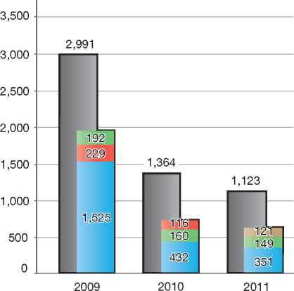

Country of Origin:

| Afghanistan | | Albania J Eritrea

~ Iran

Interview 15

UASCs aged 12 or over will normally be interviewed about the substance of their asylum application. Children invited to attend an asylum interview are interviewed by a specially trained case owner. The child must be accompanied by a responsible adult, that is, someone whom the child trusts. A responsible adult could be their legal representative, social worker, guardian/relative, foster care parent, doctor, priest, vicar, teacher, charity worker or Refugee Council representative. However, other

people could also assume this role. The interview is conducted using child-sensitive techniques.

In January 2009 UK Border Agency introduced a Code of Practice that applies to UK Border Agency staff and contractors. It requires all of them to be responsible to the needs of children when they encounter them and to be vigilant to indications that a child might be at risk of harm. The UK Border Agency has taken positive steps to keep children safe from harm by incorporating key principles into the practice. The key principles are as follows: ensuring the immigration procedures and situations are responsive to the needs of children; identifying children whose circumstances mean they may be at risk of harm when they come into contact with the immigration system; and referring the identified children to the appropriate agency or agencies and working together effectively with the referred agency or agencies. It also requires UKBA staff to be trained in specific children's issues, including communicating with children, safeguarding children, trafficking, smuggling and exploitation of children, and working effectively with other agencies.

UASCs are entitled to legal aid. However, funding has been excluded for the “first reporting event” or other “reporting event”, which are opportunities where asylum-seekers are provided with documentation and information by case owners. The Panel of Advisers usually assists in finding a legal representative for the child.

All the processes followed and the decisions taken by the UK Border Agency must take into account the effect of the circumstances of each case as they would impact on children or on persons with children.

Arising out of the UK's treaty obligations under the 1989 UN Convention on the Rights of the Child (CRC) and other international commitments, including the relevant EU directives that require the best interests of the child to be a primary consideration for Member States when implementing provisions involving minors, section 55 of the Borders, Citizenship and Immigration Act 2009 requires the UK Border Agency to carry out its existing functions in a way that takes into account the need to safeguard and promote the welfare of children in the UK.

The statutory duty to children includes the need to demonstrate that asylum applications involving children are dealt with in a timely and sensitive fashion. In accordance with the CRC and the UK Supreme Court judgment in *ZH (Tanzania) (FC) (Appellant) v SSHD*[335], the best interests of the child will be a primary consideration (although not necessarily the only consideration) when making decisions affecting children, whether the child is the direct subject of the application or an adult applicant is the primary parent or guardian of a child in the UK or has a genuine and subsistent family life with a child in the UK.

Specially trained staff deal with asylum applications made by minors.

1. Decision-Making and Statuses
   1. Inclusion Criteria
      1. Convention Refugee

The Immigration Rules state that an asylum­seeker will be granted asylum in the UK if he or she is a refugee as defined in regulation 2 of the Qualification Regulations.

* + 1. Complementary Forms of Protection

Humanitarian Protection

Humanitarian Protection (HP) is granted in cases where the asylum-seeker runs a real risk of serious harm, that is:

* The death penalty or execution
* Unlawful killing
* Torture or inhuman or degrading treatment or punishment
* Serious and individual threat to life or person by reason of indiscriminate violence in situations of international or internal armed conflict.

Discretionary Leave

Discretionary Leave (DL) or Restricted Leave[336] may be granted to persons who do not meet the criteria for refugee status but fall under one of the following categories:

* They are excluded from the benefit of refugee status by virtue of Article 1F of the 1951 Convention
* They can be returned by virtue of Article 33(2) of the 1951 Convention but it would be contrary to ECHR obligations to enforce removal to the country of origin.

Similar principles apply to persons excluded from Humanitarian Protection (HP), but the rules derive from the Qualification Directive) rather than the 1951 Convention. Where a person would qualify for refugee status or HP, but is excluded for reasons of criminality, the applicant can normally claim that their Article 3 ECHR rights would be infringed upon if he or she was returned to the country of origin. In such cases, DL is usually granted for a six-month period and is subject to active review at the time an application is made for further leave.

Applicants who cannot claim refugee status or HP since they do not fulfil the criteria for protection­based leave, but whose return would breach obligations under the ECHR (usually Article 3 or 8), may also be granted Discretionary Leave. Such persons, who are usually granted leave for a period of three years, may be subdivided into four categories:

**British Case Law: Clarifying Grounds for Protection**

Defining Particular Social Group

"Membership of a particular social group” (PSG) is one of the more complex of the Convention grounds, but the term is now well established through case law and the Qualification Directive at Regulation 6 (1) (d). The most important UK case on PSG is the House of Lords judgment in *Shah and Islam* [1999] INLR 144 (and as later interpreted in the lower UK Courts). As a result, it is established that the independent defining characteristic of a PSG must be an innate, immutable or unchangeable characteristic of some kind, and a characteristic or association that members of the group should not be forced to forsake because it is so fundamental to their human dignity.

The case of *Shah and Islam* also demonstrated that the Courts were willing to define certain sections of a population, in this case Pakistani women, as constituting a PSG. Crucial to this decision was the legal and societal discrimination against women in Pakistan.

Defining Article 15(c) of the Qualification Directive

As a result of judgments by the European Court of Justice *(Elgafaji[2009] EUECJ C-465-07),* and the UK's Court of Appeal *(QD and AH v SSHD [2009] EWCA Civ 620)* decision-makers are required to consider claims based on Article 1 5(c) of the EU Qualification Directive on the basis of indiscriminate violence in the country of origin.

* Article 3: There are some cases where the Article 3 breach does not arise from a need for protection as such (e.g. where a person's medical condition or severe humanitarian conditions in the country would make return contrary to Article 3). Persons falling into this category are granted DL rather than Humanitarian Protection
* Article 8: Where return would involve a breach of Article 8 of the ECHR (right to respect for private and family life) on the basis of family life established in the UK. For example, in the context of a marriage or civil partnership application where, although the requirements of the Immigration Rules are not met, there are genuine Article 8 reasons that would make return inappropriate
* Other articles: These may be engaged if return to the country of origin would amount to a “flagrant breach or denial” of a right covered in other articles of the ECHR. For example, an applicant may argue that conditions in the country of origin are such that he or she would be completely denied the right to freedom of religion under Article 9
* Any other exceptionally compelling case falling outside the rules in which it is decided that a person should be granted Discretionary Leave - this could be for any number of reasons.

1. The Decision

The UK Border Agency case owners make decisions on asylum applications. The decision is based on an assessment of the merits of the claim, which includes consideration of the oral and documentary evidence provided by the claimant as well as country of origin information.

Decisions are provided in writing, with full reasons included for grant or refusal of a particular status or leave to remain. If no protection or leave to remain is granted, the Reasons for Refusal letter must explain why return would not breach the UK's obligations under the ECHR, or why the applicant can reasonably be expected to return voluntarily.

1. Types of Decisions, Status and Benefits Granted

Upon reviewing the merits of an asylum claim, the case owner can take one of the following decisions:

* Grant Convention refugee status
* Refuse refugee status but grant Humanitarian Protection
* Refuse refugee status but grant Discretionary Leave
* Refuse refugee status and decline grant of leave to enter or leave to remain.

**Convention Refugee Status and Humanitarian Protection**

Persons who are granted Convention refugee status or Humanitarian Protection are given a residence permit valid for five years, which entitles them to the same rights as permanent residents of the UK. Refugees have access to the labour market and various benefits, including social assistance and an integration loan. After five years, they may apply for a renewal of their permit or for permanent residence.

The five-year leave to remain can be reviewed in certain circumstances:

* If grounds for revocation of status come to light
* If there has been a significant and non­temporary change in conditions in the country of persecution
* When the refugee applies for indefinite leave to remain (ILR) or reaches the five-year mark of his or her residence permit.

Family Reunification Benefits

The UK Border Agency recognises that families become fragmented because of the speed and manner in which a person seeking asylum has fled to the UK. Family reunion is intended to allow dependent family members to reunite with their family members who are recognised refugees or who have five years' Humanitarian Protection leave in the UK. Dependants of those with Discretionary Leave or Exceptional Leave to Remain may also apply for family reunion in certain circumstances.

Only pre-existing families are eligible for family reunion, (that is, the spouse, civil partner, unmarried/same-sex partner and minor children who formed part of the family unit at the time the sponsor fled to seek asylum.

Discretionary Leave

Prior to 9 July 2012, persons granted Discretionary Leave were given a renewable residence permit valid for a period of up to three years, depending on the basis for the grant. Following six years or more of Discretionary Leave (ten years or more for excluded cases), beneficiaries became eligible for ILR. Discretionary Leave, when granted, may be subject to periodic review. Beneficiaries are entitled to work and to receive social benefits and assistance.

Starting 9 July 2012, the duration of Discretionary Leave granted is determined by the individual facts of the case but is not granted for more than 30 months (two and a half years) at a time. Subsequent periods of leave can be granted providing the applicant continues to meet the relevant criteria. From 9 July 2012, an applicant needs to have been granted at least 120 months (i.e. a total of 10 years normally consisting of four two-and-a-half-year year periods) of leave before being eligible to apply for settlement.

Where Discretionary Leave is granted to an unaccompanied minor on the basis of inadequate reception arrangements in his or her country of origin, the length of stay is three years or until the minor reaches the age of 17.5 years, whichever is the shorter period of time.

Rejection of an Asylum Claim

Asylum-seekers whose claims are rejected may have the right to appeal the decision, depending on the circumstances of their case[337]. Otherwise, if they have not been granted leave to remain on another basis, they are expected to leave the UK immediately. If they fail to return voluntarily, the UK Border Agency will enforce their return.

1. Exclusion
2. Refugee Protection

The grounds for exclusion are those set out in Articles 1D, 1E and 1F of the 1951 Convention, as replicated by Article 12 of the Qualification Directive.

The UK Border Agency applies the exclusion clauses on a mandatory basis. Where applicable, the normal procedure is to consider the asylum claim in its totality, that is, the well-founded fear of persecution as well as the asylum-seeker's position with regard to Article 1F.

Where asylum is refused on the basis that Article 1F applies[338], the person is entitled to appeal. During

the appeal, the person is entitled to challenge the applicability of exclusion. However, the grounds for exclusion must be considered first when an applicant makes an appeal. Should those hearing the appeal agree to do so, the asylum element of the appeal will be dismissed.

1. Complementary Protection

The 1951 Convention exclusion clauses are applicable to Humanitarian Protection and to the full provision of Discretionary Leave. However, where removal would place the UK in breach of Article 3 of the ECHR, the UK would grant that person a period of six months' Discretionary Leave, which would be subject to review at the end of the six-month period.

1. Cessation

With regard to clauses (1) to (4) of Article 1C of the 1951 Convention, the UK will apply the cessation clauses where it deems appropriate. The act that brings the person within the scope of these four provisions must be voluntary by that person.

With regard to clauses (5) and (6), the UK Border Agency assesses changes in circumstances on the basis of objective country information and case law. Any changes inside the country of origin must be significant/fundamental and non-temporary/non-transitory. For applications made since 21 October 2004, the UK also requires a Ministerial Statement to be issued in the Houses of Parliament announcing that the requisite changes have occurred. This would be done after consultation with the UNHCR. Cases would still be looked at on an individual, case- by-case basis.

In practice, the UK Border Agency would only consider the cessation of status for persons who obtained protection less than five years prior to the change in circumstances. Only in exceptional cases would cessation be considered for persons who obtained status more than five years earlier.

The UK first presents the person with an opportunity to comment on the intention of the UK Border Agency to cease their refugee status, to provide grounds as to why their status should not be ceased, and to provide any other reasons they have for wishing to remain in the UK. Such an opportunity is generally provided for in writing, although an interview may be applicable in certain circumstances. Once the person has responded, the UK Border Agency looks at those grounds and makes a decision on whether to proceed with cessation. If so, the UK contacts the UNHCR with its proposal and allows the Refugee Agency the opportunity to respond. A consideration of the grounds advanced by the UNHCR is considered before a final decision is taken. Even after such a decision is taken, the person will generally be provided with an opportunity to appeal the decision.

Decisions to cease refugee status may not be appealed on their own but such decisions are almost always taken in conjunction with decisions to revoke, vary or curtail leave. These are immigration decisions, which lead to a right of appeal, and the appellant may raise issues relating to cessation in the appeal.

1. Revocation of Status

Revocation of status can occur when the person comes within the scope of Article 1F(a) or 1F(c) after they have been granted refugee status. Asylum may also be revoked if a person comes within the “danger to the security of the country” element of Article 33(2) of the 1951 Convention. A process similar to that described above for cessation is adopted.

The UK also has provision to cancel refugee status when, after a person has been recognised as a refugee, evidence comes to light that such status should never have been granted in the first place (usually this is when it has been gained through deception). Again, a similar process to that described above for cessation is adopted.

1. Support and Tools for Decision-Makers
2. Country of Origin Information (COI)

The Country of Origin Information (COI) Service, which sits within the UK Border Agency, researches and collates accurate, balanced, relevant, up-to-date and publicly available (or that can be placed in the public domain) COI for use by officials involved in the asylum determination process. The unit's remit does not, however, include the analysis of country information or the provision of country-specific policy advice.

COI Service produces COI reports focusing on the main asylum and human rights issues in the 20 countries that generate the greatest number of asylum-seekers to the UK. COI reports on other countries of particular operational interest

are sometimes also produced. All reports are published on the UK Border Agency's website[339].

In addition to COI reports, COI Service produces bulletins, which provide updates on country situations or cover a particular issue in a country; some bulletins are published on the UK Border Agency's website. The unit also provides COI for use in litigation cases where the general situation in a country is under consideration, and operates a rapid response service to provide information on issues not covered in existing products.

As well as desk-based research, the unit sometimes undertakes fact-finding missions to countries of origin to obtain information that is not available from existing sources. Reports of missions are published on the UK Border Agency's website.2122

External Oversight of UK Border Agency's COI

In 2003 the independent Advisory Panel on Country Information (APCI) was established to provide expert, external scrutiny of the Home Office's COI material to ensure that it met the highest standards[340]. The APCI recommended in 2004 that the information and policy functions of the then Country Information and Policy Unit be separated into two operationally- distinct arms: a COI research unit and a country policy unit. COI Service was established in June 2005 with the remit of providing country information to officials involved in the asylum determination process.

In March 2009, the APCI was replaced by the Independent Advisory Group on Country Information (IAGCI)[341],which was established by the Independent Chief Inspector of Borders and Immigration. The Group is composed of academics and representatives of the UNHCR and the UK’s immigration courts, and makes recommendations to the Chief Inspector on the content of material produced by COI Service as well as recommendations of a more general nature. The review process is transparent: reviews of COI reports (and COI Service responses), thematic reviews cutting across COI reports and minutes of meetings are published on the Chief Inspector’s website.

By working closely with the APCI and the Chief Inspector, COI Service has seen a steady and continuous improvement in its standards of research and the quality of information provided to decision­makers since its creation in 2005.

1. Language Analysis

Some asylum applicants assume a nationality which is not their own. A language analysis process operates, on a case-by-case basis, to assist in identifying whether an asylum applicant is actually from their claimed country of nationality, and in deterring fraudulent claims.

The process involves the asylum applicant undertaking a telephone interview with a linguistic expert. Initial verbal results are followed by a written report and transcription of the interview, which are available in the case of any appeal.

1. Operational Guidance Notes (OGNs) and Country Policy Bulletins

OGNs contain an evaluation of the relevant country information applied to general asylum policy and case law. The OGNs are designed to provide clear guidance on how to deal with general asylum policy and with the main categories of asylum and human rights claims received from applicants from the country concerned.

Country policy bulletins are issued on an *ad hoc* basis to provide guidance on how to deal with particular country-specific issues arising in asylum applications.

The purpose of OGNs is not to replace other information or guidance but to supplement it and ensure the consistent application of policies and information contributing to the quality and consistency of asylum decision-making. All asylum claims are considered on their individual merits according to criteria set out in the 1951 Convention, against the background of the latest available country information that UK Border Agency case owners are obliged to follow.

1. Efficiency and Integrity Measures
   1. Technological Tools
      1. Fingerprinting

All asylum claimants may be required to have their fingerprints taken for identification purposes (Section 141 and 142 of the Immigration and Asylum Act 1999). All fingerprints taken from asylum-seekers are entered into the Immigration and Asylum Fingerprint System (IAFS). The purpose of fingerprinting asylum

claimants is to positively identify them, and also to identify and deter multiple asylum claims at the national and international level. The fingerprints of all applicants from the age of 14 are recorded on, and checked against, the EURODAC database for Dublin Regulation purposes.

* + 1. DNA Tests

A new project began in January 2009 based on isotope recognition. Isotopes, which exist in soil, water and rock, remain the same as they pass through the food chain. They are subsequently stored in the body and a person's country of origin or route of travel can be deduced by examination of small quantities of hair and/or nail samples. As part of this work, mitochondrial DNA testing may also take place as a secondary tool in the identification process.

* + 1. Forensic Testing of Documents

Forensic examination of suspect travel and identity documents in the UK to look for evidence of fraud, forgery or counterfeiting is led by the UK Border Agency's National Document Fraud Unit (NDFU). The NDFU is responsible for training in, and development of, document-examination skills of forgery detection teams throughout the UKBA. It is also the centre of excellence for document examination and information on document fraud. NDFU document examiners are accepted as expert witnesses by UK courts. The UK Border Agency is looking to take this remit further in the future, to develop information and examination of supporting documentation that is non-travel or identity related.

* + 1. Database of Asylum Applications/Applicants

The Casework Information Database (CID) is used to record details of all asylum applications received. All management information extracted from the system adheres to a strict methodology to ensure accurate measurement of the Public Service Agreement (PSA) Targets.

The UK Border Agency is developing a new, user­friendly and flexible casework and IT system through the Immigration Case Work (ICW) programme. One of the key functions of the IT system will be to draw together all casework interactions between the UKBA and an asylum­seeker, enabling the caseworker to gain a single accurate view of the customer. It will gradually remove the need for paper files across the business, and rely instead on electronic case files containing scanned images of documents where necessary.

* + 1. Reporting Technology

To facilitate reporting by asylum-seekers, the UK has in place RepARC, an IT reporting system that uses the Application Registration Card (ARC). The ARC is linked to the automatic payment of asylum support. The UKBA is responsible for the reporting of asylum-seekers. Paragraph 21(2) of Schedule 2 to the Immigration Act 1971 gives the UKBA the power to require any asylum-seeker to report to an immigration reporting centre or a police station. Frequency of reporting is agreed on a case-by- case basis between the case owner and the reporting centre responsible.

* 1. Length of Procedures

There are no specific time limits for making an asylum application, but an unexplained delay in making an application for asylum following arrival in the UK is likely to damage an applicant's general credibility, unless the claimant is a refugee *sur place*.

Cases dealt with in the Detained Fast Track are subject to an accelerated procedure as outlined above. The timeframes for turnaround of decisions by the UKBA and the appeal judge in the case of Detained Fast-Track applications are strictly adhered to.

* 1. Backlog Cases

The UK Border Agency is tackling the backlog of older unresolved asylum applications. This is not an amnesty.

As at 30 September 2012, there were 17,294 cases pending at the first instance.

* 1. Information Sharing

The UK has the following agreements and trials in place for sharing information on asylum claims with other States:

• The Dublin II Regulation between Member States of the EU, Iceland, Norway and Switzerland (by separate agreement with the Community) concerning asylum applicants' details and fingerprints. The Dublin system is supported by information provided by the database of fingerprints established by the EURODAC Regulation

* Trials have taken place and an agreement is being developed among the countries of the Four Country Conference (FCC) (UK, U.S., Canada and Australia) for the purpose of identifying persons who have made immigration applications in more than one FCC State, verifying identity, and assisting with decision­making throughout the immigration process
* Trilateral Memorandum of Understanding (MOU) for sharing intelligence with France and Belgium around juxtaposed controls



Cooperation with UNHCR

The UK Border Agency has developed a relationship with the UNHCR over a number of years through the Quality Initiative Project and through consultation on subject areas concerning EU directives, access to protection and resettlement. The UNHCR is a member of the main UKBA stakeholder forum, the National Asylum Stakeholder Forum, which meets quarterly.

The UK Border Agency acknowledges the UNHCR's assistance in the development and integration of quality assurance mechanisms within the asylum process. The Quality Initiative project ran from 2004 to 2009 and aimed to positively influence the quality of first-instance decision-making and related asylum procedures in the UK.

**Quality Integration Project**

The UNHCR continues to work with the UK Border Agency to implement recommendations stemming from collaborative work under the Quality Initiative. Recognising the progress in developing the area of Quality Assurance in asylum, the project has now moved into a phase of supporting the UK Border Agency’s continued development and integration of quality assurance mechanisms into the various areas of the Agency's work. This new phase and the related joint project between the UNHCR and UK Border Agency is known as the Quality Integration project.

The Quality Integration Project is a joint UK Border Agency/UNHCR initiative covering three areas - Quality Integration (QI) in the UK, Asylum Management in Greece and Resettlement. QI in the UK monitors the quality of asylum decisions at first instance. UNHCR staff members have been based in the UK Border Agency since August 2004 and are involved in a range of work streams aimed at continually improving the quality of decision-making.

• Memorandum of Understanding (MOU) on information exchange on war criminals, signed in April 2007 by the countries of the Four Country Conference. This is intended to identify persons who are convicted or suspected of committing war crimes, crimes against humanity or genocide, for the purpose of making casework decisions and complying with international law

• Various individual agreements with different countries for specific purposes.

1. Assistance and Reception Benefits for Asylum-Seekers
   1. Procedural Support and Safeguards
      1. Legal Assistance

The case owner will often provide the asylum­seeker with information on finding a legal representative. It is strongly recommended that asylum-seekers seek advice only from a solicitor[342] or an adviser who is registered with the Office of the Immigration Services Commissioner. The Community Legal Service Direct manages a directory of legal advisers whom asylum-seekers can access. Destitute asylum-seekers may qualify for legal aid.

Access to Legal Aid

Legal Aid on a question of English law is available to anyone who satisfies the means and merits test. The Legal Services Commission (LSC) administers the legal aid system in England and Wales through a provision of contracting with solicitor's firms and not-for-profit agencies. The enabling legislation is the Access to Justice Act 1999.

Before funding is granted for representation by the LSC, each application is considered on an individual basis by the legal representative and is subject to a statutory means test. At the appeal stage, in addition to qualifying financially, an appellant must also show that the merits of the case justify granting public funding.

The application is considered against criteria specific to the type of case. Generally this means the prospects of success at appeal have to be moderate or better (that is, clearly over 50 per cent). If the prospects of success are borderline or unclear, funding can be granted if the case has wider public interest or is of overwhelming importance to the applicant. The initial decision

to grant public funding or apply for public funding is made by the solicitor or an experienced adviser, having regard to any relevant convention, statute and case law, including “country guidance” and “starred” cases from the Asylum and Immigration Tribunal, which aim to provide guidance. The legal representative is required to exercise his or her professional judgment regarding the granting of funding.

Solicitor Fee Schemes

The Legal Services Commission (LSC) introduced new solicitor fee schemes on 1 October 2007. These set out what the solicitor will be paid to represent an asylum-seeker in his or her application and subsequent appeal. The Immigration and Asylum Graduated Fee Scheme (the graduated fee) covers the majority of asylum cases made with the Home Office after 1 October 2007.

There is a single fee for work that is undertaken at the initial asylum application stage and two fees for the asylum appeal stage.

Additional payments of fixed values are made for representation at the UKBA asylum interview, in certain cases (namely for minors and those with mental health issues), and for representation at hearings before the Asylum and Immigration Tribunal.

An “escape mechanism” has been included within the scheme for cases where the actual solicitor profit costs, based on current hourly rates, are significantly higher than the value of the graduated fees. If the actual costs reach the threshold for the escape mechanism, then the total profit costs incurred by the solicitor will be paid in full.

All disbursements, including interpreter costs and expert reports, are paid on top of the graduated fees. Extensions for further work can be sought from the LSC, and these will be granted where the requests are reasonable and necessary.

* + 1. Interpreters

The UK Border Agency will provide an interpreter at public expense whenever it is considered to be necessary and the service is needed in connection with the submission of the applicant's case. Interpreters are offered by the Immigration and Asylum Tribunal for all Immigration Judge appeals. The application form contains a section in which an interpreter can be requested and a language and dialect specified.

* + 1. NGOs

Non-governmental organisations (NGOs), such as Asylum Aid and Oxfam, which represent the interests of asylum-seekers, also offer advice.

* 1. Reception Benefits

The UKBA has overall responsibility for the reception of asylum-seekers. The case owner responsible for the examination of an asylum claim is competent for facilitating the provision of reception benefits to the asylum-seeker, such as by providing information on access to benefits and the steps necessary to access these benefits.

* + 1. Accommodation

Asylum-seekers who are destitute[343] are provided with support by the UK Border Agency in the form of subsistence or accommodation or both. Those asylum-seekers provided with accommodation are dispersed around the UK, generally outside London, to areas of the country where there is a steady supply of housing. Exceptions can be made, for example, where a person needs to remain in London or the south-east of England for specialist health care reasons.

Those asylum-seekers who are not provided with supported accommodation by the UK Border Agency are free to live where they wish, although since 2007 all applicants are subject to contact management arrangements, which can include reporting at reporting centres, a police station or another location, electronic monitoring - tagging or voice recognition, telephone contact, and outreach visits.

* + 1. Social Assistance

Under the terms of the Immigration and Asylum Act 1999, the Secretary of State may provide, or arrange for the provision of, support for asylum­seekers or dependants of asylum-seekers, who appear to be destitute or who are likely to become destitute within a 14-day period.

As noted above, asylum support is provided in the form of subsistence, accommodation or both, as applicable. An application must be made and if it is granted, cash support is issued once a week and housing is allocated. The asylum-seeker

must sign an agreement indicating that he or she will follow a set of conditions, including living in the designated housing and report any changes in circumstances. Pregnant women and mothers with children under the age of three are entitled to supplementary financial assistance.

* + 1. Health Care

Asylum-seekers and their dependants are eligible to receive health care from the National Health Service (NHS), which entitles them to free medical treatment by a general practitioner (GP) or at a hospital. Asylum-seekers who are receiving housing and social assistance from the UK Border Agency may obtain supplementary free health care services, such as NHS prescriptions and dental care. Other asylum-seekers may apply to receive these services free of charge on the grounds of low income.

* + 1. Education

Minor asylum-seekers between the ages of five and 16 have the same rights as do all other children in the UK during the period of compulsory education. All 16- to 18-year-old asylum-seekers are eligible for the Learning and Skills Council (LSC) funding for attendance in a further education (FE) course, as are UK students.

Asylum-seekers aged 19 or over are treated as UK students for the purpose of fees for further education, if they have been legally in the UK for longer than six months pending consideration of their application for asylum or if they have failed in their claim but have been granted support under the Immigration and Asylum Act 1999. This follows the granting of concessions to enable asylum-seekers to access LSC funding in certain circumstances, for example, for courses teaching English for Speakers of Other Languages. Otherwise, they are treated as international students and may be required to cover the full cost of their course. However, an FE college or provider has discretion over the level of fee that they actually charge.

Asylum-seekers have access to higher education courses as international students and can expect to be charged the full cost of their course by the university concerned.

* + 1. Access to Labour Market

Asylum-seekers do not have permission to work while awaiting a decision on their claim by the UK Border Agency. There is an exception for asylum­seekers who have been awaiting a first-instance decision for more than 12 months, if the delay is through no fault of their own. In such cases, an asylum-seeker can request permission to work while awaiting a final decision on the claim. This is in line with Council Directive 2003/9/EC[344]. Any permission granted is withdrawn once the asylum claim has been rejected and all appeal rights are exhausted.

Access to Benefits and Services by Rejected Asylum­Seekers

Rejected asylum-seekers are entitled to receive free medical treatment in Accident and Emergency departments and for specified infectious diseases such as tuberculosis. They may also receive immediately necessary treatment regardless of their ability to pay for it. Other treatment may be given at the discretion of the hospital concerned. Rejected asylum-seekers may continue, free of charge, treatment started prior to a final decision on the claim until they leave the UK.

Rejected asylum-seekers who had been receiving asylum support during the procedure will continue to receive this support during any appeal that is made. If no appeal is made, free accommodation and financial assistance will cease 21 days after the decision of the UK Border Agency. However, asylum­seekers with dependants under the age of 18 will continue to receive asylum support until the date of departure from the UK. Similarly, support continues for children and vulnerable adults who qualify for local authority care provision.

Rejected asylum-seekers are expected to leave the UK voluntarily. However, if they are destitute, they can continue to receive support if they are taking reasonable steps to return or are able to point to a legitimate barrier to their return. To receive support, an application must be made and, if granted, accommodation is allocated and voucher support is issued once a week.

Minor asylum-seekers are entitled to receive an education following a rejection on an asylum claim and before return takes place.

1. Status and Permits Granted Outside the Asylum Procedure
   1. Discretionary Leave

Applications for Discretionary Leave may be made outside the asylum procedure on human rights grounds, and decisions are made in accordance with ECHR obligations.

* 1. Temporary Protection

There is provision for the grant of Temporary Protection (TP), provided the applicant is a person entitled to temporary protection as defined by, and in accordance with Council Directive 2001/55/EC[345]. The Directive provides for Members States to grant TP to additional categories of persons, but there has first to be a Council Decision in respect of some persons - a Member State cannot trigger the Directive unilaterally.

* 1. Withholding of Removal/ Risk Assessment

The UK Border Agency does not enforce return of unsuccessful asylum-seekers until it is satisfied it is safe to do so.

* 1. Obstacles to Return

There is no generally applicable rule on the granting of status or residence permits to persons who cannot be returned, as long as they can return voluntarily. As indicated above, the UK enforces the return of unsuccessful asylum-seekers only if it is satisfied that it is safe to do so.

1. Return

The UK Border Agency case owner who examines an asylum claim and the Local Immigration Team to which they belong are responsible for arranging the return of a rejected asylum-seeker to his or her country of origin, whether it is on a voluntary basis or enforced.

* 1. Pre-departure Considerations

Prior to setting directions for removal from the United Kingdom, individual circumstances are reviewed to ensure that all outstanding appeals have been dealt with and that there are no compelling humanitarian considerations that have not previously been taken into account.

* 1. Procedure

Persons are notified in advance of the date of their removal. This notification is usually served in person at an immigration reporting centre, police station or detention centre. A 72-hour minimum timeframe applies between the notification of the removal directions and the actual time of removal, to enable those being removed to seek legal advice, either to make further representations or to apply for judicial review. Where persons provide new information or put forward submissions that exceptional circumstances apply in their case such that they should not be removed, this will be considered in line with guidance and as set out in paragraph 353B of the Immigration Rules, and a decision as to whether removal can proceed will be made. It is normal practice to postpone removal instructions where an application for judicial review (JR) is made or an injunction staying removal is granted.

However, the UKBA no longer automatically suspends removal instructions in detained cases where a further JR claim is made on the same or virtually identical grounds to those raised before within three months of a judge refusing permission. This may be the case particularly in instances where the first claim was found to be clearly without merit or where the claim was withdrawn or otherwise concluded.

Voluntary Return

Voluntary return is offered and the Government's preferred means to return those who no longer have a legal basis to remain in the UK to the country of origin.

The current package of reintegration assistance for asylum-seekers under the Voluntary Assisted Return and Reintegration Programme (VARRP) is designed to be flexible enough to meet the different needs of returnees and their families. Reintegration assistance is about ensuring detailed and informed discussions alongside a range of practical options and services available, in order to meet the varying reintegration needs of returnees.

There are four main strands of reintegration assistance:

* Business set-up
* Education
* Vocational training
* Job placements.

In addition to the above, reintegration assistance can also be used for the following:

* Accommodation - Assistance can be used to pay for building materials and labour to either build new accommodation or improve existing accommodation. It can also be used to pay for rent on housing or business premises, for up to a maximum of three months
* Personal belongings - Returnees are also able to avail themselves of extra baggage allowance, as returnees will often have a large amount of personal belongings to take before returning permanently to their country of origin
* Childcare fees
* Medical assistance - Requests for medical assistance are considered on a case-by-case basis, and reintegration assistance can assist in paying for a limited period of medication. It does not pay for elective surgery, such as cosmetic surgery.

Assisted Voluntary Return of Irregular Migrants (AVRIM) assists those people who are in the UK illegally and would like help in returning to their country of origin. The programme offers support in acquiring travel documentation, a flight to the country of origin and onward domestic travel.

Reintegration assistance is not generally available to those who return under AVRIM. However, exceptions can be made for particularly vulnerable groups on a case-by-case basis, such as unaccompanied minors and victims of trafficking. In these cases, £ 1,000 in reintegration assistance is made available, which can be used for business start-up, education and vocational training. Furthermore, this group can also use their assistance for counselling, which is particularly important for unaccompanied minors and those who have been victims of trafficking.

* 1. Freedom of Movement/ Detention

Where it is believed that a person will not voluntarily comply with the removal instructions, he or she will be detained. The decision as to whether detention is necessary is made on a case-by-case basis, taking account of all the circumstances of each individual case.

Detention is subject to regular review, and every detained person is provided with written reasons for his or her detention at the time of initial detention and every month thereafter. There is no fixed time limit for detention, but a person cannot be detained for longer than necessary. If it becomes apparent that removal cannot be effected within a reasonable timeframe, the person will be released.

All detainees arriving at an immigration removal centre are advised of their right to legal representation within 24 hours of arrival, and they are able to apply for bail as often as they wish. A copy of the Bail for Immigration Detainees (BID) notebook, which sets out how they can apply for bail, is made available in the centre's library for detainees' use.

There are no rights of appeal against a decision to detain but the lawfulness of detention can be challenged in court through the processes of *habeas corpus* or judicial review.

* 1. Readmission Agreements

Readmission agreements are a means whereby Member States of the European Union and other countries party to the Schengen agreement can seek to enforce the return of both nationals of the country concerned and third country nationals, where there is good evidence that they transited or resided in that country. The purpose of a readmission agreement is to set out the reciprocal obligations, as well as administrative and operational procedures, to facilitate the return and transit of people who no longer have a legal basis to stay in the Participating States.

The UK supports the European Community's policy on readmission agreements and has opted into all 16 European Commission negotiating mandates agreed so far[346]. European Community readmission agreements can support the UK when conducting enforced returns, and by underpinning and

reinforcing a good enforcement policy. This can make voluntary return more attractive. Voluntary return, even when supported by an Assisted Voluntary Return (AVR) package, is considered a more cost-effective way to return an unsuccessful asylum-seeker to his or her country of origin.

1. Integration

Persons granted refugee status have full entitlement to access public funds and services, and the UK Border Agency is committed to providing documentation that helps facilitate access to these entitlements.

Registration of  
claim

Deciding the  
claim

Appealing the  
claim

**Local  
Enforcement  
Teams (40%)**

**Asylum  
Screening Unit  
(50%)**

*r*

TCU Removal

*r*

nterview

Withdrawn

Refuse

Grant (HP/DL/ Refugee Status)

Third Country Unit  
(TCU)

Detained Fast-  
Track

T  
I  
I  
I  
I  
I  
I  
I  
I  
I  
I  
I

Concluding the \ claim *j*

Decide

M I M

I

I

I

I

I

I

I

I

I

I

I

I

*A significant proportion are individuals who have overstayed visas or have extant leave

*Asylum Procedures in IGC States*

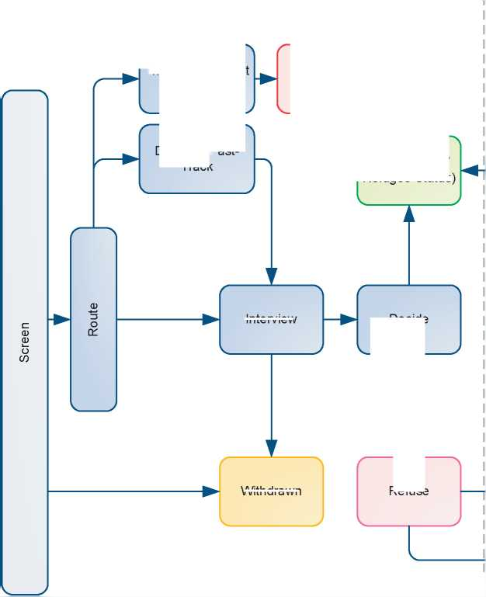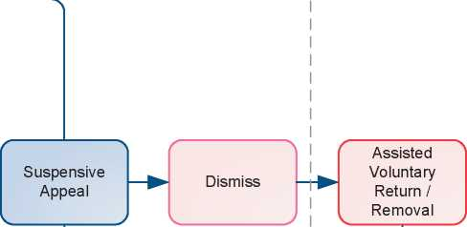

1. Additional Statistical Information

Figure 4: Asylum Applications from Top 10 Countries of Origin in 2009, 2010, 2011 and first half of 2012 [347]

**2009 2010 2011 Jan-Jun 2012**

|  |  |  |  |  |  |  |  |  |
| --- | --- | --- | --- | --- | --- | --- | --- | --- |
| **1** | Zimbabwe | 7,611 | Iran | 2,224 | Pakistan | 4,005 | Pakistan | 2,281 |
| **2** | Afghanistan | 3,539 | Pakistan | 2,151 | Iran | 3,051 | Iran | 1,389 |
| **3** | Iran | 2,146 | Zimbabwe | 1,955 | Sri Lanka | 2,142 | Sri Lanka | 1,021 |
| **4** | Pakistan | 2,099 | Afghanistan | 1,843 | Afghanistan | 1,529 | Nigeria | 635 |
| **5** | China | 1,584 | Sri Lanka | 1,635 | Libya | 1,204 | Bangladesh | 572 |
| **6** | Sri Lanka | 1,446 | China | 1,369 | Nigeria | 1,105 | India | 526 |
| **7** | Eritrea | 1,408 | Nigeria | 1,149 | China | 1,023 | Afghanistan | 517 |
| **8** | Somalia | 1,103 | Eritrea | 772 | Eritrea | 827 | China | 408 |
| **9** | Iraq | 993 | Somalia | 679 | Sudan | 793 | Syria | 404 |
| **10** | Nigeria | 911 | Sudan | 643 | Zimbabwe | 757 | Albania | 375 |

Figure 5: Decisions Taken at the First Instance in 2009, 2010 and 2011

|  |  |  |  |  |  |  |  |  |  |
| --- | --- | --- | --- | --- | --- | --- | --- | --- | --- |
|  | **Geneva Convention** | | **Subsidiary/**  **Complementary**  **Protection and Humanitarian Status** | | **Rejections** | | **Withdrawn, Closed, Abandoned Cases** | | **Grand**  **Total** |
| **Number** | **%** | **Number** | **%** | **Number** | **%** | **Number** | **%** |  |
| **2009** | 5,589 | 18% | 2,798 | 9% | 22,568 | 73% | 0 | 0% | **30,955** |
| **2010** | 4,456 | 17% | 1,984 | 8% | 20,008 | 76% | 0 | 0% | **26,448** |
| **2011** | 5,493 | 24% | 1,689 | 7% | 15,610 | 68% | 0 | 0% | **22,792** |

**Figure 6.a: Positive [348] First- and Second-Instance Decisions,Top Countries of Origin in 2009**

**Rate out of Total Decisions [349]**

|  |  |  |  |  |
| --- | --- | --- | --- | --- |
|  | | **Total Positive** | **Total Decisions** | **Rate** |
| 1 | Zimbabwe | 2,816 | 8,273 | 34.0% |
| 2 | Afghanistan | 1,447 | 3,482 | 41.6% |
| 3 | Eritrea | 944 | 1,861 | 50.7% |
| 4 | Somalia | 620 | 1,276 | 48.6% |
| 5 | Iran | 464 | 2,449 | 18.9% |
| 6 | Iraq | 284 | 1,507 | 18.8% |
| 7 | Sri Lanka | 227 | 1,631 | 13.9% |
| 8 | Pakistan | 166 | 1,956 | 8.5% |
| 9 | China | 131 | 1,201 | 10.9% |
| 10 | Myanmar | 126 | 235 | 53.6% |

Total Positive Decisions by Status

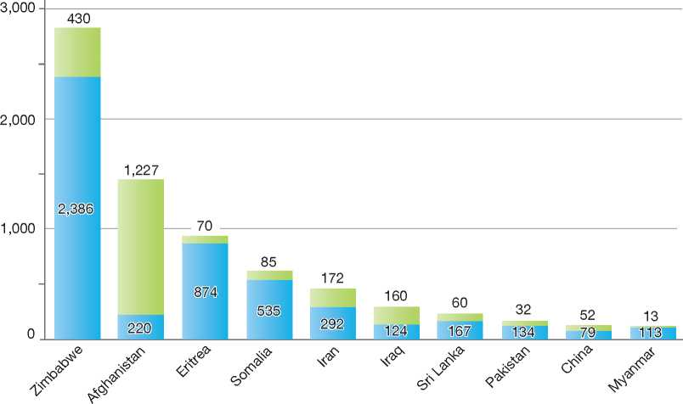

**Total Positive Decisions by Status**

Geneva Convention Status | | Subsidiary/Complementary Protection and Humanitarian Status

**Figure 6.b: Positive [350] First- and Second-Instance Decisions,Top Countries of Origin in 2010**

**Rate out of Total Decisions [351]**

|  |  |  |  |  |
| --- | --- | --- | --- | --- |
|  | | **Total Positive** | **Total Decisions** | **Rate** |
| 1 | Iran | 844 | 2,701 | 31.2% |
| 2 | Afghanistan | 830 | 2,431 | 34.1% |
| 3 | Zimbabwe | 755 | 2,510 | 30.1% |
| 4 | Eritrea | 599 | 1,004 | 59.7% |
| 5 | Somalia | 533 | 1,021 | 52.2% |
| 6 | Sudan | 414 | 658 | 62.9% |
| 7 | Sri Lanka | 285 | 2,046 | 13.9% |
| 8 | Pakistan | 230 | 2,337 | 9.8% |
| 9 | Gambia | 183 | 507 | 36.1% |
| 10 | Iraq | 169 | 915 | 18.5% |

**Total Positive Decisions by Status**

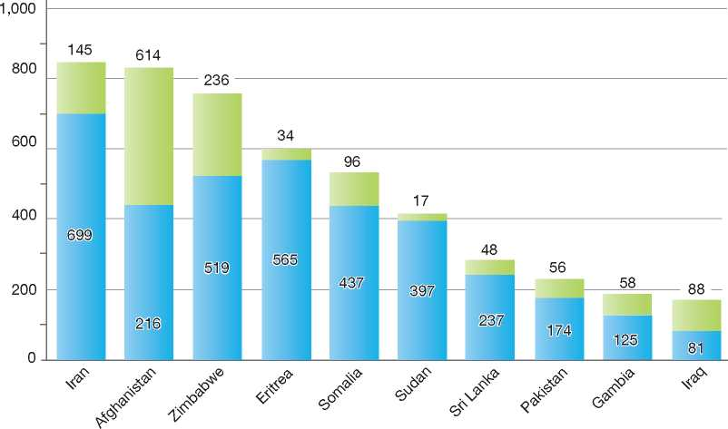

**Total Positive Decisions by Status**

| Geneva Convention Status | | Subsidiary/Complementary Protection and Humanitarian Status

**Figure 6.c: Positive [352] First- and Second-Instance Decisions,Top Countries of Origin in 2011**

**Rate out of Total Decisions [353]**

|  |  |  |  |  |
| --- | --- | --- | --- | --- |
|  | | **Total Positive** | **Total Decisions** | **Rate** |
| 1 | Iran | 1,273 | 2,738 | 46.5% |
| 2 | Eritrea | 677 | 914 | 74.1% |
| 3 | Sudan | 545 | 739 | 73.7% |
| 4 | Somalia | 470 | 662 | 71.0% |
| 5 | Pakistan | 455 | 3,142 | 14.5% |
| 6 | Afghanistan | 451 | 1,608 | 28.0% |
| 7 | Sri Lanka | 388 | 1,951 | 19.9% |
| 8 | Zimbabwe | 253 | 832 | 30.4% |
| 9 | China | 228 | 1,066 | 21.4% |
| 10 | Libya | 187 | 915 | 20.4% |

**Total Positive Decisions by Status**

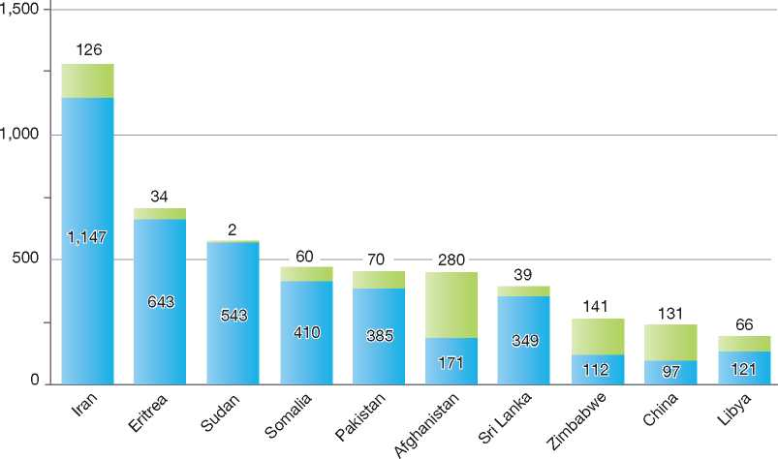

**Total Positive Decisions by Status**

| Geneva Convention Status Subsidiary/Complementary Protection and Humanitarian Status

United States of America

1. BackGRound: MajoR asyluM tRends and developMents 467
2. national leGal FRaMewoRk 469
3. institutional FRaMewoRk 472

4. pRe-entRy MeasuRes 472

5. asyluM pRoceduRes 473

1. decision-MakinG and statuses 480
2. eFFiciency and inteGRity MeasuRes 487
3. assistance and Reception BeneFits FoR asyluM-seekeRs 489
4. status/stays GRanted outside the asyluM pRoceduRe 490

10. RetuRn 491

11. inteGRation 492

12. annexes

493

1. Background: Major Asylum Trends and Developments

Asylum Applications

In the mid-1980s, the United States (U.S.) was receiving between 16,000 and 26,000 asylum claims per year. The number of annual claims started to increase significantly from 1988, reaching a peak of over 154,000 in fiscal year 1995 (1 October to 30 September). Annual claims started to decrease significantly from 1996 onward, and since fiscal year 2004, between 44,000 and 53,000 claims have been received annually1.**[354] [355]**

Important Reforms

The Refugee Act of 1980 was passed with the primary purpose of bringing U.S. refugee law in line with U.S. obligations under the 1967 Protocol relating to the Status of Refugees, which entered into force for the U.S. on 1 November 1968. Under interim regulations published in June 1980, Immigration and Naturalization Service (INS) District Directors were given the authority to adjudicate asylum requests of those foreign nationals not in exclusion or deportation proceedings.

Due to immigration events, such as the arrival of large influxes of Haitian and Cuban migrants, and the ensuing debate over the proper role of asylum

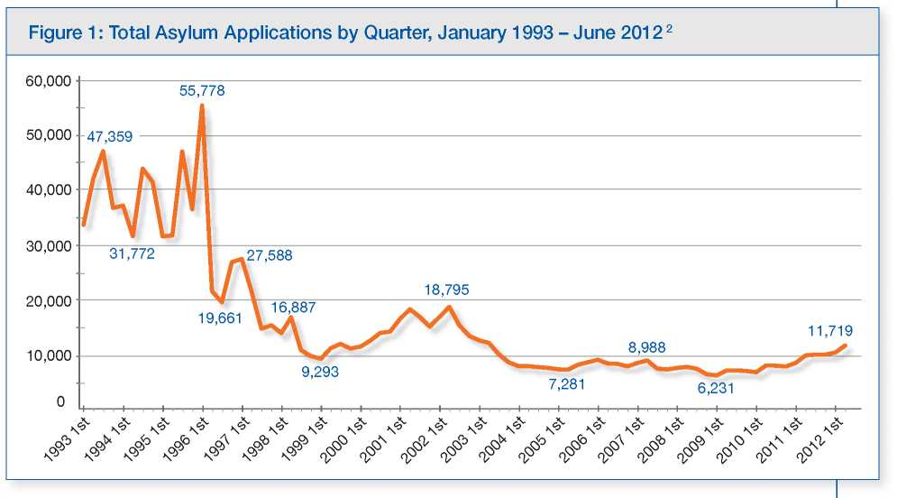

Top Nationalities

In the 1990s, the majority of asylum claims came from El Salvador, Guatemala, Mexico, China, and Haiti. Since 2000, most claimants originate from China, Haiti, Mexico and Colombia. in U.S. immigration decision-making, a final rule on the asylum system was not published until 27 July 1990. The final rule became effective on 1 October 1990 and provided for the following:

A corps of professional asylum officers, trained in international human rights law and non- adversarial interview techniques, was created solely to adjudicate affirmative asylum claims



Those applicants not eligible for asylum who were not in legal immigration status were allowed to renew their applications for asylum when in deportation or exclusion proceedings before an immigration judge

Country conditions information would be compiled from multiple sources and be maintained in ahuman rights documentation centre managed by the INS Office of International Affairs.

The rule also made asylum applicants eligible for employment authorisation so long as their applications were deemed “non-frivolous”.**[356]**

In July 1993, President Clinton directed the Department of Justice to develop an administrative plan to reform asylum due to mounting backlogs and a lack of timely asylum adjudications. The resulting asylum reforms became effective on 4 January 1995. The comprehensive package of reforms was the product of collaboration between government representatives and members of the non-governmental organisation (NGO) community and had been the subject of extensive public consultation. There were five main components to the 1995 asylum reforms.

Applicants who applied for asylum on or after 4 January 1995 are not automatically eligible for a work permit as they previously were, as long as the asylum request was not deemed “frivolous”. Under the 1995 reforms, work permits are granted only if applicants are approved for asylum or if the Government takes longer than 180 days to reach a final decision, whichever comes first.

The 1995 reforms streamlined the review process for cases not granted by the asylum officer corps. Prior to reform, asylum officers issued final decisions

**Figure 2: Asylum Applications Received from Top 5 Countries of Origin in 2009, 2010 and 20113**

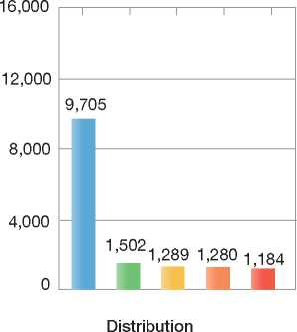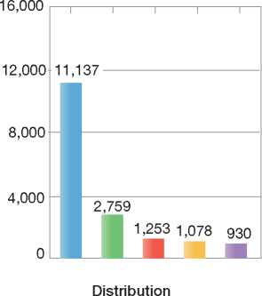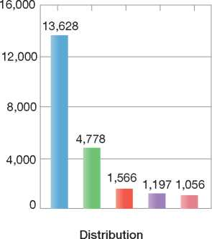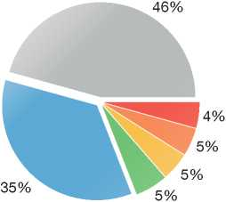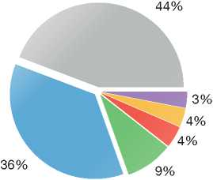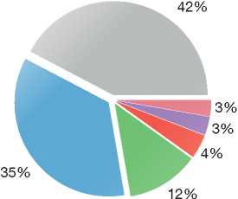

2009

Volumes

2010

Volumes

2011

Volumes

|  |  |  |  |
| --- | --- | --- | --- |
| **Country of Origin:** | | | |
| China | Egypt | El Salvador | | Guatemala |
| Haiti | Nepal | Mexico | Others |

on all applications for asylum and withholding of deportation. An applicant who was found ineligible was denied, and the applicant had the right to file an asylum application *de novo* with the Office of the Chief Immigration Judge, if exclusion or deportation proceedings were initiated. Pursuant to the 1995 revised regulations, and current regulations, requests filed by applicants who are deportable or removable and who are found ineligible for asylum must be referred directly to an immigration judge for adjudication in immigration proceedings. The immigration judge adjudicates the same asylum application that was filed with the asylum office. As a matter of discretion, the immigration judge may allow the applicant to supplement or amend the application. Asylum officers continue to have the authority to grant asylum to qualified applicants in the exercise of discretion.

Prior to reform, asylum applicants who were found ineligible for asylum were sent written explanations for the decision and provided an opportunity to rebut the preliminary decision before a final decision was made. Under the reform regulations, only applicants who are in the United States legally are provided a Notice of Intent to Deny (NOID) explaining the negative determination and providing an opportunity to rebut the decision. All other applicants who are not granted asylum are referred directly to an immigration judge.

Prior to reform, asylum decisions and any documents initiating deportation or exclusion proceedings were mailed to the applicant's last known address. Since reform, most applicants are required to pick up decisions in person, insuring that, if they are placed in removal proceedings, they are served with the charging documents, informing them of the date and place of hearing. An exception is made for asylum applicants who are interviewed at a location other than one of the eight asylum offices (see below).

Prior to 1995, asylum officers adjudicated requests for withholding of deportation (now withholding of removal) with each asylum request. Currently, asylum officers adjudicate only requests for asylum despite the fact that the application for asylum is at the same time an application for withholding of removal. Applicants may present to an immigration judge a request for withholding of removal based on the original asylum application.

1. National Legal Framework
   1. Legal Basis for Granting

Protection

The main instrument of domestic immigration legislation in force in the United States is the Immigration and Nationality Act (INA), passed by Congress in 1952. In 1968, the U.S. acceded to the 1967 Protocol, thus undertaking obligations under the 1951 Convention relating to the Status of Refugees (1951 Convention). On 17 March 1980, the Refugee Act of 1980 was signed into law, a far-reaching piece of legislation that amended the INA and brought U.S. domestic law into conformity with the 1951 Convention. The U.S. counterpart to the refugee definition in Article 1 of the Convention is section 101(a)(42) of the INA. The INA also provides for the granting of asylum status, covering issues such as who is eligible to apply for asylum, conditions for granting asylum, and the asylum procedure.

Additionally, the federal agencies responsible for asylum adjudications have expanded upon the INA's asylum sections by providing federal regulations, incorporated in the Code of Federal Regulations (CFR) at 8 CFR § 208, which further explain asylum eligibility requirements and procedures.

The U.S. offers four other forms of protection that are granted either inside or outside the asylum procedure. These are as follows:

* Withholding of removal under Article 33 of the 1951 Convention (INA § 241 (b) (3), 8 CFR § 208.16, and 8 CFR § 1208.16)
* Protection under Article 3 of the Convention against Torture and Other Cruel, Inhuman or Degrading Treatment or Punishment (Convention against Torture, CAT), as implemented in United States law (8 CFR §§ 208.16(c) - 208.18 and 8 CFR §§ 1208.16(c) - 1208.18)
* Temporary Protected Status (TPS), codified at INA § 244, 8 CFR § 244, and 8 CFR § 1244
* Deferred Enforced Departure (DED), an authority that is held by the President not to initiate or enforce removal orders against a person or group of persons if he or she deems it in the foreign policy interest of the U.S. to do so.

The various types of protection are described later in the chapter[357].

* 1. Recent Reforms

Terrorist-Related Inadmissibility Grounds

Since 2000, the U.S. Congress has passed three major pieces of legislation concerning terrorist-related inadmissibility grounds that serve as a bar (exclusion) to asylum. The USA PATRIOT Act of 2001 (“Patriot Act”) expanded grounds of inadmissibility based on terrorism, broadened the definition of “terrorist activity”, added two definitions of “terrorist organisation”, and added a separate ground of inadmissibility for those who have been associated with a terrorist organisation. The Patriot Act also added a subsection on membership in an undesignated terrorist organisation to those grounds on which a person would not be eligible for asylum[358]. The INA, as amended by the Patriot Act, allows those persons who fall under subsection (IV) of 212(a) (3)(B)(i) (representative of a terrorist organisation) to be eligible for an exception to the bar if it is determined that there are not reasonable grounds to believe that they are a danger to the security of the United States.

The REAL ID Act of 2005 further broadened the categories of persons who are inadmissible for terrorist activities by including those who have received military-type training from or on behalf of a terrorist organisation. It also broadened the inadmissibility ground regarding espousing terrorist activity to no longer require that the person hold a “position of prominence”. The statute also limited the affirmative defense to the inadmissibility ground for someone who “engaged in a terrorist activity” through soliciting things of value, soliciting persons for membership in, or for providing material support to, an undesignated terrorist organisation, to require the person to “demonstrate by clear and convincing evidence that he did not know, and reasonably should not have known, that the organisation was a terrorist organisation”[359].

The statute also amended INA § 212(d) to create an inapplicability provision for the material support ground, as well as for persons and representatives of groups who endorse or espouse terrorist activity. The inapplicability ground allows the Secretary of Homeland Security, after consultation with the Secretary of State and the Attorney General, to not apply the provisions of sections 212(a)(3)(B)(i) (IV)(bb) (related to representatives of organisations that endorse or espouse terrorist activity), 212(a) (3)(B)(i)(VII) (relating to those who endorse or espouse terrorist activity), or 212(a)(3)(B)(iv)(VI) (related to material support to a terrorist or terrorist organisation) to a person in the Secretary's sole unreviewable discretion.

On 26 December 2007, the Consolidated Appropriations Act (CAA) of 2008 was signed into law. Through this legislation, Congress amended the discretionary authority of the Secretary of Homeland Security and the Secretary of State, under section 212(d)(3)(B)(i) of the INA, to exempt, in certain cases, the effect of a person's terrorist activities on his or her inadmissibility or removability from the United States. There are limits to the Secretaries' authority under this provision as amended; in particular, the provision cannot be used to exempt foreign nationals who “knowingly and voluntarily” engaged in terrorist activity on behalf of a designated terrorist organisation. The CAA requires that the Taliban be considered a designated terrorist organisation for immigration purposes.

The CAA also identified ten groups that are not to be considered terrorist organisations under the INA based on actions taken before the statute's enactment[360]. On 3 June 2008, Secretary of Homeland Security Michael Chertoff and Secretary of State Condoleezza Rice, in consultation with each other and the Attorney General, exercised their discretionary authority under INA section 212(d)(3)(B)(i) not to apply most of the terrorist- related grounds of inadmissibility to persons for activities or associations related to any of the ten groups named in the CAA.

Evidentiary and Credibility Standards

The REAL ID Act of 2005 also modified the evidentiary and credibility standards used in asylum proceedings. It modified the requirements concerning an asylum applicant's burden of proof to require that the asylum applicant have the burden of proof to establish that race, religion, nationality, membership in a particular social group or political opinion was or would be at least one central reason for the persecutor's motivation[361].

Additionally, the REAL ID Act amended the INA's section on sustaining the burden of proof in asylum adjudications to the following: “The testimony of the applicant may be sufficient to sustain the applicant's burden without corroboration, but only if the applicant satisfies the trier of fact that the applicant's testimony is credible, is persuasive, and refers to specific facts sufficient to demonstrate that the applicant is a refugee”[362]. If the adjudicator “determines that the applicant should provide evidence that corroborates otherwise credible testimony, such evidence must be provided unless the applicant does not have the evidence and cannot reasonably obtain the evidence”[363]. Congress amended the statute in this way in order to resolve conflicts between administrative and judicial tribunals with respect to, among other issues, the sufficiency of testimonial evidence to satisfy the applicant's burden of proof. Finally, in making a credibility determination, the REAL ID Act modified INA § 208(b)(1)(B)(iii) to require that adjudicators consider “the totality of the circumstances, and all relevant factors”.

Serious Non-Political Crime Bar to Asylum

The Child Soldiers Accountability Act of 2008 (CSAA), which came into force on 3 October 2008, created both criminal and immigration prohibitions on the recruitment or use of child soldiers. Specifically, the CSAA established a ground of inadmissibility at section 212(a)(3)(G) of the INA and a ground of deportability at section 237(a) (4)(F) of the INA. These parallel grounds set forth that any foreign national “who has engaged in the recruitment or use of child soldiers in violation of section 2442 of title 18, United States Code” is inadmissible and is deportable.

The statute also required that DHS and DOJ promulgate regulations establishing that a person who is subject to these grounds of inadmissibility or removability “shall be considered an alien with respect to whom there are serious reasons to believe that the alien committed a serious non-political crime”, and is therefore ineligible for asylum pursuant to INA section 208(b)(2)(A) (iii). The regulations are in the process of being promulgated. In the interim, the Congressional intent in enacting the CSAA, as well as the nature of the serious crime of the use of child soldiers, is considered in determining whether an applicant is subject to the serious non-political crime bar.

Consideration of Asylum Applications Made by Unaccompanied Minors

On 23 December 2008, the William Wilberforce Trafficking Victims Protection Reauthorisation Act (TVPRA) of 200811 was signed into law. The TVPRA makes a number of changes to the INA that affects unaccompanied alien children (UACs) who have filed for asylum. First, the TVPRA amended the INA so that the one-year filing deadline and Safe Third Country Agreement bars to applying for asylum no longer apply to UACs.

Second, the TVPRA provides USCIS asylum officers with initial jurisdiction over any asylum application filed by a UAC, regardless of whether the application was filed in accordance with INA sections 208 or 235(b). As a result, UACs filing for asylum who previously would have had their case heard by an immigration judge in the first instance will now receive an affirmative interview with an asylum officer.

Third, the TVPRA requires the U.S. Government to develop regulations for principal applicants for asylum and other forms of relief “which take into account the specialised needs of UACs and which address both procedural and substantive aspects of handling UACs' cases”.

Fourth, the TVPRA authorises the Secretary of Health and Human Services (HHS) to appoint independent child advocates, who advocate for the child's best interests, for child trafficking victims and other vulnerable UACs.

Pending Reforms

The Refugee Protection Act 2010 is before Congress. It proposes several changes to the current asylum procedure, including:

* Enabling asylum-seekers to first pursue their claims before the asylum office of the DHS in the case of expedited removal proceedings
* Requiring the immigration detention system to provide access to counsel, religious practice, and visits from family
* Allowing certain children and family members of refugees to be considered as derivative applicants for refugee status
* Establishing a “humanitarian track” that allows the Secretary of State to designate certain groups as eligible for protection *prima facie*
* Modifying definitions of terrorist activity in the Immigration and Nationality Act to ensure innocent asylum-seekers and refugees are not unfairly denied protection
* Admitting refugees to the U.S. as lawful permanent residents.

1. Institutional Framework
   1. Principal Institutions

Asylum and refugee protection are governed by the provisions outlined in the Immigration and Nationality Act (INA), with a number of different bodies responsible for its implementation.

Department of Homeland Security

The Homeland Security Act of 2002 dismantled the former Immigration and Naturalization Service (INS) and separated the former agency into three components within the Department of Homeland Security (DHS):

* U.S. Citizenship and Immigration Services (USCIS) is responsible for adjudicating applications for immigration benefits, including asylum applications and refugee resettlement determinations, and is responsible for conducting protection screening interviews of persons who would otherwise be returned without a hearing
* U.S. Customs and Border Protection (CBP) enforces U.S. immigration and customs laws at the U.S. border
* U.S. Immigration and Customs Enforcement (ICE) enforces customs and immigration laws in the interior, manages the detention and removal of certain foreign nationals, and investigates immigration fraud and abuse for appropriate action in administrative, civil or criminal courts.

Department of Health and Human Services

The Department is responsible for funding programmes administered by individual states and non-profit organisations to provide cash and medical assistance, training programmes, employment and other support services to asylees and refugees. It is also responsible for the care and custody of unaccompanied minors in U.S. custody.

Department of Justice

The Executive Office for Immigration Review (EOIR) within the Department of Justice houses the immigration courts (administrative tribunals that adjudicate asylum applications filed in removal proceedings), the decisions of which may be appealed to EOIR's Board of Immigration Appeals.

Department of State

The Department of State (DOS) is responsible for issuing non-immigrant and immigrant visas to persons overseas; formulating policies on population, refugees and migration; and administering U.S. refugee assistance and admissions (resettlement) programmes. DOS also provides opinions on certain individual asylum cases, facilitates completion of the adjudication process for asylees' immediate family members overseas, and conducts overseas document and information verification in some asylum cases as part of fraud prevention efforts.

1. Pre-entry Measures
   1. Visa Requirements

A citizen of a foreign country who seeks to enter the U.S. generally must first obtain a U.S. visa. Certain international travellers may be eligible to travel to the U.S. without a visa if they meet the requirements for visa-free travel.

The Visa Waiver Program (VWP) enables nationals of certain countries to travel to the United States for tourism or business for stays of 90 days or less without obtaining a visa. The programme was established in 1986 with the objective of eliminating unnecessary barriers to travel, stimulating the tourism industry, and permitting the Department of State to focus consular resources in other areas. Not all countries participate in the VWP[364], and not all travellers from VWP countries are eligible to use the programme. VWP travellers are required to apply for authorisation through theElectronic System for Travel Authorization (ESTA), are screened at their port of entry into the United States, and are enrolled in the Department of Homeland Security's US-VISIT program[365].

* 1. Interception

Neither U.S. immigration law nor international refugee law instruments are applicable to the interdiction and repatriation of undocumented migrants encountered on the high seas[366]. Notwithstanding, for over twenty years, the handling of migrants intercepted at sea has been guided by successive Executive Orders.

Currently, Executive Orders 12,807 (24 May 1992) and 13,276 (15 November 2002), as amended by Executive Order 13,286 (28 February 2003), instruct the U.S. Coast Guard to interdict and repatriate undocumented migrants at sea. However, the Secretary of Homeland Security may decide that a person who is a refugee will not be returned without that person's consent. Since 1981, Attorneys General and now the Secretary of Homeland Security have exercised their authority to make such determinations, by providing interdicted migrants who express a fear of return with an opportunity to speak to a USCIS Officer before repatriation is considered. Generally, USCIS Officers interview migrants interdicted at sea on board a Coast Guard vessel to determine whether they have a credible fear of persecution or torture in their home country.

The U.S. does not generally allow interdicted migrants who require protection to settle in the U.S.; rather, the U.S. will seek resettlement in a third country. Third-country resettlement promotes two complementary goals: to save lives by discouraging dangerous sea travel, and to provide protection screening to those who do attempt the passage.

1. Asylum Procedures
   1. Application Possibilities and Requirements, Procedures, and Legal Remedies

Application Possibilities

Persons may make asylum claims at ports of entry (airports, seaports, and border crossings) through the credible/reasonable fear process and, once inside the country, by filing an asylum application by mail to a USCIS Service Center. Asylum field offices also accept direct filings in limited circumstances. An asylum-seeker may file an asylum application regardless of his or her immigration status.

Outside the country, certain persons may access the U.S. Refugee Admissions Program (USRAP) for consideration for resettlement in the U.S. The USRAP, including how persons access the programme, is described below15.

Access to Information

The USCIS website provides information to asylum applicants regarding the overall process and specific procedures. The USCIS Asylum Division also publishes an information pamphlet on the asylum process that is available on the Internet and in each of the eight asylum field offices. The pamphlet has been translated into the ten languages most frequently encountered by the Asylum Division nationwide.

Persons who are detained pending a credible fear determination are given an orientation regarding the credible fear process as well as a list of *pro bono* legal service providers.

Processes for Granting Asylum

The U.S. Government conducts asylum adjudications through two separate processes. The Asylum Division of U.S. Citizenship and Immigration Services (USCIS) adjudicates the asylum applications of persons who are not in removal proceedings and affirmatively file for asylum. Affirmative applicants may be persons who are in valid immigration status in the U.S. and those who are not. Asylum officers adjudicate these “affirmative” asylum applications by conducting non-adversarial interviews and writing and issuing decisions.

In addition, an asylum application can be adjudicated by an immigration judge with the Department of Justice's Executive Office for Immigration Review (EOIR). This process is adversarial, with a DHS Immigration and Customs Enforcement trial attorney representing the Government in a court proceeding. There are two main ways that an asylum applicant's case will be before an immigration judge:

15 See in particular the section on Resettlement.



* A person is placed by DHS in removal proceedings, at which time he or she files an asylum application
* USCIS decides to not grant the case of a person without legal immigration status and refers the case to the immigration court for a *de novo* asylum hearing.

1. Outside the Country

During annual refugee consultations with Congress, the nationalities and categories of persons deemed to be of “special humanitarian concern” to the U.S. are designated under a worldwide priority system. Only persons who qualify under this priority system are permitted to “apply” for refugee resettlement consideration through the U.S. Refugee Admissions Program (USRAP). The worldwide processing priority system (outlined in the Priority section below) is the tool that the Department of State (DOS) uses to manage overall refugee admissions and helps ensure that those refugees who are of greatest concern to the United States have access to the refugee programme.

Currently, applicants for refugee status must fall under the following categories:

* They must have been referred by the U.N. High Commissioner for Refugees (UNHCR), a designated non-governmental organisation (NGO) or a U.S. embassy
* They must be members of specified groups with special characteristics in certain countries as determined periodically by the United States Government, or
* They must be a designated national with a close relative who was admitted as a refugee or granted asylum in the United States.

Humanitarian Parole

Humanitarian parole enables an otherwise inadmissible person to enter the United States temporarily due to urgent humanitarian reasons. Parole is not intended to be used to avoid regular visa-issuing procedures or to bypass immigration procedures. Parole does not confer any permanent immigration status but does enable a recipient to apply for and receive employment authorisation.

Humanitarian parole is typically granted for the duration of the emergency or compelling situation at issue. A person granted humanitarian parole must depart the United States prior to its expiration date or risk being placed in removal proceedings. A person paroled into the United States, however, may submit a request for re­parole to USCIS to extend his or her stay in the United States.

Anyone may file an application for humanitarian parole, including the prospective parolee, a sponsoring relative, an attorney, or any other interested person or organisation[367].

Applications at Diplomatic Missions

Applicants for refugee status may be referred by diplomatic missions through Priority 1 of the worldwide priority system[368]. A person who approaches a U.S. diplomatic mission seeking refugee protection is generally referred to either the host government, if the host government is a signatory to the 1951 Convention, or the UNHCR. However, a U.S. diplomatic mission has the authority to refer individual cases to the USRAP under Priority 1. Embassies may identify a high- profile case or a person who is associated with the embassy in some way and for whom compelling humanitarian or security circumstances exist such that he or she merits a referral to the USRAP.

Referrals made by a U.S. embassy are generally transmitted through the Department of State (DOS) cable system. While most refugee applicants, by statute, must be outside of their country of origin, the U.S. is authorised to process certain persons in-country, including applicants from Iraq, Cuba, and the Former Soviet Union, as well as those of any nationality referred by a U.S. embassy, though such in-country referrals are presented only in exceptional circumstances.

Resettlement/Quota Refugees

Competent Authorities

The USRAP is an inter-agency partnership of several governmental agencies and NGOs, located both overseas and domestically, whose mission is to identify refugees for resettlement to the United States. The Bureau of Population, Refugees, and Migration (PRM) within DOS coordinates and manages the USRAP overall. Determining which persons or groups are of humanitarian concern is a PRM responsibility.

PRM works closely with its programme partners in administering the USRAP:

* U.S. Citizenship and Immigration Services (USCIS), the agency authorised to interview refugee applicants and adjudicate refugee applications
* The UNHCR, the organisation that refers cases to the USRAP for resettlement consideration and provides important information with regard to the worldwide refugee situation
* Resettlement Support Centers (RSCs), international or non-governmental organisations under cooperative agreement with DOS that carry out administrative functions, assist in preparing cases for interview, including form filing and data collection, and perform a variety of post-DHS out-processing steps to prepare approved refugees to travel to the U.S.
* The International Organization for Migration (IOM), which arranges travel for all U.S.-bound refugees, provides panel physicians and/or serves as the RSC in certain locations
* The Department of Health and Human Services' Office of Refugee Resettlement (DHHS/ORR), which provides resettlement assistance to arriving refugees.

Eligibility and Criteria for Resettlement as a Refugee

To be eligible for refugee status, applicants must:

* Be among the refugees determined by the President to be of special humanitarian concern to the U.S.
* Meet the definition of a refugee contained in Section 101(a)(42) of the Immigration and Nationality Act (INA)
* Not be firmly resettled in a third country
* Be otherwise admissible under U.S. law.

Quota

An annual refugee admissions ceiling is established each fiscal year by the President, in consultation with Congress[369]. In fiscal year 2012, total refugee admissions are designated at 76,000, of which 73,000 refugee admissions are allocated to various regions of the world[370].

Priorities

During the consultation process on the annual quota, processing priorities are established in order to outline the groups of refugee applicants that will be eligible for consideration for resettlement. There are currently three priorities or categories of cases eligible for resettlement consideration through the USRAP:

* Priority 1 - Individual cases referred to the programme by reason of their circumstances and apparent need for resettlement. The UNHCR, a U.S. embassy, or a designated NGO may identify and refer cases to the programme
* Priority 2 - Groups of cases within certain nationalities designated as having access to the programme by reason of their circumstances and apparent need for resettlement
* Priority 3 - Individual cases from eligible nationalities granted access for purposes of reunification with anchor family members already in the United States.

Procedures

RSCs are international organisations or non­governmental organisations under cooperative agreement with DOS to carry out administrative and processing functions for the refugee programme. RSCs conduct an initial screening of refugee applicants to collect biographic information and an account of the applicant's claim of persecution or fear of future harm. After the initial pre-screening is completed, all forms are prepared and required name checks are requested by the RSC, and USCIS conducts refugee eligibility interviews with the applicants.

Decisions

Eligibility for refugee status is decided on a case- by-case basis. A USCIS officer conducts a non- adversarial personal interview with the applicant in order to elicit information on the applicant's claim for refugee status, to verify family relationships, and to identify possible activities that might render the applicant ineligible for refugee status. During a refugee interview, an officer confirms the basic biographical data of the applicant and his or her relatives and, *inter alia*, determines whether the applicant has suffered past persecution or has a well-founded fear of future persecution on the basis of one of the five grounds of the 1951 Convention, and assesses the credibility of the applicant. USCIS officers also confirm that required security checks have been completed for every applicant, and the results of these checks are analysed and reviewed prior to approval.

If found by USCIS to be eligible for refugee status, the applicant's case is returned to the RSC for continuation of processing, including medical screening, sponsorship assurances, cultural orientation, and scheduling for onward travel to the United States.

There is no appeal for a denial of an application for refugee status. USCIS may exercise its discretion to review a case upon timely receipt of a request for review from the principal applicant. The request must include one or both of the following:

* A detailed account explaining how a significant error was made by the adjudicating officer
* New information that would merit a change in the determination.

USCIS will only accept one request that is postmarked or received by USCIS within 90 days of the date of the denial.

1. At Ports of Entry

Persons who make an application for asylum at a port of entry may be paroled into the U.S. to file an application under the normal in-country asylum procedure, or they may be subject to an accelerated procedure (credible fear process). Each process is described below.

1. **Inside the Territory *Responsibility for Processing the Claim* The Safe Third Country Agreement (STCA)** *Application and Procedure*

The Safe Third Country Agreement between Canada and the United States came into effect on 29 December 2004.

The Agreement affirms the commitment of Canada and the U.S. to share responsibility with respect to refugee claims. Under the Agreement, a refugee claimant must seek protection in the country (Canada or the U.S.) where he or she first has the opportunity to do so, unless he or she qualifies for an exception. The agreement applies to persons making asylum claims at a land border port of entry on the U.S.-Canadian border or persons in transit through one country while being removed from the other.

There are five exceptions to the Agreement:

* Canadian citizenship or habitual residency in Canada if stateless
* Unaccompanied minor
* Family members with lawful status other than non-immigrant or who are asylum applicants aged 18 or older
* Validly issued visa if required
* Public interest or discretionary.

If asylum-seekers qualify for one of these exceptions, they are placed in the credible fear asylum process, described below.

*Freedom of Movement/Detention*

Persons subject to the Agreement may be detained while USCIS determines which country is responsible for the claim. Persons may also be detained after a decision has been made to return the person to the country responsible for the asylum application.

*Conduct of Transfers*

U.S. Immigration and Customs Enforcement (ICE) is generally responsible for the transfer of persons to Canada where their entry has been barred by the STCA.

*Review/Appeal*

Supervisory asylum officers and USCIS Asylum Division Headquarters review all cases subject to the STCA. Persons subject to the Agreement may not appeal the decisions and decisions are not reviewed by immigration judges.

Application

To apply for asylum in the United States, an applicant must ask for asylum, or express a fear of return, at a port-of-entry or file an asylum application within one year of his or her last arrival in the United States, unless there are changed circumstances that materially affect his or her eligibility for asylum or extraordinary circumstances relating to the delay in filing.

Bars to Applying for Asylum

An asylum-seeker is barred from applying for asylum under section 208(a)(2) of the INA under the following circumstances:

* The person failed to file an asylum claim within one year of his or her last arrival in the U.S., unless he or she demonstrates either the existence of changed circumstances that materially affect his or her eligibility for asylum or extraordinary circumstances relating to the delay in filing (8 CFR § 208.4)
* The person previously applied for asylum and was refused by an immigration judge or the Board of Immigration Appeals, unless he or she establishes the existence of changed circumstances materially affecting asylum eligibility
* The person can be removed to a safe third country pursuant to a bilateral or multilateral agreement (currently only Canada).

Changed circumstances (8 CFR § 208.4(a)(4)) may include the following:

* Changes in conditions in the applicant's country of origin
* Changes in the applicant's circumstances that materially affect his or her eligibility for asylum, including changes in U.S. law and activities he or she becomes involved in outside the country of origin
* Loss of the spousal or parent-child relationship to the principal applicant through marriage, divorce, death, or attainment of age 21.

Extraordinary circumstances (8 CFR § 208.4 (a)(5)) as they relate to a delay in filing the asylum claim may include the following:

* Serious illness or mental or physical disability
* Legal disability during the first year after arrival
* Ineffective assistance of counsel
* The applicant has maintained Temporary Protected Status (TPS) or lawful immigrant or non-immigrant status or was given parole until a reasonable period before the filing of the application
* A timely filing that was rejected for being incomplete and that was refiled within a reasonable period of time after being returned for correction

• Death, serious illness, or incapacity of the applicant's legal representative or a member of the applicant's immediate family.

Accelerated Procedures

Undocumented Asylum-Seekers at Ports of Entry

When asylum-seekers arrive at ports-of-entry without valid travel documents, they are subject to expedited removal without a hearing before an immigration judge. If they express a fear of return or an intention to apply for asylum, they are referred by a CBP or ICE official to a USCIS asylum officer for a screening interview. The aim of the screening interview is to determine if the asylum-seeker has a credible fear of persecution or torture[371]. At this stage of the process, the asylum officer does not consider any “bars” (i.e. grounds for exclusion) to asylum.

If USCIS determines that a credible fear of persecution or torture exists, the asylum-seeker is referred to an immigration judge for a full hearing on the merits during the course of removal proceedings. If USCIS does not find a credible fear and the immigration judge sustains the negative determination, the asylum-seeker is ordered removed.

Normal Procedure

Asylum-seekers making claims at the border or inside the U.S. can follow one of two types of procedures: affirmative or defensive.

Affirmative Procedure

Persons who are physically present in the United States, regardless of how they arrived and regardless of their current immigration status, may apply for asylum through the affirmative procedure. They make an asylum claim “affirmatively” by submitting an application to USCIS.

Application

When an asylum-seeker is eligible to apply for asylum under INA §208(a), he or she files an application form, Form I-589, “Application for Asylum and for Withholding of Removal”, at the USCIS Service Center with jurisdiction over his or her place of residence. Asylum field offices also accept direct filings in limited circumstances.

Applicants between the ages of 12 years and 9 months and 75 years must have their fingerprints taken at a USCIS Application Support Center. At that time, the applicant's photograph and signature are captured. The fingerprints are automatically submitted for checks against U.S. criminal and immigration databases.

Interview

An affirmative asylum applicant is generally interviewed by USCIS within 43 days of filing the application. The applicant is interviewed by an asylum officer at one of eight asylum offices, or at another USCIS field office if the applicant lives a far distance from the asylum office with jurisdiction. The interview is non-adversarial. The asylum officer verifies the asylum-seeker's identity, records basic biographical information, and elicits detailed information regarding the applicant's claim for asylum.

If the asylum-seeker fails to appear for the interview and does not provide USCIS with a written explanation within 15 days of the date of the scheduled interview, the case will be either referred to the immigration court (for those without legal status) or will be administratively closed. The asylum office Director has discretion to reschedule the interview if the asylum-seeker provides a reasonable explanation for his or her failure to appear.

The applicant's spouse and children under the age of 21 who are included in the application must also appear for the interview.

The asylum-seeker must bring the following documents to the interview:

* Identity documents, including any passport(s), other travel or identification documents, or an Arrival-Departure Record (Form I-94)
* The originals of any birth certificates, marriage certificates, or other documents the asylum­seeker previously submitted with Form I-589
* A copy of his or her Form I-589 and other supplementary material that he or she previously submitted
* Any additional available items documenting the asylum claim.

Defensive Procedure

Asylum-seekers enter the defensive asylum procedure - in other words, they make a claim for asylum as a defence against removal from the United States - in one of the following circumstances:

* Through referral by an asylum officer of USCIS when the asylum claim is refused following an affirmative procedure
* After being placed in removal proceedings, or
* By trying to enter the U.S. at a port of entry without proper documents and having been found to have a credible fear of persecution or torture.

The asylum-seeker appears before an immigration judge (IJ) with the Executive Office for Immigration Review (EOIR), an agency within the Department of Justice (DOJ), in formal adversarial hearings. The IJ hears the applicant's claim along with any concerns about the validity of the claim raised by the Government, which is represented by an attorney.

Review/Appeal of the Normal Procedure

The immigration judge's decision may be appealed to the Board of Immigration Appeals (BIA), an agency within EOIR and the DOJ. The BIA's decision may then be appealed to the U.S. federal court system.

Freedom of Movement during the Normal Procedure

Asylum-seekers subject to the affirmative procedure and those referred to an immigration judge by USCIS are generally free to live in a place of their choosing in the U.S. pending the completion of the asylum procedure.

If an asylum-seeker wishes to travel outside the country during the procedure, he or she must receive advance permission (Advance Parole) from USCIS before leaving the United States.

Detention

Some asylum-seekers may be detained at certain points during the asylum procedure. Asylum­seekers without proper documentation who are apprehended by immigration officials at a U.S. port of entry and are not found to have a credible fear of persecution or torture are kept in detention until their removal from the United States. Asylum­seekers who are found to have a credible fear of persecution or torture and are placed in the defensive procedure are also kept in detention but may be considered for discretionary release by ICE Enforcement and Removal Officers pursuant to standardised parole guidelines.

Reporting

The asylum-seeker has an obligation to inform USCIS or the immigration court within ten days of a change of address. The applicant should separately notify the asylum office of a change of address at any time during the affirmative procedure.

Repeat/Subsequent Applications

Affirmative Procedure

An asylum-seeker can reapply after the issuance of a final denial by an asylum office, the dismissal of a motion to re-open or reconsider (MTR) or the withdrawal of a previous application, provided that he or she is not under the jurisdiction of the immigration court. The asylum-seeker will still be subject to the one-year filing deadline for applications. In addition, the previous adjudication by the asylum office will be considered in the adjudication of any repeat application.

Defensive Procedure

An asylum-seeker who was previously denied asylum by EOIR is prohibited from filing a new application for asylum, unless there are changed circumstances which materially affect the applicant's asylum eligibility. In addition, a new application can be filed with USCIS only where EOIR no longer has jurisdiction over the case.

* 1. Safe Country Concepts
     1. Safe Country of Origin

There is no safe country of origin provision in the U.S. process.

* + 1. First Country of Asylum

Asylum applicants who are found to have been “firmly resettled” in another country prior to their arrival in the U.S. are ineligible for asylum. An applicant is considered to be firmly resettled if, prior to his or her arrival in the United States, he or she entered another country with, or while in that country received, an offer of permanent resident status, citizenship, or some other type of permanent settlement. A person will not be considered “firmly resettled” if:

• The applicant establishes that his or her entry into that nation was a necessary consequence of his or her flight from persecution, that he or she remained in that nation only as long as was necessary to arrange onward travel, and that he or she did not establish significant ties in that country, or

• The applicant establishes that the conditions of his or her residence in that nation were so substantially and consciously restricted by the authority of the country of refuge that he or she was not in fact resettled. In making his or her determination, the asylum officer or immigration judge considers the conditions under which other residents of the country live, the type of housing made available to the refugee, whether permanent or temporary, the types and extent of employment available to the refugee, and the extent to which the refugee received permission to hold property and to enjoy other rights and privileges.

* + 1. Safe Third Country

The U.S. applies the Safe Third Country Agreement with Canada, as described earlier.

* 1. Special Procedures
     1. Unaccompanied Alien Children

Asylum Procedure

The USCIS Asylum Division has put in place a number of procedures in recent years in order to address the special concerns that arise with minor principal applicants for asylum.

Figure 3: Asylum Applications by

Unaccompanied Minors

No data available.

Care and Custody

The Office of Refugee Resettlement (ORR) at the Department of Health and Human Services has statutory authority over the custody and care of unaccompanied minor children. ORR is responsible for case management and provides accommodation, health care and education to UACs.



Child-Friendly Asylum Procedures

The predecessor to USCIS, the Immigration and Naturalization Service, in 1998 issued Guidelines for Children's Asylum Claims, which provided guidance particularly with regard to child-sensitive interview procedures and analysis of common issues arising in children's asylum claims. Among other things, the Guidelines suggest that a trusted adult may be present at the interview to provide moral support to the minor and that asylum officers should put the minor at ease and explain the procedures and conduct the interview in a way in which a young child can understand and participate. Additionally, when an asylum officer weighs the testimony of a minor, he or she is required to take into account the child's age, education, and awareness of past events, as well as the effect of past trauma, when evaluating whether the child's testimony is credible or whether the child has met his or her burden of proof.

In order to ensure that issues related to minors receive proper attention, the Asylum Division provides training on child­specific procedures and law to new asylum officers and also requires that all cases filed by minor principal applicants undergo quality assurance review at the headquarters level. Additionally, in August 2007, the Asylum Division issued a memorandum with updated procedures for minor principal applicant claims. This memorandum described a new mechanism to track unaccompanied alien children (UACs) and provided guidance concerning information to elicit in an asylum interview with regard to the applicant's care and custody and parental awareness of the asylum application. The Asylum Division also conducted a pilot project to facilitate access to *pro bono* representation for unrepresented unaccompanied children.

The Department of Justice's Executive Office for Immigration Review (EOIR) also has in place a number of child-sensitive procedures. For the past 10 years, EOIR has trained immigration judges on children's issues with the help of experts from other federal agencies and non-governmental organisations. In addition, EOIR has issued guidelines for immigration judges to create a child-friendly environment in the immigration court, including special court dockets for children, child-friendly courtroom modifications, pre-hearing courtroom orientations, and child­sensitive questioning. Moreover, representatives of the EOIR Legal Orientation & Pro Bono Program, together with immigration judges and other court staff, have worked closely with others inside and outside the U.S. Government to identify children in need of legal assistance and to facilitate *pro bono* legal services.

Due to these partnership efforts, the large majority of unaccompanied minors in government custody have access to basic legal immigration programmes.

With the William Wilberforce Trafficking Victims Protection Reauthorization Act (TVPRA) of 2008, Congress gave USCIS initial jurisdiction over any asylum application filed by an UAC. This law took effect on 23 March 2009. As a result, UACs filing for asylum who previously would have had their case heard by an immigration judge in the first instance now receive an affirmative interview with an asylum officer. The Homeland Security Act of 2002 defines a UAC as a person under 18 years of age who has no lawful immigration status in the U.S. and who either has no parent or legal guardian in the U.S. or has no parent or legal guardian in the U.S. who is available to provide care and physical custody.

1. Group-based Protection

There are no grounds in U.S. law upon which a group may be granted asylum. However, under U.S. regulations, an applicant may establish individual eligibility for asylum if the applicant establishes that there is a pattern or practice of persecution against persons similarly situated to the applicant (i.e. a group) and the applicant establishes his or her inclusion in, and identification with, this group of persons[372].

Within the U.S. Refugee Admissions Program, Priority Two (P-2) designations are used for specific groups who are of special humanitarian concern to the United States. P-2 groups are designated by the Department of State in consultation with USCIS, NGOs, the UNHCR and other experts. Only those members of the specifically identified groups are eligible for processing under Priority Two. Persons within P-2 designations must still individually establish eligibility for resettlement by meeting the definition of a refugee under INA section 101(a)(42).

1. Stateless Persons

Stateless persons are required to establish past persecution and a well-founded fear in the country determined to be their place of last habitual residence.

1. Decision-Making and Statuses

Asylum-seekers under the affirmative and defensive procedures are referred to as “asylees” once they are granted protection according to the criteria set out in the INA.

* 1. Inclusion Criteria
     1. Convention Refugee

An asylum-seeker must fit the definition of a refugee in INA §101(a)(42)(A) in order to qualify for asylum. Two Supreme Court cases have had a substantial impact on eligibility standards for asylum.

In *INS v. Cardoza-Fonseca*, 480 U.S. 421, 431 (1987), the Supreme Court held that the well- founded fear standard used in the asylum context is more generous than the “more likely than not” standard used for withholding of removal. The well-founded standard is satisfied if the applicant

shows that there is a “reasonable possibility” of persecution, noting that “[o]ne can certainly have a well-founded fear of an event happening when there is less than a 50 per cent chance [the withholding of removal standard] of the occurrence taking place”.

In *INS v. Elias-Zacarias*, 502 U.S. 478 (1992), the Supreme Court clarified that, to qualify as persecution on account of one of the five Convention grounds, the persecution must be on account of the victim's protected characteristic, or one attributed to the applicant, rather than the persecutor's. Additionally, the Supreme Court held that forced recruitment by guerrillas and harm for refusing to join or cooperate with guerrilla forces do not, per se, constitute persecution on account of a protection ground. Guerrilla forces may recruit for reasons unrelated to a protection ground, such as the need to increase their ranks.

The Board of Immigration Appeals (BIA), the administrative appeals body responsible for immigration matters, has also played a key role in determining legal standards relating to asylum and withholding of removal.

In *Matter of Acosta*, 19 I&N Dec. 211 (1985), for instance, it held that persecution means harm or suffering inflicted upon a person in order to punish him or her for possessing a belief or characteristic a persecutor seeks to overcome, and does not encompass the harm that arises out of civil or military strife in a country. It also concluded that “persecution on account of membership in a particular social group” refers to persecution that is directed toward a person who is a member of a group of persons, all of whom share a common, immutable characteristic, that is, a characteristic that either is beyond the power of the individual members of the group to change or is so fundamental to their identities or consciences that it ought not to be required to be changed.

In *Matter of Mogharrabi*, 19 I&N Dec. 439 (1987), the Board held that an asylum applicant has established a well-founded fear of persecution if a reasonable person in his or her circumstances would fear persecution.

Resistance to Coercive Population Control (CPC) Program

The definition of a refugee in INA § 101(a)(42) provides that an asylum-seeker is deemed to have been persecuted on account of political opinion if he or she has been subject to the following:

* Forced abortion of a pregnancy
* Involuntary sterilisation
* Persecution for failure or refusal to undergo one of the procedures above or for other resistance to a coercive population control programme.

Applicants who express a well-founded fear that they will be forced to undergo the procedures described above or be subject to persecution for such failure, refusal, or resistance may also be eligible for asylum.

Withholding of Removal under the 1951 Convention

Withholding of removal implements Article 33 of the 1951 Convention. To receive withholding of removal, the person must demonstrate that his or her “life or freedom” would be threatened on account of one of the following grounds:

* Race
* Religion
* Nationality
* Membership in a particular social group
* Political opinion.

In *INS v. Stevic*, 467 U.S. 407 (1984), the Supreme Court held that to establish eligibility for withholding of removal (i.e. *non-refoulement*), there must be evidence establishing that it is more likely than not that the applicant would be persecuted or tortured in the country of removal. The Supreme Court held that this “clear probability” standard was different from the “well-founded fear” standard used for asylum adjudications but declined to interpret the latter[373].

Withholding of removal is specific to the country of removal and allows removal to a third country where the person would not be persecuted.

* + 1. Complementary Forms of Protection

Complementary protection is granted outside of the affirmative asylum procedure. However, an application for asylum in the defensive procedure, raised as a defence to removal, is simultaneously an application for withholding of removal and protection under both the 1951 Convention and the Convention against Torture (CAT).

Protection under Article 3 of the CAT may be granted in one of two forms:

* Withholding of removal, which allows the person to remain in the U.S. with work authorisation until such time as an immigration judge terminates the status, or
* Deferral of removal, where the applicant is ineligible for withholding of removal, which does not lead to any lawful or permanent status in the U.S. or necessarily result in the person's release from detention.
  1. The Decision

Affirmative Procedure

At the completion of their asylum interviews, asylum applicants receive a notice[374] informing them of the next steps in the asylum process and the date and time that the applicant is to return to the office to receive the decision. Asylum applicants then receive the decision in person within two weeks of the interview. In some circumstances, such as for persons in valid immigration status or following an applicant's failure to appear at the pick-up appointment, the decision will be sent by mail. The decision letters are translated into ten languages, including Spanish, French, Chinese, Haitian Creole, Arabic, Russian, and Amharic. USCIS does not issue final decisions to grant asylum until background security checks are complete. If a case is not granted and is instead referred to the immigration court, at minimum the security checks must have been initiated.

Under the affirmative procedure, asylum officers record asylum decisions in a written assessment that is supported by interview notes and information on country conditions as well as any documentation or other information provided by the asylum applicant. A supervisory asylum officer (SAO) reviews all decisions before they are issued. Certain cases require quality assurance review by the Asylum Division Headquarters[375].

Defensive Procedure

Under the defensive procedure, immigration judges (IJs) of the Executive Office for Immigration Review (EOIR), an agency of the Department of Justice (DOJ), are responsible for making decisions on asylum claims. Decisions by the immigration judge are recorded. The decision may be rendered orally accompanied by a written summary order or it may be issued in writing. If an oral decision is appealed to the Board of Immigration Appeals (BIA), the record of the hearing and oral decision are transcribed. Decisions of the BIA are provided to the parties in writing.

USCIS Quality Assurance

*Supervisory Review*

Supervisors review all proposed decisions for legal sufficiency and consistency with established Asylum Division procedures and policies, and discuss any concerns regarding the legal analysis or decision in a case with the asylum officers. Disputes are elevated to the asylum office Deputy Director for review.

*Quality Assurance/Training Officers*

Quality assurance/training officers (QA/Ts) are present in each of the asylum offices. They are responsible for developing local training each week for the asylum officers and for conducting random reviews of a sampling of cases on a regular basis to identify any issues or concerns with quality and the supervisory review process. QA/Ts are required to attend an instructor training course to learn methodologies for adult student-centred instruction and to improve their skills as training coordinators for the field offices.

*Quality Assurance Review*

Certain sensitive or difficult cases are submitted to the Headquarters Quality Assurance program for review before a decision. These cases include cases filed by juvenile principal applicants, domestic violence cases where the claim is based on a particular social group defined in whole or in part by gender, cases likely to be publicised on a national level, and certain cases involving issues of national security.

*Quality Assurance Initiative*

A quality checklist was developed in 2010 based on existing procedures and post-decisional review of a statistically generated sample of cases. This checklist was employed in a pilot in fiscal year 2010 and put into effect permanently in fiscal year 2011. The data from the quality check is entered into a database directly by the reviewer, allowing for instantaneous review and reporting. This initiative has been expanded into two other product lines, covering the vast majority of the Asylum Division's adjudications.

* 1. Types of Decisions, Status and Benefits Granted

Under the affirmative procedure, an asylum officer may make one of the following decisions:

* Grant of asylum: The applicant is provided with the date on which he or she is considered to be an “asylee” and information about eligibility for certain benefits
* Recommended approval: The applicant receives a Recommended Approval when USCIS has made a preliminary determination to grant him or her asylum but USCIS has not yet received complete results of an investigation on the applicant's identity and background. These decisions are rare under existing procedures
* Referral to an immigration court: If USCIS determines that the applicant is not eligible for asylum and he or she has no legal status in the United States, the asylum-seeker is placed in removal proceedings before an immigration judge
* Notice of Intent to Deny (NOID): If USCIS decides that the applicant is not eligible for asylum and he or she is in lawful status, he or she will receive a Notice of Intent to Deny (NOID) explaining the reasons he or she has been found ineligible for asylum. The applicant will be given 16 days to provide a response before the final decision is made
* Final denial: An applicant who receives a Notice of Intent to Deny (NOID) will be sent a Final Denial letter if he or she fails to submit a rebuttal to the NOID within the time limit or if the applicant submits a rebuttal but the evidence or argument offered fails to overcome the grounds for denial as stated in the NOID. The applicant cannot appeal the decision.

Under the defensive procedure, an immigration judge may make one of the following decisions:

* Grant asylum
* Deny asylum: Because the immigration judge will also hear the applicant's claim for withholding of removal under the 1951 Convention or the Convention against Torture, the immigration judge may deny asylum but grant another form of protection (e.g. withholding of removal).

U.S. Immigration and Customs Enforcement (ICE) of the Department of Homeland Security (DHS) may seek administrative closure of cases pending in the immigration court if they deem the cases suitable and the persons concerned do not pose a danger or risk to the U.S. Under this policy, suitable asylum applicants will have the choice to proceed with their case before the immigration court or have their case administratively closed.

Benefits

An asylee is entitled to the following benefits:

* Authorisation to work
* Employment assistance, including job search assistance, career counselling, and occupational skills training
* Needs-based public benefits, including medical care, cash assistance, housing assistance and food stamps
* Benefits funded by the U.S. Department of Health and Human Services (HHS) including refugee cash and medical assistance, employment preparation and job placement, and English language training
* Post-secondary educational loans and grants
* Ability to petition to have his or her spouse or unmarried child under 21 years of age join him or her in the United States
* An unrestricted Social Security card
* Eligibility to apply for adjustment of status to lawful permanent residence after one year of residence in the United States following the grant of asylum.

Withholding of Removal

Withholding of removal allows a person to remain in the U.S. with work authorisation until such time as an immigration judge terminates the status. This form of protection cannot lead to permanent status within the U.S. and does not allow the person to petition for relatives to join him or her in the U.S.

* 1. Exclusion
     1. Refugee Protection

The asylum officer or immigration judge considers whether any mandatory bars to eligibility for asylum apply during the asylum procedure. An asylum­seeker will be barred from a grant of asylum pursuant to INA § 208(b)(2) if it is determined that he or she is responsible for the following:

* Ordered, incited, assisted, or otherwise participated in the persecution of a person on account of race, religion, nationality, membership in a particular social group or political opinion (note that this exclusion is also part of the definition of a refugee at INA § 101(a)(42)). In a recent Supreme Court case, *Negusie v. Holder*, 467 U.S. 837 (2009), the Court remanded the case to the BIA to let the administrative agency determine, in the first instance, whether the persecutor bar in the refugee definition applies irrespective of the voluntariness of the person's participation in persecutory acts.
* Was convicted of a particularly serious crime such that he or she is a danger to the U.S. (including an “aggravated felony” as defined under INA § 101(a)(43))
* There are serious reasons to believe that the applicant committed a serious non-political crime outside the United States
* There are reasonable grounds for regarding the applicant as a danger to the security of the United States, or
* The person has been firmly resettled in another country prior to arriving in the United States (see 8 CFR § 208.15 for a definition of “firm resettlement”). A recent decision by the BIA, *Matter of A-G-G-*, 25 I&N Dec. 486, (BIA 2011), has established a four-step framework for adjudicating the firm resettlement bar to asylum.

An asylum-seeker will also be barred from a grant of asylum under INA § 208(B)(2) if he or she is described in the terrorism- and national security- related grounds at INA §§ 212(a)(3)(B)(i) or INA § 237(a)(4)(B) because of the following:

* The person has engaged in terrorist activity
* The person has engaged in or is likely to engage after entry in terrorist activity (a consular officer or the Attorney General knows, or has reasonable grounds to believe, that this is the case)
* The person has, under circumstances indicating an intention to cause death or serious bodily harm, incited terrorist activity
* The person is a representative of: (a) a terrorist organisation or (b) a political, social or other similar group that endorses or espouses terrorist activity, unless the Secretary of Homeland Security or the Attorney General determines there are not reasonable grounds for regarding the applicant a danger to the security of the United States
* The person is a member of a terrorist organisation designated under section 219 of the INA (Tier I) or otherwise designated through publication in the Federal Register under INA section 212(a)(3)(B)(vi)(II) (Tier II)
* The person is a member of an undesignated terrorist organisation described in INA section 212(a)(3)(B)(vi)(III) (Tier III), unless he or she can demonstrate by clear and convincing evidence that he or she did not know, and should not reasonably have known, that the organisation was a terrorist organisation
* The person endorses or espouses terrorist activity or persuades others to endorse or espouse terrorist activity or support a terrorist organisation
* The person has received military-type training, which is defined at 18 U.S.C. § 2339D(c)(1) to include “training in means or methods that can cause death or serious bodily injury, destroy or damage property, or disrupt services to critical infrastructure, or training on the use, storage, production, or assembly of any explosive, firearm or other weapon, including any weapon of mass destruction...” from or on behalf of any organisation that, at the time the training was received, was a terrorist organisation
* The person is the spouse or child of a person who is inadmissible under this subparagraph, if the activity causing the person to be found inadmissible occurred within the last five years. To qualify as a “child,” the person must be unmarried and under 21 years of age.

Under section 212(d)(3)(B)(i) of the INA, the Secretary of Homeland Security, in consultation with the Secretary of State and the Attorney General, or the Secretary of State, in consultation with the Secretary of Homeland Security and the Attorney General, may conclude in his or her sole unreviewable discretion to not apply certain of the terrorist-related grounds of inadmissibility at section 212(a)(3)(B) of the INA. The Secretary of State does not have jurisdiction to grant an exemption to a terrorist-related ground of inadmissibility once removal proceedings have commenced against the person.

Thus far, the Secretaries have exercised their authority to grant exemptions in eight broad categories of cases:

* For those who voluntarily provided material support to ten specific named groups
* For those who provided material support under duress to terrorist organisations designated by the U.S. Government pursuant to section 212(a) (3)(B)(vi)(I) or (II) of the INA
* For those who provided material support under duress to an undesignated terrorist organisation pursuant to section 212(a)(3)(B)(vi)(III) of the INA
* For those who received military-type training under duress from or on behalf of a designated or undesignated terrorist organisation
* For those who solicited funds under duress for or on behalf of a designated or undesignated terrorist organisation
* For those who provided medical care on a voluntary basis to a member of a designated or undesignated terrorist organisation
* For those persons who engaged in certain activities or associations with one of the ten named groups referenced above, but who did not benefit from the automatic relief provisions of the Consolidated Appropriations Act of 2009 (CAA), referenced later
* For those who provided various forms of support to three Iraqi groups, one Indian group, one Bosnian group, and one Burmese group.

On 26 December 2007, Congress exempted ten groups from the definition of “terrorist organisation” for activities occurring prior to the date of enactment of the CAA.

For those immigration benefits adjudicated by the Department of Homeland Security (such as asylum, refugee status and permanent residence), the Secretary of Homeland Security has directed that USCIS, in consultation with ICE, will adjudicate all exemptions. No formal application is required of the person. The adjudicating officer makes an exemption determination during the regular processing of the case. The officer records his or her determination on a worksheet, which is reviewed by at least one supervisor if it involves, for example, voluntary activities such as activities or associations involving the ten named groups in CAA, or two levels of supervisors for those exemptions where the person claims to have provided support to a terrorist organisation under duress. Additionally, for those foreign nationals in removal proceedings and subject to the jurisdiction of the EOIR, all exemption determinations will be made by USCIS, in consultation with ICE.

Each exemption determination is made based on the totality of the circumstances and subject to the person passing required security checks. Once a decision is made whether to apply the exemption with respect to a particular applicant, that decision will continue to apply in other benefit adjudications involving that applicant, unless additional information comes to light or circumstances change so that a reconsideration of the applicability of the exemption is warranted.

Withholding of Removal *(Non-refoulement)*

An applicant is ineligible for withholding of removal if he or she falls in one of the following categories:

* The applicant has ordered, incited, assisted or otherwise participated in the persecution of others
* The applicant has been convicted of a particularly serious crime and constitutes a danger to the community (a crime with a sentence of imprisonment of five years or more is deemed necessarily to constitute a particularly serious crime, although crimes with lesser sentences may also qualify as such)
* There are serious reasons to believe the applicant committed a serious non-political crime before entering the United States
* There are reasonable grounds to believe the applicant is a danger to the community (defined to include anyone who meets the terrorist bars outlined above).

In the recent case of *Negusie v. Holder*, 467 U. S. 837 (2009), the Supreme Court found that the BIA had incorrectly assumed the Court's earlier decision in *Fedorenko v. United States*, 449 U.S. 490 (1981), which interpreted a different statutory provision, to be controlling on the question of whether a person who, under duress, participates in persecution of a person on account of that person's race, religion, nationality, membership in a particular social group or political opinion is nevertheless barred from asylum and withholding of removal. The Court remanded the case to the BIA to let the administrative agency determine, in the first instance, whether the persecutor bar in the refugee definition applies irrespective of the voluntariness of the person's participation in persecutory acts.

In *INS v. Aguirre-Aguirre*, 526 U.S. 415 (1999), the Court held that a lower court was incorrect in balancing the risk of potential harm to the applicant against the seriousness of a crime committed by the applicant prior to his arrival in the U.S., in determining whether that crime amounts to a serious non-political crime and thereby precludes the applicant from eligibility for withholding of removal. The Court also held that even if the crime was committed out of genuine political motives, it should be considered a serious non-political crime if the act is disproportionate to the objective, or if it is of an atrocious or barbarous nature.

* + 1. Complementary Protection

Protection under the Convention Against Torture

Consistent with Article 3 of the Convention Against Torture, there are no bars for those persons eligible for such relief. A person who is barred from receiving withholding of removal but has established that it is more likely than not that he or she would be tortured will receive “deferral of removal”.

* 1. Termination of Asylum Status

Under U.S. law, asylum status may be terminated for the following reasons:

* There is evidence of fraud in the asylee's application such that he or she was not eligible for asylum at the time it was granted
* The asylee no longer meets the definition of a refugee due to a fundamental change in circumstances
* The asylee is a persecutor, a danger to the security of the United States, inadmissible under terrorist grounds, or firmly resettled in another country; or the asylee was convicted of a particularly serious crime or there are serious reasons to believe that the asylee committed a serious non-political crime outside the United States
* The asylee may be removed pursuant to a safe third country agreement
* The asylee voluntarily re-availed himself or herself of the protection of the country of feared persecution by returning to such country with the reasonable possibility of obtaining or having obtained permanent resident status with the same rights and obligations of other permanent residents of the country
* The asylee has acquired a new nationality and enjoys the protection of that country.

If USCIS granted asylum status, the asylum office may terminate the status after providing the asylee with an opportunity to rebut the grounds for termination during an interview with an asylum officer. USCIS must then establish by a preponderance of the evidence that one or more grounds for termination applies. If asylum status is terminated and the person is subject to a ground of inadmissibility or deportability, the person will be placed in removal proceedings.

If an asylum-seeker was granted asylum by an immigration judge, ICE may seek termination of asylum status by filing a motion with the judge to re-open the case to terminate asylum. In that case, ICE must provide evidence that was previously unavailable.

In *Robleto-Pastora v. Holder*, 591 F.3d 1051 (9th Cir. 2010), the Ninth Circuit Court of Appeals held that once an asylee adjusts status to lawful permanent resident, that status is retained until a final order of removal is entered. Accordingly, termination of asylum status would not affect the lawful permanent resident. USCIS has determined that an asylee who has adjusted status may be subject to removal without requiring termination of asylum status. Therefore, USCIS asylum offices no longer terminate the asylum status of lawful permanent residents. Although *Robleto-Pastora* applied only to the Ninth Circuit, USCIS has decided to follow the decision nationwide.

* 1. Support and Tools for Decision-Makers
     1. Country of Origin Information

The Research Unit (RU) provides officers of the Refugee, Asylum, and International Operations Directorate (RAIO) with credible and objective information from refugee- and asylum-seeker­producing countries. This helps RAIO officers to adjudicate claims in a timely manner while ensuring that the right benefit is granted to the right person. As Department of Homeland Security's (DHS) primary human rights research unit, the RU provides other components of and DHS agencies with humanitarian information on international natural disasters, conflict, and migration and displacement.

RAIO officers have access to country conditions information via a hard copy and virtual library. The hard copy library contains more than 100 serials and other publications catalogued by country of origin. The RAIO virtual library consists of materials generated by government agencies, non-governmental organisations, international organisations, human rights monitors, academics, news media and RU research products. The electronic database organised by geographical region, country and thematic issues is fully text- searchable and accessible to all RAIO staff.

RU staff also train new and veteran RAIO officers. New officers learn about the RU at the Asylum and Refugee Officer Basic Training Courses. RU researchers also conduct training at the Refugee Affairs Division and various asylum field offices toensure that adjudicators are informed of emerging humanitarian developments.

* + 1. Procedures Manuals

The Asylum Division has procedures manuals for affirmative asylum adjudications, credible and reasonable fear screenings, and identity and security checks. These manuals are issued from Asylum Division Headquarters and frequent updates are issued to the field and posted to Refugee, Asylum and International Operations Virtual Library. The procedures for the adjudication of affirmative asylum applications are publicly available on the USCIS website.

* + 1. Training Materials

The Asylum Division maintains a collection of 33 training modules, the basis for instruction at the six-week Asylum Officer Basic Training Course. These modules, or “lesson plans”, not only provide instruction to new officers on all aspects of the asylum adjudication, including legal analysis, decision writing and interviewing skills, but they also form the core of Asylum Division guidance to all officers on the adjudication of cases. The lesson plans are regularly updated and distributed to all Asylum Division personnel.

Consolidated Training Course

Under the directive of the Refugee, Asylum, and International Operations Directorate (RAIO), the RAIO divisions have been engaged in an extensive effort to combine and consolidate training materials and instruction in order to promote consistency, quality and flexibility of the RAIO workforce. RAIO launched the new consolidated training course in October 2012.

Over approximately four weeks, the RAIO portion of the course covered refugee protection, international human rights law, international religious freedom, national security, inadmissibilities, and a range of other topics. The combined course was immediately followed by approximately two weeks of division-specific training in which each division separately covered topics and procedures specific to the work of their division, and focused on practical application of the broader lessons to the work of the division.

RAIO Training has created a number of lesson modules for the combined training by adapting existing training materials from both the Asylum Division and Refugee Affairs Division. In addition to the modules adapted from existing materials, RAIO has published a new lesson module, Guidance for Adjudicating Lesbian, Gay, Bisexual, Transgender, and Intersex (LGBTI) Refugee and Asylum Claims. This new module provides guidelines for adjudicating and considering immigration benefits, petitions, protections, and other immigration-related requests by LGBTI applicants. The module addresses the legal analysis of claims that involve LGBTI applicants as well as related interviewing considerations.

1. Efficiency and Integrity Measures
   1. Technological Tools
      1. Fingerprinting

Applicants between the ages of 12 years and 9 months and 75 years have their fingerprints taken at an Application Support Center. The fingerprints are sent to the Federal Bureau of Investigation (FBI) for a background security check, and a cleared response is required for all applicants between 14 and 75 years of age. The results of this check, as well as checks against other DHS databases, are automatically reported back to the Asylum Division.

At the time of the USCIS refugee interview, applicants 14 to 79 years of age are fingerprinted using live scan equipment.



* + 1. DNA Tests

USCIS field offices may suggest DNA testing as a means of establishing family relationships when other forms of evidence have proven inconclusive and blood parentage testing does not clearly establish the claimed parental relationship. The applicant or petitioner has the burden of proof when the evidence submitted has not satisfied the evidentiary threshold and USCIS would otherwise deny the application or petition without more conclusive evidence such as that which DNA testing could provide. These tests are rarely requested in the asylum programme.

* + 1. Forensic Testing of Documents

For original documents voluntarily submitted by the applicant, forensic examination may take place either at the ICE Forensic Document Laboratory (FDL) or at another DHS facility, such as a fraudulent document unit or intelligence unit at a port of entry. Submission of a document for analysis is done only where analysis of such a document may affect the outcome of the decision.

Forensic testing of documents is frequently undertaken in the asylum process when the asylum officer believes the documents to be fraudulent or fraudulently obtained or when the applicant admits the document is fraudulent or has been fraudulently obtained.

* + 1. Database of Asylum Applications/Applicants

Data, including that of accompanying family members, on affirmative asylum applicants and the subsequent decisions are tracked in an electronic case management system designed to assist the Asylum Division in the administration of the asylum adjudications programme.

* + 1. Other Tools

A copy of the asylum application may be sent to the Department of State (DOS) for comment or other information. The asylum-seeker's biographical information is also sent to the FBI and other government agency data sets for a background check, and USCIS checks other law enforcement databases with the asylum-seeker's biographical information.

US-VISIT is a database that contains more than 80 million biometric identifying records, including DHS criminal and national-security-related information, records of immigration-related encounters with USCIS, DOS and other agencies, and DHS entry and exit information. All asylum-seekers over the age of 14 are enrolled into this system at the time of interview.

* 1. Length of Procedures

Asylum applications must be filed within one year of the person's arrival in the United States, subject to exceptions, as described above. The USCIS Asylum Division aims to adjudicate asylum applications within 60 days from the date a complete application was filed with USCIS. The vast majority of asylum applications are adjudicated within this 60-day timeframe. Applicants whose cases have been referred to the immigration court receive a decision on their application within 180 days of the filing date.

The Asylum Division instituted a six-month cycle measured in real time at the end of fiscal year 2009, meaning that cases must be completed within six months of receipt or of being re-opened.

* 1. Pending Cases

At the end of fiscal year 2011, which covers October 2010 through September 2011, there were 9,274 pending affirmative asylum applications. As at 30 September 2012, there were 15,528 pending affirmative asylum applications.

* 1. Information Sharing

U.S. law prohibits the disclosure of information contained in, or pertaining to port of entry asylum applications, except in certain circumstances. However, the U.S. has entered into a formal agreement with Canada to share case-specific asylum information, including applicants' biometric data. The former U.S. Immigration and Naturalization Service, the Department of State, and the Department of Citizenship and Immigration Canada have signed agreements that permit the exchange of immigration-related information and records between the governments of the United States and Canada. The agreements permit both sides to share, systematically or on a case-by-case basis, information on asylum-seekers and asylees to the extent permitted by the domestic laws of the U.S. and Canada. In 2010, the U.S. began sharing biometric information with Australia, Canada and the United Kingdom, and in 2011 with New Zealand.

U.S. law further provides that asylum-related information may be disclosed to any element of the U.S. intelligence community or any other federal or state agency having counter-terrorism

function, provided that the need to examine the information or the request is made in connection with its authorised intelligence or counter-terrorism function or functions and the information received will be used for the authorised purpose for which it is requested.

1. Assistance and Reception Benefits for Asylum-Seekers
   1. Procedural Support and Safeguards
      1. Legal Assistance

The asylum-seeker may have an attorney or representative in proceedings before the asylum office or immigration court at his or her own expense (that is, not at the expense of the Government).

National Customer Service

This process is aimed at providing a means to receive and respond to enquiries, ensuring service is consistent over all offices and that confidentiality is preserved. This is done by ensuring that information is passed to no one but the applicant or their legal representative. Inquiries may be made by e-mail, phone, in writing or by walk-in. Records are kept of all inquiries, both verbal and written.

* + 1. Interpreters

USCIS does not provide interpreters during the affirmative asylum interview; the asylum-seeker must bring an interpreter if he or she does not speak English fluently. A government-funded interpreter monitor listens to asylum interviews by telephone in order to ensure that the asylum­seeker's interpreter is interpreting accurately. In a case before an immigration judge, the Government provides an interpreter.

Under cooperative agreement with the Department of State, Resettlement Support Centers are responsible for providing interpreters for USCIS refugee interviews.

* + 1. UNHCR

The UNHCR in the United States has a general monitoring function and does not have a direct role in the determination of individual cases. The UNHCR may also file advisory opinions or *amicus* briefs in particular asylum cases, but these are non-binding on decision-makers.

With the cooperation of the United States Government, the UNHCR monitors detention facilities and borders as resources allow. It shares its findings and recommendations with the relevant government agencies. The UNHCR in Washington also meets regularly with the leadership of the various agencies whose policies may have an impact on asylum-seekers and refugees.

Training from the UNHCR is a regular component of the introductory courses for new asylum officers.

The address and telephone number of the UNHCR office in Washington, DC is included in the instructions on the U.S. asylum application form, and the UNHCR responds to written and telephone enquiries from asylum-seekers and refugees in the United States, particularly those in detention facilities. In response, the UNHCR provides self-help materials on the asylum process as well as contact information for those NGOs that provide legal or social services to asylum-seekers in the United States.

* + 1. NGOs

In the asylum context, NGOs may facilitate access to *pro bono* counsel for applicants, particularly those in detention, and train *pro bono* volunteers on asylum law and procedures. The NGOs also provide legal assistance to asylum-seekers by helping them prepare their case and representing them in affirmative asylum interviews or proceedings before an immigration judge or on appeal. In addition, NGOs coordinate with the asylum offices to provide *pro bono* legal consultation to applicants in the credible fear process.

NGOs are also involved in domestic resettlement activities and, along with the International Organization for Migration (IOM), in resettlement activities overseas. IOM arranges travel to the United States for all refugees. NGO resettlement agencies provide refugees assistance with initial housing, furnishings, clothing, food, health screenings, medical care, and employment referral services.

* 1. Reception Benefits

While the range of benefits available to asylum­seekers is minimal, asylees are eligible for benefits and services funded through the Office of Refugee Resettlement. In addition, asylees are eligible for the full range of needs-based public benefits provided by the federal Government.

For refugees, sponsoring organisations provide initial reception and placement services to arriving refugees under cooperative agreements with DOS. After 30 days, the HHS Office of Refugee Resettlement takes over responsibility for administering assistance programmes. Refugees are eligible for a range of social service programmes.

* + 1. Accommodation

Applicants for asylum may be eligible to live in federal or state housing, though none is specifically allotted for those persons.

* + 1. Social Assistance

Eligible asylum applicants may be entitled to obtain certain forms of social assistance from federal, state and local governments in limited circumstances. There are a wide variety of private relief programmes, some of which are partially funded by the U.S. Government, available to asylum applicants that provide services ranging from language instruction to free legal representation. Generally, asylum applicants are not eligible for most federal benefit programmes. In contrast, persons granted asylum may be eligible.

* + 1. Health Care

Asylum-seekers are eligible for emergency medical services. Some states offer medical assistance to all immigrants regardless of status.

* + 1. Education

Public school education is free in the United States, and it is available to all children under age 17.

* + 1. Access to Labour Market

Asylum-seekers may apply for work authorisation after their complete asylum application has been pending for 150 days and no decision has been made on their application. Applicants may also apply for work authorisation after they receive a recommended approval of asylum. Persons granted asylum are authorised to work as a result of their asylum status.

* + 1. Family Reunification

Persons applying for asylum may include in their application their spouse and unmarried children under the age of 21, if those persons are in the U.S. This stipulation is in place to ensure that the family is permitted to stay together while the claim is being adjudicated. Applicants may not petition USCIS to bring their family members into the U.S. while their claims are pending. After asylum-seekers have been granted asylum, they may file a petition for their spouse and unmarried children under 21 old to join them in the U.S. If the application is approved, the family members may then travel to the U.S. as asylees and join the applicant.

Under 8 CFR Section 207.7, a person applying for refugee status may include in his or her application his or her spouse and unmarried children under the age of 21. A refugee admitted to the United States may request following-to-join benefits for his or her spouse and unmarried children under the age of 21, if the family was separated before the principal refugee was admitted into the U.S.

* + 1. Access to Benefits by

Rejected Asylum-Seekers

Rejected asylum-seekers receive emergency health care, access to primary and secondary education, and may be granted employment authorisation if they cannot be returned to any of the countries listed by the asylum-seeker or because the removal is otherwise impracticable or contrary to the public interest[376].

1. Status/Stays Granted Outside the Asylum Procedure
   1. Withholding of Removal

An application for asylum in the defensive procedure, raised as a defence to removal, is simultaneously an application for withholding of removal[377].

* 1. Deferred Enforced

Departure (DED)

Deferred Enforced Departure (DED) is within the President's discretion to authorise and arises from his or her power to conduct foreign relations. Although DED is not a specific immigration status, persons covered by DED are not subject to enforcement actions to remove them from the United States, usually for a designated period of time.

When presidents have exercised discretion to provide DED to a certain group of persons, they have generally directed that Executive Branch agencies, such as the Department of Homeland Security (DHS), take steps to implement appropriate procedures to apply DED and related benefits, such as employment authorisation, to those persons.

* 1. Temporary Protected Status

The Secretary of Homeland Security, after consultation with the appropriate government agencies, may designate a country (or part thereof, such as certain provinces or states) for Temporary Protected Status (TPS) under one or more of the following circumstances:

* Ongoing armed conflict
* An environmental disaster, if the country requests designation and is unable temporarily to adequately handle the return of nationals, and/or
* Extraordinary and temporary conditions in the country that prevent return of nationals in safety.

An applicant for TPS must demonstrate the following:

* He or she is a national of a country designated for TPS (or a person of no nationality who last habitually resided in the country)
* He or she has continuously resided in the United States as of the date established by the Secretary and has been continuously physically present in the United States as of the effective date of the most recent designation
* He or she is admissible as an immigrant except as provided under 8 CFR 244.3(a)
* He or she is not subject to one of the criminal, security-related or other bars to TPS, and
* He or she applies for TPS benefits within the initial registration period. 8 CFR 244.2(f)(2) allows for late initial registration for TPS during any subsequent extension of such designation under certain circumstances.

During the period for which a country has been designated for TPS, TPS beneficiaries may remain in the United States and may obtain work authorisation. However, TPS does not lead to permanent resident status. When the Secretary determines that conditions in the country no longer warrant TPS designation, he or she terminates the designation. Once the termination of TPS becomes effective, TPS beneficiaries return to the immigration status that they held prior to obtaining TPS (unless that status has since expired or been terminated) or any valid status that they may have acquired while registered for TPS.

A person is ineligible for TPS in one of the following instances:

* He or she has been convicted of a felony or two or more misdemeanours committed in the U.S.
* He or she is a persecutor, or is otherwise subject to one of the bars to asylum
* He or she is subject to one or more criminal or security bars.
  1. Regularisation of Status over Time

A person in removal proceedings who has been in the U.S. continuously for at least ten years may be eligible for a form of relief called “cancellation of removal” in the following circumstances:

* The person has been a person of good moral character during the ten-year period
* He or she has not been convicted of a crime that renders him or her inadmissible, and
* He or she can establish that his or her removal would result in exceptional and extremely unusual hardship to his or her spouse, parent or child who is a citizen or lawful permanent resident of the United States.
  1. Regularisation of Status of Stateless Persons

There are no specific provisions in U.S. law to regularise the status of stateless persons.

1. Return
   1. Pre-departure

Considerations

The U.S. does not have any specific procedure for pre-departure review for protection concerns for persons ordered removed. A person may file a motion to re-open the case before the immigration court if there is new previously unavailable information that merits consideration for protection.

* 1. Procedure

Returns of rejected asylum-seekers, as that of all foreign nationals ordered removed, are administered by U.S. Immigration and Customs Enforcement (ICE).

* 1. Freedom of Movement/ Detention

After being ordered removed, persons may be detained until their removal from the United States. ICE generally cannot detain foreign nationals for longer than six months or if removal is no longer reasonably foreseeable[378].

1. Integration

Asylees may be eligible to receive benefits and services through programmes funded by the U.S. Department of Health and Human Services' Office of Refugee Resettlement (ORR). ORR funds and administers various programmes that are run by states and by private or non-profit organisations, NGOs and voluntary agencies throughout the U.S. ORR benefits and services include refugee cash and medical assistance (for up to eight months from the date of final grant of asylum), employment preparation and job placement, and English-language training. Persons granted asylum under INA §208 either defensively or affirmatively are eligible for ORR benefits and services to the same extent as refugees admitted under INA § 207.

Asylees and refugees are not subject to the five- year waiting period to apply for federal public benefits and may apply for food stamps (now called SNAP), Temporary Assistance for Needy Families (TANF), Medicaid, and Supplemental Security Income (SSI) upon admission to the U.S. or grant of asylum. Asylees who are ineligible for TANF are eligible for the Refugee Cash Assistance (RCA) programme. Asylees who are ineligible for Medicaid are eligible for the Refugee Medical Assistance (RMA) programme.

Persons granted withholding of removal under the INA or withholding or deferral of removal under the CAT are not eligible for ORR benefits and services by virtue of those statuses alone. However, persons whose deportation is being withheld under §243(h) of the INA, as in effect prior to 1 April 1997, or removal is being withheld under § 241(b)(3) of the INA, as amended, may be eligible for other, non-ORR federal benefits. They might also qualify for ORR benefits and services, or other federal benefits and services, through a separate qualifying immigration status.

The USCIS Office of Citizenship was created by the Homeland Security Act of 2002 to foster immigrant integration and participation in American civic culture. The Office of Citizenship works to promote education and training on fundamental civic principles and the rights and responsibilities of citizenship. The work of the Office of Citizenship is not specific to refugees or asylees. Office of Citizenship initiatives include the following:

* Developing educational products and information resources to foster immigrant integration and participation in American civic culture
* Enhancing training initiatives to promote an understanding of, and appreciation for, U.S. civic principles and the rights and responsibilities of citizenship
* Providing federal leadership on immigrant civic integration issues.

12 Annexes

**12.1 Asylum Procedure Flow Chart : Affirmative Procedure**

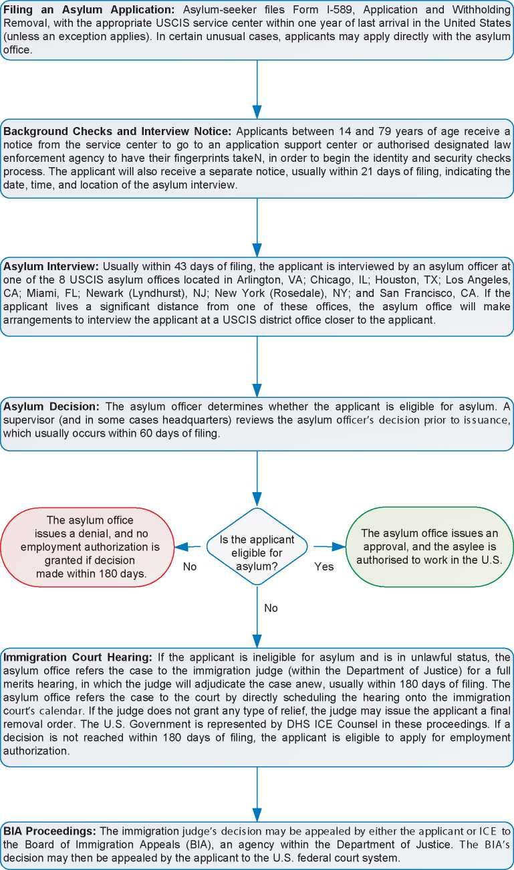

1. Additional Statistical Information

Figure 4: Asylum Applications from Top 10 Countries of Origin in 2009, 2010, 2011 and first half of 2012 [379]

**2009 2010 2011 Jan-Jun 2012**

|  |  |  |  |  |  |  |  |  |
| --- | --- | --- | --- | --- | --- | --- | --- | --- |
| **1** | China | 9,705 | China | 11,137 | China | 13,628 | China | 7,430 |
| **2** | Mexico | 1,502 | Mexico | 2,759 | Mexico | 4,778 | Mexico | 3,139 |
| **3** | El Salvador | 1,289 | Guatemala | 1,253 | Guatemala | 1,566 | Egypt | 1,050 |
| **4** | Haiti | 1,280 | El Salvador | 1,078 | Nepal | 1,197 | Guatemala | 832 |
| **5** | Guatemala | 1,184 | Nepal | 930 | Egypt | 1,056 | Nepal | 678 |
| **6** | Ethiopia | 1,066 | Ethiopia | 915 | El Salvador | 1,030 | El Salvador | 578 |
| **7** | Nepal | 906 | Haiti | 873 | Ethiopia | 818 | Haiti | 470 |
| **8** | Russia | 752 | Russia | 710 | Russia | 805 | Ethiopia | 463 |
| **9** | India | 591 | Venezuela | 573 | Haiti | 793 | Ecuador | 433 |
| **10** | Guinea (Co.) | 404 | Egypt | 471 | Venezuela | 644 | Russia | 398 |

Figure 5: Decisions Taken at the First Instance in 2009, 2010 and 2011

|  |  |  |  |  |  |  |  |  |  |
| --- | --- | --- | --- | --- | --- | --- | --- | --- | --- |
|  | **Geneva Convention** | | **Subsidiary/**  **Complementary**  **Protection and Humanitarian Status** | | **Rejections** | | **Withdrawn, Closed, Abandoned Cases** | | **Grand**  **Total** |
| **Number** | **%** | **Number** | **%** | **Number** | **%** | **Number** | **%** |  |
| **2009** | 9,761 | 30% | 0 | 0% | 19,191 | 59% | 3,441 | 11% | **32,393** |
| **2010** | 9,884 | 32% | 0 | 0% | 17,203 | 55% | 4,033 | 13% | **31,120** |
| **2011** | 11,398 | 32% | 0 | 0% | 19,205 | 54% | 4,796 | 14% | **35,399** |

**Figure 6.a: Positive [380] First- and Second-Instance Decisions,Top Countries of Origin in 2009**

**Rate out of Total Decisions [381]**

|  |  |  |  |  |
| --- | --- | --- | --- | --- |
|  | | **Total Positive** | **Total Decisions** | **Rate** |
| **1** | **China** | 2,582 | 9,497 | 27.2% |
| **2** | **Ethiopia** | 653 | 1,122 | 58.2% |
| **3** | **Haiti** | 449 | 1,262 | 35.6% |
| **4** | **Nepal** | 399 | 1,010 | 39.5% |
| **5** | **Iraq** | 379 | 453 | 83.7% |
| **6** | **Russia** | 292 | 775 | 37.7% |
| **7** | **Guatemala** | 289 | 1,273 | 22.7% |
| **8** | **Colombia** | 284 | 494 | 57.5% |
| **9** | **Eritrea** | 227 | 335 | 67.8% |
| **10** | **Iran** | 220 | 286 | 76.9% |

Total Positive Decisions by Status

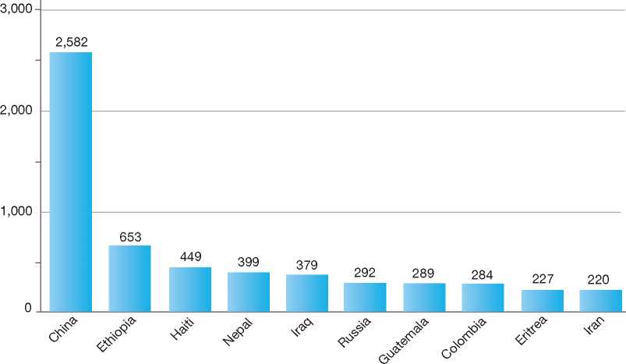

**Total Positive Decisions by Status**

| Geneva Convention Status

**Figure 6.b: Positive [382] First- and Second-Instance Decisions,Top Countries of Origin in 2010**

**Rate out of Total Decisions [383]**

|  |  |  |  |  |
| --- | --- | --- | --- | --- |
|  | | **Total Positive** | **Total Decisions** | **Rate** |
| **1** | **China** | 2,918 | 10,590 | 27.6% |
| **2** | **Ethiopia** | 603 | 964 | 62.6% |
| **3** | **Haiti** | 591 | 965 | 61.2% |
| **4** | **Nepal** | 347 | 939 | 37.0% |
| **5** | **Iran** | 324 | 407 | 79.6% |
| **6** | **Russia** | 298 | 674 | 44.2% |
| **7** | **Venezuela** | 291 | 457 | 63.7% |
| **8** | **Guatemala** | 240 | 865 | 27.7% |
| **9** | **Egypt** | 235 | 426 | 55.2% |
| **10** | **Iraq** | 207 | 260 | 79.6% |

Total Positive Decisions by Status

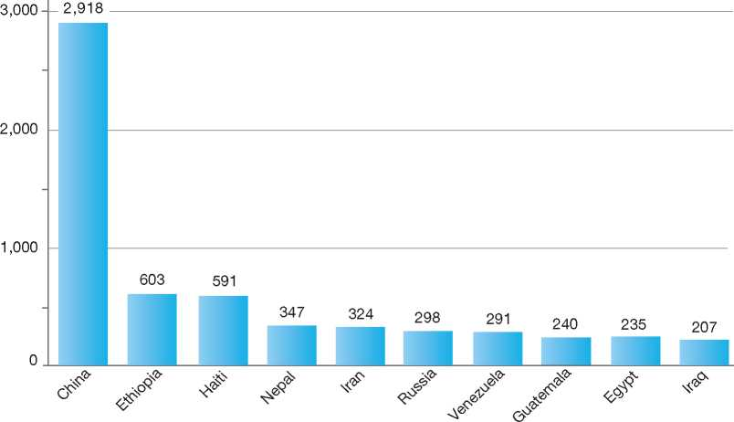

**Total Positive Decisions by Status**

Geneva Convention Status

**Figure 6.c: Positive [384] First- and Second-Instance Decisions,Top Countries of Origin in 2011**

**Rate out of Total Decisions [385]**

|  |  |  |  |  |
| --- | --- | --- | --- | --- |
|  | | **Total Positive** | **Total Decisions** | **Rate** |
| **1** | **China** | 3,614 | 11,780 | 30.7% |
| **2** | **Egypt** | 576 | 819 | 70.3% |
| **3** | **Haiti** | 541 | 832 | 65.0% |
| **4** | **Ethiopia** | 516 | 837 | 61.6% |
| **5** | **Venezuela** | 437 | 640 | 68.3% |
| **6** | **Nepal** | 375 | 1,001 | 37.5% |
| **7** | **Russia** | 337 | 696 | 48.4% |
| **8** | **Iran** | 336 | 405 | 83.0% |
| **9** | **Guatemala** | 315 | 1,130 | 27.9% |
| **10** | **Iraq** | 230 | 304 | 75.7% |
| **11** | **Mexico** | 230 | 2,187 | 10.5% |

Total Positive Decisions by Status

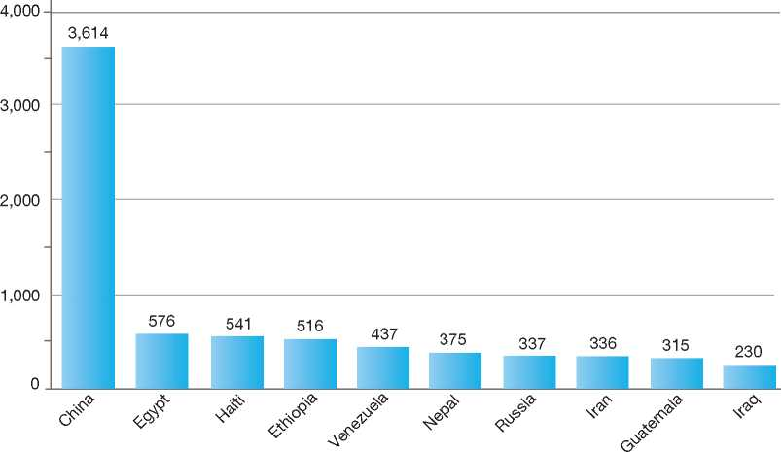

**Total Positive Decisions by Status**

| Geneva Convention Status

Annexes

Annexe 1 : Statistical Information on Asylum Applications and Decisions Made in IGC Participating States

Annexe 2 : Basic Instruments of International Refugee Law and Human Rights Law: Relevant Extracts

Annexe 3 : Selected UNHCR Executive Committee Conclusions on International Protection

Annexe 1

**Statistical Information on Asylum Applications and Decisions Made in IGC Participating States**

1. total asyluM applications in iGc paRticipatinG states
2. distRiBution oF asyluM applications in iGc paRticipatinG states
3. total asyluM applications in iGc paRticipatinG states Received peR 1,000 inhaBitants, 2011
4. asyluM applications in iGc paRticipatinG states By countRies oF oRiGin
5. distRiBution oF asyluM applications FRoM top countRies oF oRiGin in iGc paRticipatinG states
6. asyluM applications Received FRoM selected countRies oF oRiGin in iGc paRticipatinG states
7. asyluM applications By unaccoMpanied MinoRs in iGc paRticipatinG states
8. total pendinG cases in the FiRst instance oF the asyluM pRoceduRe in iGc paRticipatinG states, as at 30 septeMBeR 2012
9. total FiRst-instance asyluM decisions in iGc paRticipatinG states, peRcentaGes By cateGoRy, 2011
10. total FiRst-instance asyluM decisions in iGc paRticipatinG states, RecoGnition Rates, 2011

Explanatory Note

The statistical information presented in this annexe is, as is all the other data contained in this report, collected by the IGC directly from each government.

**Asylum Applications**

Data on asylum applications are not available for certain Participating States for the full period covered in this publication. The graphs, maps and tables on asylum applications do not include data for Greece (1992­2005), New Zealand (1992-1996), Spain (1992-1993), Sweden (1992-1993), the Netherlands (Jan-Jun 2012) and the United States (1992).

Data for Germany (1993-2012), the Netherlands (2007-2011) and the United Kingdom cover first applications only.

Sweden does not have repeat applications.

Data for Denmark from 1983 to 1997 reflect applications under active consideration, and data for 1998­2012 reflects the gross number of applications received. Since 2001, data include persons who are returned to a safe third country and persons who are transferred or re-transferred to another EU Member State.

Data for the United States only refer to principal applicants making an affirmative application or requesting a reopening of their affirmative application with USCIS. Data refer to cases not persons.

Data for Belgium, and for France (1992-2002) do not include unaccompanied minors.

Asylum Applications - Unaccompanied Minors

No data available for the following IGC Participating States: Australia, Canada, Greece, New Zealand, Spain and the United States.

1. Total Asylum Applications in IGC Participating States
2. a: Evolution of Asylum Applications in IGC Participating States by Quarter, January 1992 - June 2012[386]

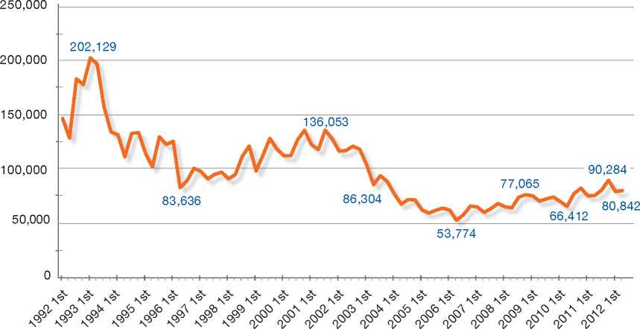

504

|  |  |  |  |  |  |  |  |  |  |  |  |  |  |  |  |  |  |  |
| --- | --- | --- | --- | --- | --- | --- | --- | --- | --- | --- | --- | --- | --- | --- | --- | --- | --- | --- |
| **Year** | **AUS** | **BEL** | **CAN** | **DNK** | **FIN** | **FRA** | **DEU** | **GRC** | **IRL** | **NLD** | **NZL** | **NOR** | **ESP** | **SWE** | **CHE** | **GBR** | **USA** | **Grand Total** |
| **1992** | 6,090 | 17,647 | 37,728 | 13,884 | 3,634 | 39,835 | 438,191 |  |  | 20,346 |  | 5,238 |  |  | 19,109 | 34,539 |  | **636,241** |
| **1993** | 7,215 | 26,882 | 21,196 | 14,347 | 2,023 | 35,406 | 320,742 |  |  | 35,399 |  | 12,876 |  |  | 25,827 | 28,000 | 160,495 | **690,408** |
| **1994** | 6,376 | 14,353 | 22,053 | 6,651 | 836 | 32,413 | 127,210 |  |  | 52,576 |  | 3,379 | 11,901 | 18,638 | 16,872 | 42,201 | 155,038 | **510,497** |
| **1995** | 7,677 | 11,420 | 25,938 | 5,104 | 854 | 25,036 | 127,937 |  |  | 29,258 |  | 1,460 | 5,678 | 9,047 | 18,067 | 54,988 | 147,686 | **470,150** |
| **1996** | 9,770 | 12,433 | 25,738 | 5,893 | 711 | 21,122 | 116,367 |  |  | 22,857 |  | 1,778 | 4,730 | 5,774 | 19,418 | 29,642 | 124,112 | **400,345** |
| **1997** | 9,704 | 11,788 | 24,325 | 5,092 | 977 | 22,637 | 104,352 |  | 3,883 | 34,443 | 2,669 | 2,273 | 4,975 | 9,619 | 25,507 | 41,500 | 79,454 | **383,198** |
| **1998** | 7,992 | 21,965 | 25,379 | 9,370 | 1,272 | 22,990 | 98,644 |  | 4,626 | 45,217 | 2,766 | 8,543 | 6,639 | 12,844 | 42,979 | 58,000 | 51,512 | **420,738** |
| **1999** | 9,496 | 35,778 | 30,897 | 12,331 | 3,106 | 31,855 | 95,113 |  | 7,724 | 39,299 | 1,777 | 10,160 | 8,405 | 11,231 | 47,513 | 71,158 | 43,677 | **459,520** |
| **2000** | 12,608 | 42,691 | 37,852 | 12,200 | 3,170 | 39,775 | 78,563 |  | 10,938 | 43,895 | 1,523 | 10,843 | 7,235 | 1 6,303 | 19,750 | 98,866 | 52,414 | **488,626** |
| **2001** | 12,366 | 24,549 | 44,706 | 12,512 | 1,650 | 48,660 | 88,287 |  | 1 0,325 | 32,579 | 1,791 | 14,782 | 9,219 | 23,515 | 21,854 | 91,553 | 67,141 | **505,489** |
| **2002** | 5,805 | 18,805 | 33,468 | 6,068 | 3,443 | 52,877 | 71,127 |  | 11,634 | 18,667 | 1,009 | 17,480 | 6,179 | 33,016 | 26,987 | 103,080 | 64,675 | **474,320** |
| **2003** | 4,205 | 16,940 | 31,899 | 4,593 | 3,221 | 61,993 | 50,563 |  | 7,900 | 13,402 | 846 | 15,613 | 5,918 | 31,355 | 21,759 | 60,047 | 43,589 | **373,843** |
| **2004** | 3,097 | 15,357 | 25,543 | 3,235 | 3,861 | 65,614 | 35,607 |  | 4,766 | 9,782 | 583 | 7,945 | 5,553 | 23,161 | 15,061 | 40,623 | 31,191 | **290,979** |
| **2005** | 3,083 | 15,957 | 19,771 | 2,281 | 3,574 | 59,221 | 28,914 |  | 4,323 | 12,347 | 348 | 5,401 | 5,049 | 17,530 | 10,799 | 30,841 | 31,460 | **250,895** |
| **2006** | 3,458 | 11,587 | 22,967 | 1,960 | 2,288 | 39,332 | 21,029 | 12,267 | 4,314 | 14,465 | 276 | 5,320 | 5,266 | 24,322 | 11,173 | 28,321 | 33,752 | **242,097** |
| **2007** | 3,951 | 11,115 | 28,530 | 2,246 | 1,505 | 35,520 | 19,164 | 25,113 | 3,985 | 7,102 | 248 | 6,528 | 7,477 | 36,207 | 10,844 | 28,299 | 32,307 | **260,141** |
| **2008** | 4,808 | 12,252 | 36,929 | 2,409 | 4,035 | 42,599 | 22,085 | 19,884 | 3,866 | 13,399 | 254 | 14,431 | 4,476 | 24,353 | 16,606 | 31,313 | 29,279 | **282,978** |
| **2009** | 7,378 | 17,186 | 33,251 | 3,855 | 5,910 | 47,686 | 27,649 | 15,928 | 2,689 | 14,905 | 336 | 17,226 | 3,007 | 24,194 | 16,005 | 30,673 | 27,556 | **295,434** |
| **2010** | 12,606 | 19,941 | 23,177 | 5,115 | 4,018 | 52,762 | 41,332 | 10,273 | 1,939 | 13,333 | 340 | 10,064 | 2,739 | 31,819 | 15,567 | 22,644 | 30,750 | **298,419** |
| **2011** | 11,534 | 25,479 | 25,356 | 3,806 | 3,088 | 57,337 | 45,739 | 9,311 | 1,290 | 11,590 | 305 | 9,053 | 3,415 | 29,648 | 22,551 | 25,898 | 38,513 | **323,913** |
| **2012\*** | 7,879 | 10,982 | 10,618 | 2,663 | 1,274 | 29,056 | 22,477 | 4,359 | 458 |  | 163 | 4,267 | 1,296 | 1 6,334 | 14,430 | 12,416 | 22,139 | **160,811** |

‘first half 2012

**1 .b: Total Asylum Applications by IGC Participating State and by Year, 1992 - 2011, first half 2012**

1. c: Volume of Total Asylum Applications by IGC Participating State by Year, 2002 - 2011[387]

|  |  |  |  |  |  |  |  |  |  |  |
| --- | --- | --- | --- | --- | --- | --- | --- | --- | --- | --- |
| **United States** | 1 1  • • | | 1  • | 1  • | 1  • | 1  • | 1  • | 1  • | 1  • | 1  • |
| **United Kingdom** | • | • | • | • | • | • | • | • | • | • |
| **Switzerland** | • | • | • | • | • | • | • | • | • | • |
| **Sweden** | • | • | • | • | • | • | • | • | • | • |
| **Spain** | • | • | • | • | • | • | • | • | • | • |
| **Norway** | • | • | • | • | • | • | • | • | • | • |
| **New Zealand** | • | • | • | • | • | • | • | • | • | • |
| **Netherlands** | • | • | • | • | • | • | • | • | • | • |
| **Ireland** | • | • | • | • | • | • | • | • | • | • |
| **Greece** |  |  |  |  | • | • | • | • | • | • |
| **Germany** | • | • | • | • | • | • | • | • | • | • |
| **France** | • | • | • | • | • | • | • | • | • | • |
| **Finland** | • | • | • | • | • | • | • | • | • | • |
| **Denmark** | • | • | • | • | • | • | • | • | • | • |
| **Canada** | • | • | • | • | • | • | • | • | • | • |
| **Belgium** | • | • | • | • | • | • | • | • | • | • |
| **Australia** | •  1 | •  1 | •  1 | •  1 | •  1 | •  1 | •  1 | •  1 | •  1 | •  1 |
|  | 2002 | 2003 | 2004 | 2005 | 2006 | 2007 | 2008 | 2009 | 2010 | 2011 |

**Applications**



0 120,000

2.a: Distribution of Asylum Applications in IGC Participative States, 2002 - 20114

13e

9e

4e

4e

9e

|  |  |  |  |
| --- | --- | --- | --- |
| **Receiving Country** | | **Applications** | **Distribution** |
| □ | **France** | 514,941 | 16.6% |
| □ | **United Kingdom** | 401,739 | 13.0% |
| □ | **Germany** | 363,209 | 11.7% |
| □ | **United States** | 363,072 | 11.7% |
| □ | **Canada** | 280,891 | 9.1% |
| □ | **Sweden** | 275,605 | 8.9% |
| □ | **Switzerland** | 167,348 | 5.4% |
| □ | **Belgium** | 164,619 | 5.3% |
| □ | **Netherlands** | 128,992 | 4.2% |
| □ | **Norway** | 109,061 | 3.5% |
| □ | **Greece** | 92,776 | 3.0% |
| □ | **Australia** | 59,925 | 1.9% |
| □ | **Spain** | 49,079 | 1.6% |
| □ | **Ireland** | 46,706 | 1.5% |
| □ | **Denmark** | 35,568 | **1.1 %** |
| □ | **Finland** | 34,943 | 1.1% |
| □ | **New Zealand** | 4,545 | 0.1% |
| **Grand Total** | | **3,093,019** | **100%** |

2.b: DisergUmtion of Asylum Applications in %GC Participati6g States, 20094

**io%**

**11%**

**9%**

**16%**

**9%**

**0% 1% 1% 1%**

**8%**

**5%**

**6%**

**6%**

**5%**

**5%**

|  |  |  |  |
| --- | --- | --- | --- |
| **Receiving Country** | | **Applications** | **Distribution** |
| □ | **France** | 47,686 | 16.1% |
| □ | **Canada** | 33,251 | 11.3% |
| □ | **United Kingdom** | 30,673 | 10.4% |
| □ | **Germany** | 27,649 | 9.4% |
| □ | **United States** | 27,556 | 9.3% |
| □ | **Sweden** | 24,194 | 8.2% |
| □ | **Norway** | 17,226 | 5.8% |
| □ | **Belgium** | 17,186 | 5.8% |
| □ | **Switzerland** | 16,005 | 5.4% |
| □ | **Greece** | 15,928 | 5.4% |
| □ | **Netherlands** | 14,905 | 5.0% |
| □ | **Australia** | 7,378 | 2.5% |
| □ | **Finland** | 5,910 | 2.0% |
| □ | **Denmark** | 3,855 | 1.3% |
| □ | **Spain** | 3,007 | 1.0% |
| □ | **Ireland** | 2,689 | 0.9% |
| □ | **New Zealand** | 336 | 0.1% |
| **Grand Total** | | **295,434** | **100%** |

1. Due **toooway**ing, the total of perce nta**2**26 in the pie ch5rt % below 100%.
2. Due torouuding, the total of percentan<t6 in the pie chart % below 100%.

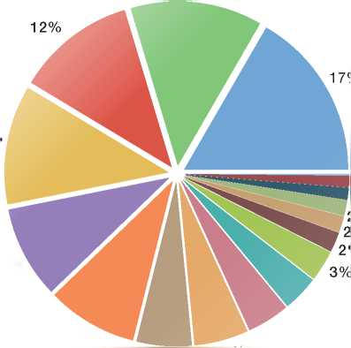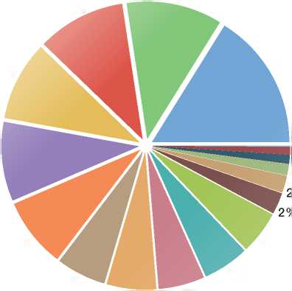

*2.c:* Distribution of Asylum Applications in IGC Participating States, 2010

**14e**

**10%**

**11%**

**18%**

**0%**

**1%**

**1%**

**1%**

**2%**

**3%**

**3%**

**8%**

**4%**

**7%**

**4%**

**5%**

|  |  |  |  |
| --- | --- | --- | --- |
| **Receiving Country** | | **Applications** | **Distribution** |
| o | **France** | 52,762 | 17.7% |
| □ | **Germany** | 41,332 | 13.9% |
| □ | **Sweden** | 31,819 | 10.7% |
| □ | **United States** | 30,750 | 10.3% |
| □ | **Canada** | 23,177 | 7.8% |
| o | **United Kingdom** | 22,644 | 7.6% |
| □ | **Belgium** | 19,941 | 6.7% |
| □ | **Switzerland** | 15,567 | 5.2% |
| □ | **Netherlands** | 13,333 | 4.5% |
| □ | **Australia** | 12,606 | 4.2% |
| o | **Greece** | 10,273 | 3.4% |
| □ | **% orway** | 10,064 | 3.4% |
| □ | **Denmark** | 5,115 | 1.7% |
| □ | **Finland** | 4,018 | 1.3% |
| □ | **Spain** | 2,739 | 0.9% |
| o | **Ireland** | 1,939 | 0.6% |
|  | **New Zealand** | 340 | 0.1% |
|  | **Grand Total** | **298,419** | **100%** |

2.d: Disttzbution of AsylumAp7lications in IGC Participating States, 20115

14%

9%

8%

7%

8t

3%

**0%**

**1%**

**1%  
1%**

**3%**

|  |  |  |  |
| --- | --- | --- | --- |
| **Receiving Country** | | **Applications** | **Distribution** |
| □ | **France** | 57,337 | 17.7% |
| □ | **Germany** | 45,739 | 14.1% |
| □ | **United States** | 38,513 | 11.9% |
| □ | **Sweden** | 29,648 | 9.2% |
| □ | **United Kingdom** | 25,898 | 8.0% |
| □ | **Belgium** | 25,479 | 7.9% |
| □ | **Canada** | 25,356 | 7.8% |
| □ | **Switzerland** | nn,55i | 7.0% |
| □ | **Netherlands** | 11,590 | 3.6% |
| □ | **Australia** | 11,534 | 3.6% |
| □ | **Greece** | 9,311 | 2.9% |
| □ | **Norway** | 9,053 | 2.8% |
| □ | **Denmark** | 3,806 | 1.2% |
| □ | **Spain** | 3,415 | 1.1% |
| □ | **Finland** | 3,088 | 1.0% |
| □ | **Ireland** | 1,290 | 0.4% |
| □ | **New Zealand** | 305 | 0.1% |
| **Grand Total** | | **323,913** | **100%** |

5 Due Swiounding, the total of percen2agei in the pie c7art is above 100%.

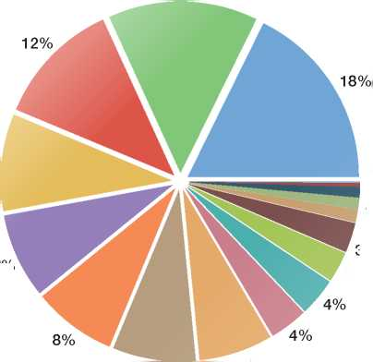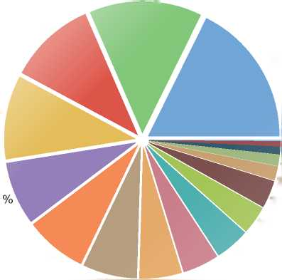

Asylum Applications per 1,000 Inhabitants

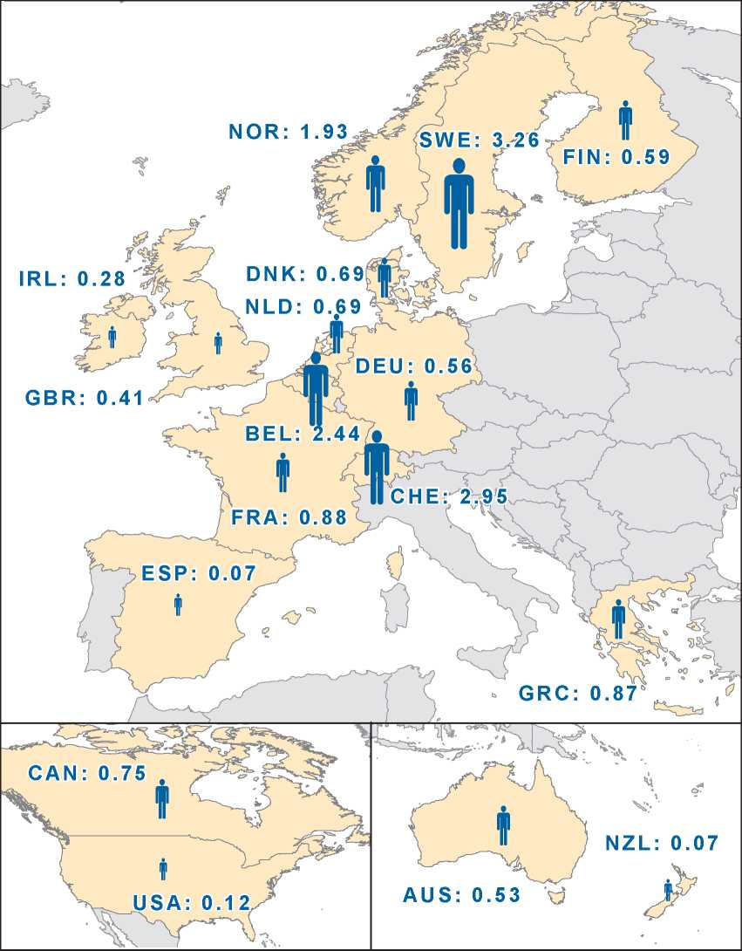

f < 0.5 f 0.5 - 1

**>**• 1 - 2 2 - 3 > 3

1 - 2 >3 [388] [389]

4.a: Asylum Applications in IGC Participating States by Countries of Origin, 2009

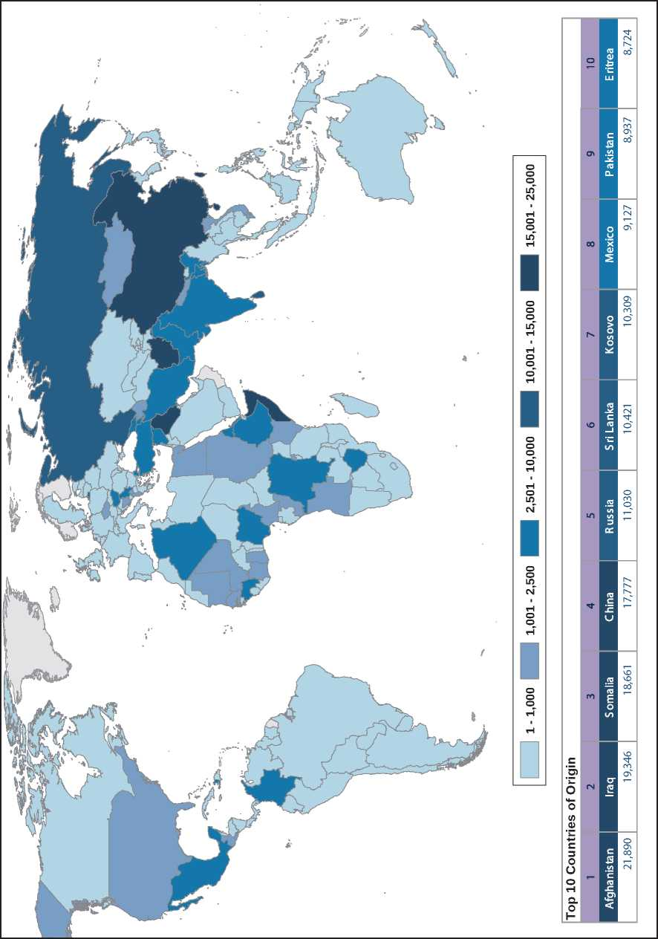

8 See Explanatory Note.

510

1 - 1,000

1,001 - 2,500

2,501 -10,000

10,001 -15,000

15,001 - 25,000

|  |  |  |  |  |  |  |  |  |  |
| --- | --- | --- | --- | --- | --- | --- | --- | --- | --- |
| **Top 10 Countries of Origin** | | | | | | | | | |
| **1** | **2** | **3** | **4** | **5** | **6** | **7** | **8** | **9** | **10** |
| **Afghanistan** | **China** | **Somalia** | **Iraq** | **Serbia** | **Kosovo** | **Russia** | **Iran** | **Sri Lanka** | **Pakistan** |
| 21,373 | | 19,626 | | 15,670 | | 15,262 | 14,967 | 11,692 | 11,454 | 11,304 | 9,143 | 8,974 |

**4.b: Asylum Applications in IGC Participating States by Countries of Origin, 2010**

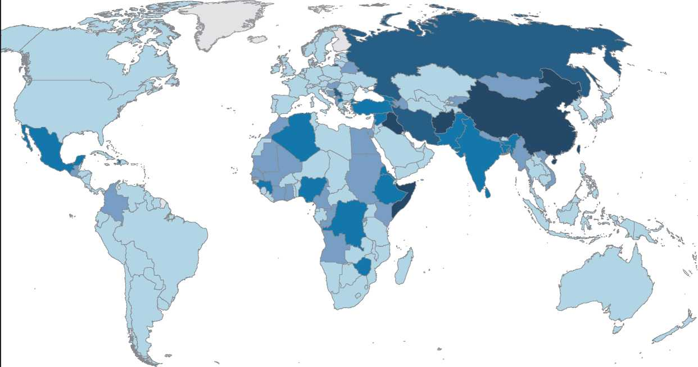

1-1,000 1,001-2,500 2,501-10,000 JS?5 10,001-15,000 15,001-25,000

|  |  |  |  |  |  |  |  |  |  |
| --- | --- | --- | --- | --- | --- | --- | --- | --- | --- |
| **Top 10 Countries of Origin** | | | | | | | | | |
| **1** | **2** | **3** | **4** | **5** | **6** | **7** | **8** | **9** | **10** |
| **Afghanistan** | **China** | **Iraq** | **Pakistan** | **Iran** | **Somalia** | **Russia** | **Serbia** | **E ritrea** | **S ri La nka** |
| 24,989 | | 22,479 | | 14,360 | | 14,158 | 13,751 | 12,258 | 11,533 | 10,740 | 9,532 | 8,658 |

**4.c: Asylum Applications in IGC Participating States by Countries of Origin, 2011**

Q

O  
cn

S

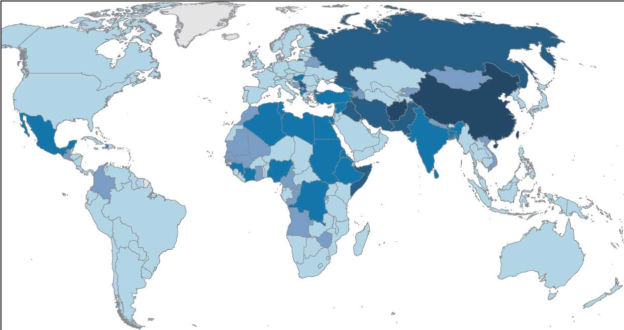

5.a: Distribution of Asylum Applications in IGC Participating States, Top 10 Countries of Origin, 2002-201110

3%

3%

**3%**

**1**

**2**

1. ■

**4**

**5**

**6**

**7**

**8**

**9**

**10**

|  |  |  |
| --- | --- | --- |
| **Receiving Country** | **Applications** | **Distribution** |
| **Iraq** | 215,684 | 7.0% |
| **China** | 174,987 | 5.7% |
| **Afghanistan** | 131,640 | 4.3% |
| **Somalia** | 118,982 | 3.8% |
| **Russia** | 113,759 | 3.7% |
| **Turkey** | 113,258 | 3.7% |
| **Pakistan** | 94,379 | 3.1% |
| **Iran** | 92,037 | 3.0% |
| **Nigeria** | 80,996 | 2.6% |
| **Congo (Dem. Rep.)** | 78,266 | 2.5% |

**4%**

5.bomaistribution of Asylum Application in IGC Participating States, Top 10 Countries of Origin, 2009

54%

3%

3%

6%

**1**

**2**

**3**

**4**

**5**

**6**

**7**

**8**

**9**

**10**

|  |  |  |  |
| --- | --- | --- | --- |
|  | **Receiving Country** | **Applications** | **Distribution** |
| **□** | **Afghanistan** | 21,890 | 7.4% |
| **D** | **Iraq** | 19,346 | 6.5% |
| **□** | **Somalia** | 18,661 | 6.3% |
| **□** | **China** | 17,777 | 6.0% |
| **D** | **Russia** | 11,030 | 3.7% |
| **□** | **Sri Lanka** | 10,421 | n.5% |
| **□** | **Kosovo** | 10,309 | 3.5% |
| **D** | **Mexico** | 9,127 | 3.1% |
| **□** | **Pakistan** | 8,937 | 3.0% |
| **□** | **Eritrea** | 8,724 | 3.0% |

**6%**

1. See Explanatory Note.
2. **Ose** to rounding, the total of pircontages in the pie ch%t is above 100%.

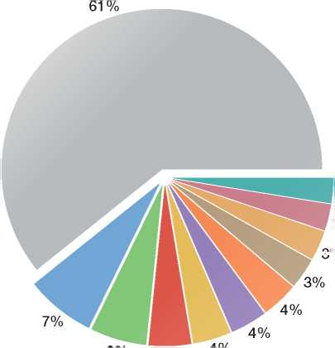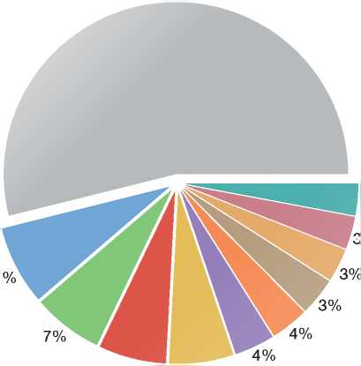

*5.c:* Distribution of Asylum Applications in IG% Participating States, Top 10 Countries of Origin, 2010

53s

3s

3%

5s

**1**

**2**

**3**

**4**

**5**

**6**

**7**

**8**

**9**

**10**

|  |  |  |  |
| --- | --- | --- | --- |
|  | **Receiving Country** | **Applications** | **Distribution** |
| □ | **Afghanistan** | 21,373 | 7.2% |
| □ | **China** | 19,626 | 6.6% |
| □ | **Somalia** | 15,670 | 5.3% |
| □ | **Iraq** | 15,262 | 5.1% |
| □ | **Serbia** | 14,967 | 5.0% |
| □ | **Kosovo** | 11,692 | 3.9% |
| □ | **Russia** | 11,454 | 3.8% |
| □ | **Iran** | 11,304 | 3.8% |
| □ | **Sri Lanka** | 9,143 | 3.1% |
| □ | **Pakistan** | 8,974 | 3.0% |

**5.d:Distribution of Asylum Application% in IGC Participating States, Top 10 Countries of Origin, 2011**

56%

3%

3%

□

**1**

**2**

1. **■**

**4**

**5**

**6**

**7**

**8**

**9**

**10**

|  |  |  |
| --- | --- | --- |
| **Receiving Country** | **Applications** | **Distribution** |
| **Afghanistan** | 24,989 | 7.7% |
| **China** | 22,479 | 6.9% |
| **Iraq** | 14,360 | 4.4% |
| **Pakistan** | 14,158 | 4.4% |
| **Iran** | 13,751 | 4.2% |
| **Somalia** | 12,258 | 3.8% |
| **Russia** | 11,533 | 3.6% |
| **Serbia** | 10,740 | 3.3% |
| **Eritrea** | 9,532 | 2.9% |
| **Sri Lanka** | 8,658 | 2.7% |

**4%4%**

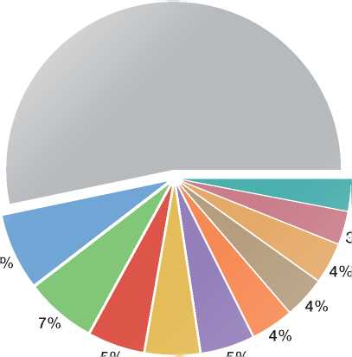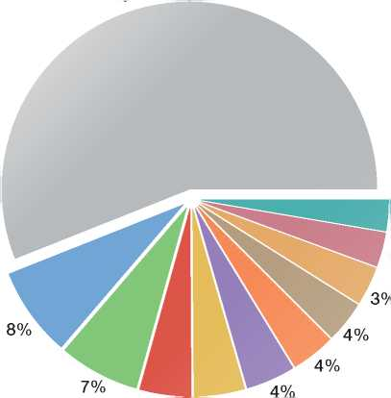

1. **a: Evolution of Asylum Applications from Afghanistan in IGC Participating States by**

**Quarter, January 2002 - June 2012**

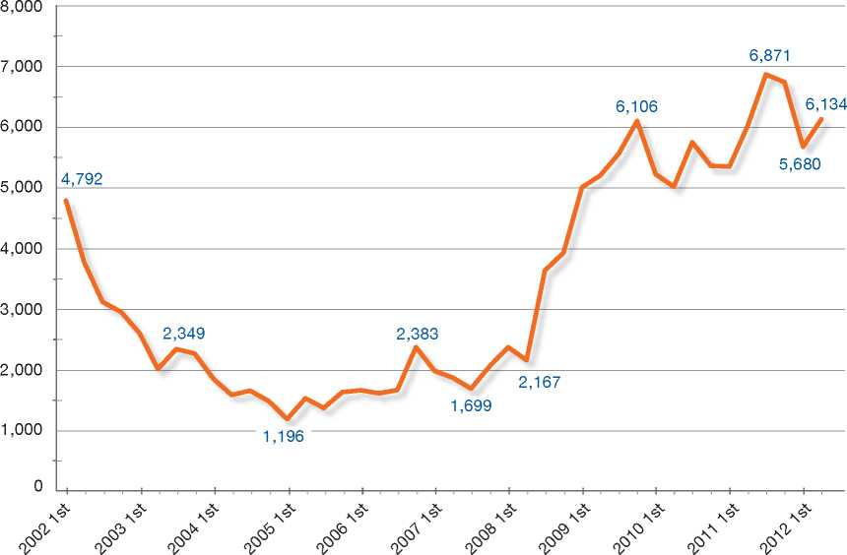

1. b: Distribution of Asylum Applications from Afghanistan in IGC Participatin4%tates, 201111 12

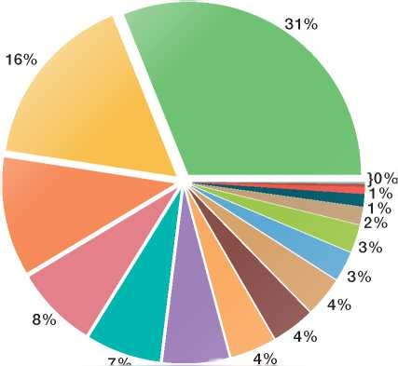

11%

6%

| ■ | **Receiving Country** | **Applications** | **Distribution** |
| --- | --- | --- | --- |
| □ | **Gtrmany** | 7,767 | 31.1% |
| □ | **Sweden** | 4,122 | 16.5% |
| □ | **Belgium** | 2,758 | 11.0% |
| □ | **Netherlands** | 1,885 | 7.5% |
| □ | **Australia** | 1,724 | 6.9% |
| □ | **United Kingdom** | 1,529 | 6.1% |
| □ | **Switzerland** | 1,052 | 4.2% |
| □ | **Norway** | 979 | 3.9% |
| □ | **Denmark** | 906 | 3.6% |
| □ | **France** | 681 | 2.7% |
| □ | **Greece** | 637 | 2.5% |
| □ | **Canada** | 398 | 1.6% |
| □ | **Finland** | 284 | 1.1% |
| □ | **United States** | 159 | 0.6% |
| □ | **Ireland** | 67 | 0.3% |
| □ | **Spain** | 30 | 0.1% |
| □ | **New Zealand** | 11 | 0.0% |
|  | **Grand Total** | **24**,**989** | **100%** |

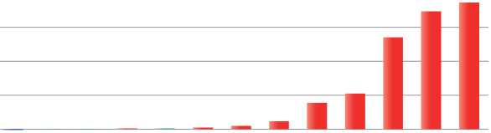

2,000

1,500

1,000

500

-500

-1,000

-1,500

/

X-

**-i 1 1 1 r**

xz z z

**Evolution: |** | < -5 % ± 5 % | | > 5 %

|  |  |  |  |  |
| --- | --- | --- | --- | --- |
| **Receiving Country** | **Jan-Dec 2010** | **Jan-Dec 2011** | **Evolution** | **Evolution %** |
| **Germany** | 5,905 | 7,767 | 1,862 | 32% |
| **Sweden** | 2,393 | 4,122 | 1,729 | 72% |
| **Belgium** | 1,411 | 2,758 | 1,347 | 95% |
| **Netherlands** | 1,364 | 1,885 | 521 | 38% |
| **Australia** | 3,093 | 1,724 | -1,369 | -44% |
| **United Kingdom** | 1,843 | 1,529 | -314 | -17% |
| **Switzerland** | 670 | 1,052 | 382 | 57% |
| **Norway** | 979 | 979 | 0 | 0% |
| **Denmark** | 1,512 | 906 | -606 | -40% |
| **France** | 794 | 681 | -113 | -14% |
| **Greece** | 524 | 637 | 113 | 22% |
| **Canada** | 391 | 398 | 7 | 2% |
| **Finland** | 265 | 284 | 19 | 7% |
| **United States** | 114 | 159 | 45 | 39% |
| **Ireland** | 69 | 67 | -2 | -3% |
| **Spain** | 41 | 30 | -11 | -27% |
| **New Zealand** | 5 | 11 | 6 | 120% |
| **Grand Total** | **21,373** | **24,989** | **3,616** | **17%** |

**6.2.b: Distribution of Asylum Applications from Iraq in IGC Participating States, 20%13**

14%

0%

}0%

1%

2%

2%

2%

□ □

□

□

□

□

□

□

□

□

□

□

□

□

□

□

□

|  |  |  |
| --- | --- | --- |
| **Receiving Country** | **Applications** | **Distribution** |
| **Germany** | 5,831 | 40.6% |
| **Belgium** | 1,948 | 13.6% |
| **Sweden** | 1,633 | 11.4% |
| **Netherlands** | 1,435 | 10.0% |
| **Finland** | 586 | 4.1% |
| **Australia** | 508 | 3.5% |
| **Switzerland** | 504 | 3.5% |
| **United Kingdom** | 377 | 2.6% |
| **Norway** | 357 | 2.5% |
| **United States** | 329 | 2.3% |
| **France** | 265 | 1.8% |
| **Greece** | 257 | 1.8% |
| **Canada** | 166 | 1.2% |
| **Denmark** | 116 | 0.8% |
| **Spain** | 19 | 0.1% |
| **Ireland** | 18 | 0.1% |
| **New Zealand** | 11 | 0.1% |
| **Grand Total** | **14,360** | **100%** |

13 Due Ausounding, the total of percenta5es in the pie ch3rfis above 100%.

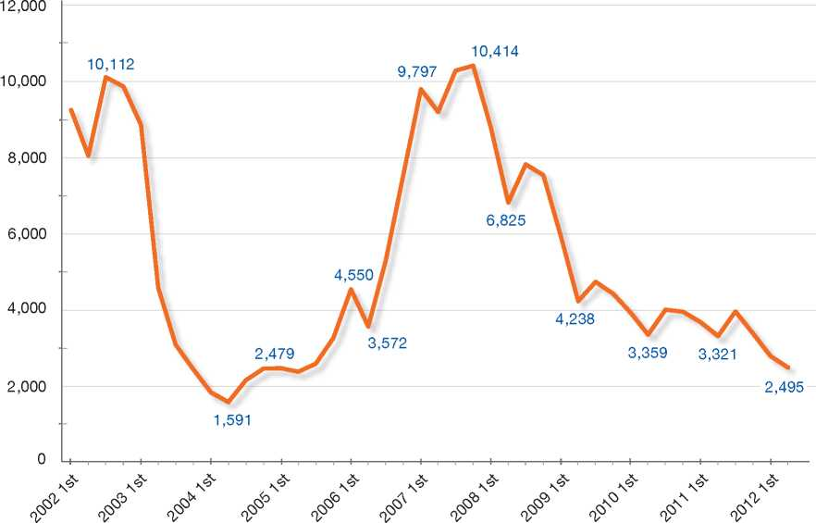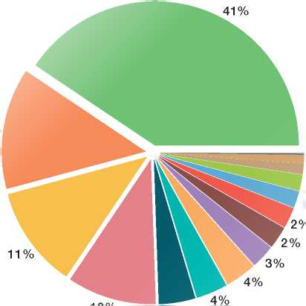

300

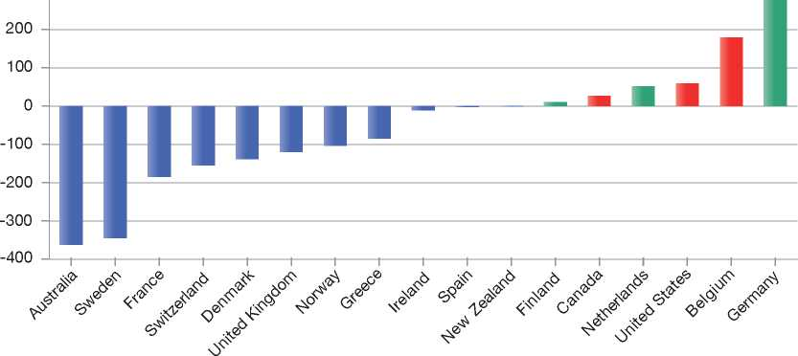

**Evolution: |** | < -5 % ± 5 *%* | | > 5 %

|  |  |  |  |  |
| --- | --- | --- | --- | --- |
| **Receiving Country** | **Jan-Dec 2010** | **Jan-Dec 2011** | **Evolution** | **Evolution %** |
| **Germany** | 5,555 | 5,831 | 276 | 5% |
| **Belgium** | 1,769 | 1,948 | 179 | 10% |
| **Sweden** | 1,977 | 1,633 | -344 | -17% |
| **Netherlands** | 1,383 | 1,435 | 52 | 4% |
| **Finland** | 575 | 586 | 11 | 2% |
| **Australia** | 870 | 508 | -362 | -42% |
| **Switzerland** | 659 | 504 | -155 | -24% |
| **United Kingdom** | 496 | 377 | -119 | -24% |
| **Norway** | 460 | 357 | -103 | -22% |
| **United States** | 270 | 329 | 59 | 22% |
| **France** | 450 | 265 | -185 | -41% |
| **Greece** | 342 | 257 | -85 | -25% |
| **Canada** | 140 | 166 | 26 | 19% |
| **Denmark** | 254 | 116 | -138 | -54% |
| **Spain** | 21 | 19 | -2 | -10% |
| **Ireland** | 29 | 18 | -11 | -38% |
| **New Zealand** | 12 | 11 | -1 | -8% |
| **Grand Total** | **15,262** | **14,360** | **-902** | **-6%** |

6.3.b: Distribution of Asylum Applications from Somalia % IGC Participating Stat5% 201114

6% 5%

|  |  |  |  |
| --- | --- | --- | --- |
|  | **Receiving Country** | **Applications** | **Distribution** |
| **□** | **Sweden** | 3,981 | 32.5% |
| **D** | **Norway** | 2,216 | 18.1% |
| **□** | **Netherlands** | 1,415 | 11.5% |
| **D** | **Germany** | 984 | 8.0% |
| **□** | **France** | 768 | 6.3% |
| **D** | **United Kingdom** | 660 | 5.4% |
| **□** | **Switzerland** | 636 | 5.2% |
| **D** | **Belgium** | 483 | 3.9% |
| **□** | **Canada** | 413 | 3.4% |
| **D** | **Finland** | 356 | 2.9% |
| **□** | **Denmark** | 113 | 0.9% |
| **D** | **United States** | 69 | 0.6% |
| **□** | **Greece** | 68 | 0.6% |
| **D** | **Spain** | 59 | 0.5% |
| **□** | **Ireland** | 21 | 0.2% |
| **D** | **Australia** | 15 | 0.1% |
| **□** | **New Zealand** | 1 | 0.0% |
| C | **Grand Total** | **12,258** | **100%** |

14 Due **Un ted**n**King, tOm** total of percenta660 in the pie ch5rfis below 100%.

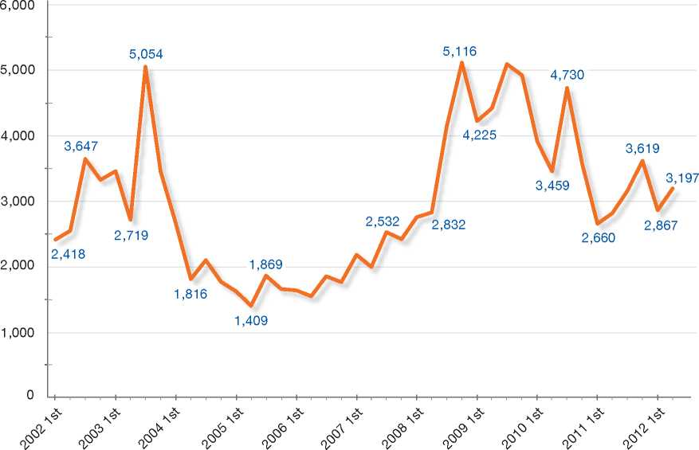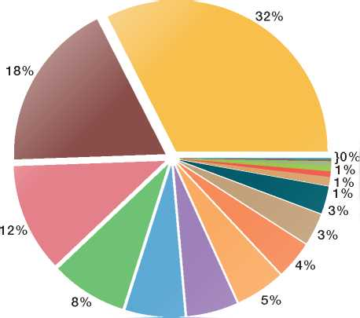

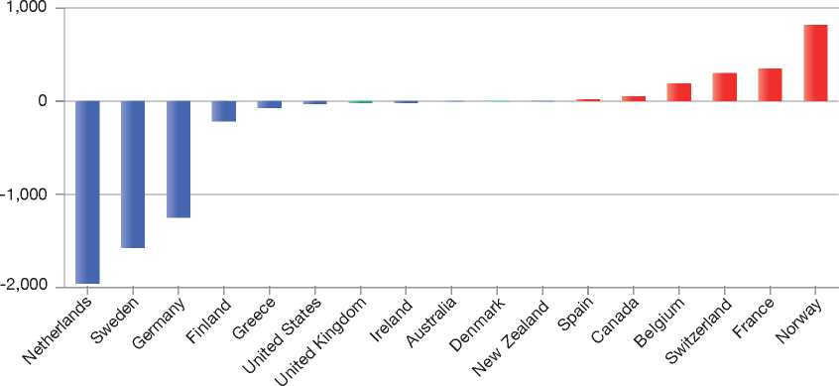

**Evolution: |** | < -5 % | | ± 5 *%* | | > 5 %

|  |  |  |  |  |
| --- | --- | --- | --- | --- |
| **Receiving Country** | **Jan-Dec 2010** | **Jan-Dec 2011** | **Evolution** | **Evolution %** |
| **Sweden** | 5,553 | 3,981 | -1,572 | -28% |
| **Norway** | 1,397 | 2,216 | 819 | 59% |
| **Netherlands** | 3,372 | 1,415 | -1,957 | -58% |
| **Germany** | 2,235 | 984 | -1,251 | -56% |
| **France** | 420 | 768 | 348 | 83% |
| **United Kingdom** | 679 | 660 | -19 | -3% |
| **Switzerland** | 337 | 636 | 299 | 89% |
| **Belgium** | 294 | 483 | 189 | 64% |
| **Canada** | 364 | 413 | 49 | 13% |
| **Finland** | 571 | 356 | -215 | -38% |
| **Denmark** | 114 | 113 | -1 | -1% |
| **United States** | 97 | 69 | -28 | -29% |
| **Greece** | 141 | 68 | -73 | -52% |
| **Spain** | 39 | 59 | 20 | 51% |
| **Ireland** | 38 | 21 | -17 | -45% |
| **Australia** | 17 | 15 | -2 | -12% |
| **New Zealand** | 2 | 1 | -1 | -50% |
| **Grand Total** | **15,670** | **12,258** | **-3,412** | **-22%** |

6.4.b: Distribution of Asylum Applications from Syria in IGC Participating States, 3% 1

6%

|  |  |  |  |
| --- | --- | --- | --- |
| **Receiving Country** | | **Applications** | **Distribution** |
| □ | **Germany** | 2,634 | 37.0% |
| □ | **Switzerland** | 826 | 11.6% |
| □ | **Sweden** | 640 | 9.0% |
| □ | **Belgium** | 555 | 7.8% |
| □ | **United Kingdom** | 508 | 7.1% |
| □ | **Denmark** | 429 | 6.0% |
| □ | **Greece** | 352 | 4.9% |
| □ | **United States** | 206 | 2.9% |
| □ | **Norway** | 198 | 2.8% |
| □ | **Canada** | 176 | 2.5% |
| □ | **Netherlands** | 168 | 2.4% |
| □ | **France** | 119 | 1.7% |
| □ | **Finland** | 110 | 1.5% |
| □ | **Spain** | 97 | 1.4% |
| □ | **Australia** | 95 | 1.3% |
| □ | **Ireland** | 9 | 0.1% |
| □ | **New Zealand** | 2 | 0.0% |
| **Grand Total** | | **7,124** | **100%** |

**}0%**

**1%**

**1%**

**2%**

**2%**

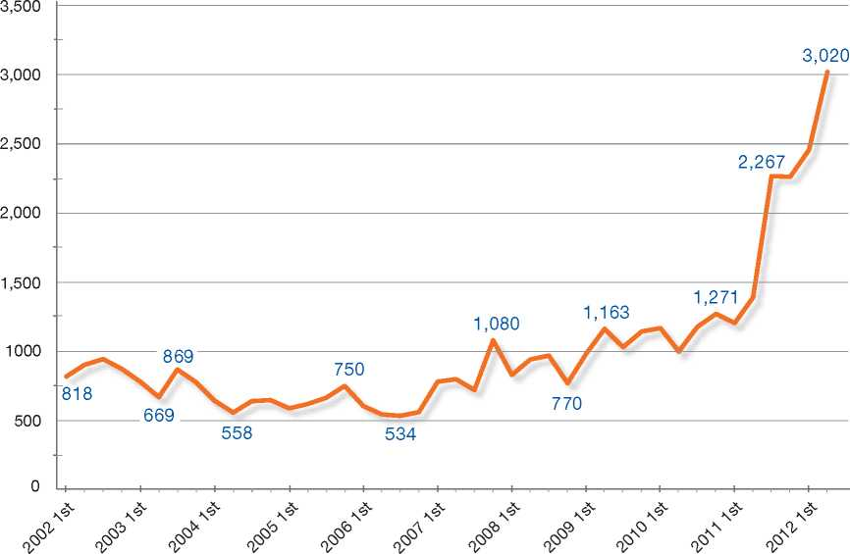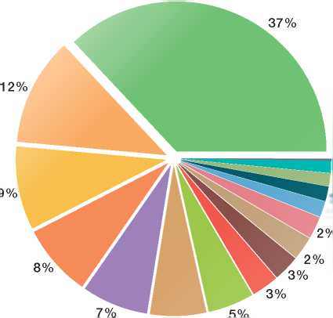

1,500

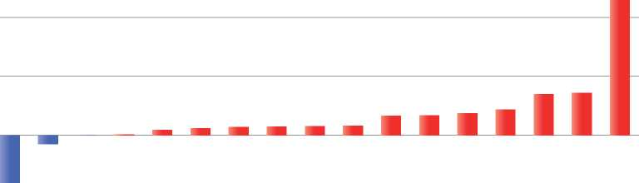

1,000

500

0

-500



**Evolution: |** | < -5 % ± 5 % | | > 5 %

|  |  |  |  |  |
| --- | --- | --- | --- | --- |
| **Receiving Country** | **Jan-Dec 2010** | **Jan-Dec 2011** | **Evolution** | **Evolution %** |
| **Germany** | 1,490 | 2,634 | 1,144 | 77% |
| **Switzerland** | 469 | 826 | 357 | 76% |
| **Sweden** | 421 | 640 | 219 | 52% |
| **Belgium** | 388 | 555 | 167 | 43% |
| **United Kingdom** | 160 | 508 | 348 | 217% |
| **Denmark** | 832 | 429 | -403 | -48% |
| **Greece** | 167 | 352 | 185 | 111% |
| **United States** | 43 | 206 | 163 | 379% |
| **Norway** | 119 | 198 | 79 | 66% |
| **Canada** | 119 | 176 | 57 | 48% |
| **Netherlands** | 125 | 168 | 43 | 34% |
| **France** | 195 | 119 | -76 | -39% |
| **Finland** | 41 | 110 | 69 | 168% |
| **Spain** | 19 | 97 | 78 | 411% |
| **Australia** | 22 | 95 | 73 | 332% |
| **Ireland** | 2 | 9 | 7 | 350% |
| **New Zealand** | 3 | 2 | -1 | -33% |
| **Grand Total** | **4,615** | **7,124** | **2,509** | **54%** |

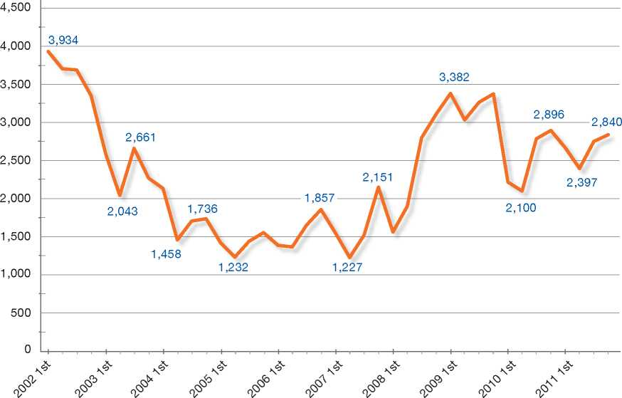

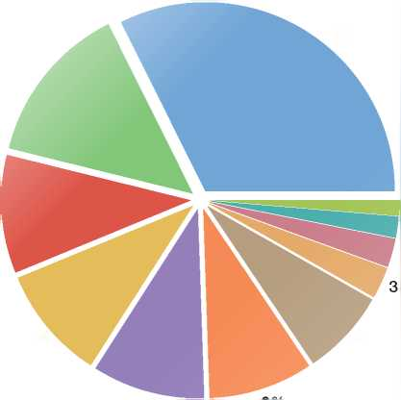7. Asylum Applications by Unaccompanied Minors in IGC Participating States15

**7.a: Evolution of Total Asylum Applications by Unaccompanied Minors in IGC Participating States By Quarter, 2002 - 2011**

**10%**

**14%**

**10%**

**32%**

**7%**

Receiving Country

| | United Kingdom

| | Sweden

| | Netherlands

| | Germany

| | Norway

| | Belgium

| | Switzerland

| | Finland

| | Denmark

| | France

| | Ireland

|  |  |  |  |  |  |  |  |  |  |  |
| --- | --- | --- | --- | --- | --- | --- | --- | --- | --- | --- |
| **Totals by Year** | | | | | | | | | | |
| **2002** | **2003** | **2004** | **2005** | **2006** | **2007** | **2008** | **2009** | **2010** | **2011** | **Total** |
| 14,683 | 9,567 | 7,034 | 5,646 | 6,262 | 6,444 | 9,367 | 13,057 | 10,000 | 10,655 | **92,715** |

**7.b: Distribution of Total Asylum Applications by Unaccompanied Minors in IGC Participating States, 2002 - 2011**

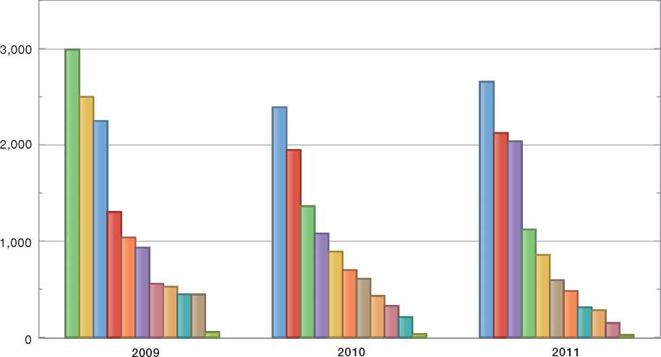

|  |  |  |  |  |
| --- | --- | --- | --- | --- |
| Receiving Country | | | | |
| Sweden | United Kingdom | □ | Germany | Norway |
| 1 Belgium | Netherlands |  | France | Denmark |
| Finland | Switzerland |  | Ireland |  |

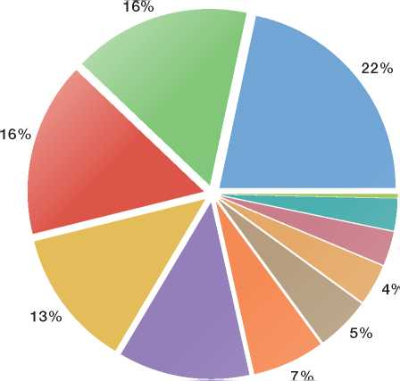

0%

3%

3%

12%

2009 - 2011

1. Due to rounding, the total of percentages in the pie chart is above 100%.

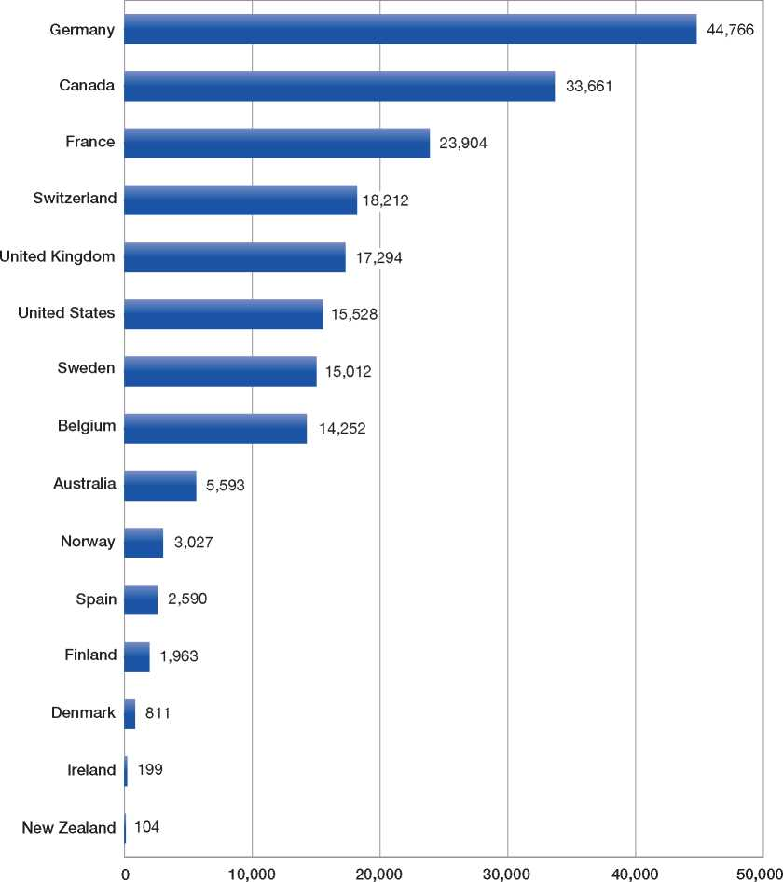

1. Australia: As at 30 September, there were 3,307 initial PV applications by non-IMAs on hand at the primary stage. While DIAC's systems cannot provide an exact figure, it is estimated that there were 2,286 initial PV applications by IMAs on hand at the primary stage at this time.

Belgium: 14,252 = 1,699 (Aliens Office) + 12,553 (CGRA) France: Excluding accompanied minors

9. Total First-Instance Asylum Decisions in IGC Participating States, Percentages by Category, 2011

|  |  |  |  |
| --- | --- | --- | --- |
| Australia | 42%  • | 0%  • | 58%  • |
| Belgium | 19%  • | 6% | 75%  • |
| Canada | 45%  • | 0%  • | 55%  • |
| Denmark | 22%  • | 11%  • | 67%  • |
| Finland | 5%  • | 35% | 60%  • |
| France | 8%  • | 3%  • | 89% |
| Germany | 21%  • | 8%  • | 71%  • |
| Greece | 2%  • | 3%  • | 95% |
| Ireland | 5%  • | 0%  • | 95% |

|  |  |  |  |
| --- | --- | --- | --- |
| Netherlands | 5%  • | 39%  • | 57%  • |
| New  Zealand | 25%  • | 0%  • | 75%  • |
| Norway | 29%  • | 13%  • | 58%  • |
|  |  |  | 98% |
| Spain | 0%  • | 2%  • | • |
| Sweden | 9%  • | 25%  • | 66%  • |
| Switzerland | 46%  • | 0%  • | 54%  • |
| United Kingdom | 24%  • | 7%  • | 68%  • |
| United States | 37%  • | 0%  • | 63%  • |

| | Geneva Convention Status

□

Subsidiary/Complementary Protection, Humanitarian Status

| | Rejections

10.a: Recognition Rate for All Countries of Origin (world map)

Geneva Convention Status

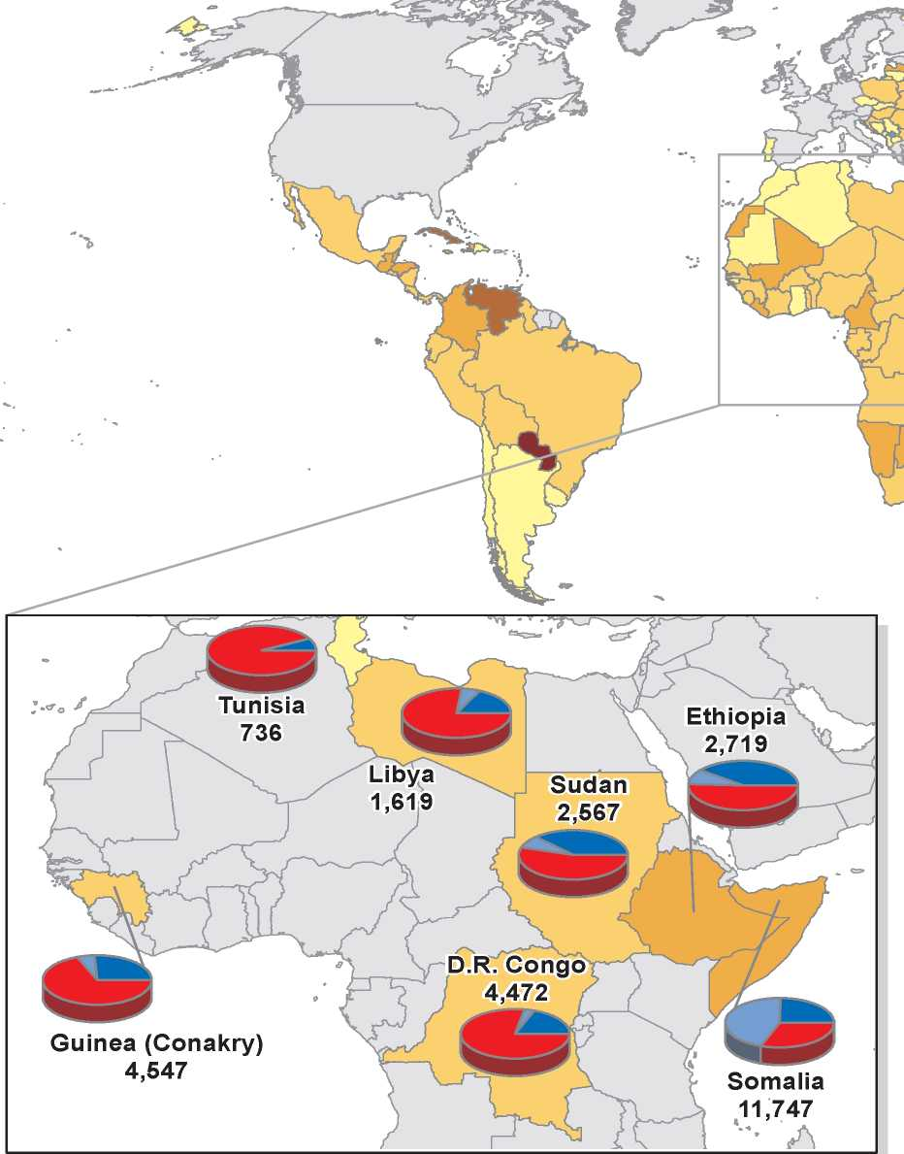

Rates, 2011

1. **b: Distribution by Category for Selected African and Asian Countries (frames)**

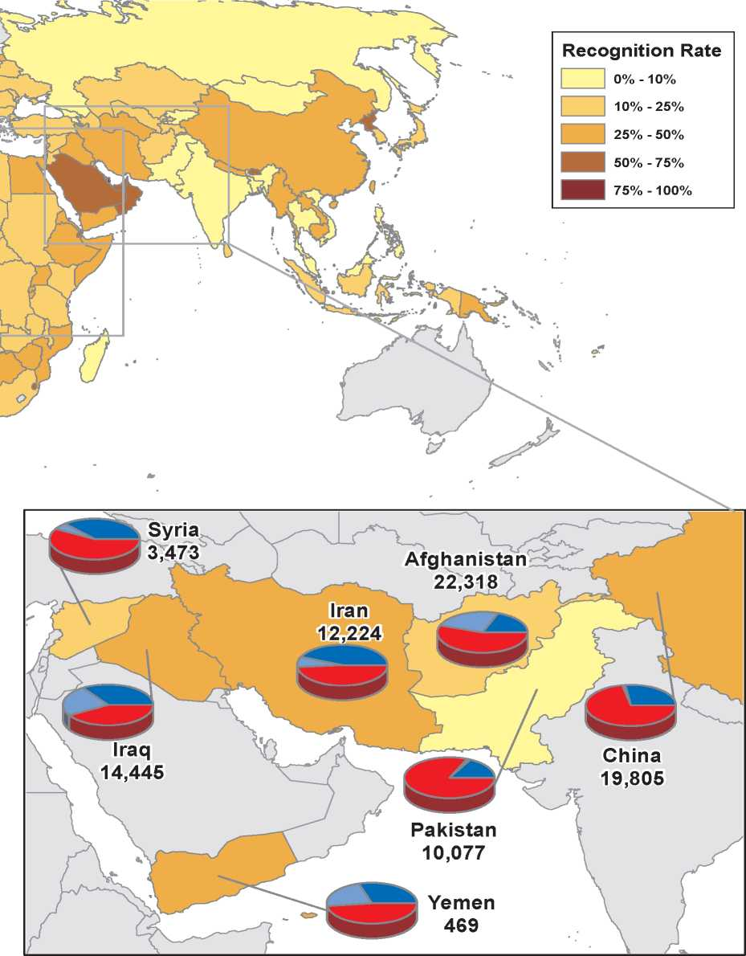



Protection, Humanitarian Status

Annexe 2

**Basic Instruments of International Refugee Law and Human Rights Law: Relevant Extracts**

1. 1948 Universal Declaration of Human Rights
2. 1950 Statute of the Office of the United Nations High Commissioner for Refugees
3. 1951 Convention Relating to the Status of Refugees
4. 1967 Protocol Relating to the Status of Refugees
5. 1954 United Nations Convention Against Torture and Other Cruel, Inhuman or Degrading Treatment or Punishment
6. 1954 Convention relating to the Status of Stateless Persons
7. 1961 Convention on the Reduction of Statelessness
8. 1966 International Covenant on Civil and Political Rights
9. 1989 Convention on the Rights of the Child
10. 1948 Universal Declaration of Human Rights

Article 13

1. Everyone has the right to freedom of movement and residence within the borders of each state.
2. Everyone has the right to leave any country, including his own, and to return to his country.

Article 14

(1) Everyone has the right to seek and to enjoy in other countries asylum from persecution.

(2) This right may not be invoked in the case of prosecutions genuinely arising from non-political crimes or from acts contrary to the purposes and principles of the United Nations.

1. 1950 Statute of the Office of the United Nations High Commissioner for Refugees

**CHAPTER I**

General Provisions

1. The United Nations High Commissioner for Refugees, acting under the authority of the General Assembly, shall assume the function of providing international protection, under the auspices of the United Nations, to refugees who fall within the scope of the present Statute and of seeking permanent solutions for the problem of refugees by assisting Governments and, subject to the approval of the Governments concerned, private organizations to facilitate the voluntary repatriation of such refugees, or their assimilation within new national communities.

In the exercise of his functions, more particularly when difficulties arise, and for instance with regard to any controversy concerning the international status of these persons, the High Commissioner shall request the opinion of the advisory committee on refugees if it is created.

**CHAPTER II**

Functions of the High Commissioner

6 . The competence of the High Commissioner shall extend to:

A. (i) Any person who has been considered a refugee under the Arrangements of 12 May 1926 and of 30 June 1928 or under the Conventions of 28 October 1933 and 10 February 1938, the Protocol of 14 September 1939 or the Constitution of the International Refugee Organization.

(ii) Any person who, as a result of events occurring before 1 January 1951 and owing to well-founded fear of being persecuted for reasons of race, religion, nationality or political opinion, is outside the country of his nationality and is unable or, owing to such fear or for reasons other than personal convenience, is unwilling to avail himself of the protection of that country; or who, not having a nationality and being outside the country of his former habitual residence, is unable or, owing to such fear or for reasons other than personal convenience, is unwilling to return to it.

The competence of the High Commissioner shall cease to apply to any person defined in section A above if:

1. He has voluntarily re-availed himself of the protection of the country of his nationality; or
2. Having lost his nationality, he has voluntarily re-acquired it; or
3. He has acquired a new nationality, and enjoys the protection of the country of his new nationality; or
4. He has voluntarily re-established himself in the country which he left or outside which he remained owing to fear of persecution; or
5. He can no longer, because the circumstances in connexion with which he has been recognized as a refugee have ceased to exist, claim grounds other than those of personal convenience for continuing to refuse to avail himself of the protection of the country of his nationality. Reasons of a purely economic character may not be invoked; or

(f ) Being a person who has no nationality, he can no longer, because the circumstances in connexion with which he has been recognized as a refugee have ceased to exist and he is able to return to the country of his former habitual residence, claim grounds other than those of personal convenience for continuing to refuse to return to that country;

B. Any other person who is outside the country of his nationality, or if he has no nationality, the country of his former habitual residence, because he has or had well-founded fear of persecution by reason of his race, religion, nationality or political opinion and is unable or, because of such fear, is unwilling to avail himself of the protection of the government of the country of his nationality, or, if he has no nationality, to return to the country of his former habitual residence.

7. Provided that the competence of the High Commissioner as defined in paragraph 6 above shall not extend to a person:

1. Who is a national of more than one country unless he satisfies the provisions of the preceding paragraph in relation to each of the countries of which he is a national; or
2. Who is recognized by the competent authorities of the country in which he has taken residence as having the rights and obligations which are attached to the possession of the nationality of that country; or
3. Who continues to receive from other organs or agencies of the United Nations protection or assistance; or
4. In respect of whom there are serious reasons for considering that he has committed a crime covered by the provisions of treaties of extradition or a crime mentioned in article VI of the London Charter of the International Military Tribunal or by the provisions of article 14, paragraph 2, of the Universal Declaration of Human Rights.
5. 1951 Convention Relating to the Status of Refugees

**Definition of the Term “Refugee”**

Article 1.A

For the purposes of the present Convention, the term “refugee” shall apply to any person who:

(1) Has been considered a refugee under the Arrangements of 12 May 1926 and 30 June 1928 or under the Conventions of 28 October 1933 and 10 February 1938, the Protocol of 14 September 1939 or the Constitution of the International Refugee Organization; Decisions of non-eligibility taken by the International Refugee Organization during the period of its activities shall not prevent the status of refugee being accorded to persons who fulfil the conditions of paragraph 2 of this section;

(2) As a result of events occurring before 1 January 1951 and owing to well-founded fear of being persecuted for reasons of race, religion, nationality, membership of a particular social group or political opinion, is outside the country of his nationality and is unable or, owing to such fear, is unwilling to avail himself of the protection of that country; or who, not having a nationality and being outside the country of his former habitual residence as a result of such events, is unable or, owing to such fear, is unwilling to return to it. In the case of a person who has more than one nationality, the term “the country of his nationality” shall mean each of the countries of which he is a national, and a person shall not be deemed to be lacking the protection of the country of his nationality if, without any valid reason based on well-founded fear, he has not availed himself of the protection of one of the countries of which he is a national.

**Cessation Clause**

Article 1.C

This Convention shall cease to apply shall cease to apply to any person falling under the terms of section A if:

(1) He has voluntarily re-availed himself of the protection of the country of his nationality; or

(2) Having lost his nationality, he has voluntarily re-acquired it, or

1. He has acquired a new nationality, and enjoys the protection of the country of his new nationality; or
2. He has voluntarily re-established himself in the country which he left or outside which he remained owing to fear of persecution; or
3. He can no longer, because the circumstances in connexion with which he has been recognized as a refugee have ceased to exist, continue to refuse to avail himself of the protection of the country of his nationality;

Provided that this paragraph shall not apply to a refugee falling under section A(1) of this article who is able to invoke compelling reasons arising out of previous persecution for refusing to avail himself of the protection of the country of nationality;

1. Being a person who has no nationality he is, because of the circumstances in connexion with which he has been recognized as a refugee have ceased to exist, able to return to the country of his former habitual residence;

Provided that this paragraph shall not apply to a refugee falling under section A (1) of this article who is able to invoke compelling reasons arising out of previous persecution for refusing to return to the country of his former habitual residence.

**Rights and Obligations of Nationality**

Article 1.E

This Convention shall not apply to a person who is recognized by the competent authorities of the country in which he has taken residence as having the rights and obligations which are attached to the possession of the nationality of that country.

**Exclusion Clause**

Article 1.F

The provisions of this Convention shall not apply to any person with respect to whom there are serious reasons for considering that:

1. he has committed a serious non-political crime outside the country of refuge prior to his admission to that country as a refugee;
2. he has been guilty of acts contrary to the purposes and principles of the United Nations.

**General obligations**

Article 2

Every refugee has duties to the country in which he finds himself, which require in particular that he conform to its laws and regulations as well as to measures taken for the maintenance of public order.

**Access to courts**

Article 16

1. A refugee shall have free access to the courts of law on the territory of all Contracting States.
2. A refugee shall enjoy in the Contracting State in which he has his habitual residence the same treatment as a national in matters pertaining to access to the courts, including legal assistance and exemption from cautio judicatum solvi.
3. A refugee shall be accorded in the matters referred to in paragraph 2 in countries other than that in which he has his habitual residence the treatment granted to a national of the country of his habitual residence.

**Refugees unlawfully in the country of refuge**

Article 31

1. The Contracting States shall not impose penalties, on account of their illegal entry or presence, on refugees who, coming directly from a territory where their life or freedom was threatened in the sense of article 1, enter or are present in their territory without authorization, provided they present themselves without delay to the authorities and show good cause for their illegal entry or presence.
2. The Contracting States shall not apply to the movements of such refugees restrictions other than those which are necessary and such restrictions shall only be applied until their status in the country is regularized or they obtain admission into another country. The Contracting States shall allow such refugees a reasonable period and all the necessary facilities to obtain admission into another country.

**Expulsion**

Article 32

1. The Contracting States shall not expel a refugee lawfully in their territory save on grounds of national security or public order.

1. The expulsion of such a refugee shall be only in pursuance of a decision reached in accordance with due process of law. Except where compelling reasons of national security otherwise require, the refugee shall be allowed to submit evidence to clear himself, and to appeal to and be represented for the purpose before competent authority or a person or persons specially designated by the competent authority.
2. The Contracting States shall allow such a refugee a reasonable period within which to seek legal admission into another country. The Contracting States reserve the right to apply during that period such internal measures as they may deem necessary.

**Prohibition of Expulsion or Return (“Refoulement”)**

Article 33(2)

1. No Contracting State shall expel or return (“refouler”) a refugee in any manner whatsoever to the frontiers of territories where his life or freedom would be threatened on account of his race, religion, nationality, membership of a particular social group or political opinion.

1. The benefit of the present provision may not, however, be claimed by a refugee whom there are reasonable grounds for regarding as a danger to the security of the country in which he is, or who, having been convicted by a final judgment of a particularly serious crime, constitutes a danger to the community of that country.

**Co-operation of the national authorities with the United Nations**

Article 35

1. The Contracting States undertake to co-operate with the Office of the United Nations High Commissioner for Refugees, or any other agency of the United Nations which may succeed it, in the exercise of its functions, and shall in particular facilitate its duty of supervising the application of the provisions of this Convention.

1. In order to enable the Office of the High Commissioner or any other agency of the United Nations which may succeed it, to make reports to the competent organs of the United Nations, the Contracting States undertake to provide them in the appropriate form with information and statistical data requested concerning:
2. The condition of refugees,
3. The implementation of this Convention, and
4. Laws, regulations and decrees which are, or may hereafter be, in force relating to refugees.
5. 1967 Protocol Relating to the Status of Refugees

**Article I**

General provision

1. The States Parties to the present Protocol undertake to apply articles 2 to 34 inclusive of the Convention to refugees as hereinafter defined.

2. For the purpose of the present Protocol, the term “refugee” shall, except as regards the application of paragraph 3 of this article, mean any person within the definition of article 1 of the Convention as if the words “As a result of events occurring before 1 January 1951 and ...” “and the words”... “a result of such events”, in article 1 A (2) were omitted.

1. The present Protocol shall be applied by the States Parties hereto without any geographic limitation, save that existing declarations made by States already Parties to the Convention in accordance with article 1 B (1) (a) of the Convention, shall, unless extended under article 1 B (2) thereof, apply also under the present Protocol.
2. 1954 United Nations Convention Against Torture and Other Cruel, Inhuman or Degrading Treatment or Punishment

Article 1

1. For the purposes of this Convention, torture means any act by which severe pain or suffering, whether physical or mental, is intentionally inflicted on a person for such purposes as obtaining from him or a third person information or a confession, punishing him for an act he or a third person has committed or is suspected of having committed, or intimidating or coercing him or a third person, or for any reason based on discrimination of any kind, when such pain or suffering is inflicted by or at the instigation of or with the consent or acquiescence of a public official or other person acting in an official capacity. It does not include pain or suffering arising only from, inherent in or incidental to lawful sanctions.

2. This article is without prejudice to any international instrument or national legislation which does or may contain provisions of wider application.

Article 3

No State Party shall expel, return (“refouler”) or extradite a person to another State where there are substantial grounds for believing that he would be in danger of being subjected to torture.

For the purpose of determining whether there are such grounds, the competent authorities shall take into account all relevant considerations including, where applicable, the existence in the State concerned of a consistent pattern of gross, flagrant or mass violations of human rights.

1. 1954 Convention relating to the Status of Stateless Persons

**Chapter I**

**GENERAL PROVISIONS**

Article 1. - Definition of the term “stateless person”

1. For the purpose of this Convention, the term “stateless person” means a person who is not considered as a national by any State under the operation of its law.

2. This Convention shall not apply:

1. To persons who are at present receiving from organs or agencies of the United Nations other than the United Nations High Commissioner for Refugees protection or assistance so long as they are receiving such protection or assistance;
2. To persons who are recognized by the competent authorities of the country in which they have taken residence as having the rights and obligations which are attached to the possession of the nationality of that country;
3. To persons with respect to whom there are serious reasons for considering that:

(b) They have committed a serious non-political crime outside the country of their residence prior to their admission to that country;

(c) They have been guilty of acts contrary to the purposes and principles of the United Nations.

Article 2. - General obligations

Every stateless person has duties to the country in which he finds himself, which require in particular that he conform to its laws and regulations as well as to measures taken for the maintenance of public order.

1. 1961 Convention on the Reduction of Statelessness

Article 1

1. A Contracting State shall grant its nationality to a person born in its territory who would otherwise be stateless. Such nationality shall be granted:

1. at birth, by operation of law, or
2. upon an application being lodged with the appropriate authority, by or on behalf of the person concerned, in the manner prescribed by the national law. Subject to the provisions of paragraph 2 of this article, no such application may be rejected.

A Contracting State which provides for the grant of its nationality in accordance with subparagraph (b) of this paragraph may also provide for the grant of its nationality by operation of law at such age and subject to such conditions as may be prescribed by the national law.

2. A Contracting State may make the grant of its nationality in accordance with subparagraph (b) of paragraph 1 of this article subject to one or more of the following conditions:

1. that the application is lodged during a period, fixed by the Contracting State, beginning not later than at the age of eighteen years and ending not earlier than at the age of twenty-one years, so, however, that the person concerned shall be allowed at least one year during which he may himself make the application without having to obtain legal authorization to do so;
2. that the person concerned has habitually resided in the territory of the Contracting State for such period as may be fixed by that State, not exceeding five years immediately preceding the lodging of the application nor ten years in all;
3. that the person concerned has neither been convicted of an offence against national security nor has been sentenced to imprisonment for a term of five years or more on a criminal charge;
4. that the person concerned has always been stateless.
5. Notwithstanding the provisions of paragraphs 1 (b) and 2 of this article, a child born in wedlock in the territory of a Contracting State, whose mother has the nationality of that State, shall acquire at birth that nationality if it otherwise would be stateless.
6. A Contracting State shall grant its nationality to a person who would otherwise be stateless and who is unable to acquire the nationality of the Contracting State in whose territory he was born because he had passed the age for lodging his application or has not fulfilled the required residence conditions, if the nationality of one of his parents at the time of the person's birth was that of the Contracting State first above mentioned. If his parents did not possess the same nationality at the time of his birth, the question whether the nationality of the person concerned should follow that of the father or that of the mother shall be determined by the national law of such Contracting State. If application for such nationality is required, the application shall be made to the appropriate authority by or on behalf of the applicant in the manner prescribed by the national law. Subject to the provisions of paragraph 5 of this article, such application shall not be refused.
7. The Contracting State may make the grant of its nationality in accordance with the provisions of paragraph 4 of this article subject to one or more of the following conditions:

(a) that the application is lodged before the applicant reaches an age, being not less than twenty-three years, fixed by the Contracting State;

(b) that the person concerned has habitually resided in the territory of the Contracting State for such period immediately preceding the lodging of the application, not exceeding three years, as may be fixed by that State;

1. that the person concerned has always been stateless.
2. 1966 International Covenant on Civil and Political Rights

**PART III**

Article 6

1. Every human being has the inherent right to life. This right shall be protected by law. No one shall be arbitrarily deprived of his life.

2. In countries which have not abolished the death penalty, sentence of death may be imposed only for the most serious crimes in accordance with the law in force at the time of the commission of the crime and not contrary to the provisions of the present Covenant and to the Convention on the Prevention and Punishment of the Crime of Genocide. This penalty can only be carried out pursuant to a final judgement rendered by a competent court.

1. When deprivation of life constitutes the crime of genocide, it is understood that nothing in this article shall authorize any State Party to the present Covenant to derogate in any way from any obligation assumed under the provisions of the Convention on the Prevention and Punishment of the Crime of Genocide.
2. Anyone sentenced to death shall have the right to seek pardon or commutation of the sentence. Amnesty, pardon or commutation of the sentence of death may be granted in all cases.
3. Sentence of death shall not be imposed for crimes committed by persons below eighteen years of age and shall not be carried out on pregnant women.
4. Nothing in this article shall be invoked to delay or to prevent the abolition of capital punishment by any State Party to the present Covenant.

Article 7

No one shall be subjected to torture or to cruel, inhuman or degrading treatment or punishment. In particular, no one shall be subjected without his free consent to medical or scientific experimentation.

1. 1989 Convention on the Rights of the Child

Article 1

For the purposes of the present Convention, a child means every human being below the age of eighteen years unless under the law applicable to the child, majority is attained earlier.

Article 2

1. States Parties shall respect and ensure the rights set forth in the present Convention to each child within their jurisdiction without discrimination of any kind, irrespective of the child's or his or her parent's or legal guardian's race, colour, sex, language, religion, political or other opinion, national, ethnic or social origin, property, disability, birth or other status.

2. States Parties shall take all appropriate measures to ensure that the child is protected against all forms of discrimination or punishment on the basis of the status, activities, expressed opinions, or beliefs of the child's parents, legal guardians, or family members.

Annexe 3

**Selected UNHCR Executive Committee Conclusions on International Protection**

1. Conclusion No.8 (XXVIII-1977) - Determination of Refugee Status
2. Conclusion No. 15 (XXX- 1979) - Refugees without an Asylum Country
3. Conclusion No. 28 (XXXIII- 1982) - Follow-up on Earlier Conclusions of the Sub-Committee of the Whole on International Protection on the Determination of Refugee Status, Inter Alia, with Reference to the Role of UNHCR in National Refugee Status Determination Procedures
4. Conclusion No. 30 (XXXIV - 1983) - The Problem of Manifestly Unfounded or Abusive Applications for Refugee Status or Asylum
5. Conclusion No. 58 (XL - 1989) - Problem of Refugees and Asylum­Seekers Who Move in an Irregular Manner from a Country in Which They Had Already Found Protection
6. Conclusion No. 81 (XLVIII) - 1997 - General Conclusion on International Protection (Extract)
7. Conclusion No. 82 (XLVIII) - 1997- Safeguarding Asylum (Extracts)

1. Conclusion No.8 (XXVIII-1977) - Determination of Refugee Status

The Executive Committee,

1. Noted the report of the High Commissioner concerning the importance of procedures for determining refugee status;
2. Noted that only a limited number of States parties to the 1951 Convention and the 1967 Protocol had established procedures for the formal determination of refugee status under these instruments;
3. Noted, however, with satisfaction that the establishment of such procedures was under active consideration by a number of Governments;
4. Expressed the hope that all Governments parties to the 1951 Convention and the 1967 Protocol which had not yet done so would take steps to establish such procedures in the near future and give favourable consideration to UNHCR participation in such procedures in appropriate form;
5. Recommended that procedures for the determination of refugee status should satisfy the following basic requirements:
6. The competent official (e.g. immigration officer or border police officer) to whom the applicant addresses himself at the border or in the territory of a Contracting State, should have clear instructions for dealing with cases which might me within the purview of the relevant international instruments. He should be required to act in accordance with the principle of non-refoulement and to refer such cases to a higher authority.
7. The applicant should receive the necessary guidance as to the procedure to be followed.
8. There should be a clearly identified authority - wherever possible a single central authority - with responsibility for examining requests for refugee status and taking a decision in the first instance.
9. The applicant should be given the necessary facilities, including the services of a competent interpreter, for submitting his case to the authorities concerned. Applicants should also be given the opportunity, of which they should be duly informed, to contact a representative of UNHCR.
10. If the applicant is recognized as a refugee, he should be informed accordingly and issued with documentation certifying his refugee status.
11. If the applicant is not recognized, he should be given a reasonable time to appeal for a formal reconsideration of the decision, either to the same or to a different authority, whether administrative or judicial, according to the prevailing stem.
12. The applicant should be permitted to remain in the country pending a decision on his initial request by the competent authority referred to in paragraph (iii) above, unless it has been established by that authority that his request is clearly abusive. He should also be permitted to remain in the country while an appeal to a higher administrative authority or to the courts is pending.
13. Requested UNHCR to prepare, after due consideration of the opinions of States parties to the 1951 Convention and the 1967 Protocol, a detailed study on the question of the extra-territorial effect of determination of refugee status in order to enable the Committee to take a considered view on the matter at a subsequent session taking into account the opinion expressed by representatives that the acceptance by a Contracting State of refugee status as determined by other States parties to these instruments would be generally desirable;
14. Requested the Office to consider the possibility of issuing-for the guidance of Governments-a handbook relating to procedures and criteria for determining refugee status and circulating -- with due regard to the confidential nature of individual requests and the particular situations involved -- significant decisions on the determination of refugee status.
15. Conclusion No. 15 (XXX- 1979) - Refugees without an Asylum Country

The Executive Committee,

Considered that States should be guided by the following considerations:

General principles

1. States should use their best endeavours to grant asylum to bona fide asylum-seekers;
2. Action whereby a refugee is obliged to return or is sent to a country where he has reason to fear persecution constitutes a grave violation of the recognized principle of non-refoulement;
3. It is the humanitarian obligation of all coastal States to allow vessels in distress to seek haven in their waters and to grant asylum, or at least temporary refuge, to persons on board wishing to seek asylum;
4. Decisions by States with regard to the granting of asylum shall be made without discrimination as to race, religion, political opinion, nationality or country of origin;
5. In the interest of family reunification and for humanitarian reasons, States should facilitate the admission to their territory of at least the spouse and minor or dependent children of any person to whom temporary refuge or durable asylum has been granted;

Situations involving a large-scale influx of asylum-seekers

1. In cases of large-scale influx, persons seeking asylum should always receive at least temporary refuge. States which because of their geographical situation, or otherwise, are faced with a large-scale influx should as necessary and at the request of the State concerned receive immediate assistance from other States in accordance with the principle of equitable burden-sharing. Such States should consult with the Office of the United Nations High Commissioner for Refugees as soon as possible to ensure that the persons involved are fully protected, are given emergency assistance, and that durable solutions are sought;
2. Other States should take appropriate measures individually, jointly or through the Office of the United Nations High Commissioner for Refugees or other international bodies to ensure that the burden of the first asylum country is equitably shared;

Situations involving individual asylum-seekers

1. An effort should be made to resolve the problem of identifying the country responsible for examining an asylum request by the adoption of common criteria. In elaborating such criteria the following principles should be observed:
2. The criteria should make it possible to identify in a positive manner the country which is responsible for examining an asylum request and to whose authorities the asylum-seeker should have the possibility of addressing himself;
3. The criteria should be of such a character as to avoid possible disagreement between States as to which of them should be responsible for examining an asylum request and should take into account the duration and nature of any sojourn of the asylum-seeker in other countries;
4. The intentions of the asylum-seeker as regards the country in which he wishes to request asylum should as far as possible be taken into account;
5. Regard should be had to the concept that asylum should not be refused solely on the ground that it could be sought from another State. Where, however, it appears that a person, before requesting asylum, already has a connection or close links with another State, he may if it appears fair and reasonable be called upon first to request asylum from that State;
6. Reestablishment of criteria should be accompanied by arrangements for regular consultation between concerned Governments for dealing with cases for which no solution has been found and for consultation with the Office of the United Nations High Commissioner for Refugees as appropriate;
7. Agreements providing for the return by States of persons who have entered their territory from another contracting State in an unlawful manner should be applied in respect of asylum-seekers with due regard to their special situation.
8. While asylum-seekers may be required to submit their asylum request within a certain time limit, failure to do so, or the non-fulfilment of other formal requirements, should not lead to an asylum request being excluded from consideration;
9. In line with the recommendation adopted by the Executive Committee at its twenty-eighth session (document A/AC.96/549, paragraph 53(6), (E) (i)), where an asylum-seeker addresses himself in the first instance to a frontier authority the latter should not reject his application without reference to a central authority;
10. Where a refugee who has already been granted asylum in one country requests asylum in another country on the ground that he has compelling reasons for leaving his present asylum country due to fear of persecution or because his physical safety or freedom are endangered, the authorities of the second country should give favourable consideration to his asylum request;
11. States should give favourable consideration to accepting, at the request of the Office of the United Nations High Commissioner for Refugees, a limited number of refugees who cannot find asylum in any country;
12. States should pay particular attention to the need for avoiding situations in which a refugee loses his right to reside in or to return to his country of asylum without having acquired the possibility of taking up residence in a country other than one where he may have reasons to fear persecution;
13. In line with the purpose of paragraphs 6 and 11 of the Schedule to the 1951 Convention, States should continue to extend the validity of or to renew refugee travel documents until the refugee has taken up lawful residence in the territory of another State. A similar practice should as far as possible also be applied in respect of refugees holding a travel document other than that provided for in the 1951 Convention.
14. **Conclusion No. 28 (XXXIII- 1982) - Follow-up on Earlier Conclusions of the Sub-Committee of the Whole on International Protection on the Determination of Refugee Status, inter alia, with Reference to the Role of UNHCR in National Refugee Status Determination Procedures**

The Executive Committee,

1. Considered the report of the High Commissioner on the progress made in regard to the determination of refugee status (EC/SCP/22/Rev.1);
2. Noted with satisfaction that since the twenty-eighth session of the Executive Committee procedures for the determination of refugee status have been established by a further significant number of States
3. Reiterated the importance of the establishment of procedures for determining refugee status and urged those States Parties to the 1951 Convention and the 1967 Protocol which had not yet done so to establish such procedures in the near future;
4. Recognized the need for measures to meet the problem of manifestly unfounded or abusive applications for refugee status. A decision that an application is manifestly unfounded or abusive should only be taken by or after reference to the authority competent to determine refugee status. Consideration should be given to the establishment of procedural safeguards to ensure that such decisions are taken only if the application is fraudulent or not related to the criteria for the granting of refugee status laid down in the 1951 United Nations Convention relating to the Status of Refugees. In view of its importance, the question of manifestly unfounded or abusive applications for refugee status should be further examined by the Sub-Committee at its next meeting, as a separate item on its agenda and on the basis of a study to be prepared by UNHCR;
5. Noted with satisfaction the participation in various forms of UNHCR in procedures for determining refugee status in a large number of countries and recognized the value of UNHCR thus being given a meaningful role in such procedures.
6. Conclusion No. 30 (XXXIV - 1983) - The Problem of Manifestly Unfounded or Abusive Applications for Refugee Status or Asylum

The Executive Committee,

1. Recalled Conclusion No. 8 (XXVIII) adopted at its twenty-eighth session on the Determination of Refugee Status and Conclusion No. 15 (XXX) adopted at its thirtieth session concerning Refugees without an Asylum Country;
2. Recalled Conclusion No. 28 (XXXIII) adopted at its thirty-third session in which the need for measures to meet the problem of manifestly unfounded or abusive applications for refugee status was recognized;
3. Noted that applications for refugee status by persons who clearly have no valid claim to be considered refugees under the relevant criteria constitute a serious problem in a number of States parties to the 1951 Convention and the 1967 Protocol. Such applications are burdensome to the affected countries and detrimental to the interests of those applicants who have good grounds for requesting recognition as refugees;
4. Considered that national procedures for the determination of refugee status may usefully include special provision for dealing in an expeditious manner with applications which are considered to be so obviously without foundation as not to merit full examination at every level of the procedure. Such applications have been termed either “clearly abusive” or “manifestly unfounded” and are to be defined as those which are clearly fraudulent or not related to the criteria for the granting of refugee status laid down in the 1951 United Nations Convention relating to the Status of Refugees nor to any other criteria justifying the granting of asylum;
5. Recognized the substantive character of a decision that an application for refugee status is manifestly unfounded or abusive, the grave consequences of an erroneous determination for the applicant and the resulting need for such a decision to be accompanied by appropriate procedural guarantees and therefore recommended that:

(i) as in the case of all requests for the determination of refugee status or the grant of asylum, the applicant should be given a complete personal interview by a fully qualified official and, whenever possible, by an official of the authority competent to determine refugee status;

1. the manifestly unfounded or abusive character of an application should be established by the authority normally competent to determine refugee status;
2. an unsuccessful applicant should be enabled to have a negative decision reviewed before rejection at the frontier or forcible removal from the territory. Where arrangements for such a review do not exist, governments should give favourable consideration to their establishment. This review possibility can be more simplified than that available in the case of rejected applications which are not considered manifestly unfounded or abusive.
3. Recognized that while measures to deal with manifestly un-founded or abusive applications may not resolve the wider problem of large numbers of applications for refugee status, both problems can be mitigated by overall arrangements for speeding up refugee status determination procedures, for example by:

(i) allocating sufficient personnel and resources to refugee status determination bodies so as to enable them to accomplish their task expeditiously, and

(ii) the introduction of measures that would reduce the time required for the completion of the appeals process.

1. Conclusion No. 58 (XL - 1989) - Problem of Refugees and Asylum-Seekers Who Move in an Irregular Manner from a Country in Which They Had Already Found Protection
2. The phenomenon of refugees, whether they have been formally identified as such or not (asylum-seekers), who move in an irregular manner from countries in which they have already found protection, in order to seek asylum or permanent resettlement elsewhere, is a matter of growing concern. This concern results from the destabilizing effect which irregular movements of this kind have on structured international efforts to provide appropriate solutions for refugees. Such irregular movements involve entry into the territory of another country, without the prior consent of the national authorities or without an entry visa, or with no or insufficient documentation normally required for travel purposes, or with false or fraudulent documentation. Of similar concern is the growing phenomenon of refugees and asylum-seekers who wilfully destroy or dispose of their documentation in order to mislead the authorities of the country of arrival;
3. Irregular movements of refugees and asylum-seekers who have already found protection in a country are, to a large extent, composed of persons who feel impelled to leave, due to the absence of educational and employment possibilities and the non-availability of long-term durable solutions by way of voluntary repatriation, local integration and resettlement;
4. The phenomenon of such irregular movements can only be effectively met through concerted action by governments, in consultation with UNHCR, aimed at:
5. identifying the causes and scope of irregular movements in any given refugee situation,
6. removing or mitigating the causes of such irregular movements through the granting and maintenance of asylum and the provision of necessary durable solutions or other appropriate assistance measures,
7. encouraging the establishment of appropriate arrangements for the identification of refugees in the countries concerned and,
8. ensuring humane treatment for refugees and asylum-seekers who, because of the uncertain situation in which they find themselves, feel impelled to move from one country to another in an irregular manner;
9. Within this framework, governments, in close co-operation with UNHCR, should

i) seek to promote the establishment of appropriate measures for the care and support of refugees and asylum-seekers in countries where they have found protection pending the identification of a durable solution and

ii) promote appropriate durable solutions with particular emphasis firstly on voluntary repatriation and, when this is not possible, local integration and the provision of adequate resettlement opportunities;

1. Refugees and asylum-seekers, who have found protection in a particular country, should normally not move from that country in an irregular manner in order to find durable solutions elsewhere but should take advantage of durable solutions available in that country through action taken by governments and UNHCR as recommended in paragraphs (c) and (d) above;
2. Where refugees and asylum-seekers nevertheless move in an irregular manner from a country where they have already found protection, they may be returned to that country if

i) they are protected there against refoulement and

ii) they are permitted to remain there and to be treated in accordance with recognized basic human standards until a durable solution is found for them. Where such return is envisaged, UNHCR may be requested to assist in arrangements for the re-admission and reception of the persons concerned;

1. In is recognized that there may be exceptional cases in which a refugee or asylum-seeker may justifiably claim that he has reason to fear persecution or that his physical safety or freedom are endangered in a country where he previously found protection. Such cases should be given favourable consideration by the authorities of the State where he requests asylum;
2. The problem of irregular movements is compounded by the use, by a growing number of refugees and asylum-seekers, of fraudulent documentation and their practice of wilfully destroying or disposing of travel and/or other documents in order to mislead the authorities of their country of arrival. These practices complicate the personal identification of the person concerned and the determination of the country where he stayed prior to arrival, and the nature and duration of his stay in such a country. Practices of this kind are fraudulent and may weaken the case of the person concerned;
3. In is recognized that circumstances may compel a refugee or asylum-seeker to have recourse to fraudulent documentation when leaving a country in which his physical safety or freedom are endangered. Where no such compelling circumstances exist, the use of fraudulent documentation is unjustified;
4. The wilful destruction or disposal of travel or other documents by refugees and asylum-seekers upon arrival in their country of destination, in order to mislead the national authorities as to their previous stay in another country where they have protection, is unacceptable. Appropriate arrangements should be made by States, either individually or in co-operation with other States, to deal with this growing phenomenon.
5. Conclusion No. 81 (XLVIII) - 1997 - General Conclusion on International Protection (Extract)

The Executive Committee,

1. Reaffirms Conclusion No. 80 (XLVIII), and notes that a comprehensive approach to refugee protection comprises, *inter alia*, respect for all human rights; the principle of *non-refoulement*; access, consistent with the 1951 Convention and the 1967 Protocol, of all asylum-seekers to fair and effective procedures for determining status and protection needs; no rejection at frontiers without the application of these procedures; asylum; the provision of any necessary material assistance; and the identification of durable solutions which recognize human dignity and worth;

*Asylum Procedures: Report on Policies and Practices in IGC Participating States* takes its inspiration from the Report on Asylum Procedures, which the IGC Secretariat published in 2009.

In the last three years, the legal and procedural framework for asylum determination has been the subject of important reform and development in IGC States. While the number of asylum claims has fluctuated, Participating States have continued to pursue a common goal of enhancing the quality, efficiency and integrity of asylum procedures. Against the backdrop of the establishment of a common asylum system in the European Union and greater efforts at practical cooperation and information exchange across the continents, IGC States have taken similar approaches to attaining their goal.

The Asylum Procedures report contains 17 standardised country chapters that aim to facilitate a quick comparison of policies and practices while also providing a comprehensive picture of asylum determination from entry to appeal. Complementary information on pre-entry measures, decision­making, reception, return and integration is also presented. The report is supplemented by statistical data on applications, top countries of origin and decisions, and by extracts of relevant international human rights and refugee law provisions.

With information sourced directly from governments, the report provides an authoritative account of asylum procedures as they are practised in IGC States today.

**ISBN 978-2-8399-1184-9**

j : g C ' Cl 1 iOl" S

on migration, asylum and refugees

Rue de Vermont 37-39, 1202 Geneva, Switzerland  
[info@igc-publications.ch](mailto:info@igc-publications.ch) / [www.igc-publications.ch](http://www.igc-publications.ch)

1. Based on *International Migration Law: Glossary on Migration,* International Organization for Migration (IOM) (2004) and *Master Glossary of Terms,* United Nations High Commissioner for Refugees (UNHCR) (June 2006), unless otherwise indicated.
2. *Black's Law Dictionary with Pronunciations,* fifth edition, 1979.
3. Austrian Red Cross/ ACCORD, *Researching Country of Origin Information: A Training Manual, Part 1*, 2004 (updated April 2006), available online at: <http://www.coi-training.net/content/doc/en-COI%20Manual%20Part%20I%20plus%20Annex%2020060426.pdf>.
4. *Black's Law Dictionary with Pronunciations,* fifth edition, 1979.
5. UNESCO, *People on the Move: Handbook of Selected Terms and Concepts,* July 2008.
6. *Black's Law Dictionary with Pronunciations,* fifth edition, 1979.
7. European Migration Network (EMN), *Glossary of Terms relating to Asylum and Migration,* available online at : <http://emn.intrasoft-intl.com/Glossary/index.do>.
8. UNESCO & The Hague Process, *People on the Move: Handbook of Selected Terms and Concepts,* July 2008.
9. Australia: no data until 1989; Finland: no data until 1985; Greece: no data until 2006; New Zealand: no data until 1997.
10. LGBTI stands for lesbian, gay, bisexual, transgender and intersex.
11. Since 1945 the department's functions and responsibilities have changed several times: Department of Immigration (DI) (1945-1974); Department of Labour and Immigration (DLI) (1974 - 1975); Department of Immigration and Ethnic Affairs (DIEA) (1976 - 1987); Department of Immigration, Local Government and Ethnic Affairs (DILGEA) (1987 - 1993); Department of Immigration and Ethnic Affairs (DIEA) (1993 - 1996); Department of Immigration and Multicultural Affairs (DIMA) (1996 - 2001); Department of Immigration, Multicultural and Indigenous Affairs (DIMIA) (2001 - 2006); Department of Immigration and Multicultural Affairs (DIMA) (2006 - 2007); Department of Immigration and Citizenship (DIAC) (2007 - present).
12. In 2001, the following places were excised: the Ashmore and Cartier Islands, Christmas Island, Cocos (Keeling) Islands and Australian offshore resource and sea installations. From 22 July 2005, further territories were excised which included: all islands that form part of Queensland and are north of latitude 21° south, all islands that form part of the Northern Territory and are north of latitude 16° south, all islands that form part of Western Australia and are north of latitude 23° south, and the Coral Sea Islands Territory. See section 5.3.3 for more information about Excision.
13. See section 2.2 on Recent/Pending Reforms.
14. <http://www.immi.gov.au>.
15. Applications for persons in the Middle East and parts of South-West Asia (Afghanistan, Bahrain, Iran, Iraq, Jordan, Kuwait, Lebanon, Oman, Pakistan, Qatar, Saudi Arabia, Syria, Turkey, United Arab Emirates and Yemen) are made at the DIAC Melbourne office, while applications from Africa and the rest of the world are made at the DIAC Sydney office.
16. The specific class of BV that a PV applicant will be eligible for depends on their immigration status at the time they apply for a PV. Depending on their status and immigration history, they will either be eligible for work rights or can gain access to work rights, if they can demonstrate a compelling need to work and, in some cases, an acceptable reason for delay in making the protection visa application. Generally, applicants with access to work rights can also get access to publicly funded national health care. The Bridging Visa granted in association with the protection visa application will allow them to remain lawfully in the community until the PV application is finally determined. A further Bridging Visa can be granted to clients who seek judicial review.
17. See section 5.3 on Repeat/Subsequent Applications.
18. See also the section above on Admissibility.
19. These laws were introduced to strengthen Australia's territorial integrity, reduce instances of people entering Australia by means of hazardous sea or air voyages and without a visa that is in effect, and deter the activities of people smugglers. Excised offshore places are still under Australian jurisdiction and sovereignty and the Migration Act continues to apply in these places in all other respects.
20. Immediate family members eligible for reunification must be presented within five years of the granting of the PV and may include a spouse, a dependent child under 18 years of age, and a parent of the PV holder.
21. PIC 4002 refers to the Public Interest Criterion that outlines the interpretation of, and procedures for, assessing visa applicants against security requirements. Further reference to legal developments regarding PIC 4002 can be found in the section below on Return: Freedom of Movement/Detention.
22. These IMAs will be eligible for ASAS.
23. For the purpose of this exercise, positive decisions include decisions to grant Convention status, subsidiary/complementary protection, and other humanitarian status.
24. Excluding withdrawn, closed and abandoned claims.
25. For the purpose of this exercise, positive decisions include decisions to grant Convention status, subsidiary/complementary protection, and other humanitarian status.
26. Excluding withdrawn, closed and abandoned claims.
27. For the purpose of this exercise, positive decisions include decisions to grant Convention status, subsidiary/complementary protection, and other humanitarian status.
28. Excluding withdrawn, closed and abandoned claims.
29. Accompanied minor dependants are not included.
30. Accompanied minor dependants are not included.
31. The Aliens Act is currently only available in French and Dutch at the following links on the website of the Immigration Department: <https://dofi.ibz.be/sites/dvzoe/FR/Documents/19801215_F.pdf> (French) and <https://dofi.ibz.be/sites/dvzoe/NL/Documents/19801215_n.pdf> (Dutch).
32. Council Directive 20003/9/EC of 27 January 2003 laying down minimum standards for the reception of asylum­seekers (Reception Directive).
33. <http://www.cgvs.be/en/Publications/brochures>.
34. Council Regulation (EC) No. 343/2003 of 18 February 2003 establishing the criteria and mechanisms for determining the Member State responsible for examining an asylum application lodged in one of the Member States by a third- country national (Dublin II Regulation).
35. See the section on Repeat Applications.
36. Protocol on Asylum for Nationals of Member States of the European Union (Page 103 of the Treaty of Amsterdam), annexed to the Treaty of Amsterdam, which was signed on 2 October 1997 and came into force on 1 May 1999.
37. Council Directive 2001/55/EC of 20 July 2001 on minimum standards for giving temporary protection in the event of a mass influx of displaced persons and on measures promoting a balance of efforts between Member States in receiving such persons and bearing the consequences thereof (Temporary Protection Directive).
38. Adding 1,699 files still pending at the Immigration Department, the total number of pending asylum cases as at 30 September 2012 equals 14,252 files.
39. One of the centres provides for a stay of between one and four months.
40. Accompanied minor dependants are not included.
41. First instance decision data for 2009-2011 are rounded to the nearest five.
42. For the purpose of this exercise, positive decisions include decisions to grant Convention status, subsidiary/complementary protection, and other humanitarian status.
43. First instance decision data for 2009-2011 are rounded to the nearest five.
44. For the purpose of this exercise, positive decisions include decisions to grant Convention status, subsidiary/complementary protection, and other humanitarian status.
45. First instance decision data for 2009-2011 are rounded to the nearest five.
46. For the purpose of this exercise, positive decisions include decisions to grant Convention status, subsidiary/complementary protection, and other humanitarian status.
47. First instance decision data for 2009-2011 are rounded to the nearest five.
48. *Singh v. Minister of Employment and Immigration [1985]* 1 S.C.R. 177.
49. See the section on Unaccompanied Minors for more information on the guidelines.
50. For more details on the DCO policy, see section 5.2.1 on Safe Countries of Origin.
51. Under PCISA and in an effort to combat human smugglers, the Minister of Public Safety can designate the arrival of a group of individuals who enter or attempted to enter Canada in violation of immigration laws as such. Persons falling under this designation are subject to different rules.
52. The designation of the U.S. as a “safe third country” was challenged in the Federal Court of Canada by three non­governmental organisations (NGOs) and an anonymous asylum-seeker in the U.S. While the Federal Court ruled that the designation was invalid, the Federal Court of Appeal overturned that ruling, finding that the designation of the U.S. as a safe third country was not outside the authority of the Government and that the STCA between Canada and the U.S. was not illegal. On 5 February 2009, the Supreme Court of Canada declined to grant leave to the NGO and individual challengers to hear an appeal of the Federal Court of Appeal decision.
53. The STCA defines a family member as a spouse or common­law partner, legal guardian, parent, sibling, grandparent, uncle/aunt, or nephew/niece.
54. A representative can be a lawyer, an immigration consultant, a trusted advisor or a family member.
55. See the Safe Third Country Agreement section above for further detail.
56. The guidelines can be found at [http://www.irb-cisr.gc.ca/eng/brdcom/references/pol/guidir/](http://www.irb-cisr.gc.ca/eng/brdcom/references/pol/guidir/Pages/GuideDir3.aspx) Pages/GuideDir3.aspx
57. A person who is excluded from refugee protection is also inadmissible to Canada and his or her claim will not be referred to the IRB. However, refugee claims of other inadmissible persons may be referred to the IRB based on the type of inadmissibility. In other words, an excluded person is also inadmissible to Canada but an inadmissible person is not necessarily excluded from refugee protection.
58. *Suresh v. Canada (Minister of Citizenship and Immigration), 2002.*
59. See the next section for more information on the TRP.
60. For the purpose of this exercise, positive decisions include decisions to grant Convention status, subsidiary/complementary protection, and other humanitarian status.
61. Excluding withdrawn, closed and abandoned claims.
62. For the purpose of this exercise, positive decisions include decisions to grant Convention status, subsidiary/complementary protection, and other humanitarian status.
63. Excluding withdrawn, closed and abandoned claims.
64. For the purpose of this exercise, positive decisions include decisions to grant Convention status, subsidiary/complementary protection, and other humanitarian status.
65. Excluding withdrawn, closed and abandoned claims.
66. Denmark changed the way of counting asylum applications in 2001 to be in line with other EU Member States. Data since 2001 include persons who are returned to a safe third country and persons who are transferred or re-transferred to another EU Member State.
67. Council Regulation (EC) No. 343/2003 of 18 February 2003 establishing the criteria and mechanisms for determining the Member State responsible for examining an asylum application lodged in one of the Member States by a third- country national (Dublin II Regulation).
68. Council Regulation (EC) No. 2725/2000 of 11 December 2000 concerning the establishment of “Eurodac” for the comparison of fingerprints for the effective application of the Dublin Convention (Eurodac Regulation).
69. See the section on Safe Third Country for more information on the application of this policy.
70. Section 7 of the Aliens Act describes the criteria for granting refugee status.
71. See the section above on Accelerated Procedure.
72. As per section 31 of the Aliens Act.
73. Reports drawn up on the basis of fact-finding missions are published on the website [www.nyidanmark.dk](http://www.nyidanmark.dk). Most reports are available in English.
74. This number includes only spontaneous asylum applications at the first instance and does not include pending applications for a permit on humanitarian grounds.
75. See the section above on Reception Benefits for information on the food allowance programme and the general conditions in regular accommodation centres for asylum-seekers.
76. Since August 2010, the target group of the Danish Integration Act covers all foreign nationals with a residence permit as well as nationals of other Nordic countries and nationals of EU and EEA countries benefiting from the rules on free movement of persons in the EU.
77. For the purpose of this exercise, positive decisions include decisions to grant Convention status, subsidiary/complementary protection, and other humanitarian status.
78. Excluding withdrawn, closed and abandoned claims.
79. For the purpose of this exercise, positive decisions include decisions to grant Convention status, subsidiary/complementary protection, and other humanitarian status.
80. Excluding withdrawn, closed and abandoned claims.
81. For the purpose of this exercise, positive decisions include decisions to grant Convention status, subsidiary/complementary protection, and other humanitarian status.
82. Excluding withdrawn, closed and abandoned claims.
83. Council Directive 2005/85/EC of 1 December 2005, on minimum standards on procedures in Member States for granting and withdrawing refugee status (Asylum Procedures Directive).
84. Council Directive 2004/83/EC of 29 April 2004 on minimum standards for the qualification and status of third country nationals or stateless persons as refugees or as persons who otherwise need international protection and the content of the protection granted (Qualification Directive).
85. Council Regulation (EC) No. 343/2003 of 18 February 2003 establishing the criteria and mechanisms for determining the Member State responsible for examining an asylum application lodged in one of the Member States by a third- country national (Dublin II Regulation).
86. Council Regulation (EC) No. 343/2003 of 18 February 2003 establishing the criteria and mechanisms for determining the Member State responsible for examining an asylum application lodged in one of the Member States by a third- country national (Dublin II Regulation).
87. Further information on grounds for detention can be found in the section on Freedom of Movement below.
88. See the section on Subsequent Applications.
89. At the request of the Finnish Immigration Service, the Police may conduct asylum interviews if the number of applications has increased dramatically or there are other compelling reasons for delegating this task to the Police. In addition to the Finnish Immigration Service, the Security Police may conduct a further asylum interview, if Finland's national security or international relations require it.
90. The financial guarantee is returned to the person when it is no longer required to establish whether the person meets the requirements for entering the country or to prepare for or ensure the implementation of removal. In other cases, the financial guarantee may be used to cover expenses related to accommodation or return.
91. Factors that may lead to detaining an asylum-seeker in order to establish his or her identity include the asylum-seeker having provided unreliable information or having refused to give the required information regarding identity, or the presence of other compelling reasons to believe the person's identity has not been firmly established.
92. Detention inside Police and Border Guard detention facilities is also governed by the Act on the Treatment of Persons in Police Detention (841/2006).
93. Directive 2008/115/EC of the European Parliament and of the Council of 16 December 2008 on common standards and procedures in Member States for returning illegally staying third-country nationals.
94. Council Directive 2001/55/EC of 20 July 2001 on minimum standards for giving temporary protection in the event of a mass influx of displaced persons and on measures promoting a balance of efforts between Member States in receiving such persons and bearing the consequences thereof (Temporary Protection Directive).
95. The notion of a family member is laid down in section 37 of the Aliens Act. According to section 115 of the Act, a residence permit is issued to other relatives of a refugee or an alien who has been granted a residence permit on the basis of subsidiary protection or humanitarian protection or enjoyed temporary protection, if refusing a residence permit would be unreasonable because the persons concerned intend to resume their close family life in Finland or because the relative is fully dependent on the sponsor living in Finland. Issuing a residence permit does not require that the alien have secure means of support.
96. Statistics on the length of procedures are available on the  
    website of the Finnish Immigration Service: [www.migri.fi](http://www.migri.fi).
97. The Finnish Immigration Service may hear the views of UNHCR and of legal counsel of the Finnish Refugee Advice Centre on individual asylum applications and may choose to take these views into consideration when examining the merits of the claim.
98. Where categories such as “others” or “unknown” are in the top ten, they are removed as they cannot be attributed to a single nationality.
99. For the purpose of this exercise, positive decisions include decisions to grant Convention status, subsidiary/complementary protection, and other humanitarian status.
100. Excluding withdrawn, closed and abandoned claims.
101. For the purpose of this exercise, positive decisions include decisions to grant Convention status, subsidiary/complementary protection, and other humanitarian status.
102. Excluding withdrawn, closed and abandoned claims.
103. For the purpose of this exercise, positive decisions include decisions to grant Convention status, subsidiary/complementary protection, and other humanitarian status.
104. Excluding withdrawn, closed and abandoned claims.
105. Accompanied minors not included in the period 1992-2002.
106. Regions in metropolitan France are subdivided into 96 administrative departments (departements). The national government is represented at the local level by a prefect (prefet) and its administration (prefecture).
107. Council Directive 2004/83/EC of 29 April 2004 on minimum standards for the qualification and status of third country nationals or stateless persons as refugees or as persons who otherwise need international protection and the content of the protection granted (Qualification Directive).
108. The text of the CESEDA (consolidated version dated 1 February 2009) is available in French on the government legislation website: [http://www.legifrance.gouv.fr/affichCode.do?cidTexte=LEGIT](http://www.legifrance.gouv.fr/affichCode.do?cidTexte=LEGITEXT000006070158) EXT000006070158.
109. In other words, by ratifying an international legal instrument, France immediately incorporates this document into national law. International law can thus be directly applied by the national courts and citizens may invoke international law just as they may invoke national law.
110. Council Regulation 343/2003/EC of 18 February 2003 establishing the criteria and mechanisms for determining the Member State responsible for examining an asylum application lodged in one of the Member States by a third- country national (Dublin II Regulation).
111. The decision-making process is described later in the chapter.
112. Where categories such as “others” or “unknown” are in the top three, they were removed as they cannot be attributed to a single nationality.
113. See the section on Review/Appeal.
114. Ibid.
115. Ibid.
116. Council Regulation (EC) No 2725/2000 of 11 December 2000
117. concerning Eurodac for the comparison of fingerprints for the effective application of the Dublin Convention (Eurodac Regulation).
118. Consequently, in the case of his or her asylum application being rejected by either OFPRA or the CNDA, the asylum­seeker must leave the centre.
119. This stipulation is in accordance with Directive No 2006-25 of 22 November 2006.
120. Council Directive 2001/55/EC of 20 July 2001 on minimum standards for giving temporary protection in the event of a mass influx of displaced persons and on measures promoting a balance of efforts between Member States in receiving such persons and bearing the consequences thereof (Temporary Protection Directive).
121. Article L.313-11, 3° of the CESEDA.
122. Data exclude accompanied minors.
123. For the purpose of this exercise, positive decisions include decisions to grant Convention status, subsidiary/complementary protection, and other humanitarian status.
124. Data exclude accompanied minors.
125. For the purpose of this exercise, positive decisions include decisions to grant Convention status, subsidiary/complementary protection, and other humanitarian status.
126. Data exclude accompanied minors.
127. For the purpose of this exercise, positive decisions include decisions to grant Convention status, subsidiary/complementary protection, and other humanitarian status.
128. Data exclude accompanied minors.
129. The Directives transposed are the Asylum Procedures Directive (Council Directive 2005/85/EC of 1 December 2005 on minimum standards on procedures in Member States for granting and withdrawing refugee status), the Qualification Directive (Council Directive 2004/83/EC of 29 April 2004 on minimum standards for the qualification and status of third country nationals or stateless persons as refugees or as persons who otherwise need international protection and the content of the protection granted) and the Reception Conditions Directive (Council Directive 2003/9/EC of 27 January 2003 laying down minimum standards for the reception of asylum-seekers).
130. The granting of subsidiary protection under this provision is further described in the section on Status and Permits Granted outside the Asylum Procedure.
131. Section 3 para. 2 Residence Act.
132. See the following sections on the Normal Procedure and on Decision-Making (section 6) for information on grounds for rejecting an application as manifestly unfounded.
133. Ibid.
134. Section 29 para. 2 of the Residence Act.
135. Access to the labour market is dependent on the following factors: whether the employment of the person entitled to subsidiary protection would have an adverse effect on the labour market; and whether German citizens, EU citizens or other foreign nationals with a work permit are qualified and available for the job.
136. See section above on Appeals.
137. Joined Cases *C-57/09 and C-101/09 Germany v B* and *Germany v D.*
138. Council Directive 2001/55/EC of 20 July 2001 on minimum standards for giving temporary protection in the event of a mass influx of displaced persons and on measures promoting a balance of efforts between Member States in receiving such persons and bearing the consequences thereof (Temporary Protection Directive).
139. This discretion has been exercised, for example, in the case of Iraqi nationals currently from Jordan and Syria (see section on Resettlement above). The resettled Iraqis are granted a renewable residence permit valid for three years.
140. These requirements include adequate accommodation space, knowledge of the spoken German language, secured livelihood, and no convictions or suspicion of having participated in extremist or terrorist activities or serious criminal offences.
141. The documentation of this project is partly available in English: <http://www.iom.int/germany/en/downloads/CT%20Asyl/> [120606%20Projektbeschreibung%20eng%20LANG_2.pdf](http://www.iom.int/germany/en/downloads/CT%20Asyl/120606%20Projektbeschreibung%20eng%20LANG_2.pdf)
142. Data refer to first applications only. Where categories such as “others” or “unknown” are in the top ten, they were removed as they cannot be attributed to a single nationality.
143. For the purpose of this exercise, positive decisions include decisions to grant Convention status, subsidiary/complementary protection, and other humanitarian status.
144. Where categories such as “others” or “unknown” are in the top ten, they were removed as they cannot be attributed to a single nationality.
145. Excluding withdrawn, closed and abandoned claims.
146. For the purpose of this exercise, positive decisions include decisions to grant Convention status, subsidiary/complementary protection, and other humanitarian status.
147. Where categories such as “others” or “unknown” are in the top ten, they were removed as they cannot be attributed to a single nationality.
148. Excluding withdrawn, closed and abandoned claims.
149. For the purpose of this exercise, positive decisions include decisions to grant Convention status, subsidiary/complementary protection, and other humanitarian status.
150. Where categories such as “others” or “unknown” are in the top ten, they were removed as they cannot be attributed to a single nationality.
151. Excluding withdrawn, closed and abandoned claims.
152. According to Frontex figures, Greece accounted for 75 to 80 per cent of all detections of illegal border crossings in the EU in 2009 and the first months of 2010.
153. Council Directive 2004/83/EC of 29 April 2004 on minimum standards for the qualification and status of third country nationals or stateless persons as refugees or as persons who otherwise need international protection and the content of the protection granted (Qualification Directive).
154. Council Directive 2003/9/EC of 27 January 2003 laying down minimum standards for the reception of asylum-seekers (Reception Directive).
155. Council Directive 2005/85/EC of 1 December 2005 on minimum standards on procedures in Member States for granting and withdrawing refugee status (Asylum Procedures Directive).
156. Council Directive 2003/86/EC of 22 September 2003 on the  
     right to family reunification (Family Reunification Directive).
157. Council Directive 2001/55/EC of 20 July 2001 on minimum standards for giving temporary protection in the event of a mass influx of displaced persons and on measures promoting a balance of efforts between Member States in receiving such persons and bearing the consequences thereof (Temporary Protection Directive).
158. Council Regulation (EC) No. 343/2003 of 18 February 2003 establishing the criteria and mechanisms for determining the Member State responsible for examining an asylum application lodged in one of the Member States by a third- country national (Dublin II Regulation).
159. For the purpose of this exercise, positive decisions include decisions to grant Convention status, subsidiary/complementary protection, and other humanitarian status.
160. Excluding withdrawn, closed and abandoned claims.
161. For the purpose of this exercise, positive decisions include decisions to grant Convention status, subsidiary/complementary protection, and other humanitarian status.
162. Excluding withdrawn, closed and abandoned claims.
163. Relevant Irish Asylum and Immigration Legislation can be viewed on the Irish Naturalisation and Immigration Service website: <http://www.inis.gov.ie/en/INIS/Pages/WP07000072> and <http://www.inis.gov.ie/en/INIS/Pages/immigration%20Legislation>. For the amended Refugee Act 1996, see “unofficial restatement updated to 2004” version - 21 November 2005.
164. Removal Orders pertain to European Union citizens subject to Regulation 20 of the European Communities (Free Movement of Persons) Regulation 2006.
165. Visas are issued through cooperation between INIS Visa Offices, located in Dublin and at the Irish Embassies in Abu Dhabi, Abuja, Beijing, London, Moscow and New Delhi as well as at Irish Missions overseas, which are run by the Department of Foreign Affairs. The Department of Foreign Affairs issues short-stay visas (90 days or less) under delegated sanction from INIS. Decisions not to issue a visa may be appealed in almost all circumstances. Appeals are not entertained where there has been fraud or deception in the visa application.
166. Council Regulation (EC) N° 343/2003 of 18 February 2003 establishing the criteria and mechanisms for determining the Member State responsible for examining an asylum application lodged in one of the Member States by a third- country national (Dublin II Regulation).
167. See the section on Safe Country Concepts for more information on the safe country of origin policy.
168. See the section on Review/Appeal above for further details on section 13(6) additional findings.
169. A person granted refugee status in Ireland may apply for family reunification under section 18 of the Refugee Act, 1996 (as amended). The Act defines “family members” for the purposes of family reunification as follows: spouse; parents of the refugee; and children of the refugee, who, on the date of the application are under 18 years and unmarried. The Act also specifies that the Minister may also, at his or her discretion, grant permission to a “dependent family member” to enter and reside in the State.
170. These conditions include the requirement for the applicant to have a proven close link to Ireland or other parts of the Common Travel Area. Asylum-seekers who have arrived in the State since 1 May 2004 do not satisfy the HRC and are thus excluded from receipt of social assistance payments and child benefit payments.
171. See the section on Decision-Making within the asylum procedure for further information on benefits conferred on recognised refugees.
172. A person who has been served a deportation order must leave Ireland and remain outside of Ireland.
173. Excluding withdrawn, closed and abandoned claims.
174. For the purpose of this exercise, positive decisions include decisions to grant Convention status, subsidiary/complementary protection, and other humanitarian status.
175. Excluding withdrawn, closed and abandoned claims.
176. For the purpose of this exercise, positive decisions include decisions to grant Convention status, subsidiary/complementary protection, and other humanitarian status.
177. Excluding withdrawn, closed and abandoned claims.
178. For the purpose of this exercise, positive decisions include decisions to grant Convention status, subsidiary/complementary protection, and other humanitarian status.
179. Excluding withdrawn, closed and abandoned claims.
180. First applications only since 2007.
181. First applications only. Where categories such as “others” or “unknown” are in the top five, they were removed as they cannot be attributed to a single nationality.
182. Council Directive 2001/55/EC of 20 July 2001 on minimum standards for giving temporary protection in the event of a mass influx of displaced persons and on measures promoting a balance of efforts between Member States in receiving such persons and bearing the consequences thereof (Temporary Protection Directive).
183. Council Directive 2003/9/EC of 27 January 2003 laying down minimum standards for the reception of asylum-seekers (Reception Directive).
184. Council Directive 2004/83/EC of 29 April 2004 on minimum standards for the qualification and status of third country nationals or stateless persons as refugees or as persons who otherwise need international protection and the content of the protection granted (Qualification Directive).
185. Council Directive 2005/85/EC of 1 December 2005 on minimum standards on procedures in Member States for granting and withdrawing refugee status (Asylum Procedures Directive).
186. Directive 2008/115/EC of the European Parliament and the Council of 16 December 2008 on common standards and procedures in Member States for returning illegally staying third-country nationals (Return Directive).
187. Directive 2011/95/EU of the European Parliament and of the Council of 13 December 2011 on standards for the qualification of third-country nationals or stateless persons as beneficiaries of international protection, for a uniform status for refugees or for persons eligible for subsidiary protection, and for the content of the protection granted (Qualification Directive Recast).
188. For more details on the unaccompanied minors permit, see the section on Unaccompanied Minors below.
189. When in exceptional cases a visa is issued at the border (pursuant to Regulation EC 413/2005) by a border guard, the visa is also issued on behalf of the Minister of Foreign Affairs.
190. This policy fits in with the European obligations on the forwarding of details on goods consignments and passengers to the responsible authorities in good time before crossing European borders. This method of checking persons also fits in with the already existing position in the Netherlands that the term “border” is understood to mean a series of theoretical, successive concentric circles around the Netherlands.
191. The KMar does not, however, carry out border control at Rotterdam. This is done by the Seaport Police.
192. ILOs are posted in the following cities: Accra, Amman, Bangkok, Dubai, Shanghai, Istanbul, Moscow, Nairobi, Beijing, Pretoria, Kiev, Lagos and Panama City (as from October 2012).
193. The procedure at application centres is described below.
194. Council Regulation (EC) No. 343/2003 of 18 February 2003 establishing the criteria and mechanisms for determining the Member State responsible for examining an asylum application lodged in one of the Member States by a third- country national (Dublin II Regulation).
195. Possibilities for appeal are described above in the section on Review/Appeal of Asylum Decisions.
196. The content of the ToRs is not determined by the IND alone. Relevant NGOs such as Amnesty International are also requested to contribute to the ToRs for fact-finding missions.
197. Where categories such as “others” or “unknown” are in the top ten, they were removed as they cannot be attributed to a single nationality.
198. For the purpose of this exercise, positive decisions include decisions to grant Convention status, subsidiary/complementary protection, and other humanitarian status.
199. Where categories such as “others” or “unknown” are in the top ten, they were removed as they cannot be attributed to a single nationality.
200. Excluding withdrawn, closed and abandoned claims.
201. For the purpose of this exercise, positive decisions include decisions to grant Convention status, subsidiary/complementary protection, and other humanitarian status.
202. Where categories such as “others” or “unknown” are in the top ten, they were removed as they cannot be attributed to a single nationality.
203. Excluding withdrawn, closed and abandoned claims.
204. For the purpose of this exercise, positive decisions include decisions to grant Convention status, subsidiary/complementary protection, and other humanitarian status.
205. Where categories such as “others” or “unknown” are in the top ten, they were removed as they cannot be attributed to a single nationality.
206. Excluding withdrawn, closed and abandoned claims.
207. The Department of Building and Housing, the Ministry of Economic Development and the Ministry of Science and Innovation.
208. The Residence Review Board (RRB), Removal Review Authority (RRA), Refugee Status Appeals Authority (RSAA) and Deportation Review Tribunal (DRT).
209. See section on Freedom of Movement/Detention for information on when detention would be considered appropriate.
210. See section 8.1.1 on Legal Assistance below for more details.
211. Particularly Hathaway J. *The Law of Refugee Status* (1991), Toronto and Vancouver: Butterworths.
212. *Khalon v. Attorney General (Minister of Immigration) [1996] 1 NZLR 458.* The decision concerned whether notice of a proposed adverse credibility finding must be given, and found that while there needed to be notice, this notice needed to be reasonably clear.
213. *Butler v. Attorney General [1999] NZLR 205.*
214. This test was adopted in *Refugee Appeal No. 1/91 Re TLY* and *Refugee Appeal No. 2/91 Re LAB* (11 July 1991)*.*
215. *Refugee Appeal N o 74665/03 [2005] NZLR 60; [2005] INLR 68 at [36] - [125]).*
216. *Canada (Attorney General) v. Ward [1993] 2 SCR 689, 709 (SC:Can).*
217. *Refugee Appeal No. 1312/93* (30 August 1995).
218. *Refugee Appeal No.73635* (8 September 2001).
219. Op cit footnote 6.
220. *Refugee Appeal No. 71427/99* (16 August 2000). See also *Refugee Appeal No. 1312/93 Re GJ* (30 August 1995).
221. *Refugee Appeal Nos. 1/91 and 2/91 Re TLY and LAB* (11 July 1991).
222. *Refugee Appeal No. 71427/99* (16 August 2000) at [98]. See also *Refugee Appeal No. 1312/93 Re GJ* (30 August 1995) at “Particular Social Group”.
223. *Refugee Appeal No. 76044* (11 September 2008). The RSAA addressed and rejected *Januzi v. Secretary of State for the Home Department [2006] 2 AC 426* and *AH (Sudan) v. Secretary of Sta te for the Home Department [2007] 3 WLR 832.* It also declined to follow *SZATV v. Minister for Immigration and Citizenship (2007) 237 ALR 634 and SZFDV v. Minister for Immigration and Citizenship (2007) 237 ALR 660.*
224. *Refugee Appeal No. 72635/01* (6 September 2002).
225. *Refugee Appeal No. 71398/99* (10 February 2000).
226. *AB(Iraq)* [2011] NZIPT 800014.
227. *AC(Syria)* [2011] NZIPT 800035 and *BG(Fiji)* [2012] NZIPT 800091.
228. Immigration Act 2009 section 137(2).
229. Immigration Act 2009 section 139.
230. The Country Research Branch has been previously known as the Nicholson Library, Refugee Research and Information Branch (RRIB) and the Refugee and Immigration Risk Research Unit (RIRR).
231. United States, Canada, Australia, United Kingdom and New Zealand.
232. Health and character requirements are described in the INZ operational policy manual: applicants must be found to not pose a risk to public health (such as by carrying infectious diseases) and to not be a significant financial burden (over NZD 25,000) on the public health care system. Regarding character, applicants must show they have not been convicted of a serious criminal offence (subject to more than five years' imprisonment at any time in the past or to more than one year's imprisonment in the previous ten years). Permanent residence will not be issued to a person deemed by the Minister of Immigration to be a security risk, a member of a criminal organisation or someone who has supported terrorist activities.
233. For the purpose of this exercise, positive decisions include decisions to grant Convention status, subsidiary/complementary protection,
234. and other humanitarian status.
235. For the purpose of this exercise, positive decisions include decisions to grant Convention status, subsidiary/complementary protection, and other humanitarian status.
236. Excluding withdrawn, closed and abandoned claims.
237. For the purpose of this exercise, positive decisions include decisions to grant Convention status, subsidiary/complementary protection, and other humanitarian status.
238. Excluding withdrawn, closed and abandoned claims.
239. The Ministry of Labour and Social Inclusion was in practice responsible for the fields of migration and inclusion until 20 October 2009.
240. A distinction is made between an expulsion decision and a removal decision. Expulsion entails that a foreign national must leave Norway and may only re-enter if special conditions are met. The person will normally also be entered into the Schengen Information System (SIS). A decision for removal entails that the person must leave Norway, but he or she will not be denied subsequent re-entry. A person who has received a removal decision will not be entered into SIS.
241. The UNHCR Resettlement Handbook can be found in electronic version on the UNHCR website : <http://www.unhcr.org/4a2ccf4c6.html>.
242. Council Regulation (EC) No. 343/2003 of 18 February 2003 establishing the criteria and mechanisms for determining the Member State responsible for examining an asylum application lodged in one of the Member States by a third- country national (Dublin II Regulation).
243. As at June 2012, the list included the following countries: Albania, Argentina, Australia, Austria, Barbados, Belgium, Bosnia, Bulgaria, Canada, Chile, Costa Rica, Croatia, the Czech Republic, Denmark, Estonia, the Faroes, the Falklands, Finland, France, the Former Yugoslav Republic of Macedonia (FYROM), Germany, Gibraltar, Greece, Greenland, Hungary, Iceland, Ireland, Israel, Italy, Japan, Latvia, Liechtenstein, Lithuania, Luxembourg, Malta, Moldova, Monaco, Mongolia, Montenegro, the Netherlands, New Zealand, Poland, Portugal, Romania, Serbia, Slovakia, Slovenia, South Africa, Spain, Sweden, Switzerland, the UK, the Ukraine, the USA, and Vatican City State. Applications from nationals of Cyprus are also considered according to this procedure.
244. See the section above on Accelerated Procedures for a list of the countries of origin subject to an accelerated procedure.
245. The granting of a residence permit to stateless persons on humanitarian grounds is different and separate from the granting of a residence permit to rejected asylum-seekers on humanitarian grounds, which is a competence of the UNE (see Status and Permits Granted Outside the Asylum Procedure below).
246. As described below under Types of Decisions, the UDI may also make a decision as follows: application of the 15-month rule, suspension of removal, grant of a temporary permit to persons whose identity has not been established, and determination of a manifestly unfounded claim.
247. See section above on Exclusion.
248. For the purpose of this exercise, positive decisions include decisions to grant Convention status, subsidiary/complementary protection, and other humanitarian status.
249. Excluding withdrawn, closed and abandoned claims.
250. For the purpose of this exercise, positive decisions include decisions to grant Convention status, subsidiary/complementary protection, and other humanitarian status.
251. Excluding withdrawn, closed and abandoned claims.
252. For the purpose of this exercise, positive decisions include decisions to grant Convention status, subsidiary/complementary protection, and other humanitarian status.
253. Excluding withdrawn, closed and abandoned claims.
254. Reforms in 1994 were a result of amendments contained in Law 9/1994.
255. Council Directive 2001/55/EC of 20 July 2001 on minimum standards for giving temporary protection in the event of a mass influx of displaced persons and on measures promoting a balance of efforts between Member States in receiving such persons and bearing the consequences thereof (Temporary Protection Directive).
256. Council Directive 2003/9/EC of 27 January 2003 laying down minimum standards for the reception of asylum-seekers (Reception Directive).
257. Council Directive 2004/83/EC of 29 April 2004 on minimum standards for the qualification and status of third country nationals or stateless persons as refugees or as persons who otherwise need international protection and the content of the protection granted (Qualification Directive).
258. Council Directive 2005/85/EC of 1 December 2005 on minimum standards on procedures in Member States for granting and withdrawing refugee status (Asylum Procedures Directive).
259. See the section below on Application and Admissibility for more information on review of negative admissibility decisions.
260. The summary report of the ASQAEM project is available on the UNHCR website: [www.unhcr.org/4e60a4549.html](http://www.unhcr.org/4e60a4549.html).
261. See the section above on Review/Appeal of Asylum Decisions.
262. See the section above on the Border Procedure for more details.
263. For the purpose of this exercise, positive decisions include decisions to grant Convention status, subsidiary/complementary protection, and other humanitarian status.
264. Excluding withdrawn, closed and abandoned claims.
265. For the purpose of this exercise, positive decisions include decisions to grant Convention status, subsidiary/complementary protection, and other humanitarian status.
266. Excluding withdrawn, closed and abandoned claims.
267. For the purpose of this exercise, positive decisions include decisions to grant Convention status, subsidiary/complementary protection, and other humanitarian status.
268. Excluding withdrawn, closed and abandoned claims.
269. The word Government in this context should be interpreted in its most narrow sense, as the collective of all ministers, including the prime minister (”Regeringen”).
270. In the previous Act, persons claiming gender-related persecution were determined to be persons “otherwise in need of protection”.
271. Council Directive 2004/83/EC on minimum standards for the qualification and status of third country nationals or stateless persons as refugees or as persons who otherwise need international protection and the content of the protection granted (Qualification Directive).
272. Directive 2008/115/EC of 16 December 2008 on common standards and procedures in Member States for returning illegally staying third-country nationals (Return Directive).
273. These provisions are outlined in the section below on Freedom of Movement during the Asylum Procedure.
274. See the section on Safe Country Concepts below for information on the application of the first country of asylum principle.
275. Chapter 8, section 6.
276. Council Directive 2005/85/EC of 1 December 2005, on minimum standards on procedures in Member States for granting and withdrawing refugee status.
277. Council Directive 2001/55/EC regarding minimum standards for granting protection in the case of a mass influx of displaced persons (Temporary Protection Directive).
278. See the section on Repeat/Subsequent Applications above
279. for more information on re-examination of asylum claims.
280. Refugees may apply to the Migration Board for a travel document that satisfies EU passport requirements: a computer chip includes the holder's personal details and photograph. A person under 18 must have the consent of his or her parents or legal guardian in order to acquire this document.
281. Lesbian, gay, bisexual, transgender and intersex persons.
282. This refers to the rate of successful Eurodac transactions, i.e. transactions accepted by the Eurodac quality threshold resulting in a “hit” or “no-hit” reply.
283. The acronym LMA stands for the Swedish name of the Act governing the reception of asylum-seekers: *Lagen om mottagning av asylsokande.*
284. The medical examination is not mandatory for the completion of the asylum application.
285. See the section above on Freedom of Movement during the Asylum Procedure.
286. Sweden has signed bilateral readmission agreements with the following countries: Armenia, Bosnia and Herzegovina, Bulgaria, Croatia, Cyprus, Estonia, France, Germany, Iraq, Kosovo, Latvia, Lithuania, the Former Yugoslav Republic of Macedonia (FYROM), Montenegro, Poland, Romania, Serbia, Slovakia, Switzerland and Vietnam. Sweden has also concluded a bilateral implementing protocol to the readmission agreement between the EU and Russia.
287. For the purpose of this exercise, positive decisions include decisions to grant Convention status, subsidiary/complementary protection, and other humanitarian status.
288. Excluding withdrawn, closed and abandoned claims.
289. For the purpose of this exercise, positive decisions include decisions to grant Convention status, subsidiary/complementary protection, and other humanitarian status.
290. Excluding withdrawn, closed and abandoned claims.
291. For the purpose of this exercise, positive decisions include decisions to grant Convention status, subsidiary/complementary protection, and other humanitarian status.
292. Excluding withdrawn, closed and abandoned claims.
293. See the section on Accelerated Procedures below for more information.
294. The text of the Asylum Act of 26 June 1998 is available in French, German and English on the website of the Federal Office for Migration: <http://www.admin.ch/ch/f/rs/1/142.31.fr.pdf> (French), <http://www.admin.ch/ch/d/sr/14.html> (German) and <http://www.admin.ch/ch/e/rs/c142_31.html> (English).
295. Council Regulation (EC) No. 343/2003 of 18 February 2003 establishing the criteria and mechanisms for determining the Member State responsible for examining an asylum application lodged in one of the Member States by a third- country national (Dublin II Regulation).
296. Regulation (EC) No 810/2009 of the European Parliament and of the Council of 13 July 2009 establishing a Community Code on Visas (Visa Code).
297. Art. 92 of the Aliens Act.
298. See section below on Asylum Procedures
299. Council Regulation No. 377/2004 of 19 February 2004 on the creation of an immigration liaison officers network.
300. See the section below on Application and Admissibility for information on the procedure at the reception centres.
301. The official languages are French, German and Italian.
302. A decision to dismiss the claim without entering into the substance of the application (DAWES) and stream the application into an accelerated procedure may be taken either by the FOM reception centre or the FOM headquarters, after either the initial interview or the second interview. In the majority of cases, a DAWES decision is made after the second interview.
303. In other words, an examination of obstacles to return is always undertaken during the asylum procedure, following a negative decision on the claim. The criteria for granting temporary admission are described under the section entitled Decision-Making, below.
304. See the section on Appeal of Asylum Decisions.
305. See the section on Decision-Making below for further information on criteria for obtaining refugee status and temporary admission.
306. The only appeals that do not have suspensive effect are those appeals made against decisions to apply the Dublin II Regulation and transfer a person to another State party for the examination of the asylum claim, and appeals against negative decisions on a request for review.
307. These benefits are outlined below, under the section Assistance and Benefits to Asylum-Seekers.
308. Education is compulsory for nine years, typically from the ages of 7 to 16.
309. Art. 24 of the Federal Law on the International Private Law.
310. Convention relating to the Status of Stateless Persons of 28 September 1954.
311. For the purpose of this exercise, positive decisions include decisions to grant Convention status, subsidiary/complementary protection, and other humanitarian status.
312. Where categories such as “others” or “unknown” are in the top ten, they were removed as they cannot be attributed to a single nationality.
313. Excluding withdrawn, closed and abandoned claims.
314. For the purpose of this exercise, positive decisions include decisions to grant Convention status, subsidiary/complementary protection, and other humanitarian status.
315. Where categories such as “others” or “unknown” are in the top ten, they were removed as they cannot be attributed to a single nationality.
316. Excluding withdrawn, closed and abandoned claims.
317. For the purpose of this exercise, positive decisions include decisions to grant Convention status, subsidiary/complementary protection, and other humanitarian status.
318. Where categories such as “others” or “unknown” are in the top ten, they were removed as they cannot be attributed to a single nationality.
319. Excluding withdrawn, closed and abandoned claims.
320. All figures cited include dependants. Between 2000 and 2002, the UK was the top destination country among all IGC Participating States for asylum-seekers.
321. Data refer to first applications only.
322. Ibid.
323. Council Regulation (EC) No. 343/2003 of 18 February 2003 establishing the criteria and mechanisms for determining the Member State responsible for examining an asylum application lodged in one of the Member States by a third- country national (Dublin II Regulation).
324. Council Directive 2004/83/EC of 29 April 2004 on minimum standards for the qualification and status of third country nationals or stateless persons as refugees or as persons who otherwise need international protection and the content of the protection granted (Qualification Directive).
325. Council Directive 2005/85/EC of 1 December 2005 on minimum standards on procedures in Member States for granting and withdrawing refugee status (Asylum Procedures Directive).
326. The UK Police Service, in partnership with the UK Border Agency, has also run a series of national operations, Operation Pentameter, targeting those who facilitate human trafficking for the purpose of sexual exploitation. The operation has resulted in substantial prison sentences and subsequent removal for those responsible, and the rescue of numerous victims.
327. For more information, see the UKBA website: <http://www.ukba.homeoffice.gov.uk>.
328. Ibid.
329. The screening process at application units is described in the section below on Application and Admissibility.
330. Council Regulation (EC) No 2725/2000 of 11 December 2000 concerning the establishment of Eurodac for the comparison of fingerprints for the effective application of the Dublin Convention (Eurodac Regulation).
331. Commission Regulation (EC) No. 1560/2003 of 2 September 2003 laying down detailed rules for the application of Council Regulation (EC) No 343/2003 establishing the criteria and mechanisms for determining the Member State responsible for examining an asylum application lodged in one of the Member States by a third-country national (Dublin Implementation Regulation).
332. The quality of decision-making in the Detained Fast-Track process is high, with 93 per cent of initial refusals being upheld by the courts.
333. Section 4 support is a short-term form of support provided to rejected asylum-seekers who are destitute and unable to leave the UK immediately due to circumstances beyond their control. Support is provided in the form of accommodation, which may be full-board accommodation, or where full-board accommodation cannot be provided, supported persons are provided with self-catering accommodation and will receive vouchers each week to purchase food and essential toiletries.
334. Data refer to first applications only.
335. The judgment can be found on the Supreme Court website: [http://www.supremecourt.gov.uk/decided-cases/docs/](http://www.supremecourt.gov.uk/decided-cases/docs/UKSC_2010_0002_Judgment.pdf) UKSC_2010_0002_Judgment.pdf.
336. For more details on Restricted Leave, see section above on Recent/Pending Reforms.
337. See the section above on Review/Appeal.
338. **In respect of Article 1F(a), the UK generally uses the Rome Statute of the International Criminal Court as its guide to the “international instruments drawn up to make provision in respect of such crimes”.**
339. See <http://www.ukba.homeoffice.gov.uk/policyandlaw/guidance/coi/>.
340. For more details, see the APCI website: <http://apci.homeoffice.gov.uk>.
341. For more details, see <http://icinspector.independent.gov.uk/country-information-reviews/>.
342. A solicitor may be a qualified lawyer who is a member of the Law Society and regulated by the Solicitors Regulation Authority.
343. Applicants are deemed to appear destitute if they and their dependants do not have adequate accommodation or any means of obtaining it (irrespective of whether other essential living needs are met); or if they have adequate accommodation or the means of obtaining it, but cannot meet their other essential living needs.
344. Council Directive 2003/9/EC of 27 January 2003 laying down minimum standards for the reception of asylum-seekers (Reception Directive).
345. Council Directive 2001/55/EC of 20 July 2001 on minimum standards for giving temporary protection in the event of a mass influx of displaced persons and on measures promoting a balance of efforts between Member States in receiving such persons and bearing the consequences thereof (Temporary Protection Directive).
346. To date, the European Commission has concluded eleven agreements with the following countries: Hong Kong, Macau, Sri Lanka, Russia, Ukraine, Bosnia and Herzegovina, Montenegro, Serbia, the Former Yugoslav Republic of Macedonia (FYROM), Moldova and Albania. There are mandates to negotiate readmission agreements with Turkey, China, Morocco and Algeria. The next European Community Readmission Agreements (ECRA) to be concluded will be with Pakistan. The European Commission is seeking two new mandates for Georgia and Cape Verde. Some of the ECRAs are with priority countries for asylum, which either have citizens seeking asylum or are transit countries for irregular migrants.
347. Data refer to first applications only.
348. For the purpose of this exercise, positive decisions include decisions to grant Convention status, subsidiary/complementary protection,
349. and other humanitarian status.
350. For the purpose of this exercise, positive decisions include decisions to grant Convention status, subsidiary/complementary protection, and other humanitarian status.
351. Excluding withdrawn, closed and abandoned claims.
352. For the purpose of this exercise, positive decisions include decisions to grant Convention status, subsidiary/complementary protection,
353. and other humanitarian status.
354. These numbers include both newly filed asylum applications as well as previously received asylum applications that were re-opened during the fiscal year. These numbers also reflect “affirmative” filings before U.S. Citizenship and Immigration Services and “defensive” filings by persons in removal hearings before an immigration judge of the Department of Justice Executive Office for Immigration Review.
355. These numbers do not include “defensive“ filings by persons in removal hearings before an immigration judge of the Department of Justice Executive Officer for Immigration Review (EOIR). All statistics refer to cases, not persons.
356. These numbers do not include “defensive“ filings by persons in removal hearings before an immigration judge of the Department of Justice Executive Officer for Immigration Review (EOIR). All statistics refer to cases, not persons.
357. See in particular section 9 on Status and Permits Granted Outside the Asylum Procedure.
358. Subsection (VI) was added to INA section 212(a)(3)(B)(i) by the Patriot Act.
359. REAL ID Act of 2005 § 103(b).
360. The ten groups are: Karen National Union/Karen Liberation Army (KNU/KNLA); Chin National Front/Chin National Army (CNF/CNA); Chin National League for Democracy (CNLD); Kayan New Land Party (KNLP); Arakan Liberation Party (ALP); Mustangs; Alzados; Karenni National Progressive Party; appropriate groups affiliated with the Hmong; and appropriate groups affiliated with the Montagnards.
361. INA § 208(b)(1)(B)(i).
362. INA § 208(b)(1)(B)(ii).
363. Ibid. 11 Public Law 110-457.
364. To be admitted to the VWP, a country must meet various security and other requirements, such as enhanced law enforcement and security-related data sharing with the United States and timely reporting of both blank and issued lost and stolen passports. VWP members are also required to maintain high counter-terrorism, law enforcement, border control, and document security standards. Designation as a VWP country is at the discretion of the U.S. Government. Meeting the objective requirements of the VWP does not guarantee a successful candidacy for VWP membership. See U.S. Department of State. “Visa Waiver Program,” <http://travel.state.gov/visa/temp/without/without_1990.html>.
365. U.S. Department of State. “Visa Waiver Program”, <http://travel.state.gov/visa/temp/without/without_1990.html>.
366. *Sale v. Haitian Centers Council*, 509 U.S. 155 (1993).
367. Additional information on Humanitarian Parole may be found on the USCIS website at: [www.uscis.gov](http://www.uscis.gov).
368. See the section below on Resettlement/Quota Refugees for further description of Priority 1.
369. The process leading to that annual determination was established by the Refugee Act of 1980, incorporated into Section 207 of the INA. Following the consultation process, and after receipt of congressional concurrence with the President's proposal, the DOS drafts a Presidential Determination for signature by the President, which formally authorises overall admissions levels and regional allocations for the fiscal year.
370. Unallocated slots typically go unused but are available should there be a shortfall in a particular region during the course of a year.
371. An asylum-seeker has a credible fear of persecution or torture where there is a significant possibility, taking into account the credibility of the statements made by the person and other facts known to the officer, that the asylum-seeker can establish eligibility for asylum or withholding of removal (based either on a persecution or torture claim).
372. 8 CFR 208.13(b)(2)(iii)(B).
373. See discussion above on *INS v. Elias-Zacarias*, 502 U.S. 478 (1992), for the Court's later interpretation of the well-founded fear standard.
374. This notice has been translated into the ten languages most commonly spoken by asylum applicants.
375. In addition, quality assurance/training officers in each asylum office will conduct random reviews of cases for quality.
376. See 8 CFR §274a.12(c)(18).
377. This is described in the section above on Decision-Making.
378. See *Zadvydas v. Davis*, 533 U.S. 678 (2001).
379. These numbers do not include “defensive“ filings by persons in removal hearings before an immigration judge of the Department of Justice Executive Office for Immigration Review (EOIR). All statistics refer to cases, not persons.
380. For the purpose of this exercise, positive decisions include decisions to grant Convention status, subsidiary/complementary protection, and other humanitarian status.
381. Excluding withdrawn, closed and abandoned claims.
382. For the purpose of this exercise, positive decisions include decisions to grant Convention status, subsidiary/complementary protection, and other humanitarian status.
383. Excluding withdrawn, closed and abandoned claims.
384. For the purpose of this exercise, positive decisions include decisions to grant Convention status, subsidiary/complementary protection, and other humanitarian status.
385. Excluding withdrawn, closed and abandoned claims.
386. See Explanatory Note. For differences with regard to counting applications, please refer to the individual country chapters.
387. See Explanatory Note.
388. See Explanatory Note.
389. Source of population data: CIA Factbook July 2011 estimates.